**What is vi**

The vi editor is elaborated as **vi**sual editor. It is installed in every Unix system. In other words, it is available in all Linux distros. It is user-friendly and works same on different distros and platforms. It is a very powerful application. An improved version of vi editor is **vim**.

**The vi editor has two modes:**

* **Command Mode:** In command mode, actions are taken on the file. The vi editor starts in command mode. Here, the typed words will act as commands in vi editor. To pass a command, you need to be in command mode.
* **Insert Mode:** In insert mode, entered text will be inserted into the file. The **Esc** key will take you to the command mode from insert mode.

By default, the vi editor starts in command mode. To enter text, you have to be in insert mode, just type **'i'** and you'll be in insert mode. Although, after typing **i**nothing will appear on the screen but you'll be in insert mode. Now you can type anything.

To exit from insert mode press **Esc**key, you'll be directed to command mode.

If you are not sure which mode you are in, press Esc key twice and you'll be in command mode.

Using vi

The vi editor tool is an interactive tool as it displays changes made in the file on the screen while you edit the file.

In vi editor you can insert, edit or remove a word as cursor moves throughout the file.

Commands are specified for each function like to delete it's x or dd.

The vi editor is case-sensitive. For example,**p**allows you to paste after the current line while **P**allows you to paste before the current line.

**vi syntax:**

vi **<fileName>**

In the terminal when you'll type vi command with a file name, the terminal will get clear and content of the file will be displayed. If there is no such file, then a new file will be created and once completed file will be saved with the mentioned file name.

**Command mode**

This is what you'll see when you'll press enter after the above command. If you'll start typing, nothing will appear as you are in command mode. By default vi opens in command mode.

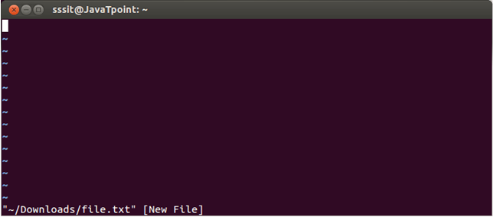

Look at the above snapshot, it is blank as it is a new file. To start typing, you have to move to the insert mode. At the end of the terminal window, directory name and file name are displayed.

**Insert mode**

To move to the insert mode press **i.** Although, there are other commands also to move to insert mode which we'll study in next page.

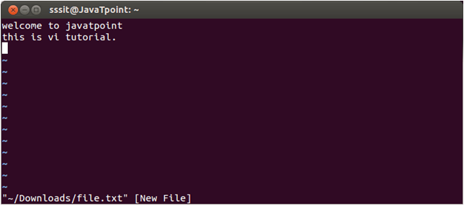

Look at the above snapshot, after pressing **i**we have entered into insert mode. Now we can write anything. To move to the next line press enter.

Once you have done with your typing, press **esc**key to return to the command mode.

**To save and quit**

You can save and quit vi editor from command mode. Before writing save or quit command you have to press colon **(:).** Colon allows you to give instructions to vi.

**exit vi table:**

|  |  |
| --- | --- |
| **Commands** | **Action** |
| :wq | Save and quit |
| :w | Save |
| :q | Quit |
| :w fname | Save as fname |
| ZZ | Save and quit |
| :q! | Quit discarding changes made |
| :w! | Save (and write to non-writable file) |

To exit from vi, first ensure that you are in command mode. Now, type :wq and press enter. It will save and quit vi.

Type **:wq** to save and exit the file.

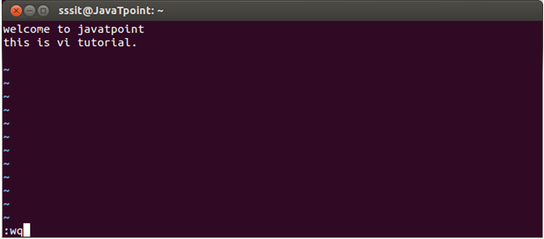

Look at the above snapshot, command :wq will save and quit the vi editor. When you'll type it in command mode, it will automatically come at bottom left corner.

If you want to quit without saving the file, use **:q.** This command will only work when you have not made any changes in the file.

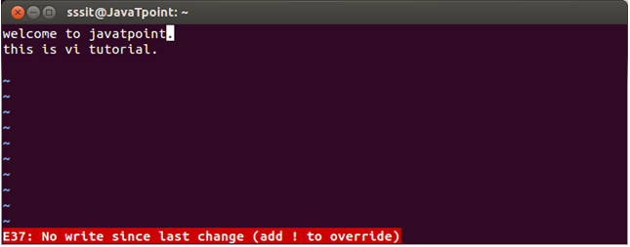

ADVERTISEMENT

Look at the above snapshot, this file is modified and hence on typing **:q** it displays this message at bottom left corner.

The above file can be saved with the command **:!q.** It discards the changes made in the file and save it.

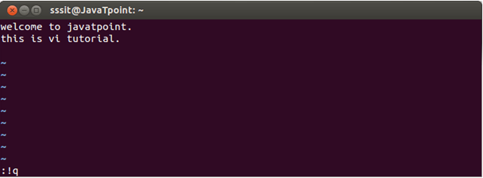

Look at the above snapshot, we have typed **:!q,** it will save our file by discarding the changes made.

**Vi Commands**

Linux vi editor is different from other editors. You have to use different keys to use different functions. Although, it's quite easy and interesting to use vi editor.

The vi editor commands are case sensitive.

**To switch from command to insert mode:**

|  |  |
| --- | --- |
| **Command** | **Action** |
| i | Start typing before the current character |
| I | Start typing at the start of current line |
| a | Start typing after the current character |
| A | Start typing at the end of current line |
| o | Start typing on a new line after the current line |
| O | Start typing on a new line before the current line |

**To move around a file:**

|  |  |
| --- | --- |
| **Commands** | **Action** |
| j | To move down |
| k | To move up |
| h | To move left |
| l | To move right |

**To delete:**

|  |  |
| --- | --- |
| **Commands** | **Action** |
| x | Delete the current character |
| X | Delete the character before the cursor |
| r | Replace the current character |
| xp | Switch two characters |
| dd | Delete the current line |
| D | Delete the current line from current character to the end of the line |
| dG | delete from the current line to the end of the file |

**To repeat and undo:**

|  |  |
| --- | --- |
| **Commands** | **Action** |
| u | Undo the last command |
| . | Repeat the last command |

**Command to cut, copy and paste:**

|  |  |
| --- | --- |
| **Commands** | **Action** |
| dd | Delete a line |
| yy | (yank yank) copy a line |
| p | Paste after the current line |
| P | Paste before the current line |

**Command to cut, copy and paste in blocks:**

|  |  |
| --- | --- |
| **Commands** | **Action** |
| <n>dd | Delete the specified n number of lines |
| <n>yy | Copy the specified n number of lines |

**Move forward or backward:**

|  |  |
| --- | --- |
| **Commands** | **Action** |
| w | Move one word forward |
| b | Move one word backward |
| <n>w | Move specified number of words forward |
| dw | Delete one word |
| yw | Copy one word |
| <n>dw | Delete specified number of words |