Step 1 Create S3 bucket
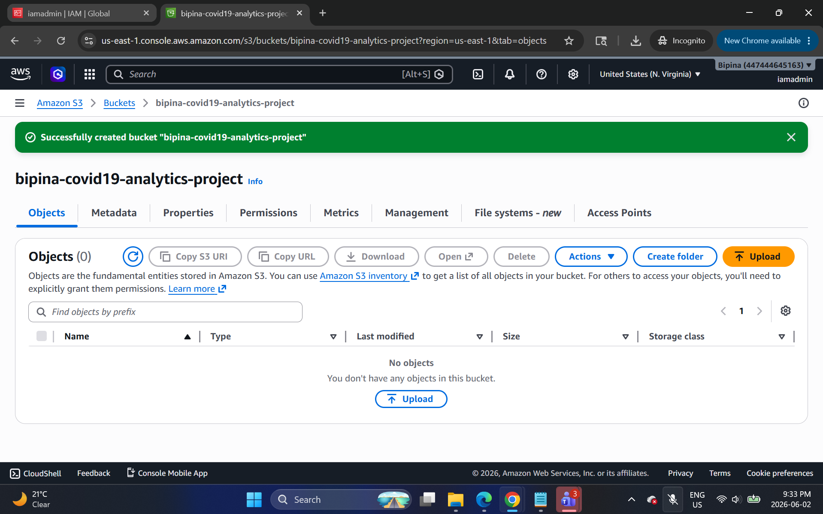
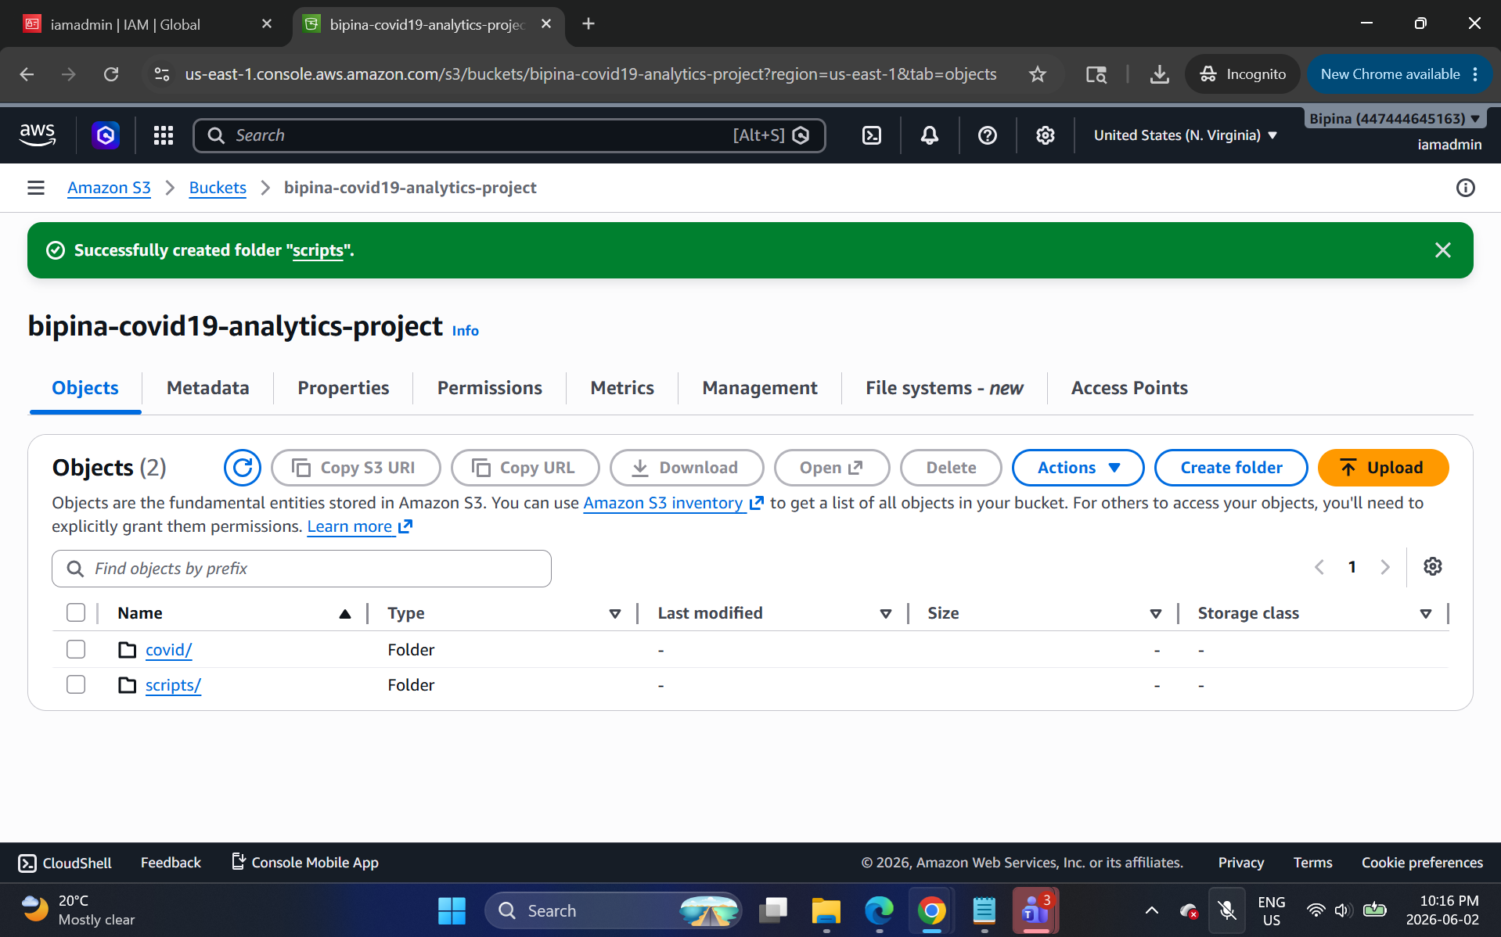
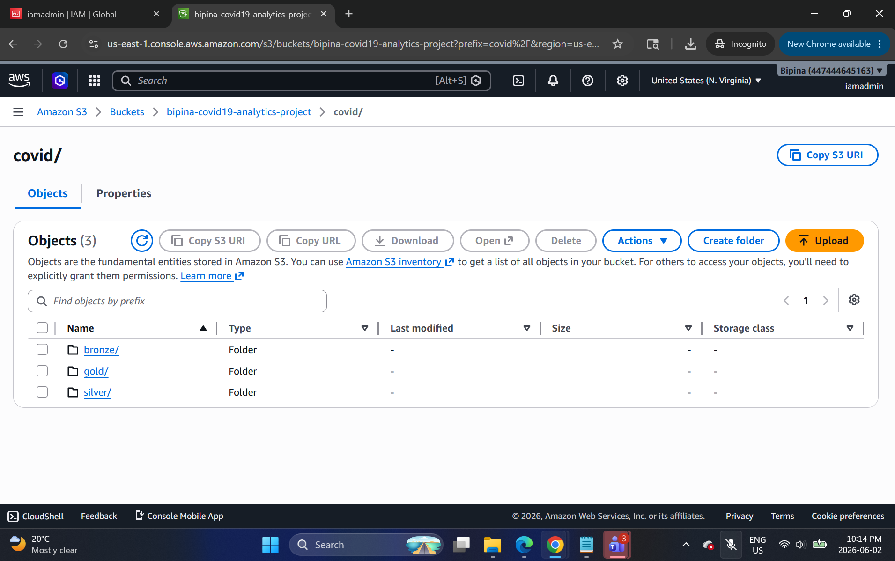

Created covid→bronze→covid_tracking../nytimes…/static folders
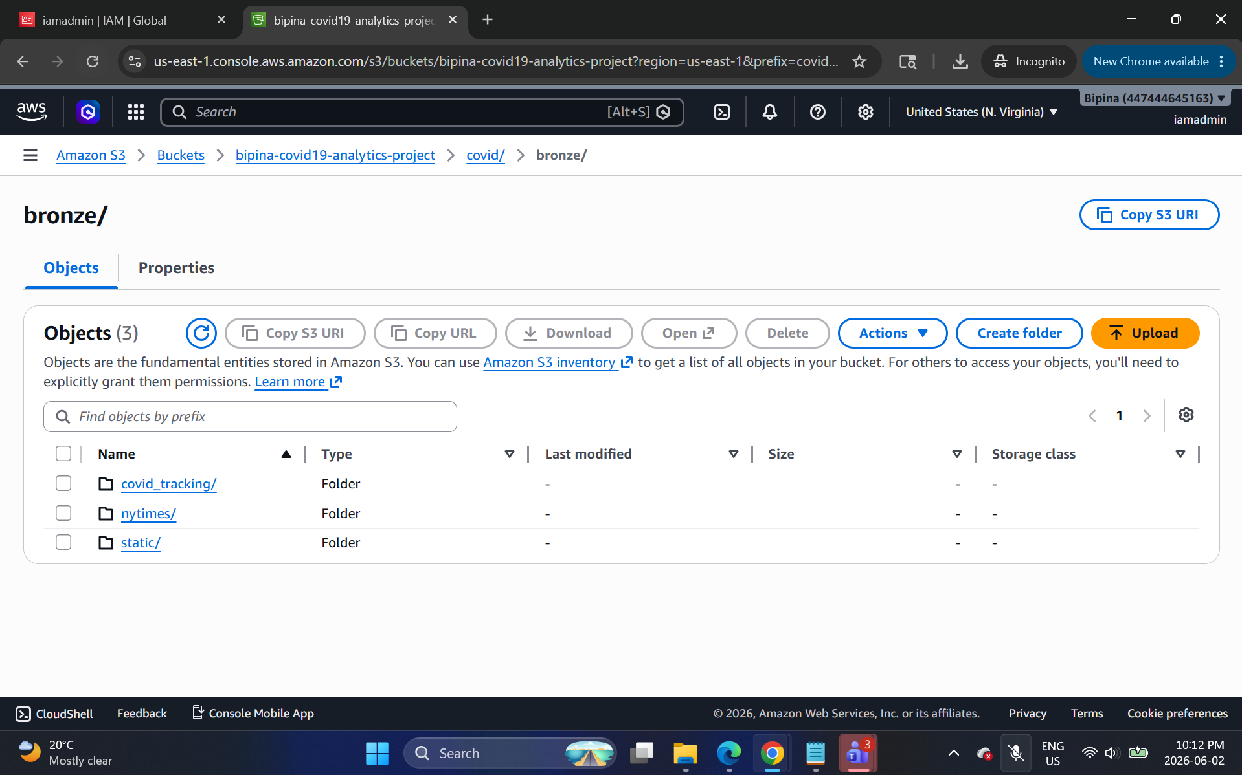
Data uploaded successfully in the required folder as below:
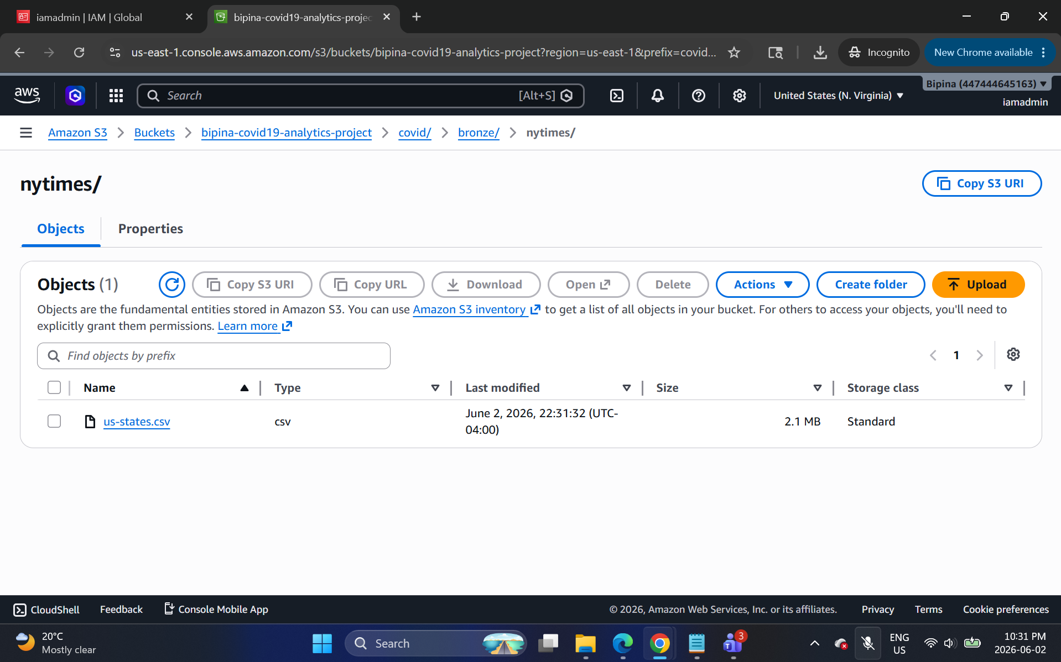

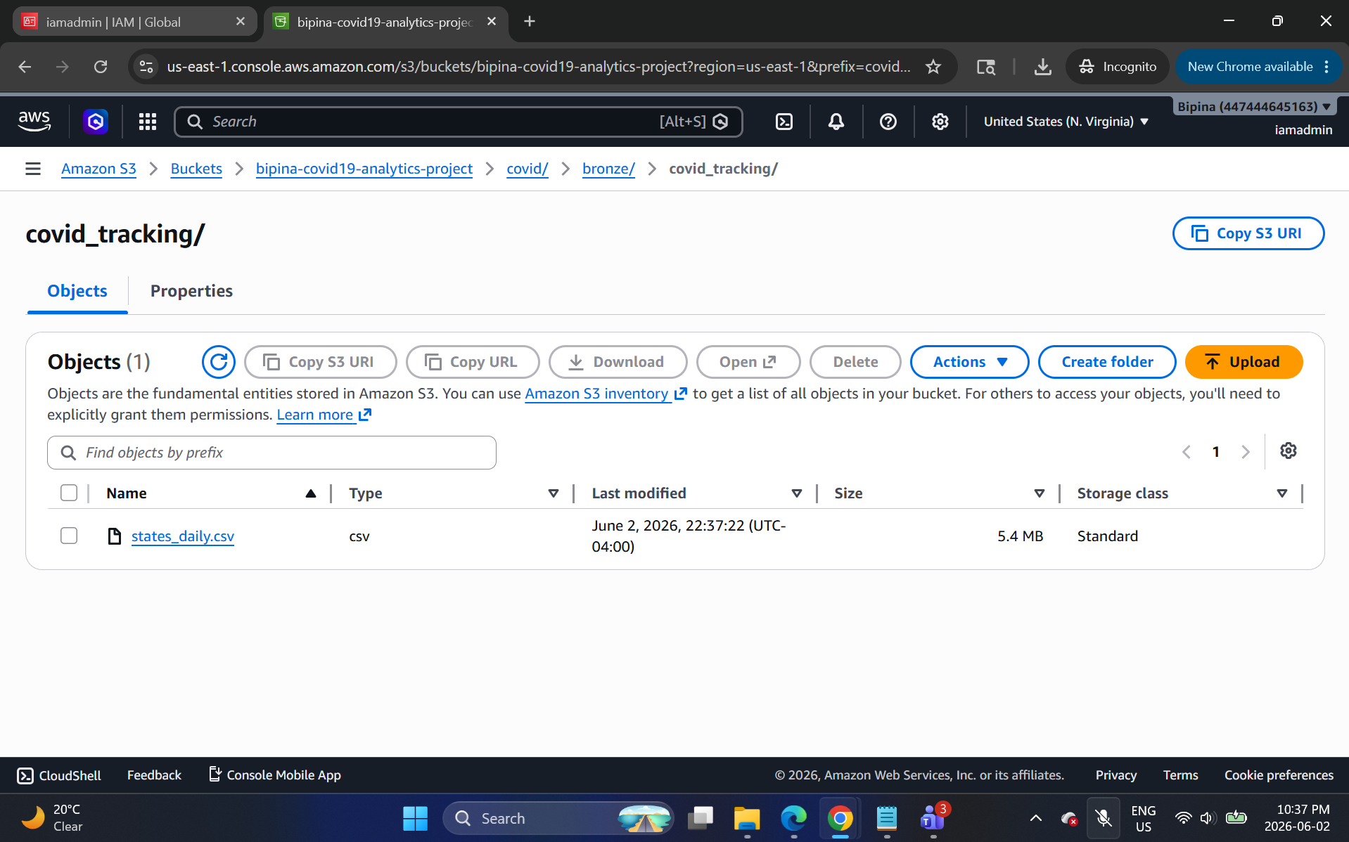
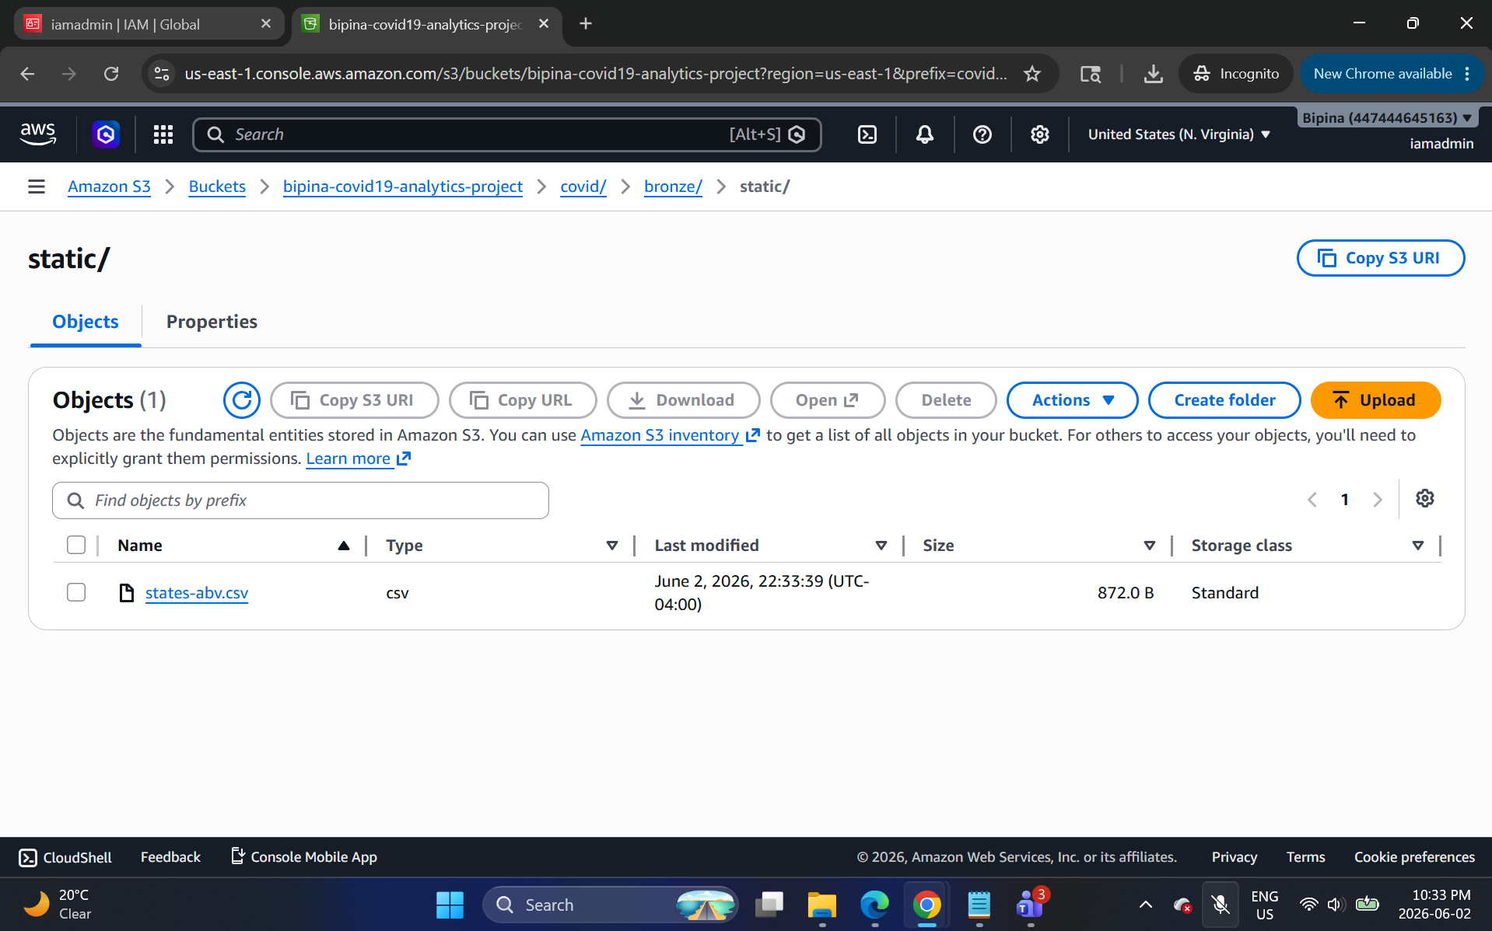

Step 2: Create IAM role for AWS Glue
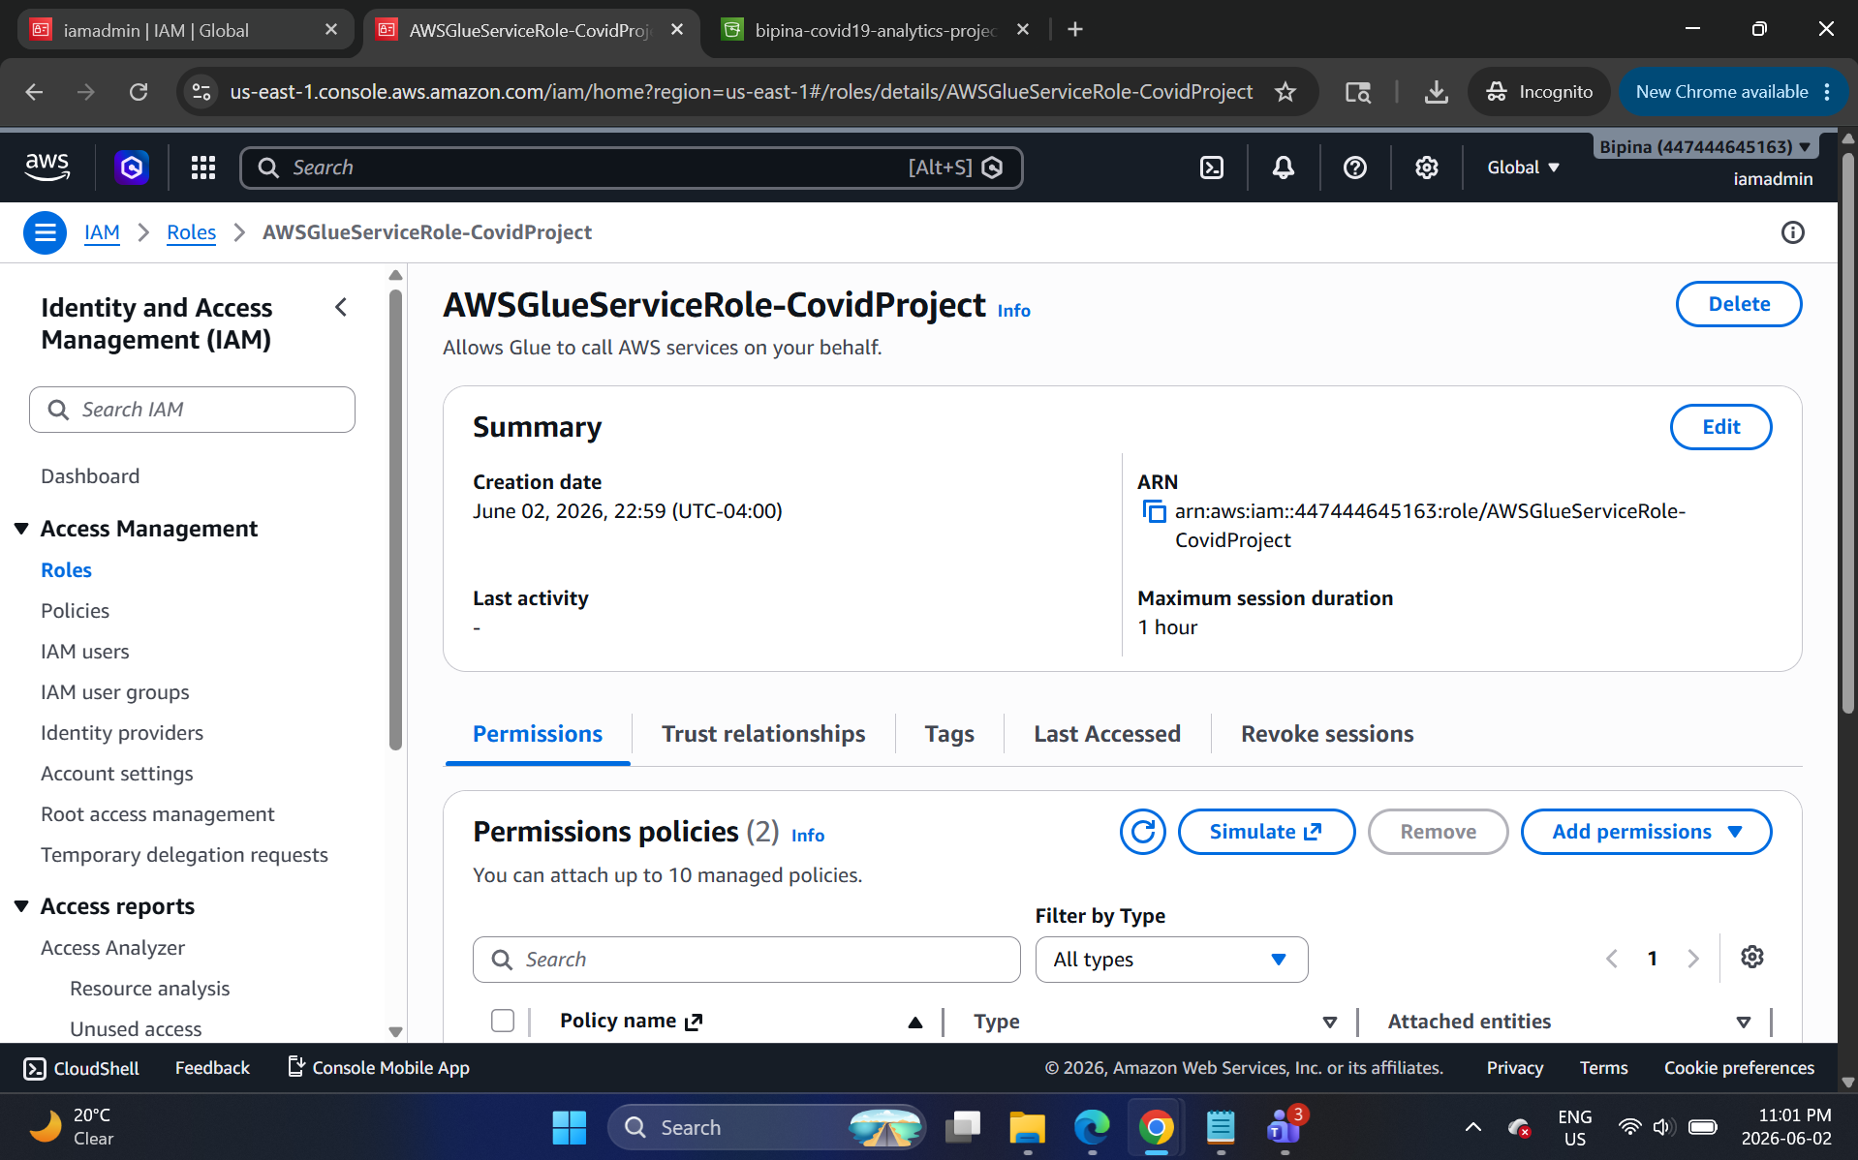

Step 3: Create AWS Glue databases
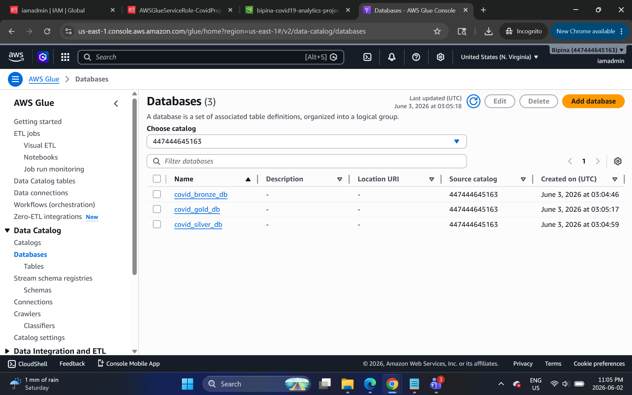
Step 4: Create Glue job for Bronze to Silver

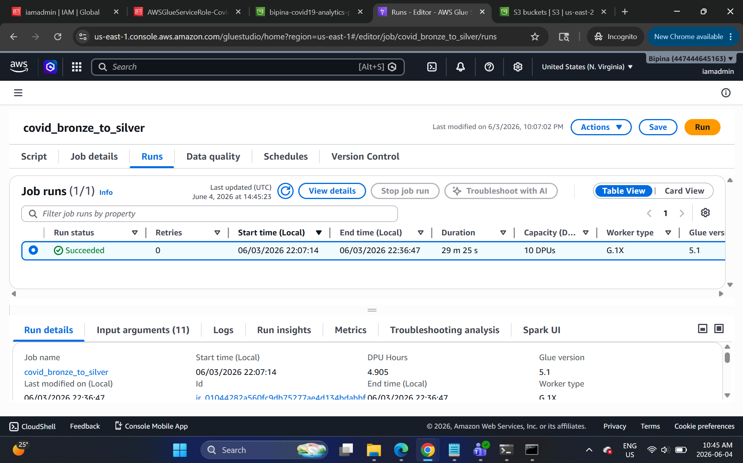
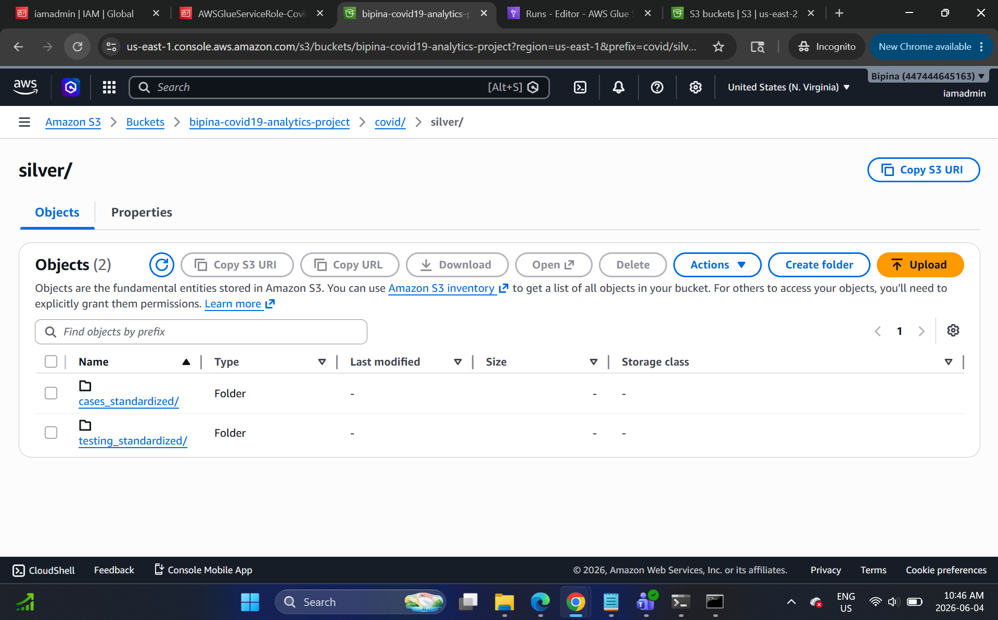
Step 5: Create Glue job for Silver to Gold

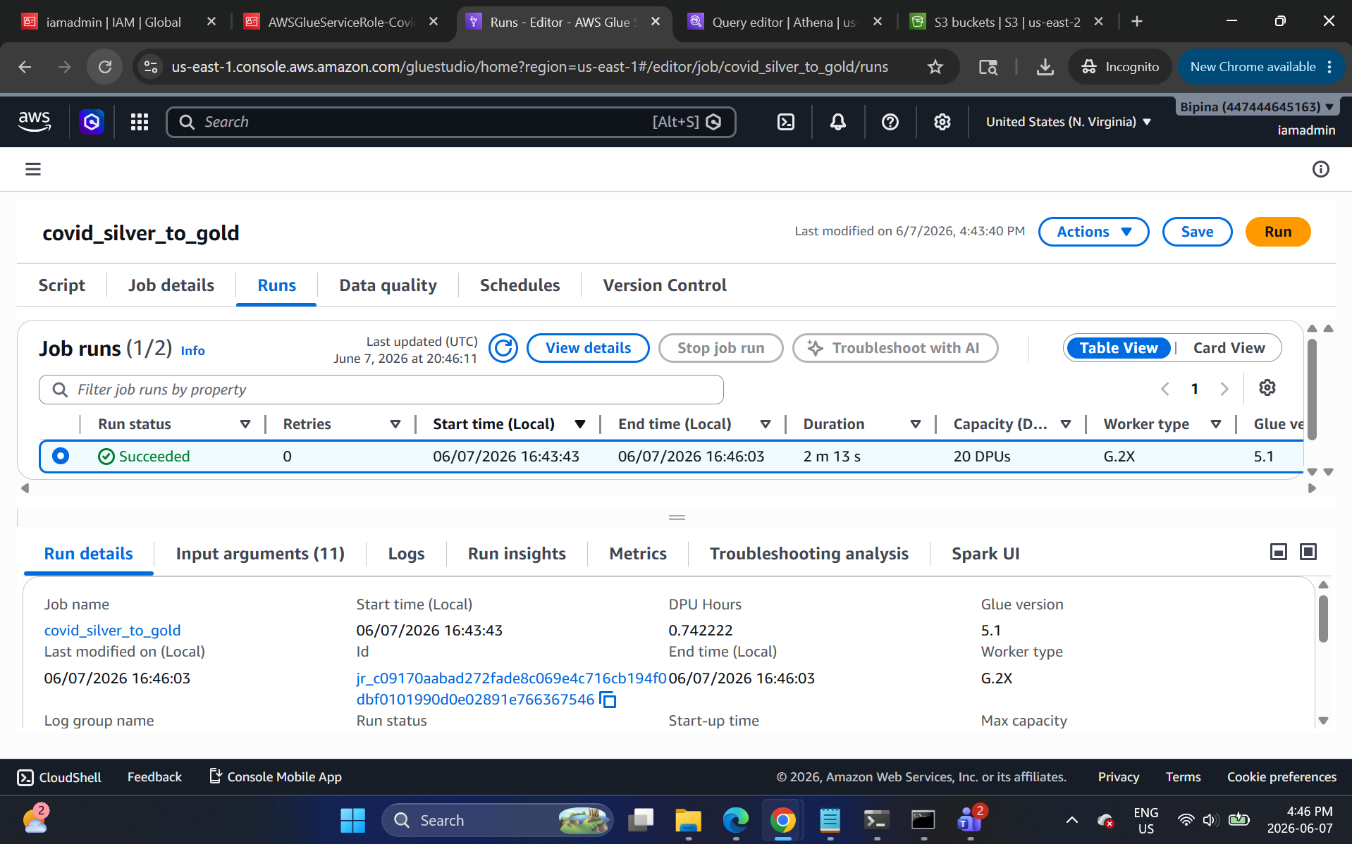
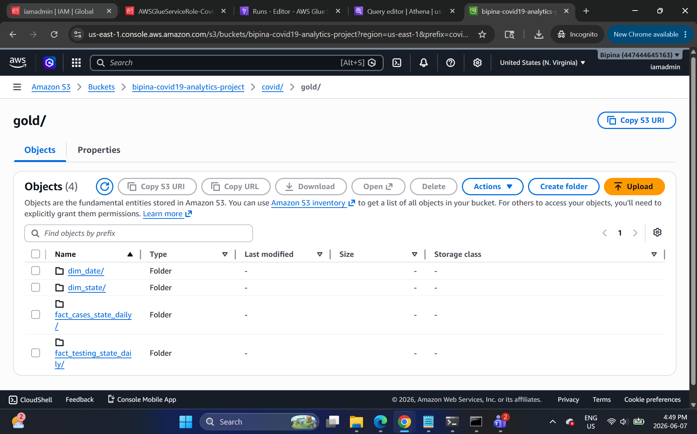

Glue/Athena — register and validate Silver
-- ---- ATHENA (SILVER) ----
CREATE DATABASE IF NOT EXISTS covid_silver_db;

-- Cases
CREATE EXTERNAL TABLE IF NOT EXISTS covid_silver_db.cases_standardized (
full_date date,
state_code string,
state_name string,
cases_cum bigint,
deaths_cum bigint,
year int,
month int,
day int
)
PARTITIONED BY (state_code string, year int, month int, day int)
STORED AS PARQUET
LOCATION 's3://YOUR_BUCKET/covid/silver/cases_standardized/';
MSCK REPAIR TABLE covid_silver_db.cases_standardized;

-- Testing
CREATE EXTERNAL TABLE IF NOT EXISTS covid_silver_db.testing_standardized (
full_date date,
state_code string,
state_name string,
tests_total_cum bigint,
tests_pos_cum bigint,
tests_neg_cum bigint,
year int, month int, day int
)
PARTITIONED BY (state_code string, year int, month int, day int)
STORED AS PARQUET
LOCATION 's3://YOUR_BUCKET/covid/silver/testing_standardized/';
MSCK REPAIR TABLE covid_silver_db.testing_standardized;

-- QUICK QA
SELECT MIN(full_date), MAX(full_date), COUNT(*) FROM covid_silver_db.cases_standardized;
SELECT state_code, COUNT(*) FROM covid_silver_db.testing_standardized GROUP BY 1 ORDER BY 2 DESC;

Step 6: Set query result location as s3://bipina-covid19-analytics-project/covid/athena-results/
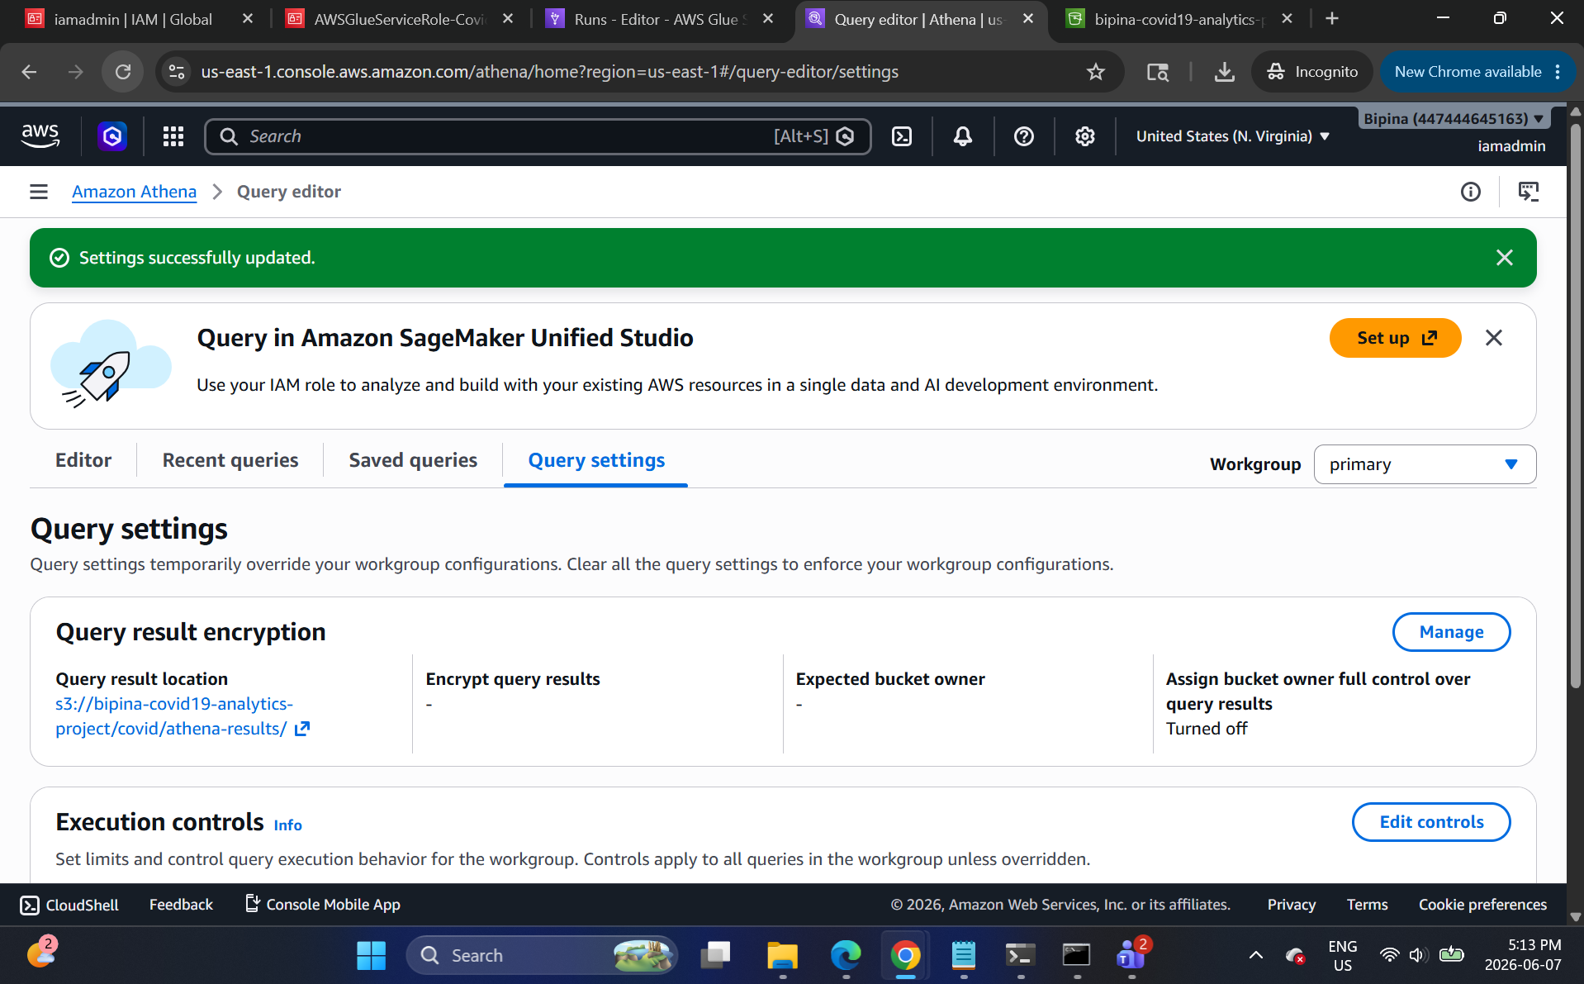

Step 7: Create Silver database
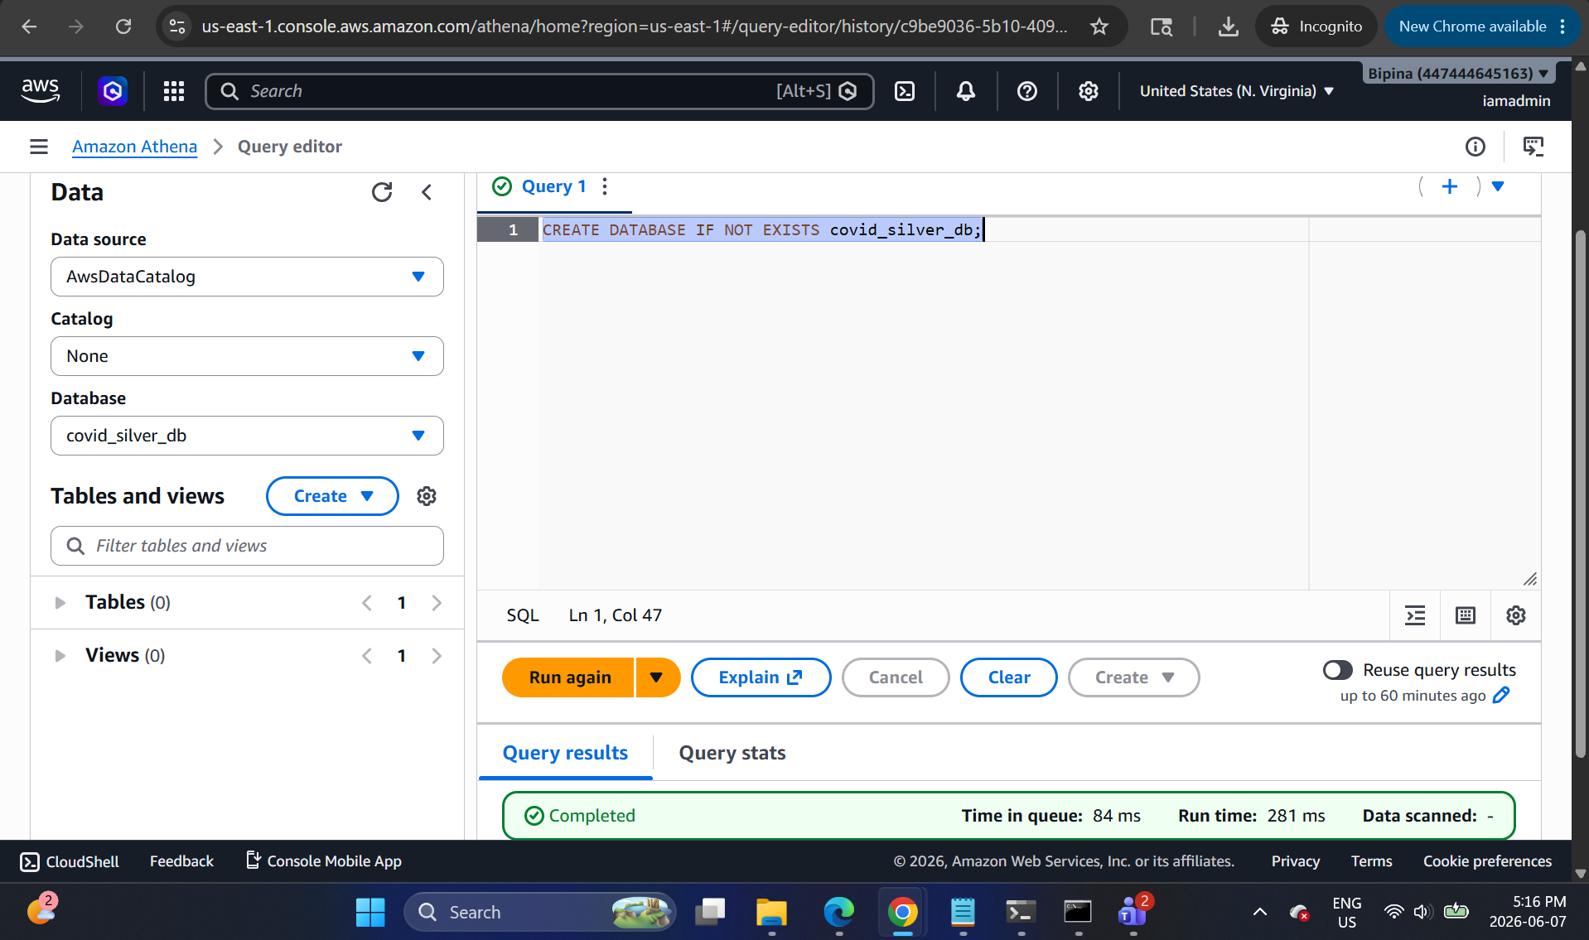
Step 8: Create Silver cases table
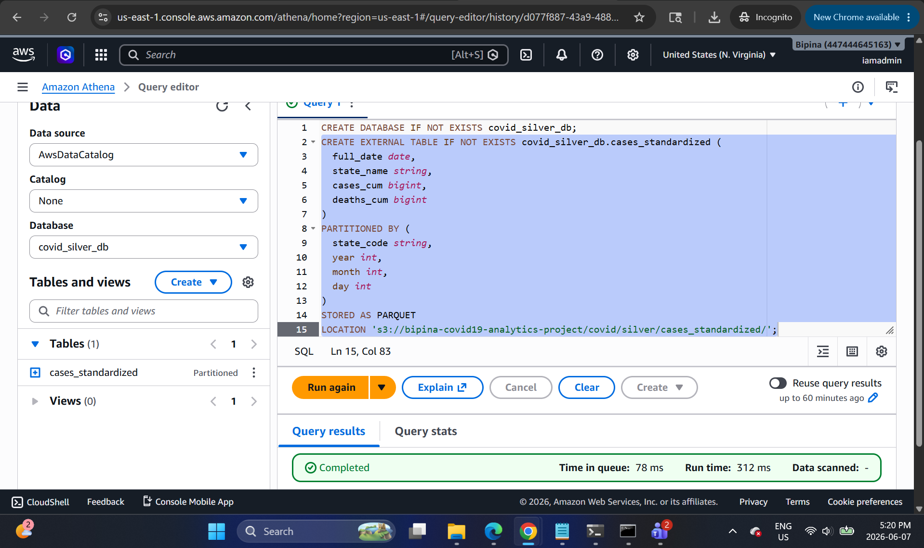
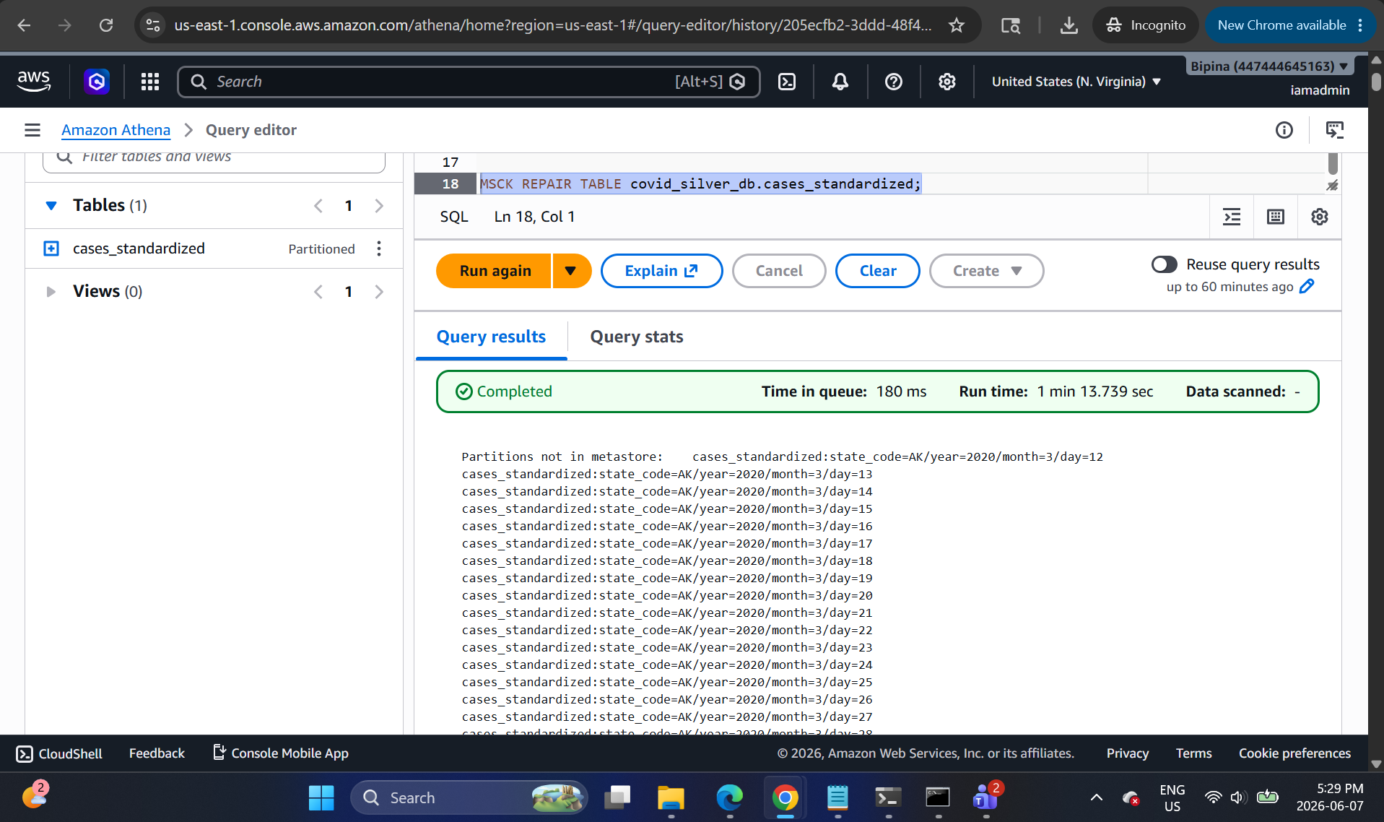

Step 9: Create Silver testing table
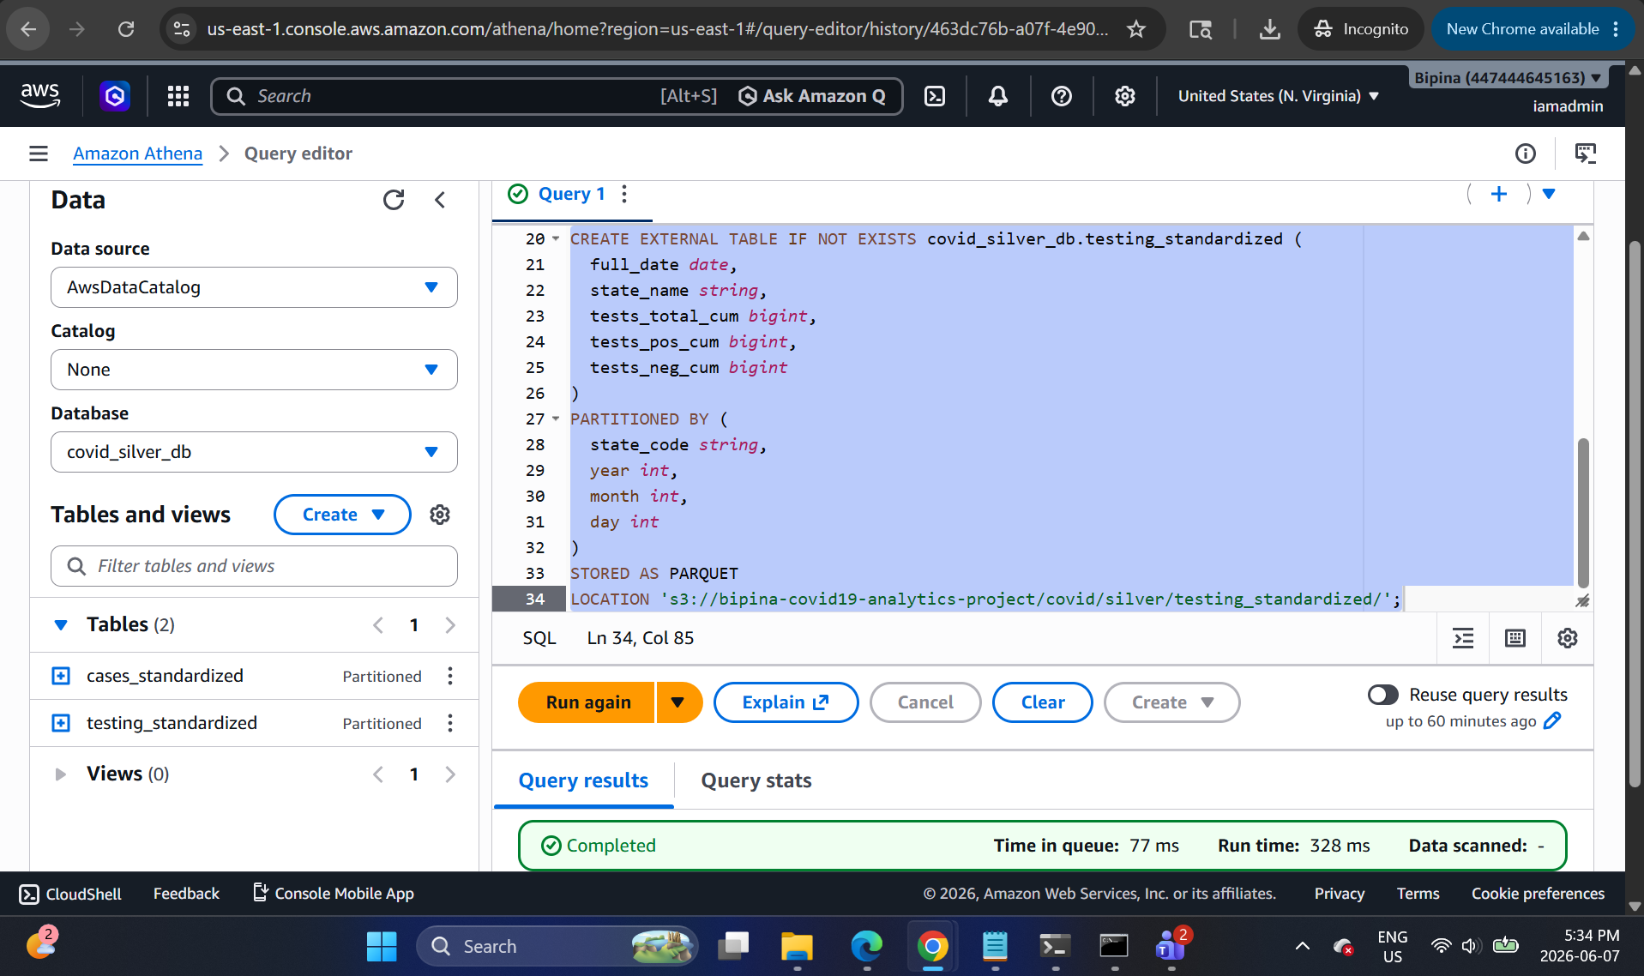

Step 10: Load partitions for testing table
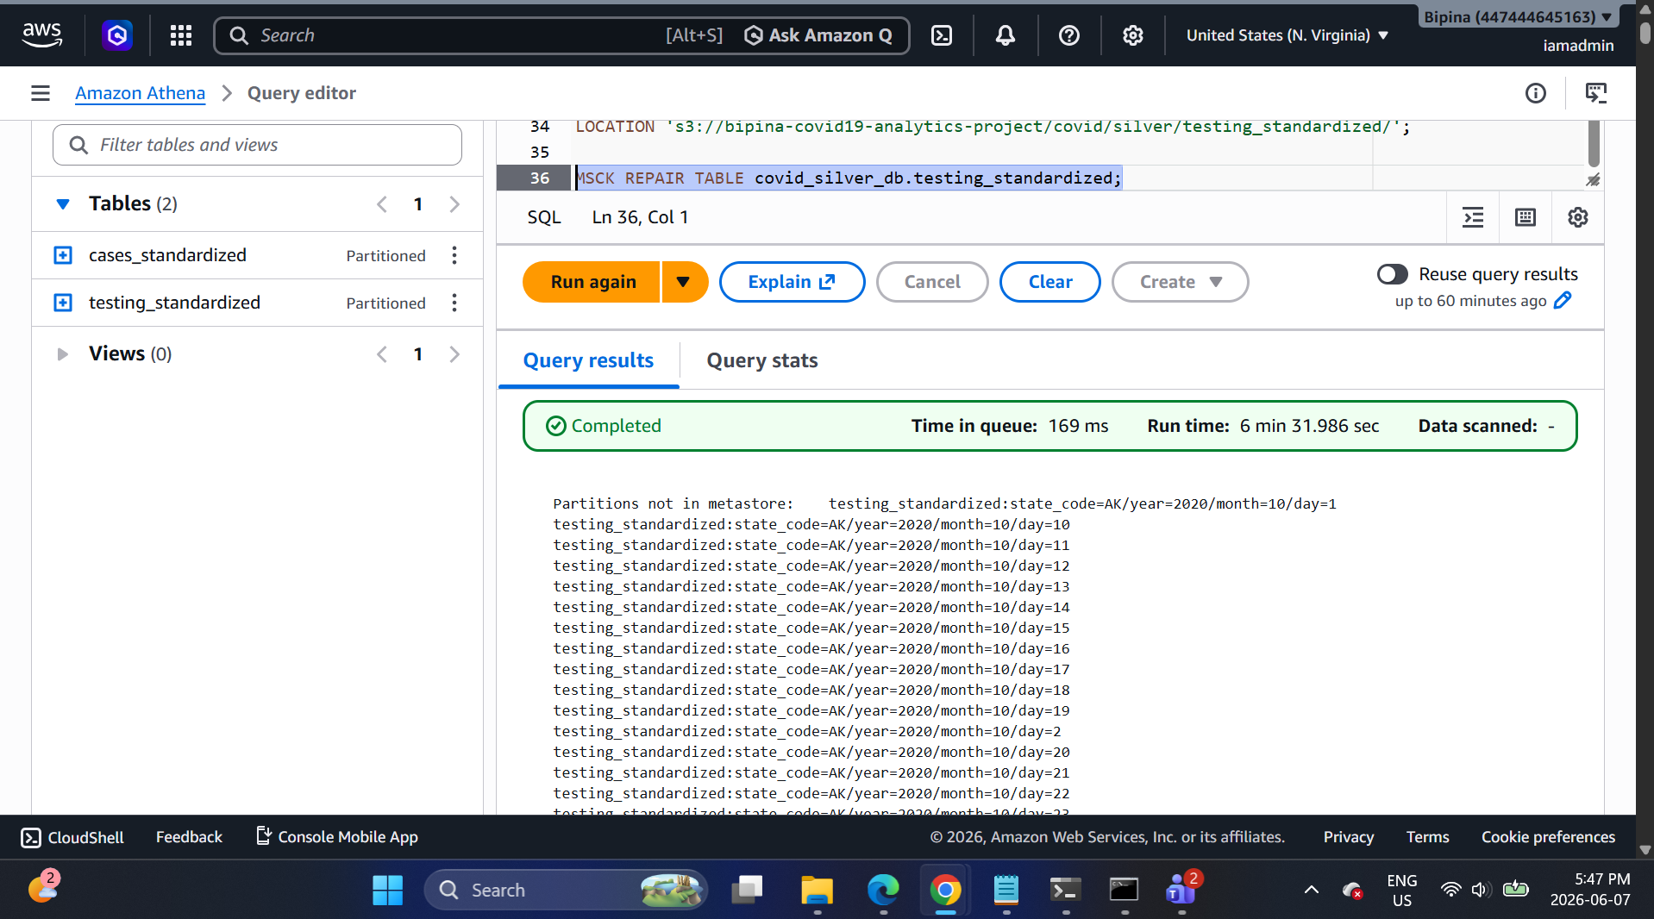

Step 11: Check if tables are created
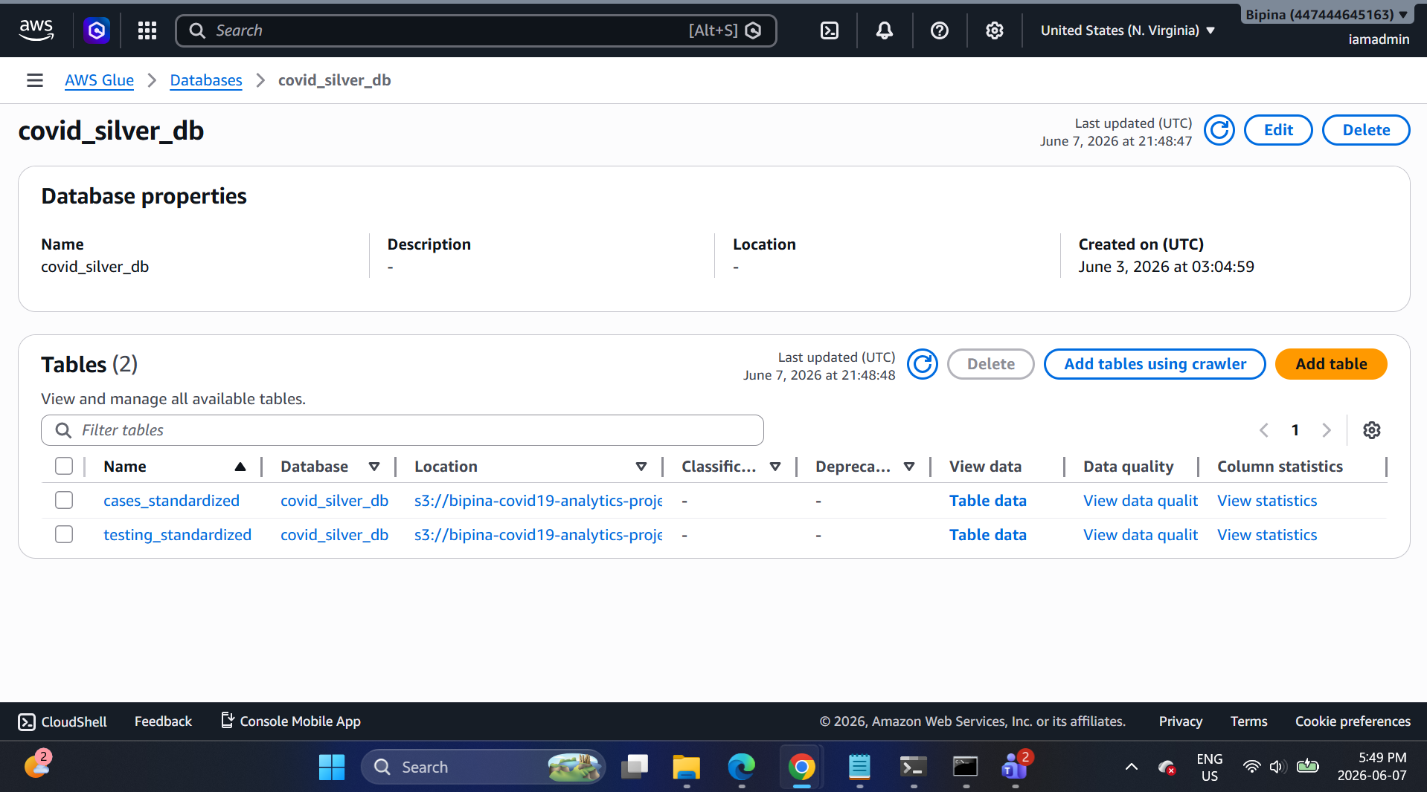

Step 12: Validation query result for Silver cases table
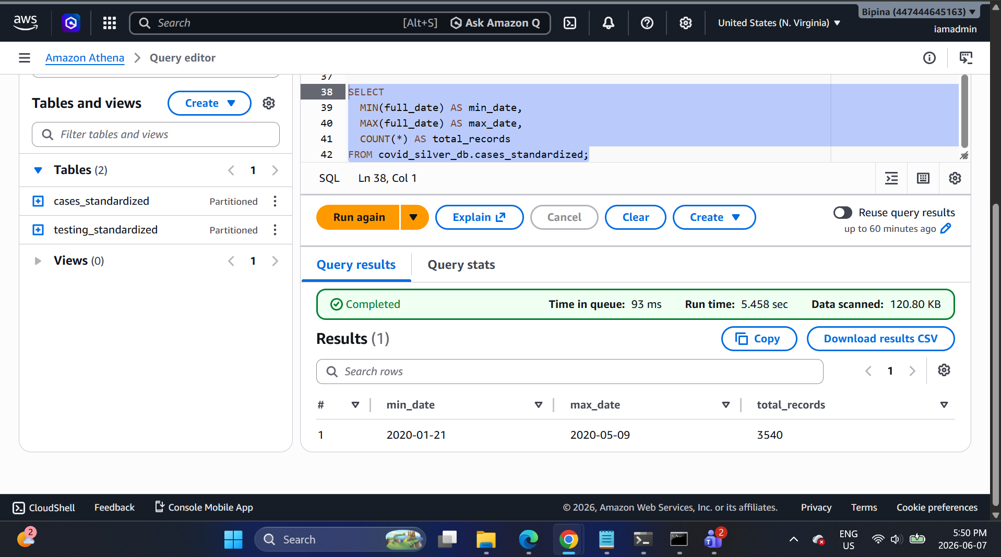
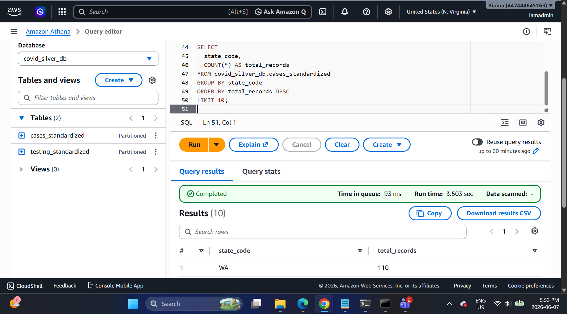
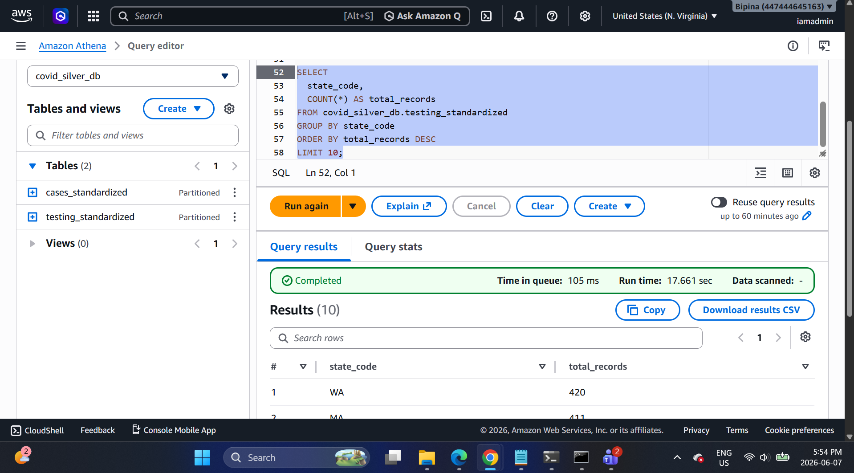

Glue/Athena — register Gold

-- ---- ATHENA (GOLD) ----
CREATE DATABASE IF NOT EXISTS covid_gold_db;

CREATE EXTERNAL TABLE IF NOT EXISTS covid_gold_db.dim_date (
date_id int,
full_date date,
year int,
month int,
day int,
dow int,
is_weekend boolean
)
STORED AS PARQUET
LOCATION 's3://YOUR_BUCKET/covid/gold/dim_date/';

CREATE EXTERNAL TABLE IF NOT EXISTS covid_gold_db.dim_state (
state_code string,
state_name string
)
STORED AS PARQUET
LOCATION 's3://YOUR_BUCKET/covid/gold/dim_state/';

CREATE EXTERNAL TABLE IF NOT EXISTS covid_gold_db.fact_cases_state_daily (
date_id int,
state_code string,
cases_cum bigint,
deaths_cum bigint,
new_cases int,
new_deaths int
)
PARTITIONED BY (state_code string)
STORED AS PARQUET
LOCATION 's3://YOUR_BUCKET/covid/gold/fact_cases_state_daily/';
MSCK REPAIR TABLE covid_gold_db.fact_cases_state_daily;

CREATE EXTERNAL TABLE IF NOT EXISTS covid_gold_db.fact_testing_state_daily (
date_id int,
state_code string,
tests_total_cum bigint,
tests_pos_cum bigint,
tests_neg_cum bigint,
new_tests int,
positivity_rate double
)
PARTITIONED BY (state_code string)
STORED AS PARQUET
LOCATION 's3://YOUR_BUCKET/covid/gold/fact_testing_state_daily/';
MSCK REPAIR TABLE covid_gold_db.fact_testing_state_daily;

Step 13: Register Gold tables in Athena
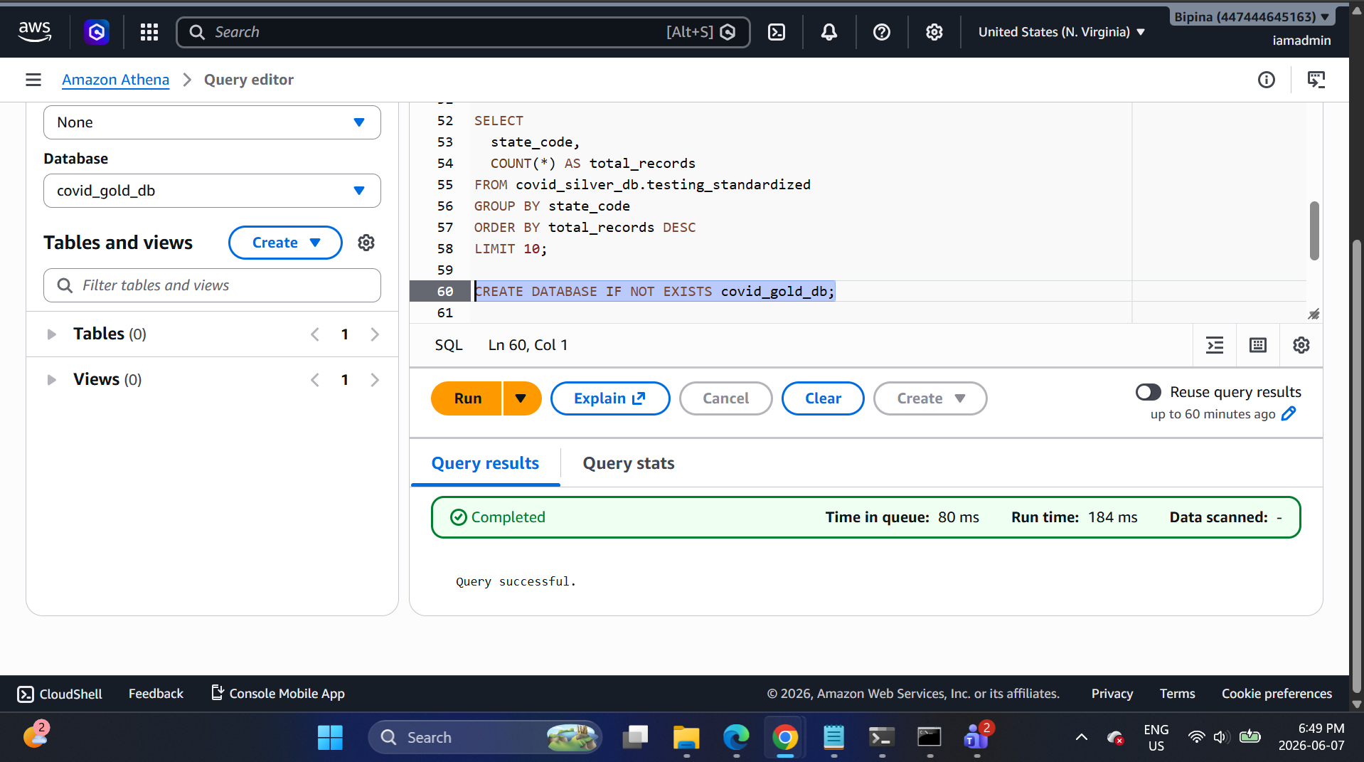

dim_date
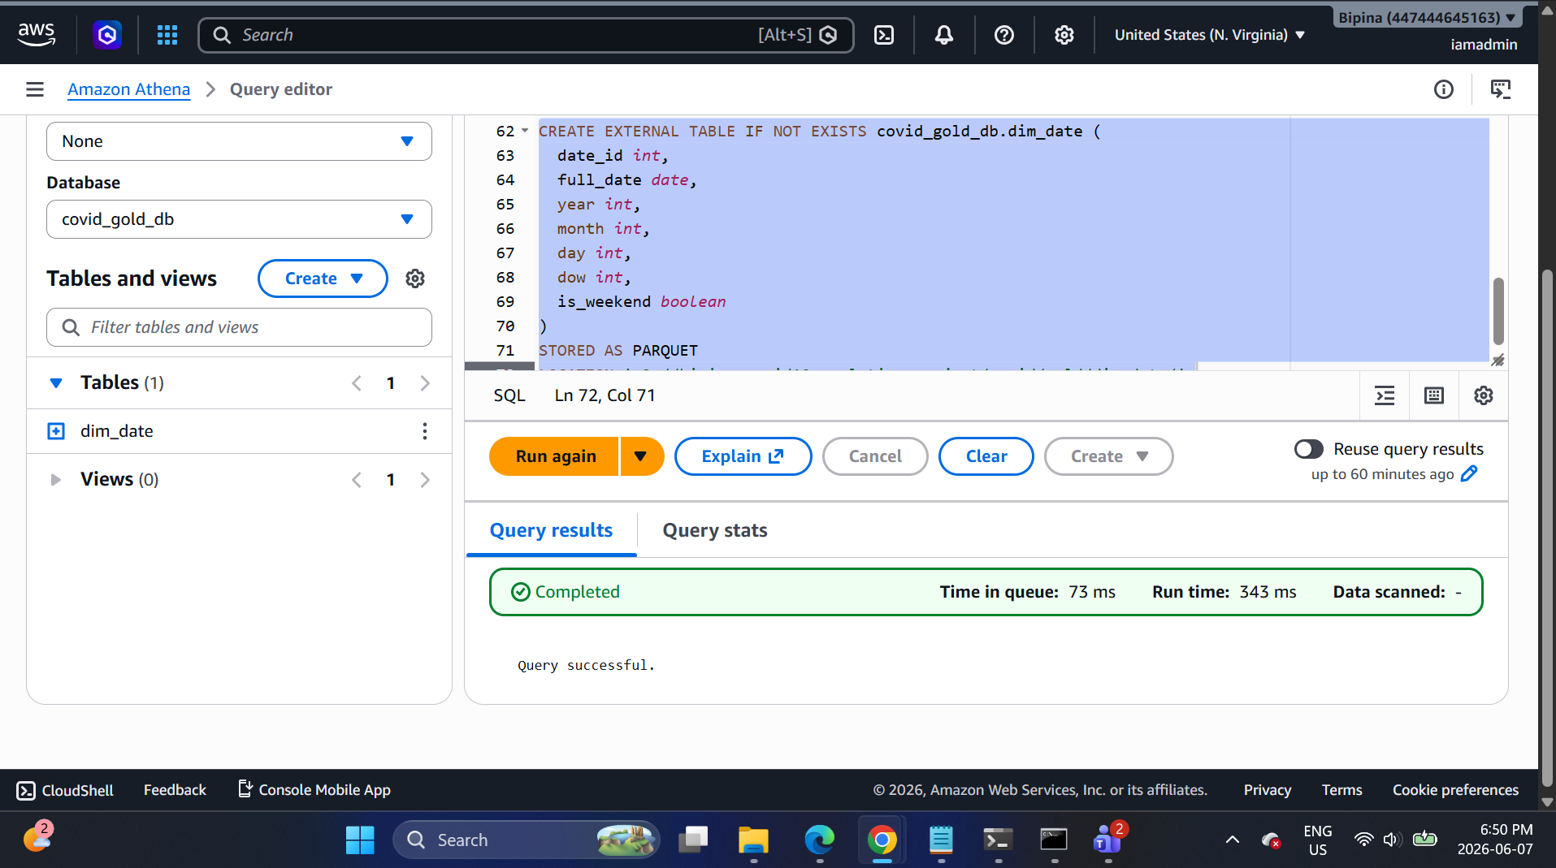

dim_state
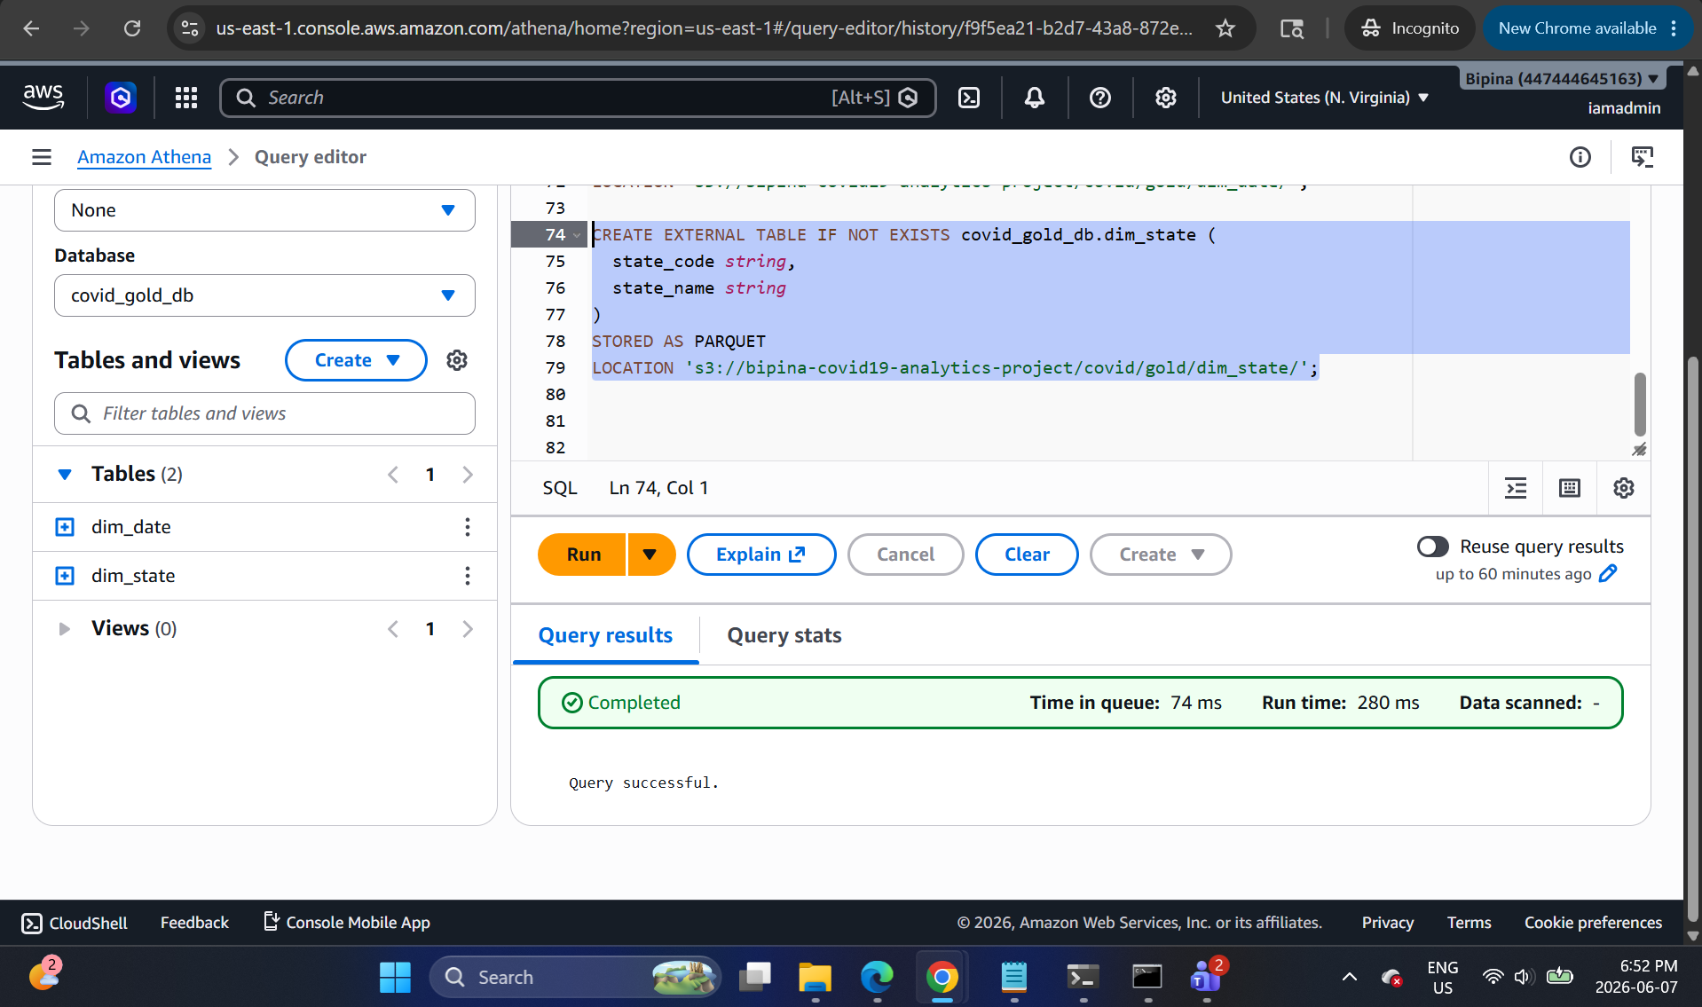

fact_cases_state_daily
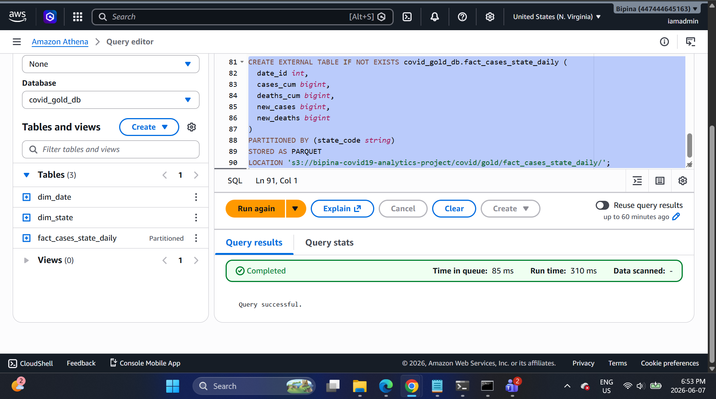
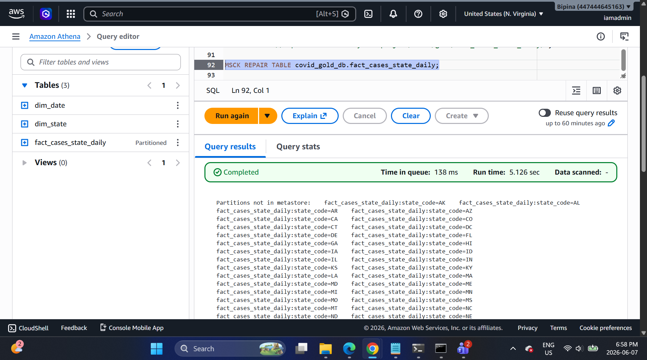

fact_testing_state_daily
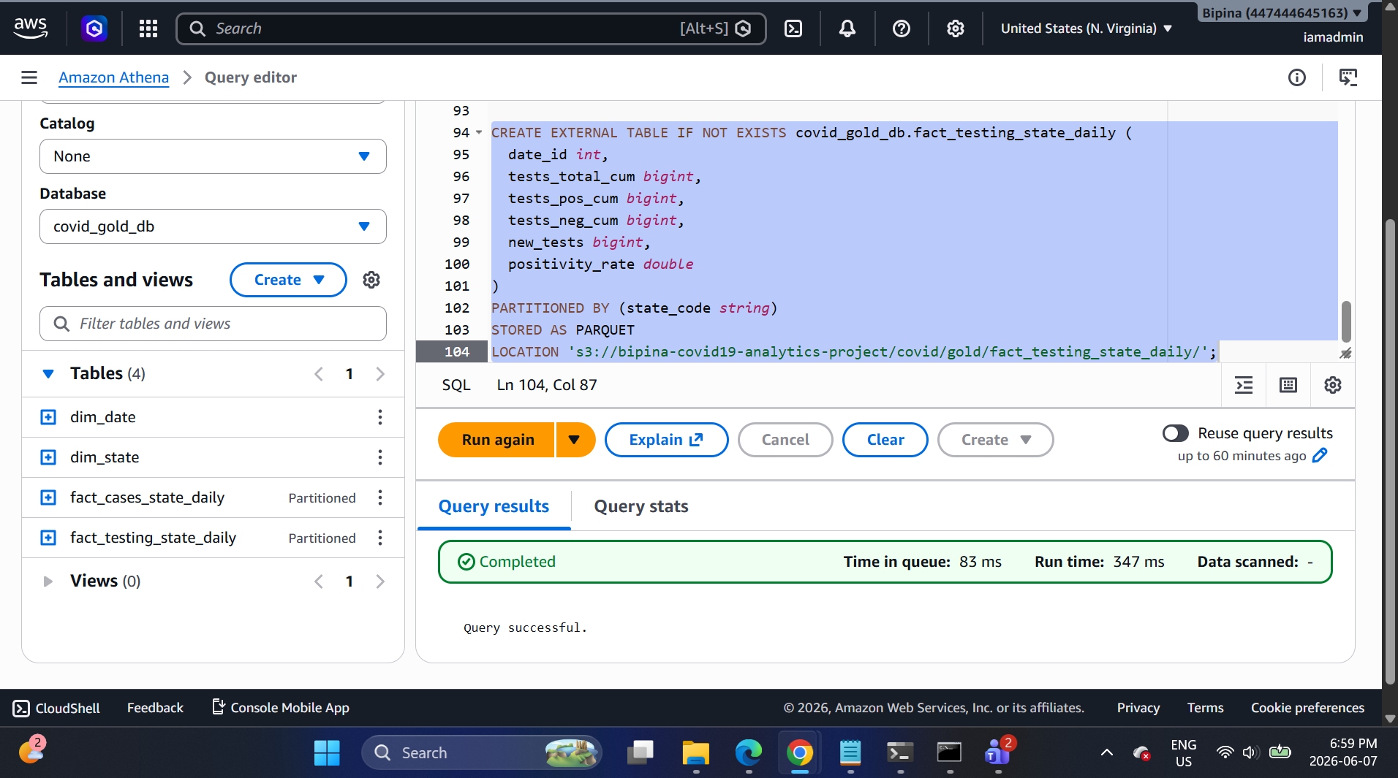

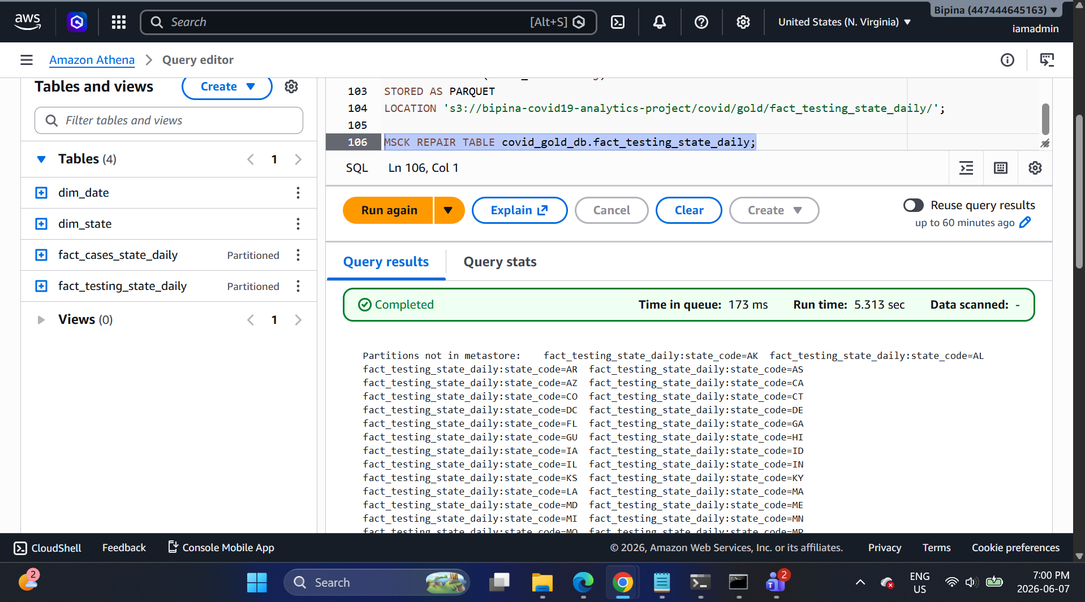

Run final analytics queries
Query 1: Top 5 states by new cases on a date
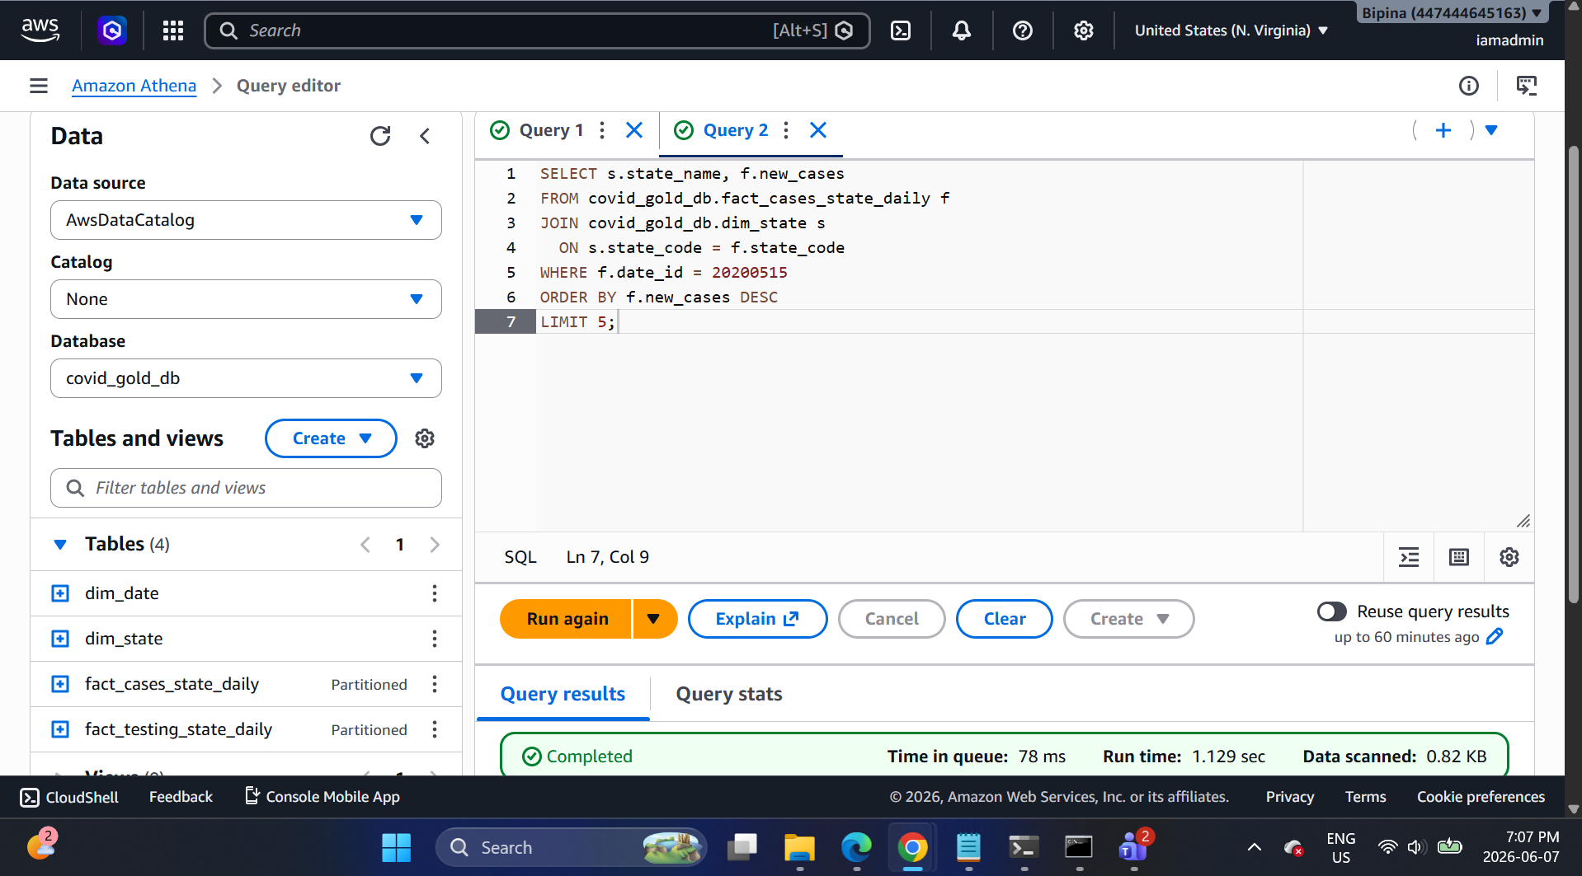

Query 2: Positivity rate trend for New York
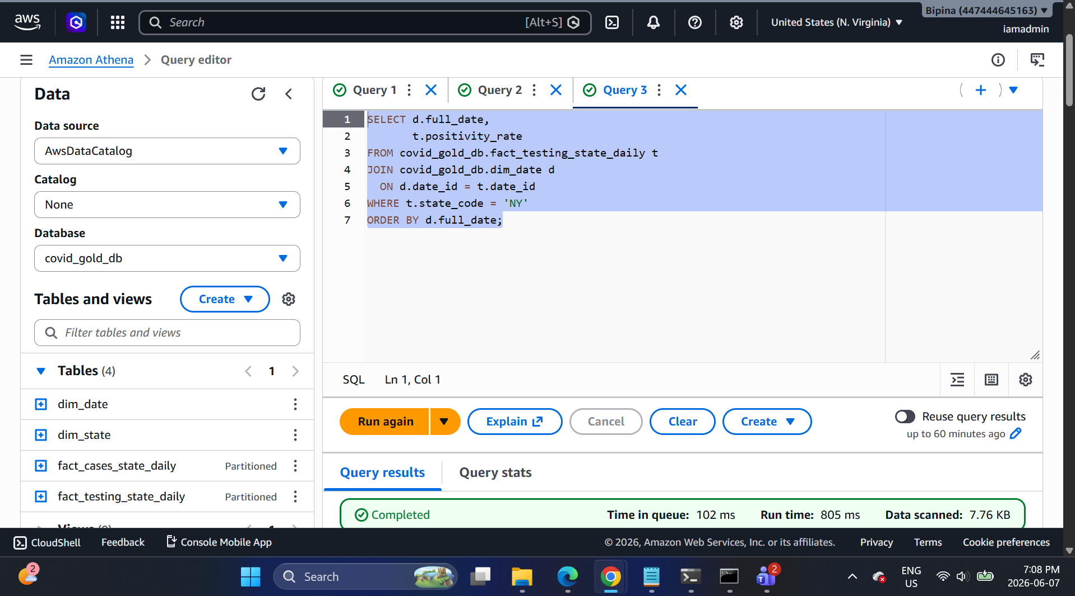
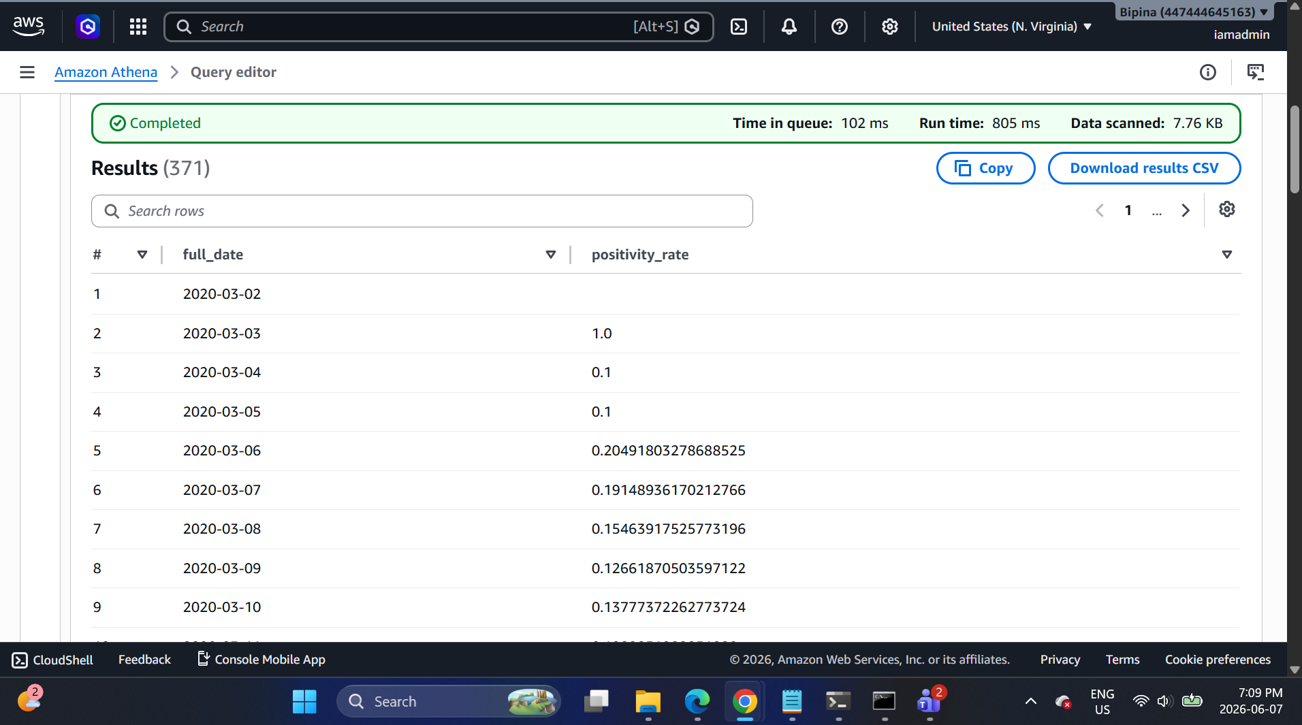

Query 3: Daily cases vs tests for California
