**Instana Agent Setup on Mac**

1. Login to the Instana user interface at: <https://instana-labs.instana.io/> Login as [apmdemo-2@yahoo.com](mailto:apmdemo-2@yahoo.com) with the password provided by the lab instructor.
2. Select the “Stan” the robot icon in the upper left corner  
   stan
3. Next, click the **“Deploy Agent”** button near the upper right corner.  
     
   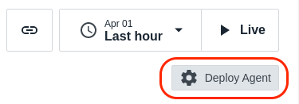
4. Download the static/dynamic MacOS package as mentioned in below

Air Gapped – Static

Internet Access – Dynamic/Static  
   
  
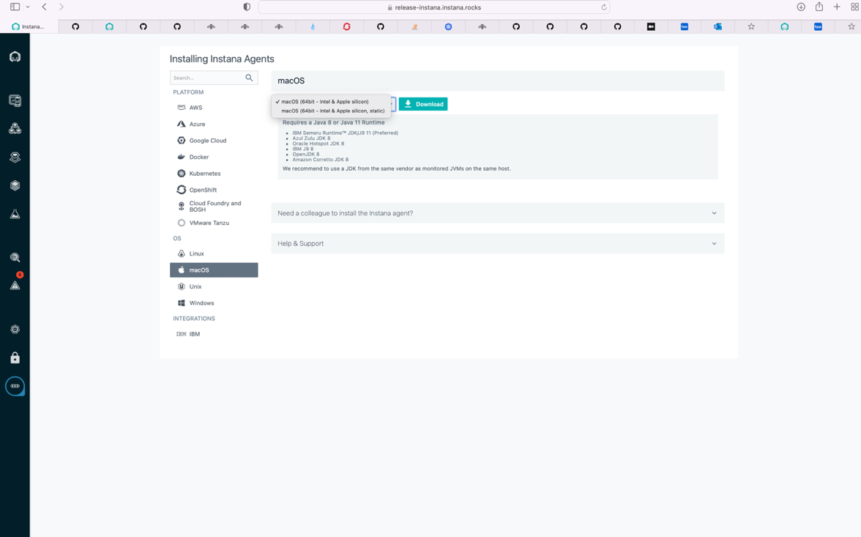

1. Download Java as per your system Req. (Preferred JDK 8) –

<https://adoptopenjdk.net/releases.html?variant=openjdk8&jvmVariant=hotspot>

1. Untar above downloaded build.
2. Set **JAVA_HOME** path in **instana-agent/bin/setenv**  file as mentioned  below:

i) uncomment **# unset JAVA_HOME** from **instana-agent/bin/setenv** file

ii) and add this line, **export JAVA_HOME=<path to your java installed>**

**Note:** Generally JAVA_HOME path /Library/Java/JavaVirtualMachines/adoptopenjdk-8.jdk/Contents/Home for MAC OS but check again according to your system…

1. To Start the agent : **cd instana-agent/bin/**  and execute  **./start**

***Note:***

On the first start of the Instana agent on Apple silicon-based machines, you might see a warning from macOS about an unsigned library that is named libsigar-universal64-macosx.dylib, which is required to run the agent.



To allow the usage of this architecture-specific library, you need to approve it from **System Preferences** -> **Security & Privacy** -> **General**.

Then, restart the agent by running the following command in the terminal, and approve the library on the upcoming pop-up window once again:

**cd instana-agent/bin/**  and execute  **./stop & then ./start**

1. Now let’s configure your agent under particular zone for that we need to update *configuration.yaml*

* Open *configuration.yaml* which is available at below path:

*<instana-agen-install-dir>/etc/instana/configuration.yaml*

* You will see Hardware & Zone. Let’s edit this section and add a Zone name.
* Zones are used to organize the Agents within the Infrastructure view in the UI, but can also be used to filter data for custom dashboards and threshold assignments.
* Uncomment the section and change the availability-zone to something meaningful like your **name** so that you can find it in the UI.

The section should look something like this:

|  |
| --- |
| # Hardware & Zone  com.instana.plugin.generic.hardware:  enabled: true # disabled by default  availability-zone: 'BipinChandraAZ' |

**Note:** *Replace “BipinChandraAZ" with your name. Zone names can contain spaces, so if I wanted, I could specify “Bipin Chandra”. Just choose a meaningful name that will be unique so that you can find your system in the user interface.*