**Instana Agent Setup on Windows**

1. Login to the Instana user interface at: <https://instana-labs.instana.io/> Login as [apmdemo-2@yahoo.com](mailto:apmdemo-2@yahoo.com) with the password provided by the lab instructor.
2. Select the “Stan” the robot icon in the upper left corner  
   stan
3. Next, click the **“Deploy Agent”** button near the upper right corner.  
     
   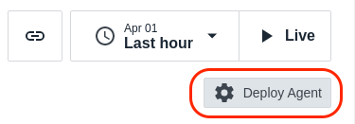
4. Installing Instana Agent (Using Windows Installer):

You can install the host agent by using a Windows installer, which helps to install the host agent automatically. Follow the steps:

* From the **OS** list, select **Windows**.
* From the **Technology** dropdown, select **Windows Installer**.
* Select the archive that matches your system architecture, and then click **Download**.

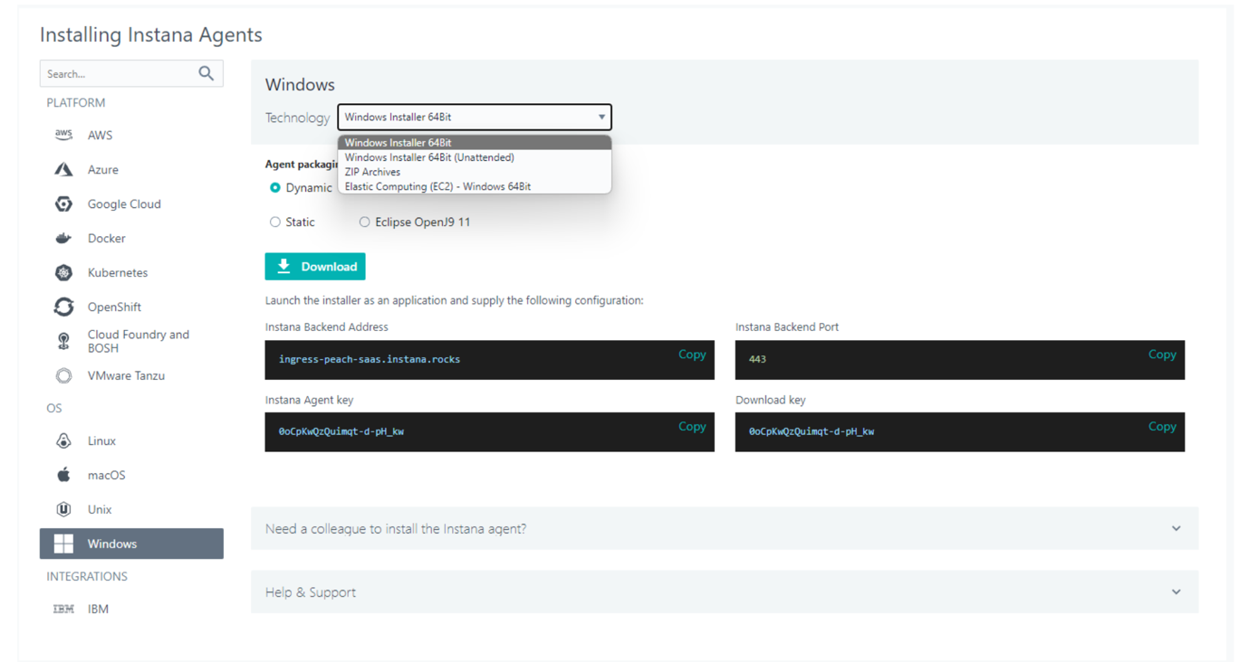

* Run the Windows installer on the Windows host machine where you want to install the host agent. A GUI guides you through the process of installing the agent and takes care of installing the prerequisites (.NET Framework 4.5 and a JVM).
* The installer also registers the agent as a service, sets the service to start automatically, and starts the service after the installation.
* To confirm whether agent is started or not check agent logs from below path :

*<instana-agent-install-dir>/data/log/agent.log*

1. Now let’s configure your agent under particular zone for that we need to update *configuration.yaml*

* Open *configuration.yaml* which is available at below path:

*<instana-agen-install-dir>/etc/instana/configuration.yaml*

* You will see Hardware & Zone. Let’s edit this section and add a Zone name.
* Zones are used to organize the Agents within the Infrastructure view in the UI, but can also be used to filter data for custom dashboards and threshold assignments.
* Uncomment the section and change the availability-zone to something meaningful like your **name** so that you can find it in the UI.

The section should look something like this:

|  |
| --- |
| # Hardware & Zone  com.instana.plugin.generic.hardware:  enabled: true # disabled by default  availability-zone: 'BipinChandraAZ' |

**Note:** *Replace “BipinChandraAZ" with your name. Zone names can contain spaces, so if I wanted, I could specify “Bipin Chandra”. Just choose a meaningful name that will be unique so that you can find your system in the user interface.*