

Tribhuvan University
Faculty of Humanities and Social Sciences

A Project Report On
E-Commerce Website for ReTech
Submitted To
Department of Computer Application
Itahari Namuna College

In partial fulfilment of the requirements for the degree of Bachelor’s in Computer Application.

Submitted By
Rupesh Yadav

Under the Supervision of
Er. Saroj Ojha
Lecturer

Tribhuvan University
Faculty of Humanities and Social Sciences
Itahari Namuna College

Supervisor’s Recommendation

I hereby recommend that this project prepared under my supervision by Rupesh Yadav entitled “E-Commerce Website for ReTech” in partial fulfilment of the requirements for the degree of Bachelor’s in Computer Application is recommended for the final evaluation.

Er. Saroj Ojha
Project Supervisor
Itahari Namuna College
Itahari-8, Sunsari

Tribhuvan University
Faculty of Humanities and Social Sciences
Itahari Namuna College

Letter of Approval

This is to certify that this project prepared by Bipin Limbu entitled “E-Commerce Website for ReTech” in partial fulfilment of the requirements for the degree of Bachelor’s in Computer Application has been evaluated. In our opinion it is satisfactory in the scope and quality as a project for the required degree.

Nabin Shrestha
HOD/Coordinator
Er. Saroj Ojha
Supervisor

External Examiner
Tribhuvan University
Internal Examiner
Itahari Namuna College

ACKNOWLEDGEMENT
The success and final outcomes of this project require a lot of guidance and assistance from many people and are very fortunate to have this all along the completion of this project. We would like to express our gratitude and appreciation to all those who gave us the possibility to complete this project. We are very glad to express our deepest sense of gratitude and sincere thanks to our supervisor Er. Saroj Ojha whose contribution in simulating suggestions and encouragement helped us in completing our project. All useful suggestions for this whole work and co-operative behaviour are sincerely acknowledged.
Last but not the least, many thanks go to our teachers, friends, guardians who directly or indirectly helped us in achieving the goal. We would like to appreciate all the guidance and support, which helped in completion of this project. Special thanks to their comment and advice.

Table of Contents
Supervisor’s Recommendation ii
Letter of Approval iii
ACKNOWLEDGEMENT iv
CHAPTER 1: INTRODUCTION 1
Introduction to Ecommerce 1
Introduction to MIS 2
Introduction to Store: ApexStriker 3
CHAPTER 2: PLANNING 4
Introduction 4
The E-Commerce Planning Process 4
CHAPTER 3: NETWORK INFRASTRUCTURE 7
Introduction 7
World Wide Web (WWW) 7
Internet 8
I-Way (Information Superhighway) 8
CHAPTER 4: PROCESS OF BUILDING WEBSITE 10
Process of Website Building 10
CHAPTER 5: PAYMENT GATEWAY 11
Introduction 11
CHAPTER 6: HANDLING SECURITY ISSUE 12
Handle Security Issue 12
CHAPTER 7: SCREENSHOTS 13
CHAPTER 8: CONCLUSION 18
Conclusion 18

CHAPTER 1: INTRODUCTION

Introduction to Ecommerce
E-commerce, short for electronic commerce, refers to the buying and selling of goods or services over the internet. It involves the use of websites and online platforms to conduct transactions, as well as the use of electronic payment methods such as credit cards and digital wallets. E-Commerce has grown rapidly in recent years, driven by the increasing availability of high-speed internet and the widespread use of smartphones and other mobile devices. It allows customers to shop online from anywhere and at any time, making it convenient and accessible. Online businesses can also reach a global audience and expand their customer base.
There are several different types of ecommerce, including:
- Business-to-Consumer (B2C): This type of e-commerce involves businesses selling products or services directly to consumers. Examples include online retailers such as Amazon and clothing websites such as ASOS.
- Consumer-to-Consumer (C2C): This type of e-commerce involves individuals selling products or services to other individuals. Examples include online marketplaces such as eBay and Etsy.
- Business-to-Business (B2B): This type of e-commerce involves businesses selling products or services to other businesses. Examples include wholesale distributors such as Alibaba and Thomas Net.
- Consumer-to-Business (C2B): This type of e-commerce involves consumers selling products or services to businesses. Examples include freelance platforms such as Upwork and Fiverr.
Ecommerce has many advantages for both businesses and consumers. For businesses, it allows for a larger customer base and increased revenue, as well as the ability to reach global audiences. It also allows for automation of many business processes, such as inventory management and customer service. For consumers, it offers convenience and accessibility, as well as the ability to easily compare prices and products.
However, ecommerce also has its challenges. Businesses must navigate the competitive online marketplace and find ways to stand out. They must also ensure that their website is user-friendly and secure to protect customer information. Additionally, ecommerce businesses must comply with legal regulations, such as those related to taxes and consumer
protection.
Overall, ecommerce is a rapidly growing industry that offers many opportunities for businesses and consumers alike. As technology continues to advance, we can expect to see even more innovation and growth in the ecommerce space in the coming years.

Introduction to MIS
Management Information Systems (MIS) is a field of study that focuses on the use of technology to support and improve decision-making, coordination, and operation within organizations. It involves the development, implementation, and management of systems and technologies that provide managers with the information they need to make informed decisions.
The main components of an MIS include:
- Hardware: The physical equipment and devices that make up the system, such as servers, computers, and mobile devices.
- Software: The programs and applications that run on the hardware, such as databases, spreadsheets, and business intelligence tools.
- Data: The information that is stored, processed, and analyzed by the system, such as financial data, customer data, and sales data.
- Procedures: The set of processes and protocols that are used to manage and operate the system, such as data entry, data validation, and data backup.
- People: The users of the system, such as managers, employees, and customers.
An MIS can support a wide range of business functions, including:
- Operations management: The management of day-to-day business activities, such as inventory management, supply chain management, and production planning.
- Decision-making: The use of data and analytics to inform strategic and tactical decision-making. 2
- Financial management: The management of financial resources, such as budgeting, forecasting, and accounting.
- Marketing: The management of marketing activities, such as customer relationship management, market research, and advertising.
- Human resources: The management of human resources activities, such as recruitment, training, and performance management.
MIS is an interdisciplinary field that draws on knowledge from computer science, information technology, management, and other areas. Professionals in this field often have skills in programming, database management, systems analysis, and project management, as well as knowledge of business operations and processes.
The field of MIS is constantly evolving as new technologies and trends emerge. Cloud computing, big data, and artificial intelligence are some of the recent trends that are shaping the future of MIS. Organizations are increasingly using these technologies to gain insights from data, automate processes, and improve customer engagement.
In summary, Management Information Systems (MIS) is a field of study that focuses on the use of technology to support and improve decision-making, coordination, and operation within organizations. It helps the management to take better decisions by providing them with accurate and relevant information, it also helps to automate various business processes and improve overall efficiency of the organization.

Introduction to Store: ReTech
In today’s digital age, convenience and accessibility are essential for a successful online shopping experience. Our project, Retech, is designed to provide a simple and reliable online marketplace for customers looking to buy and sell second-hand electronic products.
Our mission is to provide a C2C e-commerce platform where users can list their used electronic products for sale and other users can discover and purchase them directly. The platform can include products such as mobile phones, laptops, headphones, cameras, gaming devices, accessories, and other second-hand electronics, providing users with an affordable and convenient way to buy and sell used products.
Whether you are looking to sell an unused electronic product or find a second-hand device at a suitable price, Retech aims to make the buying and selling experience smooth and convenient. The platform includes features such as product search and filtering, customer reviews, user product listings, reporting, order management, and administrator monitoring and control.
Retech does not use a shopping cart system. Instead, customers can directly purchase an available product from its listing and select eSewa or Cash on Delivery (COD) as the payment method. The administrator monitors the platform and manages users, product listings, reports, and other activities to help maintain a reliable and trustworthy marketplace.

CHAPTER 2: PLANNING

Introduction
The success of a strategy in E-Commerce should be measured by the sales data generated and ultimately the profits made. The most important thing is to have a clear strategy, define goals, and measure progress against those goals.
An online store can be built quickly, but upfront planning ensures that the site attracts enough customers to generate revenue. Proper planning also helps allocate resources efficiently, understand business objectives, and set KPIs to verify that the e-commerce strategy is successful.

The E-Commerce Planning Process
The planning process for our ReTech project involves several key steps:
- Define Your Vision & Goals:
  - Target Market: Identify ideal customers such as individuals looking to buy affordable second-hand electronics, as well as users who want to sell their used or unused electronic products.
  - Value Proposition: Provide a convenient C2C platform where users can list and purchase second-hand electronics directly from other users at suitable prices.
  - Goals: Set SMART goals (Specific, Measurable, Achievable, Relevant, Time-bound) for increasing user registrations, product listings, successful sales, customer satisfaction, and platform growth.
- Market Research & Competitor Analysis:
  - Market Research: Analyze the demand for second-hand electronics in Nepal and identify customer preferences, pricing trends, and common concerns related to buying and selling used products.
  - Competitor Analysis: Study existing online marketplaces and e-commerce platforms such as Daraz and other second-hand marketplaces to identify their strengths, weaknesses, and opportunities that Retech can address.
- Product Selection & User Listings:
  - Product Range: Allow users to list different types of second-hand electronics such as mobile phones, laptops, cameras, headphones, gaming devices, tablets, accessories, and other electronic products.
  - Product Listing: Users can create listings by providing product information, images, price, condition, and other relevant details to help potential buyers make informed decisions.
- E-Commerce Platform & Website Development:
  - Platform Selection: Use the Django framework with an SQLite database for developing and managing the C2C e-commerce platform.
  - Website Design: Build a user-friendly and responsive website with product categories, search and filtering functionality, secure login/signup, product listings, customer reviews, direct purchase, and user dashboards.
- Marketing & Customer Acquisition Strategy:
  - Marketing Channels: Use social media platforms such as Facebook and Instagram along with other digital marketing methods to reach users interested in buying and selling second-hand electronics.
  - Customer Acquisition: Encourage users to join the platform through attractive product listings, competitive prices, promotional offers, and a simple buying and selling process.
- Logistics & Fulfilment:
  - Seller Fulfilment: Sellers are responsible for preparing their listed products for delivery or handover after receiving a successful purchase.
  - Shipping & Returns: Establish clear delivery and return procedures to help ensure that buyers receive products safely and can request returns according to the platform's policies.
- Payment Processing:
  - Payment Methods: Provide convenient payment options such as eSewa and Cash on Delivery (COD) for customers in Nepal.
  - Payment Security: Ensure that payment-related information and transaction details are handled securely through the platform.
- Customer Service & Platform Management:
  - Customer Support: Provide support for user inquiries, product-related issues, orders, payments, returns, and other concerns.
Customer Feedback: Use customer reviews and feedback to improve the buying and selling experience and increase trust between users.
  - Reporting System: Allow users to report suspicious listings or problematic users. The administrator can review these reports and take appropriate action when necessary.
  - Administrator Monitoring: Provide administrators with control and monitoring tools to manage users, product listings, reports, orders, and other platform activities.
- Launch & Monitoring:
  - Launch: Perform testing and a soft launch to identify and resolve technical or functional issues before full deployment.
  - Monitoring: Continuously monitor product listings, orders, users, customer reviews, reports, and user feedback to improve the platform.
Remember:
The e-commerce planning process is cyclical. As data, customer feedback, and user activity are collected, the strategies, product categories, platform features, and management processes can be refined to achieve long-term success for Retech.

CHAPTER 3: NETWORK INFRASTRUCTURE

Introduction
A network infrastructure is a critical component of any e-commerce website, as it provides the foundation for the website’s operations and enables the exchange of data between the platform, users, and administrators. For our Retech, a reliable and secure network infrastructure ensures smooth browsing, secure transactions, efficient product listing management, and a positive user experience.
A network can be defined as:
- Building Block of Online Commerce: Provides the basic connectivity required for Retech to operate as a C2C e-commerce platform where users can buy and sell second-hand electronics.
- Technology to Integrate Business Processes: Connects important processes such as product listings, direct purchases, payments, orders, reviews, user management, and reporting.
- Mediator for Digital Data Transmission: Enables the exchange of product information, user details, order information, payment-related data, and reviews between users and the system.
- Interaction Framework: Facilitates communication and interaction between buyers, sellers, and administrators through the e-commerce platform.
- Secure and Reliable System: Provides reliable access to the platform while helping protect user information, product data, and transaction details.
- Platform Monitoring: Enables administrators to monitor users, product listings, reports, orders, and other activities to maintain a safe and reliable marketplace.

World Wide Web (WWW)
The World Wide Web (WWW) is a system of interconnected web pages and resources accessed through the Internet. It allows users to access and interact with different types of content, including product information, images, and other multimedia content through a web browser.
In our project, Retech, the WWW acts as the primary medium through which users access the C2C second-hand electronics marketplace. Users can browse available products, search for electronic items, apply product filters, view product details, and directly purchase available products.
The WWW also enables users to list their second-hand electronic products for sale and manage their activities through the platform. Administrators can monitor and manage users, product listings, orders, and other platform activities. It provides accessibility to the platform through the Internet and supports important e-commerce features such as secure authentication, eSewa and Cash on Delivery (COD) payments, direct purchasing, and online order processing.

Internet
The Internet is a worldwide network that connects billions of devices and enables the exchange of information and communication between users from different locations.
For our project, Retech, the Internet acts as the backbone that connects users, sellers, buyers, administrators, and the Django-based e-commerce platform. It supports:
- Secure login and signup for users and administrators.
- Product search, browsing, and filtering.
- Integration with Nepali payment methods such as eSewa and Cash on Delivery (COD).
- Updates related to product availability, orders, and payment status.
- Data exchange between buyers, sellers, and the administrator dashboard.
- Online product listing, direct purchasing, order management, and administrator monitoring.

I-Way (Information Superhighway)
The Information Superhighway refers to the telecommunications infrastructure that provides rapid and reliable access to information. It acts as a digital highway that connects users, buyers, sellers, and administrators, enabling smooth communication and online transactions. In our Retech project, the I-Way enables users to browse second-hand electronic products, list products for sale, make purchases, and complete payments through the e-commerce platform.
Components of I-Way in our project:
- Consumer Access Equipment:
Users and administrators use smartphones, laptops, desktops, and tablets to access Retech. These devices depend on hardware such as modems and routers and software such as operating systems and web browsers. For example, a user using Chrome on a smartphone can access the Django-based marketplace, browse second-hand electronics, view product details, and directly purchase an available product.
- Access Road or Media:
This is the communication infrastructure that transmits data between users and the server. In Nepal, this includes broadband internet, fiber-optic networks, mobile data services, and wireless networks. Users can connect through fiber-optic internet, 4G/5G mobile data, or Wi-Fi. These access methods support product browsing, image loading, product listing, order processing, and online payment transactions.
- Global Information Distribution Networks:
These are communication infrastructures that connect networks across different regions and countries, providing reliable access to online services. They include undersea cables, satellite networks, data centers, and cloud hosting services. For Retech, such infrastructure helps keep the platform accessible to users from different locations and provides a foundation for future growth of the C2C second-hand electronics marketplace.

CHAPTER 4: PROCESS OF BUILDING WEBSITE

Process of Website Building
Our ApexStriker is a multi-vendor e-commerce website developed using the Django framework with an SQLite database. The process of building the website involves several structured steps to ensure that the platform is secure, user-friendly, and suitable for managing customers, vendors, products, orders, and other e-commerce activities.
Steps of the procedure of website building are as follows
- Create Django Project: Initialize the project using django-admin startproject as_project.
- App Creation: Create a dedicated Django app named as_app to handle models, forms, views, templates, and other application functionality.
- Define Models: Create models for User, Vendor, Customer, Brand, Product, ProductImage, Wishlist, Cart, Order, OrderItem, Disbursement, Review, and Report. These models provide structured storage and management of the system's data.
- Design Forms: Develop forms for customer and vendor registration, login, product management, reviews, vendor-related operations, and other required inputs.
- Develop Views: Implement views for the homepage, product listing, category and brand filtering, product details, cart, wishlist, checkout, order management, customer dashboard, vendor dashboard, and administrator dashboard.
- Templates & UI: Develop responsive templates for login/signup, product listings, product details, dashboards, shopping cart, checkout, and navigation using HTML, JavaScript, and Tailwind CSS to create a consistent and user-friendly interface.
- Vendor Management: Implement functionality for vendor registration, approval and rejection, product management, order processing, commission calculation, payouts, and vendor reporting.
- Payment Integration: Integrate supported payment methods such as eSewa and Cash on Delivery (COD) for customer orders.
- Testing on Local Server: Run the project locally using python manage.py runserver and test features such as registration, login, product browsing and filtering, cart operations, wishlist, reviews, vendor management, ordering, payments, and reporting.

CHAPTER 5: PAYMENT GATEWAY

Introduction
A payment gateway is a service that allows merchants to accept electronic payments from customers through their website. It acts as an intermediary between the e-commerce platform and the payment service, helping verify and process transactions. Payment gateways use secure communication and authentication mechanisms to protect transaction information and provide a convenient payment experience for online customers.
In our ApexStriker, we support eSewa and Cash on Delivery (COD) as payment methods. These options make the payment process convenient and suitable for customers in Nepal.
eSewa
eSewa is a widely used digital wallet and online payment service in Nepal. It provides a convenient platform for making online payments and other financial transactions. In our project, eSewa allows customers to pay for their football products electronically during checkout, making the purchasing process faster and more convenient.
Cash on Delivery (COD)
Cash on Delivery is a payment method where customers pay for their order when the product is delivered to them. In ApexStriker, COD provides an alternative for customers who prefer to pay in cash instead of making an online payment. This makes the platform more accessible to customers who may not use digital payment services.

CHAPTER 6: HANDLING SECURITY ISSUE

Handle Security Issue
Security is one of the most important aspects of any e-commerce website. In our ApexStriker, multiple layers of security are implemented to protect both the admin panel and customer data.
- Authentication: To access the admin panel, users must enter the correct username or email along with the password stored in the database. If the credentials do not match, access is denied. This prevents unauthorized users from entering the system.
- Authorization: Role-based access control ensures that only admins can manage products, orders, and reviews, while customers can only access their own dashboard. This separation of privileges reduces the risk of misuse.
- Password Protection: All passwords are stored in the database using hashing algorithms. This ensures that even if the database is compromised, raw passwords cannot be retrieved.
- CSRF and Session Security: Django’s built-in CSRF tokens protect against cross-site request forgery attacks. Secure session handling ensures that user login sessions cannot be hijacked.

CHAPTER 7: SCREENSHOTS

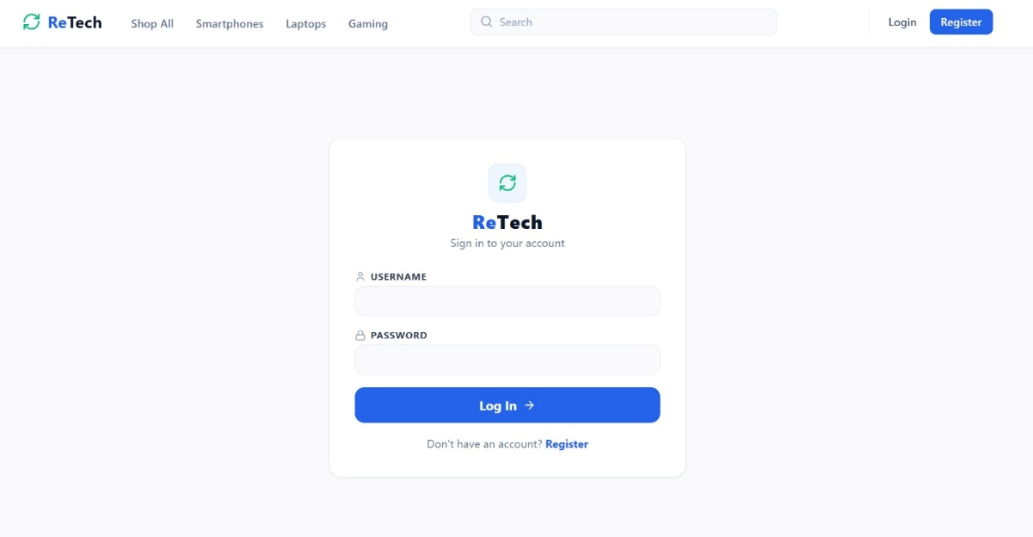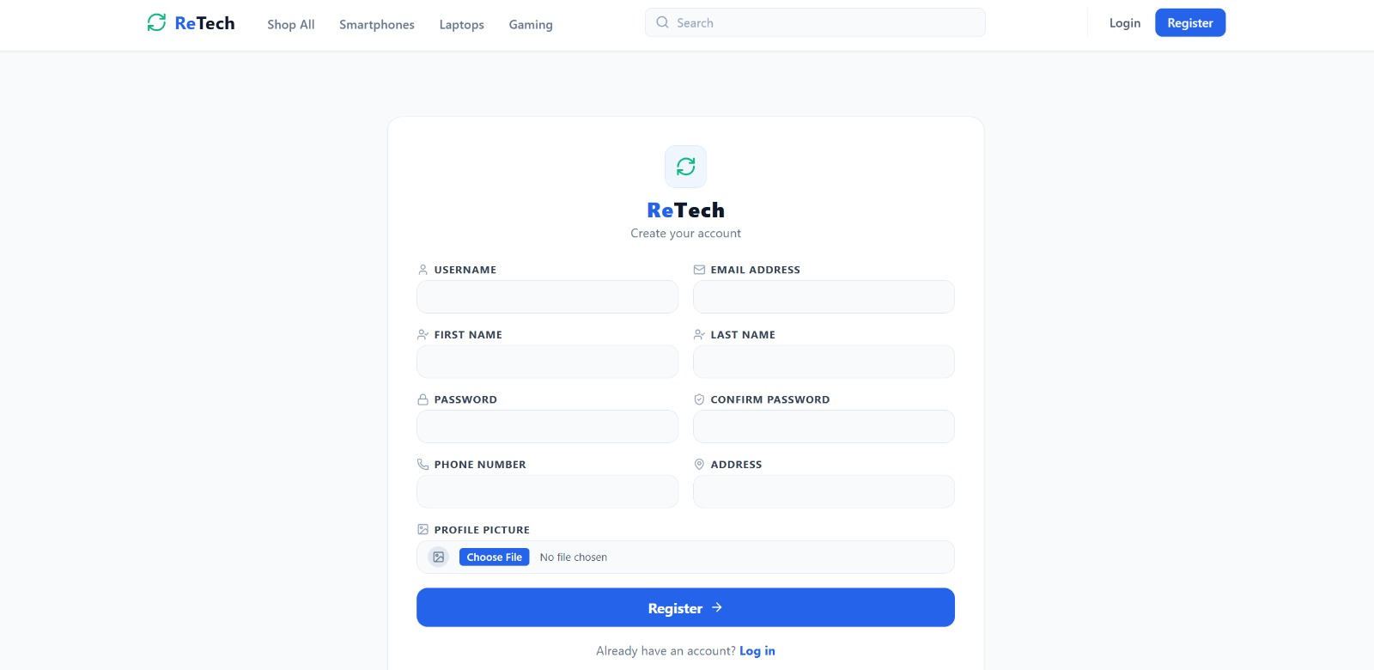
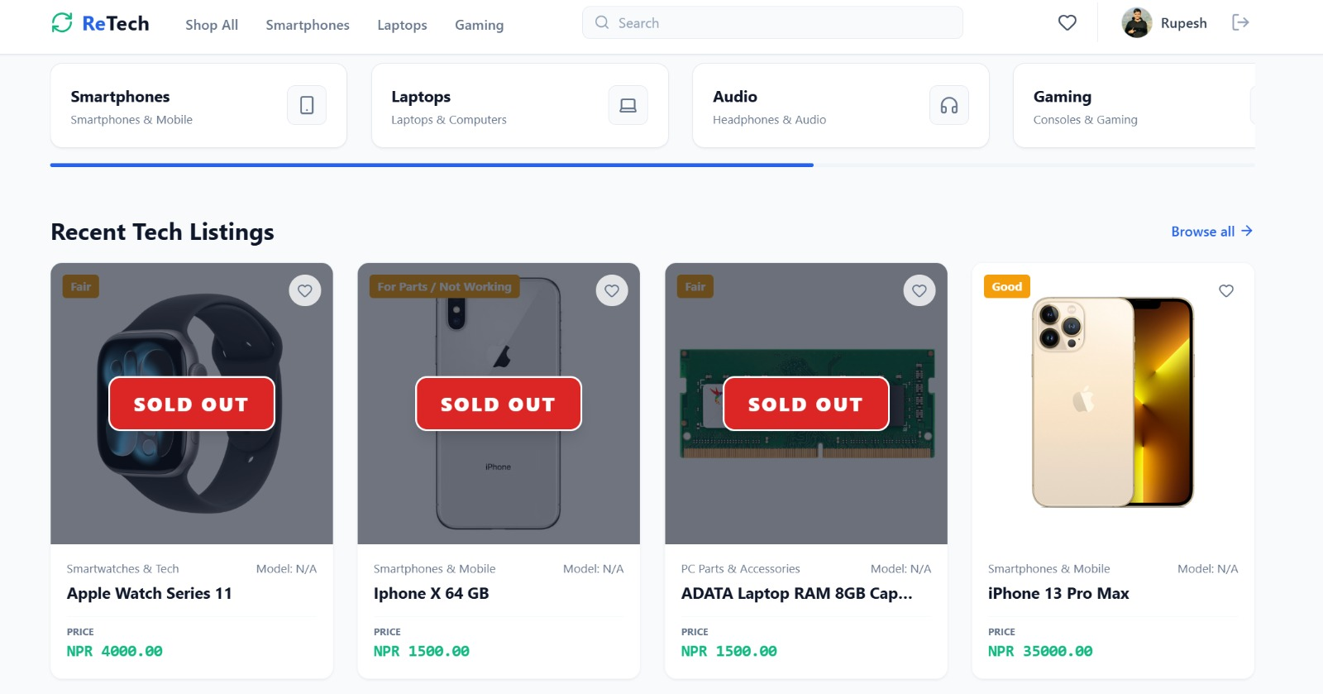
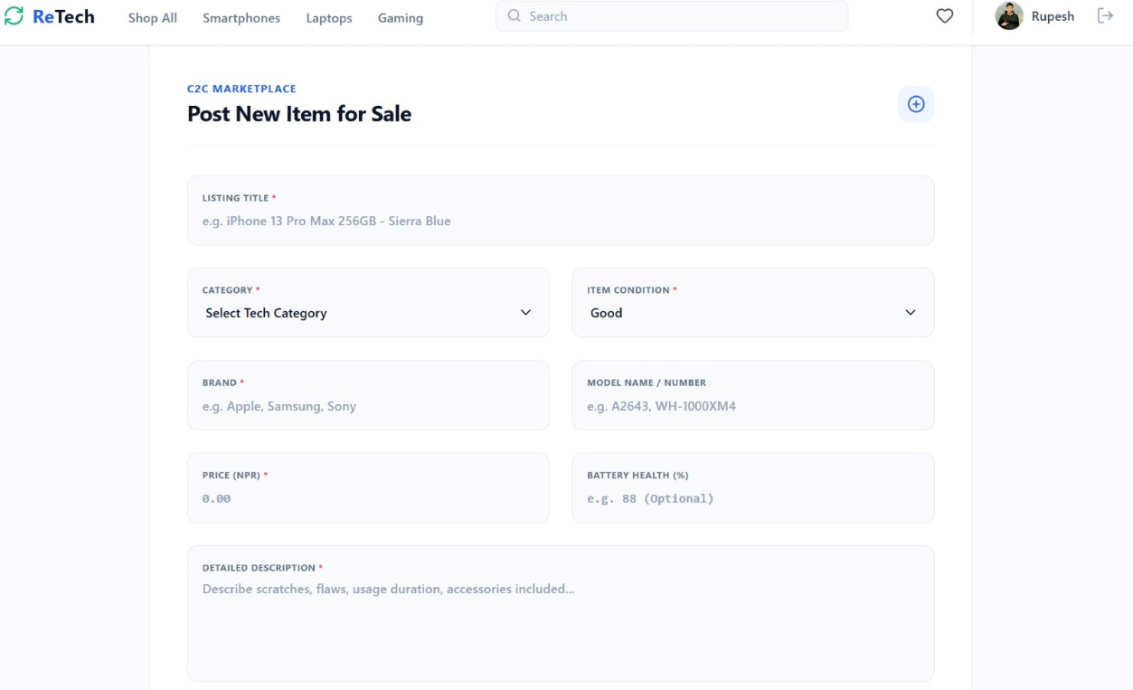
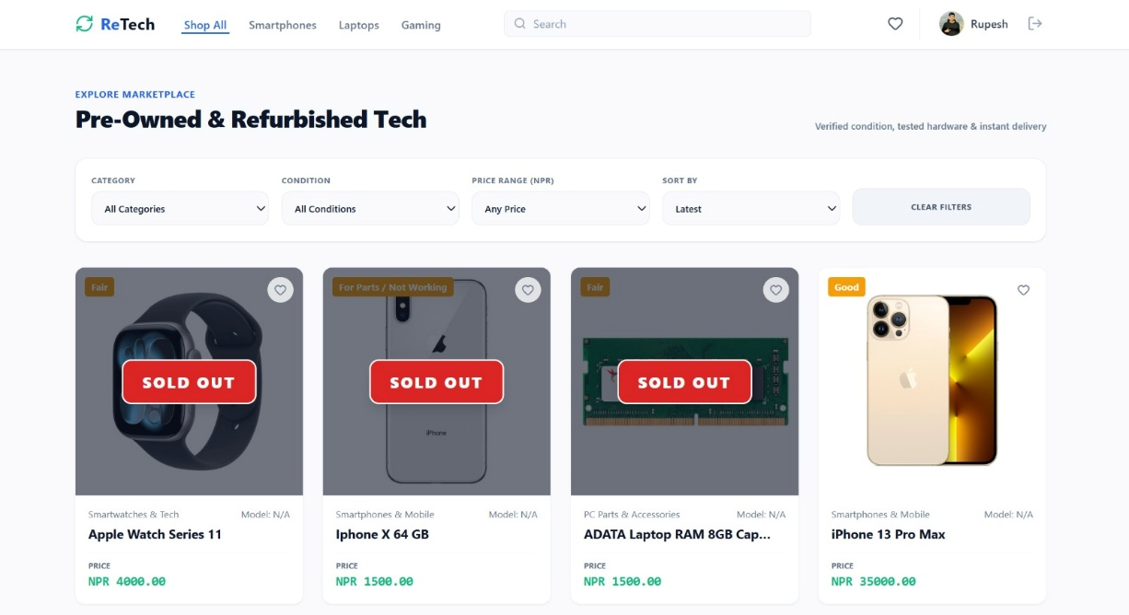
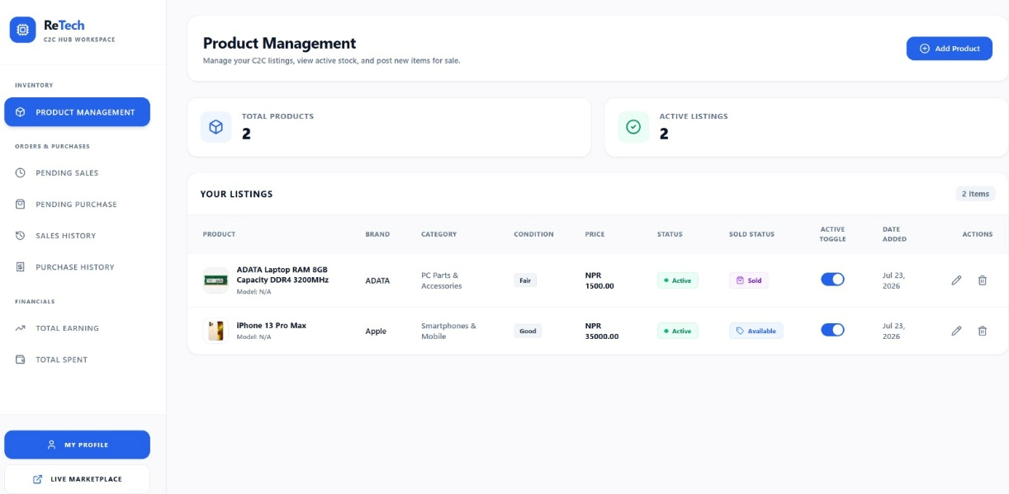
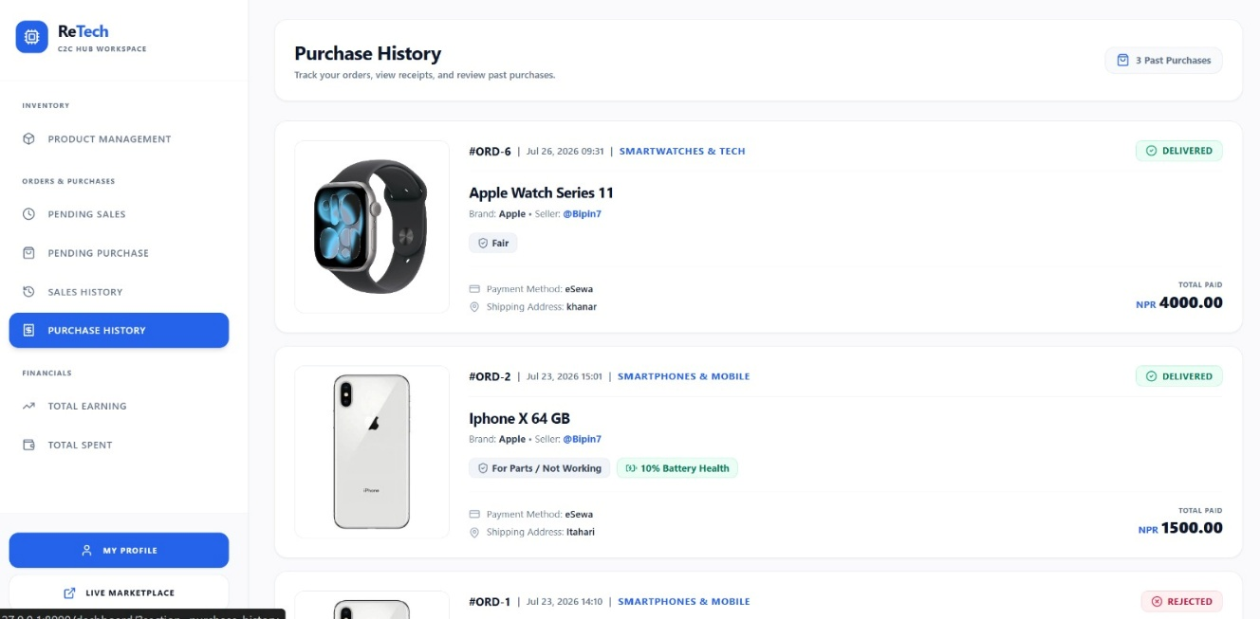
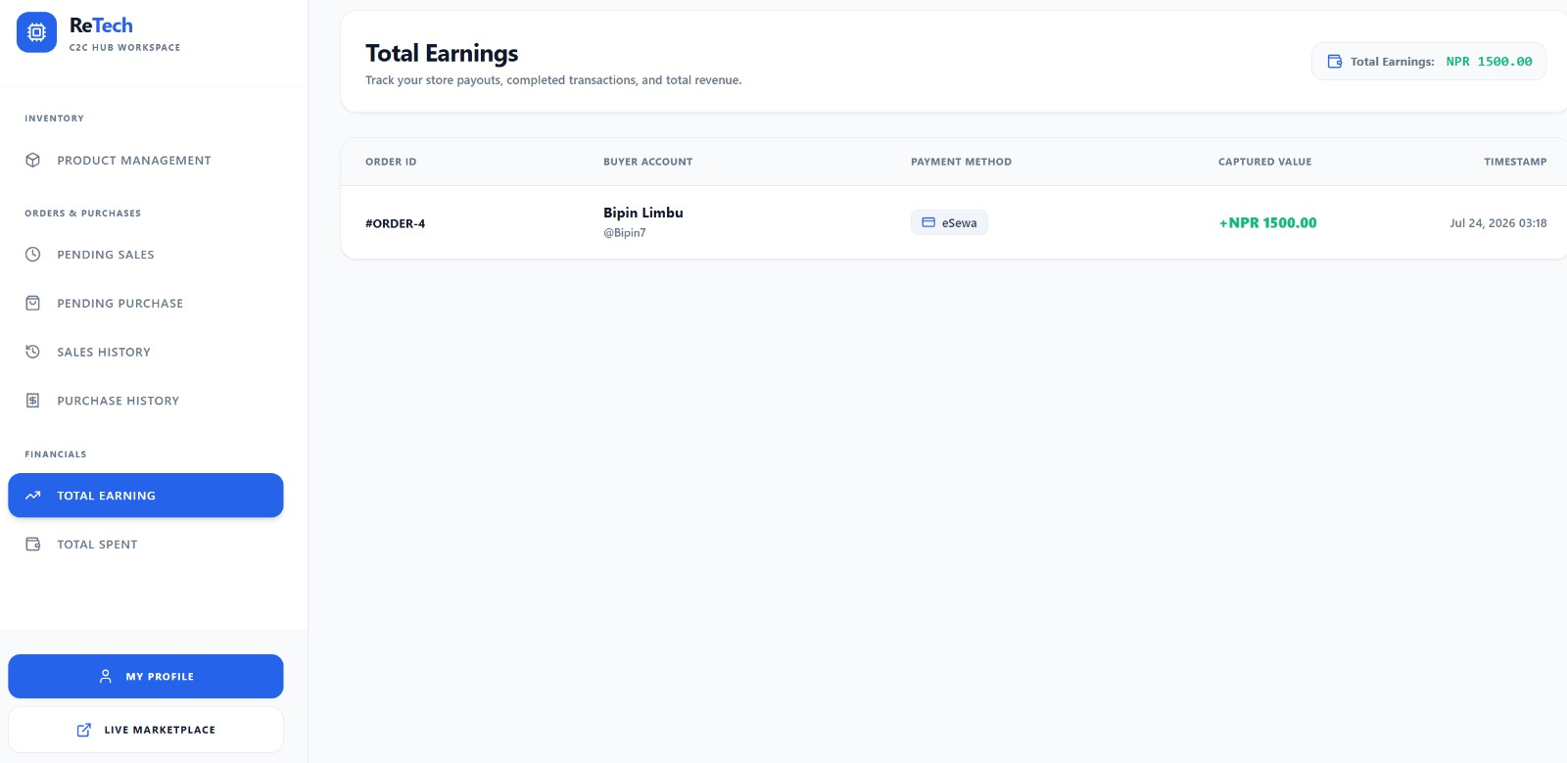
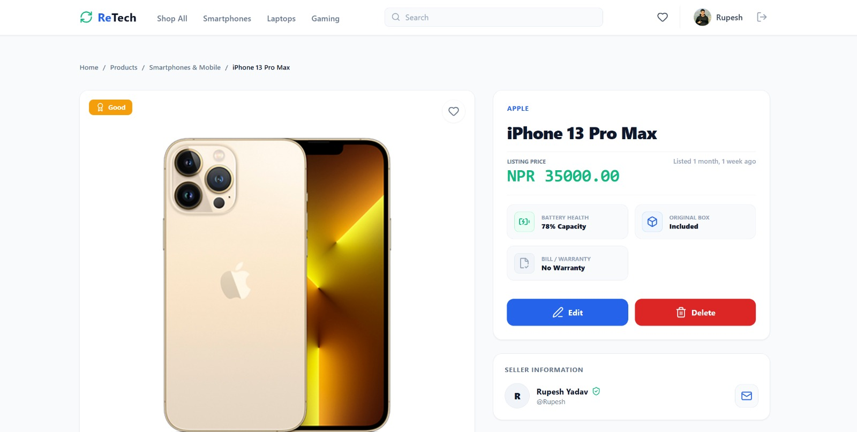

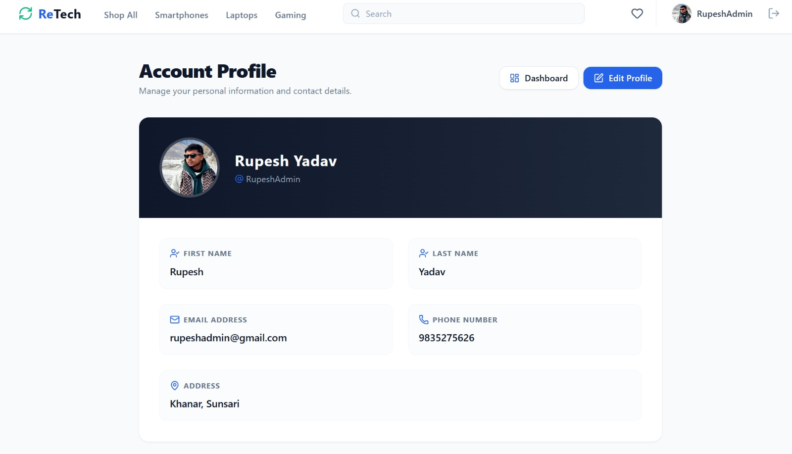
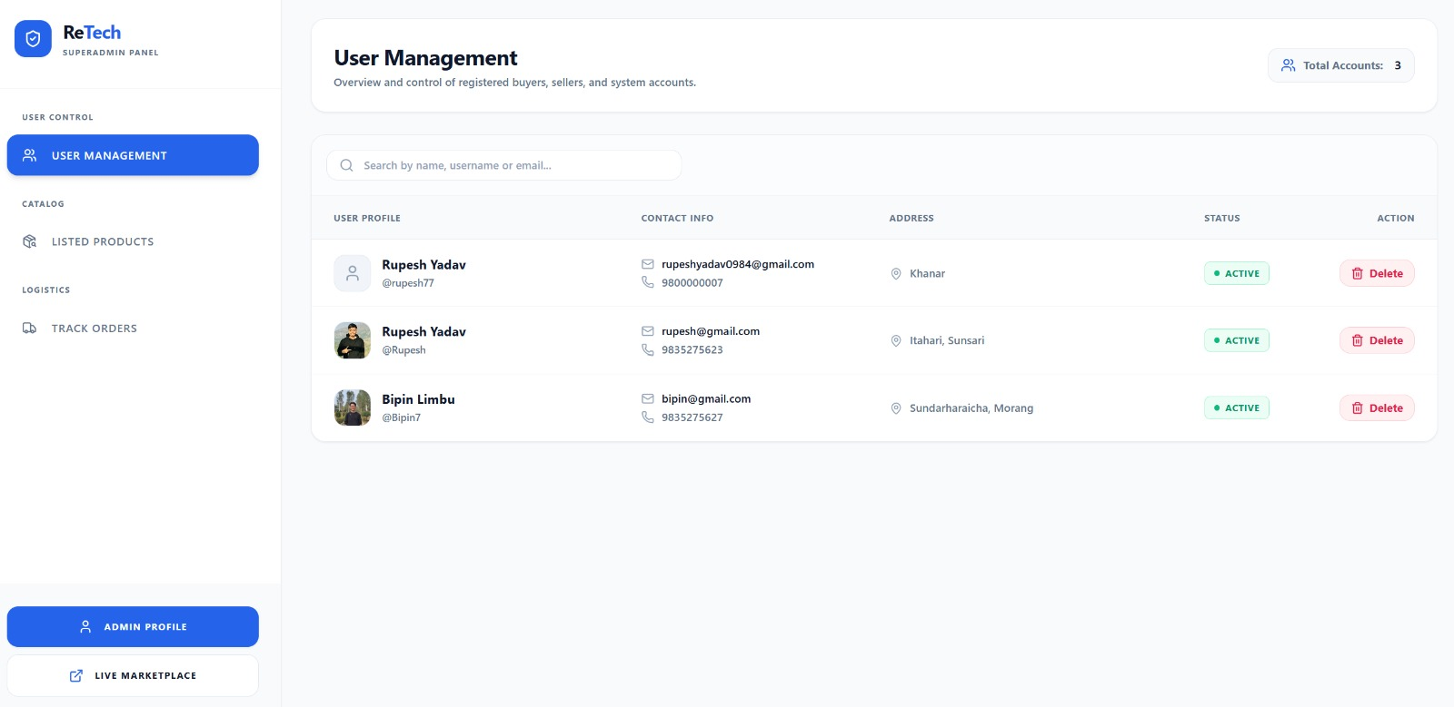
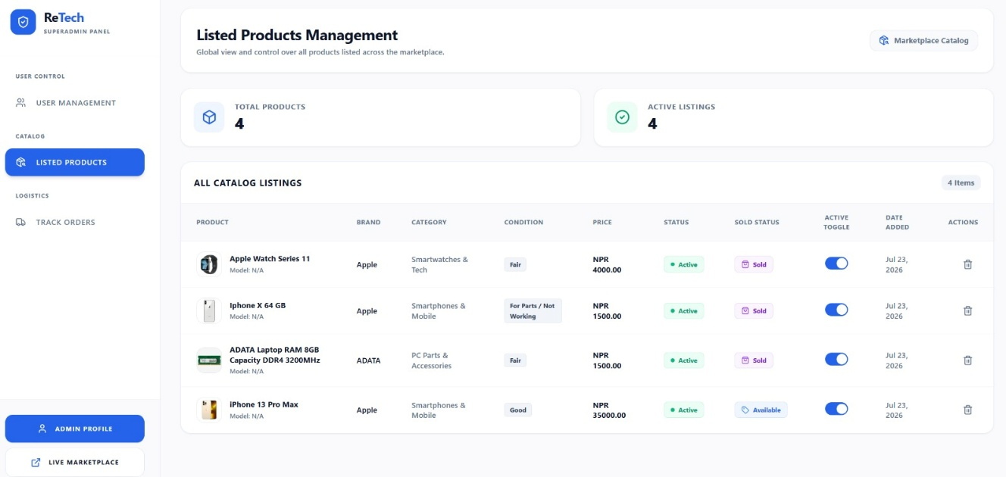
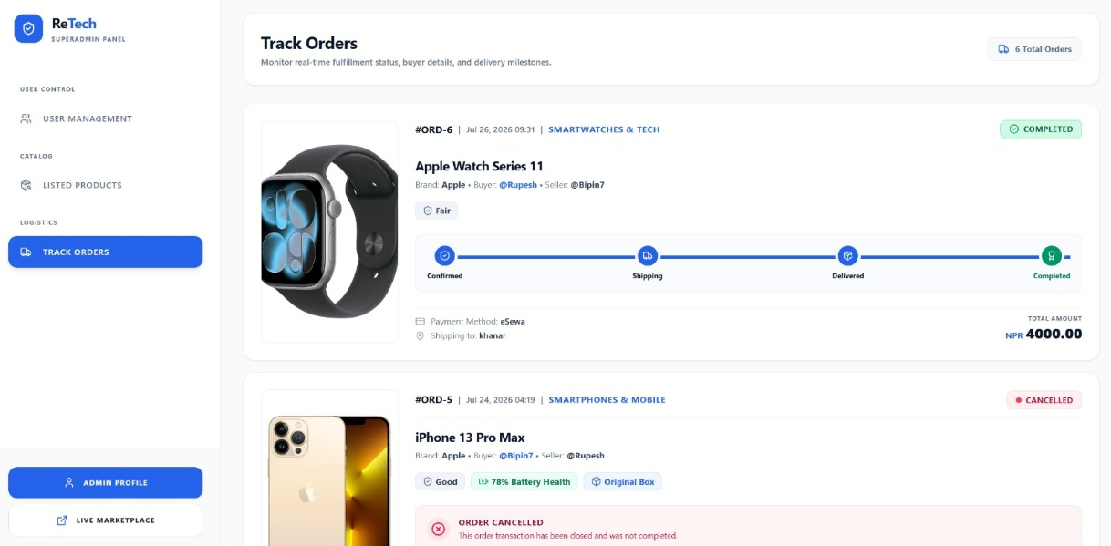
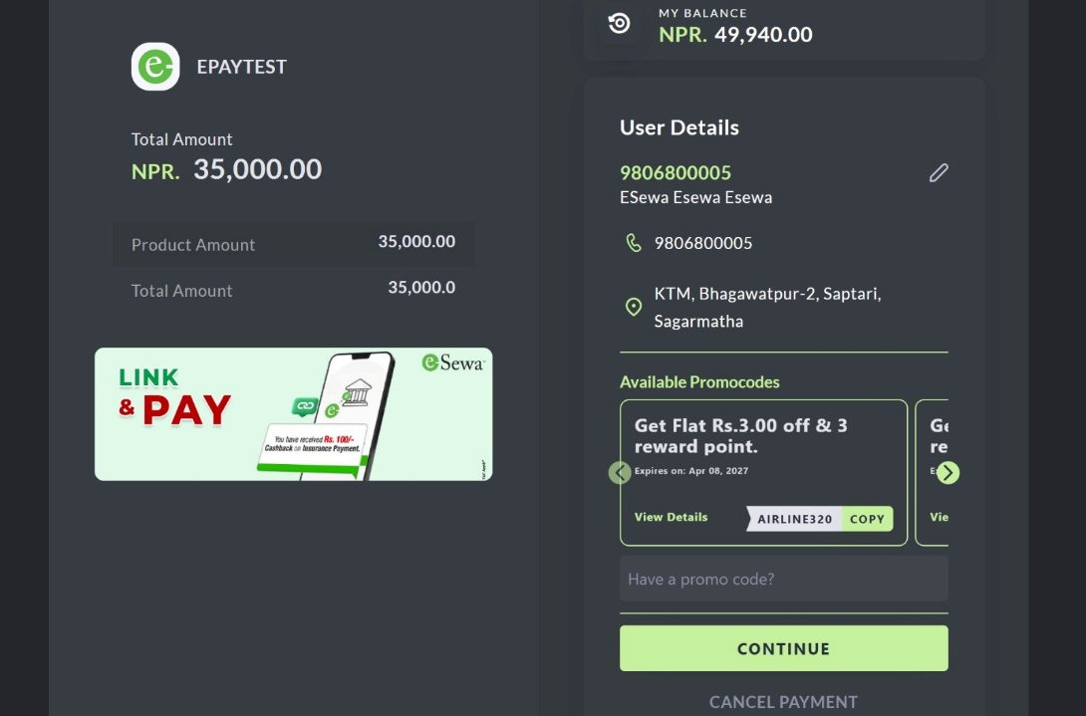
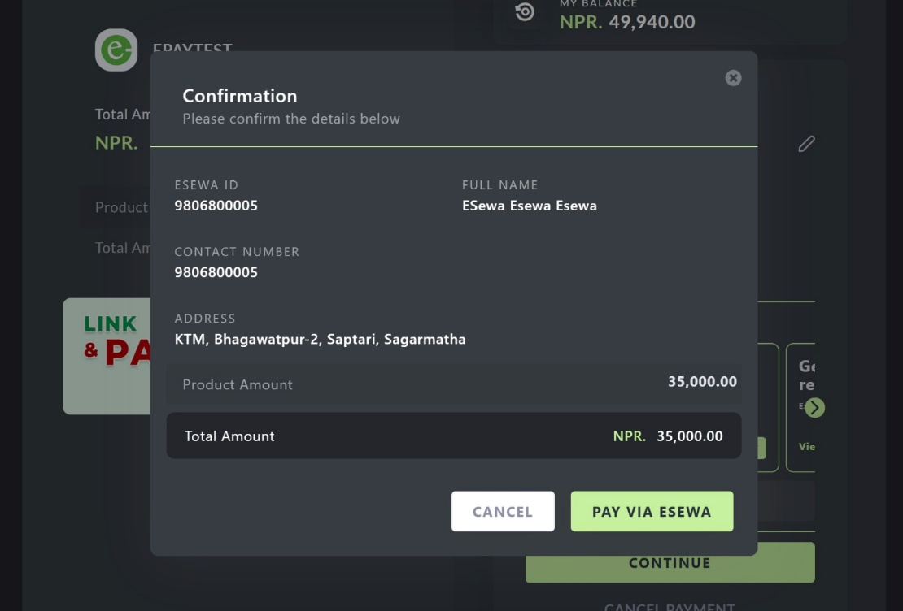

CHAPTER 8: CONCLUSION

Conclusion
In conclusion, developing an e-commerce website for ApexStriker using the Django framework provides a flexible and reliable platform for establishing a strong online presence in the football accessories market. Django's structured architecture and built-in security features allow the system to be developed according to the requirements of customers, vendors, and administrators. The integration of an SQLite database supports efficient management of products, users, vendors, orders, reviews, and other system data, while payment options such as eSewa and Cash on Delivery (COD) make the platform suitable for customers in Nepal.
Throughout the development process, emphasis was placed on creating a smooth and user-friendly experience, from product browsing and filtering to cart management and checkout. Features such as brand and category filters, customer reviews, secure login/signup, vendor management, vendor reporting, and separate customer, vendor, and administrator functionalities improve usability, trust, and overall system management.
By utilizing Django, SQLite, Tailwind CSS, and modern web technologies, ApexStriker provides a feature-rich multi-vendor e-commerce platform for football enthusiasts. The system allows multiple vendors to sell football-related products while providing administrators with control over vendors, products, orders, commissions, reports, and platform activities. Ultimately, the project demonstrates how a localized and customer-focused e-commerce solution can support the growing demand for online football accessories in Nepal.

