1. Enter the task name, duration, predecessors and resource names and view the gantt chart.

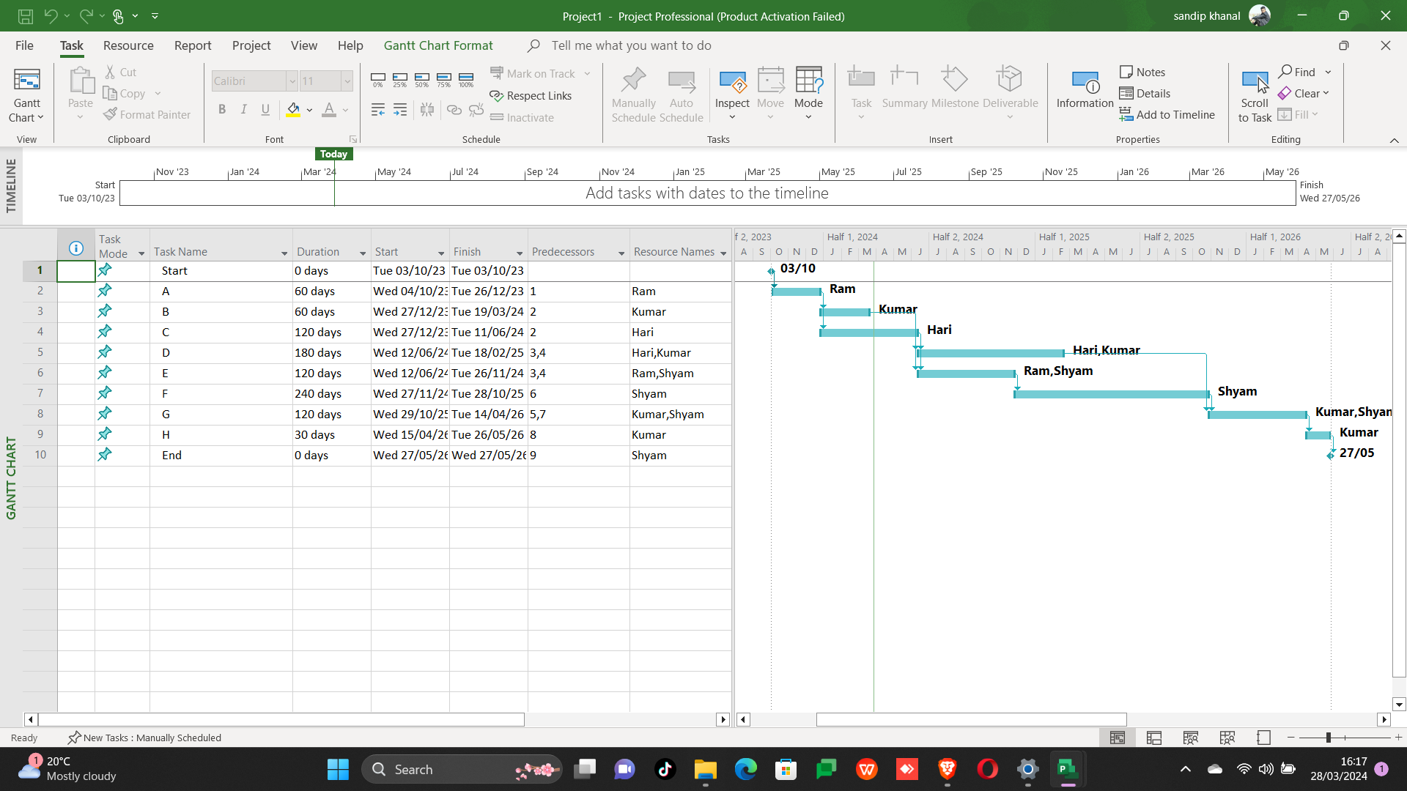

1. Allocate resources and set the cost and rate for the resources.

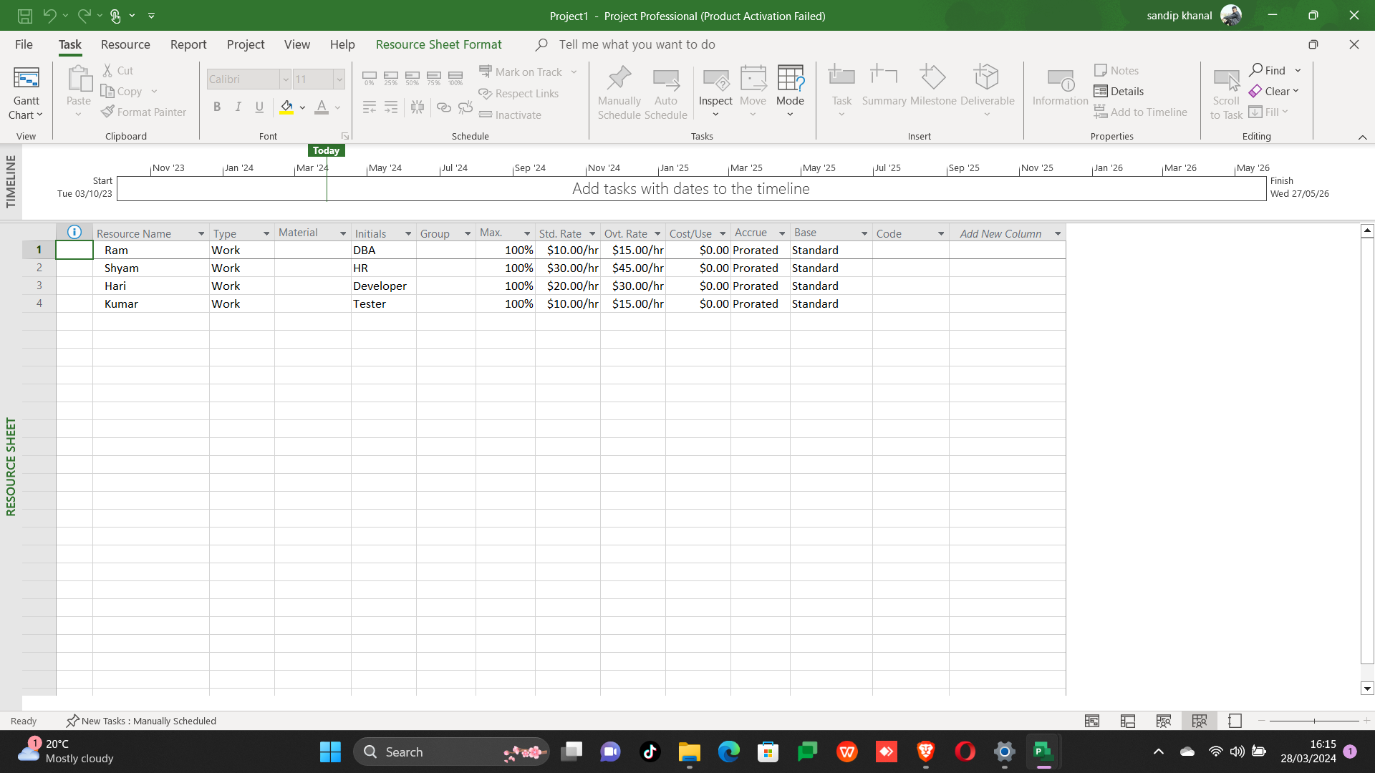

Iii) Calculate estimate schedule and cost based on variances and work complete percentage

