VEDANTA PLACEMENT AGENCY

Jobs Page – Final UI & Functional Flow
Use the 5 reference screens in this document as the visual reference. Keep the implementation simple, clean and consistent.

1. MOST IMPORTANT RULE
LOGIN ALONE MUST NOT UNLOCK SCHOOL DETAILS
School name + exact location + protected school information stay hidden until the candidate completes the required Vedanta registration.
Login = account access. Registration = eligibility/unlock for protected job details.

2. JOB POSTING – SALARY RANGE FIELD (MUST BE INCLUDED)
When Admin/Recruiter creates or posts a job, the salary section should work like the provided reference screenshot. Do not replace this with a single salary field. The admin must be able to select how the pay is displayed.
Field | Default / Option | What Admin Enters | Frontend Result
Show pay by | Range | Select Range from dropdown | ₹40,000 – ₹55,000 per month
Minimum | Required for Range | e.g. ₹40,000.00 | Starting salary shown
Maximum | Required for Range | e.g. ₹55,000.00 | Maximum salary shown
Rate | Per month | Select: per month (and keep future options extensible) | “per month” appears after salary
Dropdown options shown in the reference: Range • Starting amount • Maximum amount • Exact amount
Recommended behaviour: If Range is selected, Minimum + Maximum are visible. If Exact amount is selected, show only one amount field. The frontend should automatically format the salary consistently.
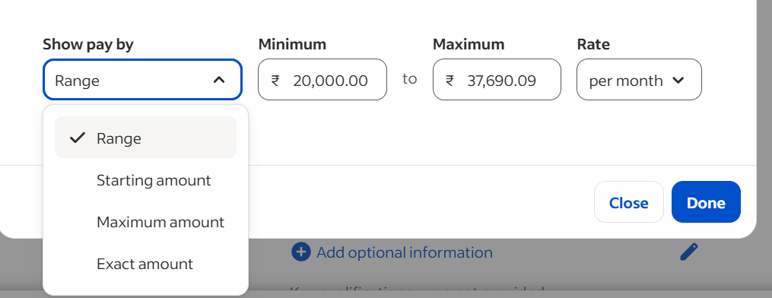
Reference Image – Salary Range control to follow

3. FOUR EXISTING JOB SCREENS – KEEP THIS SAME VISUAL FLOW
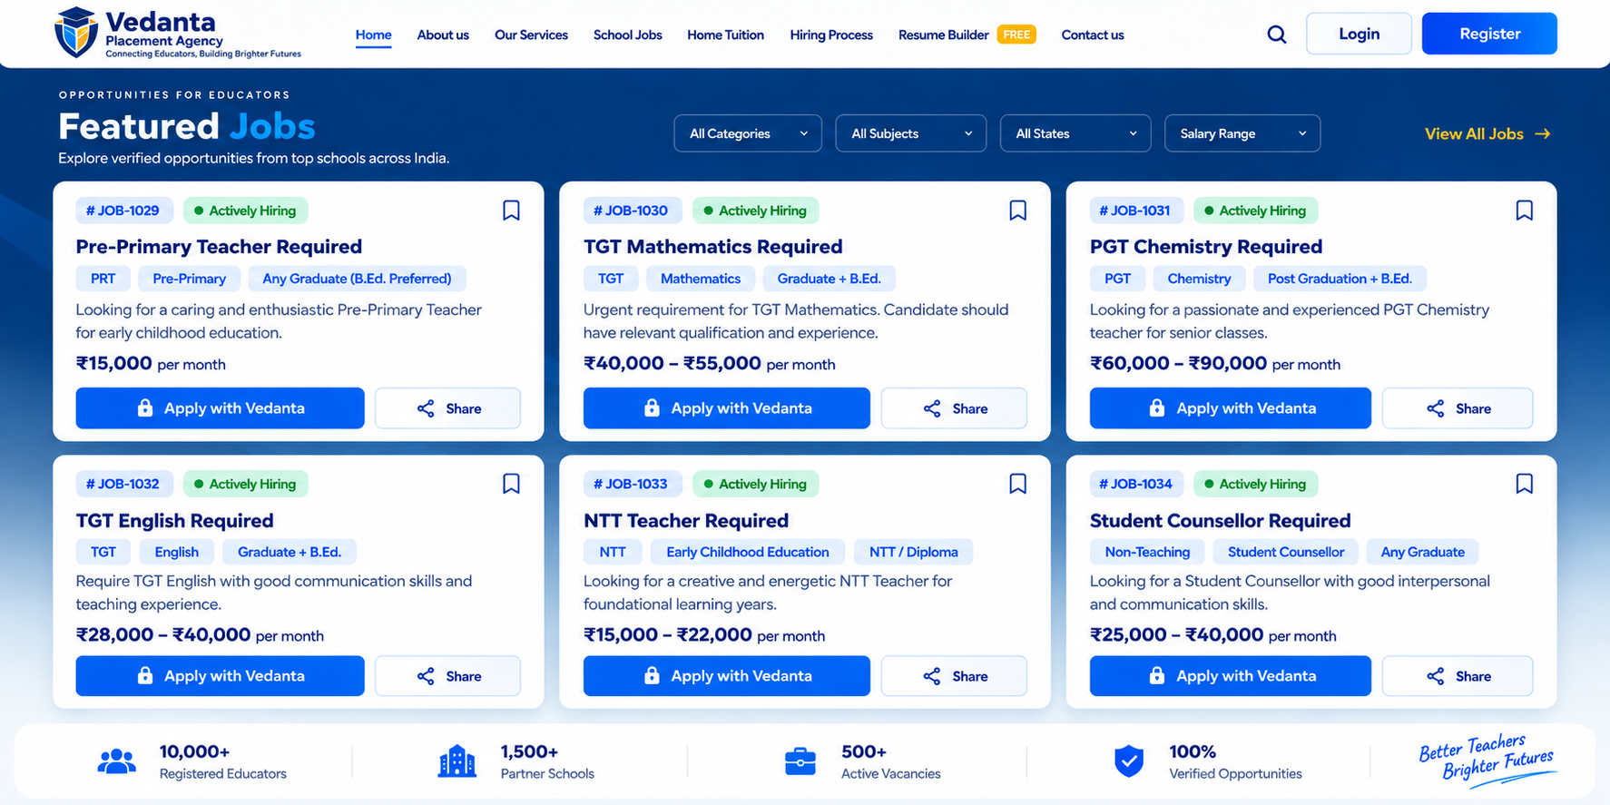
IMAGE 1 – Featured Jobs / Home: user sees job cards and can open a job.
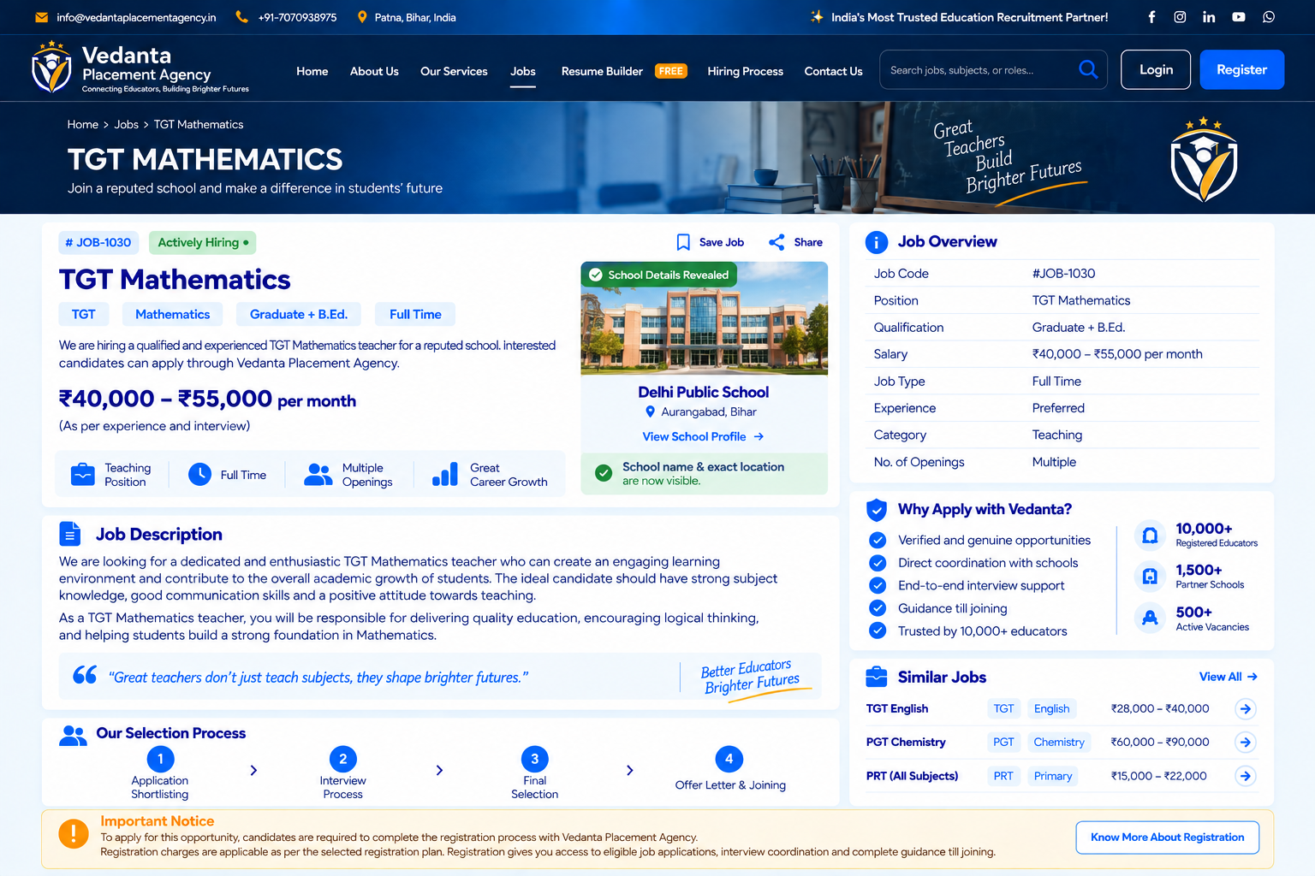
IMAGE 2 – Job Details / Unlocked State: school image, school name and location are visible after eligibility is unlocked.
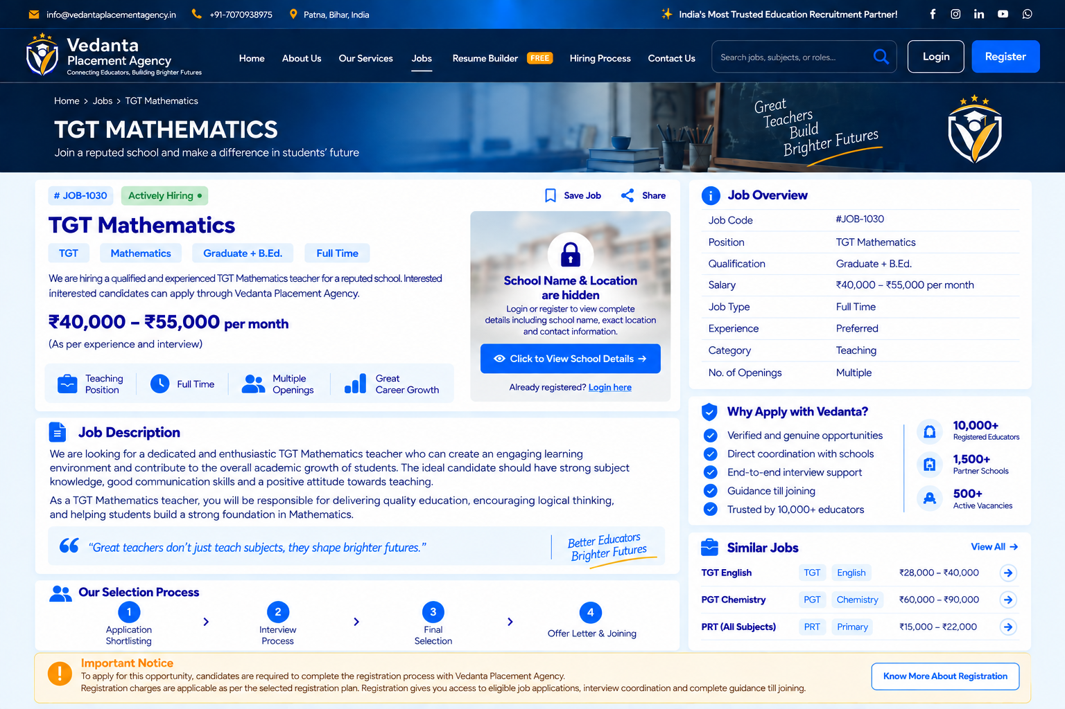
IMAGE 3 – Job Details / Locked State: school name and exact location are hidden behind the protected-details area.
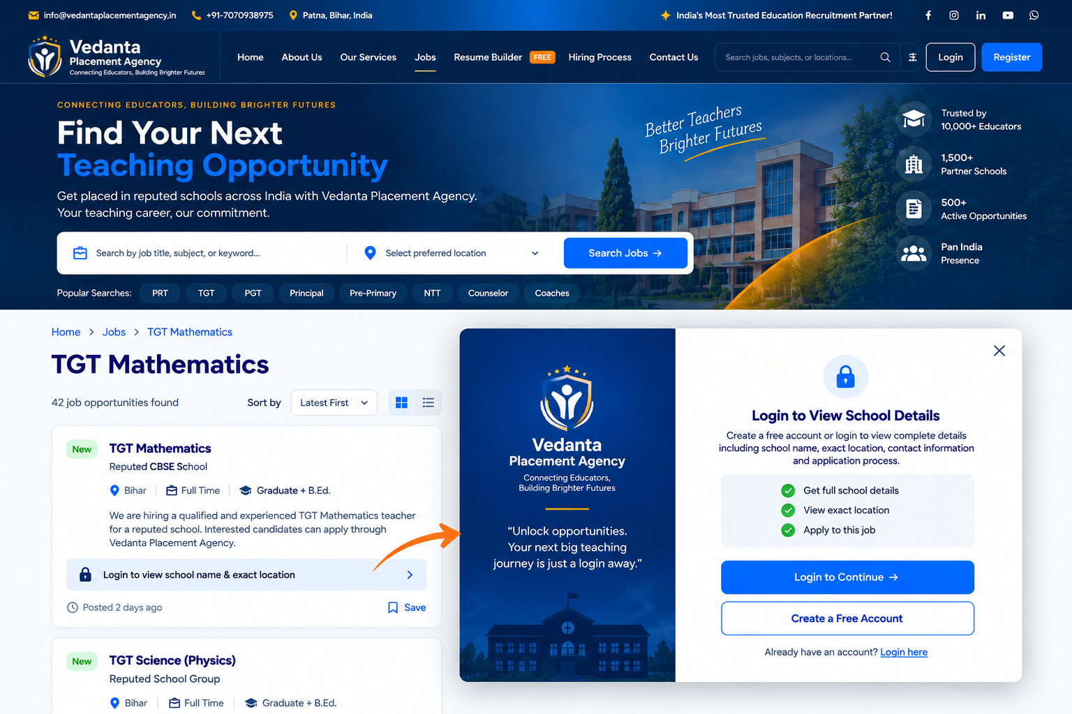
IMAGE 4 – Jobs Listing + Login Popup: clicking the protected-details area opens the login/create-account popup.

4. LOCKED SCHOOL DETAILS – MAKE THE LOCK SMALL & CLEAN
Important change from the earlier concept: Do NOT make the lock a large separate UI/popup covering the job page. The lock should be a small, premium-looking protected-details indicator inside the school-details card.
• Keep the school image/card area compact and visually similar to Image 3.
• Place a small lock icon in a small circular/rounded badge over the protected area.
• Use a short heading such as “School Name & Location Hidden”.
• Add one short line: “Complete registration to view details.”
• Keep one clear button/link: “View School Details →”.
• The whole locked card can be clickable; the user should not have to click only the tiny lock icon.
• On click, open the login/registration modal. The lock itself should NOT become a large popup.
• After registration is completed, replace the locked card with the unlocked card shown in Image 2.

5. COMPLETE USER FLOW
1. User opens Jobs/Home: Normal job cards are visible. Salary, position, qualification and other public job information can be shown.
2. User opens a job: Public job details are visible. School name and exact school location remain protected if the candidate is not eligible to view them.
3. User sees locked school card: Small lock badge + “School Name & Location Hidden” + “View School Details →”.
4. User clicks View School Details: Open a small/clean modal, not a full-page UI.
5. User is NOT logged in: Modal shows “Login to Continue” and “Create a Free Account”.
6. User logs in: Login succeeds, but school details STILL remain locked if registration is not completed.
7. Registration check: System checks the candidate's registration status.
8. Registration not completed: Take the candidate to the registration step / registration prompt. Do not reveal school name or exact location.
9. Registration completed: Unlock eligible protected school details.
10. Final state: Show school image, school name, exact location and permitted school information; allow the application flow.

6. LOGIN / REGISTRATION STATUS LOGIC
Candidate Status | School Details | Click Action | Expected Result
Not logged in | LOCKED | View School Details | Login / Create Account modal
Logged in, registration pending/not completed | LOCKED | View School Details | Registration prompt/process
Logged in + registration completed | UNLOCKED | View School Details | Show school details

7. IMPORTANT BACKEND / SECURITY RULE
Do not only hide the information visually on the frontend. Protected school name, exact address/location, school contact details and any other restricted information should not be exposed in public API responses, page source or hidden frontend fields before the candidate is eligible. The backend must verify the registration status before returning protected data.

8. RECOMMENDED UI TEXT
UI Area | Text
Locked heading | School Name & Location Hidden
Locked helper | Complete registration to view school details.
Locked CTA | View School Details →
Login modal heading | Login to Continue
Login modal helper | Login or create an account to continue.
New user CTA | Create a Free Account
Existing user | Already have an account? Login here
Registration state | Complete Registration to Unlock School Details
Unlocked label | School Details Revealed
Unlocked CTA | View School Profile →

9. ADMIN / RECRUITER JOB POSTING CHECKLIST
☐ Job title
☐ Category / job type
☐ Subject
☐ Qualification
☐ Experience
☐ Salary display mode
☐ Minimum salary (for Range)
☐ Maximum salary (for Range)
☐ Salary rate (e.g. per month)
☐ School name (protected)
☐ School image (protected if required)
☐ Exact school location (protected)
☐ Public location/state if the business rules allow it
☐ Job description
☐ Number of openings
☐ Application / registration eligibility settings

10. FINAL DEVELOPER INSTRUCTION – IMPLEMENT THIS EXACTLY
The Jobs module should follow the four supplied job screens as the base design. Add the salary Range control shown in the fifth screenshot to the Admin Job Posting form. On the candidate side, keep the school name and exact location locked. The lock should be small and integrated into the school-details card, not a large popup. Clicking the locked area opens a simple login/create-account modal. After login, the system must check registration status. Login by itself must never reveal the school details. Only after the required registration is completed should the school name, exact location and permitted protected details be returned and displayed. The final unlocked design should follow the unlocked reference screen.

VISUAL / UI DESIGN INSTRUCTION
Important for Developer / Designer: The reference screenshots are only for understanding the layout, spacing, flow and functionality. The logos, school photos, icons and other visual elements shown in the AI-generated reference images should NOT be copied exactly or treated as final assets.

1. Logo & Branding
Do not spend time matching the logo shown inside the reference screenshots pixel-by-pixel. Use the actual Vedanta Placement Agency logo/brand assets supplied by the website owner. If a logo is not available in a particular mockup, use a clean temporary placeholder and keep the layout ready for the final official logo.

2. School / Job Images
The school building images in the reference screenshots are for visual representation only. They may be AI-generated and should not be assumed to represent the actual school. The developer should use proper, high-quality and relevant images from the actual school/authorized source when available. If no image is available, use a professional neutral education/school placeholder.

3. Icons & Visual Elements
Use a consistent professional icon library and design system instead of copying the icons from the AI-generated screenshots. Keep icons simple, modern and consistent in size, stroke and spacing.

4. Reference Images – What to Follow
- Follow the overall page structure and information hierarchy.
- Follow the locked-school-details concept and the small lock treatment.
- Follow the click → small popup/modal → login/registration flow.
- Follow the salary-range fields and posting flow shown in the reference.
- Improve spacing, typography, responsiveness, accessibility and overall polish wherever required.
- The final website should look like a professionally designed real product, not like an AI-generated screenshot.

5. Final Design Principle
Use the screenshots as a functional reference, not as a pixel-copying instruction. The developer/designer has freedom to create better visuals, better icons, better images, better responsive behaviour and cleaner UI while keeping the exact requested functionality and flow.

Developer Note
Priority order: 1) Functionality and security → 2) User flow → 3) Clean UI/UX → 4) Professional visuals → 5) Final branding/assets. The school name, exact location and protected contact information must remain hidden until the required registration condition is satisfied.

