**Guided Capstone Project Report**

Big Mountain Resort, Montana, have recently installed an additional chair lift, which raises their annual operational expense by $1,540,000. They want to cover these costs as well as review their pricing policy maintain profitability. For this task, we were provided with data on different mountain resorts and their pricing as well as facilities from across the country.

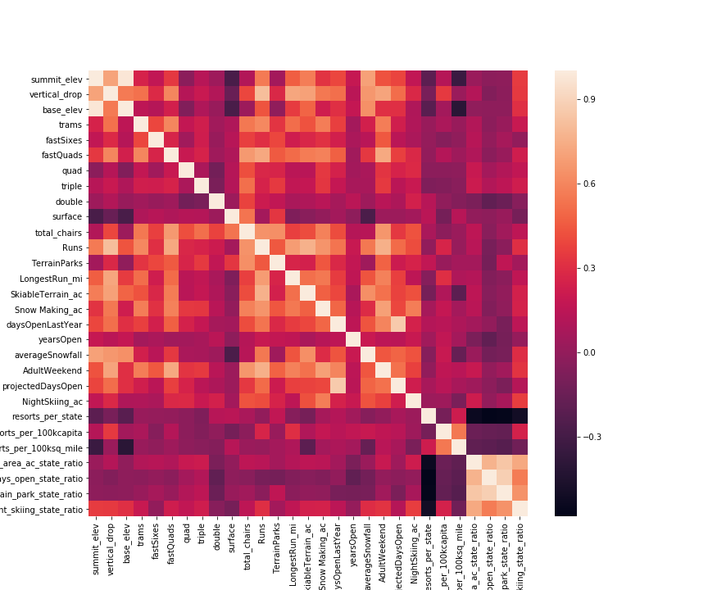The Big Mountain Resort maintained that their pricing policy was simple – charge a premium on the average market share. The first question that comes to mind is – is that really an efficient strategy? To answer this question, we needed to take a deeper look into the data. The data had 330 rows and 27 columns before cleaning (removing missing values/rows, outliers, etc.) and 227 rows and 25 columns after dropping unwanted/misleading data.

After the data was scaled, the data was examined using various visualization techniques. A good way to look at all the different features and how they depend on each other is to build a correlation map. Quite clearly, our target variable (“AdultWeekend”) has strong correlations to multiple variables, thus proving that the facilities at the resort, in addition to other external factors, play a part in the ticket prices.

This examination was done on data from all the states as well as some additional data obtained elsewhere (e.g., population of the state, area, etc.). These relationships were also visualized using the scatterplots which show the relation between the ticket price and the other variables, some examples shown below:

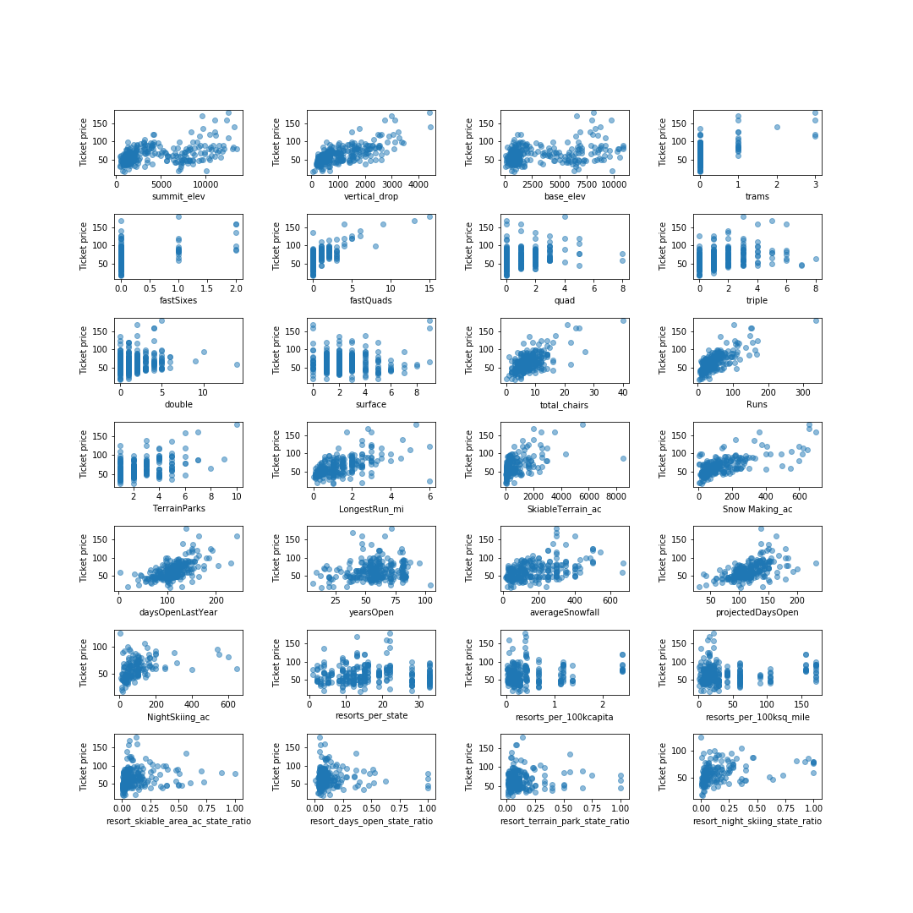

These facts reveal a clear relation of the ticket price to numerous other factors, and our recommendation is that these factors be taken into account while considering the pricing.

In addition, we trained a model designed to predict how the ticket price should change based on changes in these features. Without any changes, the model predicted the ticket price to be $94. Even if we considered a standard deviation of $10, this would bring the price down to $84, which is still higher than the original pricing of $81. This is a positive sign, as it shows that there is definite room for an increment in the pricing. This model was used to predict the increase in ticket prices on changing other features. For example, how would the ticket price and therefore, revenue change on closing some of the runs down? The question is answered by the model:

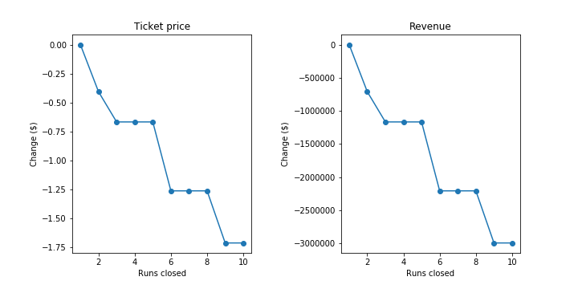

**Recommendations:**

The Big Mountain Resort currently charges $81 per adult. Since the revenue and the ticket price don't change on closing one run, this is what we would suggest. Closing the run should help with reduction of maintenance costs. Alternatively, if Big Mountain is okay with closing down 3 runs, they might as well close 5 of them, as there is no change in revenue between 3 and 5. Closing down 5 runs would significantly help with the reduction of maintenance costs.

If the management wants to add an additional run, install the vertical drop by 150 feet and install an additional chair lift, the price may be increased by $1.99. We don't recommend adding two acres of snow making, as this won't affect the ticket prices, but instead will increase costs of maintenance. We believe that these steps will help an increase in revenue by almost $3,500,000. If 5 runs are closed in addition to this, it will lead to a decrease in revenue of around $1,250,000. This added to the $1,540,000 for the operational expense for the additional chair lift, will still leave some profit for the resort.