User Guide

## Background:

Amazon Music is a music streaming service that allows Amazon users to listen to millions of songs on demand and ad-free. Users can listen to an unlimited number of songs on their device and explore new artists and genres with ease. It comes with

## Details:

**Name: Offline Download**

Users have the option to save songs and albums to their devices so that they can access their favorite music without an internet connection. To save a song or album:

**Steps:**

Click on the additional options icon, which resembles three dots, to the right of the song or album.

Select “download”

Wait for the song to download

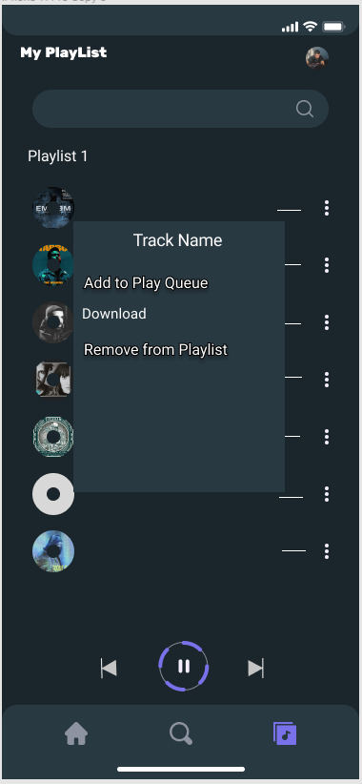

Once a song or album is downloaded, it can’t be transferred to another device, but it can be accessed from a device that isn’t connected to the internet or that is in offline music mode.

Note: To stream and download music without issues, user need a strong Internet connection. To troubleshooting download issues:

Confirm that device is connected to Wi-Fi or a mobile network,

If using a mobile network, confirm that the Amazon Music app settings allow for Cellular, or

Force stop and reopen the app.

**Name: Create a Playlist from a Song Choice**

User can see a dashboard with a menu along the left side. Under My Playlists, click the Create Playlist button. Give it a name when prompted and click Save. Or can directly add tracks from the home screen.

Steps:

Click the plus icon (It is there on every track).

Once Clicked, it asks to Create a New Playlist.

Give it a name and click Save.

Now when user find a song user added; user’s new playlist name will display under my playlist tab.

Note: To add or remove songs to playlist. You must be connected to the network.

**Name: Using Voiceover for beginners**

The Amazon Music app features the Amazon Alexa voice assistant, Alexa. This means users can choose music without touching or looking at the screen. Simply say “Alexa, play” followed by the song, artist, album, or genre you want to listen to.

This feature is still in beta phase and might be unstable.

Note: Did not made in prototype so didn’t attached the screenshot.

Most of the issues can be solve by

1. Updating to the latest version of the app,
2. Force stopping the app, or
3. Clearing the app cache.