Amazon’s long-rumored on-demand music streaming service is now available. The company has launched its new service as Amazon Music, an on-demand competitor to the likes of Spotify, Apple Music, and Google Play Music. Amazon has done a number of things to differentiate Amazon Music from its competitors, but the most notable one is its price: the service will be available to Amazon Prime members for a cheaper rate than the premium options from Spotify or Apple Music. In addition, owners of one of Amazon’s voice-controlled Echo devices will be able to get the service too.

Amazon’s Music apps have been completely redesigned with fresh typography, revised navigation, and a focus on artist imagery and album art. They feature some clever perks, such as the ability to automatically download music Amazon thinks you’d like while in the background, so you’ll always have something to listen to while offline, as well as lyrics integration. We are also touting tight integration with Echo devices and Alexa voice assistant as the real differentiator here.

We launched our Music App in the US. Our results are 150K+ downloads within couple of weeks. We have a huge collection of 10 million tracks on our platform.

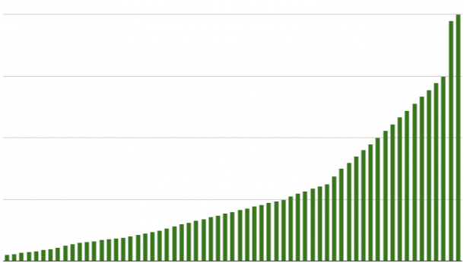

Next, we are planning to expand to other countries and increased our music library.

This launch would not be possible without the hard work of all the members of our team

Thanks.

Bipin Kumar Sultania && < list all your team members >

### Post Launch Activities

**Success metric for the test**

* **Monitor metrics.** I will have a dashboard that tracks all the KPIs, check the state of your product frequently. Dashboards will help us to communicate with your leadership. Some of the metrics and KPI are
* **Customer Support Tickets**:
* **Percentage of Product Defects**
* **Number of Customers**
* **Customer Satisfaction & Retention**
* LOB Revenue Vs. Target
* Profit
* **Feedback** Will try to listen to our users and customers by reading reviews for our app, asking customer support to pull statistics for your app reviews, looking for articles about our product, sending surveys.
* **Documentation in a central location** Documentation is very import part of this process, will collect and document all the feedback at one central place. Will look for patterns and themes in the data. Identify the underlying problems and start developing possible solutions

**Feedback with solution**

We have feedback from the field that our users are struggling to enter their credit card information to make payment for the subscriptions. We do not know if this is they are still not sure about the product or just difficulty of typing.

Potential Solutions to the Credit Card Problem

* Add Autocomplete for the credit card numbers
* Implement AmazonPay
* We will test the AmazonPay because it would be the easiest solution for our engineers to implement

#### A/B Test

* For the users in the control group: we will do nothing (group A)
* For the users in the variant group: we will offer AmazonPay (Group B)
* Our hypothesis is that the AmazonPay will make it easier for users to complete transactions so we will see more complete transactions in Group B