Task Description:

Install Prometheus and Grafana on a Linux EC2 machine, connect Prometheus to Grafana, and create a dashboard to view metrics.
Solution:
Step-1:
Launch EC2 Instance (AWS)
AMI: Amazon Linux 2023
Instance type: t3.micro
Security Group – Open ports
22 – SSH
9090 – Prometheus
3000 – Grafana
9100 – Node Exporter
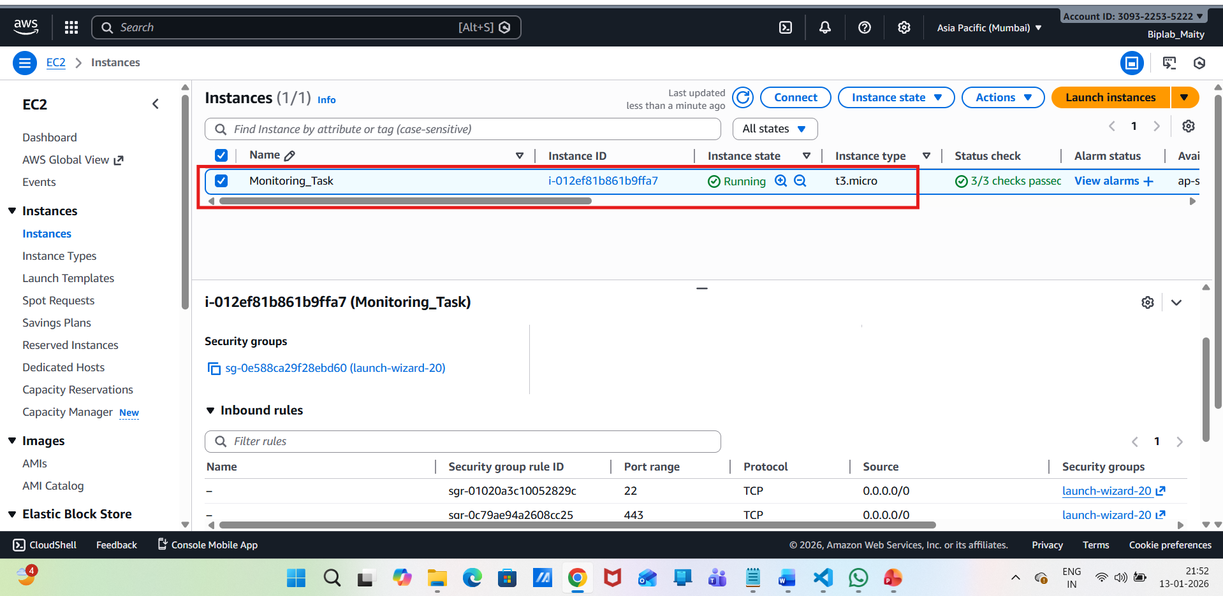
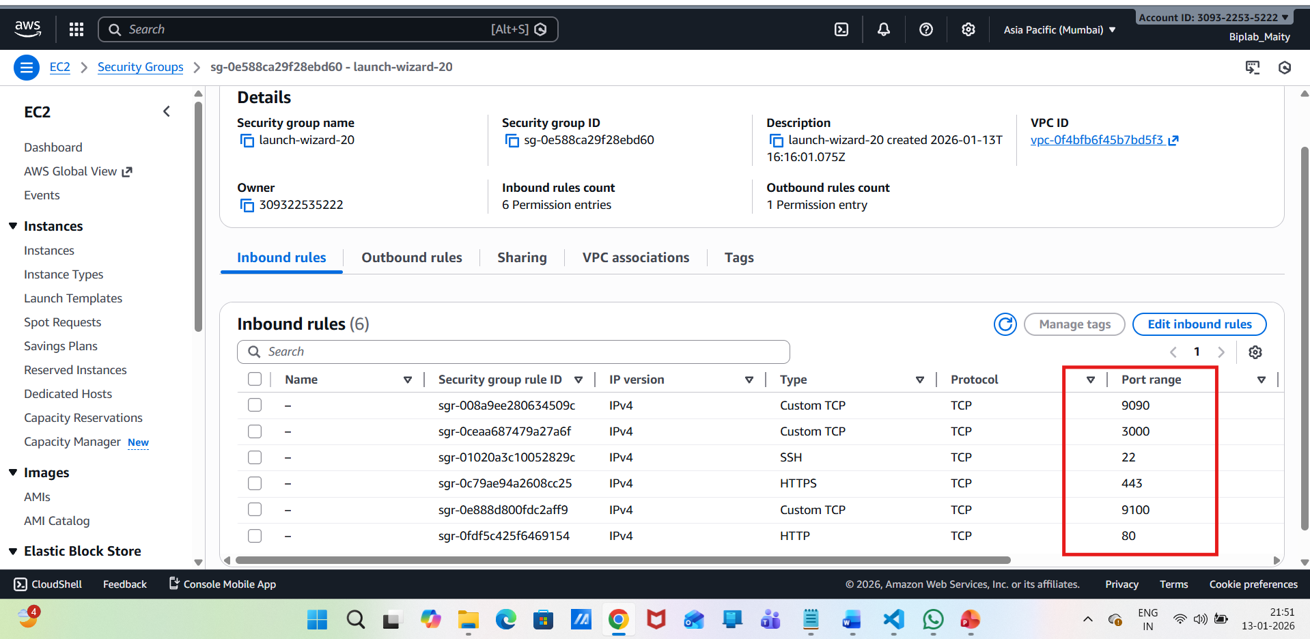
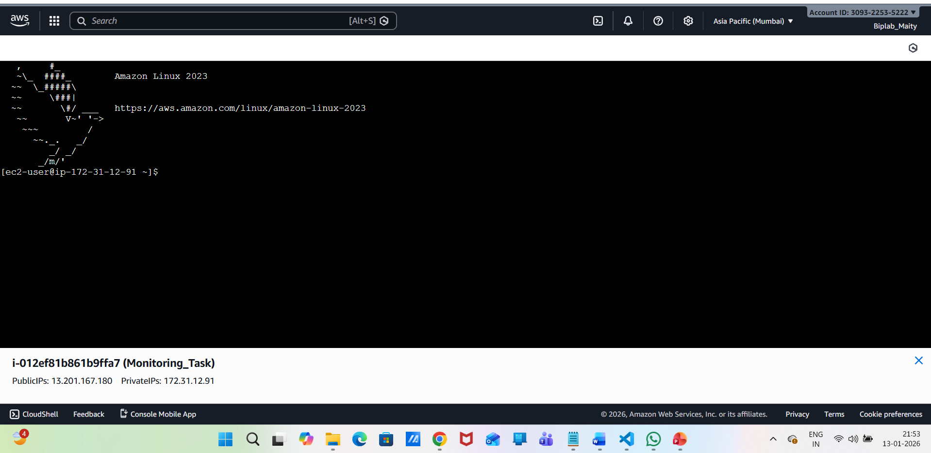
Install Node Exporter (System Metrics):

cd /opt
sudo wget https://github.com/prometheus/node_exporter/releases/download/v1.7.0/node_exporter-1.7.0.linux-amd64.tar.gz
sudo tar -xvf node_exporter-1.7.0.linux-amd64.tar.gz
sudo mv node_exporter-1.7.0.linux-amd64 node_exporter
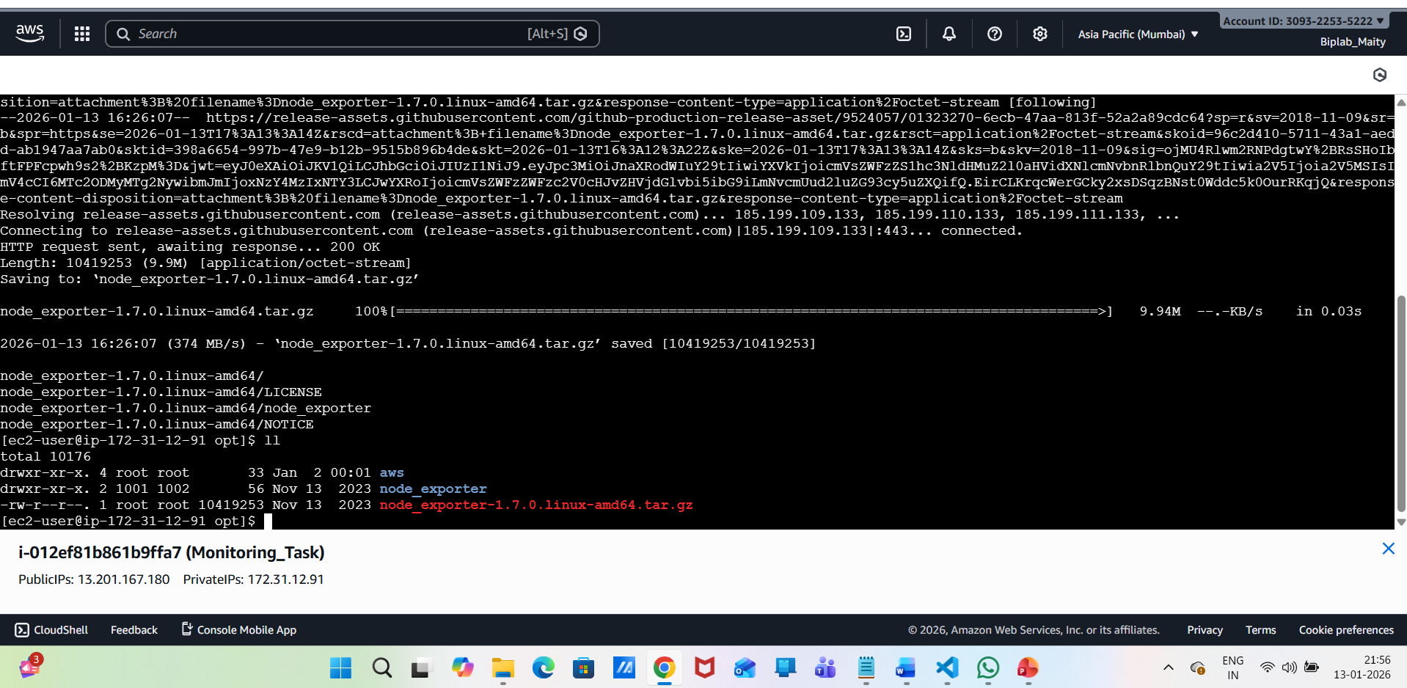
Create systemd service:
sudo vi /etc/systemd/system/node_exporter.service
[Unit]
Description=Node Exporter
After=network.target
[Service]
User=root
ExecStart=/opt/node_exporter/node_exporter
[Install]
WantedBy=multi-user.target
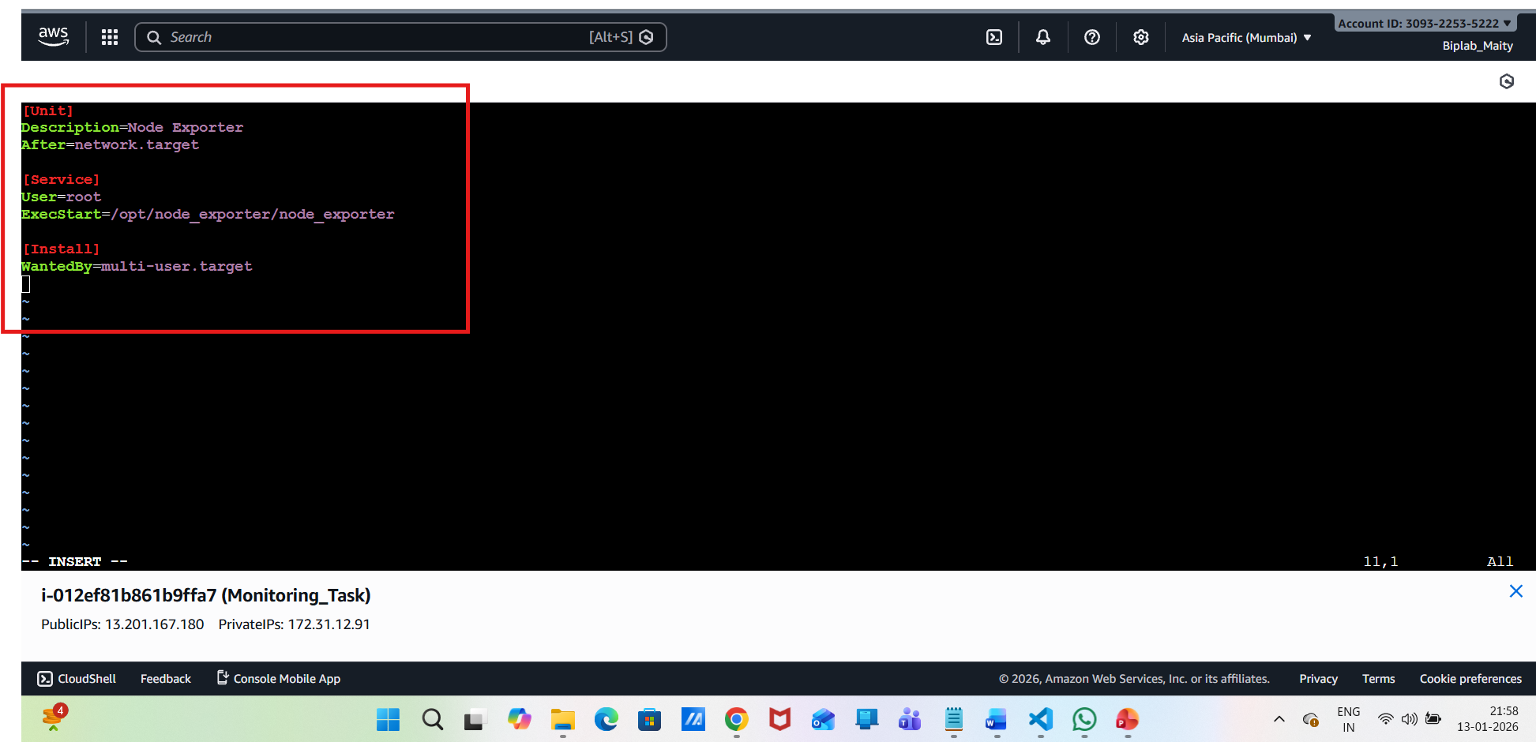

Start Node Exporter:
sudo systemctl daemon-reexec
sudo systemctl daemon-reload
sudo systemctl enable node_exporter
sudo systemctl start node_exporter

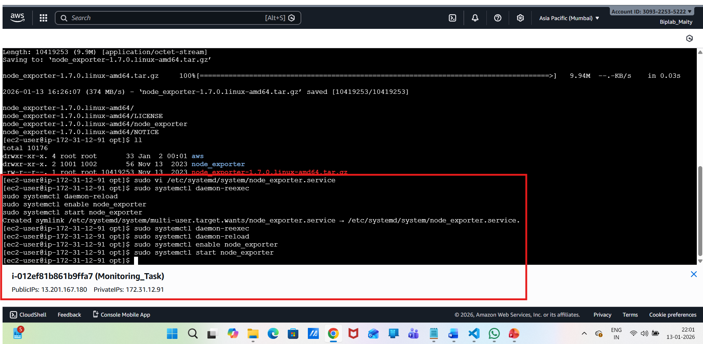
Verify the installation :
http://13.201.167.180:9100/metrics

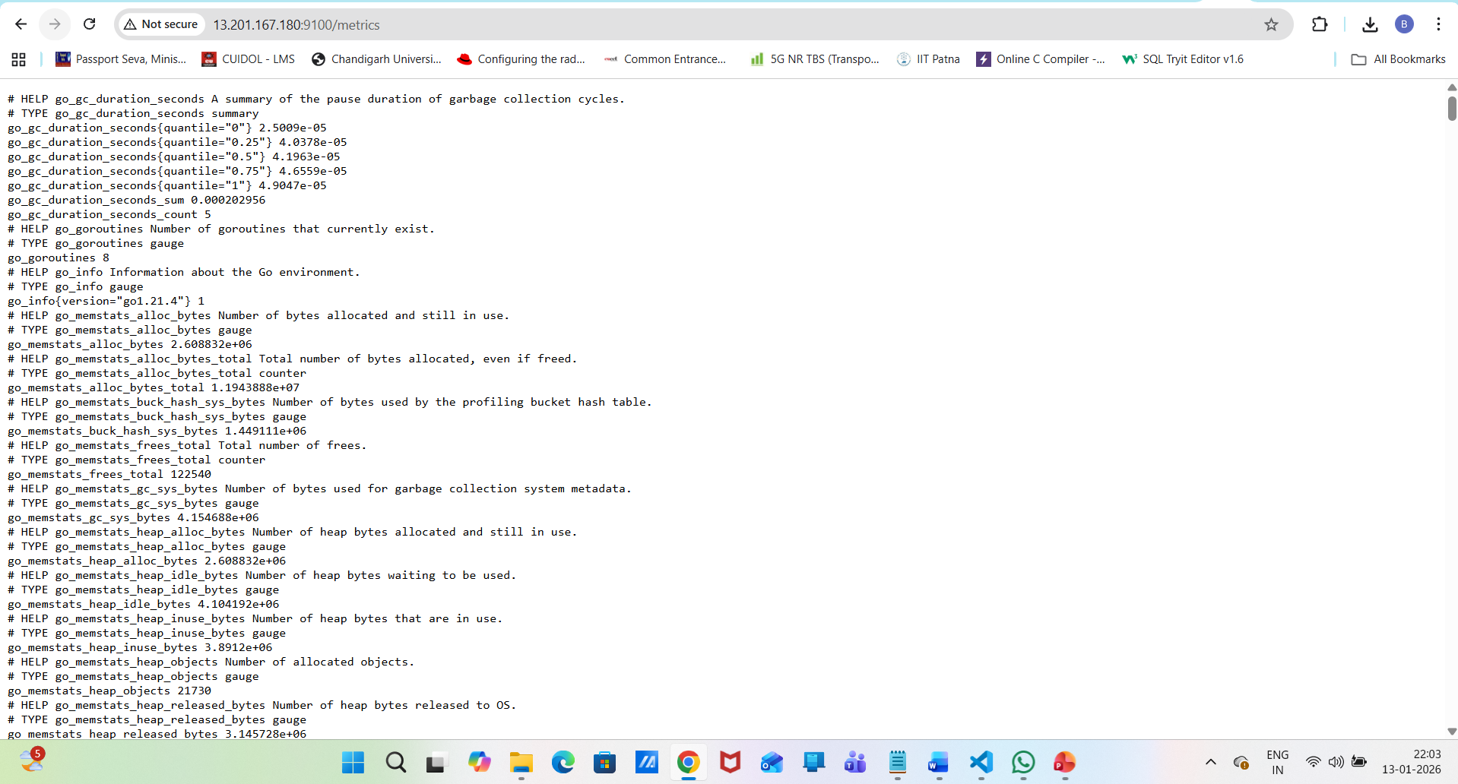
Install Prometheus:
cd /opt
sudo wget https://github.com/prometheus/prometheus/releases/download/v2.52.0/prometheus-2.52.0.linux-amd64.tar.gz
sudo tar -xvf prometheus-2.52.0.linux-amd64.tar.gz
sudo mv prometheus-2.52.0.linux-amd64 prometheus
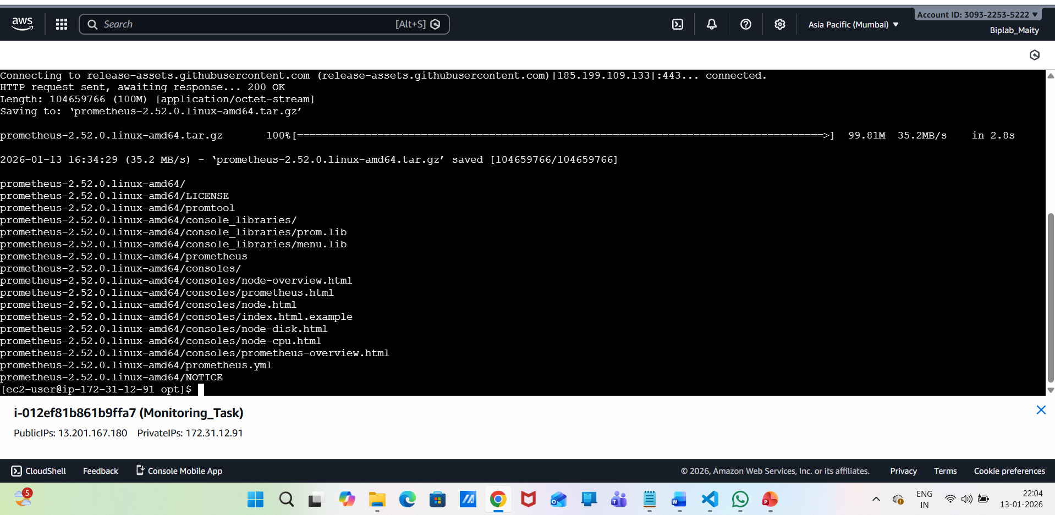
Configure Prometheus to Scrape Node Exporter:
Edit the configurations :
sudo vi /opt/prometheus/prometheus.yml
global:
scrape_interval: 15s

scrape_configs:
- job_name: "node_exporter"
static_configs:
- targets: ["localhost:9100"]
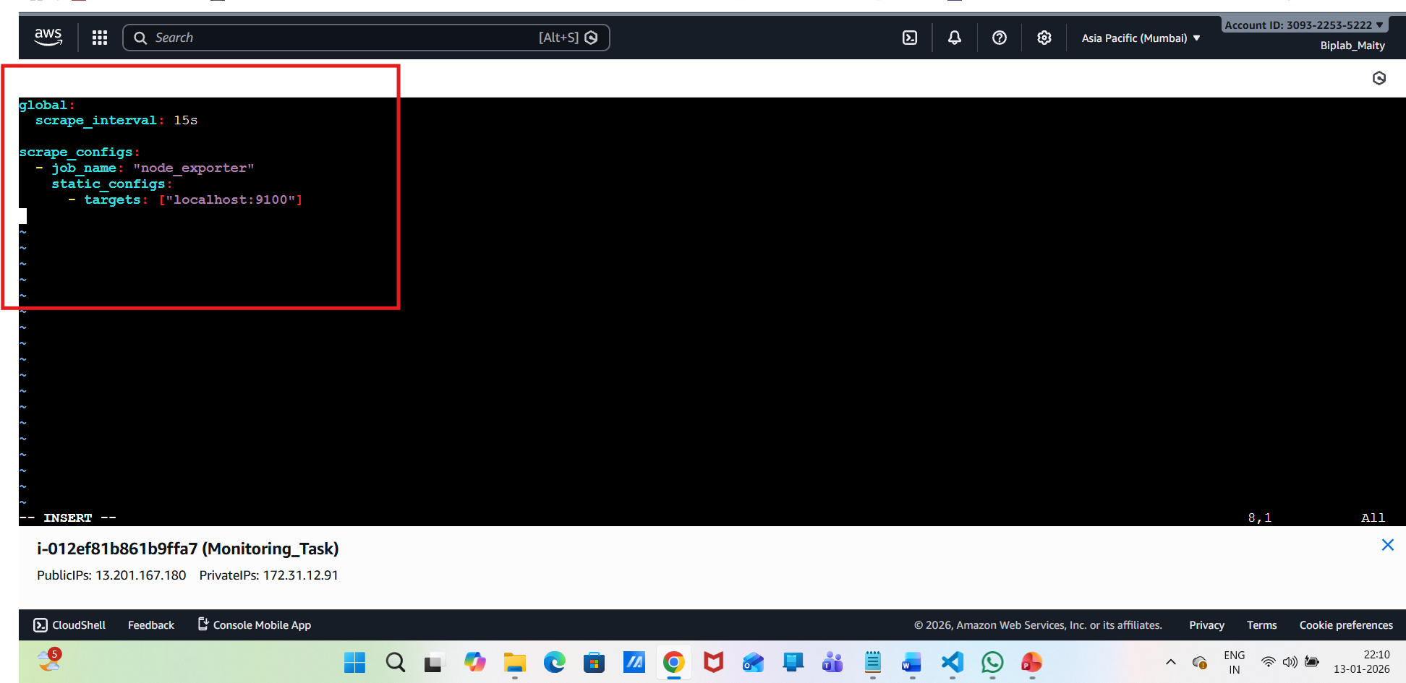
Create Prometheus systemd Service:
sudo vi /etc/systemd/system/prometheus.service
[Unit]
Description=Prometheus
After=network.target

[Service]
User=root
ExecStart=/opt/prometheus/prometheus \
--config.file=/opt/prometheus/prometheus.yml \
--storage.tsdb.path=/opt/prometheus/data

[Install]
WantedBy=multi-user.target
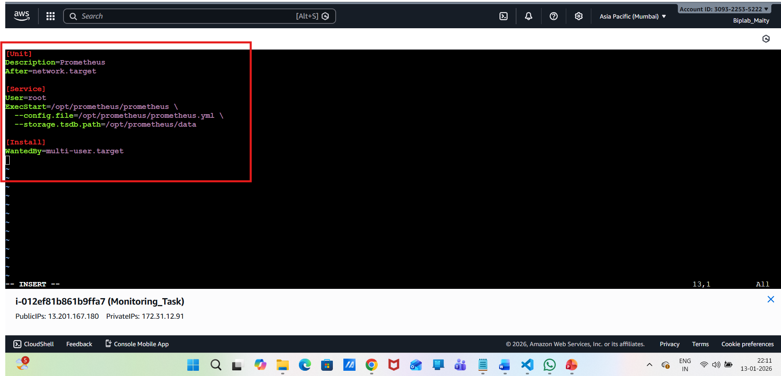
Start Prometheus:
sudo systemctl daemon-reload
sudo systemctl enable prometheus
sudo systemctl start prometheus
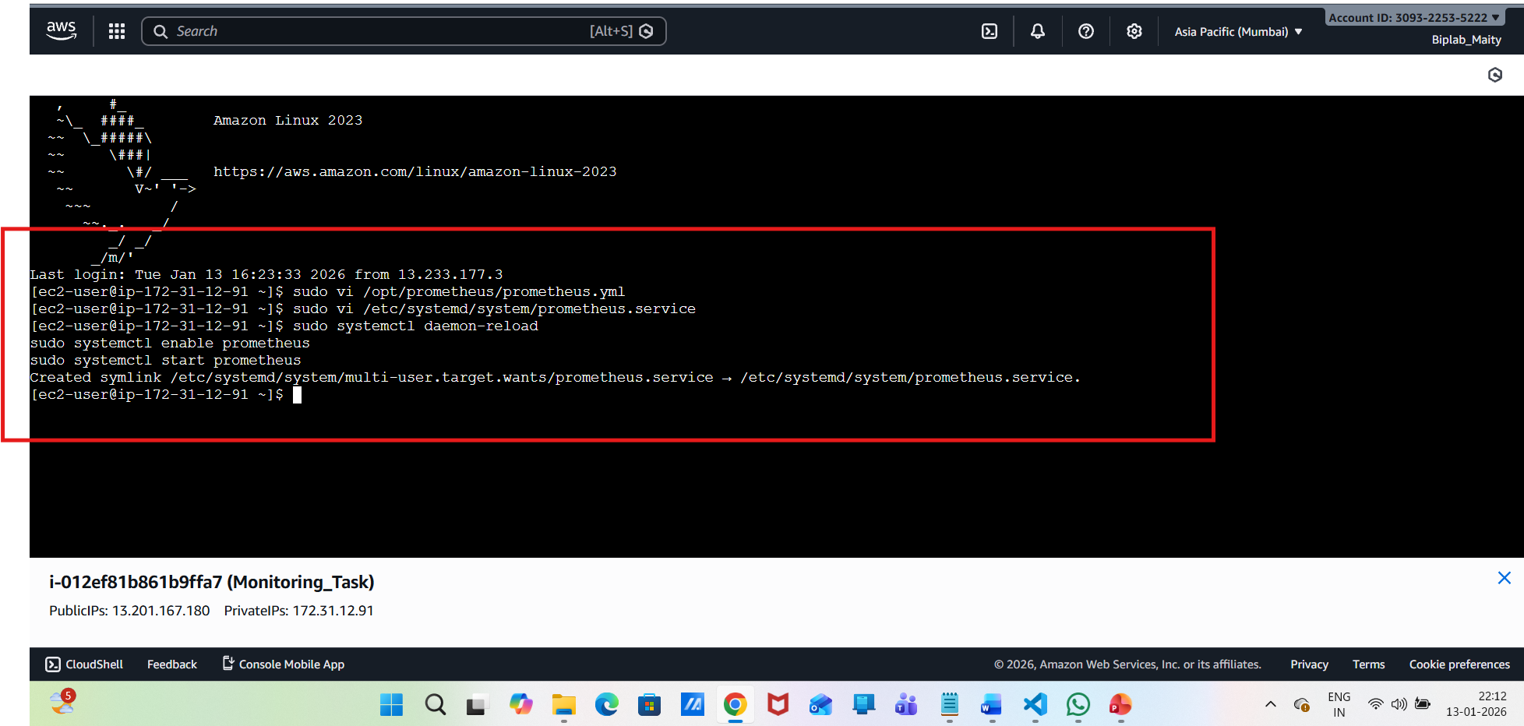
Verify:
http://13.201.167.180:9090
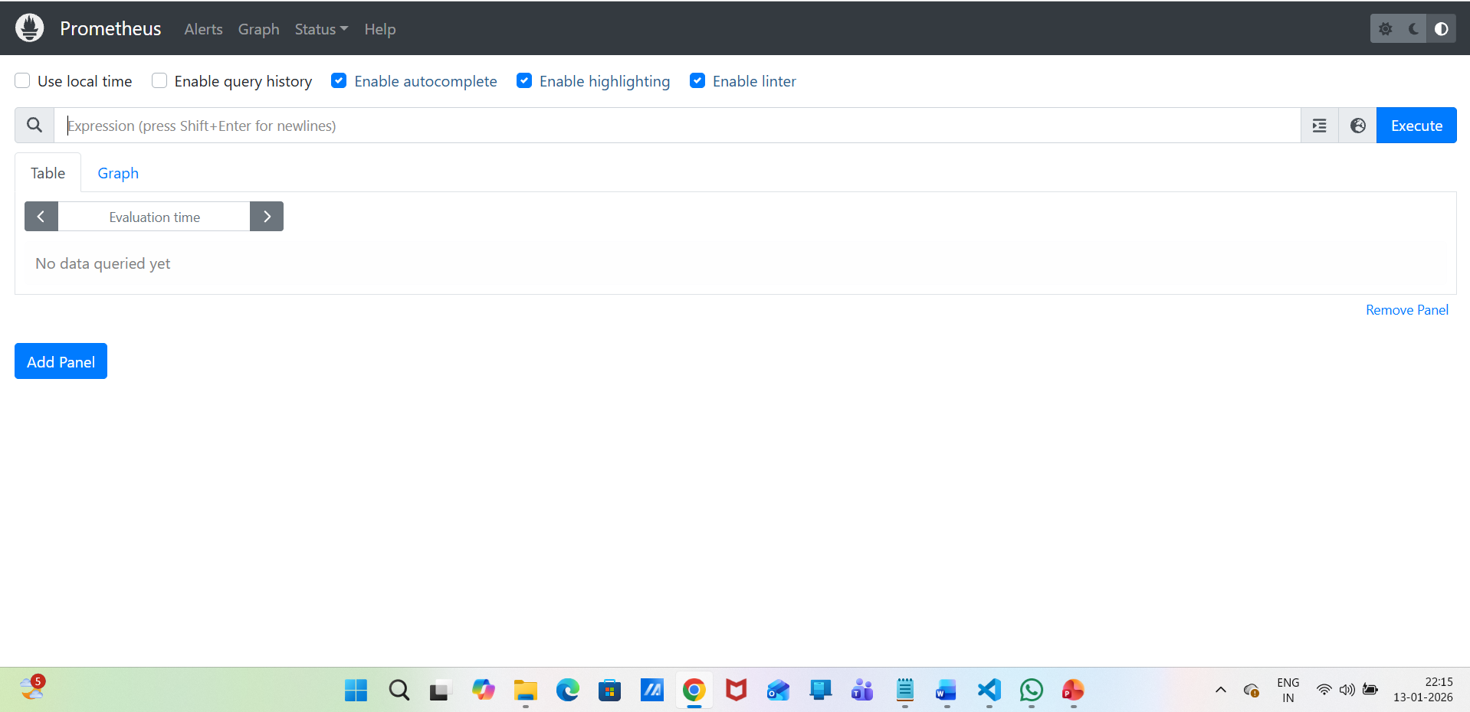
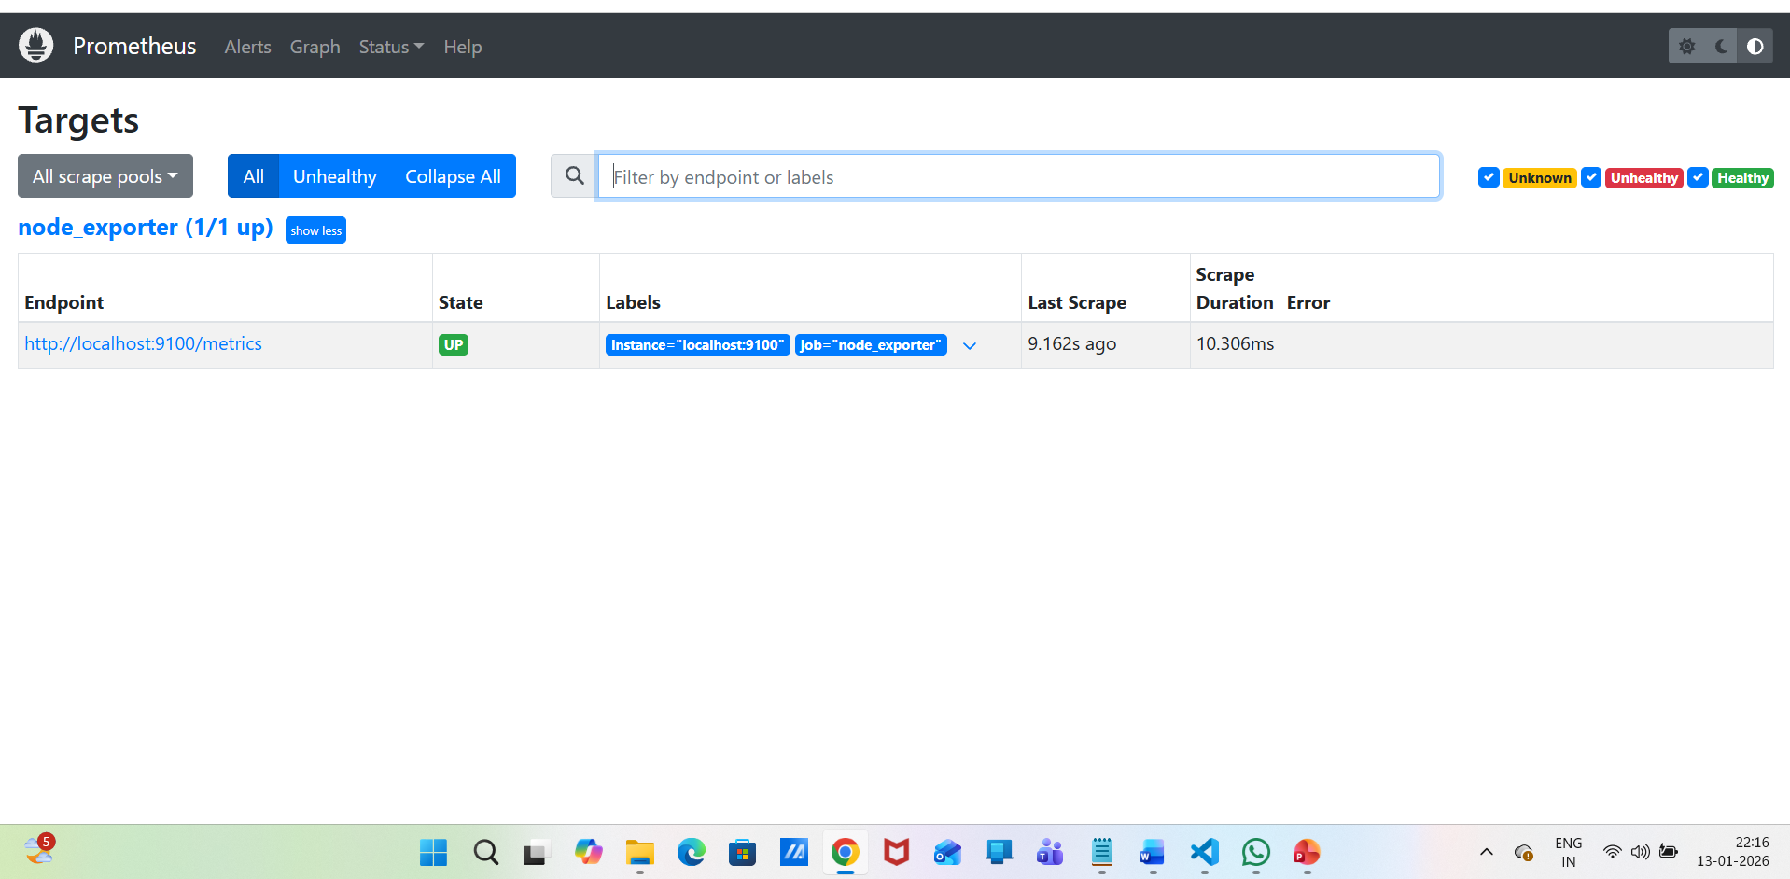
Install Grafana:
sudo tee /etc/yum.repos.d/grafana.repo <<EOF
[grafana]
name=grafana
baseurl=https://rpm.grafana.com
repo_gpgcheck=1
enabled=1
gpgcheck=1
gpgkey=https://rpm.grafana.com/gpg.key
EOF
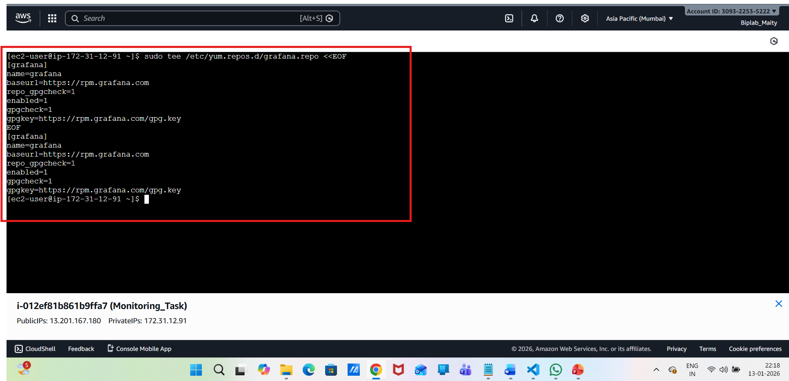
Install & start:
sudo yum install grafana -y
sudo systemctl daemon-reload
sudo systemctl enable grafana-server
sudo systemctl start grafana-server
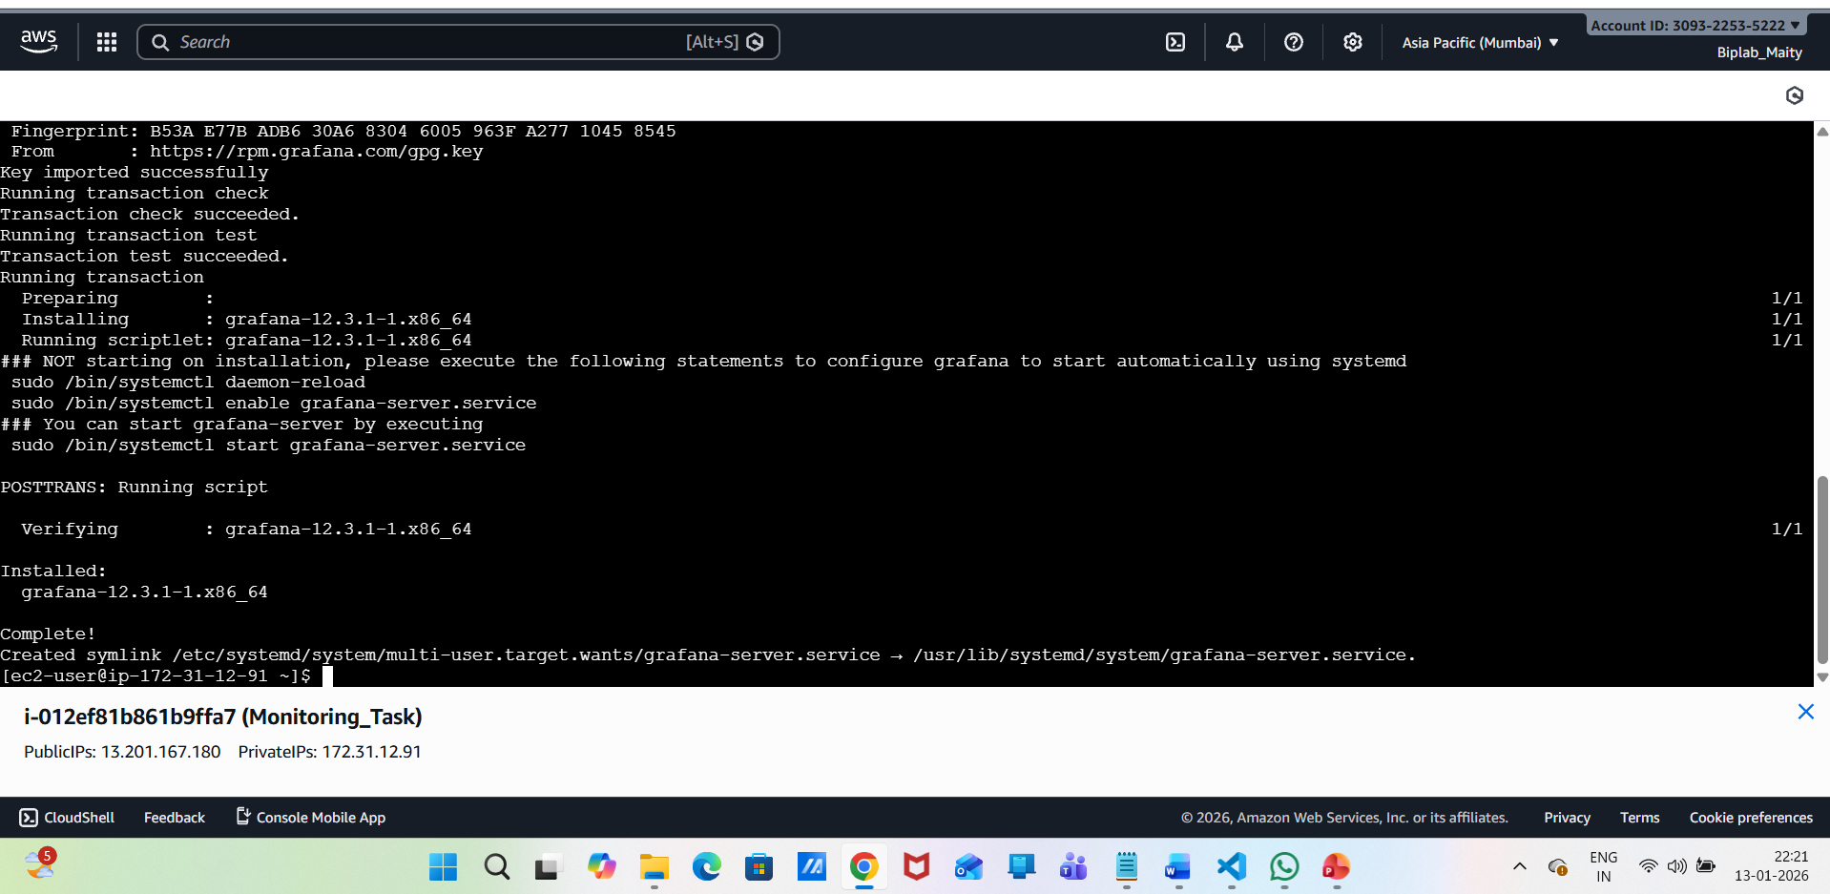
Access Grafana:
http://13.201.167.180:3000


Default login:
username: admin
password: admin
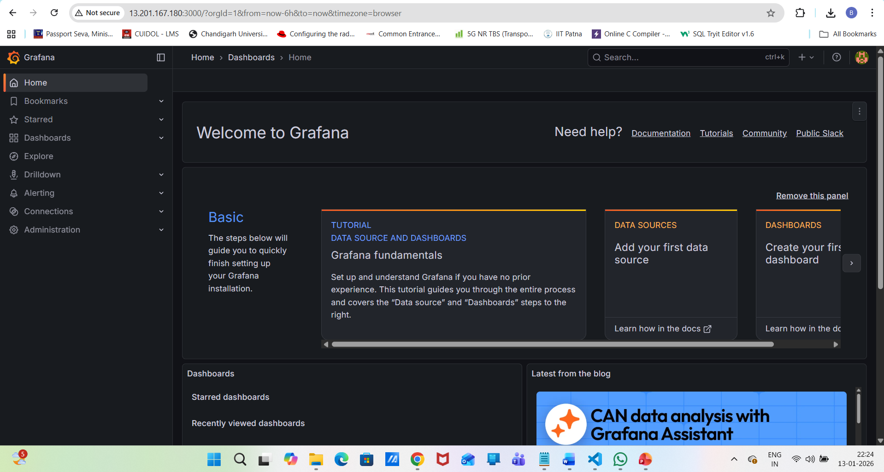
Connect Prometheus to Grafana:
Add Data Source
Grafana UI → connection → Data Sources
Add data source
Choose Prometheus
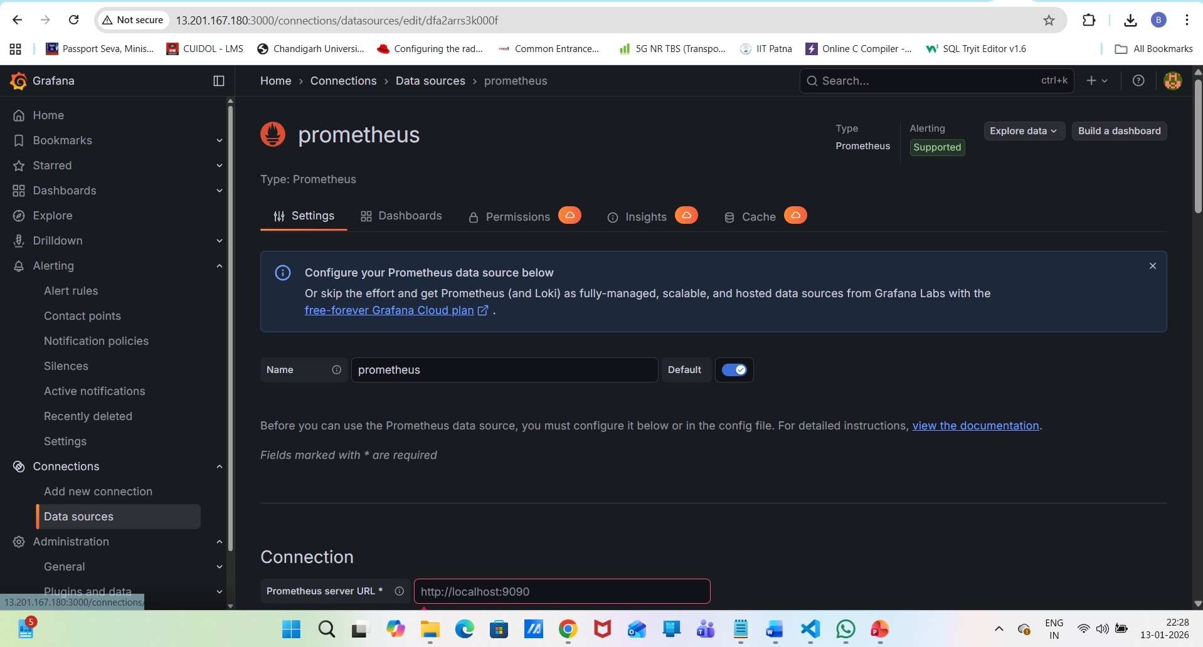
URL: http://13.201.167.180:9090
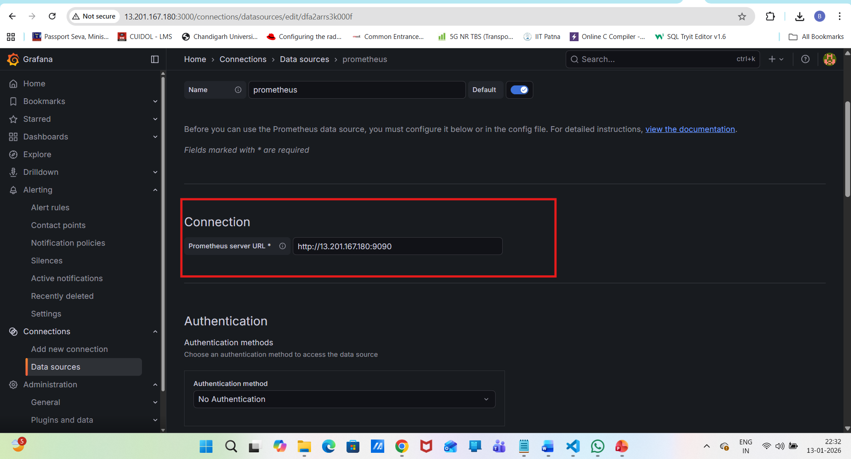
save & test:
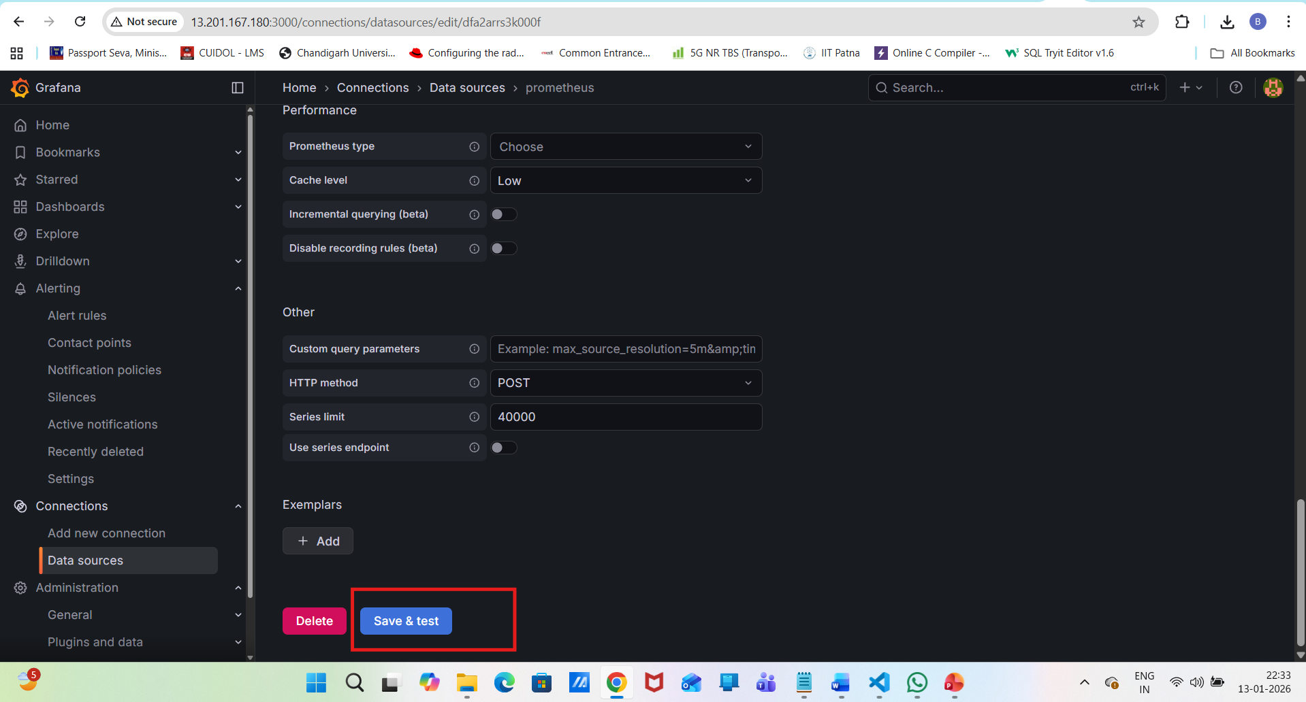
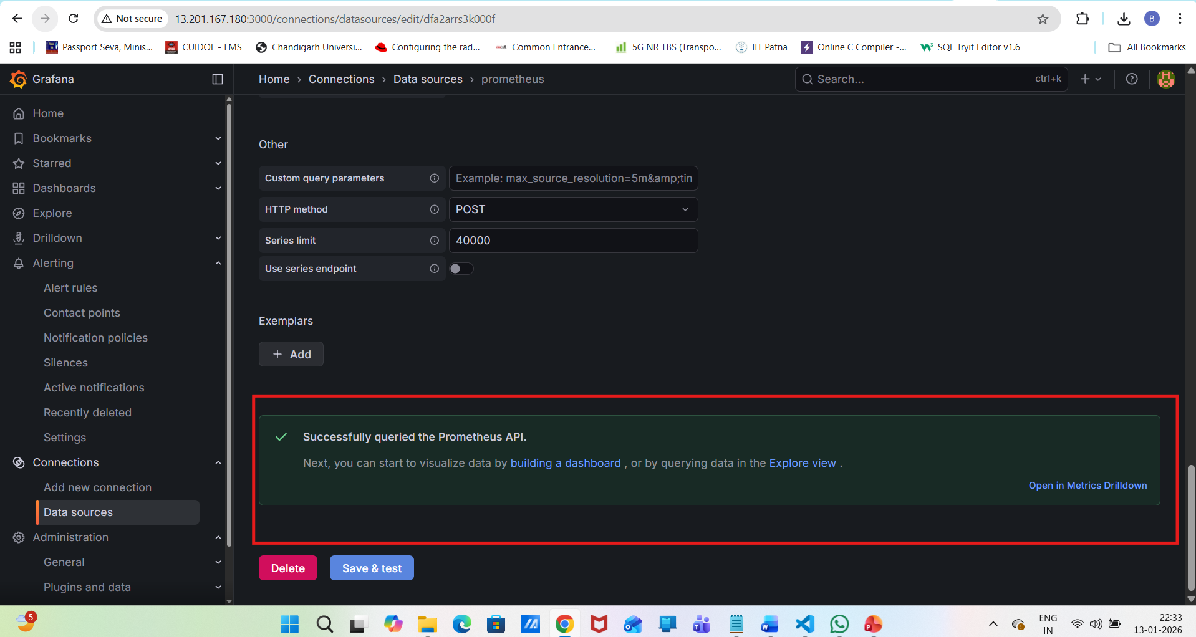
Now Create Dashboard:
Grafana → Import dashboard
Dashboard ID:1860
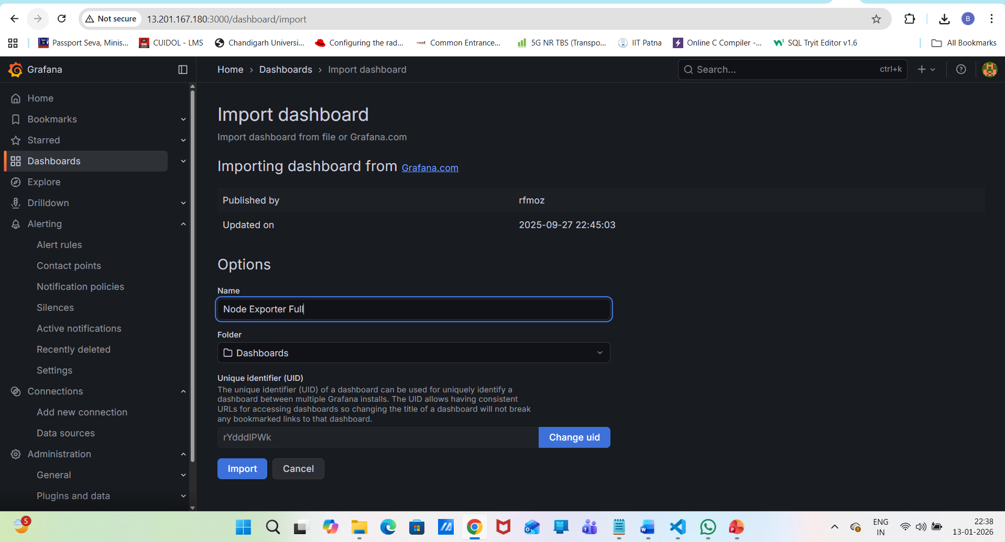
Now select
Select Prometheus as data source
Click Import
full EC2 monitoring dashboard:
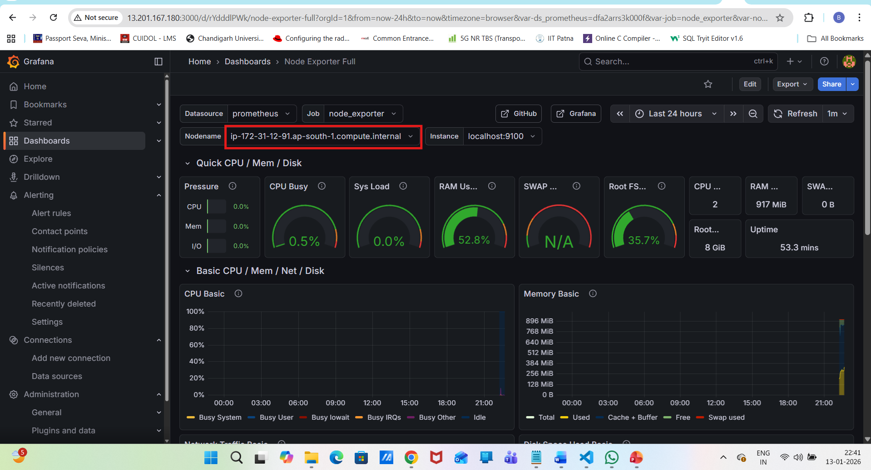
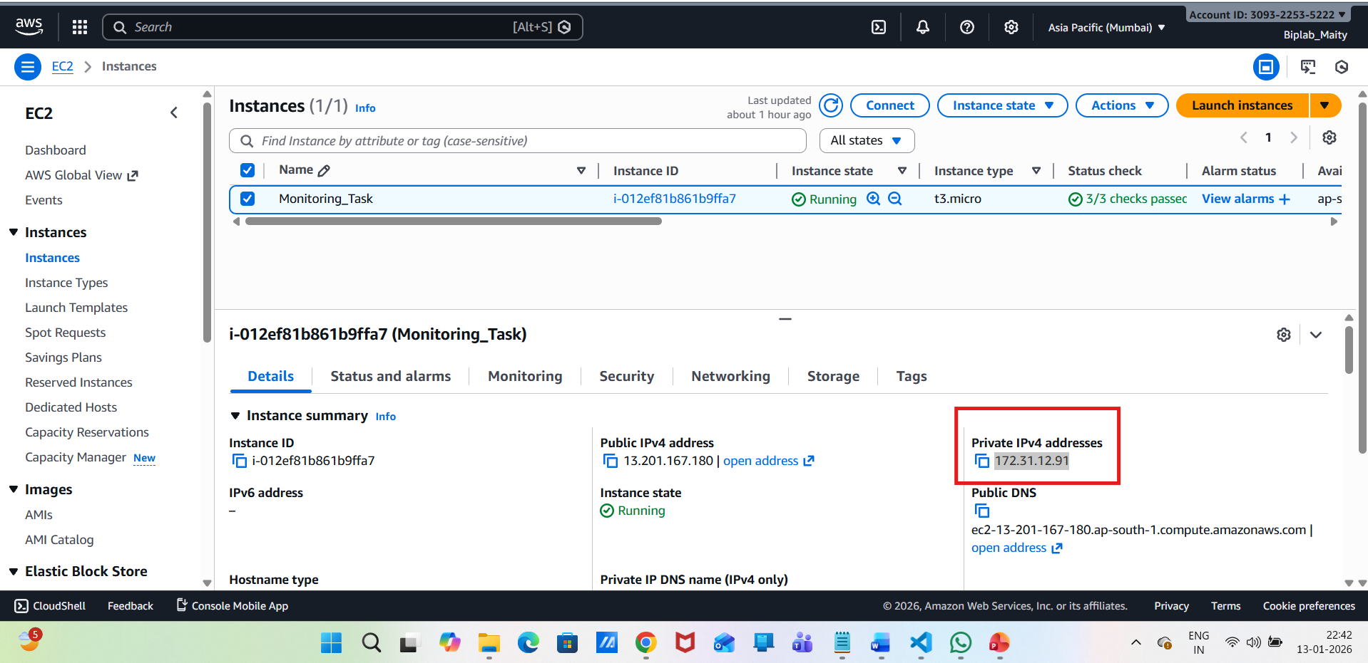
Validation Commands (CLI):
# Check services
systemctl status node_exporter
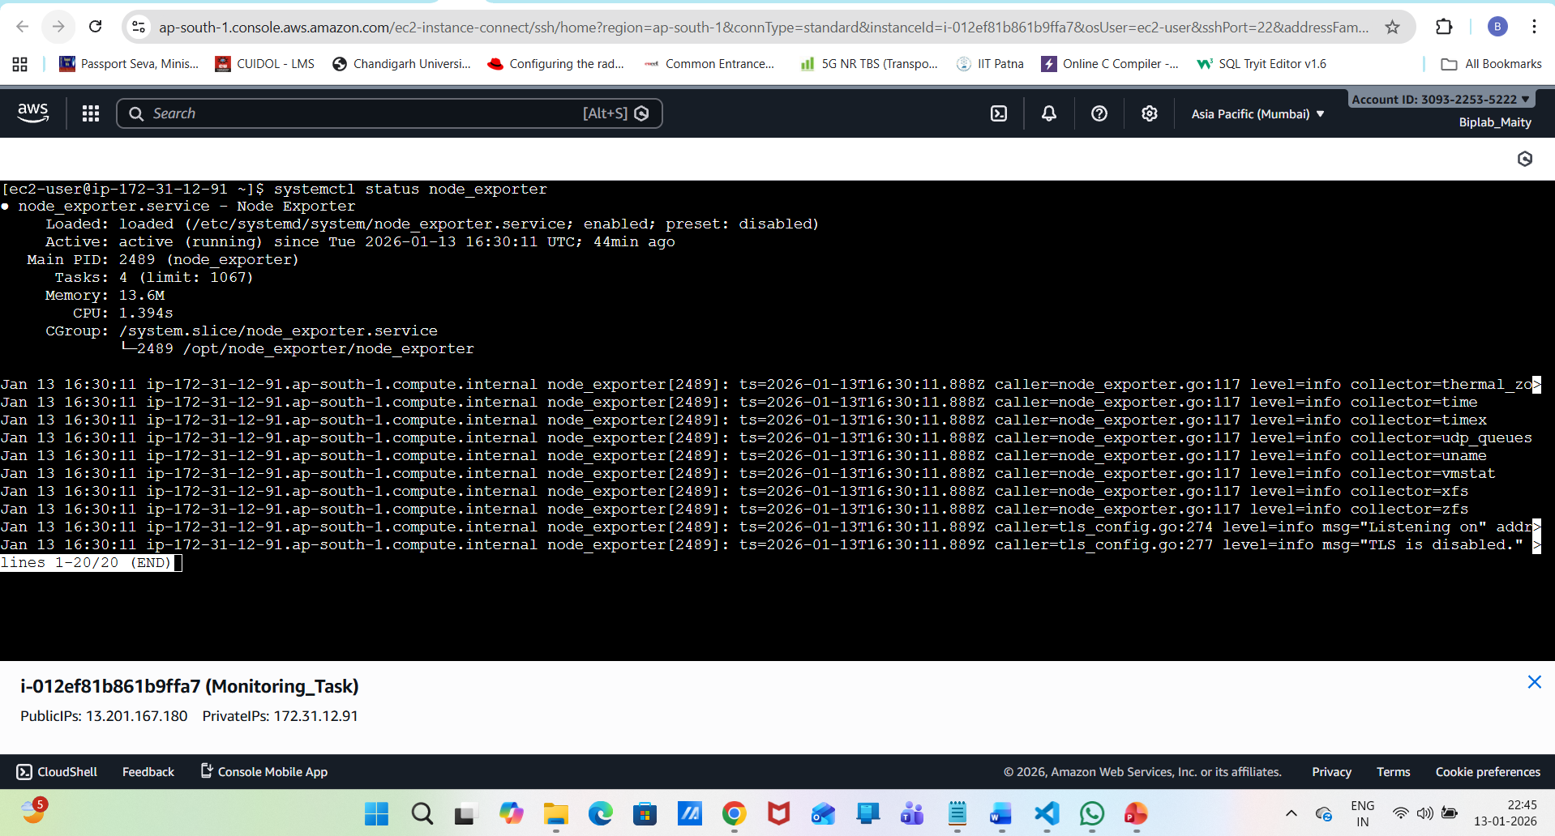
systemctl status Prometheus

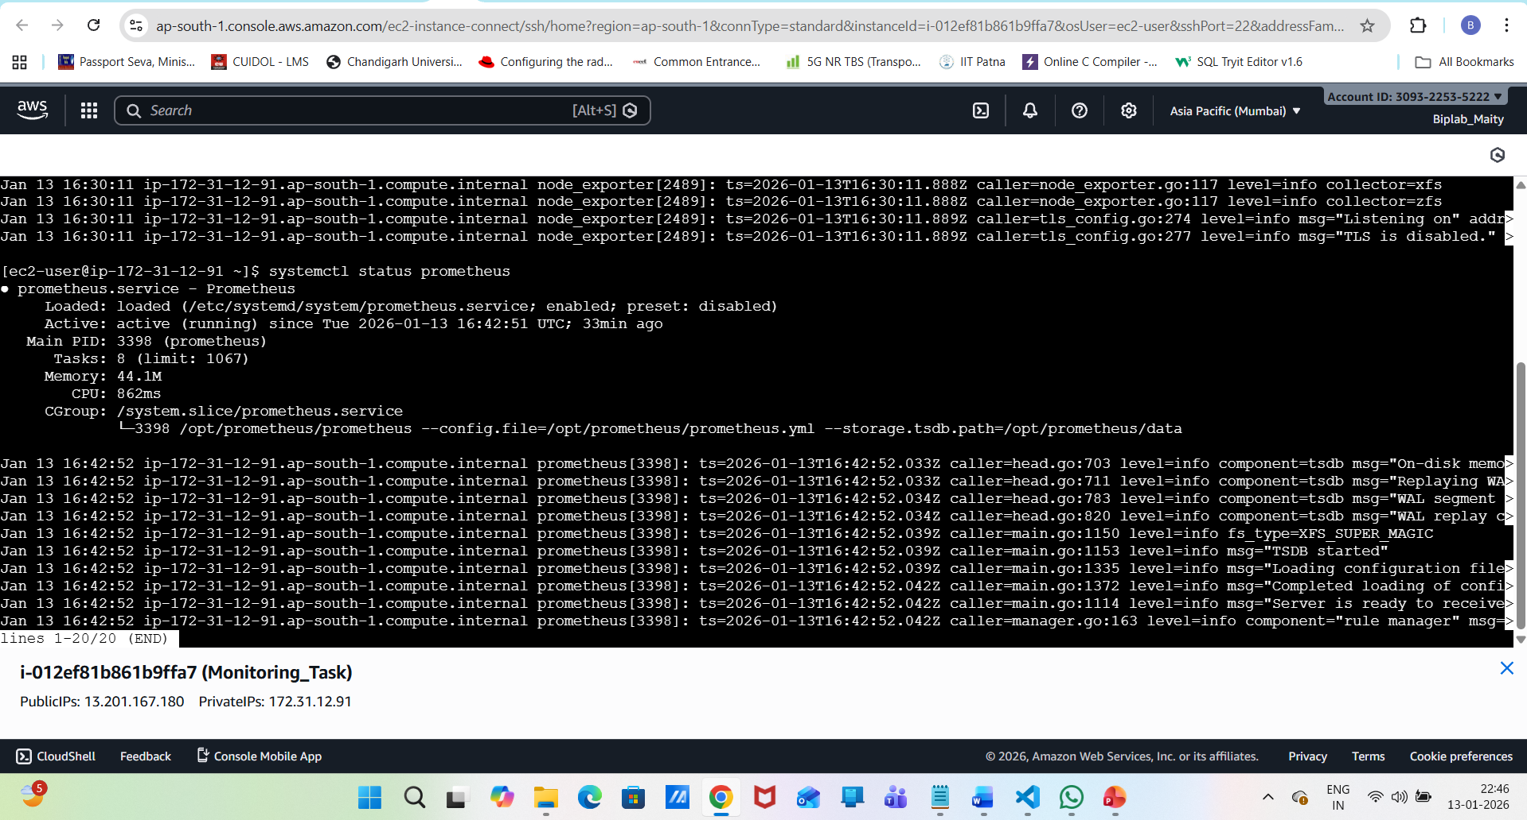
systemctl status grafana-server
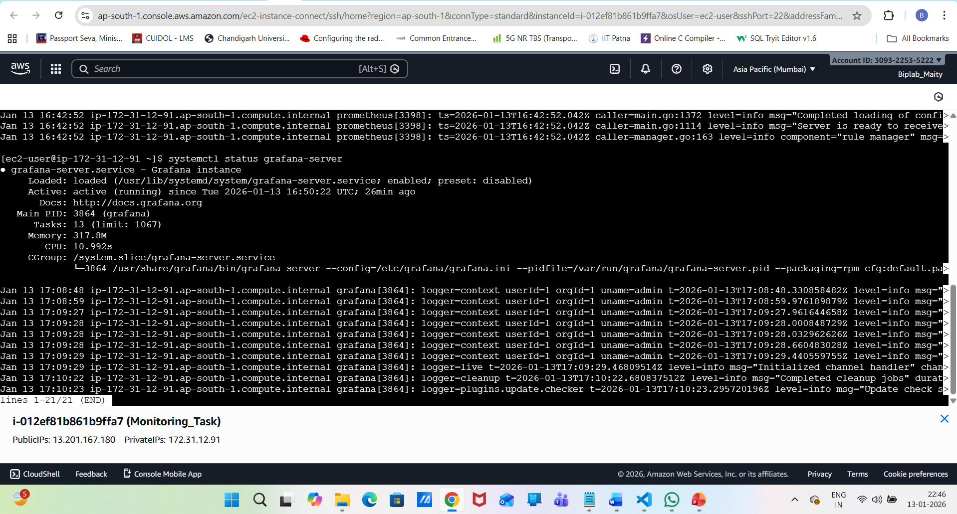
# Check Prometheus targets
curl http://localhost:9090/api/v1/targets
