- Clone & Run the Application (Port 80):
git clone https://github.com/sriram-R-krishnan/devops-build.git
cd devops-build
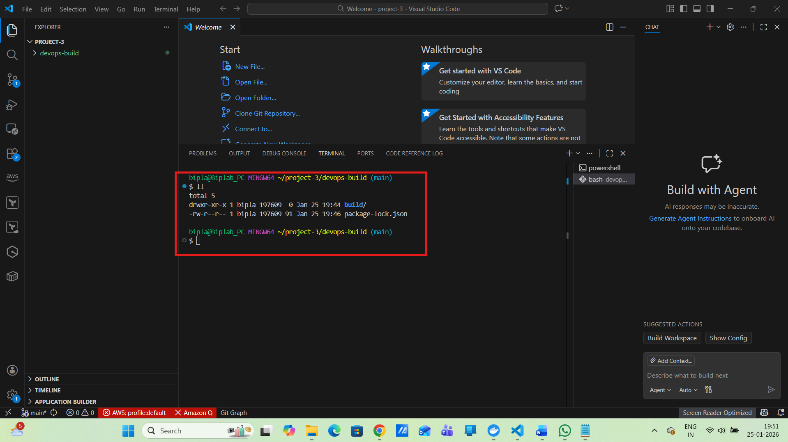
npm init -y
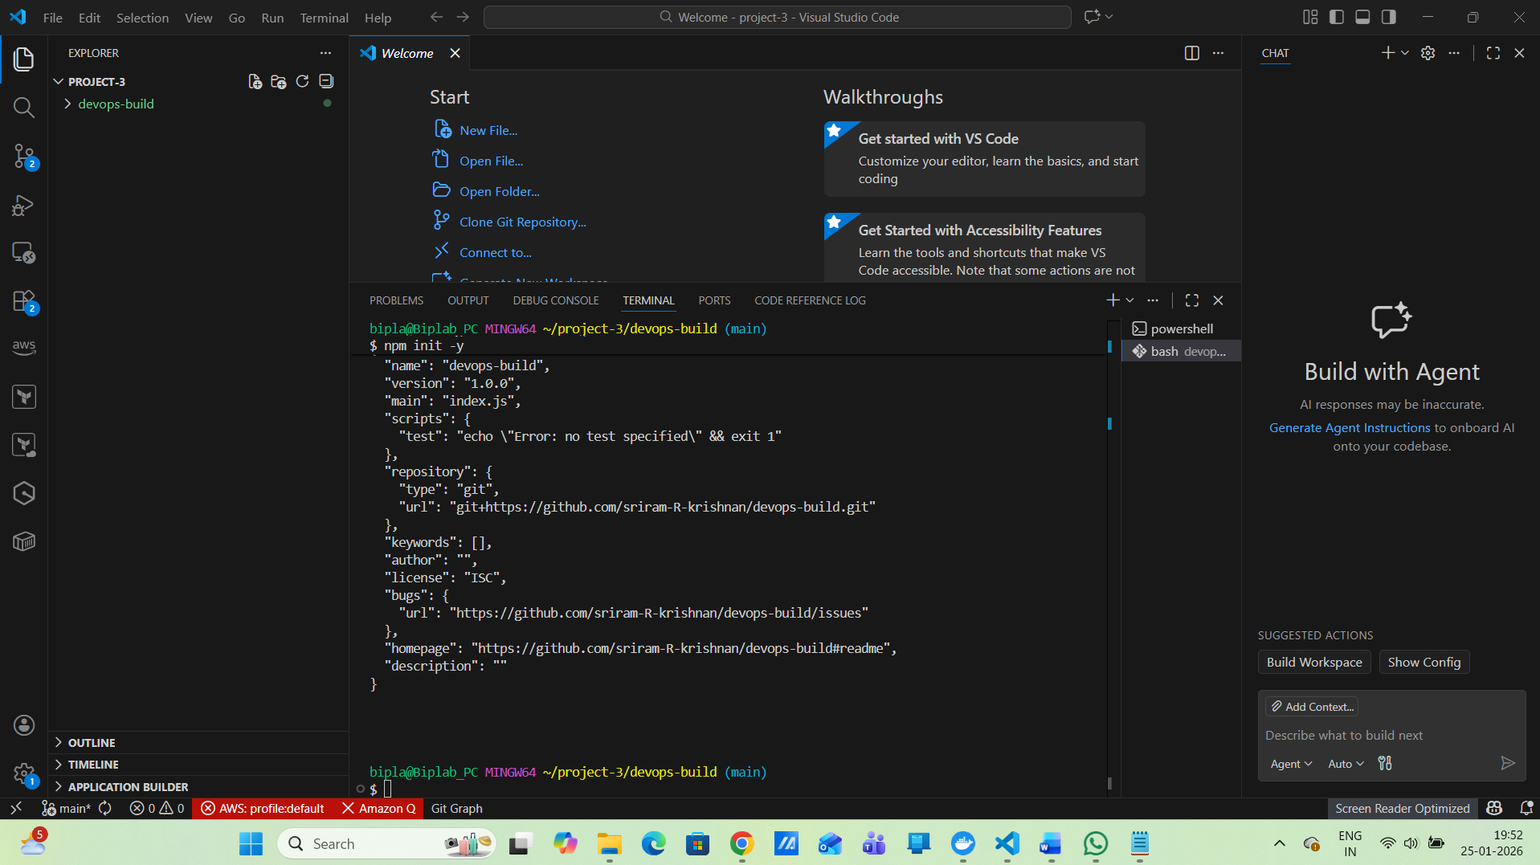
npm install
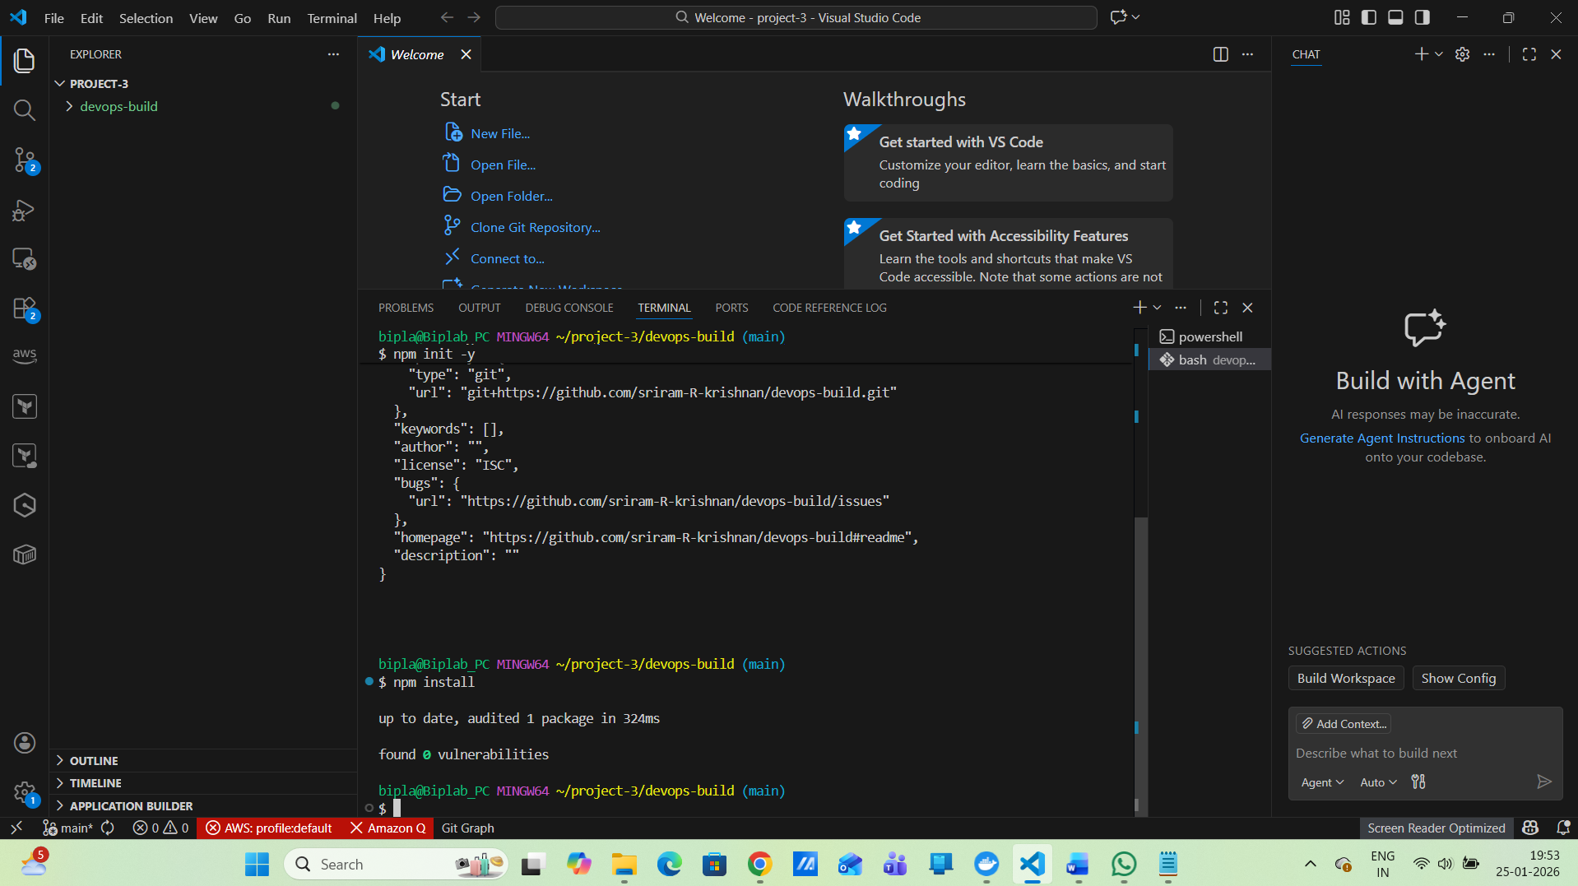
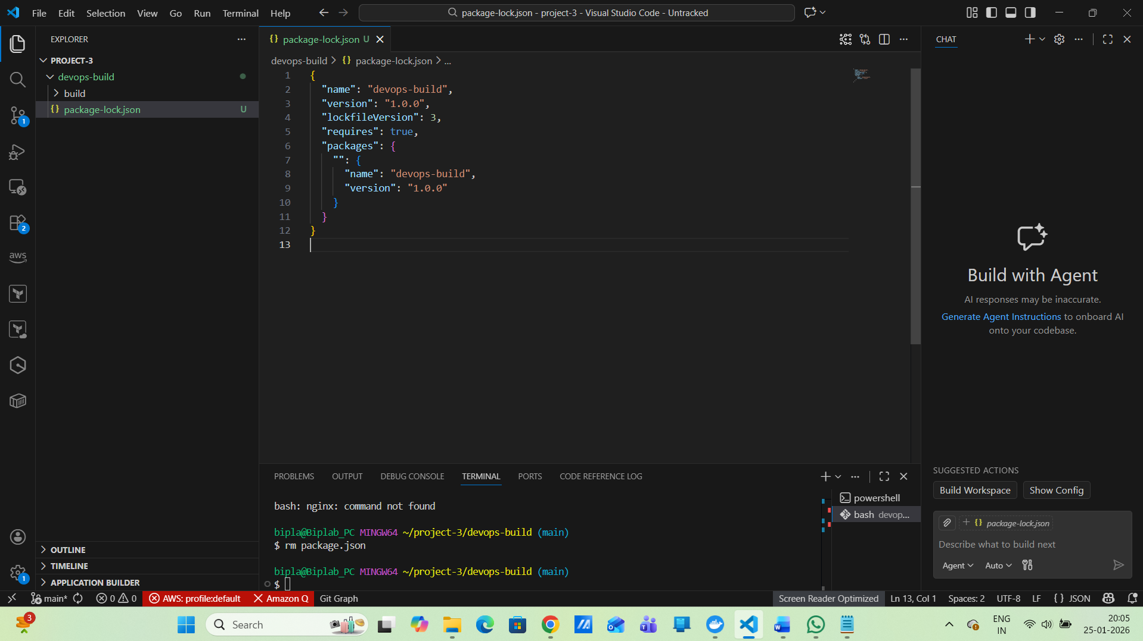
npm run build
{
"name": "devops-build",
"version": "1.0.0",
"private": true,
"scripts": {
"build": "echo \"Build already exists – skipping build\""
}
}
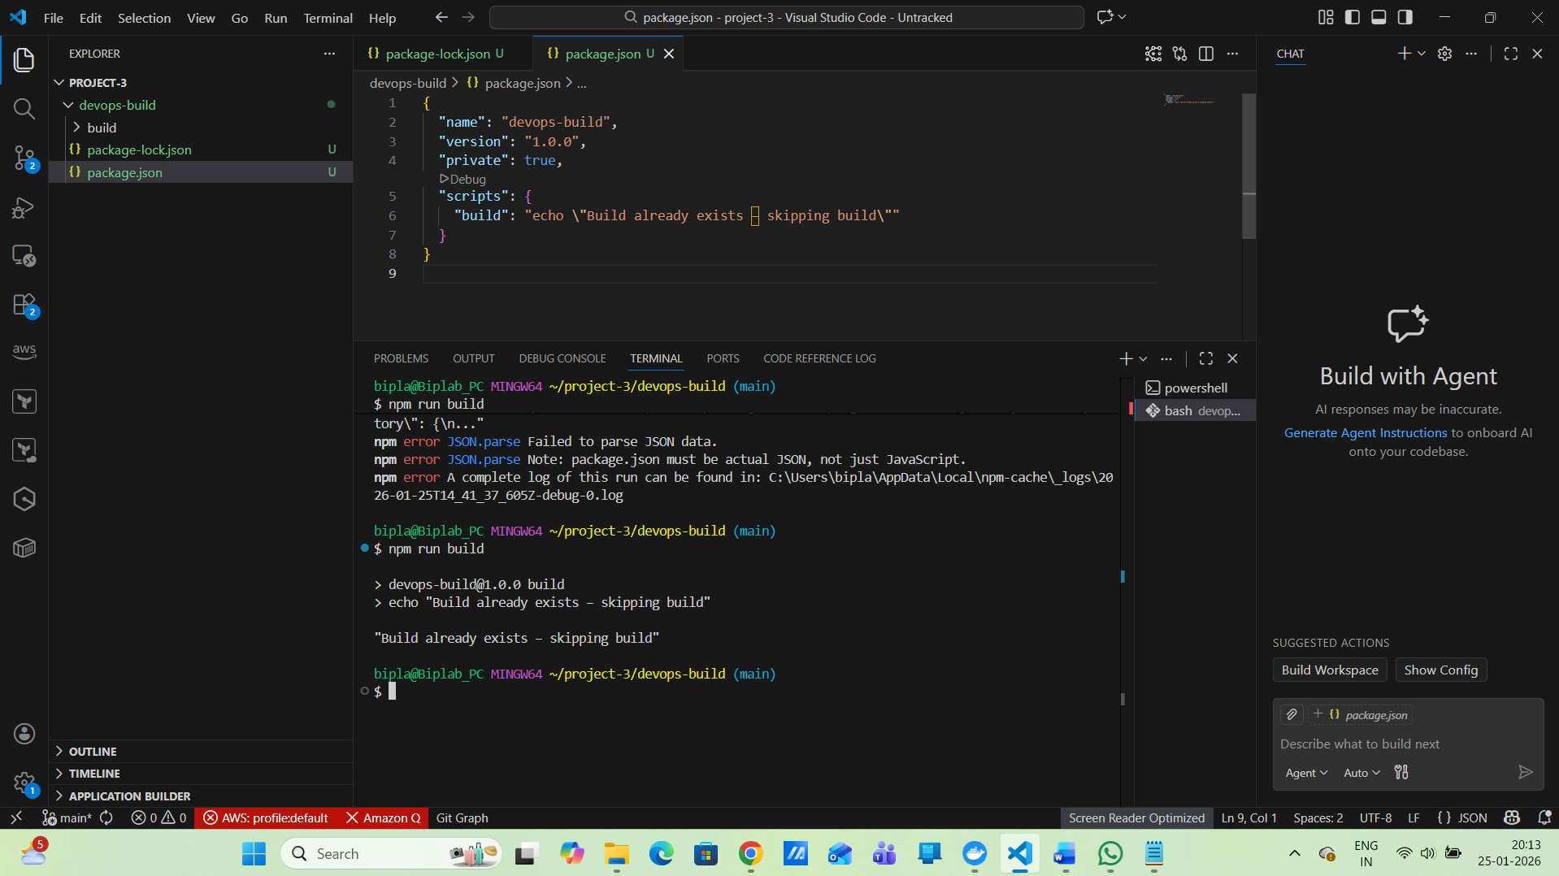
Validate now :
npm run
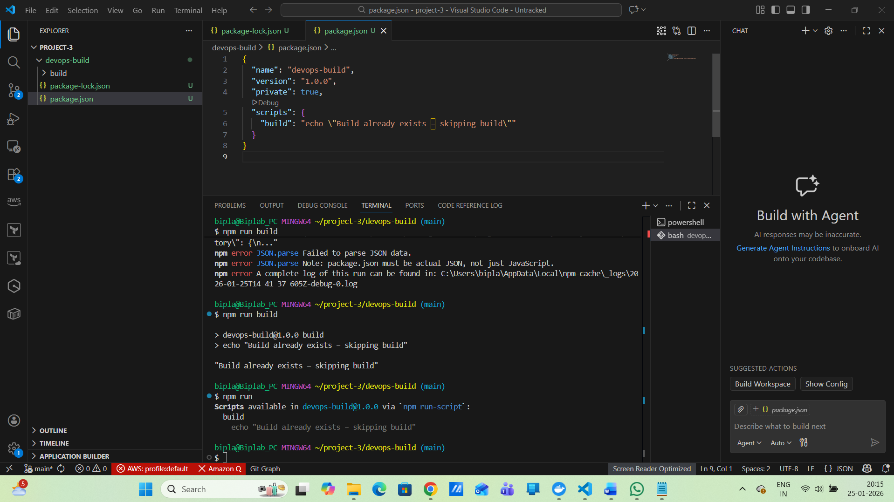
2. Dockerize the Application:
Dockerfile
# Build stage
FROM node:18-alpine AS build
WORKDIR /app
COPY package*.json ./
RUN npm install
COPY . .
RUN npm run build

# Runtime stage
FROM nginx:alpine
COPY --from=build /app/build /usr/share/nginx/html
EXPOSE 80
CMD ["nginx", "-g", "daemon off;"]
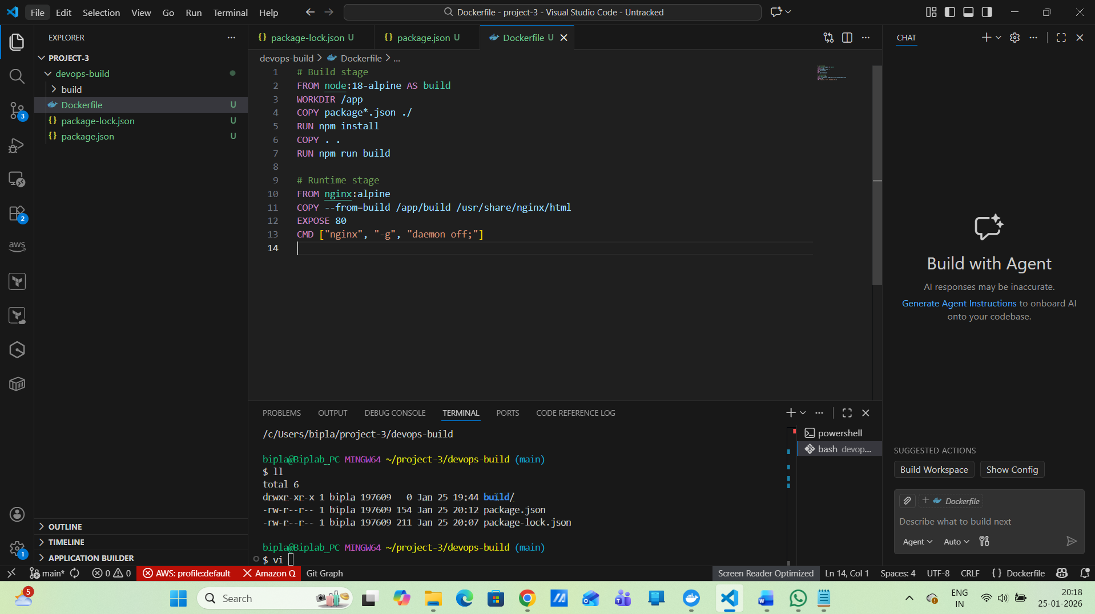
3. Docker Compose File
docker-compose.yml
version: "3.8"

services:
react-app:
image: react-app:latest
container_name: react-prod
ports:
- "80:80"
restart: always
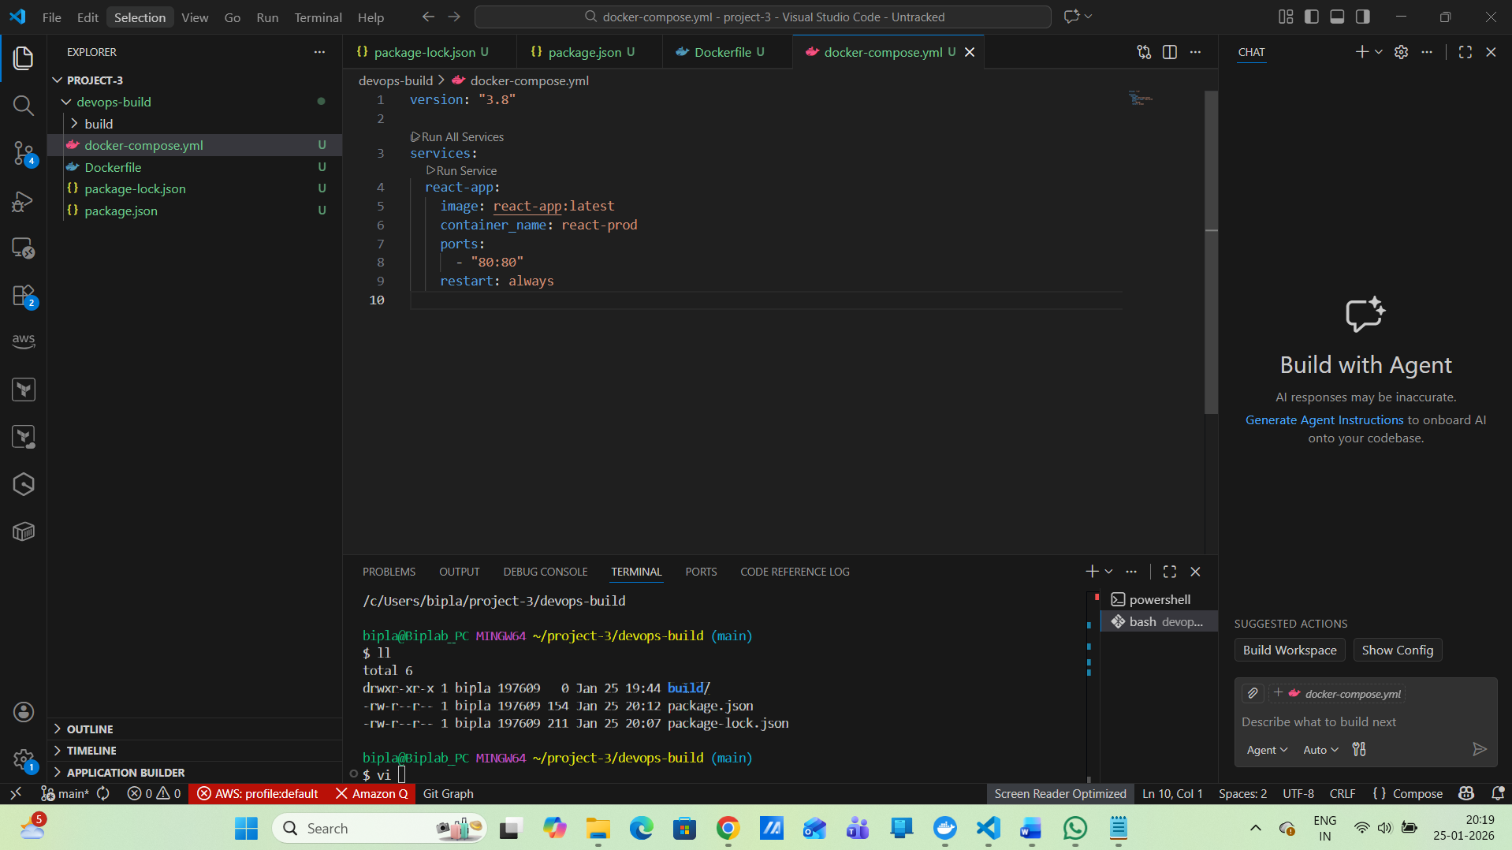
4. Bash Scripts
build.sh
#!/bin/bash
APP_NAME="react-app"
TAG=$(git rev-parse --short HEAD)

docker build -t $APP_NAME:$TAG .
docker tag $APP_NAME:$TAG $APP_NAME:latest
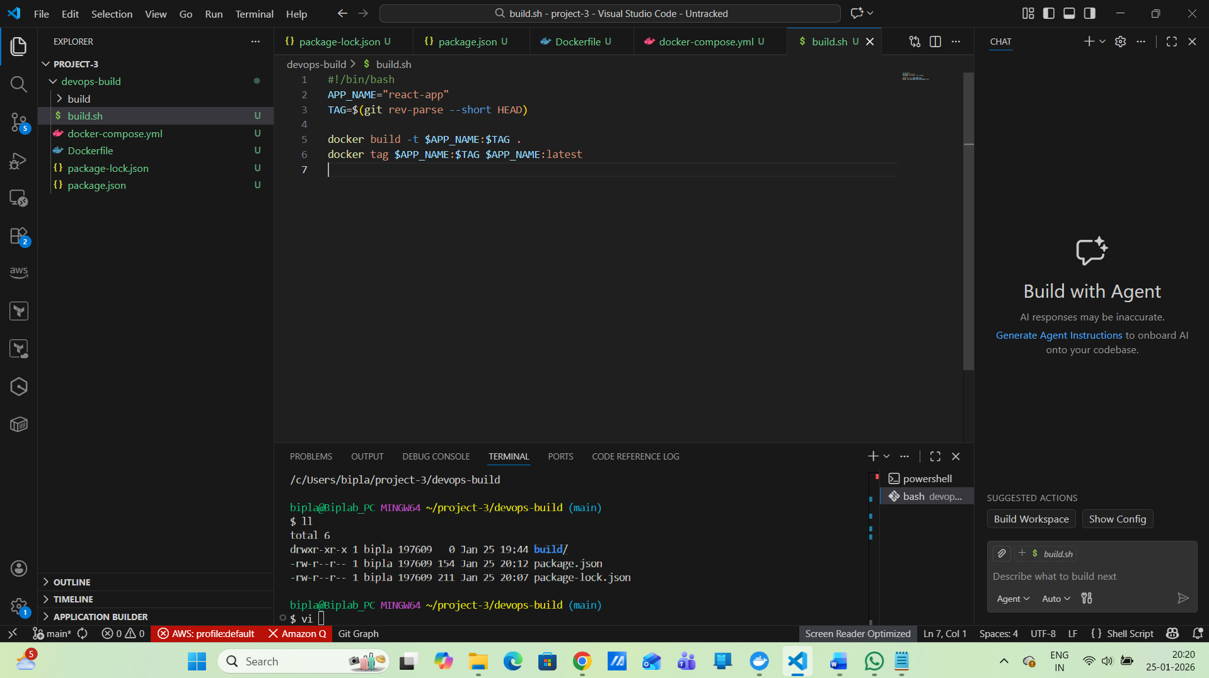
chmod +x build.sh
Now create deploy.sh
#!/bin/bash
APP_NAME="react-app"

docker stop react-prod || true
docker rm react-prod || true

docker run -d \
--name react-prod \
-p 80:80 \
--restart always \
$APP_NAME:latest
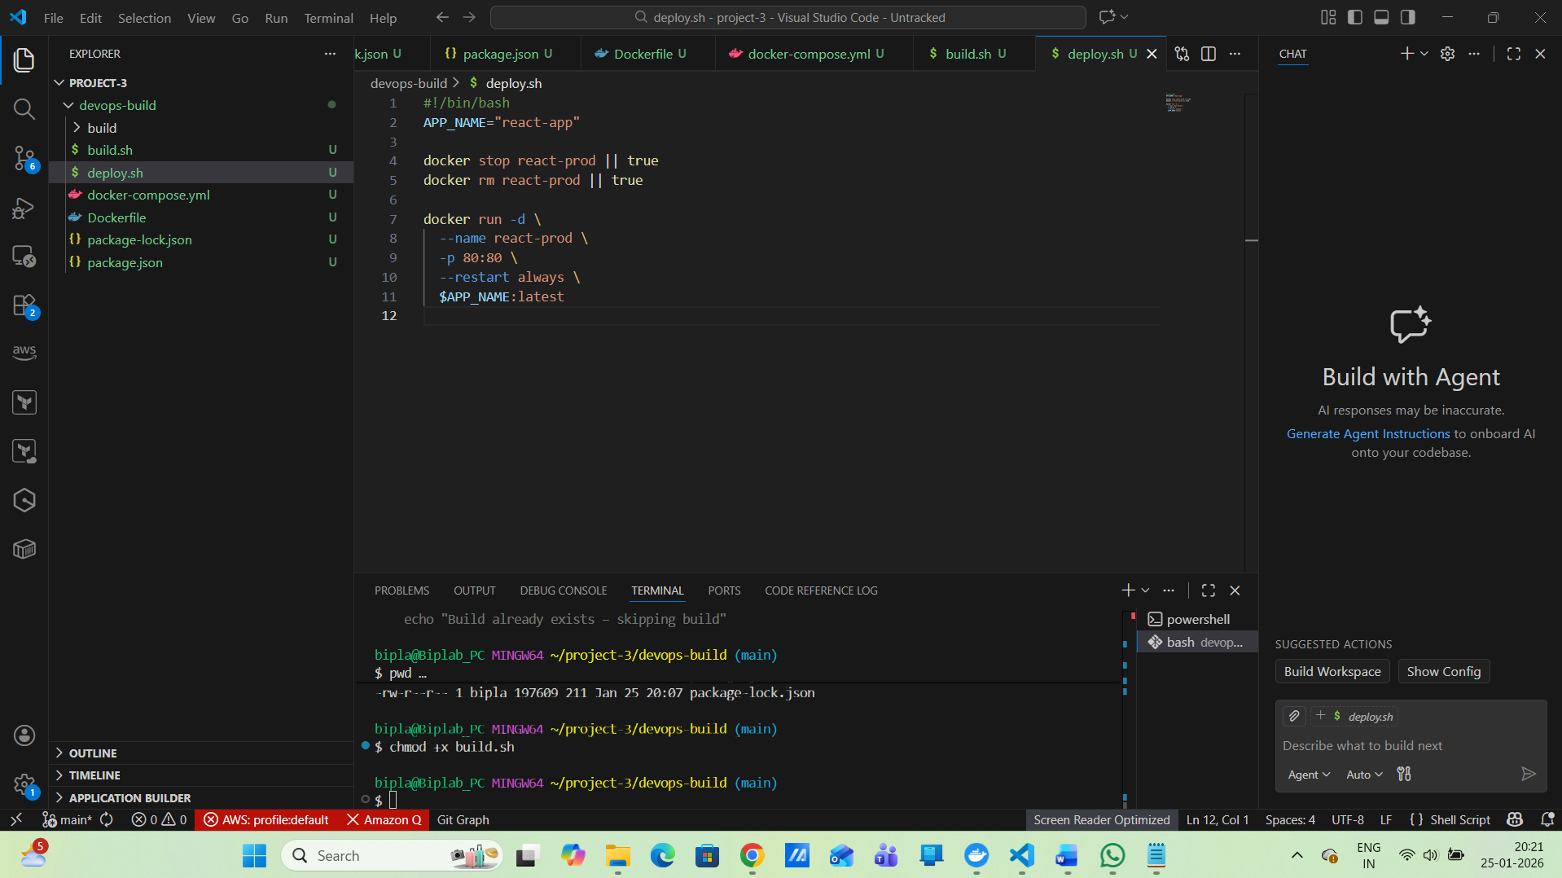
chmod +x deploy.sh
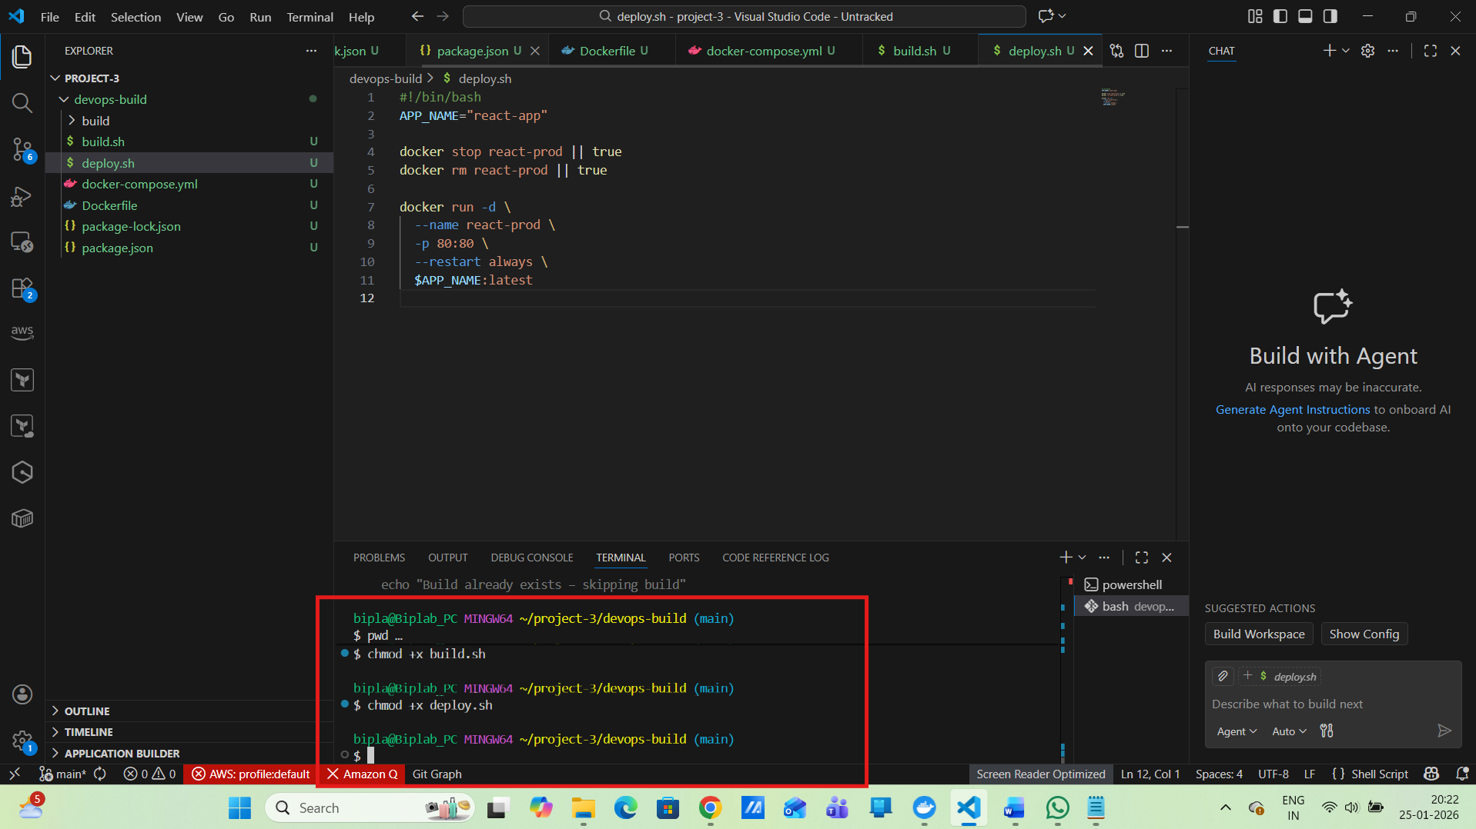
Before that, we need to do the following steps :
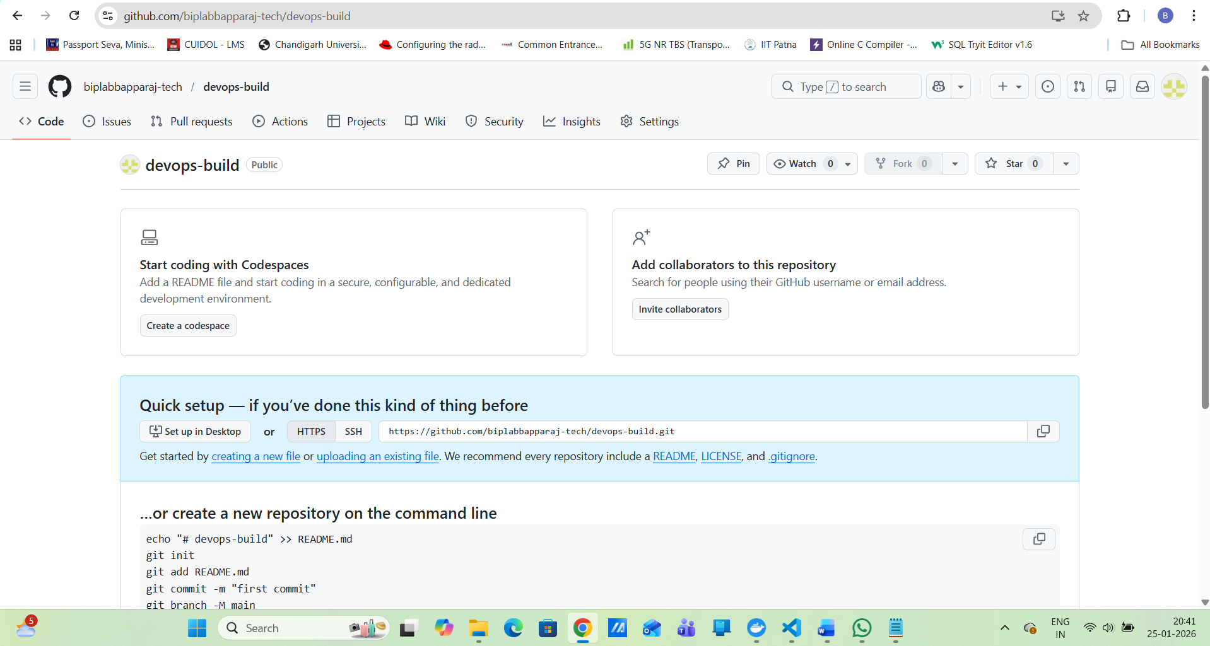
Step 1: Fork the repo on GitHub UI
Fork:
sriram-R-krishnan/devops-build
to:
biplabbapparaj-tech/devops-build
Step 2: Point your local repo to YOUR fork
git remote set-url origin https://github.com/biplabbapparaj-tech/devops-build.git
Verify:
git remote -v
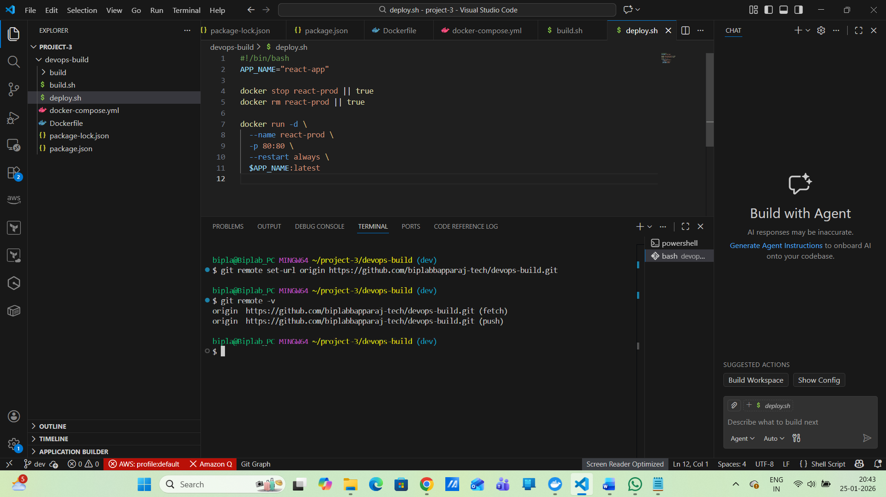
Step 3: Push
git push -u origin dev
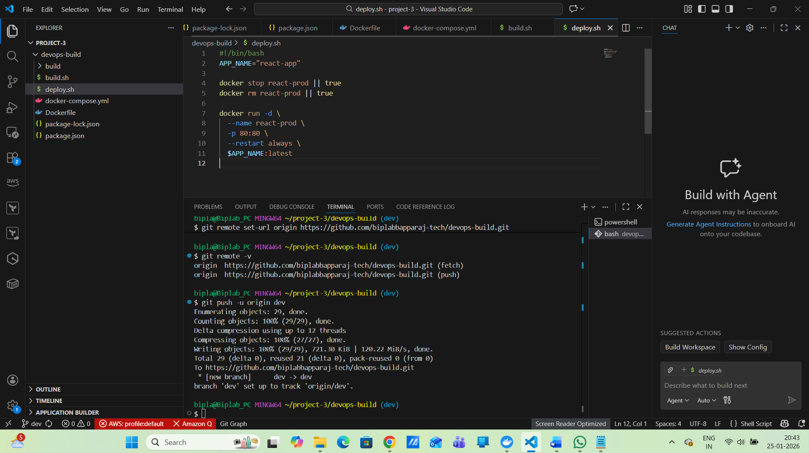
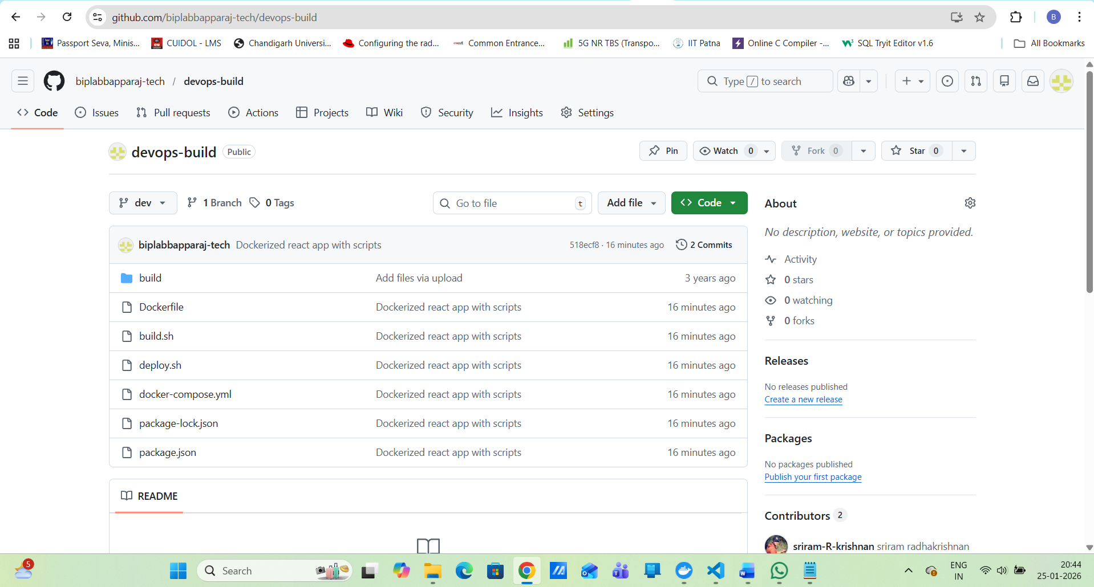
5. Git Version Control:
.gitignore
node_modules
build
.env
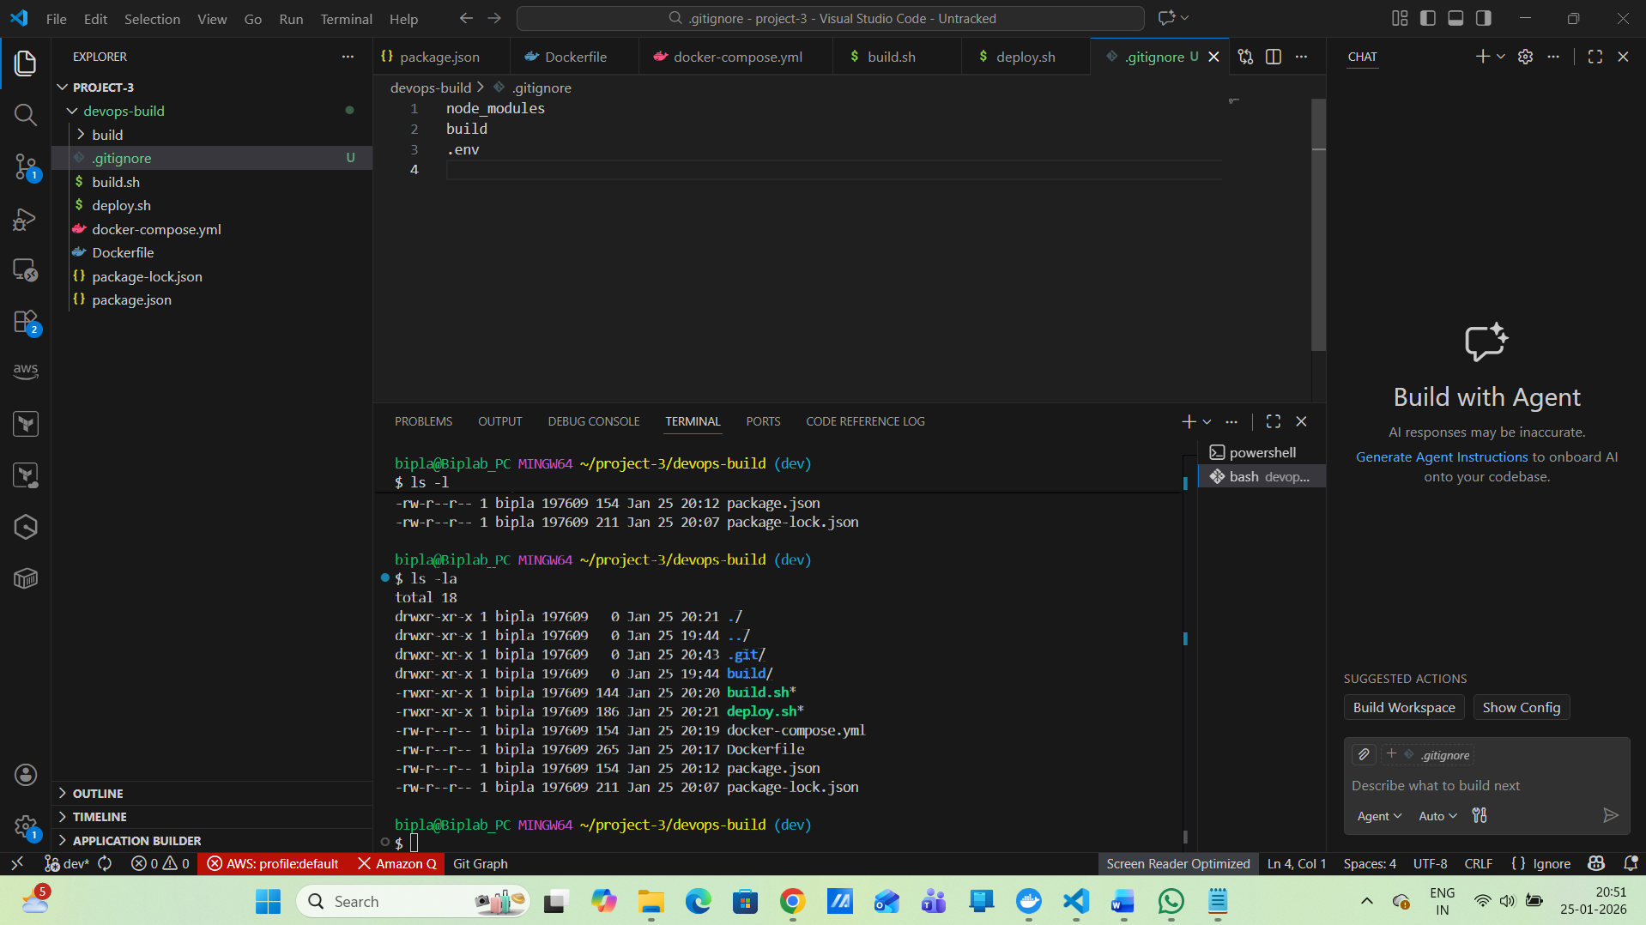
Next …..
.dockerignore
node_modules
.git
.gitignore
Dockerfile
docker-compose.yml
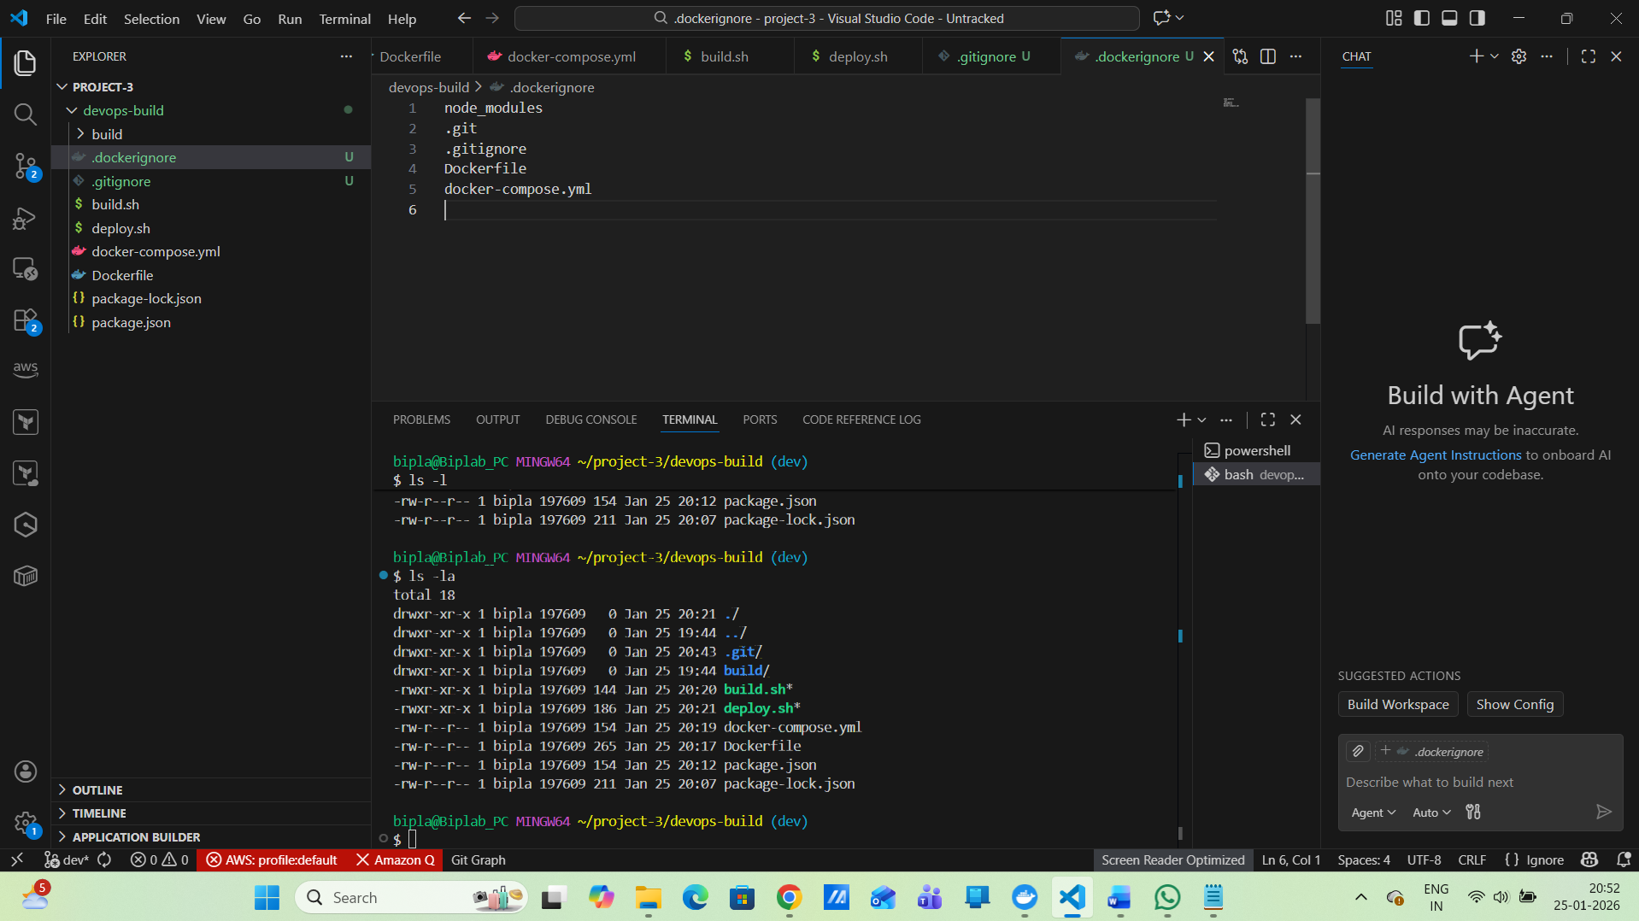
Now ls -la
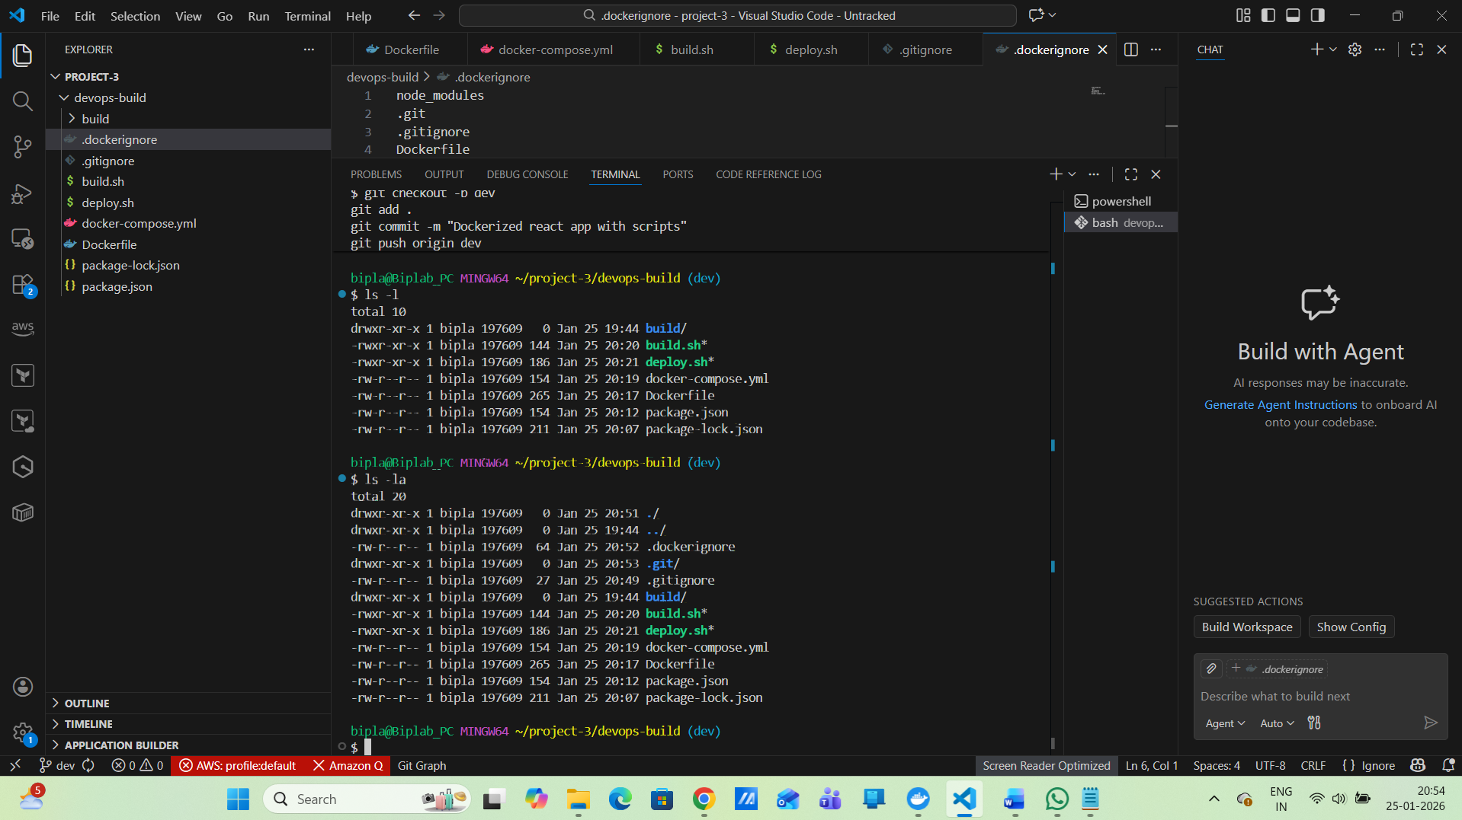
Next……….
Git Workflow
git checkout -b dev
git add .
git commit -m "Dockerized react app with scripts"
git push origin dev
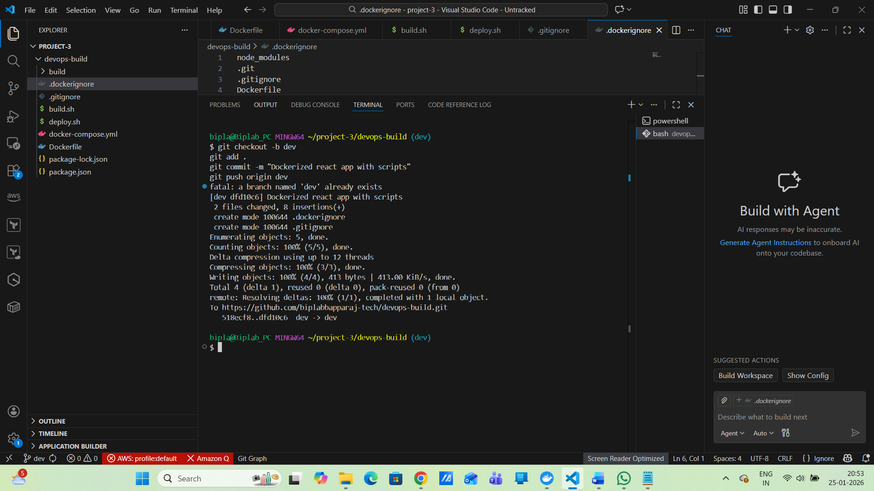
6. Docker Hub Repositories
Create Docker Hub Repositories :
Create react-app-dev(Public)
Click Go to Docker Hub open (https://hub.docker.com)
Click Repositories → Create repository
Fill:
Name → react-app-dev
Visibility → Public
Description → React App – Dev
Click Create
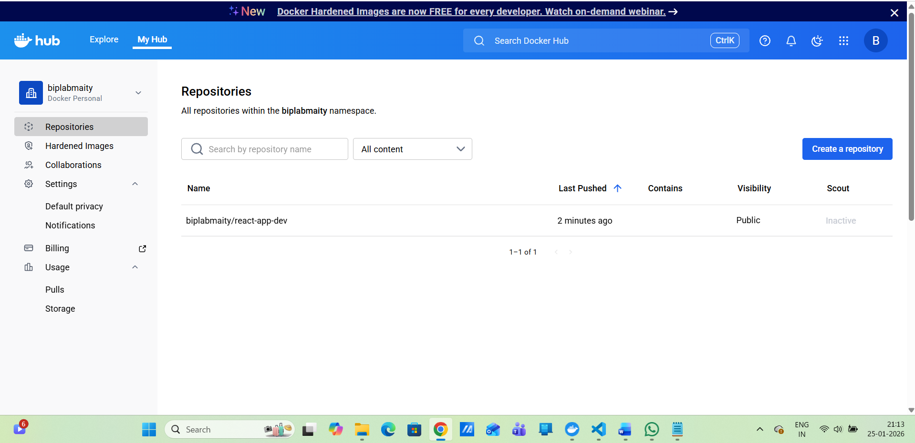
Now create PROD
For PROD (Private)
Repository Name:
react-app-prod
Visibility:
Select Private
Docker Hub will create:
biplab/react-app-prod
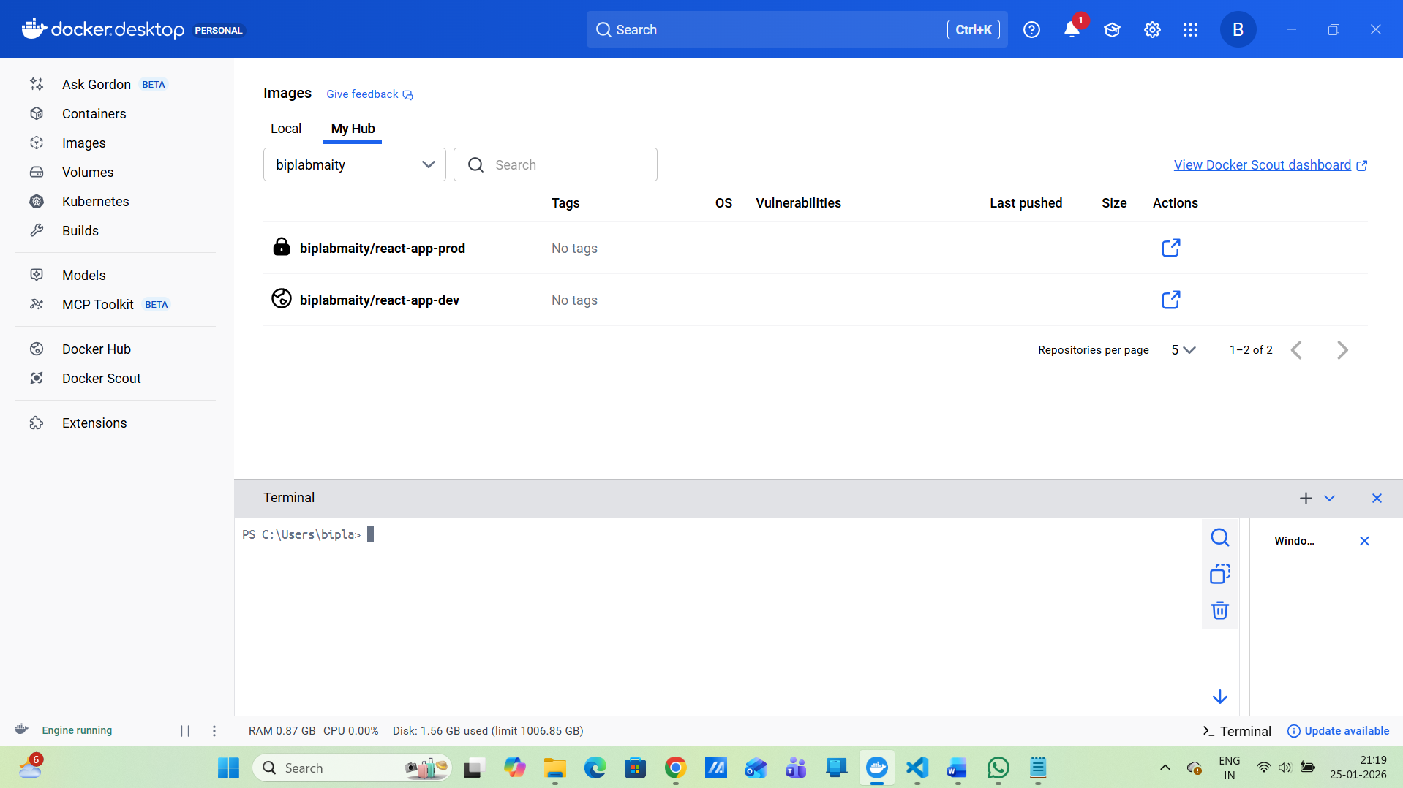
After creating repos — what to do next
Build images
cd C:\Users\bipla\project-3\devops-build
ls Dockerfile(Verify Dockerfile exists)
Now run the below
docker build -t biplab/react-app-dev:latest .
docker build -t biplab/react-app-prod:latest .
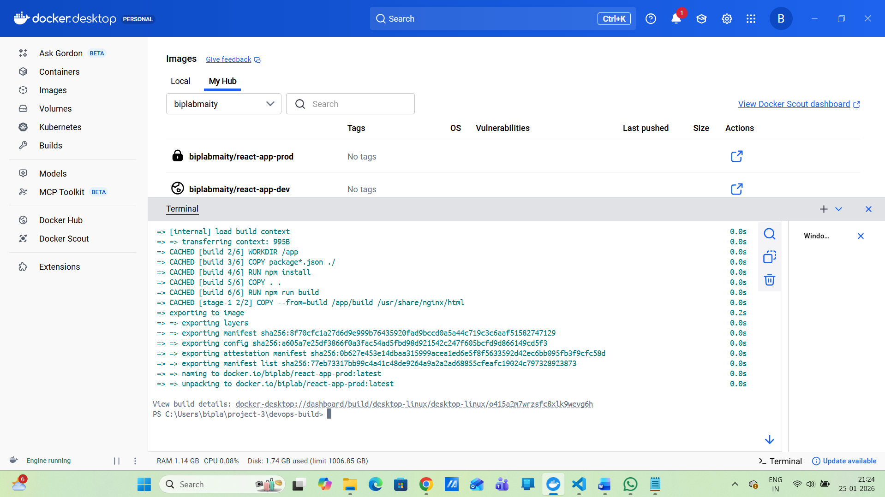
Docker Tag :
docker tag biplab/react-app-dev:latest biplabmaity/react-app-dev:latest
docker tag biplab/react-app-prod:latest biplabmaity/react-app-prod:latest
Push Image
docker login
docker push biplabmaity/react-app-dev:latest
docker push biplabmaity/react-app-prod:latest

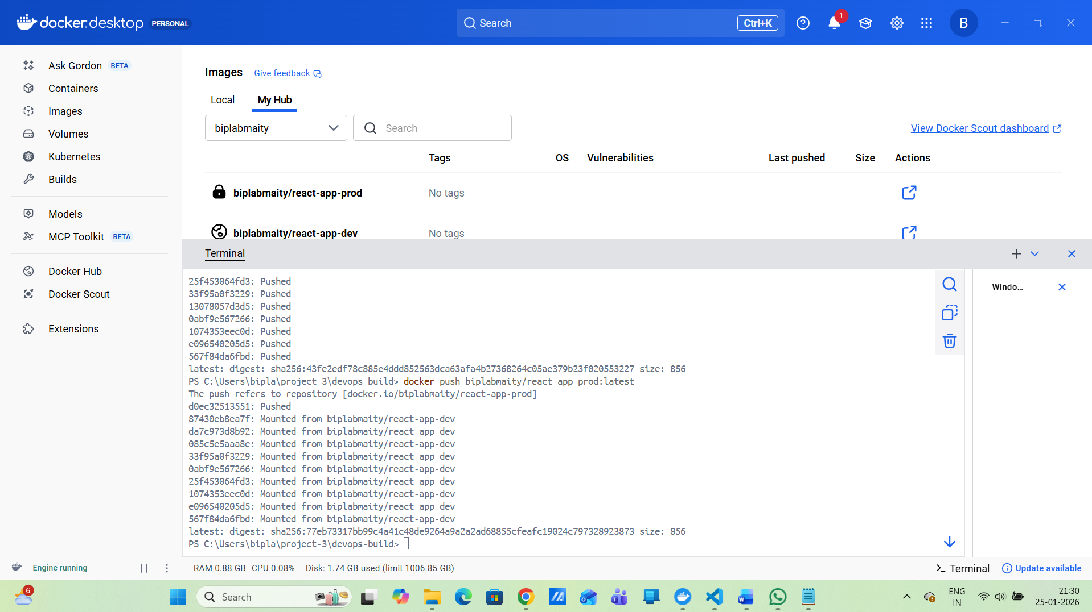
7. Jenkins Setup
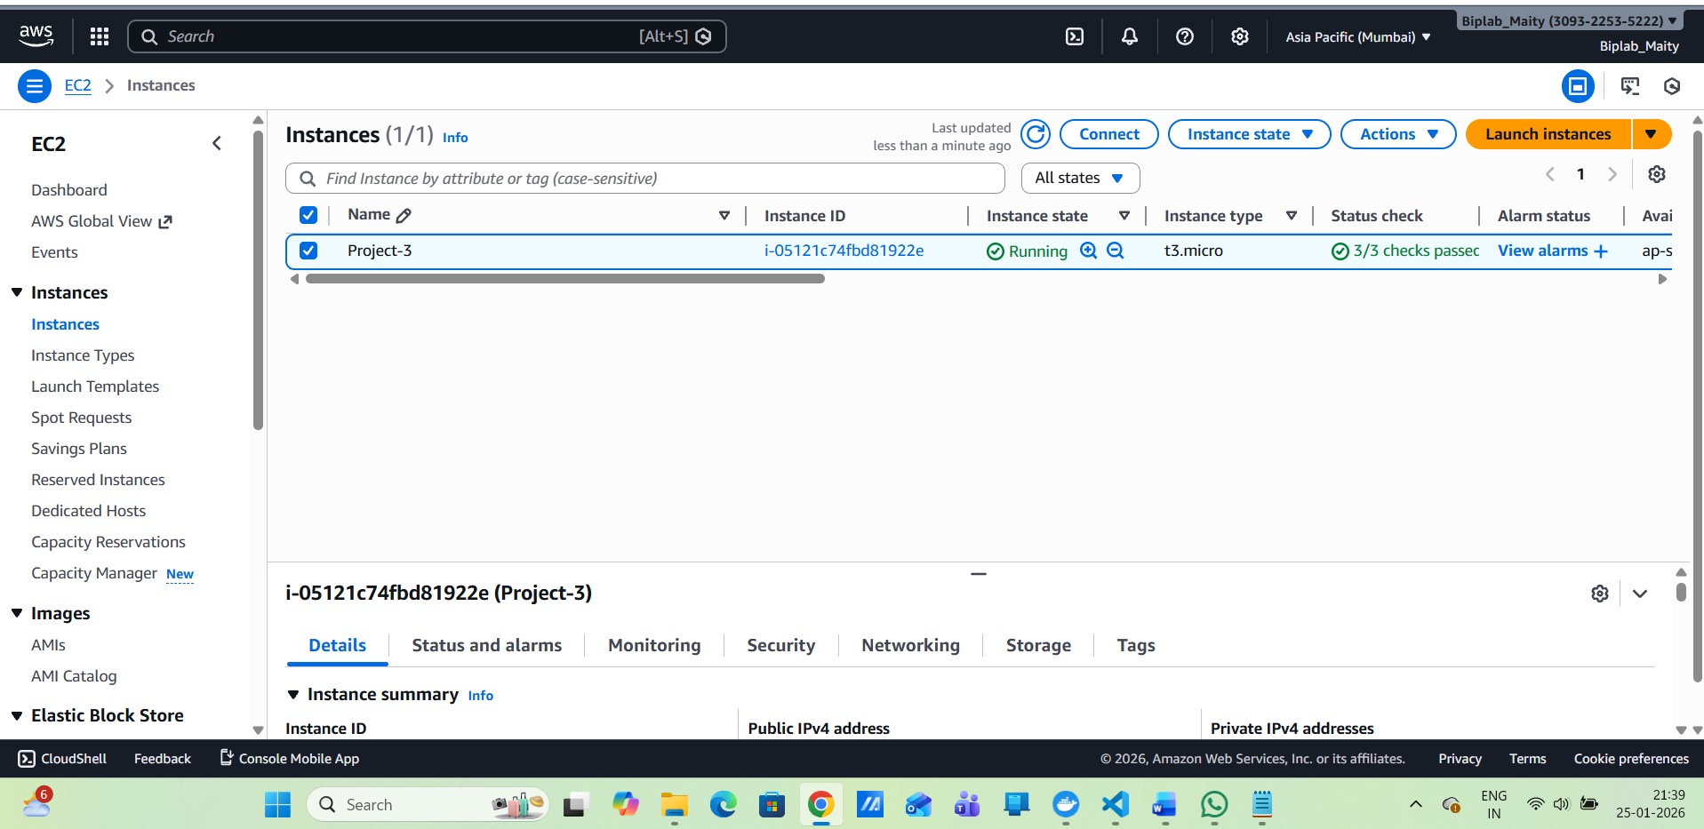
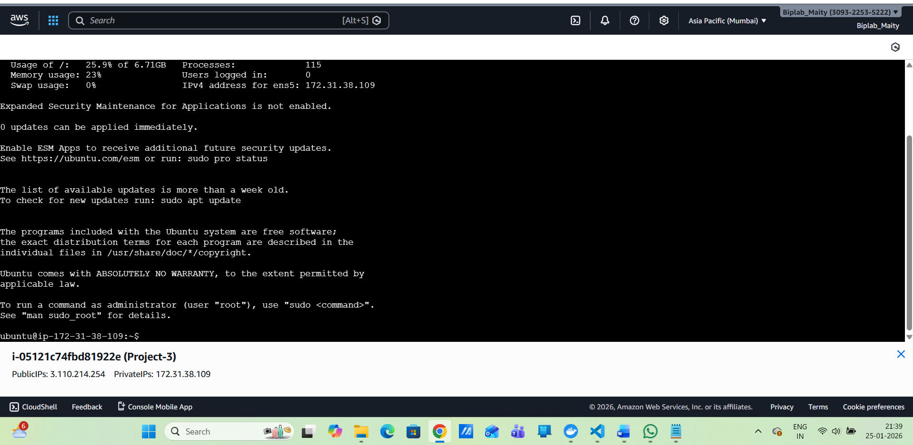
Install Jenkins
sudo apt update –y
sudo mkdir -p /usr/share/keyrings
curl -fsSL https://pkg.jenkins.io/debian/jenkins.io-2023.key | sudo tee \
/usr/share/keyrings/jenkins-keyring.asc > /dev/null
echo "deb [signed-by=/usr/share/keyrings/jenkins-keyring.asc] \
https://pkg.jenkins.io/debian binary/" | sudo tee \
/etc/apt/sources.list.d/jenkins.list
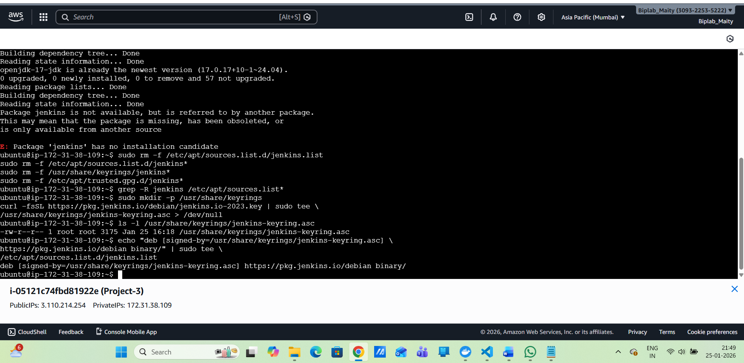
cat /etc/apt/sources.list.d/jenkins.list
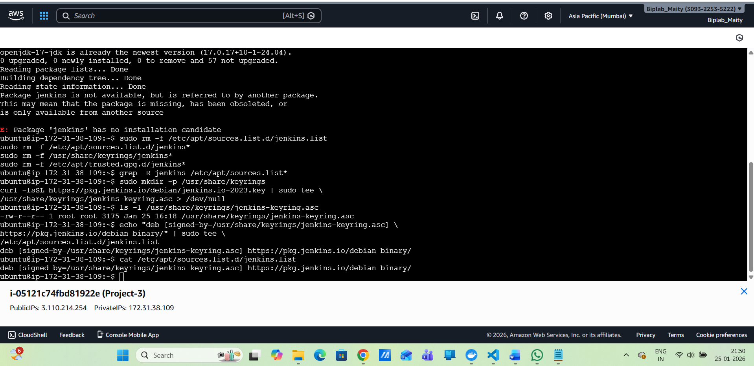
sudo apt update
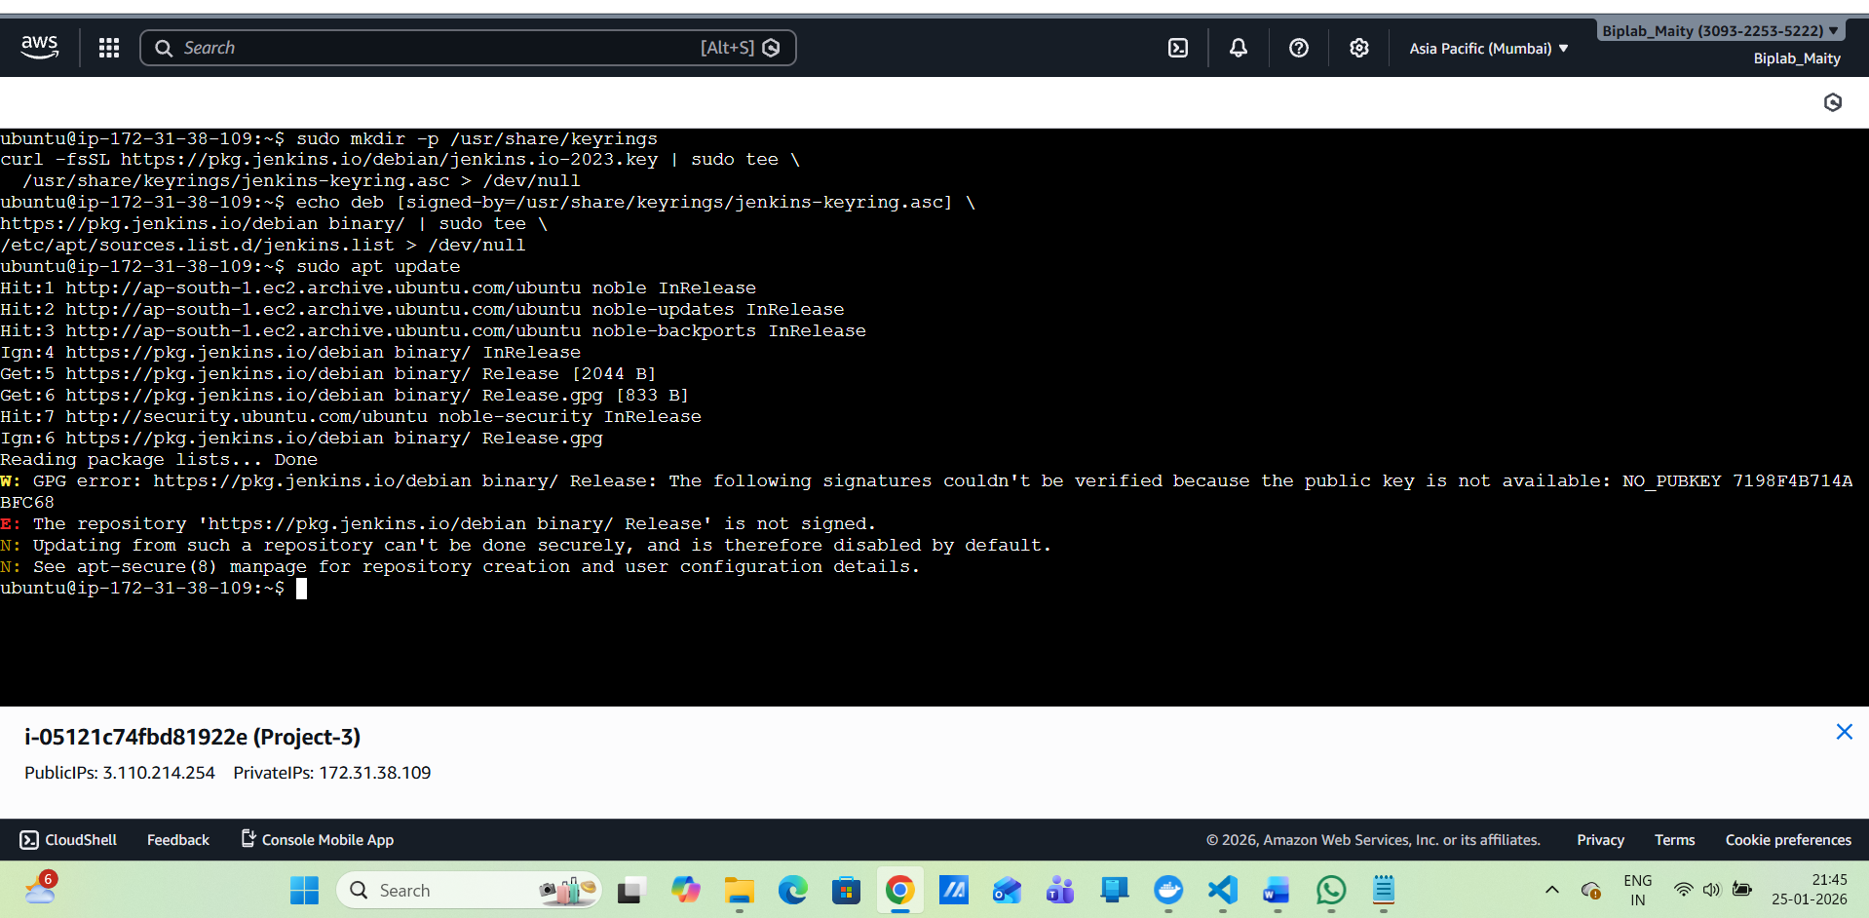
sudo apt install -y
sudo apt install -y jenkins
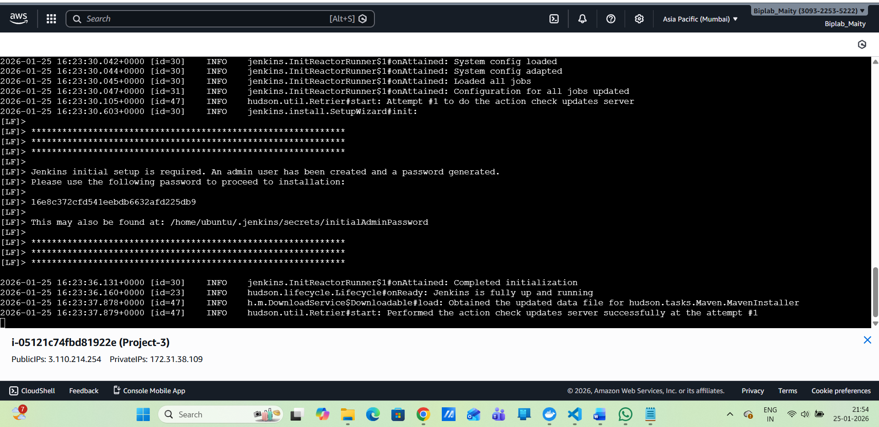
cat ~/.jenkins/secrets/initialAdminPassword
ubuntu@ip-172-31-38-109:~$ cat ~/.jenkins/secrets/initialAdminPassword
16e8c372cfd541eebdb6632afd225db9
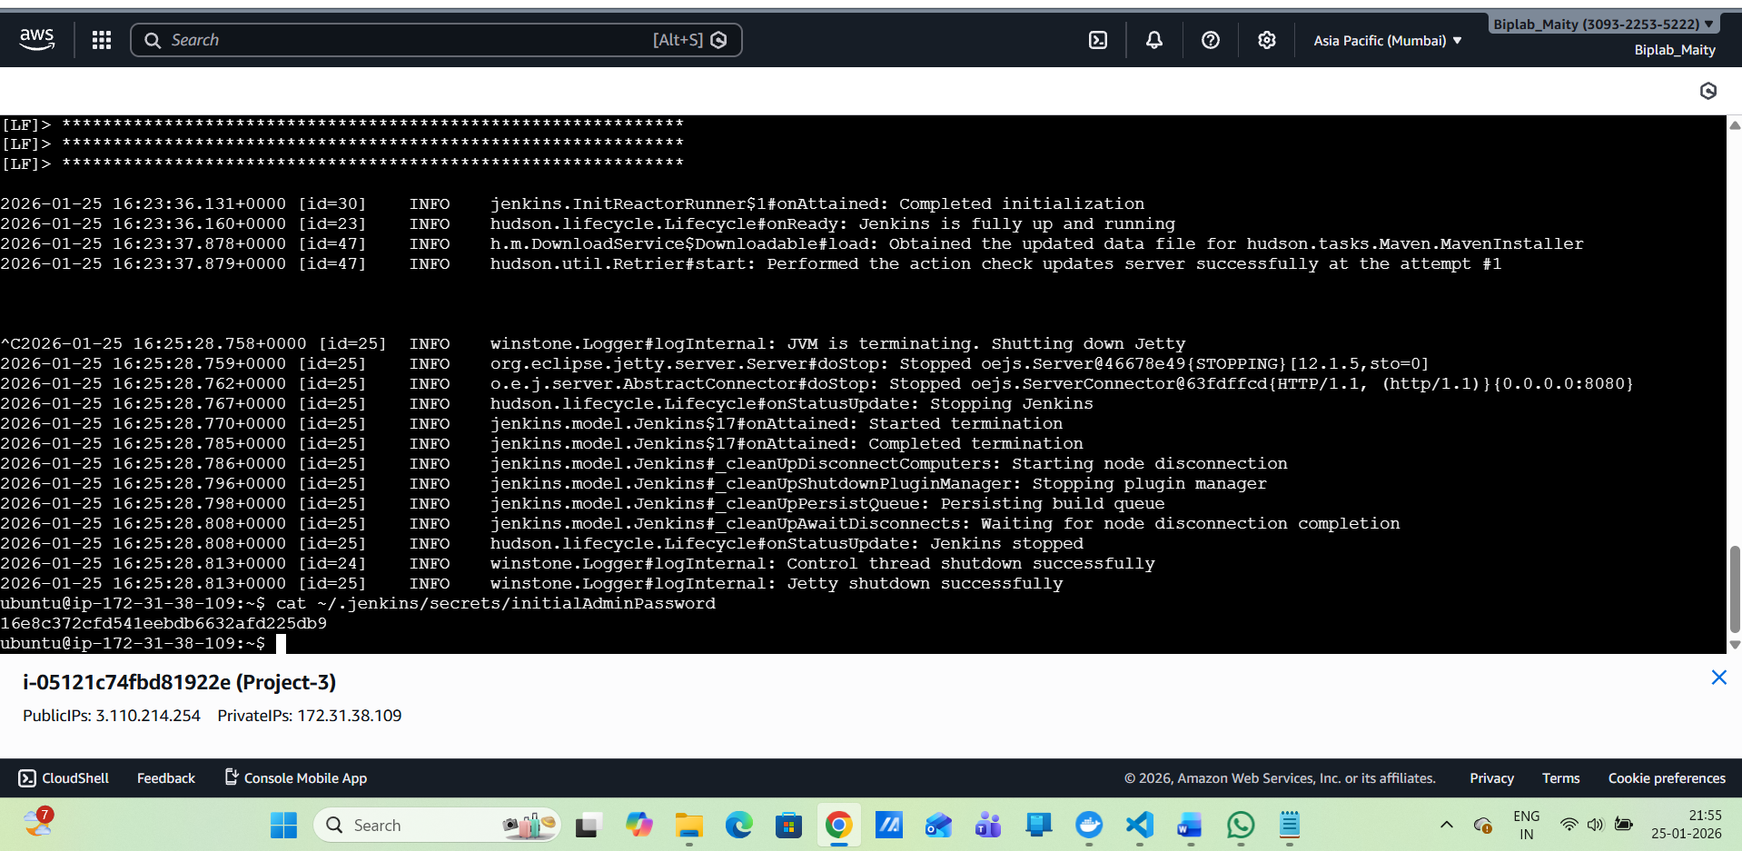
Run Jenkins in the background :
nohup java -jar jenkins.war > jenkins.log 2>&1 &

Access: http://3.110.214.254:8080/
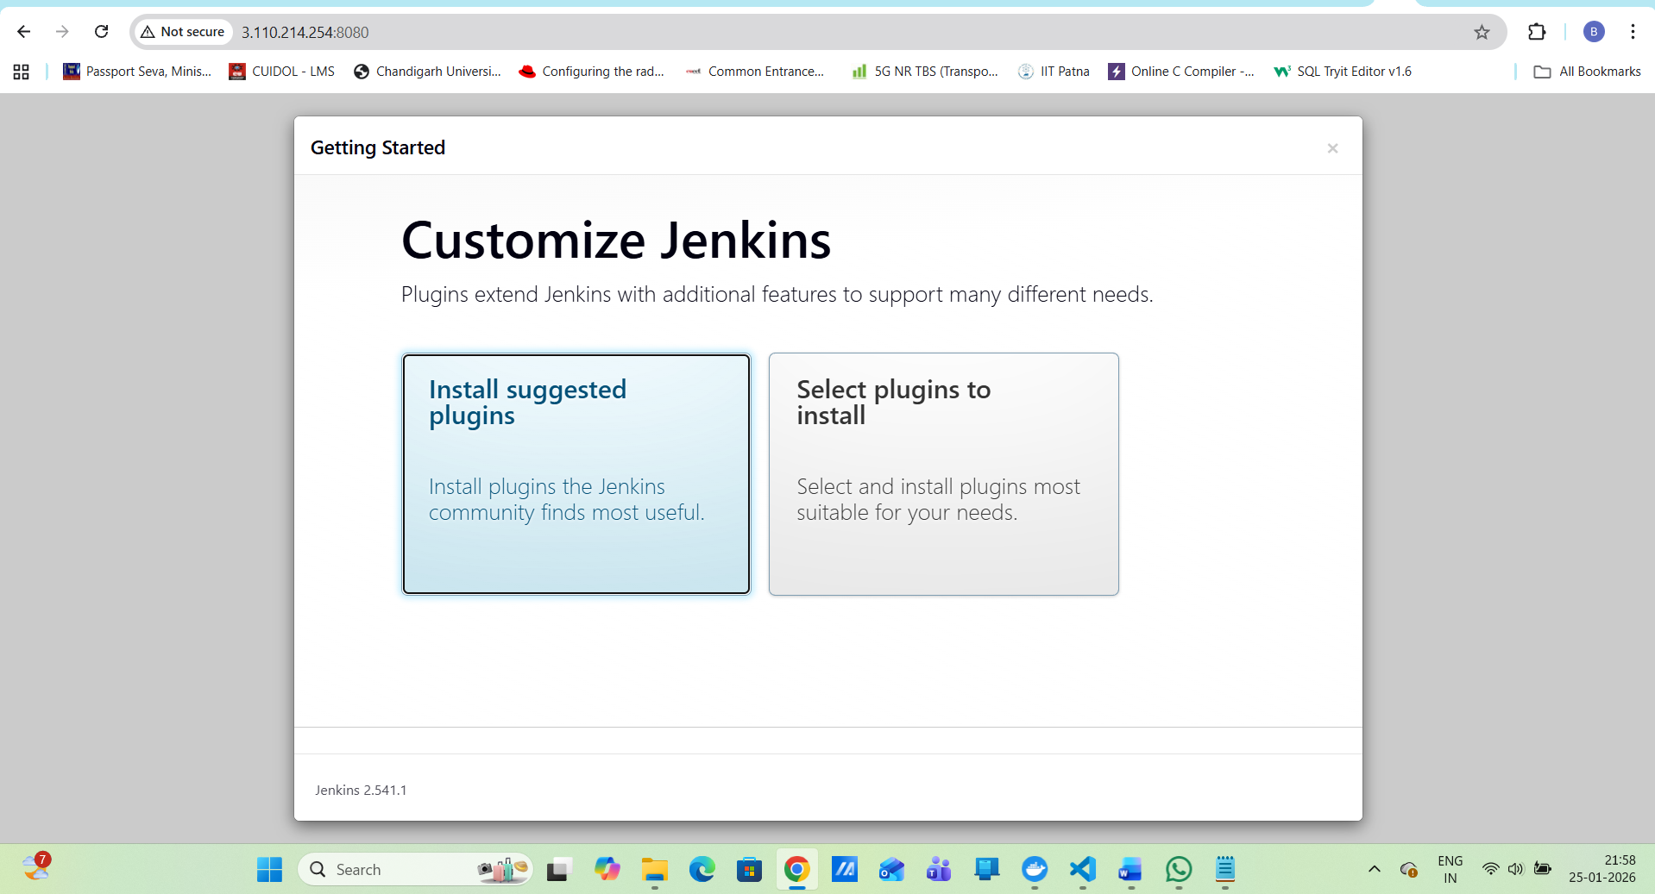
Jenkins Plugins
Install:
Git
GitHub Integration
Docker
Pipeline
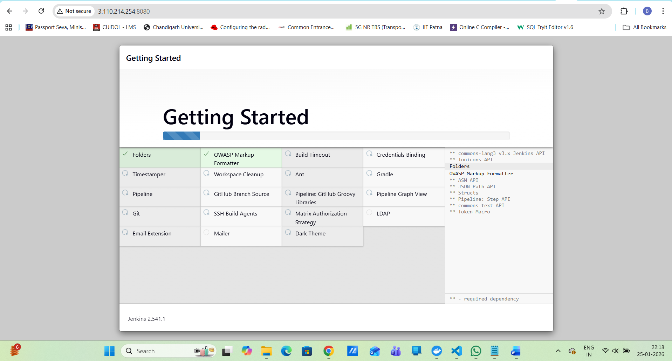
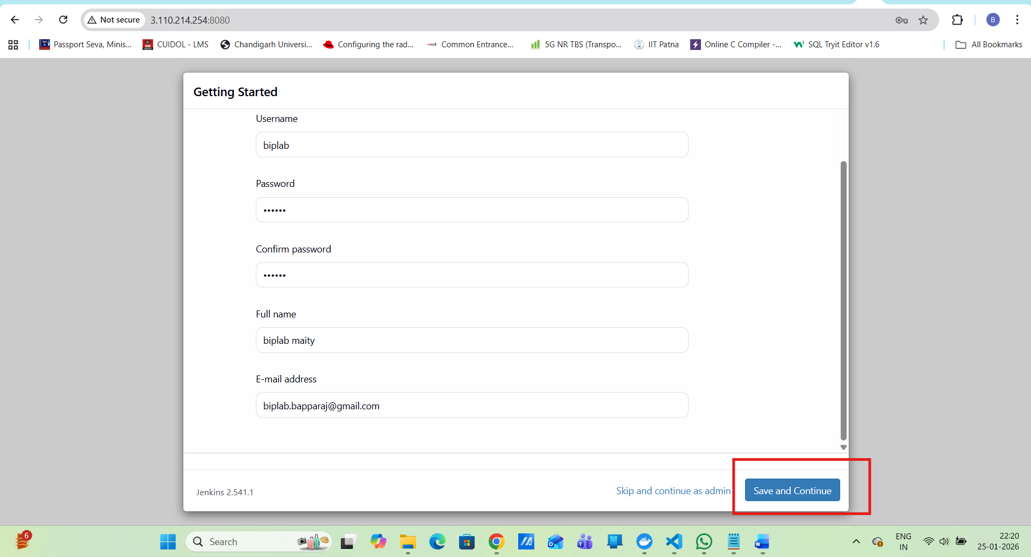
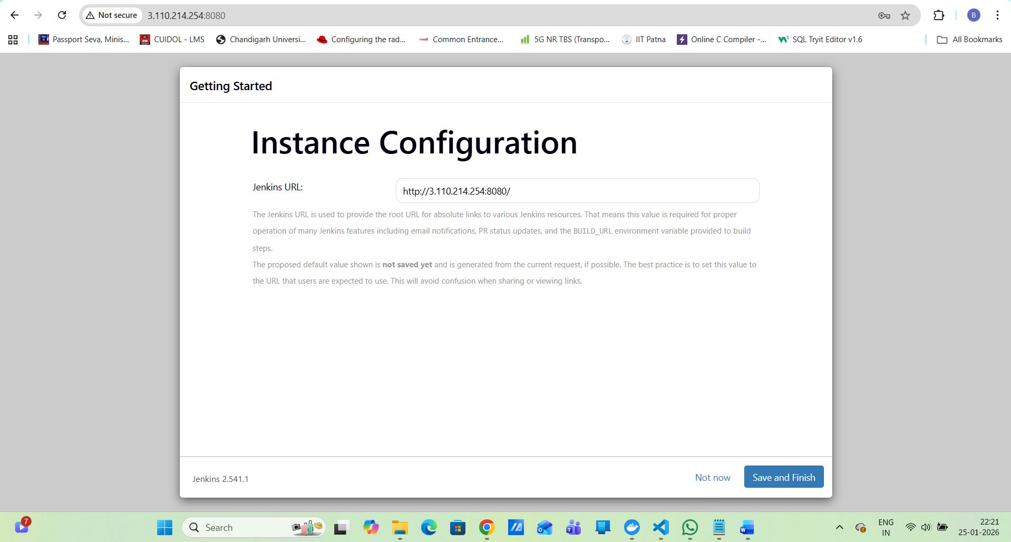
http://3.110.214.254:8080/
Jenkinsfile :
pipeline {
agent any

environment {
DOCKERHUB_USER = 'biplabmaity'
IMAGE_DEV = 'react-app-dev'
IMAGE_PROD = 'react-app-prod'
}

stages {
stage('Checkout') {
steps {
git branch: 'dev',
url: 'https://github.com/biplabbapparaj-tech/devops-build.git'
}
}

stage('Build Docker Image (Dev)') {
steps {
sh 'docker build -t $DOCKERHUB_USER/$IMAGE_DEV:latest .'
}
}

stage('Push to Docker Hub (Dev)') {
steps {
withCredentials([usernamePassword(
credentialsId: 'dockerhub-creds',
usernameVariable: 'DOCKER_USER',
passwordVariable: 'DOCKER_PASS'
)]) {
sh '''
echo "$DOCKER_PASS" | docker login -u "$DOCKER_USER" --password-stdin
docker push $DOCKERHUB_USER/$IMAGE_DEV:latest
'''
}
}
}
}
}
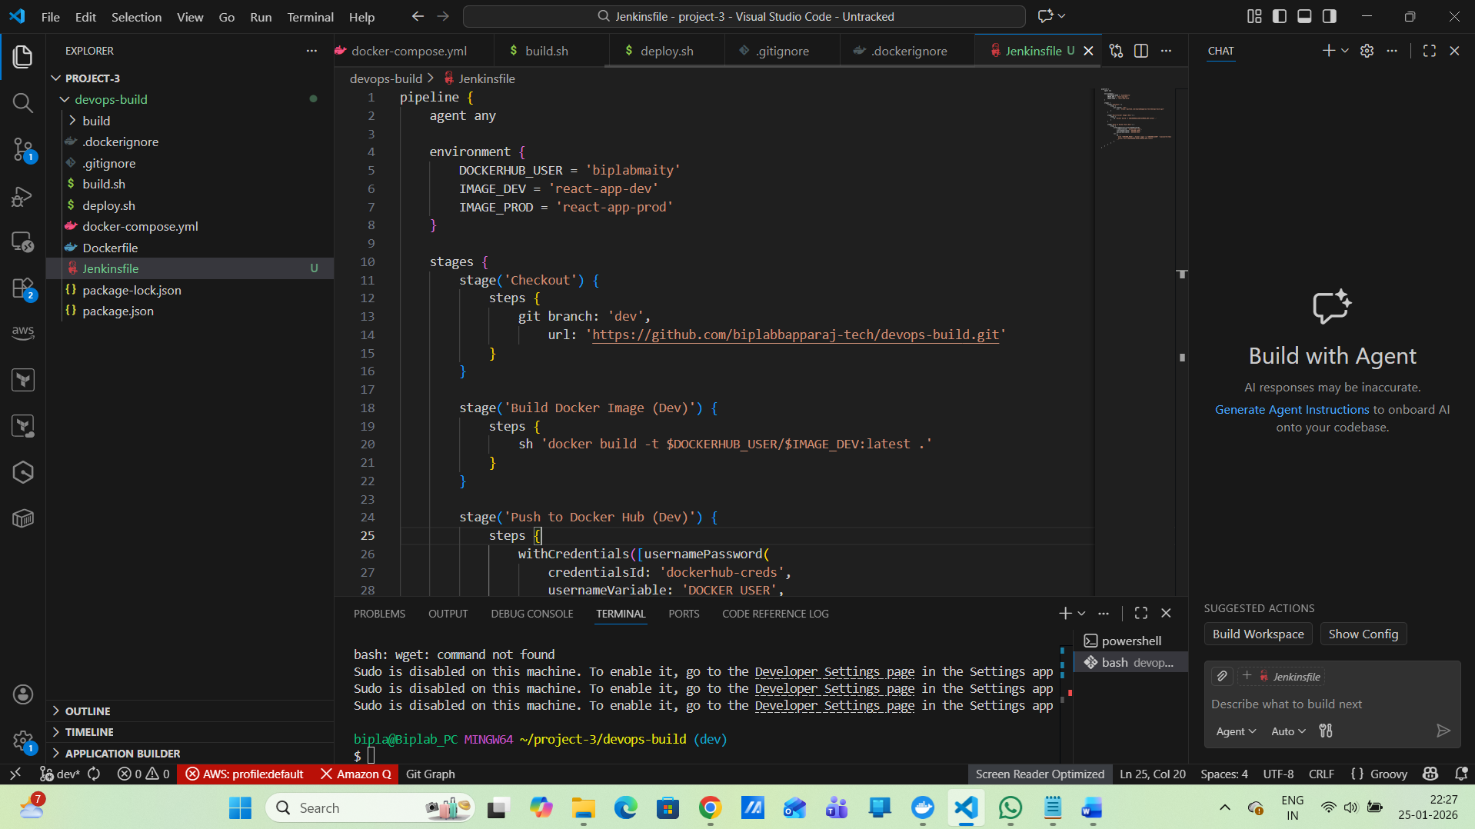
GitHub Webhook
Configure webhook → Jenkins URL → Build on push
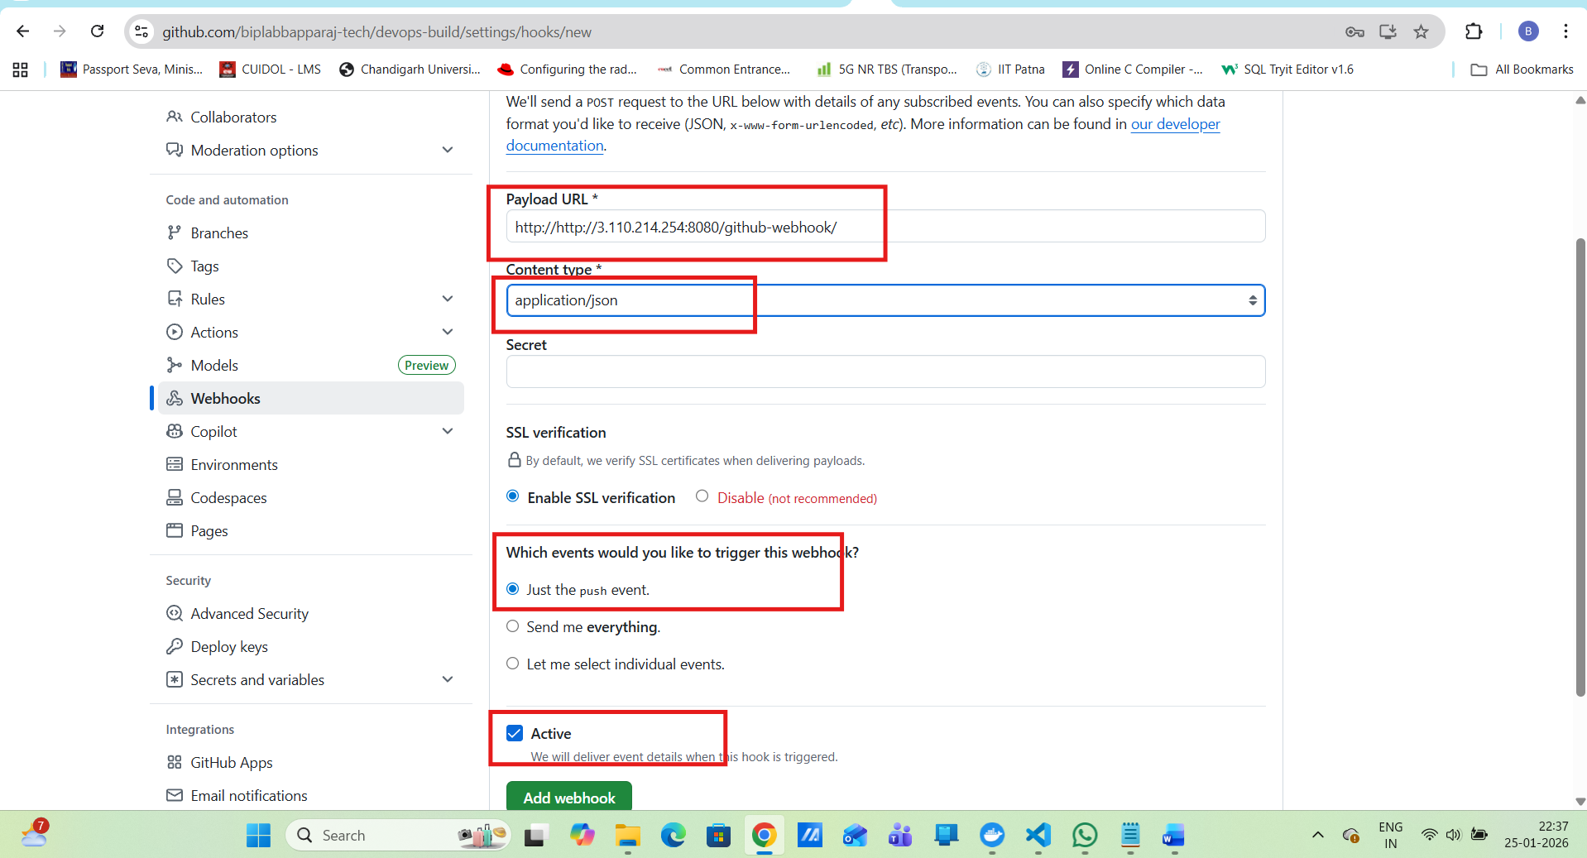
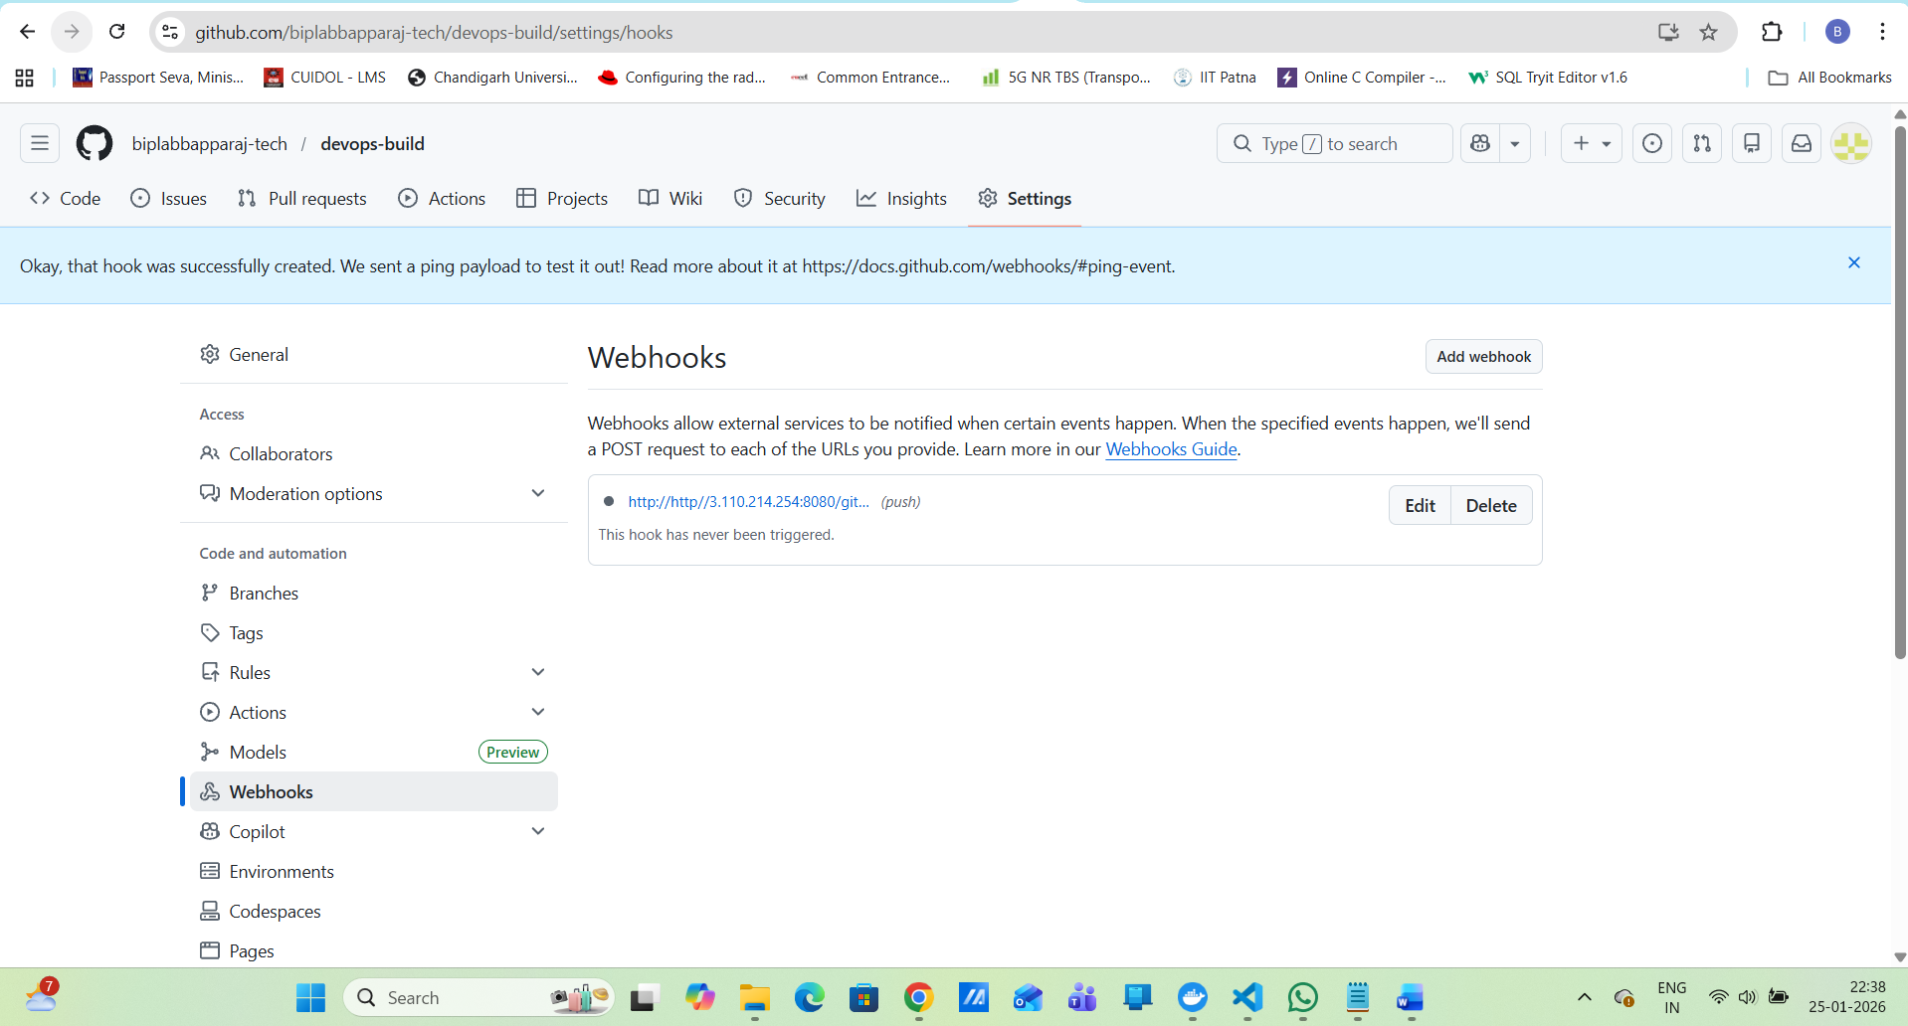
Now
git add .
git commit -m "Test webhook trigger"
git push origin dev
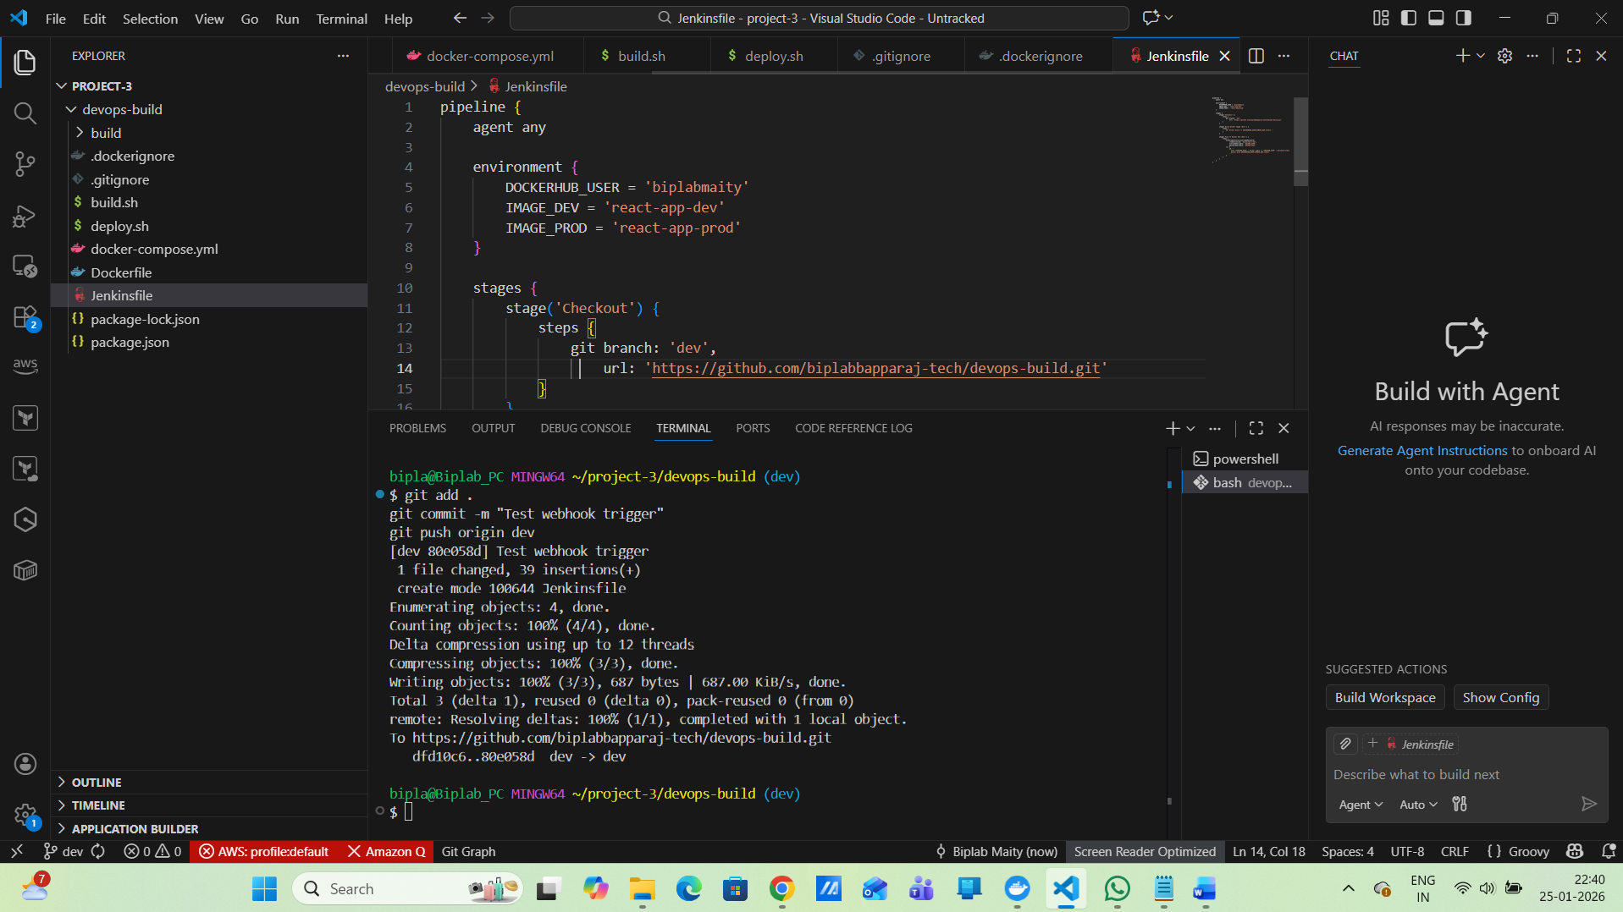
AWS Deployment:
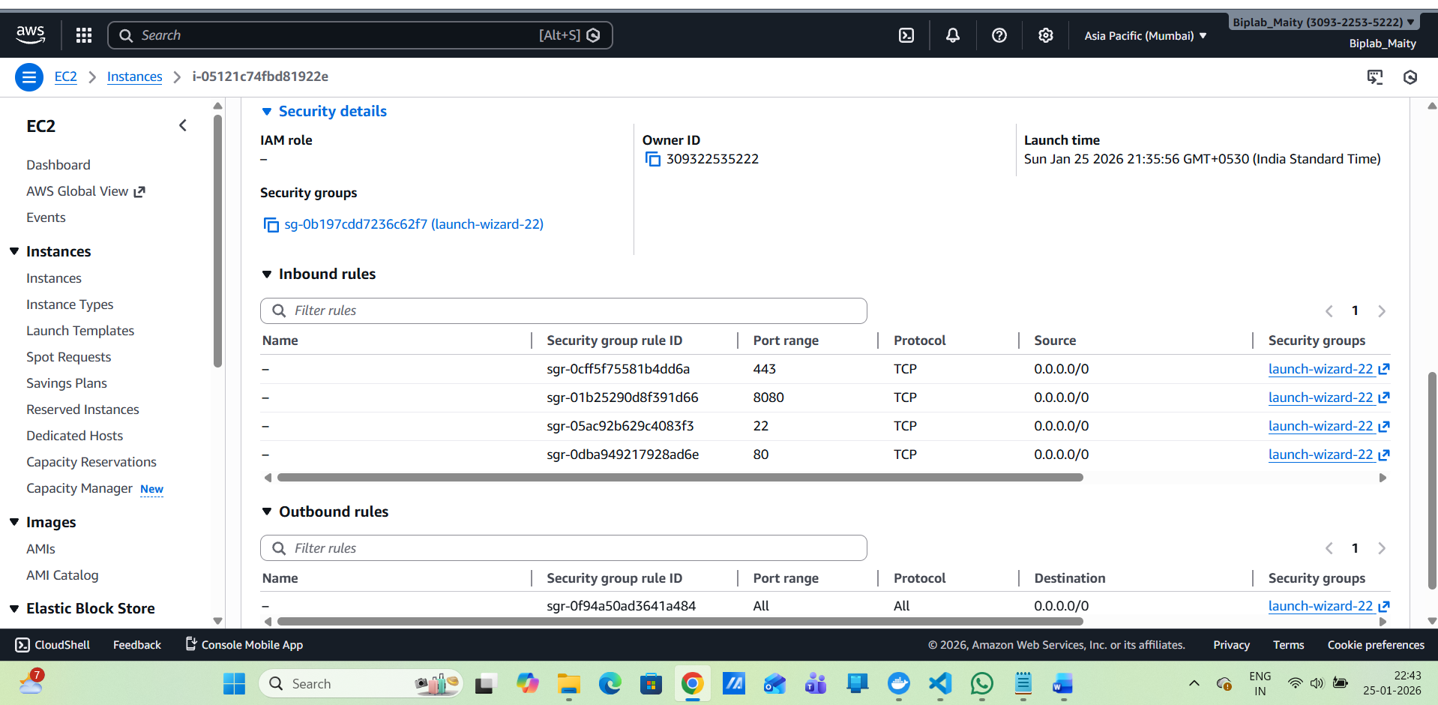
Server Setup
sudo apt update
sudo apt install docker.io -y
sudo systemctl start docker
sudo usermod -aG docker ubuntu
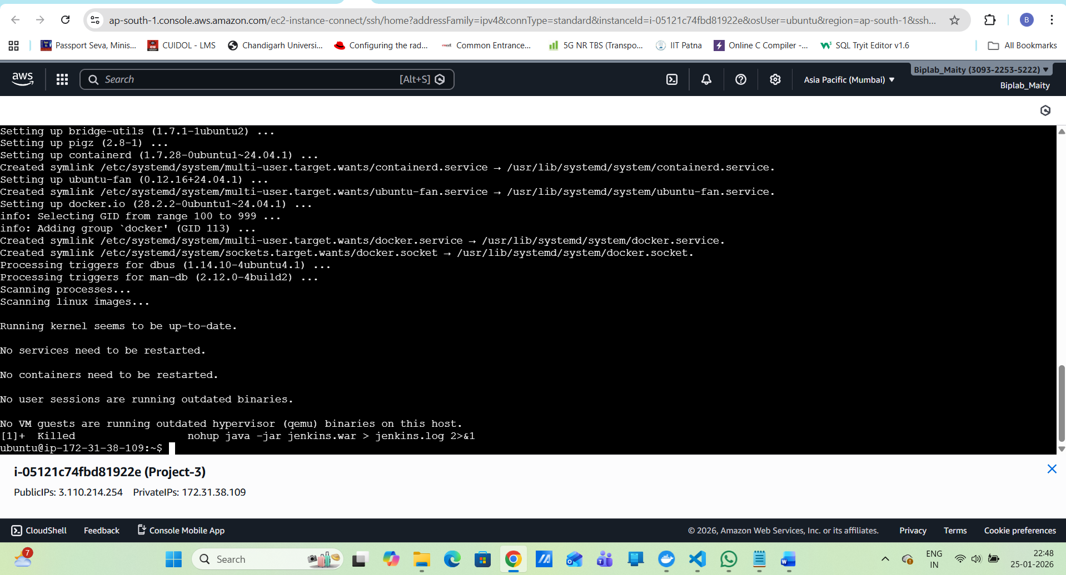
Pull & Run:
docker pull biplabmaity/react-app-prod:latest
docker run -d -p 8080:80 biplabmaity/react-app-prod:latest
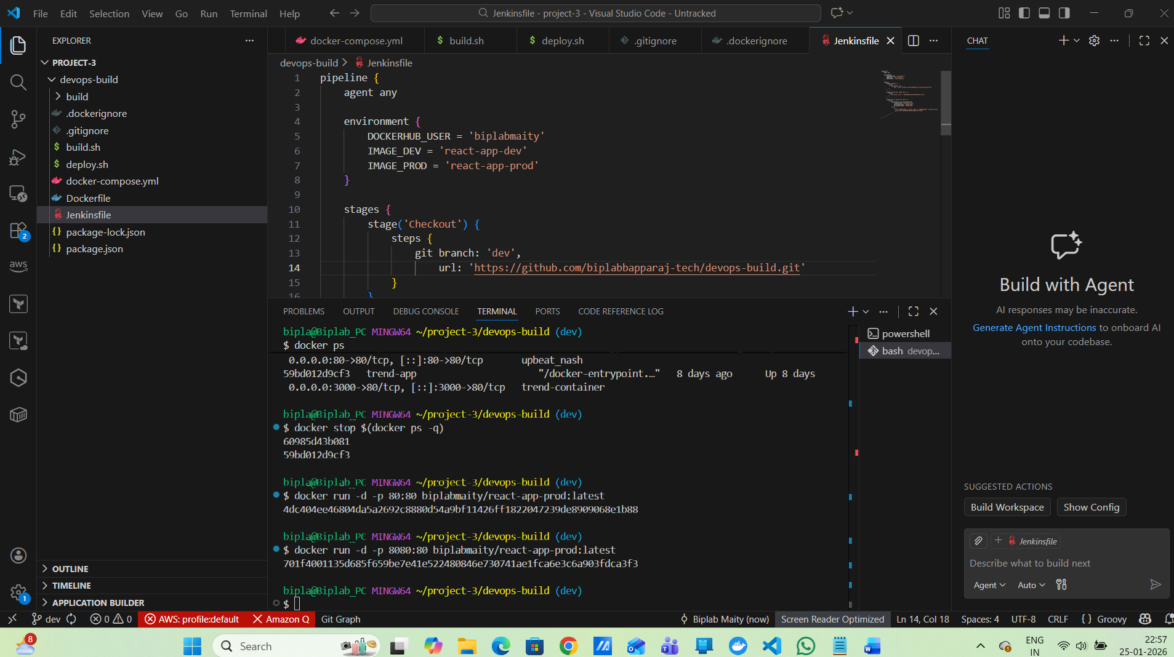
http://localhost:8080
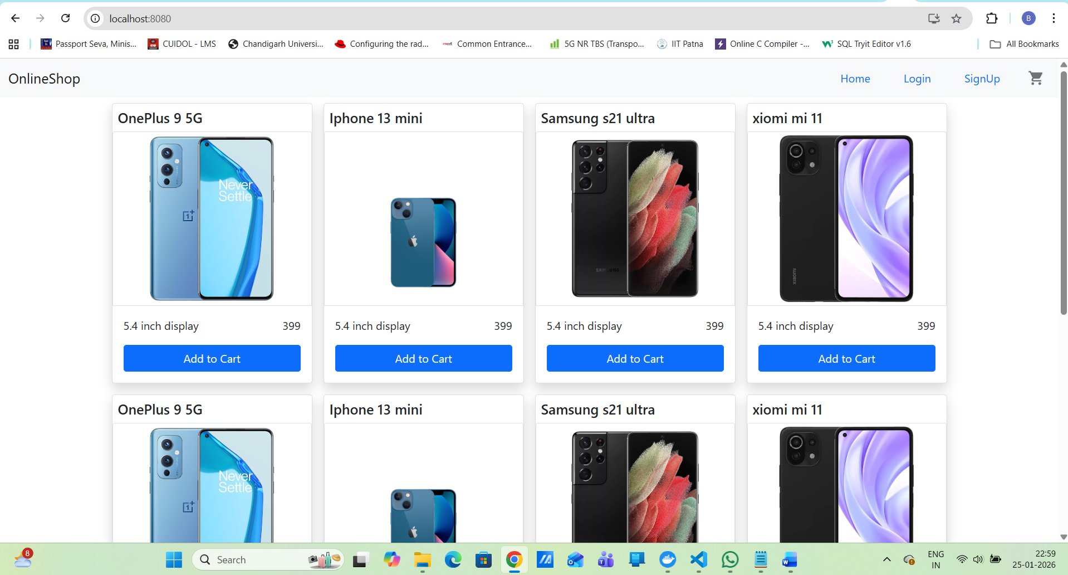

9. Monitoring :
Prometheus + Alertmanager
Health Check
Your app responds to:
curl http://localhost:8080
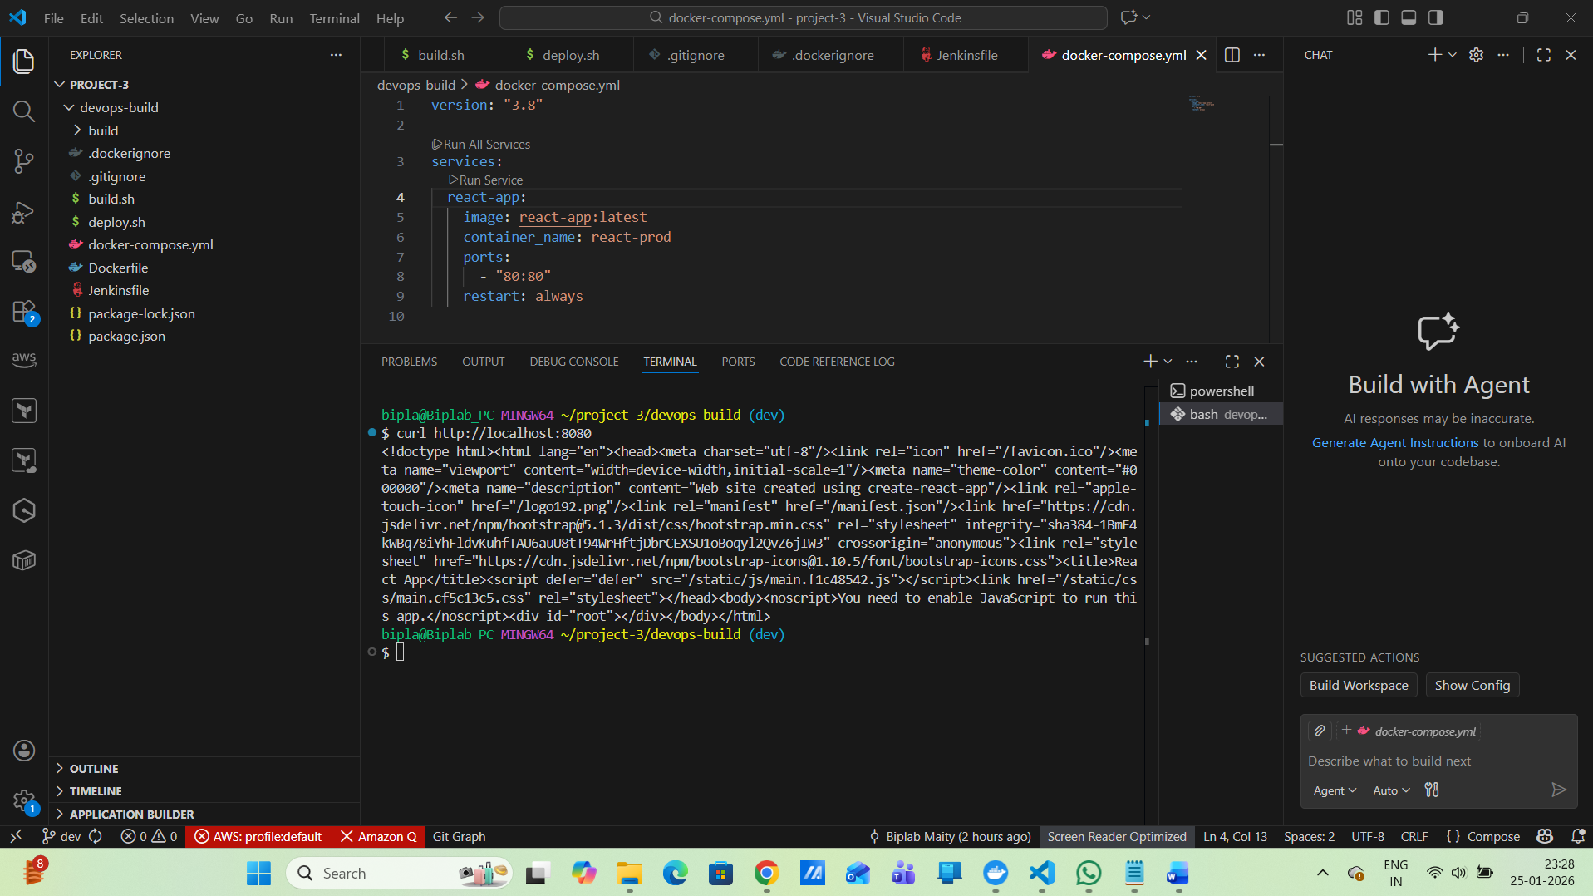
Create Monitoring Folder (inside your existing project)
in my project root (devops-build):
mkdir monitoring
cd monitoring
Prometheus Configuration
monitoring/prometheus.yml
global:
scrape_interval: 15s

rule_files:
- alert.rules.yml

scrape_configs:
- job_name: 'blackbox-http'
metrics_path: /probe
params:
module: [http_2xx]
static_configs:
- targets:
- http://host.docker.internal:8081
relabel_configs:
- source_labels: [__address__]
target_label: __param_target
- target_label: instance
source_labels: [__param_target]
- target_label: __address__
replacement: blackbox:9115
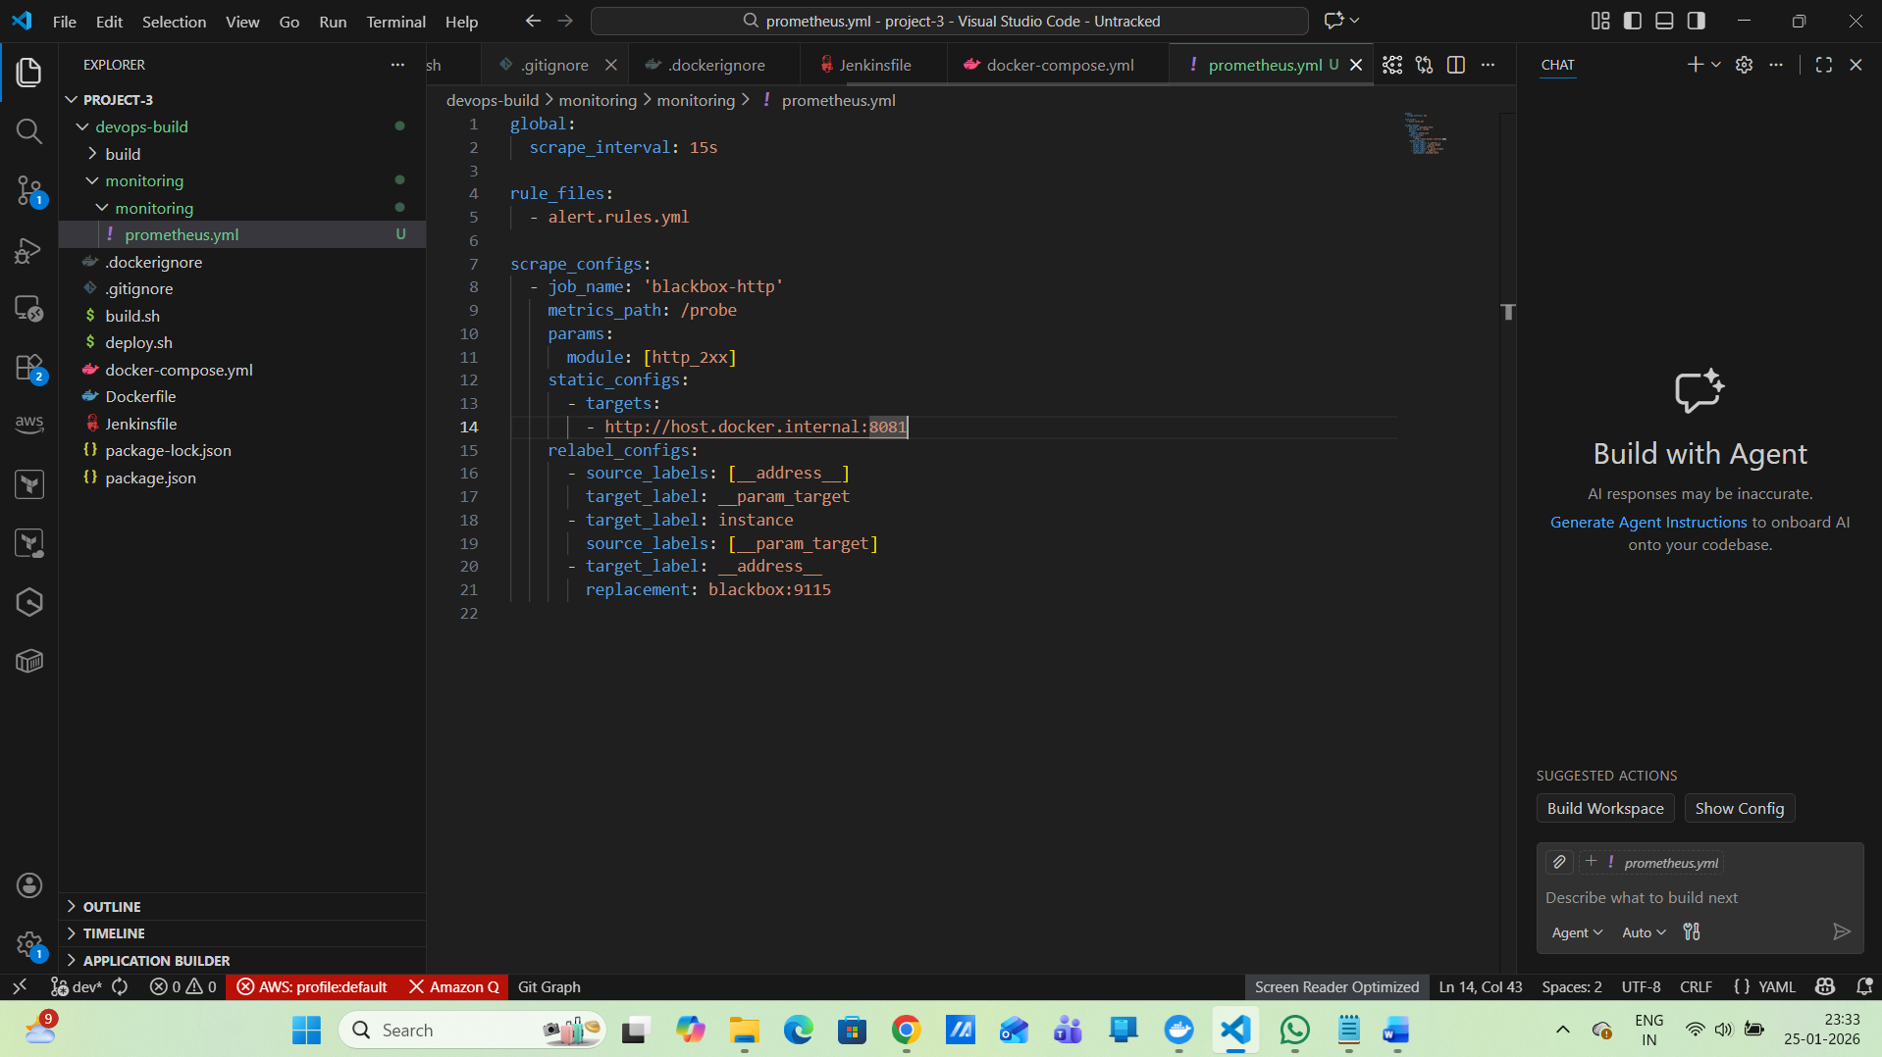
Alert Rule (ONLY when app is DOWN)
monitoring/alert.rules.yml
groups:
- name: application-alerts
rules:
- alert: AppDown
expr: probe_success == 0
for: 1m
labels:
severity: critical
annotations:
description: "Application is DOWN"
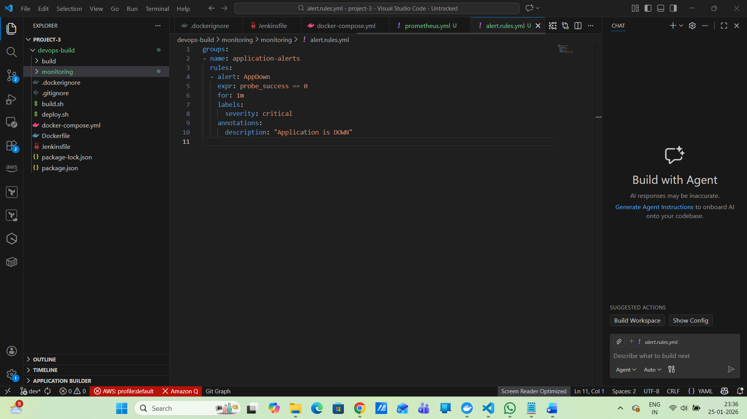
Alertmanager Configuration
monitoring/alertmanager.yml
Slack Notification (recommended)
global:
resolve_timeout: 5m

route:
receiver: "default-receiver"

receivers:
- name: "default-receiver"

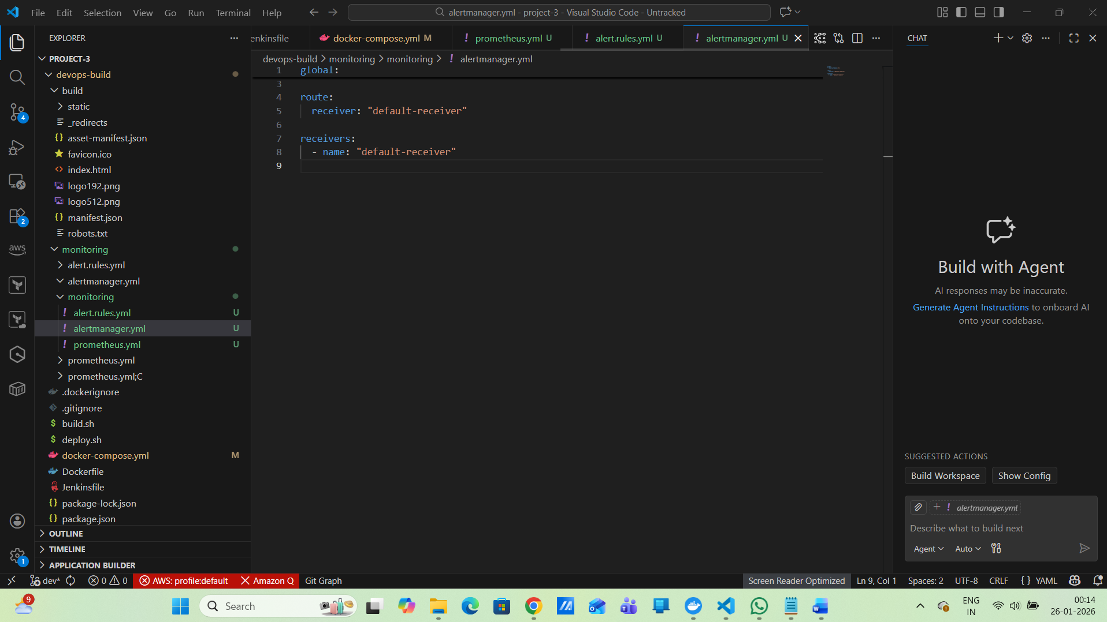
Update Existing docker-compose.yml
(App + Monitoring together)
docker-compose.yml (App + Monitoring)
services:
app:
image: biplabmaity/react-app-prod:latest
container_name: react-app
ports:
- "8080:80"
restart: unless-stopped

prometheus:
image: prom/prometheus
container_name: prometheus
volumes:
- ./monitoring:/etc/prometheus
command:
- "--config.file=/etc/prometheus/prometheus.yml"
ports:
- "9090:9090"

alertmanager:
image: prom/alertmanager
container_name: alertmanager
volumes:
- ./monitoring:/etc/alertmanager
command:
- "--config.file=/etc/alertmanager/alertmanager.yml"
ports:
- "9093:9093"

blackbox:
image: prom/blackbox-exporter
container_name: blackbox
ports:
- "9115:9115"
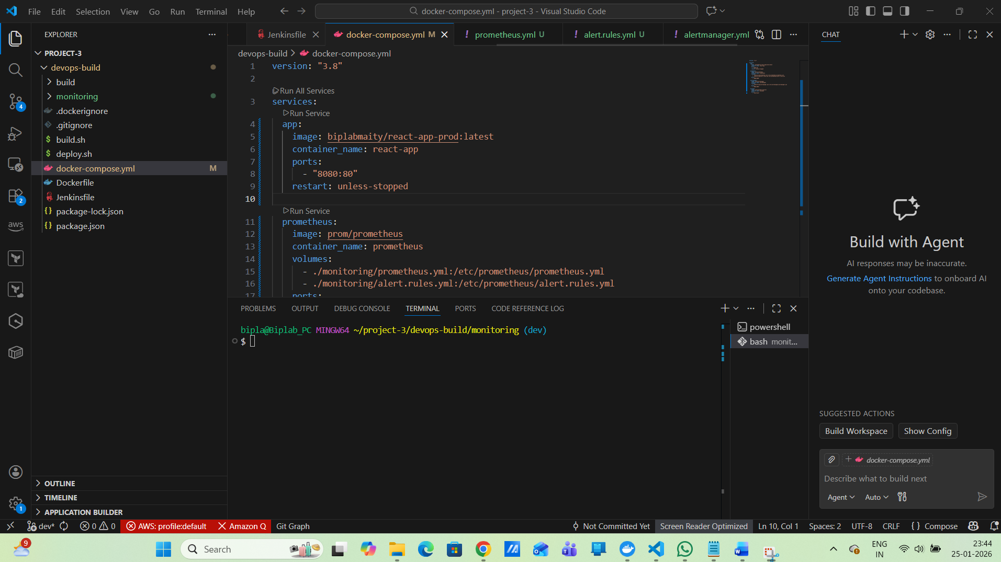
Start Everything (clean start)
docker-compose down -v
docker system prune -f
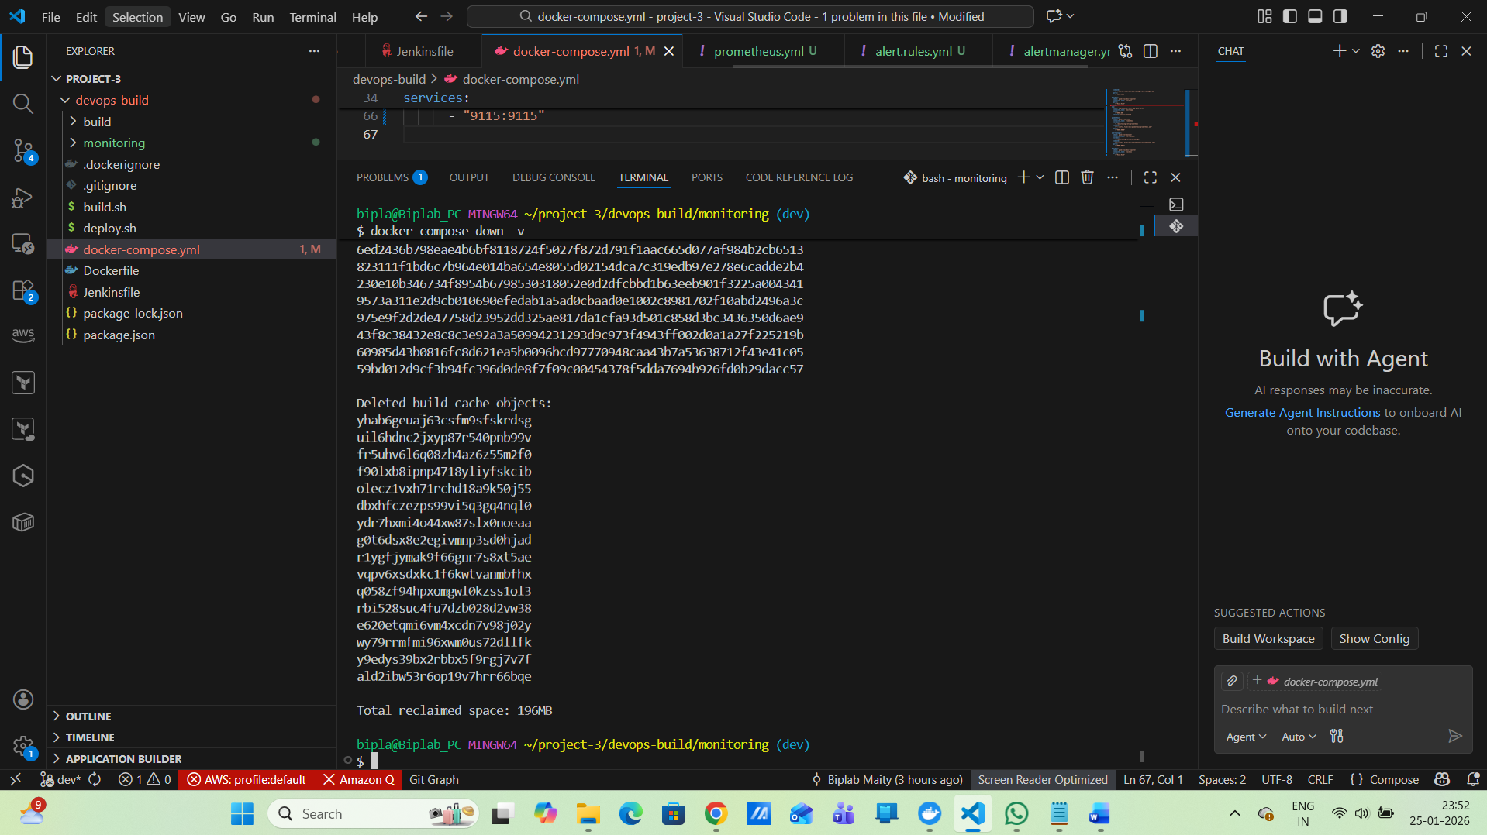
Start again
docker-compose up -d
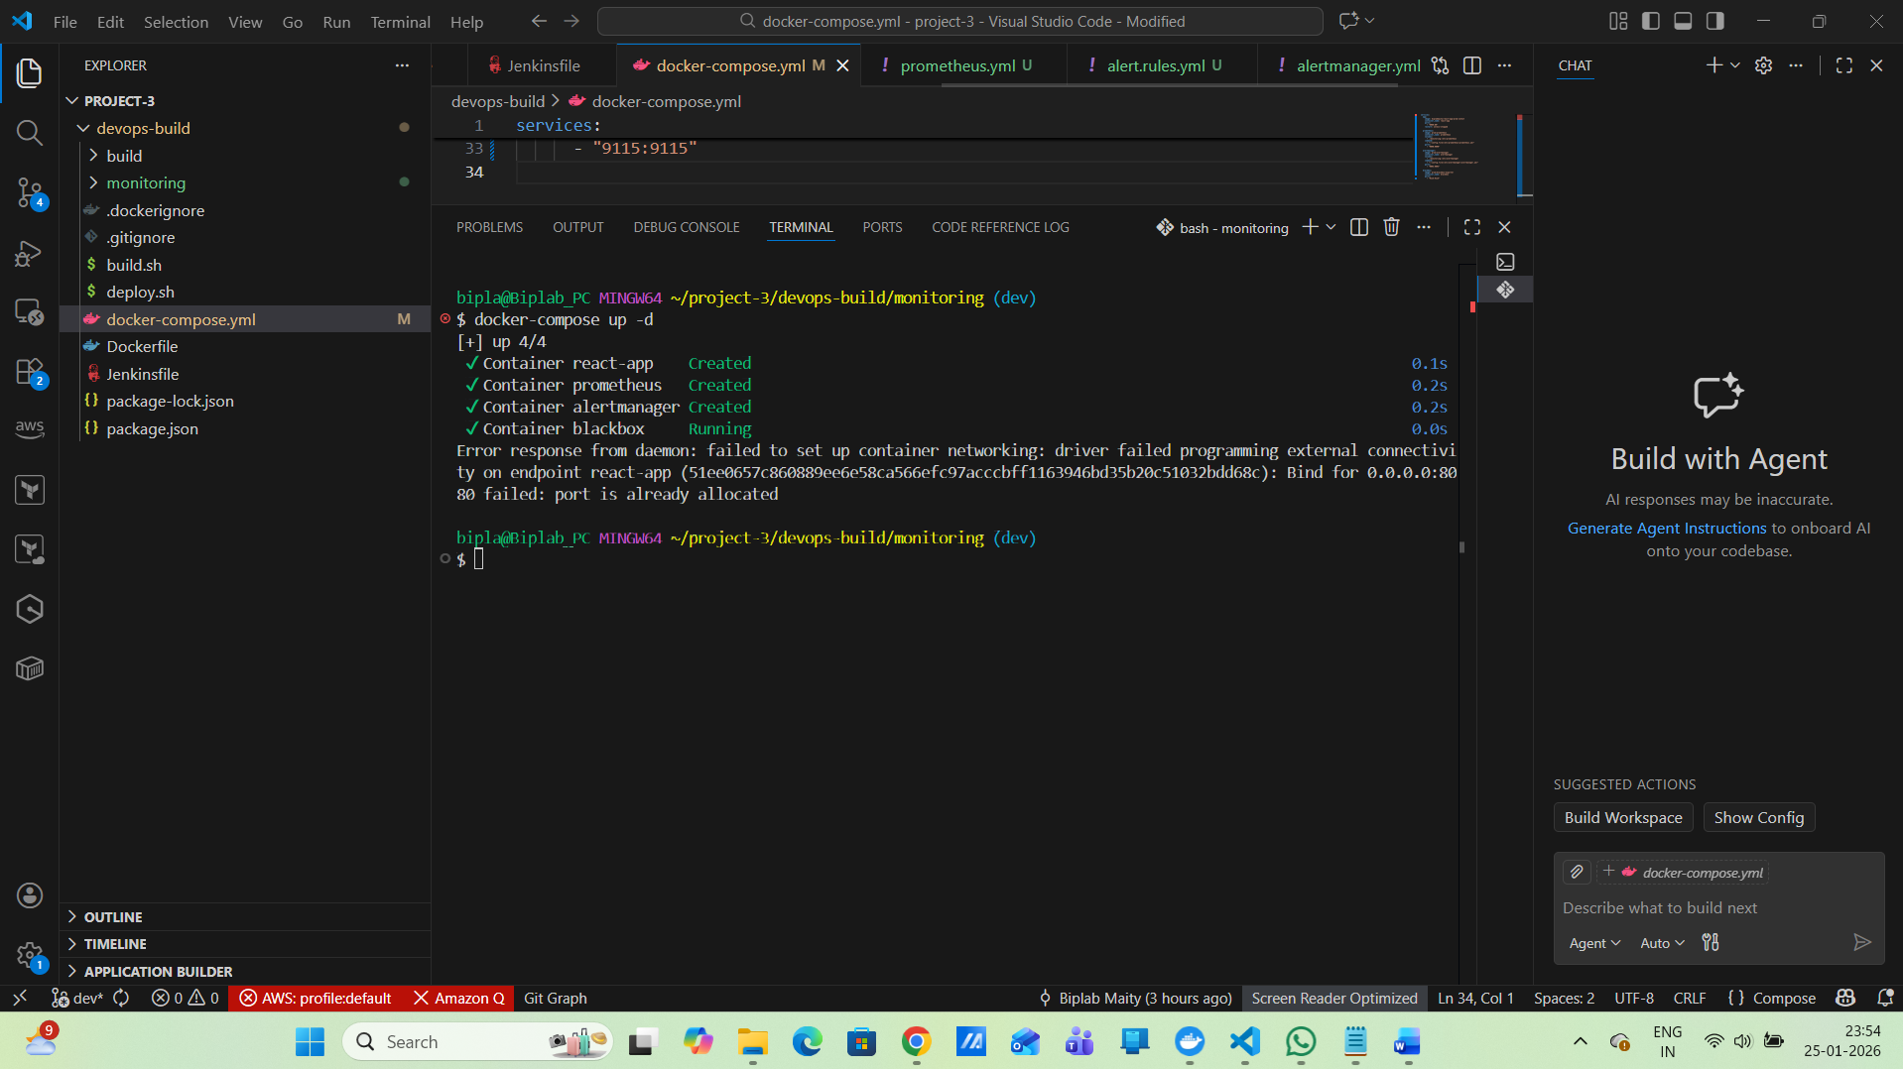
Verify everything
docker ps

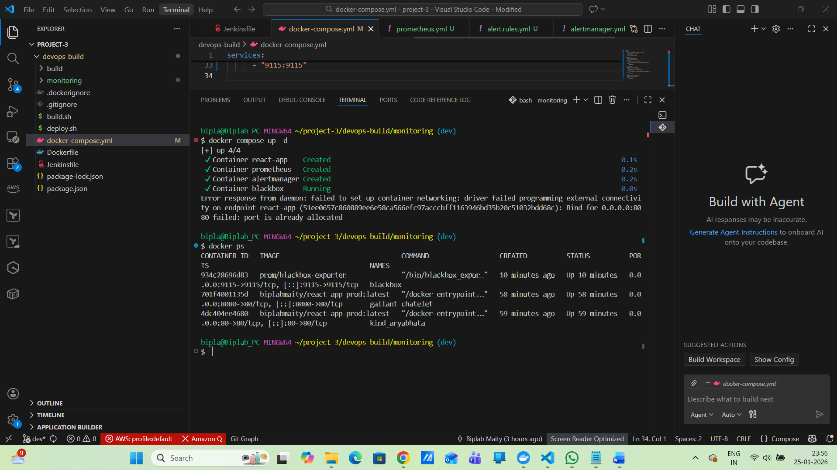
Verify URLs
Service | URL
App | http://localhost:8080
Prometheus | http://localhost:9090
Alertmanager | http://localhost:9093
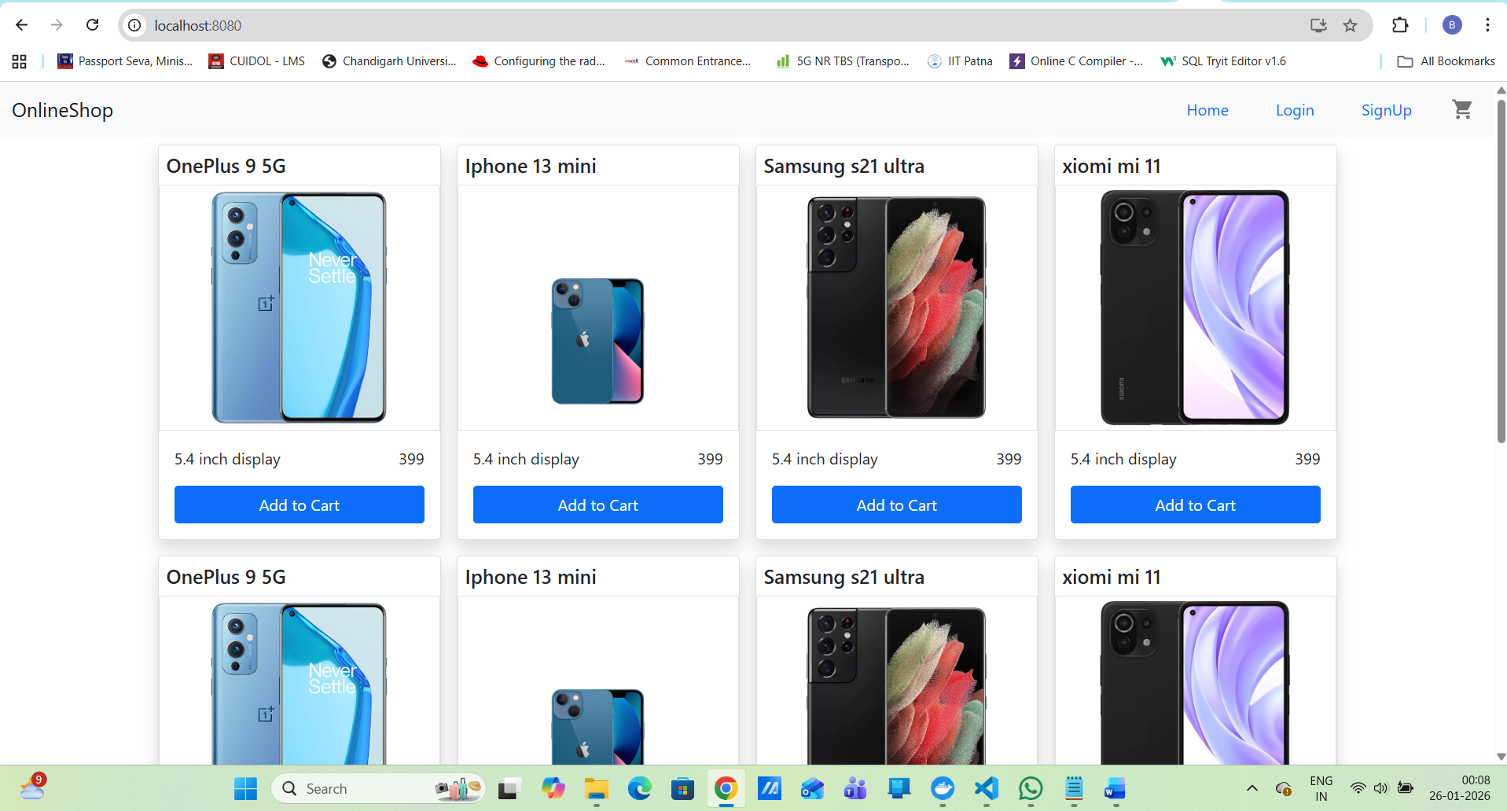
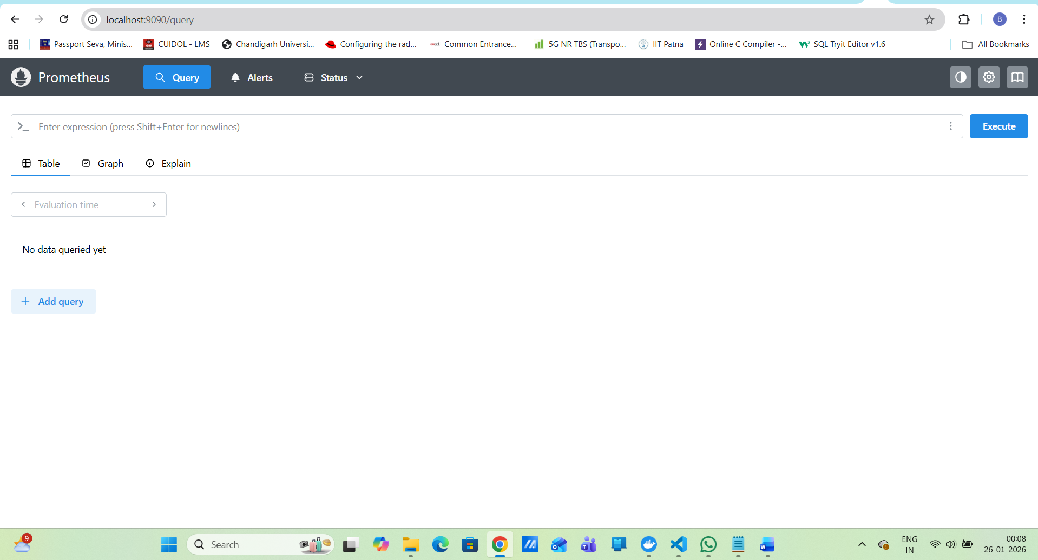
docker rm alertmanager
Run Alertmanager correctly
docker run -d \
--name alertmanager \
-p 9093:9093 \
-v $(pwd)/alertmanager.yml:/etc/alertmanager/alertmanager.yml \
prom/alertmanager
Verify
docker ps
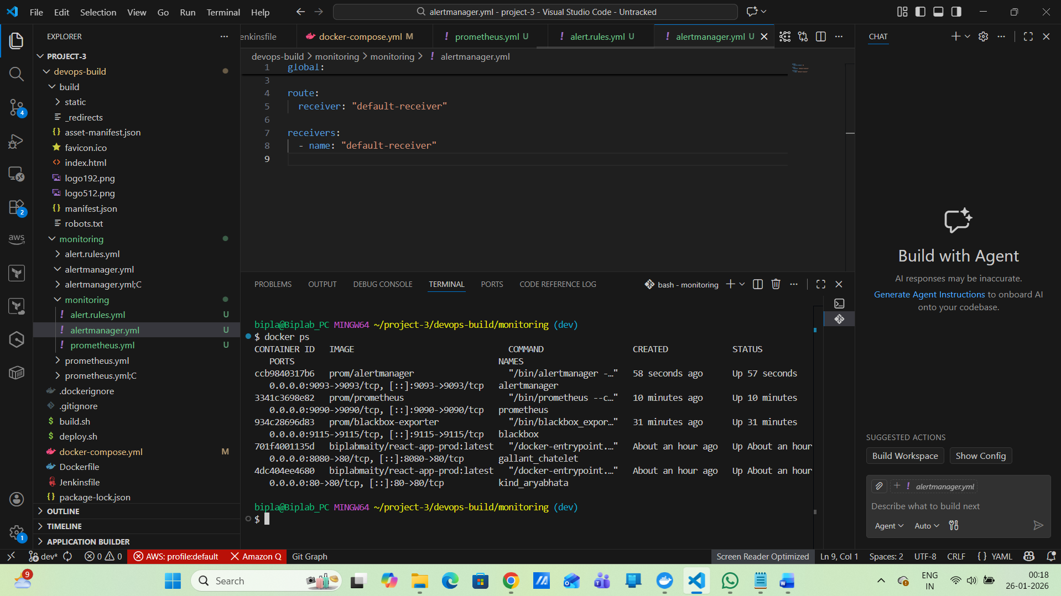
Open in browser:
http://localhost:9093
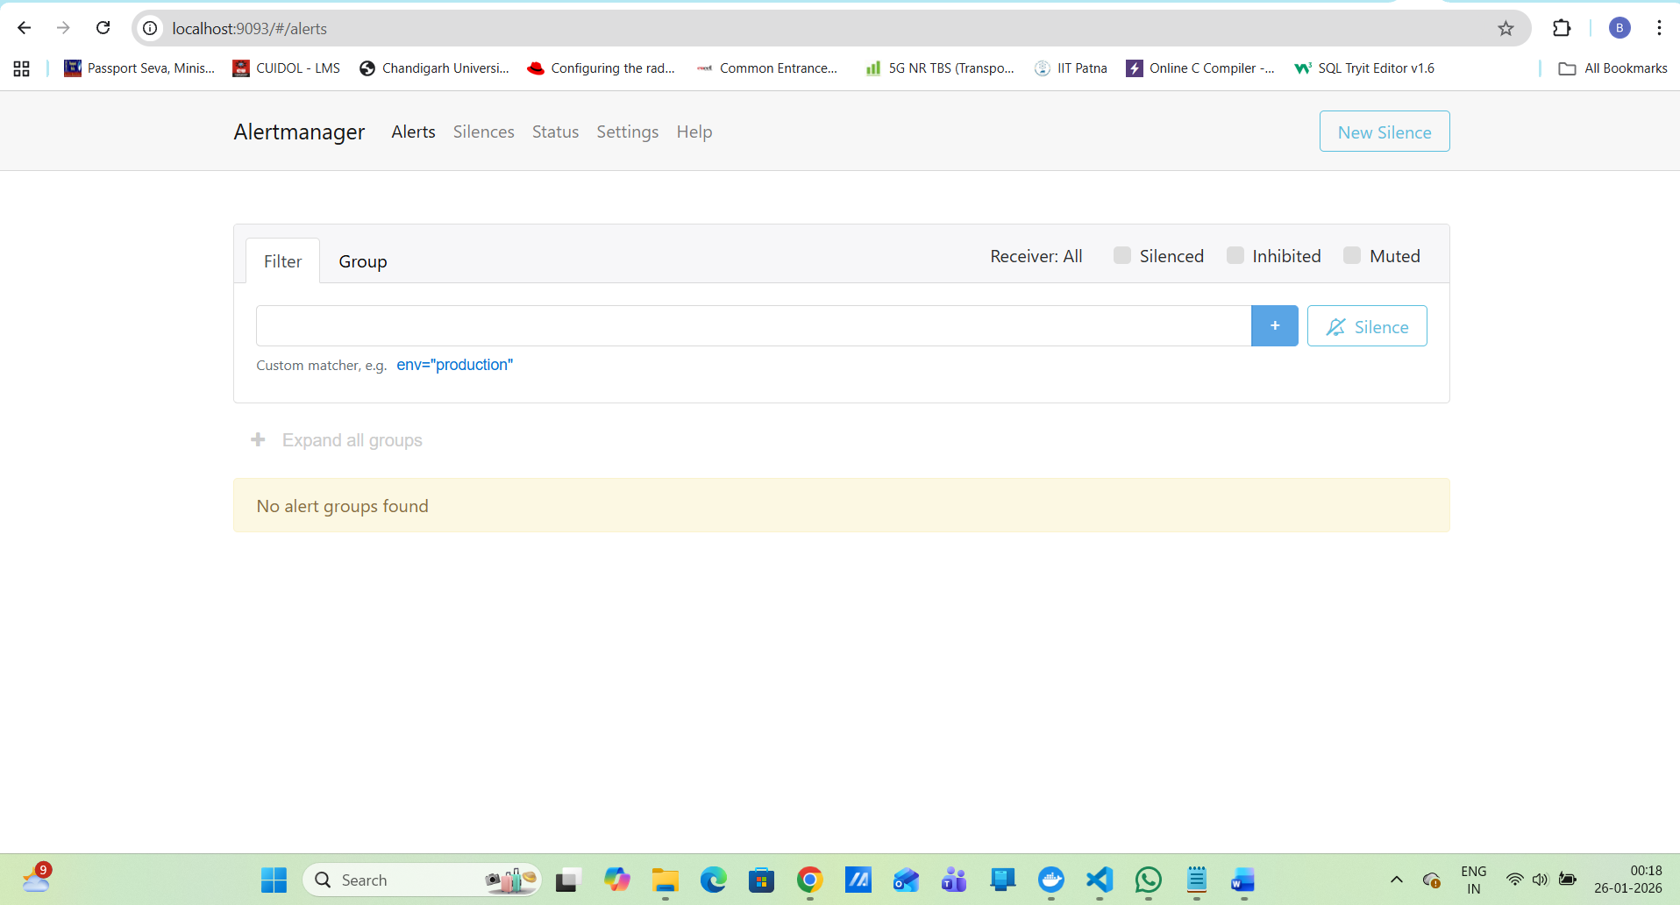

Prometheus query:
probe_success
Wait 1 minute → alert fires
docker start react-app
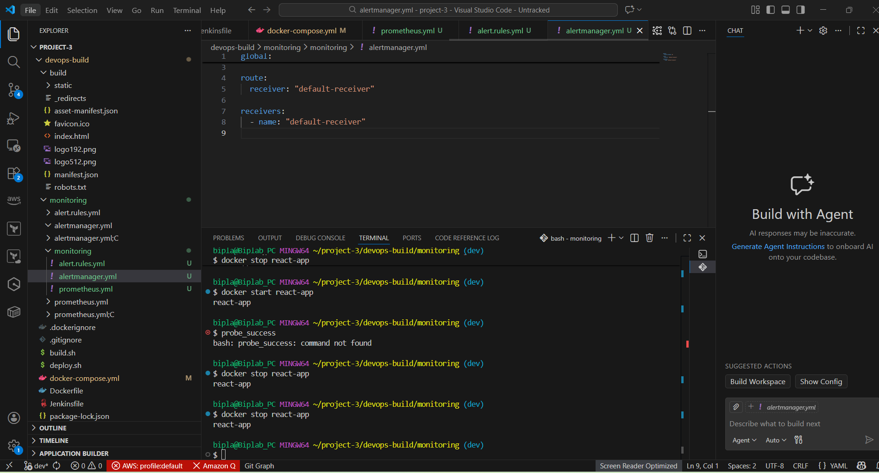
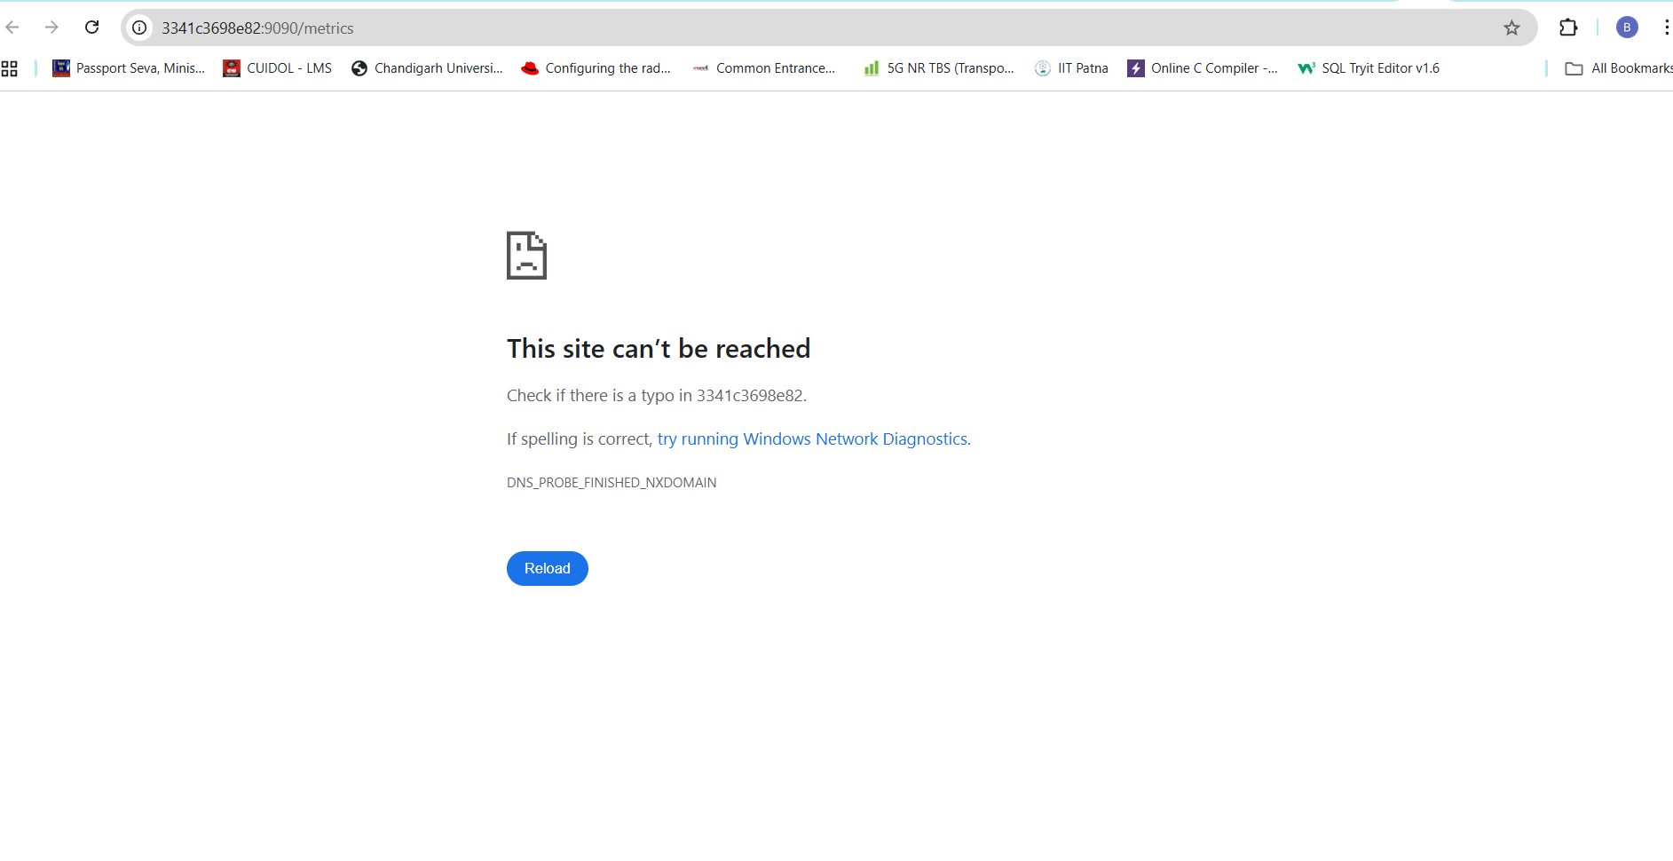
Now
docker start react-app
