Task Description:

Create 2 EC2 instances in 2 different regions and install nginx using terraform script.
Solution :
main.tf :
################################
# Terraform Block
################################
terraform {
required_providers {
aws = {
source = "hashicorp/aws"
version = "~> 5.0"
}
}
}

################################
# AWS Providers (Multi-Region)
################################

# Mumbai Region
provider "aws" {
alias = "mumbai"
region = "ap-south-1"
}

# Virginia Region
provider "aws" {
alias = "virginia"
region = "us-east-1"
}

################################
# EC2 Instance - Mumbai
################################
resource "aws_instance" "ec2_mumbai" {
provider = aws.mumbai
ami = "ami-0f5ee92e2d63afc18"
instance_type = "t3.micro"
key_name = aws_key_pair.terraform_key.key_name

vpc_security_group_ids = [
aws_security_group.web_sg_mumbai.id
]

user_data = <<-EOF
#!/bin/bash
sudo apt update -y
sudo apt install nginx -y
sudo systemctl start nginx
sudo systemctl enable nginx
systemctl status nginx
EOF

tags = {
Name = "EC2-Mumbai-NGINX"
}
}

################################
# EC2 Instance - Virginia
################################
resource "aws_instance" "ec2_virginia" {
provider = aws.virginia
ami = "ami-0c02fb55956c7d316"
instance_type = "t3.micro"
key_name = aws_key_pair.terraform_key.key_name

vpc_security_group_ids = [
aws_security_group.web_sg_virginia.id
]

user_data = <<-EOF
#!/bin/bash
sudo yum update -y
sudo amazon-linux-extras install nginx1 -y
sudo systemctl start nginx
sudo systemctl enable nginx
sudo systemctl status nginx
EOF

tags = {
Name = "EC2-Virginia-NGINX"
}
}

################################
# SSH Key Pair
################################
resource "aws_key_pair" "terraform_key" {
key_name = "terraform-key"
public_key = file("${path.module}/terraform-key.pub")
}

################################
################################
# Security Group (SSH + HTTP)
################################
resource "aws_security_group" "web_sg_mumbai" {
provider = aws.mumbai
name = "web-sg-mumbai"

ingress {
from_port = 22
to_port = 22
protocol = "tcp"
cidr_blocks = ["0.0.0.0/0"]
}

ingress {
from_port = 80
to_port = 80
protocol = "tcp"
cidr_blocks = ["0.0.0.0/0"]
}

egress {
from_port = 0
to_port = 0
protocol = "-1"
cidr_blocks = ["0.0.0.0/0"]
}
}

resource "aws_security_group" "web_sg_virginia" {
provider = aws.virginia
name = "web-sg-virginia"

ingress {
from_port = 22
to_port = 22
protocol = "tcp"
cidr_blocks = ["0.0.0.0/0"]
}

ingress {
from_port = 80
to_port = 80
protocol = "tcp"
cidr_blocks = ["0.0.0.0/0"]
}

egress {
from_port = 0
to_port = 0
protocol = "-1"
cidr_blocks = ["0.0.0.0/0"]
}
}

Then
terraform init
terraform plan
terraform apply
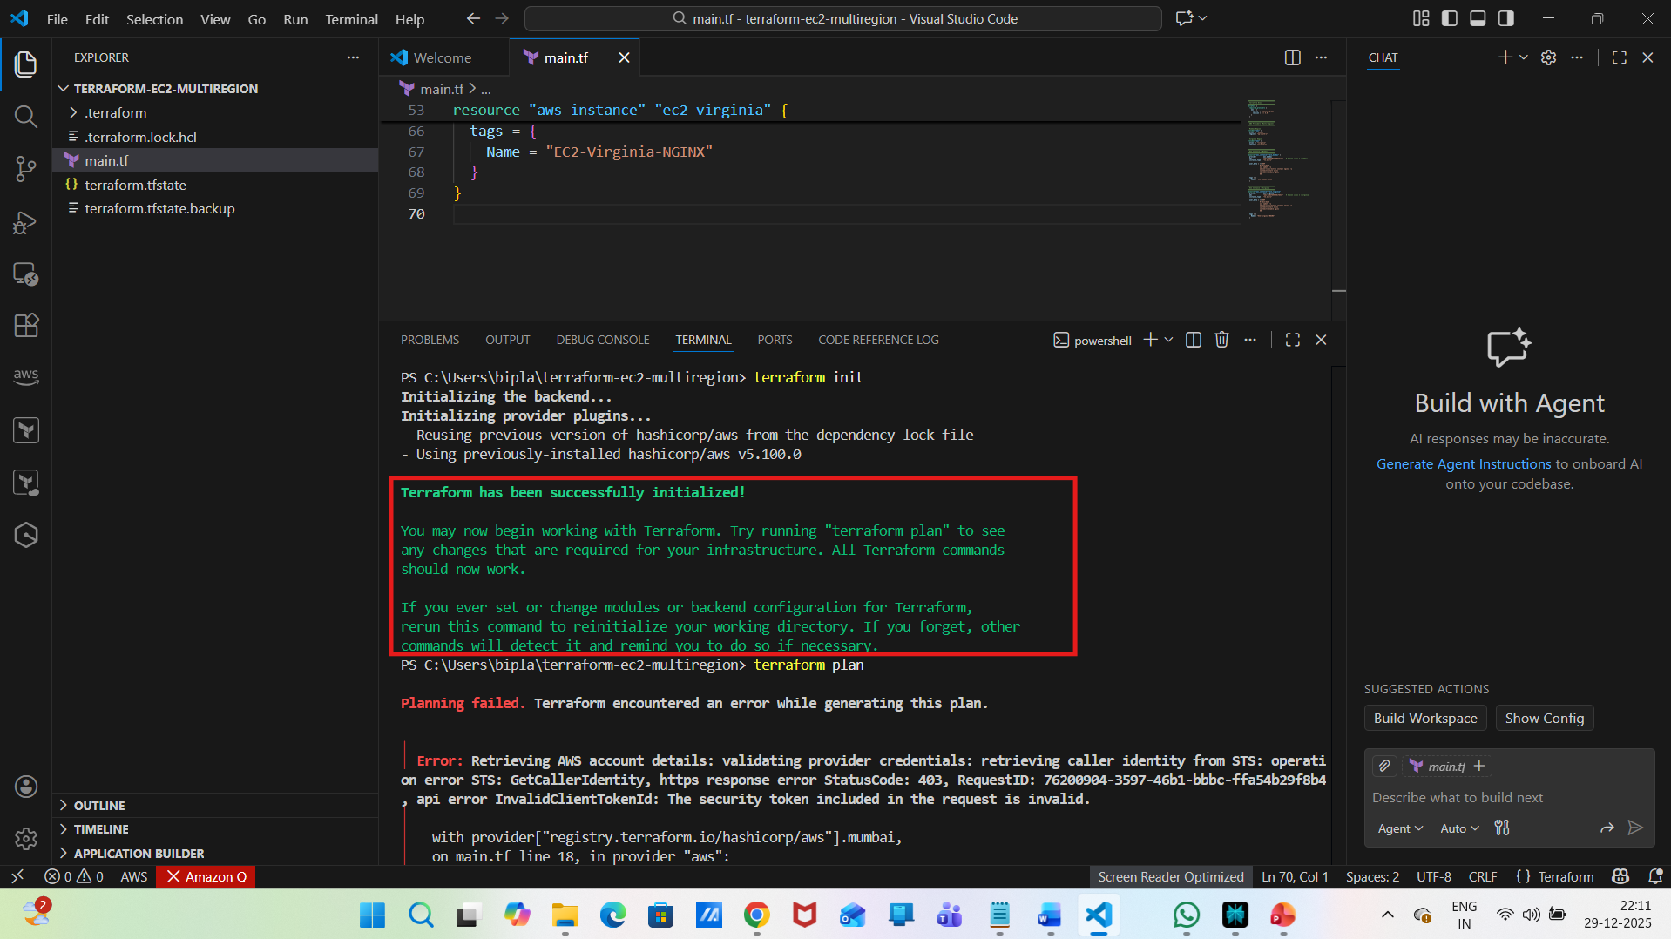
Error :
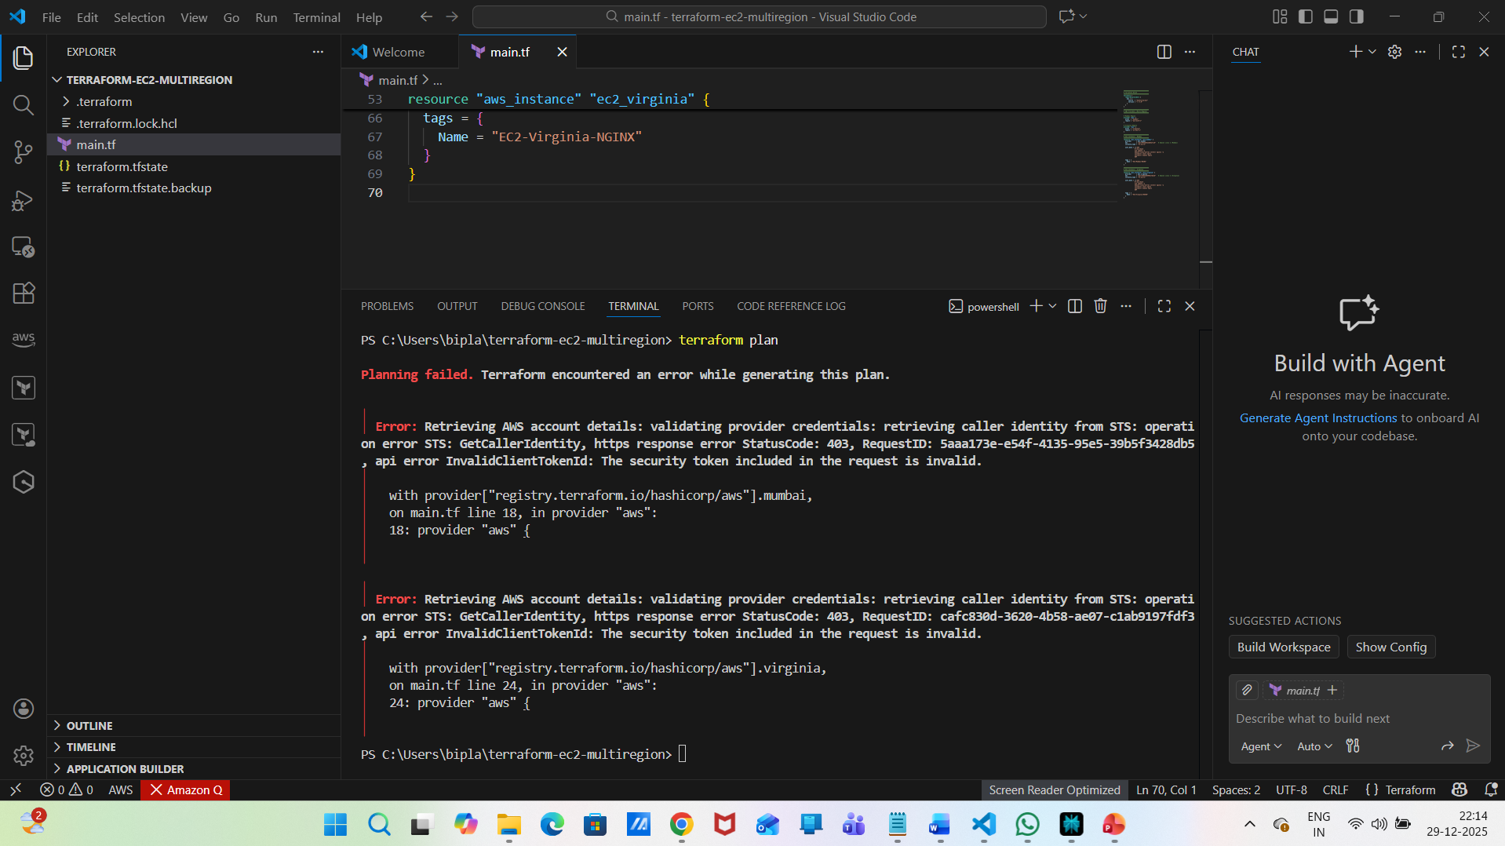
Resolution :
STEP 1: Check current AWS CLI credentials
aws sts get-caller-identity
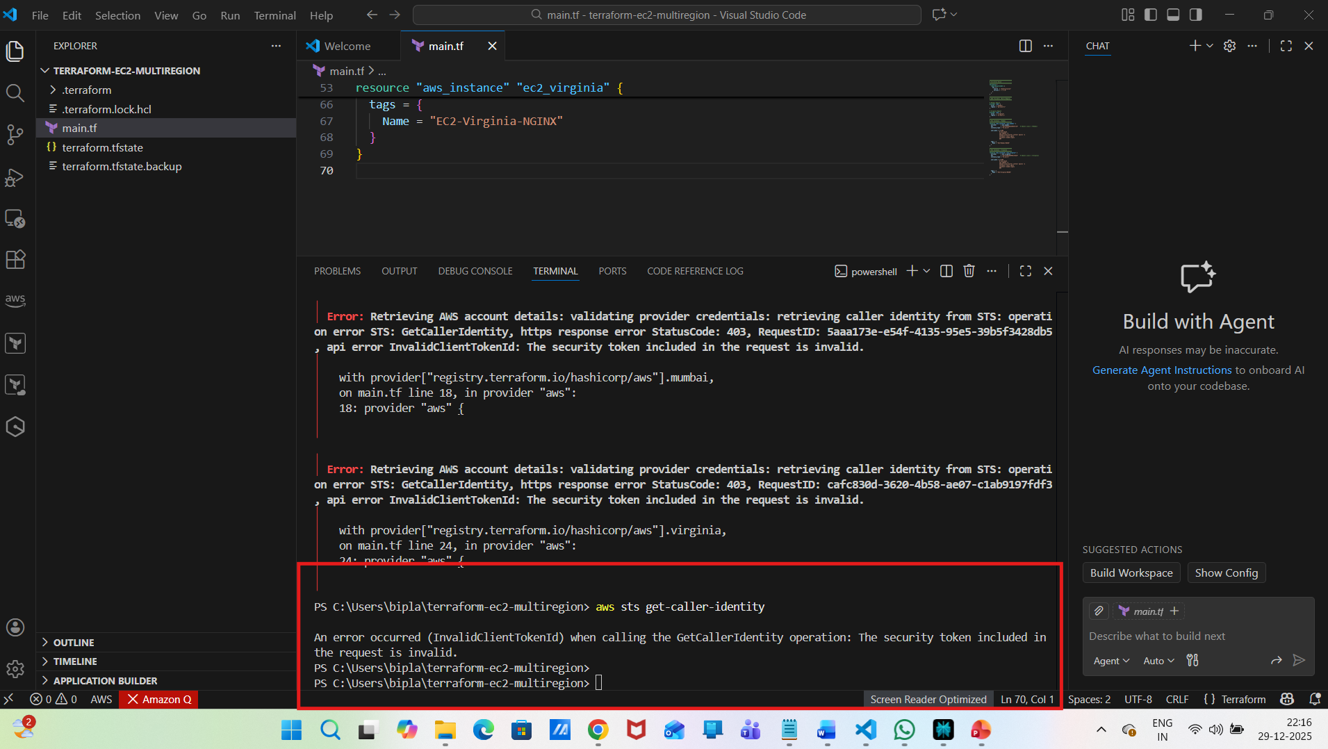
STEP 2: Delete existing local credentials :
Delete both files:
credentials
config
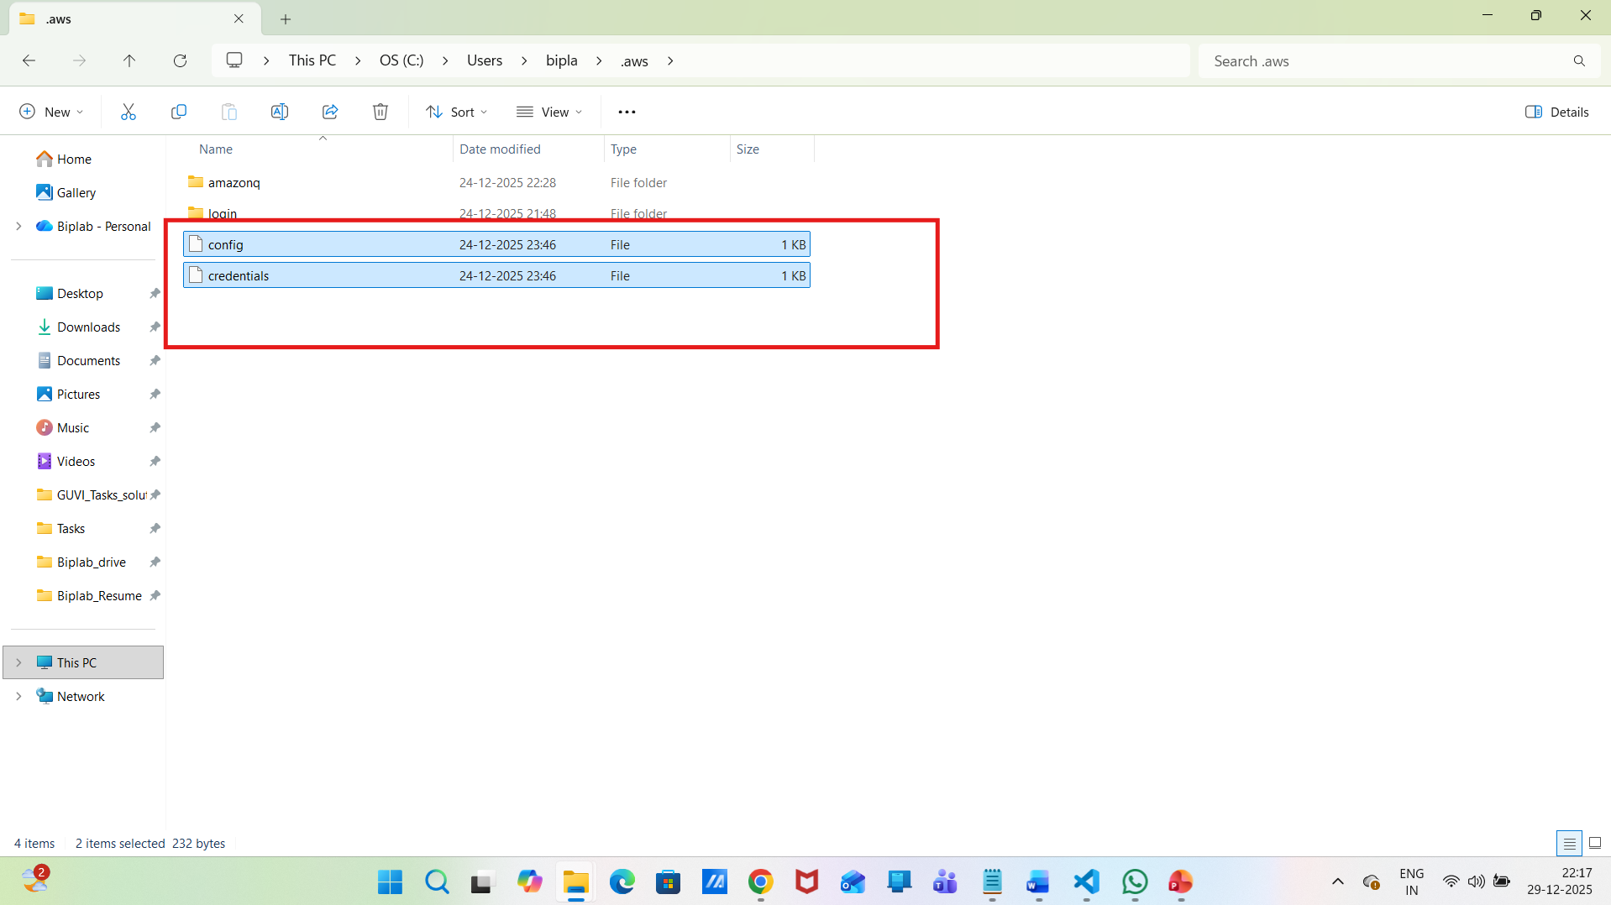
STEP 3: Create NEW Access Keys
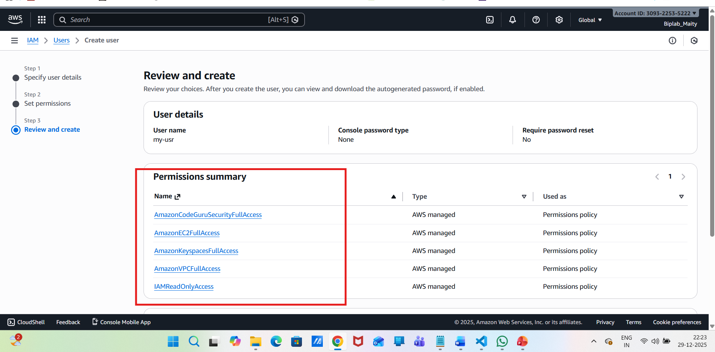
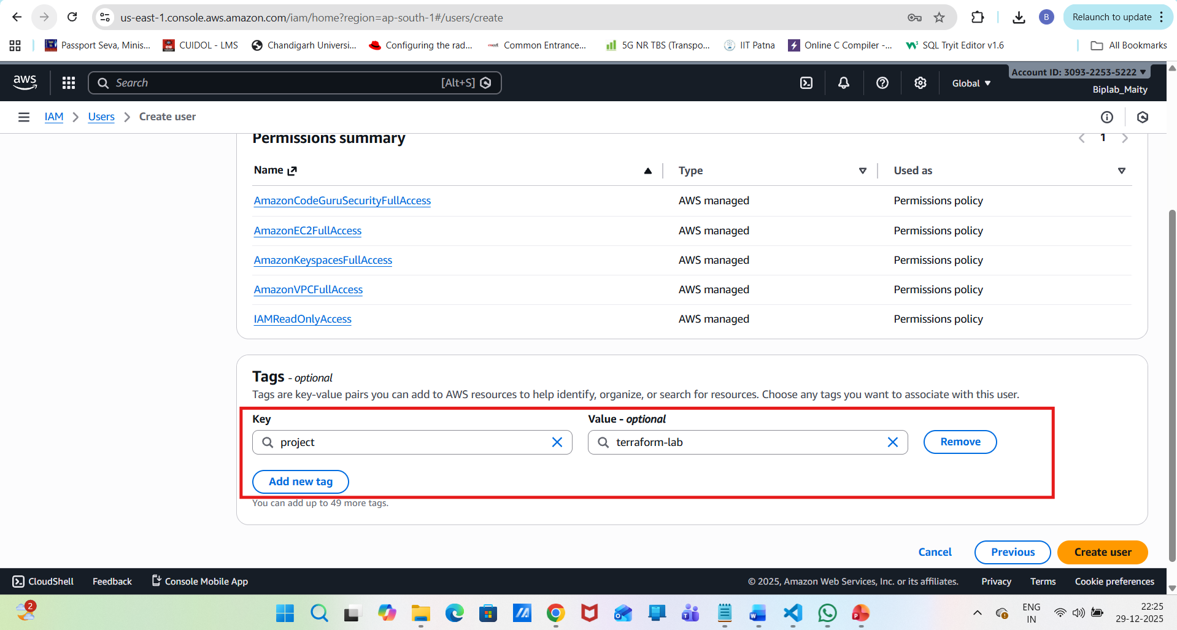
Login to AWS Console
Go to IAM → Users → my-usr
Open Security credentials
Under Access keys
Create access key
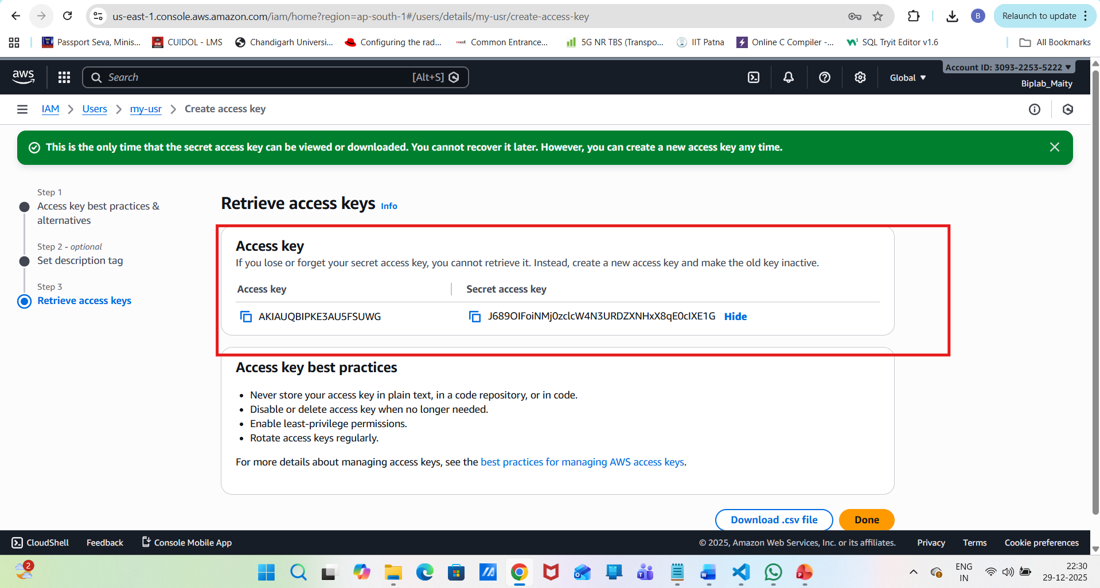
aws configure
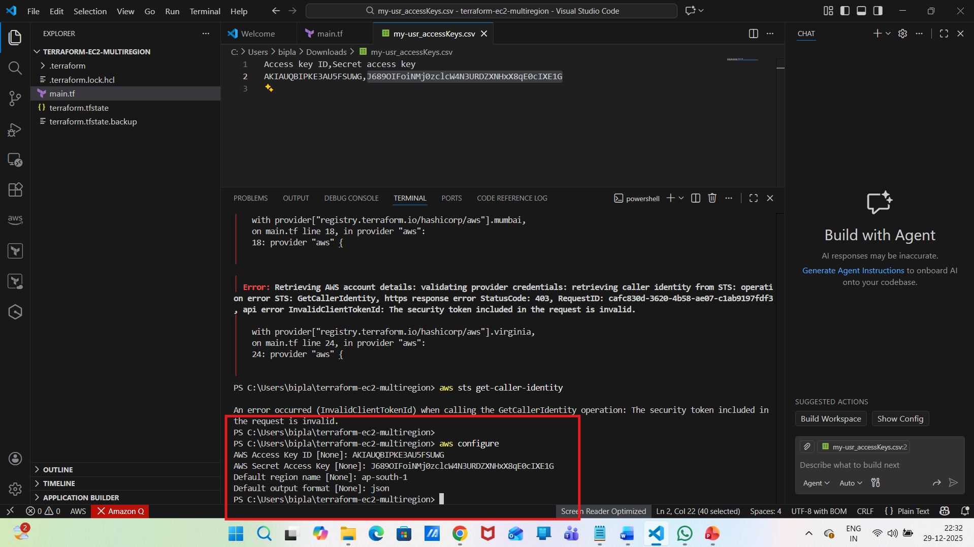
aws sts get-caller-identity
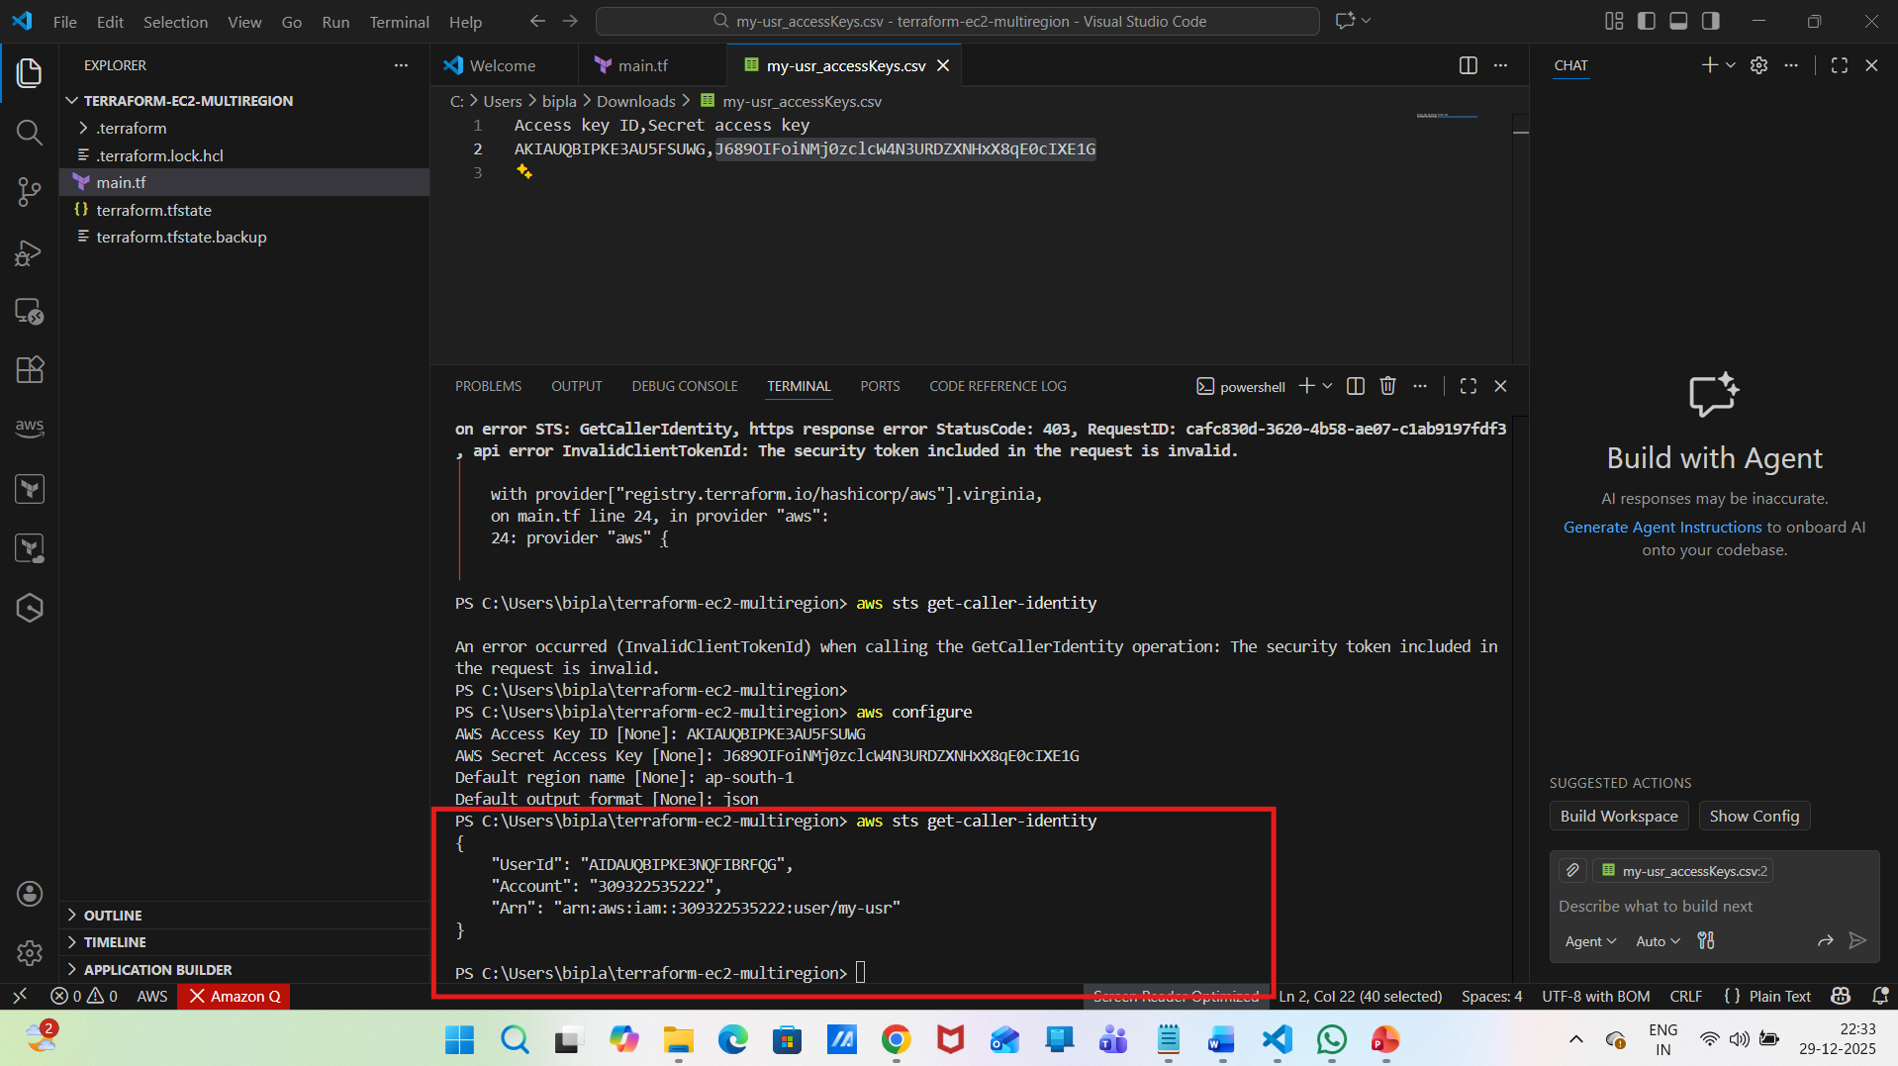
terraform plan
terraform apply
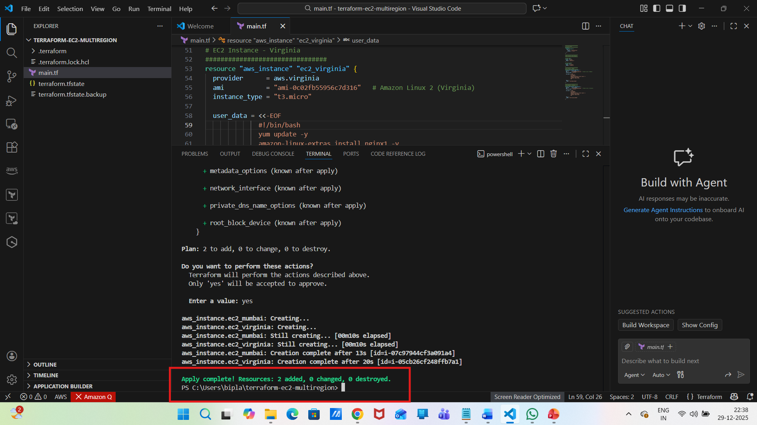
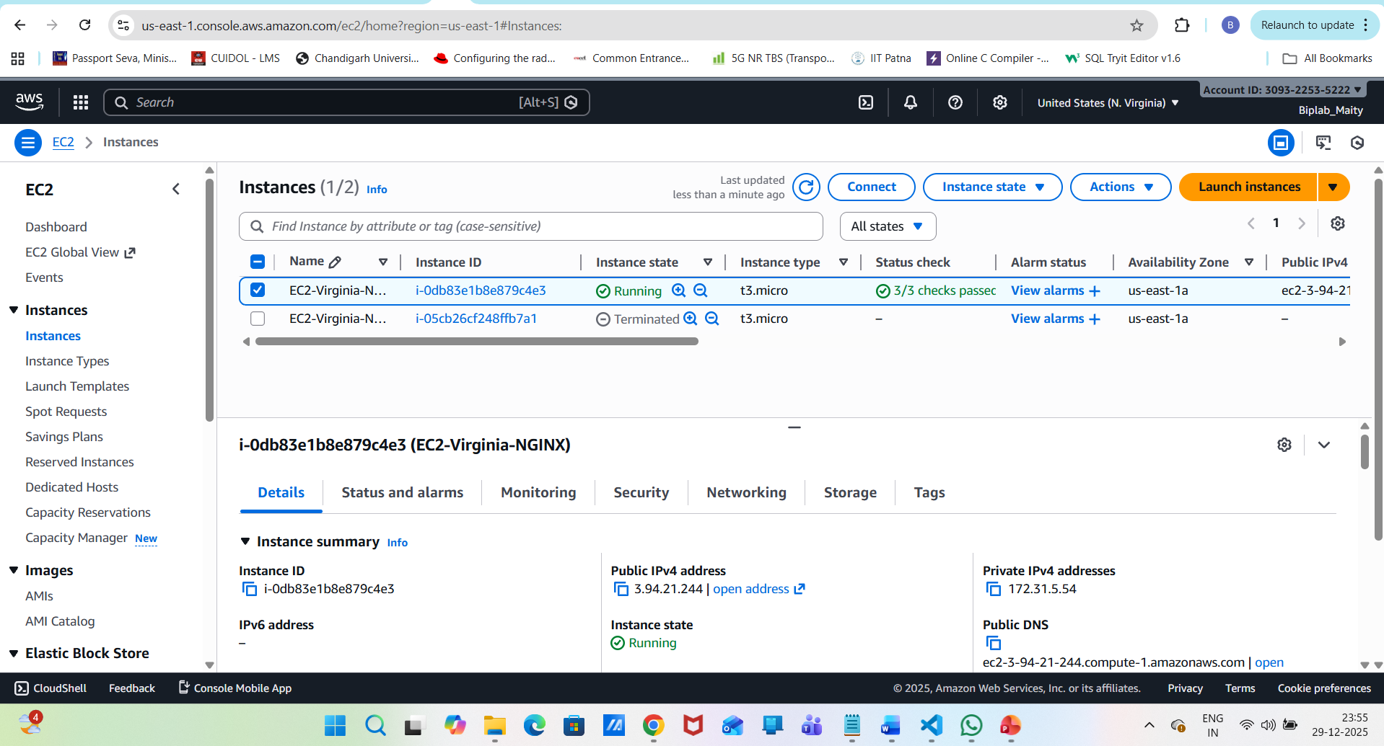
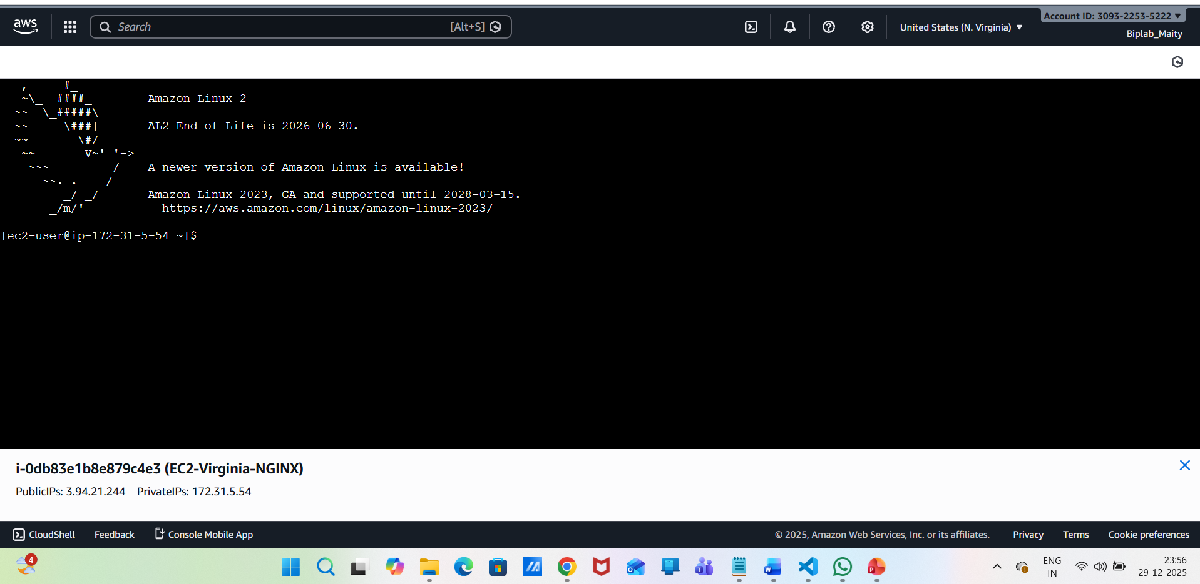
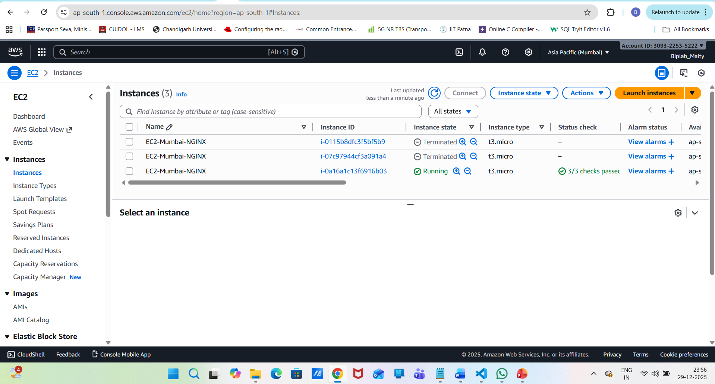
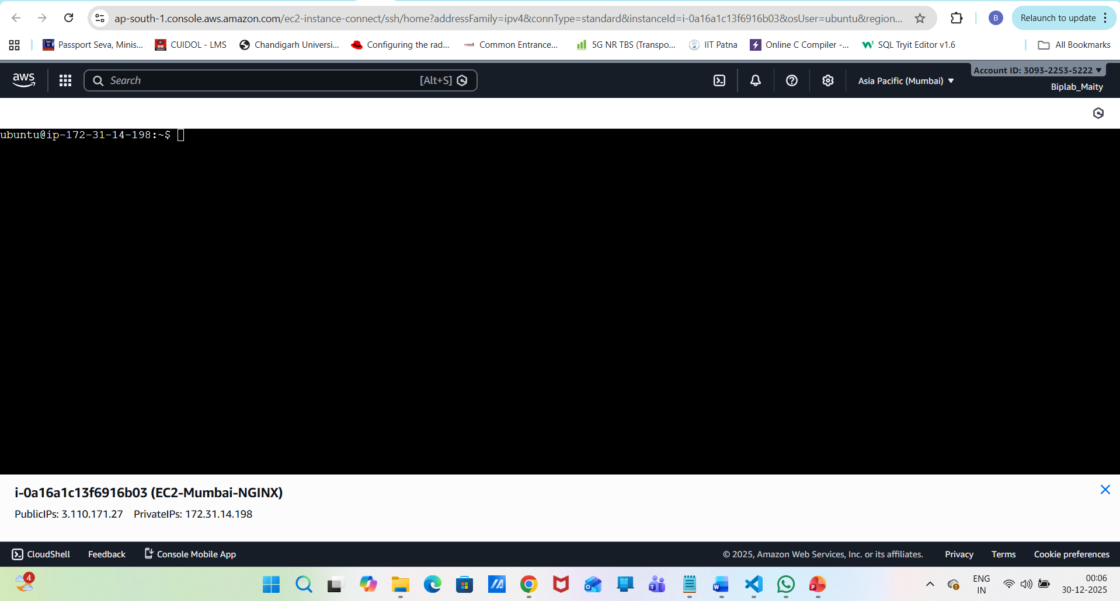
After instance creation:
Go to AWS Console → EC2
Copy Public IPv4 address
Open browser:
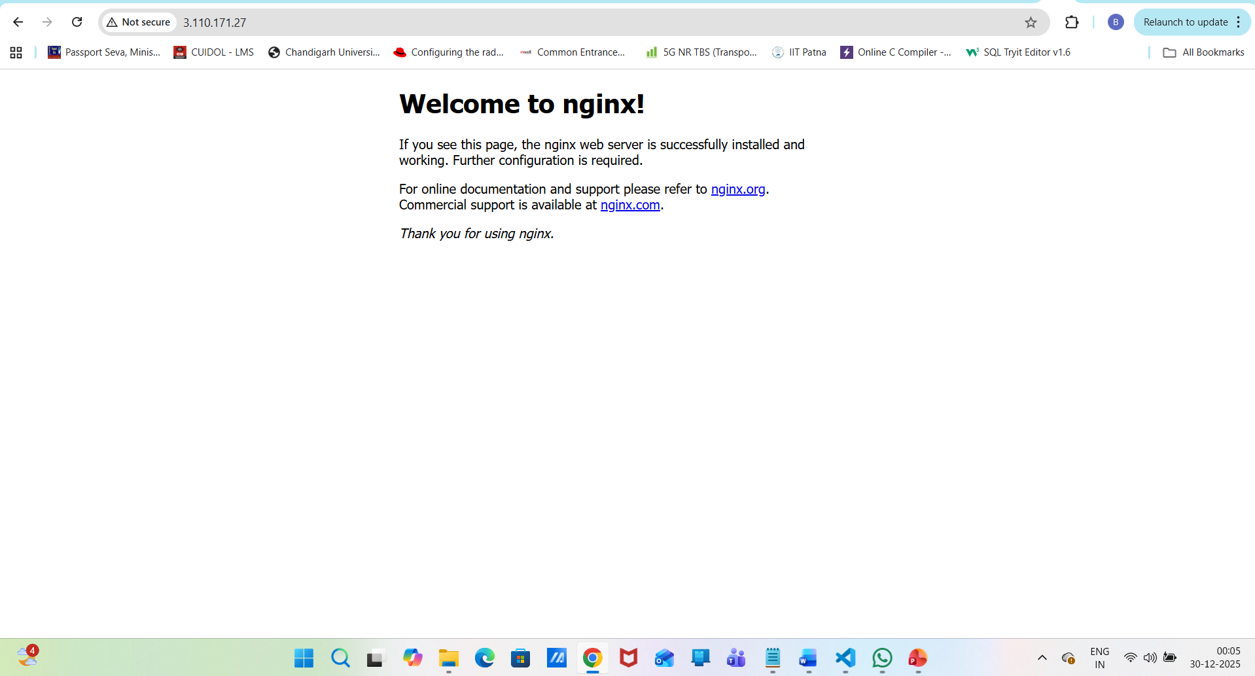
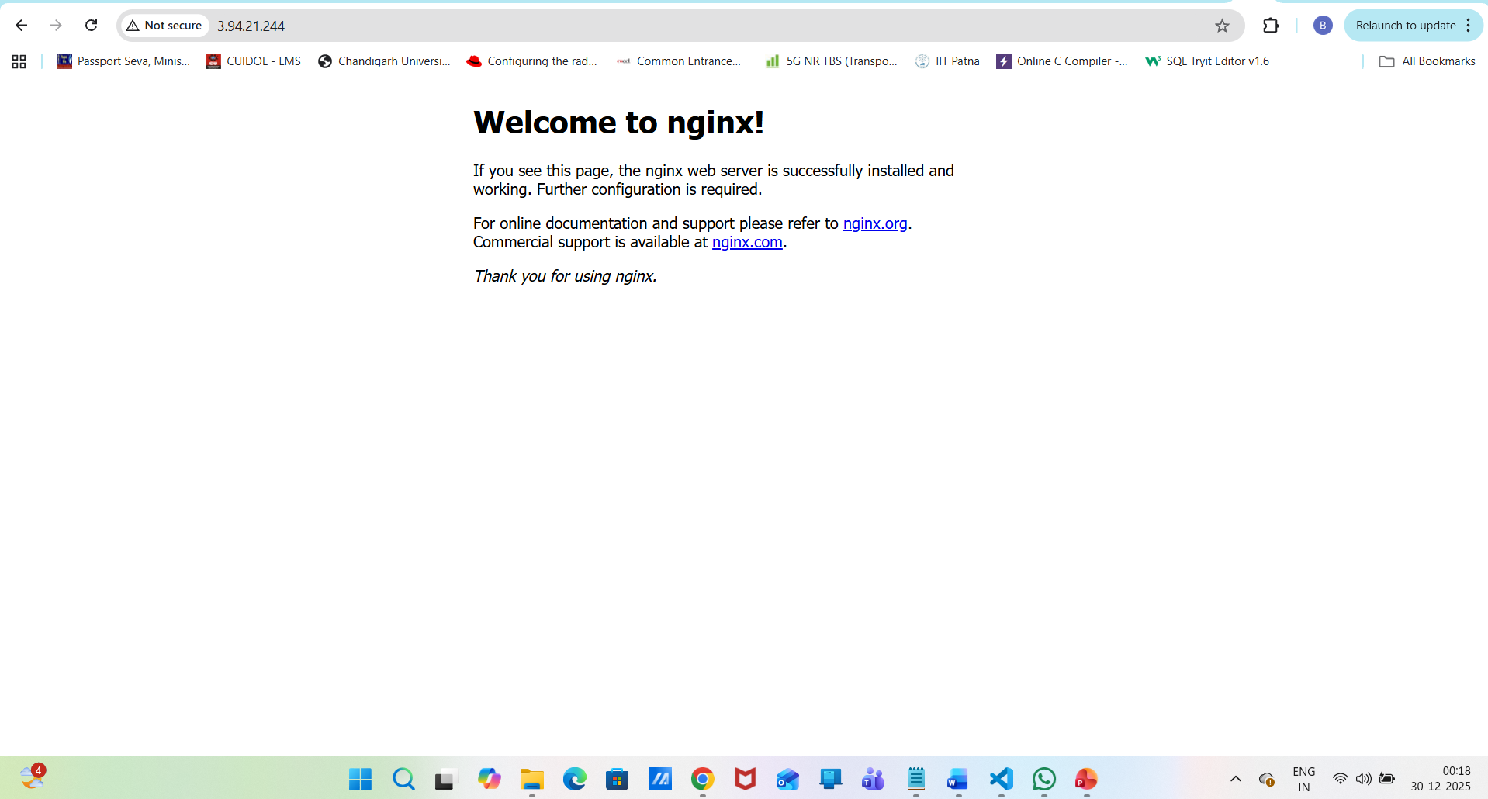
terraform destroy
