Task: Launch Linux EC2 instances in two regions using a single Terraform file.
Solution:
Step 1: Setup Visual Studio Code
Install: Visual Studio Code
Extensions:
Terraform (HashiCorp)
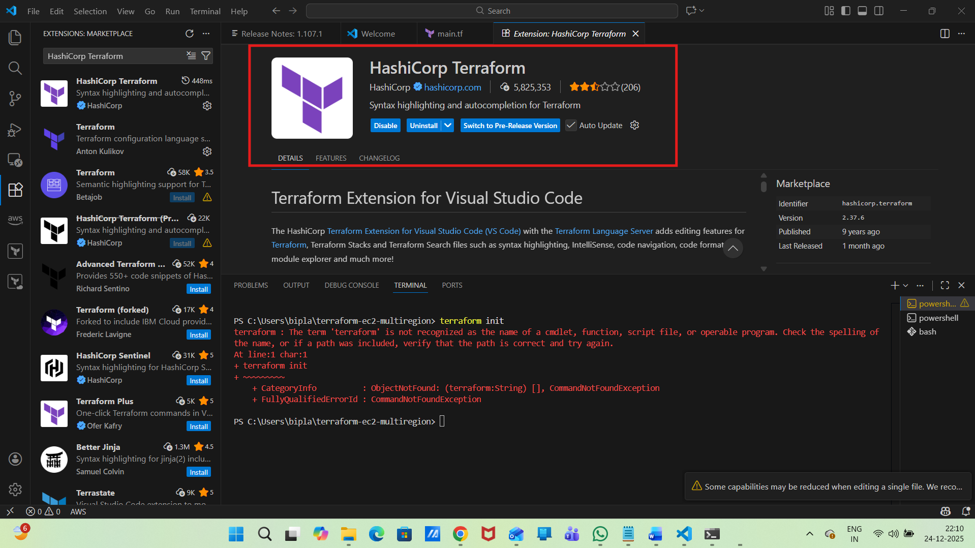
AWS Toolkit
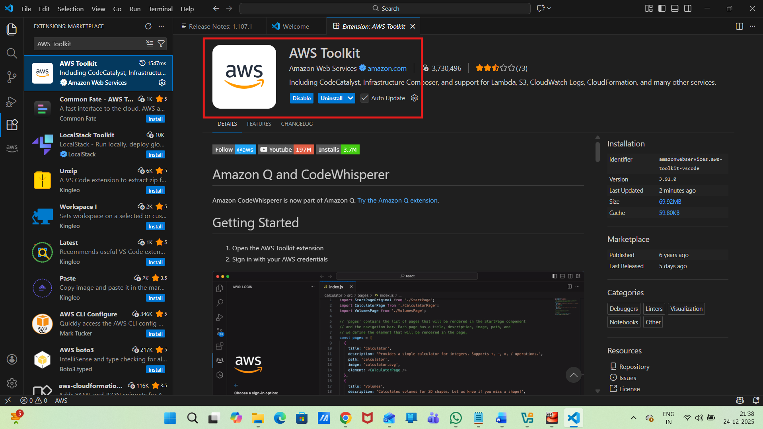
Step-2: Create Terraform Project Directory
mkdir terraform-ec2-multiregion
cd terraform-ec2-multiregion
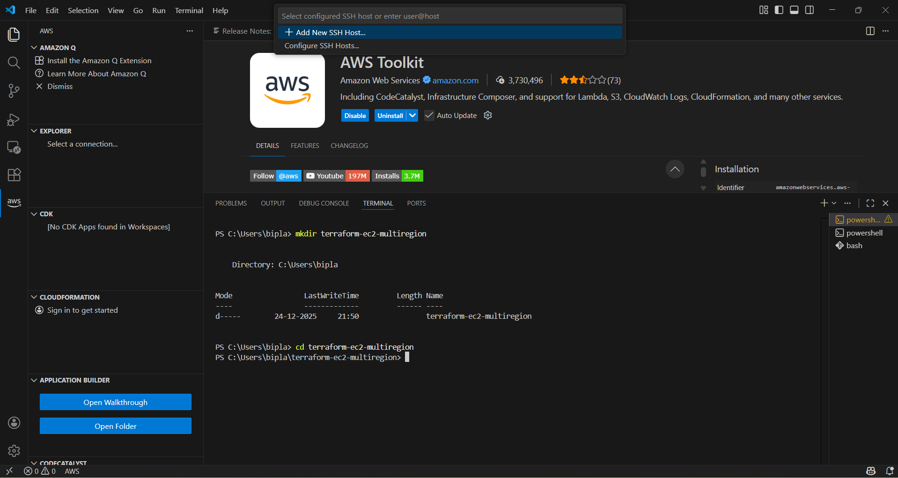
Create Terraform file: vi main.tf like below
################################
# Terraform Block
################################
terraform {
required_providers {
aws = {
source = "hashicorp/aws"
version = "~> 5.0"
}
}
}

################################
# AWS Providers (Multi-Region)
################################

# Mumbai Region
provider "aws" {
alias = "mumbai"
region = "ap-south-1"
}

# Virginia Region
provider "aws" {
alias = "virginia"
region = "us-east-1"
}

################################
# EC2 Instance - Mumbai
################################
resource "aws_instance" "ec2_mumbai" {
provider = aws.mumbai
ami = "ami-0f5ee92e2d63afc18"
instance_type = "t3.micro"

tags = {
Name = "EC2-Mumbai"
}
}

################################
# EC2 Instance - Virginia
################################
resource "aws_instance" "ec2_virginia" {
provider = aws.virginia
ami = "ami-0c02fb55956c7d316"
instance_type = "t3.micro"

tags = {
Name = "EC2-Virginia"
}
}
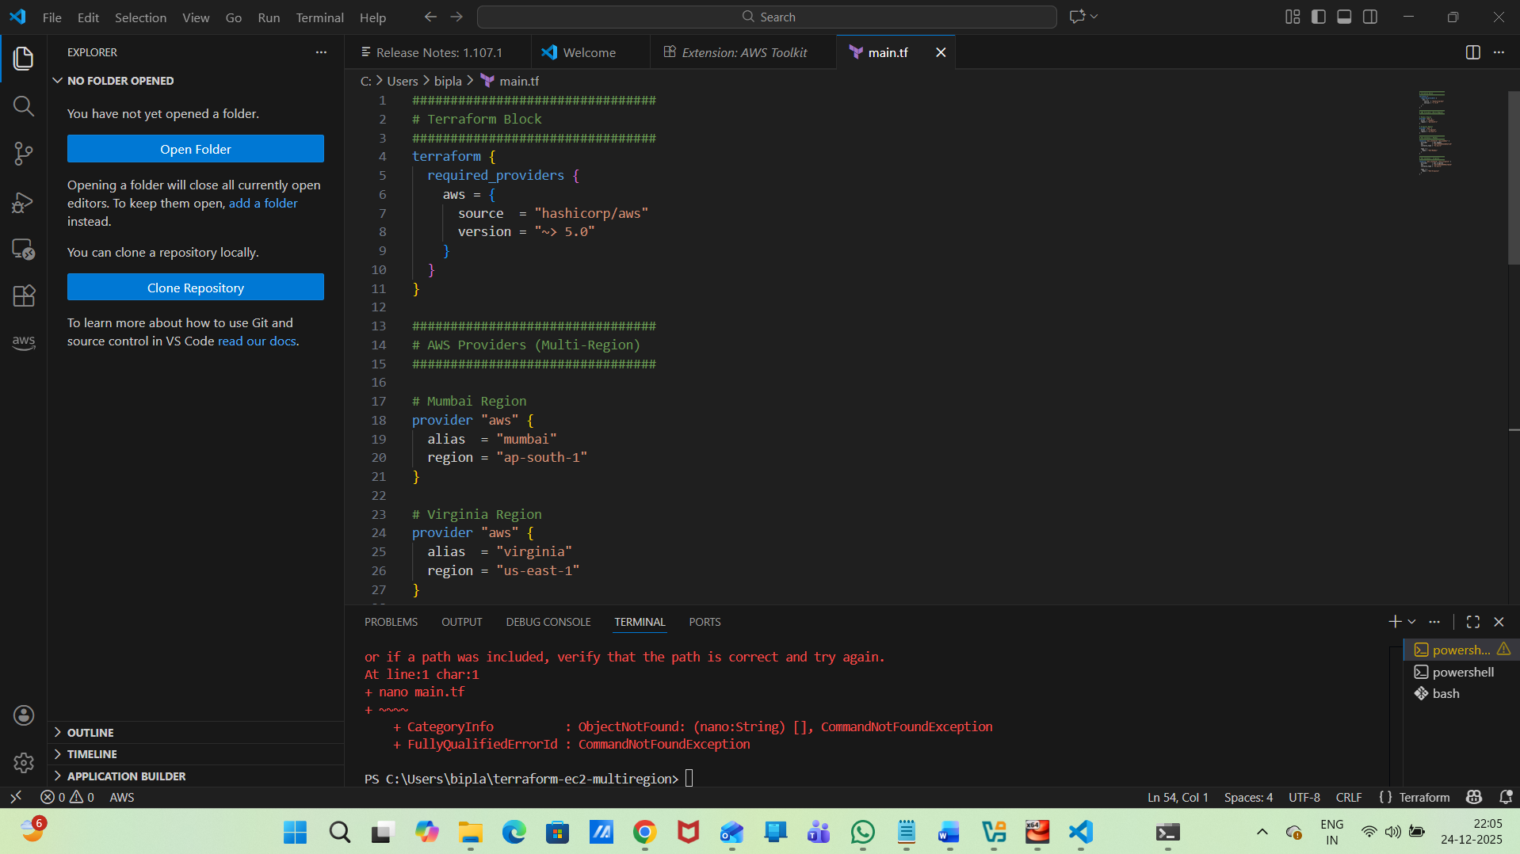
Add Terraform to Windows PATH
Press Windows + R
then type
sysdm.cpl
then enter
Then edit PATH for the following step to follow
Go to Advanced
Click Environment Variables
Under System Variables
Select Path
Click Edit
Click New
Add: C:\terraform
Click OK → OK → OK
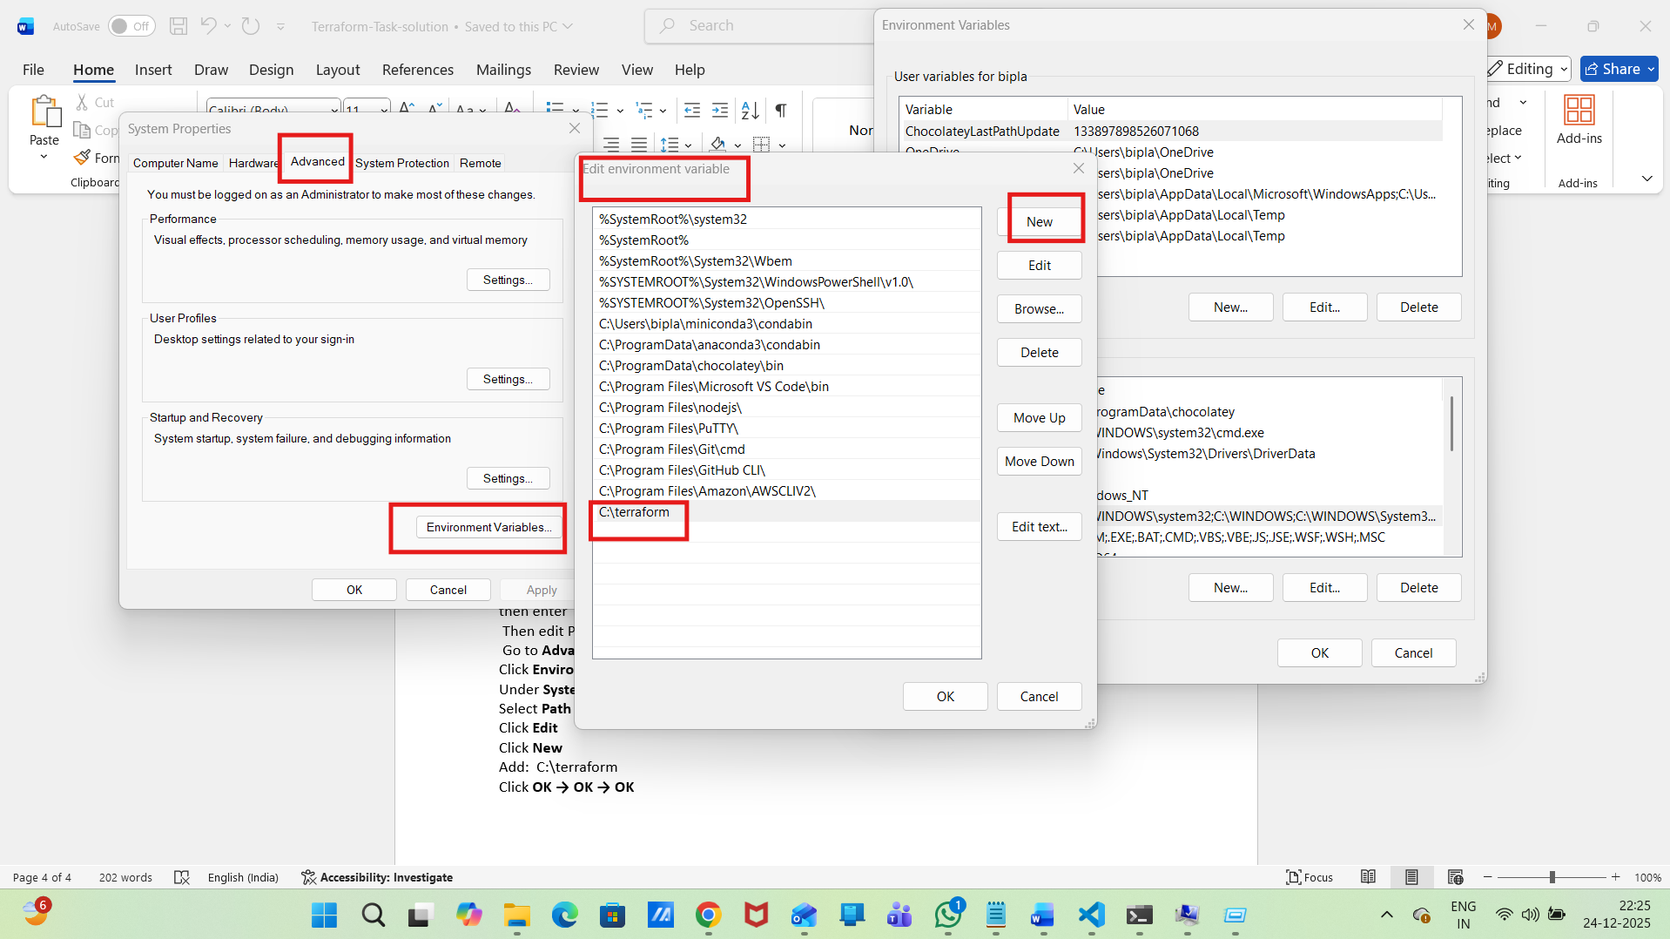
Then restart PowerShell
Close ALL PowerShell / VS Code terminals
Verify Terraform Installation
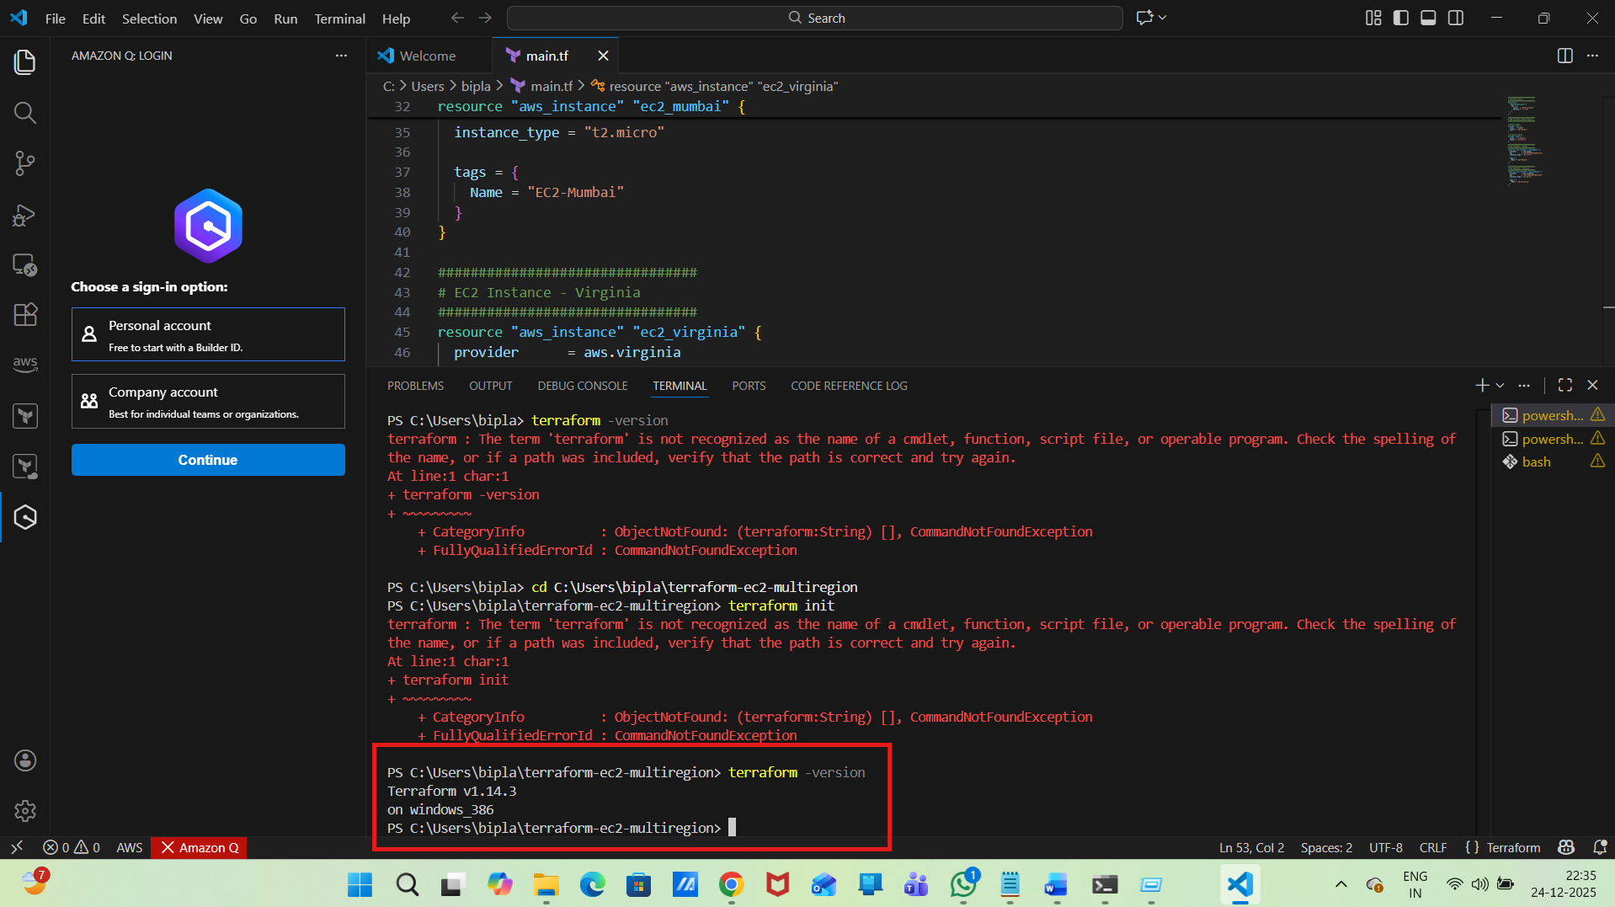
terraform init
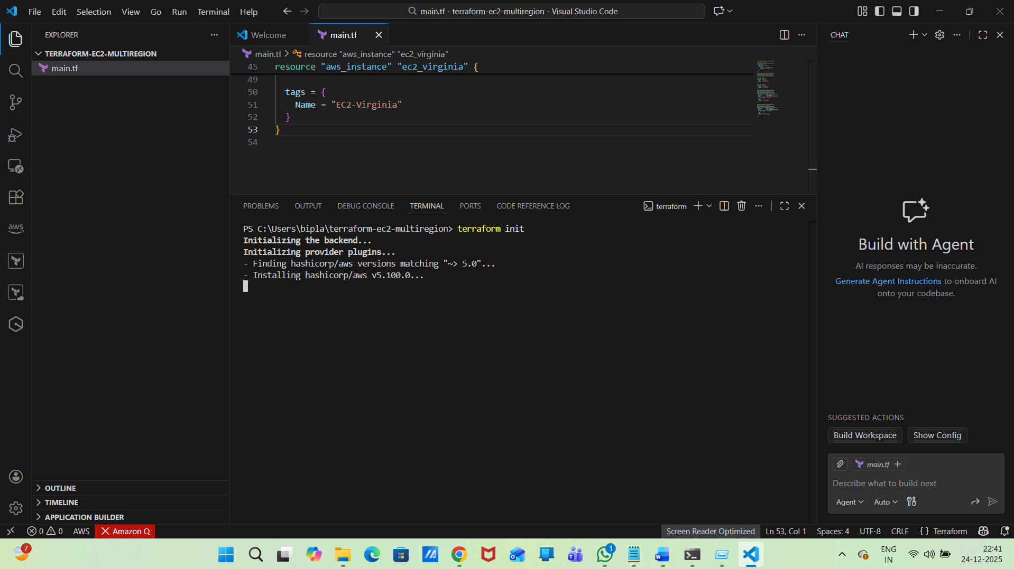
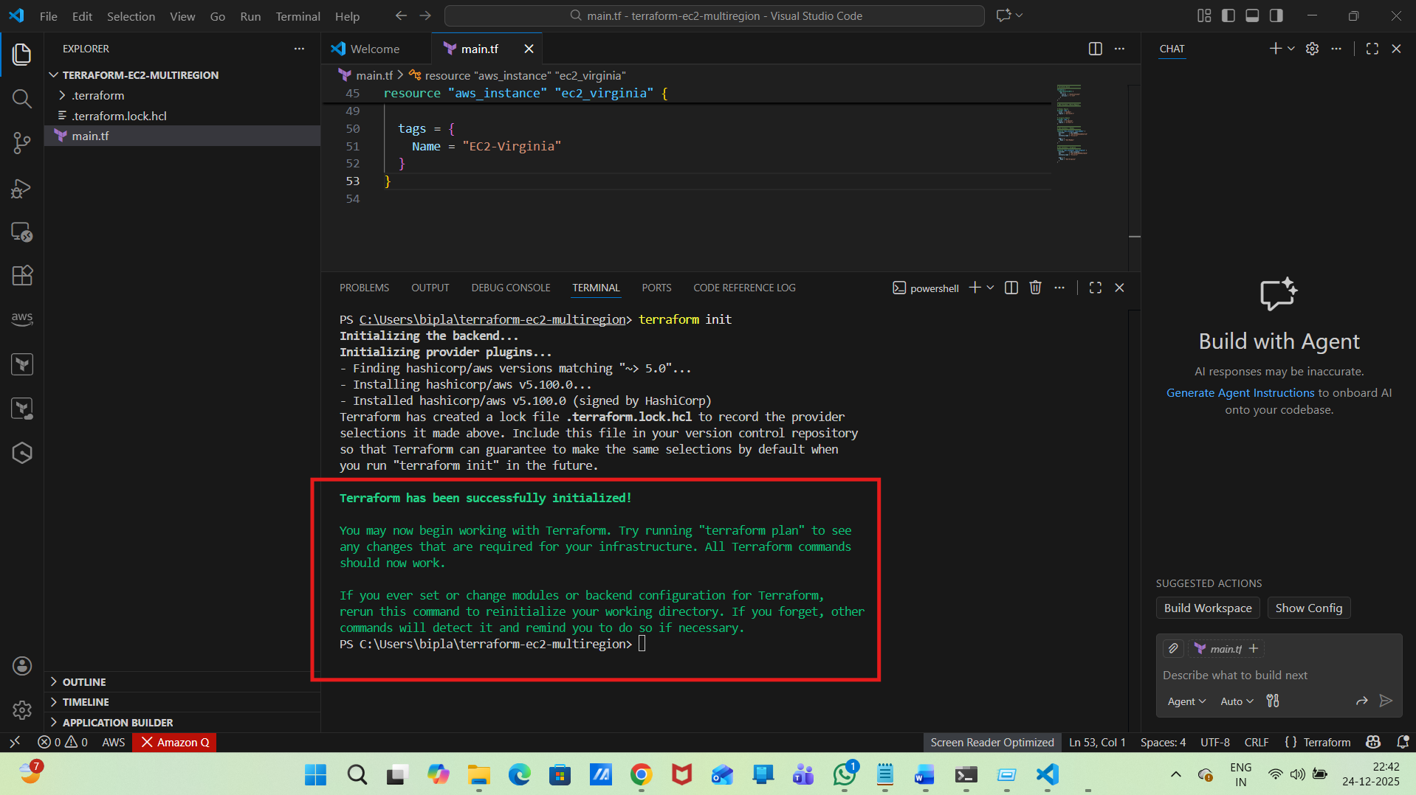
step-3: validate terraform
terraform validate
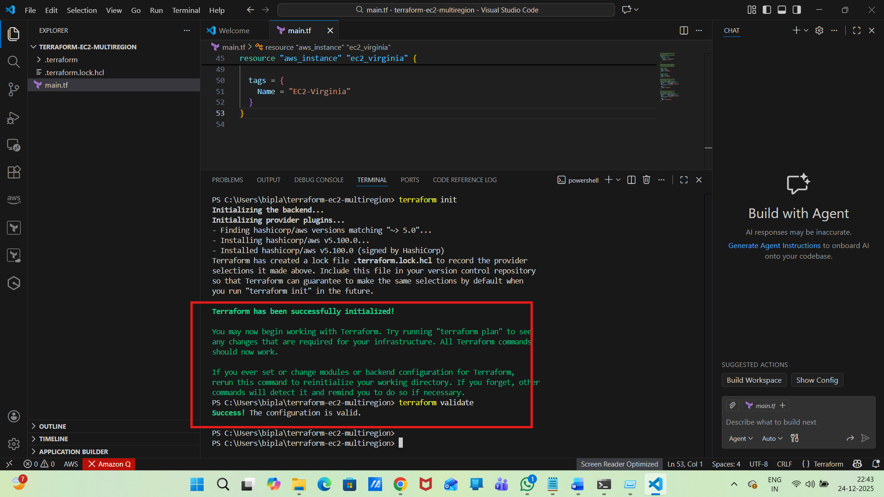
step-4:
terraform plan
Error :
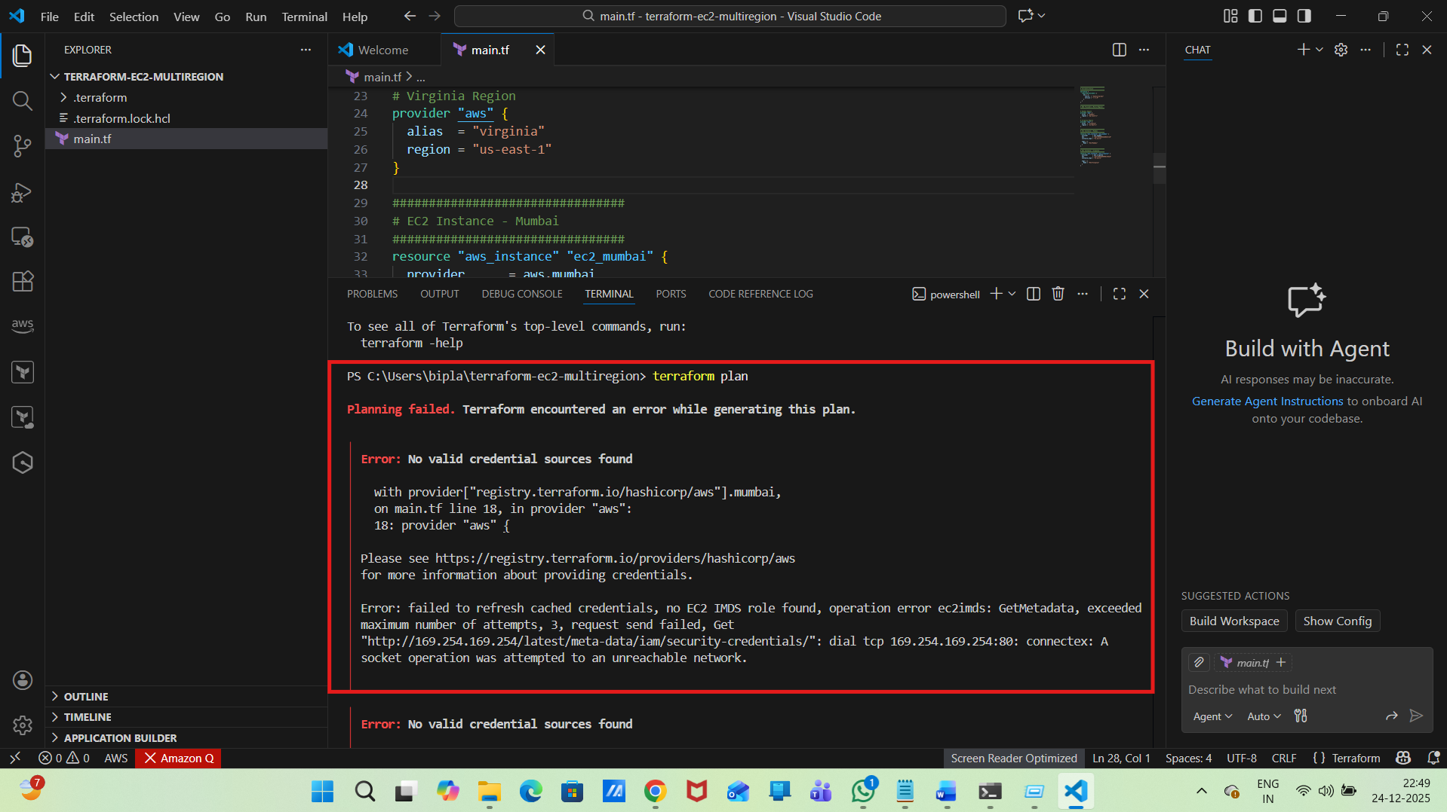
Resolution :
Configure AWS CLI Credentials
check aws version in VS code
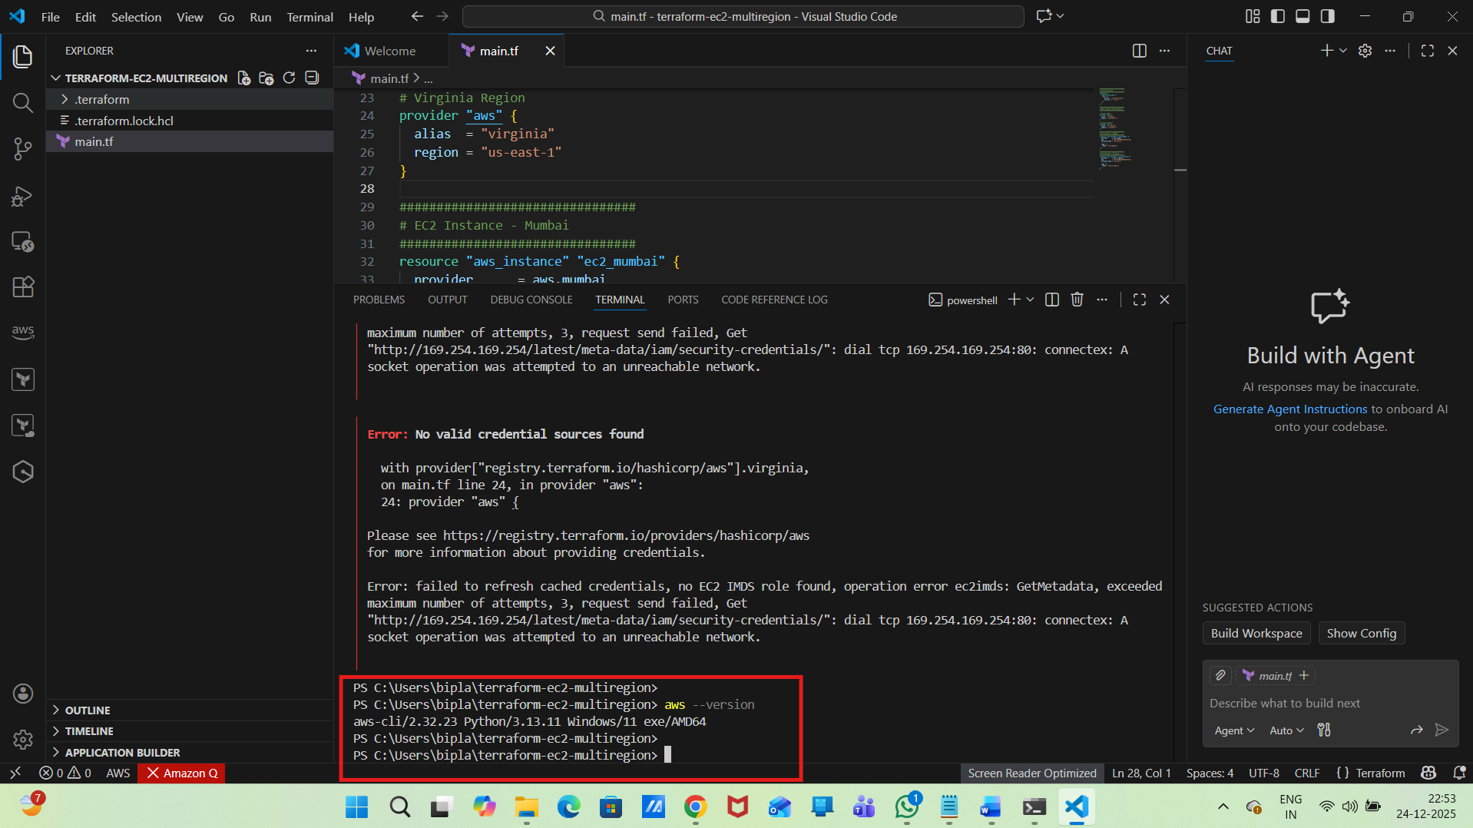
Then Get AWS Credentials from AWS Console
For that, we need:
Access Key ID
Secret Access Key
Where can you get them:

Create user
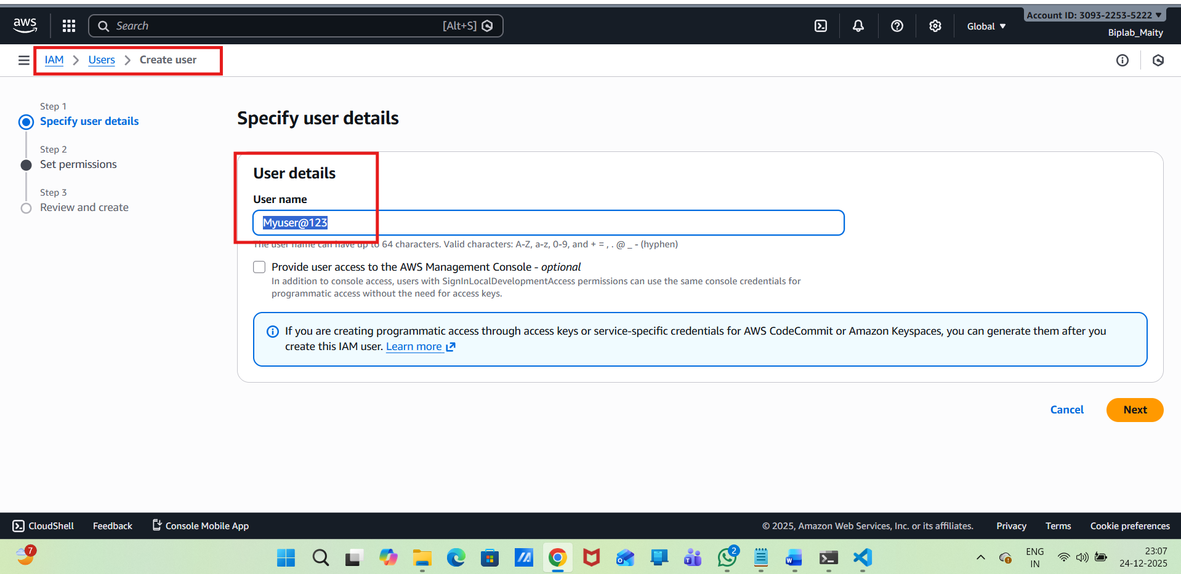
Select Attach policies directly
Attach:
AmazonEC2FullAccess
AmazonVPCFullAccess
IAMReadOnlyAccess
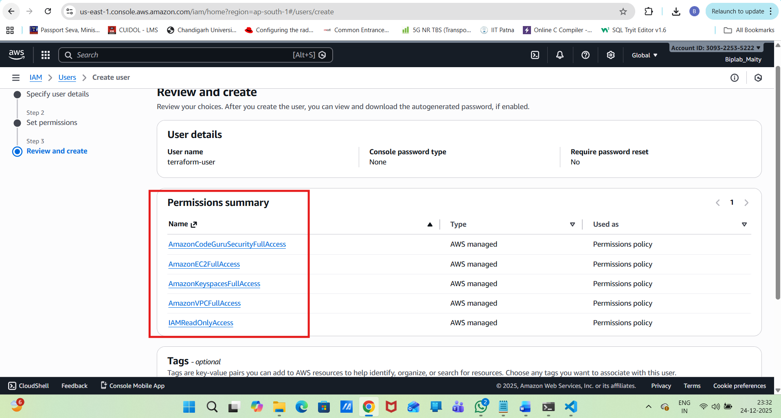
Add Tags
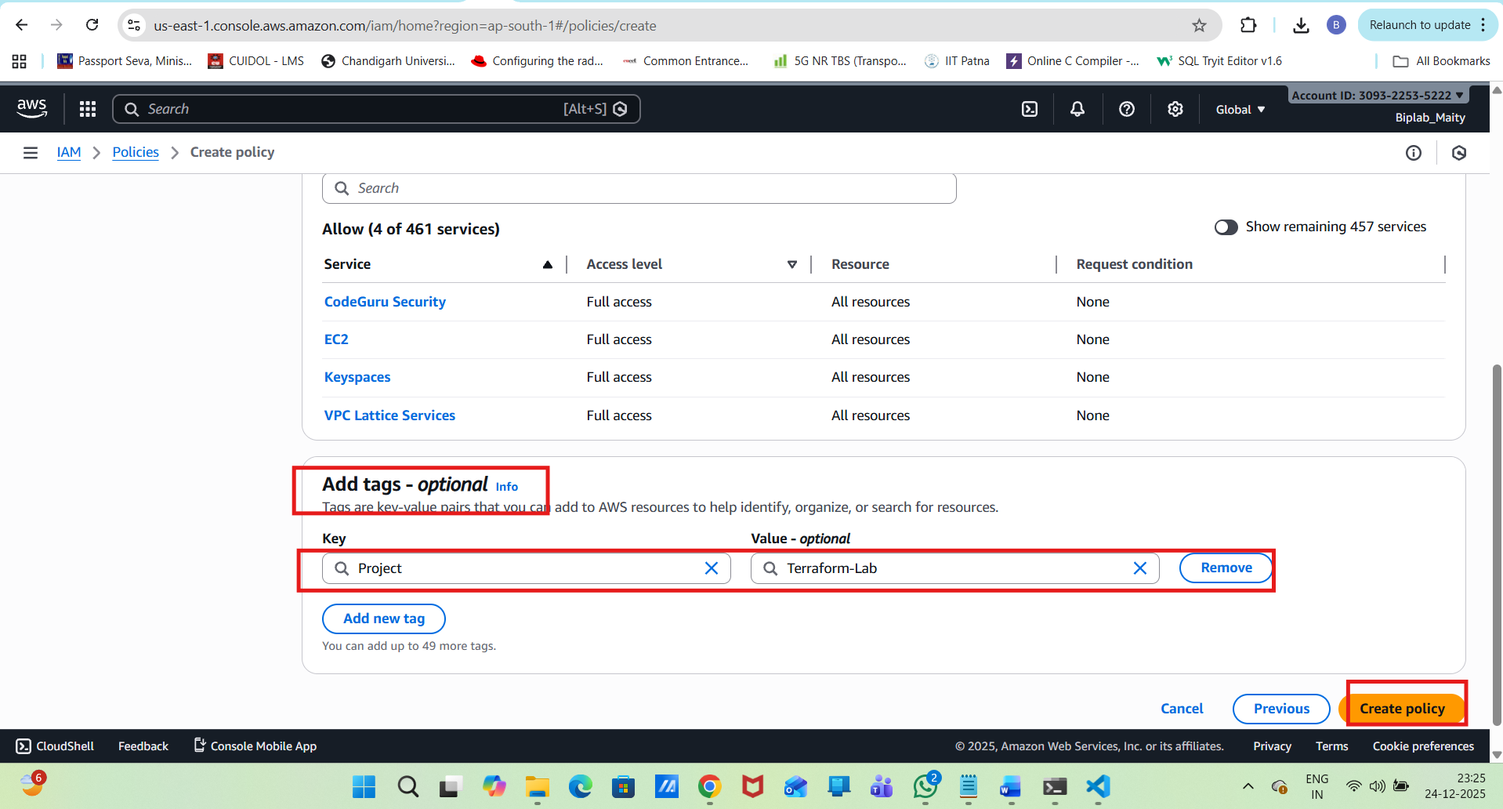
Generate Access Keys:
IAM → Users → terraform-user
→ Security credentials tab
→ Access keys → Create access key
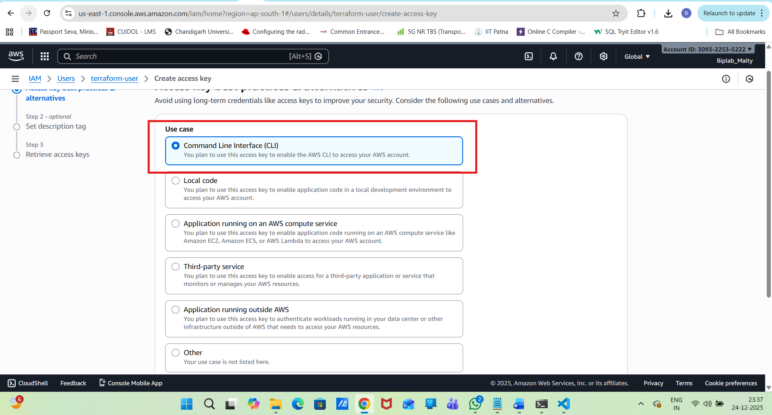
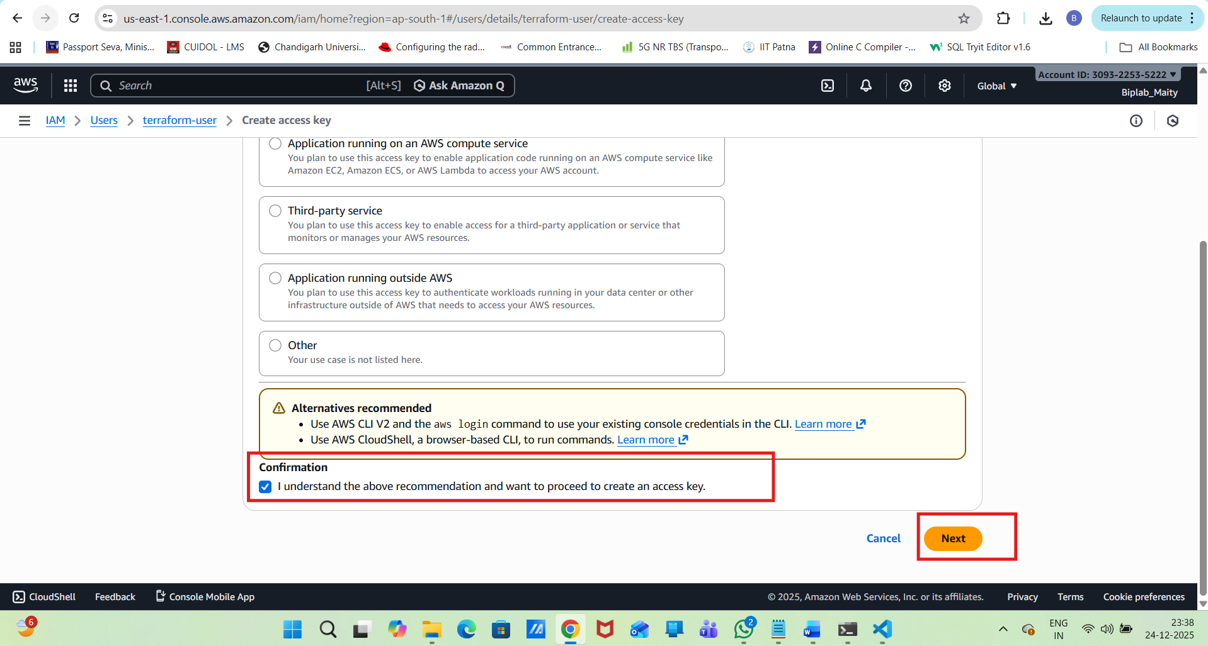
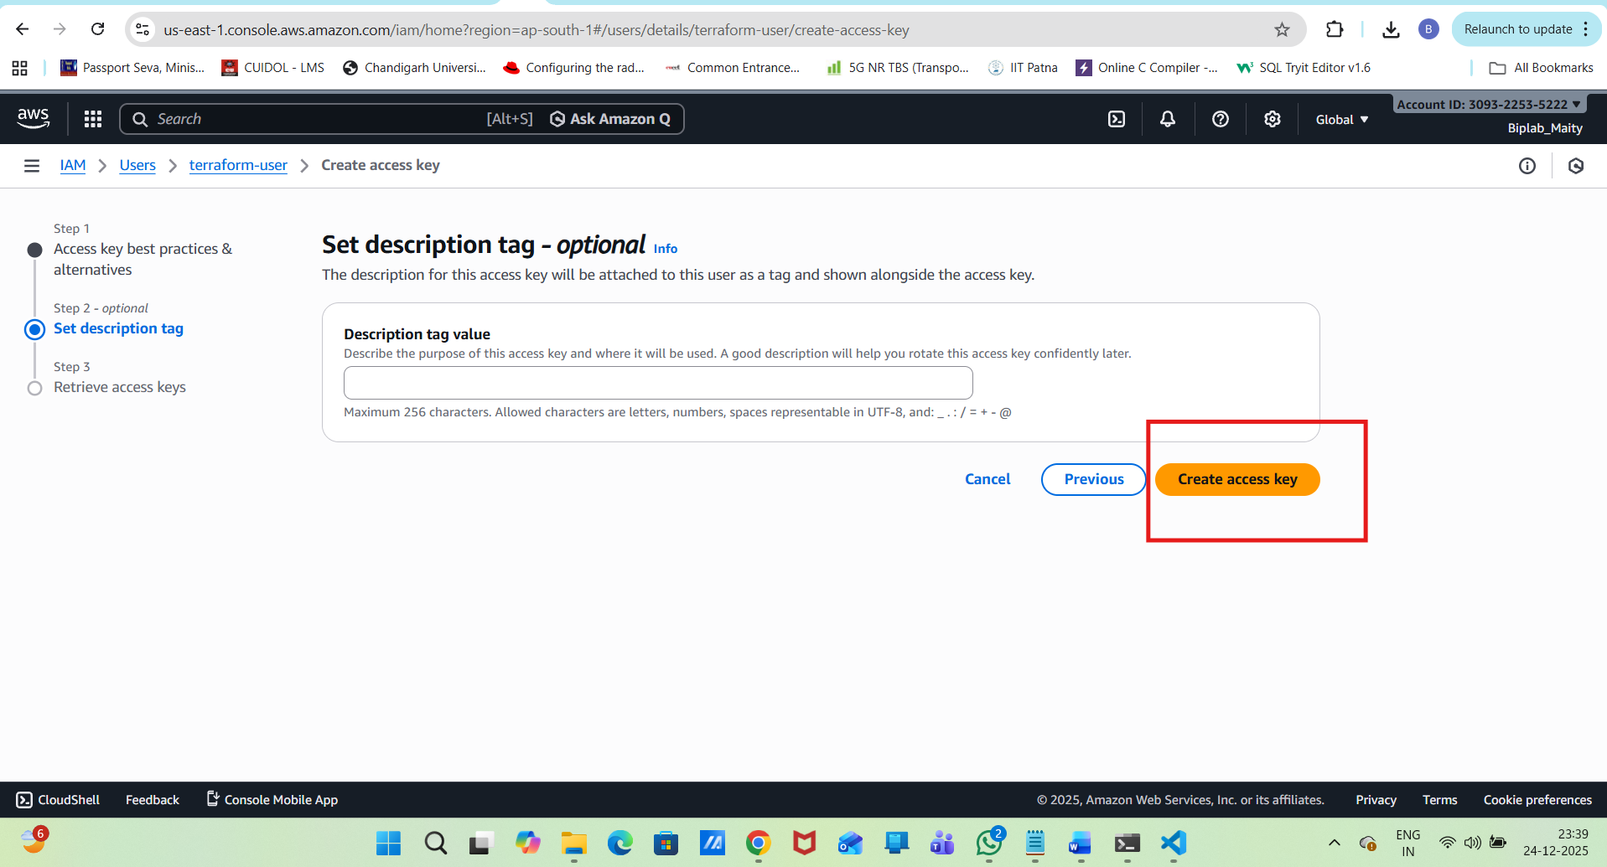
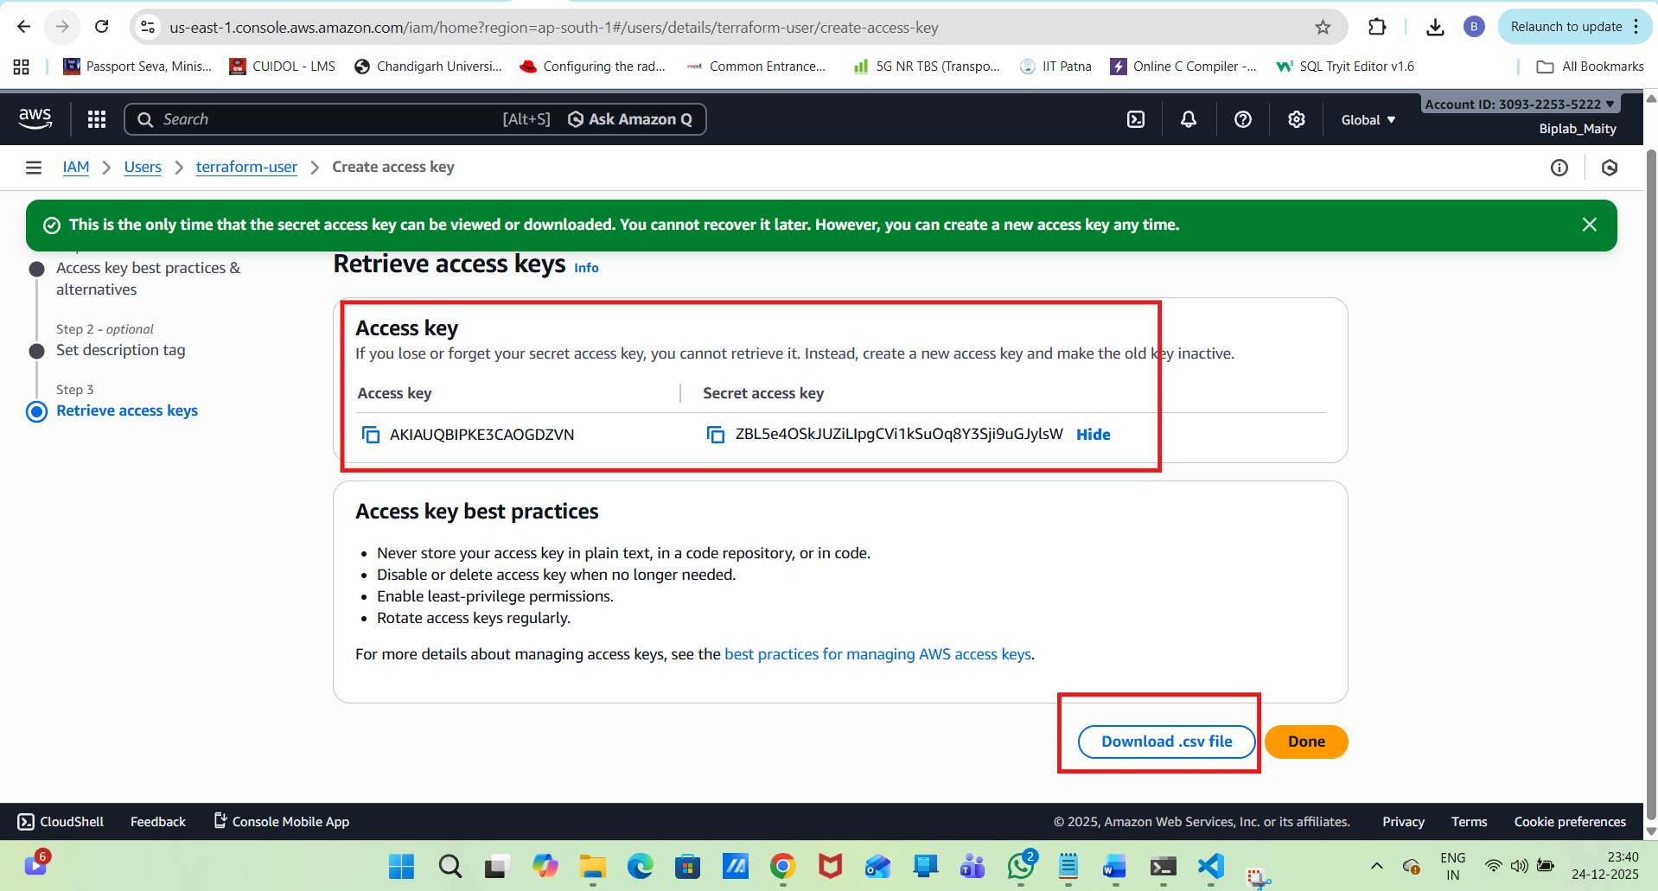
Now download
Access key
Secret key
Configure AWS CLI:
aws configure
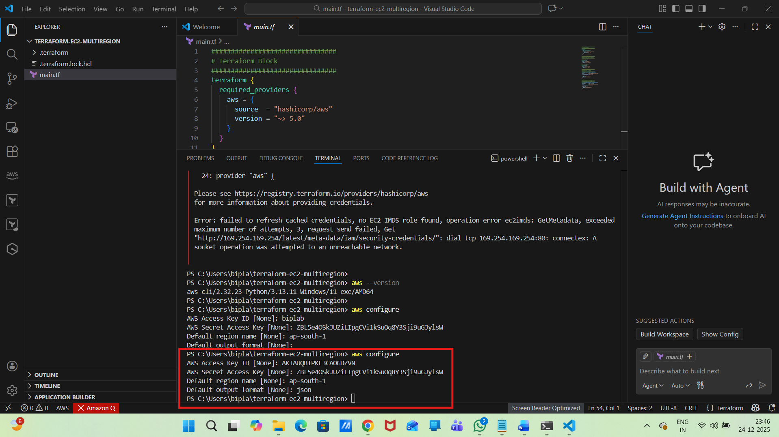
Verify:
aws sts get-caller-identity
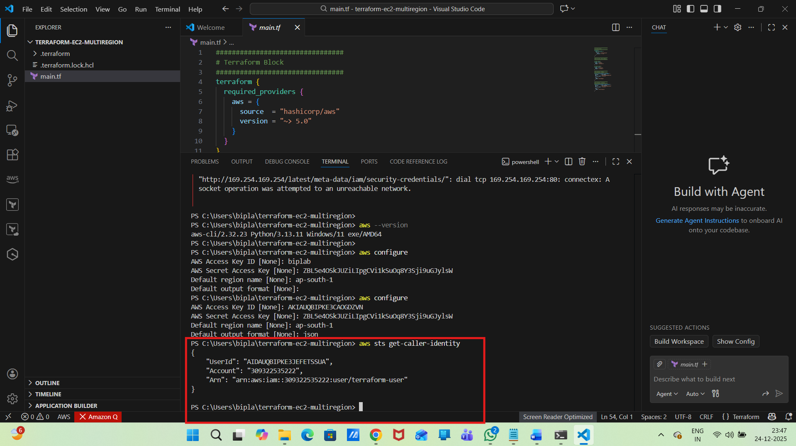
terraform init
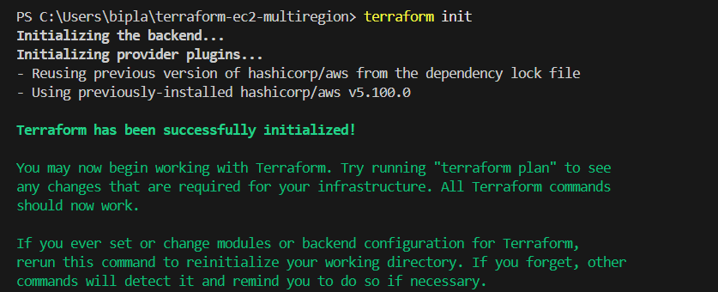
terraform plan
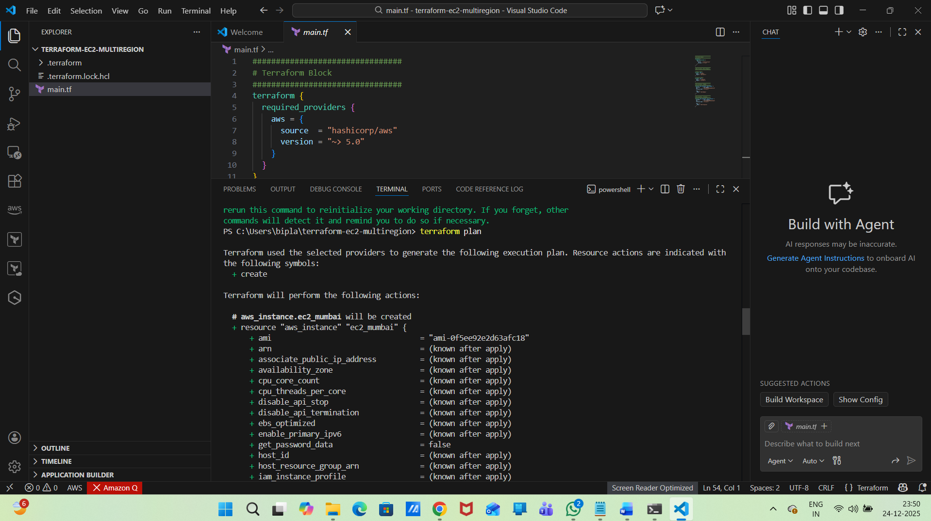
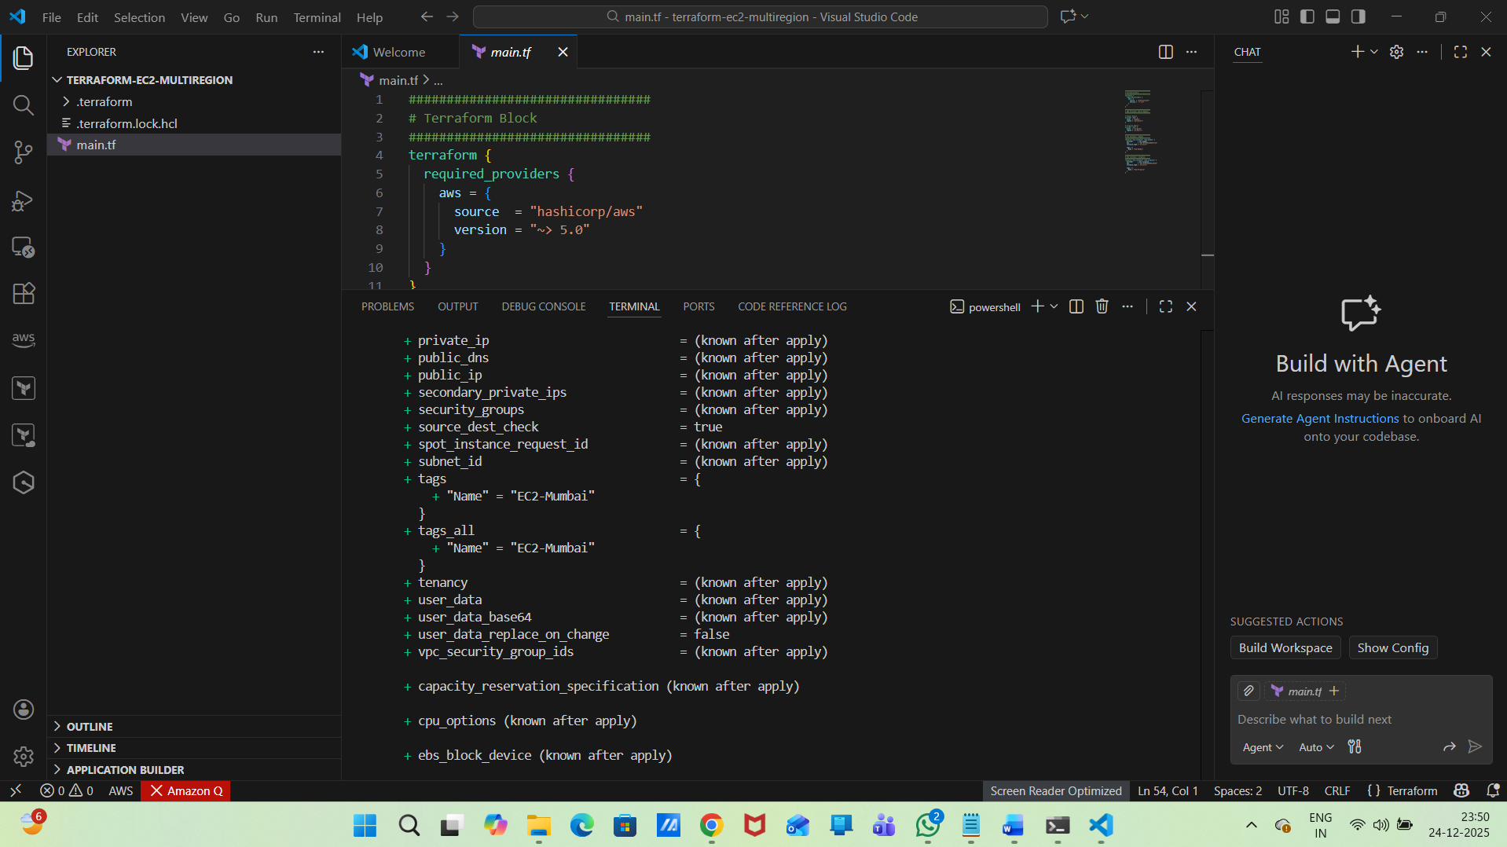
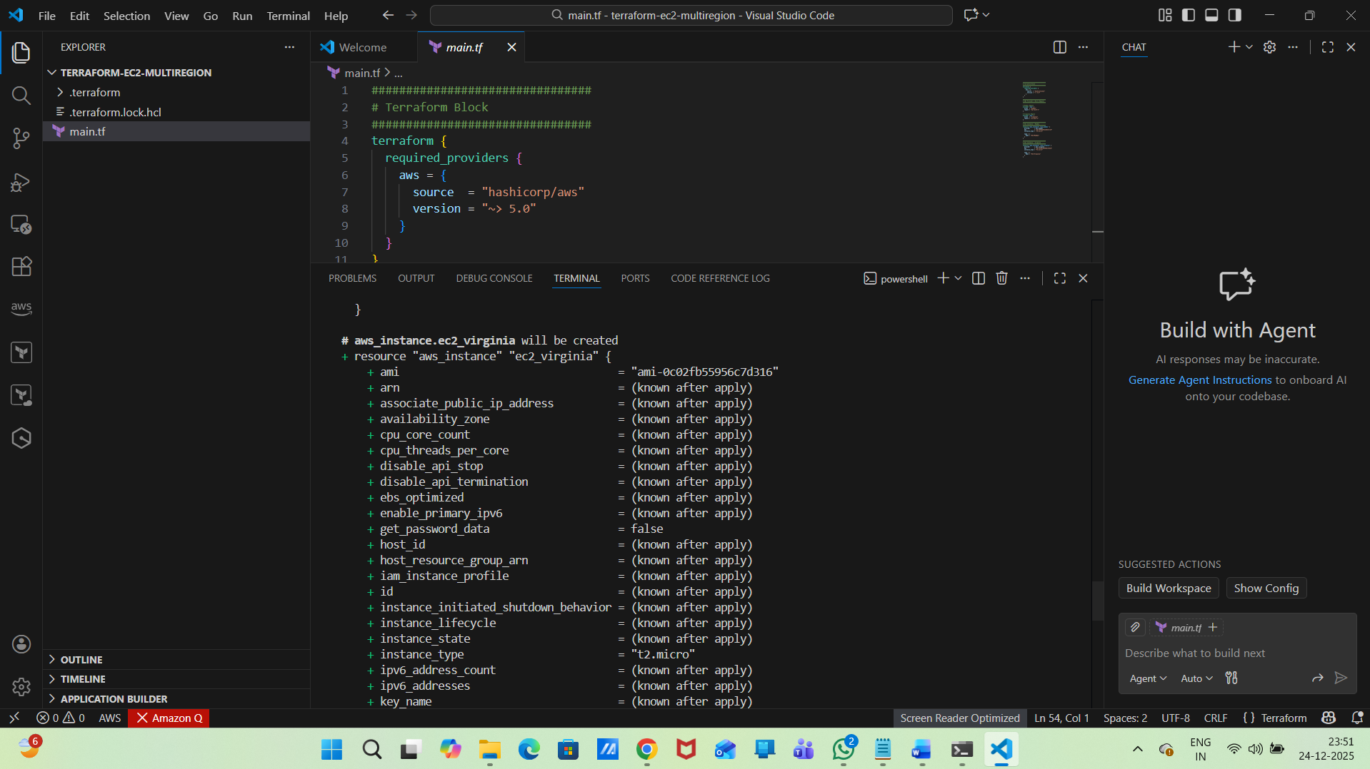
Apply (Create EC2 Instances):
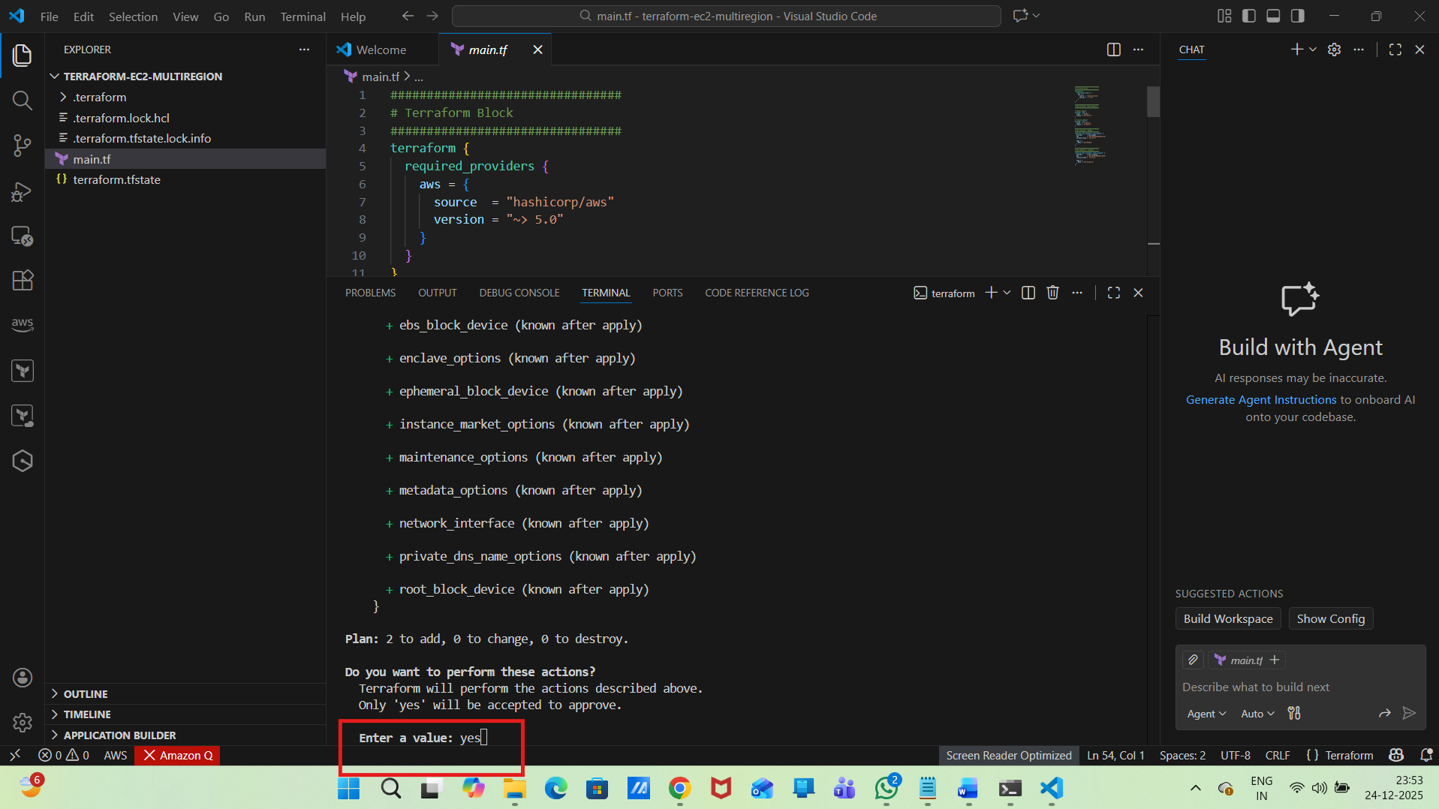
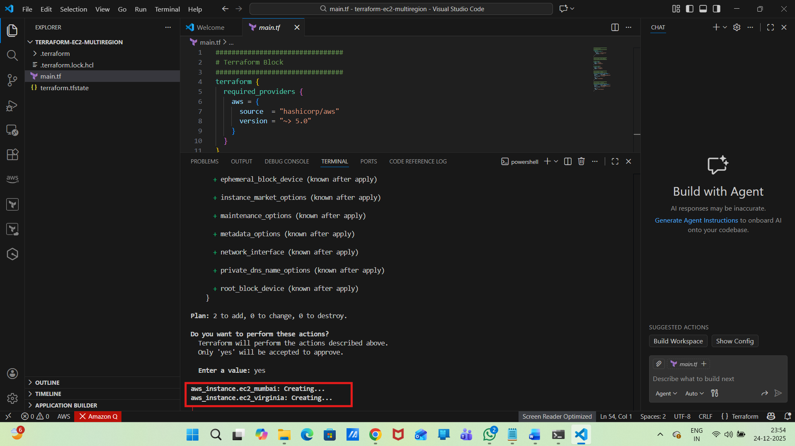
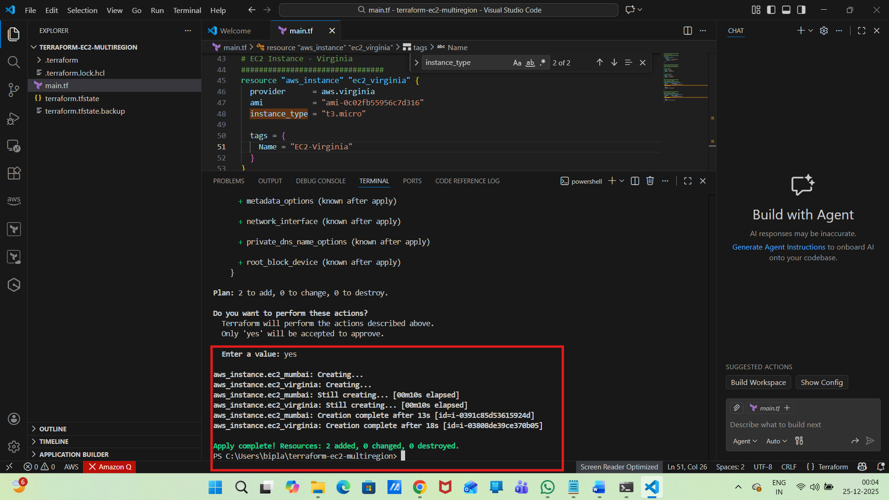
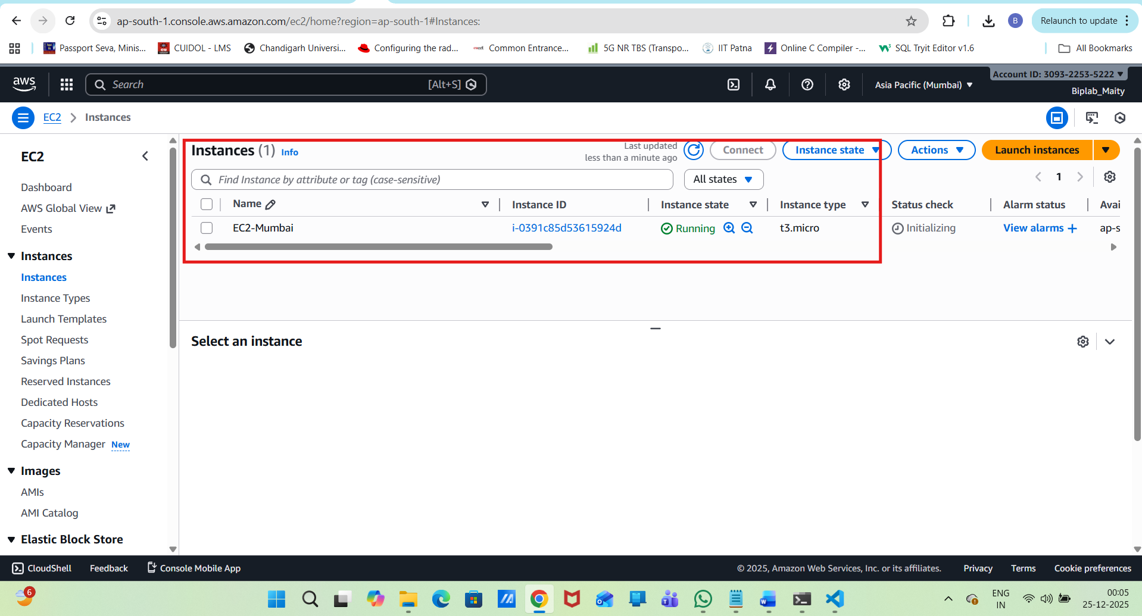
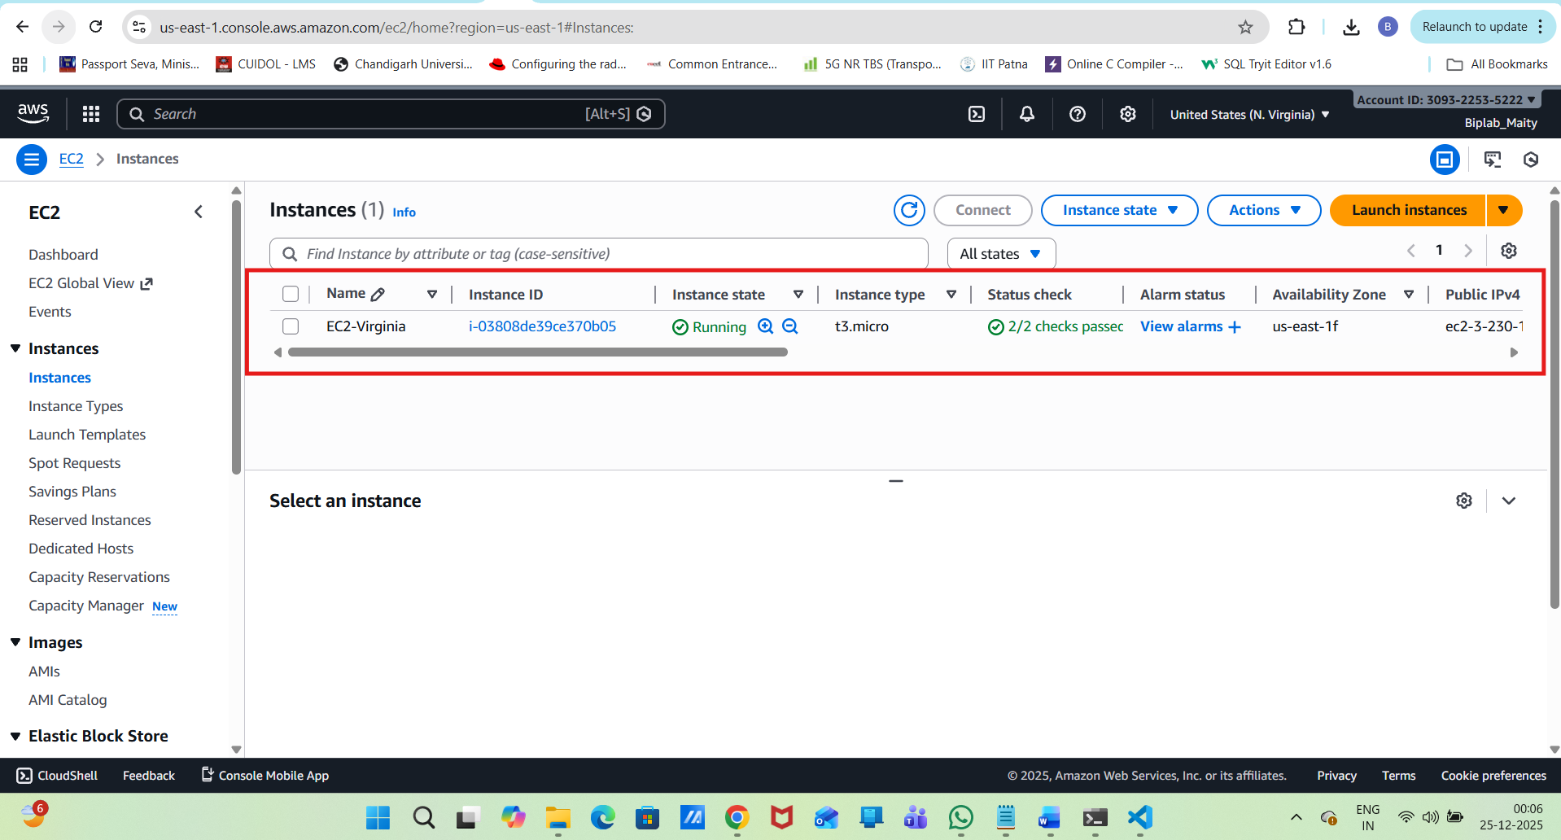
we can also Verify Using AWS CLI
aws ec2 describe-instances --region ap-south-1
aws ec2 describe-instances --region us-east-1
>>>>>>>>>>>>>>>>
PS C:\Users\bipla\terraform-ec2-multiregion> aws ec2 describe-instances --region ap-south-1
{
"Reservations": [
{
"ReservationId": "r-0dfbfa7e2012bae17",
"OwnerId": "309322535222",
"Groups": [],
"Instances": [
{
"Architecture": "x86_64",
"BlockDeviceMappings": [
{
"DeviceName": "/dev/sda1",
"Ebs": {
"AttachTime": "2025-12-24T18:34:16+00:00",
"DeleteOnTermination": true,
"Status": "attached",
"VolumeId": "vol-0ee488aeaea189868"
}
}
],
"ClientToken": "terraform-20251224183414374200000001",
"EbsOptimized": false,
"EnaSupport": true,
"Hypervisor": "xen",
"NetworkInterfaces": [
{
"Association": {
"IpOwnerId": "amazon",
"PublicDnsName": "ec2-13-232-80-203.ap-south-1.compute.amazonaws.com",
"PublicIp": "13.232.80.203"
},
"Attachment": {
"AttachTime": "2025-12-24T18:34:15+00:00",
"AttachmentId": "eni-attach-023d6df6599dc95bd",
"DeleteOnTermination": true,
"DeviceIndex": 0,
"Status": "attached",
"NetworkCardIndex": 0
},
"Description": "",
"Groups": [
{
"GroupId": "sg-087bcc69e9ec8f044",
"GroupName": "default"
}
],
"Ipv6Addresses": [],
"MacAddress": "0a:31:76:f2:66:79",
"NetworkInterfaceId": "eni-0afa5ba7211942dcb",
"OwnerId": "309322535222",
"PrivateDnsName": "ip-172-31-11-156.ap-south-1.compute.internal",
"PrivateIpAddress": "172.31.11.156",
"PrivateIpAddresses": [
{
"Association": {
"IpOwnerId": "amazon",
"PublicDnsName": "ec2-13-232-80-203.ap-south-1.compute.amazonaws.com",
"PublicIp": "13.232.80.203"
},
"Primary": true,
"PrivateDnsName": "ip-172-31-11-156.ap-south-1.compute.internal",
"PrivateIpAddress": "172.31.11.156"
}
],
"SourceDestCheck": true,
"Status": "in-use",
"SubnetId": "subnet-0c8db688ea20671d1",
"VpcId": "vpc-0f4bfb6f45b7bd5f3",
"InterfaceType": "interface",
"Operator": {
"Managed": false
}
}
],
"RootDeviceName": "/dev/sda1",
"RootDeviceType": "ebs",
"SecurityGroups": [
{
"GroupId": "sg-087bcc69e9ec8f044",
"GroupName": "default"
}
],
"SourceDestCheck": true,
"Tags": [
{
"Key": "Name",
"Value": "EC2-Mumbai"
}
],
"VirtualizationType": "hvm",
"CpuOptions": {
"CoreCount": 1,
"ThreadsPerCore": 2
},
"CapacityReservationSpecification": {
"CapacityReservationPreference": "open"
},
"HibernationOptions": {
"Configured": false
},
"MetadataOptions": {
"State": "applied",
"HttpTokens": "optional",
"HttpPutResponseHopLimit": 1,
"HttpEndpoint": "enabled",
"HttpProtocolIpv6": "disabled",
"InstanceMetadataTags": "disabled"
},
"EnclaveOptions": {
"Enabled": false
},
"PlatformDetails": "Linux/UNIX",
"UsageOperation": "RunInstances",
"UsageOperationUpdateTime": "2025-12-24T18:34:15+00:00",
"PrivateDnsNameOptions": {
"HostnameType": "ip-name",
"EnableResourceNameDnsARecord": false,
"EnableResourceNameDnsAAAARecord": false
},
"MaintenanceOptions": {
"AutoRecovery": "default",
"RebootMigration": "default"
},
"CurrentInstanceBootMode": "legacy-bios",
"NetworkPerformanceOptions": {
"BandwidthWeighting": "default"
},
"Operator": {
"Managed": false
},
"InstanceId": "i-0391c85d53615924d",
"ImageId": "ami-0f5ee92e2d63afc18",
"State": {
"Code": 16,
"Name": "running"
},
"PrivateDnsName": "ip-172-31-11-156.ap-south-1.compute.internal",
"PublicDnsName": "ec2-13-232-80-203.ap-south-1.compute.amazonaws.com",
"StateTransitionReason": "",
"AmiLaunchIndex": 0,
"ProductCodes": [],
"InstanceType": "t3.micro",
"LaunchTime": "2025-12-24T18:34:15+00:00",
"Placement": {
"AvailabilityZoneId": "aps1-az3",
"GroupName": "",
"Tenancy": "default",
"AvailabilityZone": "ap-south-1b"
},
"Monitoring": {
"State": "disabled"
},
"SubnetId": "subnet-0c8db688ea20671d1",
"VpcId": "vpc-0f4bfb6f45b7bd5f3",
"PrivateIpAddress": "172.31.11.156",
"PublicIpAddress": "13.232.80.203"
}
]
}
]
}

PS C:\Users\bipla\terraform-ec2-multiregion> aws ec2 describe-instances --region us-east-1
{
"Reservations": [
{
"ReservationId": "r-0705306d504030f10",
"OwnerId": "309322535222",
"Groups": [],
"Instances": [
{
"Architecture": "x86_64",
"BlockDeviceMappings": [
{
"DeviceName": "/dev/xvda",
"Ebs": {
"AttachTime": "2025-12-24T18:34:18+00:00",
"DeleteOnTermination": true,
"Status": "attached",
"VolumeId": "vol-03df885eb7c320592"
}
}
],
"ClientToken": "terraform-20251224183415424800000001",
"EbsOptimized": false,
"EnaSupport": true,
"Hypervisor": "xen",
"NetworkInterfaces": [
{
"Association": {
"IpOwnerId": "amazon",
"PublicDnsName": "ec2-3-230-148-232.compute-1.amazonaws.com",
"PublicIp": "3.230.148.232"
},
"Attachment": {
"AttachTime": "2025-12-24T18:34:17+00:00",
"AttachmentId": "eni-attach-03ed6a72394fe6012",
"DeleteOnTermination": true,
"DeviceIndex": 0,
"Status": "attached",
"NetworkCardIndex": 0
},
"Description": "",
"Groups": [
{
"GroupId": "sg-05277b20b4005b8c9",
"GroupName": "default"
}
],
"Ipv6Addresses": [],
"MacAddress": "16:ff:f2:97:4f:89",
"NetworkInterfaceId": "eni-0a47b86edb41bd188",
"OwnerId": "309322535222",
"PrivateDnsName": "ip-172-31-68-5.ec2.internal",
"PrivateIpAddress": "172.31.68.5",
"PrivateIpAddresses": [
{
"Association": {
"IpOwnerId": "amazon",
"PublicDnsName": "ec2-3-230-148-232.compute-1.amazonaws.com",
"PublicIp": "3.230.148.232"
},
"Primary": true,
"PrivateDnsName": "ip-172-31-68-5.ec2.internal",
"PrivateIpAddress": "172.31.68.5"
}
],
"SourceDestCheck": true,
"Status": "in-use",
"SubnetId": "subnet-0e862a4fc38b08f83",
"VpcId": "vpc-02703e7eb7084baa7",
"InterfaceType": "interface",
"Operator": {
"Managed": false
}
}
],
"RootDeviceName": "/dev/xvda",
"RootDeviceType": "ebs",
"SecurityGroups": [
{
"GroupId": "sg-05277b20b4005b8c9",
"GroupName": "default"
}
],
"SourceDestCheck": true,
"Tags": [
{
"Key": "Name",
"Value": "EC2-Virginia"
}
],
"VirtualizationType": "hvm",
"CpuOptions": {
"CoreCount": 1,
"ThreadsPerCore": 2
},
"CapacityReservationSpecification": {
"CapacityReservationPreference": "open"
},
"HibernationOptions": {
"Configured": false
},
"MetadataOptions": {
"State": "applied",
"HttpTokens": "optional",
"HttpPutResponseHopLimit": 1,
"HttpEndpoint": "enabled",
"HttpProtocolIpv6": "disabled",
"InstanceMetadataTags": "disabled"
},
"EnclaveOptions": {
"Enabled": false
},
"PlatformDetails": "Linux/UNIX",
"UsageOperation": "RunInstances",
"UsageOperationUpdateTime": "2025-12-24T18:34:17+00:00",
"PrivateDnsNameOptions": {
"HostnameType": "ip-name",
"EnableResourceNameDnsARecord": false,
"EnableResourceNameDnsAAAARecord": false
},
"MaintenanceOptions": {
"AutoRecovery": "default",
"RebootMigration": "default"
},
"CurrentInstanceBootMode": "legacy-bios",
"NetworkPerformanceOptions": {
"BandwidthWeighting": "default"
},
"Operator": {
"Managed": false
},
"InstanceId": "i-03808de39ce370b05",
"ImageId": "ami-0c02fb55956c7d316",
"State": {
"Code": 16,
"Name": "running"
},
"PrivateDnsName": "ip-172-31-68-5.ec2.internal",
"PublicDnsName": "ec2-3-230-148-232.compute-1.amazonaws.com",
"StateTransitionReason": "",
"AmiLaunchIndex": 0,
"ProductCodes": [],
"InstanceType": "t3.micro",
"LaunchTime": "2025-12-24T18:34:17+00:00",
"Placement": {
"AvailabilityZoneId": "use1-az5",
"GroupName": "",
"Tenancy": "default",
"AvailabilityZone": "us-east-1f"
},
"Monitoring": {
"State": "disabled"
},
"SubnetId": "subnet-0e862a4fc38b08f83",
"VpcId": "vpc-02703e7eb7084baa7",
"PrivateIpAddress": "172.31.68.5",
"PublicIpAddress": "3.230.148.232"
}
]
}
]
}
Destroy Resources :
terraform destroy
