- Create a shell script to print the HTTP error code of guvi.in & print, the success/failure message based on the error code response.

Main script(scripting_task1.sh): 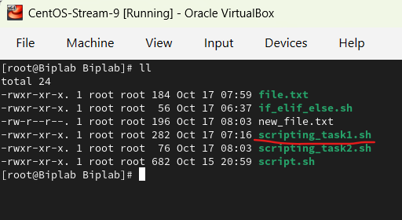

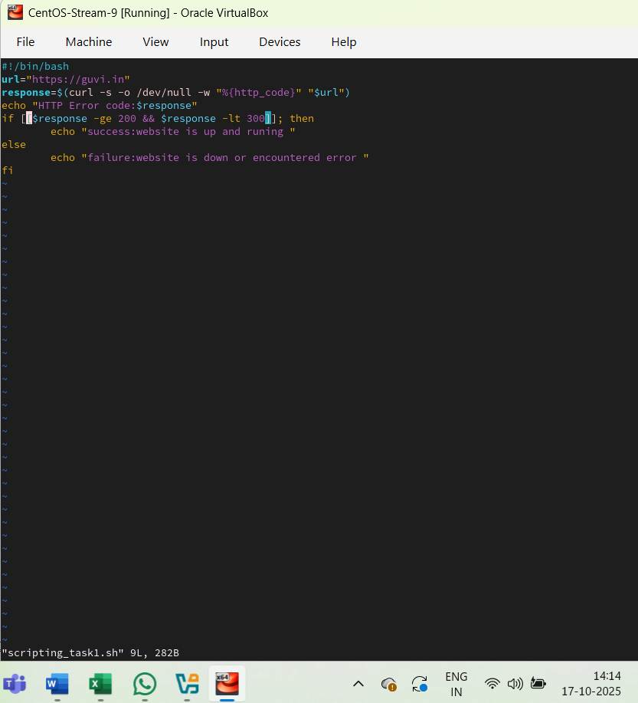

OutPUT:
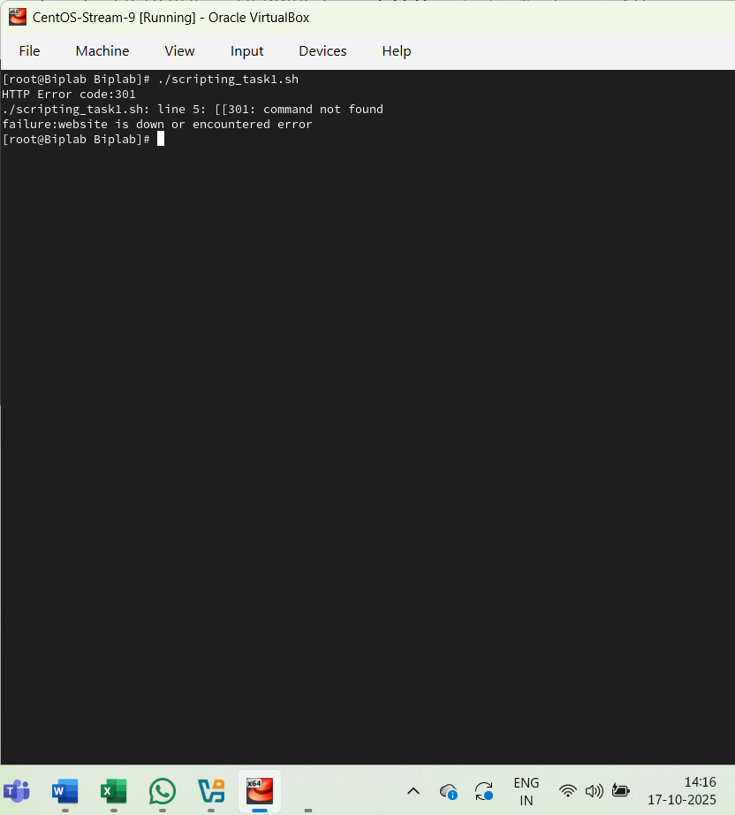

- Given a file, replace all occurrence of the word "give" with "learning" from 5th line till the end in only those lines that contain the word "welcome"

Main script(scripting_task2.sh):
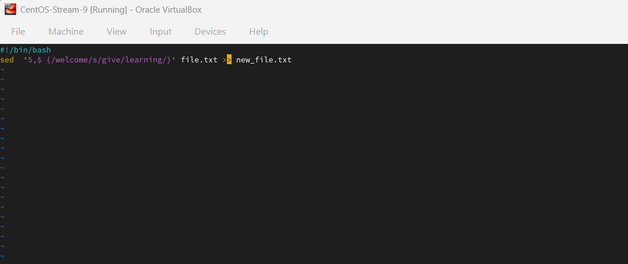

Input text file(file.txt):
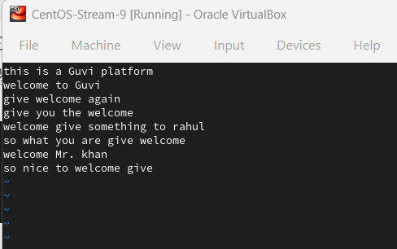

Created output text file(new_file.txt):
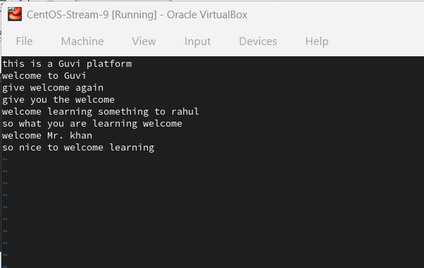
All files for task-2:
