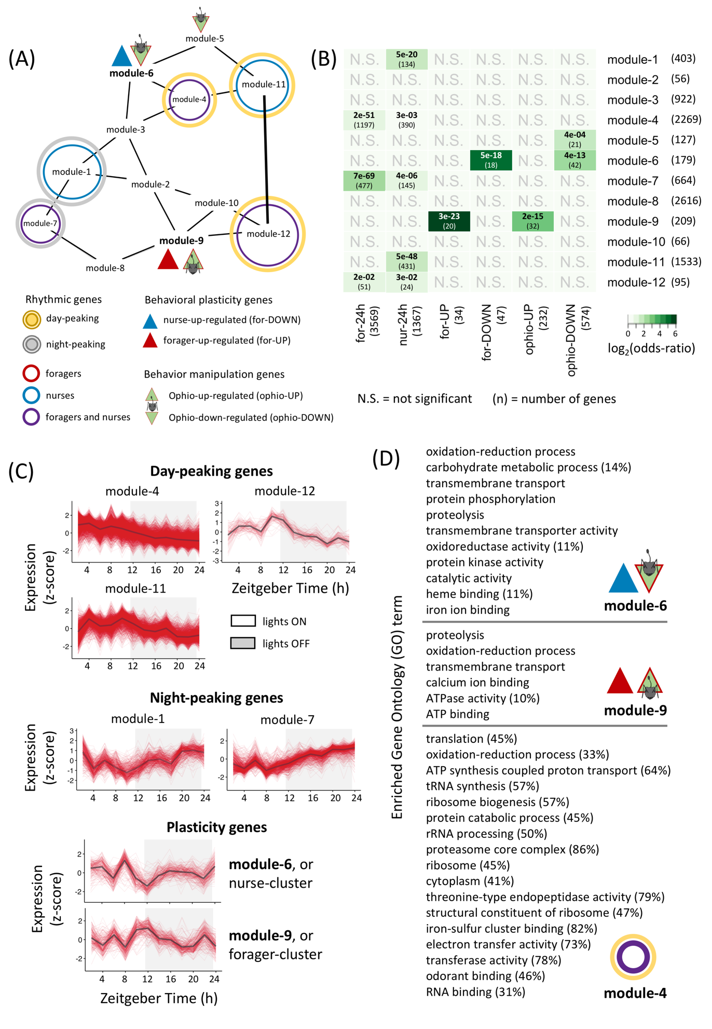

Figure XX. **The gene co-expression network (GCN) in *Camponotus floridanus* ant brains.** (A) The figure shows a simplified view of the network in which we identified twelve modules of highly co-expressed genes. The figure also identifies the different modules of interest that are putatively important for the interplay of rhythmicity, behavioral plasticity and parasitic behavioral manipulation. For example, module-6 shows a significant overrepresentation of genes involved in ant behavioral plasticity and parasite-induced behavioral manipulation, whereas module-4 is significantly enriched in ant genes that show 24h-rhythms and a peak expression during the day. Significant overlap between two genesets was inferred using a Fisher’s exact test. (B) The heatmap shows the results of all the pairwise Fisher’s exact test used to annotate the ant brain GCN. The color of the boxes represents the odds-ratio (darker the green, higher is the odds-ratio) and the Benjamini-Hochberg corrected p-values are shown. In addition to p-values, the number of genes overlapping between a module-geneset pair is shown in parenthesis. Non-significant overlaps between modules and genesets are indicated with a N.S., and the number of genes in a module or geneset are shown in parenthesis. (C) The daily expression pattern of all genes in a given module as well as the module’s median gene expression are shown. For a module, each red line represents the expression of one gene, every 2h over a 24h day, and the black line represents the module’s median gene expression. The x-axis shows the time-of-day or Zeitgeber Time in hours, whereas the y-axis shows normalized gene expression (z-scores calculated from log2-transformed expression data). The 12h:12h light-dark cycles during which the samples were collected are also shown; white background indicates the light phase (lights on at ZT24/ZT0) and grey background indicates the dark phase (lights turned off at ZT12). (D) The Gene Ontology (GO) terms that we found to be significantly overrepresented in the different modules are shown. For a given enriched GO term, the number in parenthesis indicates what percentage of all genes annotated with the term is found in the module. For example, module-6 contains 14% of all “carbohydrate metabolic process” genes in *C. floridanus*, whereas 45% of all genes annotated with “translation” are found in module-4. Percentages that are higher than 10 are only shown.