Systems analysis to understand host-parasite interactions: an overview

Systems analysis to understand host-parasite interactions: an example

In this section, we provide an example of using systems analysis to identify the host processes that are targeted by a behavior manipulating parasite, allowing us to form novel data-driven hypothesis.

In this section, we illustrate the usefulness of using systems tools to identify the host genes and processes that are affected by a behavior-manipulating parasite and the biological relevance of such targeted genes for the host.

Motivation: Several ant species are infected by the fungal parasite *Ophiocordyceps* sp. in a species-specific manner (REF). After a brief incubation period inside the ant, the parasite induces a suite of specific behavioral changes in the infected host: hyperactivity, nest abandonment, tree-top disease, and the characteristic “death-grip” (REF). Recently, we (Will et al. 2019) compared the transcriptomes of infected *Camponotus floridanus* ant heads during the manipulated death-grip to healthy controls to identify several host genes that underlie the parasite-induced behavioral manipulation (manipulation genes). Although the study identified the host genes that undergo differential expression, it remained to be seen what the importance of these genes are in the context of the complex system that underlies behavioral output in an ant.

Ants, like most social insects, are known to display extreme behavioral plasticity. [explain briefly the caste differentiation into forager and nurse ants]. To understand the chronobiological basis of behavioral plasticity in ants, we (Das and de Bekker, 2021; bioRxiv) compared the daily transcriptomes of *C. floridanus* forager and nurse brains. We found [blah, blah, blah; behavioral plasticity genes (DEGs)]. Once again, it remained to be seen if the behavioral plasticity genes in ants are scattered throughout the network of gene expression, or if they are co-localized.

Objective: The question we set out to answer was which regions of the host gene expression network is affected by the fungal parasite during manipulation, and if the same regions are enriched in host genes that are under clock control or underlie behavioral plasticity. The first step was to build the gene co-expression network (GCN) for *C. floridanus.* Time-course RNASeq data are ideal for creating such GCNs for the following reasons: (1) blah, (2) blah, and (3) blah.

We combined the time-course RNASeq datasets of nurse and forager brains to construct a generalized ant circadian GCN using the WGCNA pipeline (SUPP). Next, we annotated the ant circadian GCN by identifying modules that show significant overlap with genes that: (1) are 24h-rhythmic, (2) underlie ant behavioral plasticity, and (3) are involved in behavioral manipulation (SUPP). What we found was unexpected; the ant genes affected during parasite-induced behavioral manipulation are located in the same two clusters that contains most of the genes underlying ant behavioral plasticity (FIG). In other words, the manipulating parasite seems to be targeting the same genes and processes that allow ants to display extreme behavioral plasticity.

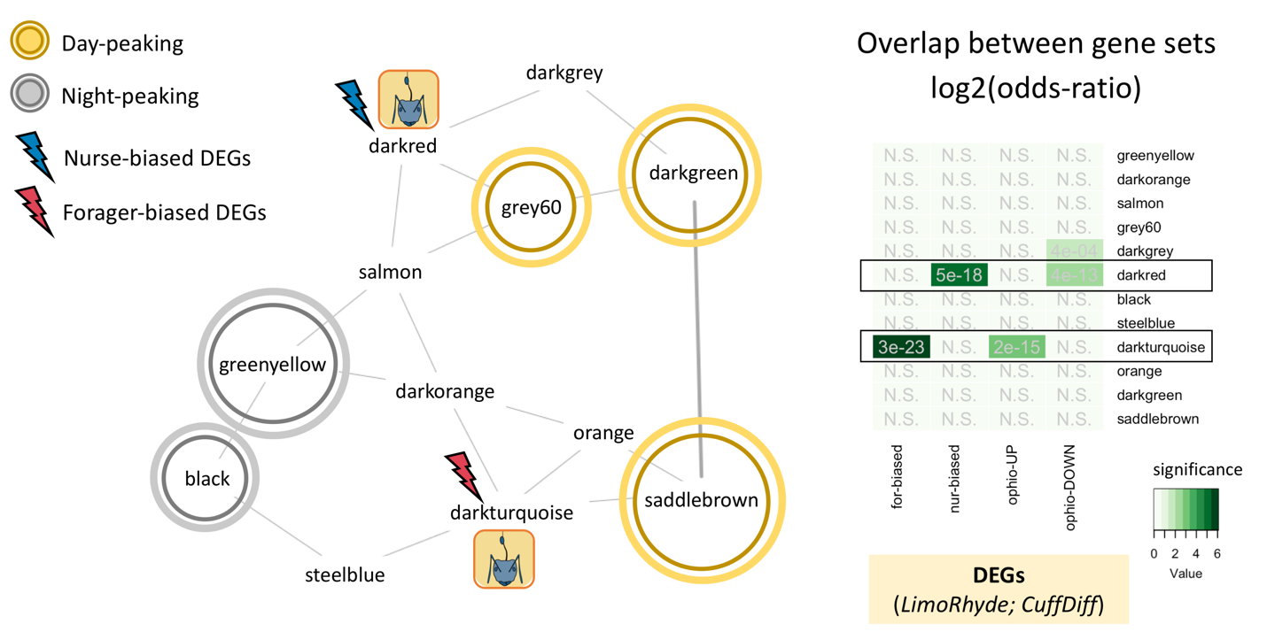

More specifically, the genes higher expressed in forager brains are significantly overrepresented in only one module, the darkturquoise cluster (called “forager-cluster” from here on). Whereas, the genes higher expressed in nurse brains are in the darkred cluster (called “nurse-cluster” from here on). Although the forager-cluster and the nurse-cluster do not contain genes that are 24h-rhythmic they are connected to the rhythmic modules (grey60 and saddlebrown). Differential expression of the forager- and nurse-cluster can affect the expression of the rhythmic modules and, therefore, induce changes to the rhythmic output at the physiological and behavioral level.

References

1. Langfelder P, Horvath S: **WGCNA: an R package for weighted correlation network analysis.** *BMC Bioinformatics* 2008, **9:**559.

2. Langfelder P, Luo R, Oldham MC, Horvath S: **Is My Network Module Preserved and Reproducible?** *PLOS Computational Biology* 2011, **7:**e1001057.