Host-parasite-clocks

Biplabendu Das

29 November, 2021

## Overview/Goals

This document provides a step-by-step tutorial on how to: - build a circadian gene co-expression network (GCN), - how to annotate the network using published data, - infer functions of your gene-clusters-of-interest.

## Step 1: Build circadian GCN

### 1.1 Load data

We will build a circadian GCN for the ant, Camponotus floridanus, using time-course RNASeq data collected in Das and de Bekker (2021; bioRxiv). The raw data is deposited in NCBI under BioProject PRJNA704762.

Description of the dataset: Three forager and three nurse ant brains were sampled and pooled for RNA extraction and Illumina sequencing, every 2h over a 24h period. This resulted in 24 RNASeq datasets for ant brains (12 forager and 12 nurse datasets over the course of a 24h LD 12:12 day).

One would need to perform the usual steps – trimming the reads, mapping the reads to the genome, and quantifying normalized gene counts – to obtain normalized gene expression data from the raw reads. At the end, for each gene in the genome, we should have the normalized expression for each time point, throughout the 24h day.

For the purpose of this tutorial, we assume that you have organized the processed data into a (gene-expr X time-point) format, in a chronological order, as shown below.

figure goes here

X2F = forager brain sampled at ZT2 (2h after lights were turned on), X4F = forager brain sampled at ZT4, and so on.

Now we read the data into R.

# loading database which contains data for Das and de Bekker 2021 (bioRxiv)  
db <- dbConnect(RSQLite::SQLite(), paste0(path_to_repo,"/data/databases/TC5_data.db"))  
  
# extract the (gene-expr X time-point) data  
dat <-  
 db %>%  
 tbl(., "annot_fpkm") %>%  
 select(gene_name, X2F:X24N) %>%  
 collect()  
  
dim(dat)

## [1] 13813 25

### 1.2 Clean data

The above dataset contains all genes (n=13,813) in the ant genome. However, not all of these genes are expressed in the ant brain, and some are expressed at very low levels that are not biologically meaningful.

Therefore, we will only keep the genes that are “expressed” (≥1 FPKM) in the ant brain, for at least half of all the sampled time points.

# Which genes are expressed throughout the day in both forager and nurses brains?  
daily.exp.genes <-  
 tbl(db, "expressed_genes") %>% # note, the information is already available in the database  
 filter(exp_half_for == "yes" & exp_half_nur == "yes") %>%  
 collect() %>%  
 pull(gene_name)  
  
# Subset the gene-expr X time-point file  
dat <- dat %>% filter(gene_name %in% daily.exp.genes)  
dim(dat)

## [1] 9139 25

This is our cleaned, input data file. The daily expression for these 9139 genes will be used to create the circadian GCN of Camponotus floridanus.

### 1.3 Format data

To create the ant GCN, we will need to calculate the expression similarity (co-expression) of different gene pairs. Therefore, we would like to normalize the gene expression data by log2-transformation. Let’s do that and visualize the result.

datExpr = as.data.frame(t(log2(dat[-c(1)]+1)))  
names(datExpr) = dat$gene_name  
rownames(datExpr) = names(dat)[-c(1)]  
  
# ----------------------------------------------------------- #  
# USE THE FOLLOWING CODE TO CHECK IF YOU HAVE ANY BAD SAMPLES #  
# ----------------------------------------------------------- #  
 # gsg = goodSamplesGenes(datExpr0, verbose = 3);  
 # gsg$allOK  
 #  
 # sampleTree = hclust(dist(datExpr0), method = "average");  
 # # Plot the sample tree: Open a graphic output window of size 12 by 9 inches  
 # # The user should change the dimensions if the window is too large or too small.  
 # sizeGrWindow(12,9)  
 # #pdf(file = "Plots/sampleClustering.pdf", width = 12, height = 9);  
 # par(cex = 1);  
 # par(mar = c(0,4,2,0))  
 # plot(sampleTree, main = "Sample clustering to detect outliers", sub="", xlab="", cex.lab = 1.5,  
 # cex.axis = 1.5, cex.main = 2)  
# ----------------------------------------------------------- #  
  
# save the number of genes and samples  
# that will be used to create the circadian GCN  
nGenes = ncol(datExpr)  
nSamples = nrow(datExpr)  
  
# visualize the log-transformed data  
x = reshape2::melt(as.matrix(t(datExpr)))  
colnames(x) = c('gene_id', 'sample', 'value')  
ggplot(x, aes(x=value, color=sample)) + geom_density() + theme_Publication()

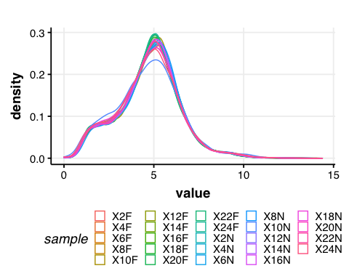

Figure 1. Normalized gene expression: The density plot above shows the distribution of log2-transformed gene expression values for each sample.

### 1.4 Calculate gene-gene similarity

Now, we can calculate the pairwise gene expression similarity for each of the 9139 genes and save it to a matrix.

I calculated expression similarity for all gene pairs in a dataset using Kendall’s tau, which measures the ordinal relationship between two variables and is used in rhythmicity detection algorithms [1].

## Calculate Kendall's tau-b correlation for each gene-gene pair  
#  
# sim_matrix <- cor((datExpr), method = "kendall") # this step takes time  
# save(sim_matrix, file = paste0(path_to_repo, "/results/temp_files/sim_matrix_for_nur_TC5.RData")) # might be useful to save the sim_matrix and  
load(paste0(path_to_repo, "/results/temp_files/sim_matrix_for_nur_TC5.RData")) # load it up  
  
## Let's display a chunk of the matrix (code from Hughitt 2016; github)  
heatmap_indices <- sample(nrow(sim_matrix), 500)  
gplots::heatmap.2(t(sim_matrix[heatmap_indices, heatmap_indices]),  
 col=inferno(100),  
 labRow=NA, labCol=NA,  
 trace='none', dendrogram='row',  
 xlab='Gene', ylab='Gene',  
 main='Similarity matrix \n correlation method = "kendall" \n (500 random genes)',  
 density.info='none', revC=TRUE)

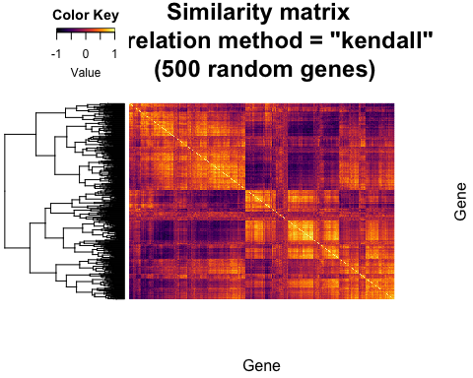

Figure 2. Similarity matrix: The heatmap shows the pairwise Kendall’s tau correlation for a set of 500 genes randomly pulled from the 9139 genes expressed in the ant brain.

### 1.5 Create adjacency matrix

From the above similarity matrix, we then need to create the adjacency matrix needed for constructing a gene co-expression network.

To create the adjacency matrix, we need to first identify the soft-thresholding power by calling the network topology analysis function from the WGCNA package [2].

# Choose a set of soft-thresholding powers  
powers = c(c(1:10), seq(from = 12, to=20, by=2))  
# # Call the network topology analysis function  
sft = pickSoftThreshold(datExpr, powerVector = powers, verbose = 5)

## pickSoftThreshold: will use block size 4895.  
## pickSoftThreshold: calculating connectivity for given powers...  
## ..working on genes 1 through 4895 of 9139  
## ..working on genes 4896 through 9139 of 9139  
## Power SFT.R.sq slope truncated.R.sq mean.k. median.k. max.k.  
## 1 1 0.845 1.900 0.995 3310.0 3390.00 4730  
## 2 2 0.248 0.276 0.930 1720.0 1710.00 3200  
## 3 3 0.343 -0.284 0.907 1050.0 988.00 2410  
## 4 4 0.696 -0.580 0.922 701.0 616.00 1930  
## 5 5 0.818 -0.762 0.951 499.0 402.00 1600  
## 6 6 0.847 -0.896 0.942 371.0 272.00 1360  
## 7 7 0.854 -0.992 0.933 285.0 190.00 1180  
## 8 8 0.868 -1.060 0.935 225.0 136.00 1030  
## 9 9 0.879 -1.110 0.940 181.0 99.10 919  
## 10 10 0.874 -1.160 0.928 148.0 73.40 824  
## 11 12 0.879 -1.220 0.928 103.0 42.20 676  
## 12 14 0.879 -1.280 0.921 74.8 25.40 568  
## 13 16 0.874 -1.310 0.916 56.1 15.80 485  
## 14 18 0.842 -1.360 0.884 43.2 10.10 420  
## 15 20 0.827 -1.390 0.874 34.0 6.64 367

# Plot the results:  
# sizeGrWindow(9, 5)  
par(mfrow = c(1,2));  
cex1 = 0.9;  
# Scale-free topology fit index as a function of the soft-thresholding power  
plot(sft$fitIndices[,1], -sign(sft$fitIndices[,3])*sft$fitIndices[,2],  
 xlab="Soft Threshold (power)",ylab="Scale Free Topology Model Fit,signed R^2",type="n",  
 main = paste("Scale independence"));  
text(sft$fitIndices[,1], -sign(sft$fitIndices[,3])*sft$fitIndices[,2],  
 labels=powers,cex=cex1,col="red");  
# this line corresponds to using an R^2 cut-off of h  
abline(h=0.90,col="red")  
# Mean connectivity as a function of the soft-thresholding power  
plot(sft$fitIndices[,1], sft$fitIndices[,5],  
 xlab="Soft Threshold (power)",ylab="Mean Connectivity", type="n",  
 main = paste("Mean connectivity"))  
text(sft$fitIndices[,1], sft$fitIndices[,5], labels=powers, cex=cex1,col="red")

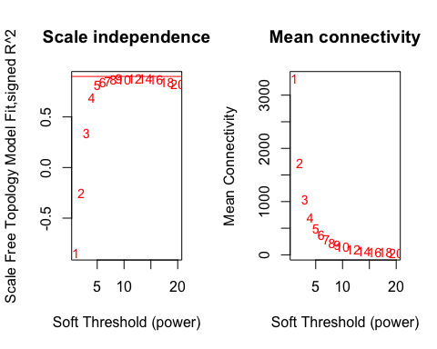

Figure 3. Soft-thresholding power: The above plots show the effect of soft-thresholding power on the topology and the mean connectivity of the transformed similarity matrix (network).

NOTE: The scale-free topology fit index reaches ~0.9 at a soft-thresholding power of 9 and it does not improve drastically beyond that.

So, we will set our soft thresholding power to 9 for creating the adjacency matrix.

## Specify the soft-thresholding-power  
soft.power = 9  
  
## Construct adjacency matrix  
# adj_matrix <- adjacency.fromSimilarity(sim_matrix,  
# power=soft.power,  
# type='signed'  
# )  
# save(adj_matrix, file = paste0(path_to_repo, "/results/temp_files/adj_matrix_for_nur_TC5.RData")) # might be useful to save the sim_matrix and  
load(paste0(path_to_repo, "/results/temp_files/adj_matrix_for_nur_TC5.RData")) # load it up  
  
  
# Convert adj_matrix to matrix  
gene_ids <- rownames(adj_matrix)  
  
adj_matrix <- matrix(adj_matrix, nrow=nrow(adj_matrix))  
rownames(adj_matrix) <- gene_ids  
colnames(adj_matrix) <- gene_ids  
  
## Same heatmap as before, but now with the power-transformed adjacency matrix  
gplots::heatmap.2(t(adj_matrix[heatmap_indices, heatmap_indices]),  
 col=inferno(100),  
 labRow=NA, labCol=NA,  
 trace='none', dendrogram='row',  
 xlab='Gene', ylab='Gene',  
 main='Adjacency matrix',  
 density.info='none', revC=TRUE)

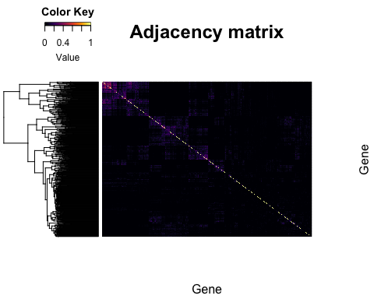

Figure 4. Adjacency matrix: The heatmap shows the result of the power-transformation on the similarity of the 500 random genes shown previously in Figure 2. As you can see, only the highest pair-wise correlations are retained whereas the weak correlations tend to zero.

## Step 2: Identify gene clusters

### 2.1 Create topological overalp matrix

# Turn adjacency into topological overlap  
# TOM = TOMsimilarity(adj_matrix);  
# dissTOM = 1-TOM  
# save(dissTOM, file = paste0(path_to_repo, "/results/temp_files/dissTOM_for_nur_TC5.RData")) # might be useful to save the sim_matrix and  
load(paste0(path_to_repo, "/results/temp_files/dissTOM_for_nur_TC5.RData")) # load it up  
  
# Call the hierarchical clustering function  
geneTree = hclust(as.dist(dissTOM), method = "average")  
  
# Plot the resulting clustering tree (dendrogram)  
# sizeGrWindow(12,9)  
plot(geneTree, xlab="", sub="", main = "Gene clustering on TOM-based dissimilarity",  
 labels = FALSE, hang = 0.04)

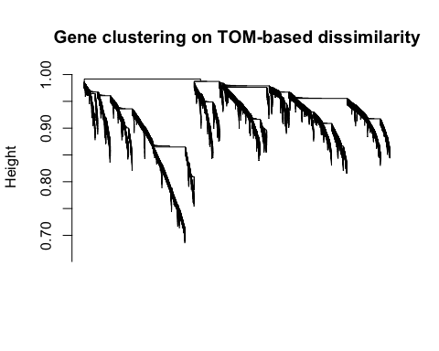

Figure 5. Clustering tree: The figure shows the clustering tree (dendrogram) that results from hierarchical clustering of the TOM-based dissimilarity matrix and will be used for identifying modules of highly similar genes in the co-expression network.

### 2.2 Identify clusters

To cluster genes with similar daily expression pattern, we use the cutreeDynamic() function from the WGCNA package.

We need to provide a minimum size for the identified clusters or modules. This can set depending on the user’s question. In our case, we want to identify fairly large modules that are biologically meaningful (i.e., enriched in different GO/PFAM terms). As such, we set the minimum module size to 30. However, as you will see later, we will refine our cluster identification by merging very similar modules. As such, the choice of minimum module size should not affect cluster identification drastically.

# We like large modules, so we set the minimum module size relatively high:  
minModuleSize = 30;  
  
# Module identification using dynamic tree cut:  
dynamicMods= cutreeDynamic(dendro = geneTree,  
 distM = dissTOM,  
 method = "hybrid",  
 verbose = 4,  
 deepSplit = 3, # see WGCNA for more info on tuning parameters  
 pamRespectsDendro = FALSE,  
 minClusterSize = minModuleSize);

## ..cutHeight not given, setting it to 0.99 ===> 99% of the (truncated) height range in dendro.  
## ..Going through the merge tree  
##   
## ..Going through detected branches and marking clusters..  
## ..Assigning Tree Cut stage labels..  
## ..Assigning PAM stage labels..  
## ....assigned 5531 objects to existing clusters.  
## ..done.

# view number of genes in each module  
table(dynamicMods)

## dynamicMods  
## 1 2 3 4 5 6 7 8 9 10 11 12 13 14 15 16   
## 1337 1172 742 723 720 579 515 506 369 299 269 265 199 149 134 134   
## 17 18 19 20 21 22 23 24 25 26 27 28 29 30   
## 112 107 99 91 88 79 75 72 66 56 55 50 45 32

# Convert numeric lables into colors  
dynamicColors = labels2colors(dynamicMods)  
table(dynamicColors)

## dynamicColors  
## black blue brown cyan darkgreen   
## 515 1172 742 149 79   
## darkgrey darkorange darkred darkturquoise green   
## 72 56 88 75 720   
## greenyellow grey60 lightcyan lightgreen lightyellow   
## 269 112 134 107 99   
## magenta midnightblue orange pink purple   
## 369 134 66 506 299   
## red royalblue saddlebrown salmon skyblue   
## 579 91 45 199 50   
## steelblue tan turquoise white yellow   
## 32 265 1337 55 723

**In the initial cluster (module) identification step, WGCNA finds 30 modules. However, some of the identified modules might have very similar expression pattern and we would rather merge this closely related modules into one.**

We do that in the next step.

### 2.3 Merge similar modules

# Calculate eigengenes  
MEList = moduleEigengenes(datExpr, colors = dynamicColors)  
MEs = MEList$eigengenes  
  
# Calculate dissimilarity of module eigengenes  
MEDiss = 1-cor(MEs, method = "kendall");  
  
# Cluster module eigengenes  
METree = hclust(as.dist(MEDiss), method = "average");  
# Plot the result  
# sizeGrWindow(7, 8)  
plot(METree, main = "Clustering of module eigengenes",  
 xlab = "", sub = "MEDiss = 1-cor(MEs, method = 'kendall')")  
  
# We choose a height cut of 0.2, corresponding to correlation of 0.8, to merge  
MEDissThres = 0.2 # user-specified parameter value; see WGCNA manual for more info  
  
# Plot the cut line into the dendrogram  
abline(h=MEDissThres, col = "red")

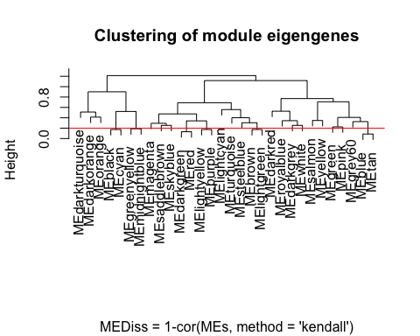

Figure 6. Merging similar modules: The above figure shows the similarity of the different gene modules using hierarchical clustering of the module’s eigenvalue (eigengene expression). The horizontal red line shows the cutoff used to merge similar modules.

We choose a cut height of 0.2, corresponding to correlation of 0.8, to merge similar modules. Although arbitrary, the cutoff was motivated by the number of modules we would like to retain in the GCN; in our case, a 0.2 threshold resulted in a total of 12 modules in the GCN (see below).

In the following code, we merge the similar modules and visualize the module assignments before and after merging.

# Call an automatic merging function  
merge = mergeCloseModules(datExpr, dynamicColors, cutHeight = MEDissThres, verbose = 3)

## mergeCloseModules: Merging modules whose distance is less than 0.2  
## multiSetMEs: Calculating module MEs.  
## Working on set 1 ...  
## moduleEigengenes: Calculating 30 module eigengenes in given set.  
## multiSetMEs: Calculating module MEs.  
## Working on set 1 ...  
## moduleEigengenes: Calculating 13 module eigengenes in given set.  
## multiSetMEs: Calculating module MEs.  
## Working on set 1 ...  
## moduleEigengenes: Calculating 12 module eigengenes in given set.  
## Calculating new MEs...  
## multiSetMEs: Calculating module MEs.  
## Working on set 1 ...  
## moduleEigengenes: Calculating 12 module eigengenes in given set.

# The merged module colors  
mergedColors = merge$colors;  
# Eigengenes of the new merged modules:  
mergedMEs = merge$newMEs;  
  
# sizeGrWindow(12, 9)  
plotDendroAndColors(geneTree,  
 cbind(dynamicColors, mergedColors),  
 c("Dynamic Tree Cut", "Merged dynamic"),  
 dendroLabels = FALSE, hang = 0.03,  
 addGuide = TRUE, guideHang = 0.05)

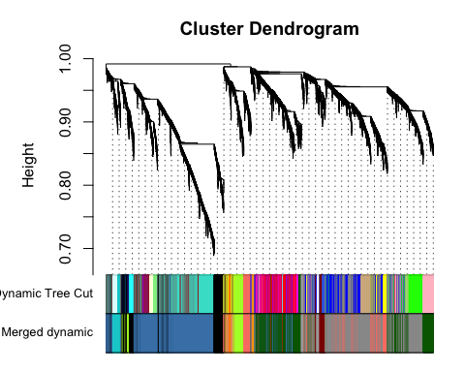

# Rename to moduleColors  
moduleColors = mergedColors  
  
# Construct numerical labels corresponding to the colors  
colorOrder = c("grey", standardColors(50));  
moduleLabels = match(moduleColors, colorOrder)-1

Figure 7. Modules of highly co-expressed genes: The above plot shows the results of module identification before (Dyanamic Tree Cut) and after (Merged dyanamic) similar modules were merged.

**We identified 12 modules in the ant GCN, the size of each of these modules are shown below.**

figure goes here

Note, WGCNA names the different modules as colors (see above), and the colors have no meaning. Therefore, it might be useful to rename the modules. In the next step we rename all the modules according to the following convention:

figure goes here

### 2.4 Calculate module-module similarity

Thus far, we have created the ant GCN (adjacency matrix) and identified 12 modules of highly co-expressed genes in the network.

Next, we investigate how the different modules are connected to each other in the GCN. To do so, we calculate the module-module similarity (Kendall’s tau-b correlation for pairwise module-eigengene expression) and then use the similarity matrix to create the module adjacency matrix.

The following code calculates the module adjacency matrix and visualizes it as a heatmap.

# Calculate similarity of the eigen-genes  
sim_matrix_ME <- cor(mergedMEs, method = "kendall")  
  
# calculate adj_matrix  
adj_matrix_ME <- adjacency.fromSimilarity(sim_matrix_ME,  
 power=1, # DO NOT power transform  
 type='signed'  
)  
  
# coerce into a matrix  
  
## GET THE NAMES OF THE MODULES  
# module_ids <- rownames(adj_matrix_ME)  
## CHANGE THE NAMES OF THE MODULES  
module_ids <- data.frame(old_labels = rownames(adj_matrix_ME),  
 new_labels = paste0("module-", 1:nrow(adj_matrix_ME)))  
  
adj_matrix_ME <- matrix(adj_matrix_ME, nrow=nrow(adj_matrix_ME))  
rownames(adj_matrix_ME) <- module_ids$new_labels  
colnames(adj_matrix_ME) <- module_ids$new_labels  
  
# png(paste0(path_to_repo, "/results/figures/ME_adjacency.png"),   
# width = 18, height = 18, units = "cm", res = 400)  
gplots::heatmap.2(t(adj_matrix_ME),  
 col=inferno(100),  
 # labRow=NA, labCol=NA,  
 trace='none', dendrogram='row',  
 xlab='', ylab='',  
 # main='Similarity matrix - MEs \n correlation method = "kendall")',  
 main='Adjacency matrix - MEs',  
 density.info='none', revC=TRUE)

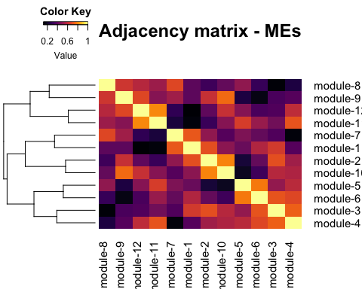

# trash <- dev.off()

Figure 8. Module-module relationships: The heatmap above shows the pairwise Kendall’s tau correlation (similarity) of the twelve modules identified in the ant GCN. Darker shades indicate low correlations and brighter shades indicate high correlations, as shown in the Color Key.

### 2.5 Visualize the network

To better visualize the global network – how the modules are connected to each other – we can simplify the network. That is, we remove most of the weak edges of the network and retain only the strong module-module correlations.

For example, to remove weak edges, we can set all correlations less than 0.6 to be zero. This will help us obtain a fairly clean network for visualization. To simplify further, we can assign the same edge weight for all correlations between 0.6 and 0.8 (e.g., 0.5), and a different edge weight for correlations ≥ 0.8 (e.g., 1).

The following code uses the igraph package in R to simplify and visualize the module-module relationships in the network.

pacman::p_load(igraph)  
  
# get rid of low correlations (0.6 & 0.8 are arbitrary)  
adj_matrix_ME[adj_matrix_ME < 0.6] <- 0  
adj_matrix_ME[adj_matrix_ME < 0.8 & adj_matrix_ME>0] <- 0.5  
adj_matrix_ME[adj_matrix_ME >= 0.8] <- 1  
  
# build_network  
network <- graph.adjacency(adj_matrix_ME,  
 mode = "upper",  
 weighted = T,  
 diag = F)  
  
# simplify network  
network <- igraph::simplify(network) # removes self-loops  
  
# E(network)$width <- E(network)$weight + min(E(network)$weight) + 1 # offset=1  
  
colors <- mergedMEs %>% names() %>% str_split("ME", 2) %>% sapply("[", 2)  
V(network)$color <- colors  
  
genes_ME <- factor(moduleColors, levels=colors) %>% summary()  
V(network)$size <- log2(genes_ME)*2  
  
V(network)$label.color <- "black"  
V(network)$frame.color <- "white"  
  
E(network)$width <- E(network)$weight^2*4  
E(network)$edge.color <- "gray80"  
  
# par(mar=c(0,0,0,0))  
# remove unconnected nodes  
# network <- delete.vertices(network, degree(network)==0)  
# plot(network,  
# layout=layout.fruchterman.reingold  
# # layout = layout.kamada.kawai  
# # layout = layout.kamada.kawai  
# )  
  
  
## Circular layout  
plot(network,  
 layout=layout.kamada.kawai,  
 # layout=layout.fruchterman.reingold  
 # layout=layout.graphopt  
 # layout=layout_in_circle,  
 # vertex.label=NA  
 # vertex.size=hub.score(network)$vector*30  
 vertex.shape="none"  
)

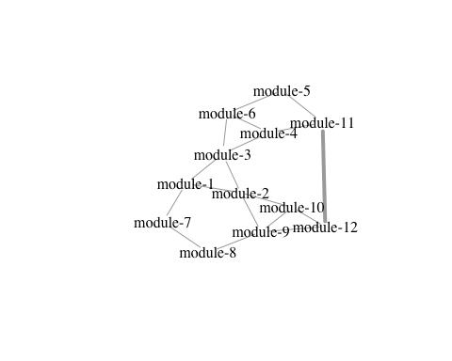

Figure 9. Visualizing the ant GCN: A simplified view of the connectivity patterns between the different gene modules of the ant GCN are shown. In our case, thick edges between two modules indicate correlations ≥ 0.8, thinner edges indicate correlations between (0.6, 0.8), and no edges indicate correlations < 0.6.

## Step 3: Annotate the network

Now that we have created the ant GCN, we can functionally annotate the network by identifying which modules contain our genes of interest. To do so, we will check for significant overlap between a module in the network and our genes of interest using Fisher’s exact test.

### 3.1 Define your genes of interest

For example, we want to identify the GCN modules that contain our 24h oscillating genes (for.rhy = 24h-rhythmic genes in forager brains, nur.rhy = 24h-rhythmic genes in nurses).

# DEFINE GENES OF INTEREST (PART 1)  
  
# load the data table that contains the results from the rhythmicity analysis (eJTK-Cycle output)  
rhy.trait.24 <- tbl(db, "ejtk_all") %>% select(gene_name:rhy) %>% collect()  
  
# pull the gene names that are rhythmic in forager brains  
for.rhy <- rhy.trait.24 %>% filter(caste=="for" & rhy=="yes") %>% pull(gene_name)  
# pull the gene names that are rhythmic in forager brains  
nur.rhy <- rhy.trait.24 %>% filter(caste=="nur" & rhy=="yes") %>% pull(gene_name)  
  
  
# DEFINE GENES OF INTEREST (PART 2)  
  
# Make a list that contains all gene names for a given cluster  
module_color = colors  
module = names(mergedMEs)  
module_colors <-  
 data.frame(module_label=module) %>%  
 mutate(module_color = str_replace(module_label, "ME", ""))  
  
module_genes <- list()  
module_color <- module_colors$module_color  
# Get the genes from each of the modules  
for (i in 1:length(module_color)) {  
  
 module_genes[[i]] <- names(datExpr)[which(moduleColors==module_color[[i]])]  
 names(module_genes)[[i]] <- module_color[[i]]  
}  
  
names(module_genes) <- module_ids$new_labels  
  
# For example, we can obtain names of all the genes in module-1 using the following code:  
# module_genes["module-1"]

Now that we have defined our genes of interest (rhythmic genes), we can use a Fisher’s exact test to check for significant overlap between our genes of interest (e.g., for.rhy) and modules in the GCN (e.g., module-7) in a pairwise manner.

For example, to check if the 24h-rhythmic genes in forager brains (for.rhy) are overrepresented in module-7, we first create the contingency table. To do so, we need to define the background number of genes, i.e., the size of the set that contains all possible genes from which module-7 and for.rhy genesets are drawn. In our case, that would be the 9139 genes that was used to build the GCN. Using this information, we can create the contingency table as shown below.

set.1 <- for.rhy  
set.2 <- module_genes[["module-7"]]  
  
# To create the contingency table for module-7 (set-1) and for.rhy (set-2), we will need the following information:  
# genes that are in both sets  
overlapping.genes <- intersect(set.1, set.2) %>% length()  
# genes in set-1 but not in set-2  
set.1.not.set.2 <- setdiff(set.1, set.2) %>% length()  
# genes in set-2 but not in set-1  
set.2.not.set.1 <- setdiff(set.2, set.1) %>% length()  
# background genes not in set-1 or set-2  
not.set.1.set.2 <- nGenes - (union(set.1, set.2) %>% unique() %>% length())  
  
# for.rhy and module-7  
  
test.table <-   
 data.frame(  
 in.module = c(overlapping.genes, set.2.not.set.1),  
 not.module = c(set.1.not.set.2, not.set.1.set.2)  
 )  
rownames(test.table) <- c("in.for.rhy", "not.for.rhy")  
  
# take a look at the contingency table  
test.table

## in.module not.module  
## in.for.rhy 477 3092  
## not.for.rhy 187 5383

The above table shows that 477 genes are found in both, for.rhy and module-7. However, there are 3092 genes that are found in for.rhy but not in module-7, whereas 187 genes occur only in module-7 but not in for.rhy. Finally, we have 5383 genes that are in the background geneset but neither in rhy.for nor in module-7.

Now, we can run the Fisher’s exact test using the fisher.test() function in R. The results of which are shown below:

# run the fisher's exact test  
fisher.test(test.table)

##   
## Fisher's Exact Test for Count Data  
##   
## data: test.table  
## p-value < 2.2e-16  
## alternative hypothesis: true odds ratio is not equal to 1  
## 95 percent confidence interval:  
## 3.719093 5.317281  
## sample estimates:  
## odds ratio   
## 4.440042

The output shows that the odds-ratio is approximately 4, which is significantly higher than 1 (p-value < 2e-16). In other words, the genes that show 24h-rhythms in forager brains are significantly overrepresented in module-7 and vice-versa, or that the two sets show significant overlap.

### 3.2 Where are my genes of interest located?

Since we need to perform multiple Fisher’s exact test for our comparisons, we will make use of the [GeneOverlap](https://www.bioconductor.org/packages/devel/bioc/vignettes/GeneOverlap/inst/doc/GeneOverlap.pdf) package in R [3].

# Load the GeneOverlap library  
pacman::p_load(GeneOverlap)  
#  
# You can find more about the package here:  
# https://www.bioconductor.org/packages/devel/bioc/vignettes/GeneOverlap/inst/doc/GeneOverlap.pdf  
  
  
## DEFINE YOUR LIST OF GENES FOR PAIRWISE TEST OF OVERLAP ##  
  
# LIST ONE - WGCNA modules  
list1 <- module_genes  
sapply(list1, length)

## module-1 module-2 module-3 module-4 module-5 module-6 module-7 module-8   
## 403 56 922 2269 127 179 664 2616   
## module-9 module-10 module-11 module-12   
## 209 66 1533 95

## LIST TWO - rhythmic genes  
list2 <- list(for.rhy, nur.rhy)  
names(list2) <- c("for24", "nur24")  
sapply(list2, length)

## for24 nur24   
## 3569 1367

## CHECK FOR OVERLAP  
  
## make a GOM object  
gom.1v2 <- newGOM(list1, list2,  
 genome.size = nGenes)  
png(paste0(path_to_repo, "/results/figures/gom_1v2.png"),   
 width = 18, height = 18, units = "cm", res = 300)  
drawHeatmap(gom.1v2,  
 adj.p=T,  
 cutoff=0.05,  
 what="odds.ratio",  
 # what="Jaccard",  
 log.scale = T,  
 note.col = "grey80")  
trash <- dev.off()

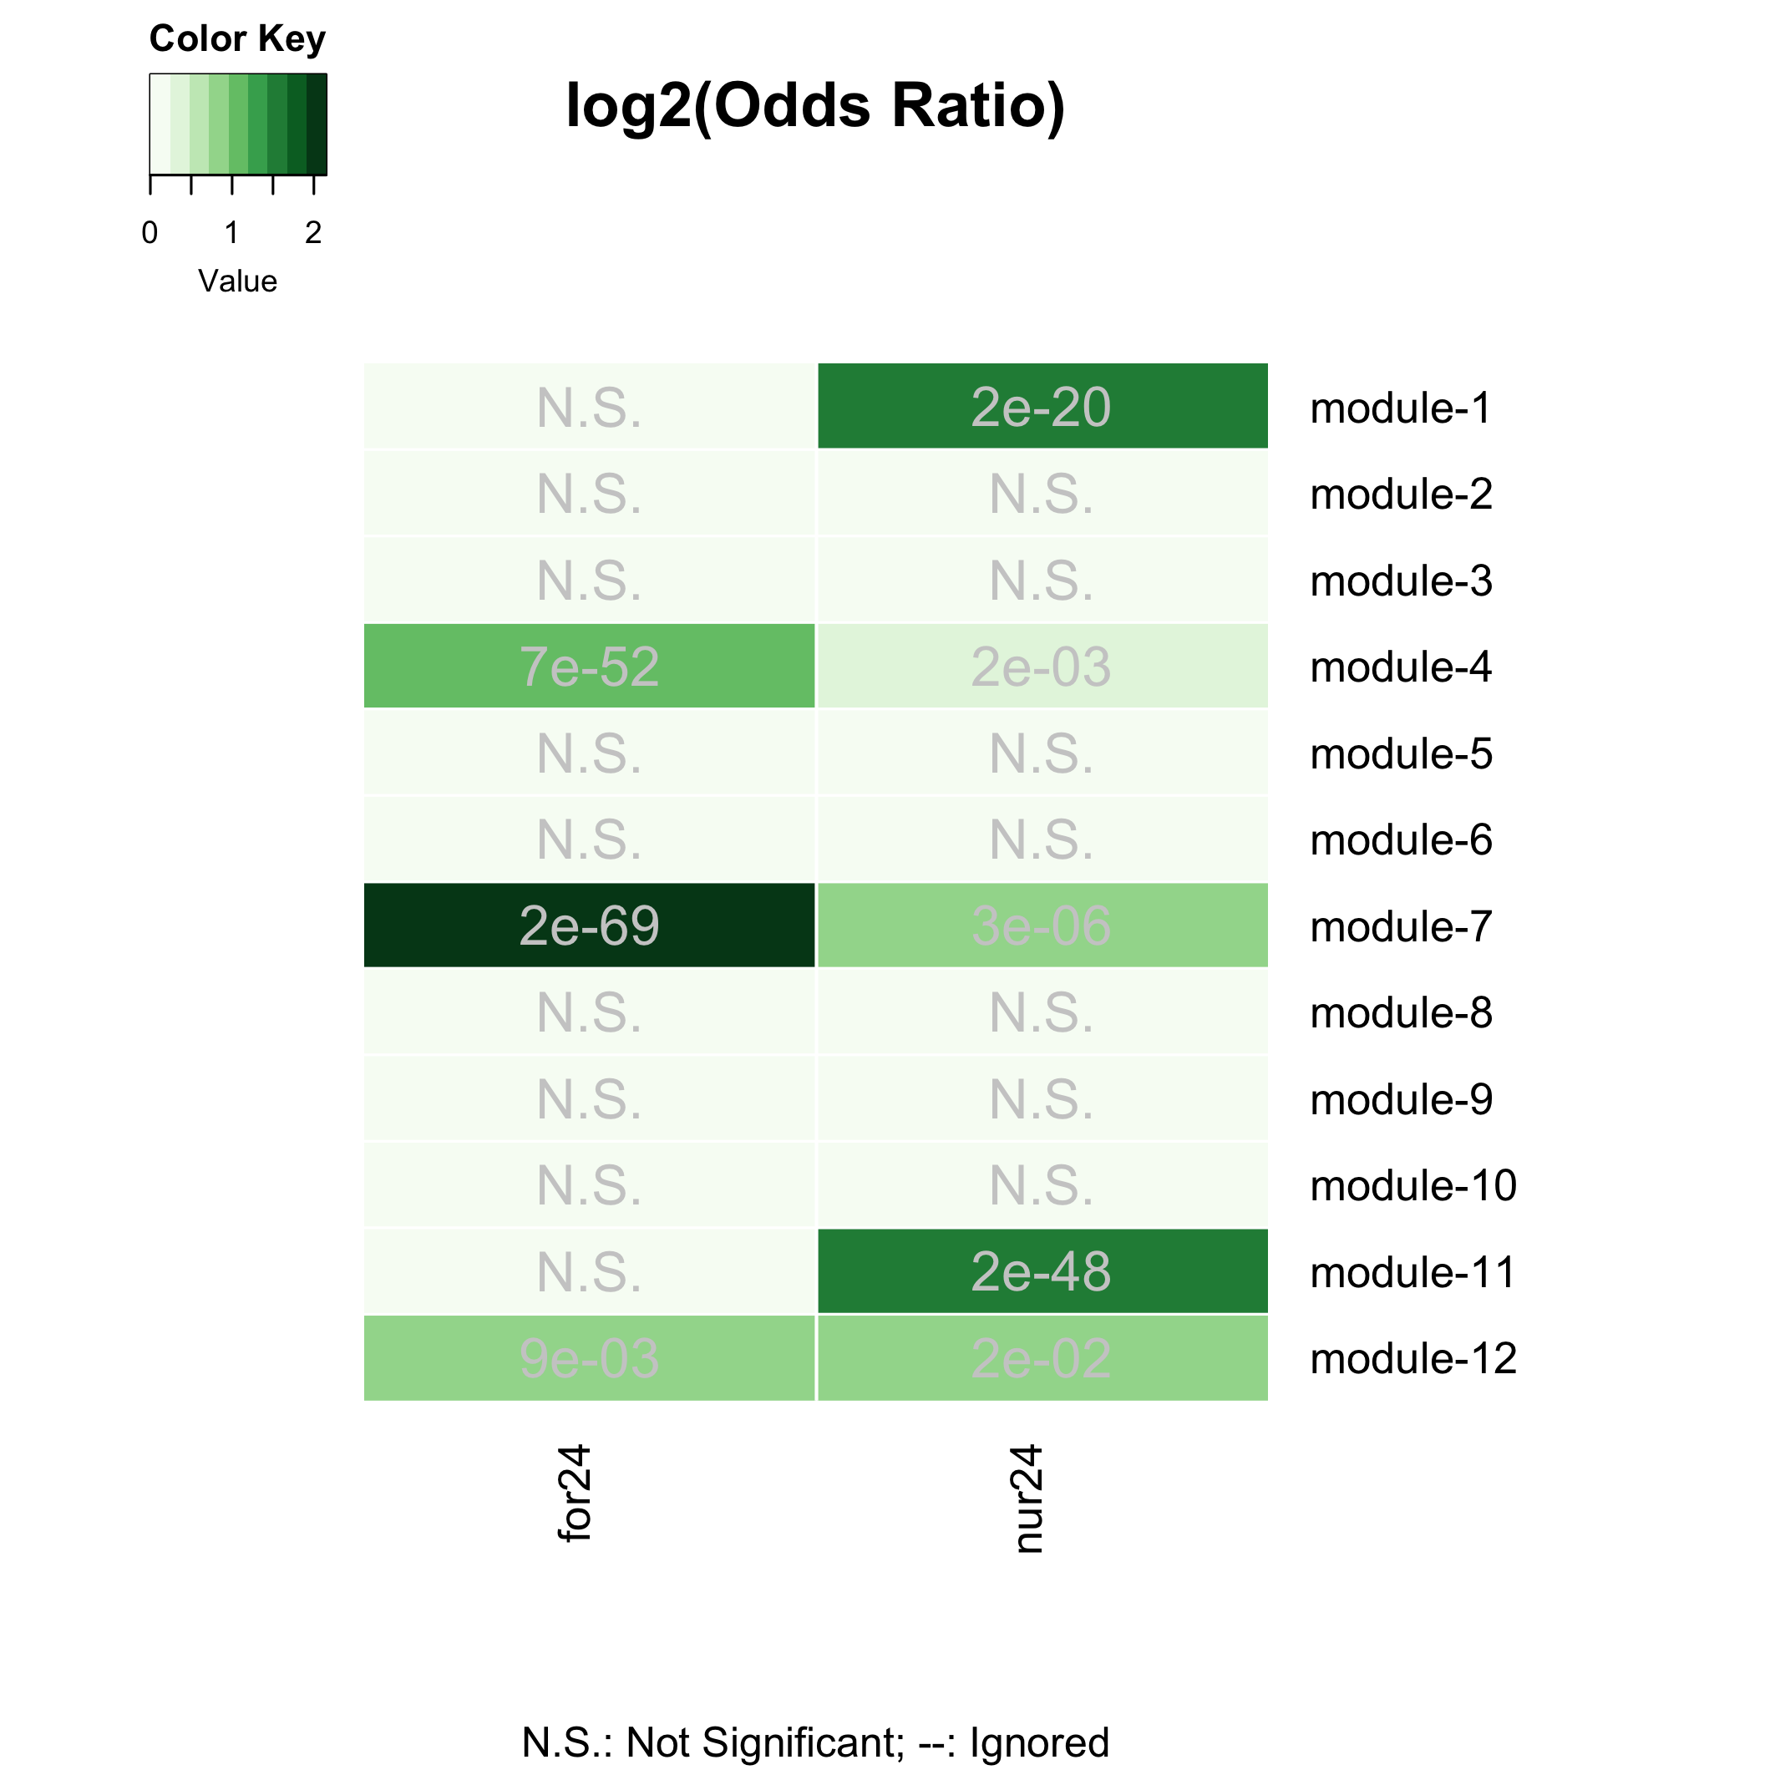

Gene-clusters with 24h-rhythmic genes

Figure 10. Gene-clusters with rhythmic genes: The above plot shows the result of the Fisher’s exact test performed for each module-geneset pair. The color of the boxes represents the odds-ratio (darker the green, higher is the odds-ratio) and the p-values are shown. The p-values shown were corrected for multiple-hypothesis testing using Benjamini-Hochberg method. Non-significant overlaps between module and geneset are indicated with a N.S. inside the box.

From the plot, we can see that the 24h-rhythmic genes are located in five of the twelve modules of the ant GCN (module-1, module-4, module-7, module-11, and module-12).

We can further annotate the rhythmic modules by identifying which of these five modules peak during the day and which peak at night in ant brains. For the purpose of this study, we focus on the daily expression patterns only in the forager brain because the Ophiocordyceps are most likely to infect forager ants that are perform bulk of the outside-nest tasks. To identify day- and night-peaking modules, we can visualize the daily expression of all genes in these rhythmic modules as well as their module eigengene expression (shown below).

# NOTE: The black line denotes median expression, not ME eigengene expression.  
  
# par(mfrow = c(3,2))  
  
# module-4 plot  
# module-11 plot  
# module-12 plot  
  
# module-1 plot  
# module-7 plot

Figure 11. Daily expression patterns of genes in rhythmic modules: The daily expression pattern of all genes in a given module as well as the module’s eigengene expression are shown. For a module, each red line represents the expression of one gene and the black line represents the eigengene expression. The x-axis shows the time-of-day or Zeitgeber Time whereas the y-axis shows normalized gene expression (z-scores calculated from log2-transformed expression data). The 12h:12h light-dark cycles during which the samples were collected are also shown; white background indicates the light phase (lights on at ZT24/ZT0) and grey background indicates the dark phase (lights turned off at ZT12).

**We found that module-4, module-11, and module-12 were day-peaking modules, whereas module-1 and module-7 were night-peaking modules.**

Using the same approach as above, we can identify the ant modules that putatively underlie behavioral plasticity, as well as the modules that are affected during Ophiocordyceps-induced behavioral manipulation.

## Genes underlying behavioral plasticity, i.e., DEGS (foragers v. nurses)  
 # genes higher expressed in forager brains (v. nurse brains)  
 for.up <- tbl(db, "TC5_DEGs_all") %>% filter(upregulation=="for") %>% collect() %>% pull(gene_name)  
 # genes lower expressed in for. brains (v. nurse brains)  
 for.down <- tbl(db, "TC5_DEGs_all") %>% filter(upregulation=="nur") %>% collect() %>% pull(gene_name)  
  
## Genes underlying parasite-induced behavioral manipulation, i.e., DEGs (ophio-ant v. control-ant)  
 # load the data table  
 ophio.dat <-   
 tbl(db, "ophio_biting_control") %>%   
 collect() %>%   
 select(gene, value_1, value_2, q_value:logFC) %>%   
 filter(abs(logFC) >= 1 & significant=="yes" & q_value < 0.05) %>%  
 mutate(ophio = ifelse(logFC > 0, "down", "up"))  
 # genes higher expressed in ant heads during Ophio-manipulated biting (v. controls)  
 ophio.up <- ophio.dat %>% filter(ophio=="up") %>% pull(gene)  
 # genes lower expressed in ant heads during manipulated biting (v. controls)  
 ophio.down <- ophio.dat %>% filter(ophio=="down") %>% pull(gene)  
  
## LIST THREE - genes underlying behavioral plasticity and parasitic behavioral manipulation  
list3 <- list(for.up, for.down, # same as list three  
 ophio.up, ophio.down)  
names(list3) <- c("for-UP", "for-DOWN",  
 "ophio-UP", "ophio-DOWN")  
  
## CHECK FOR OVERLAP  
  
## make a GOM object  
gom.1v3 <- newGOM(list1, list3,  
 genome.size = nGenes)  
## visualize the overlaps  
png(paste0(path_to_repo, "/results/figures/gom_1v3.png"),   
 width = 14, height = 18, units = "cm", res = 400)  
drawHeatmap(gom.1v3,  
 adj.p=T,  
 cutoff=0.05,  
 what="odds.ratio",  
 # what="Jaccard",  
 log.scale = T,  
 note.col = "grey80")  
trash <- dev.off()  
  
  
# # OR, do all comparisons in one:  
# list4 <- list(for.rhy, nur.rhy,  
# for.up, for.down,  
# ophio.up, ophio.down)  
# names(list4) <- c("for-24h", "nur-24h",  
# "for-UP", "for-DOWN",  
# "ophio-UP", "ophio-DOWN")  
# ## CHECK FOR OVERLAP  
# ## make a GOM object  
# gom.1v4 <- newGOM(list1, list4, genome.size = nGenes)  
# ## visualize the overlaps  
# png(paste0(path_to_repo, "/results/figures/gom_1v4.png"),   
# width = 18, height = 18, units = "cm", res = 400)  
# drawHeatmap(gom.1v4,  
# adj.p=T,  
# cutoff=0.05,  
# what="odds.ratio",  
# grid.col = "Greens",  
# # what="Jaccard",  
# log.scale = T,  
# note.col = "black")  
# trash <- dev.off()

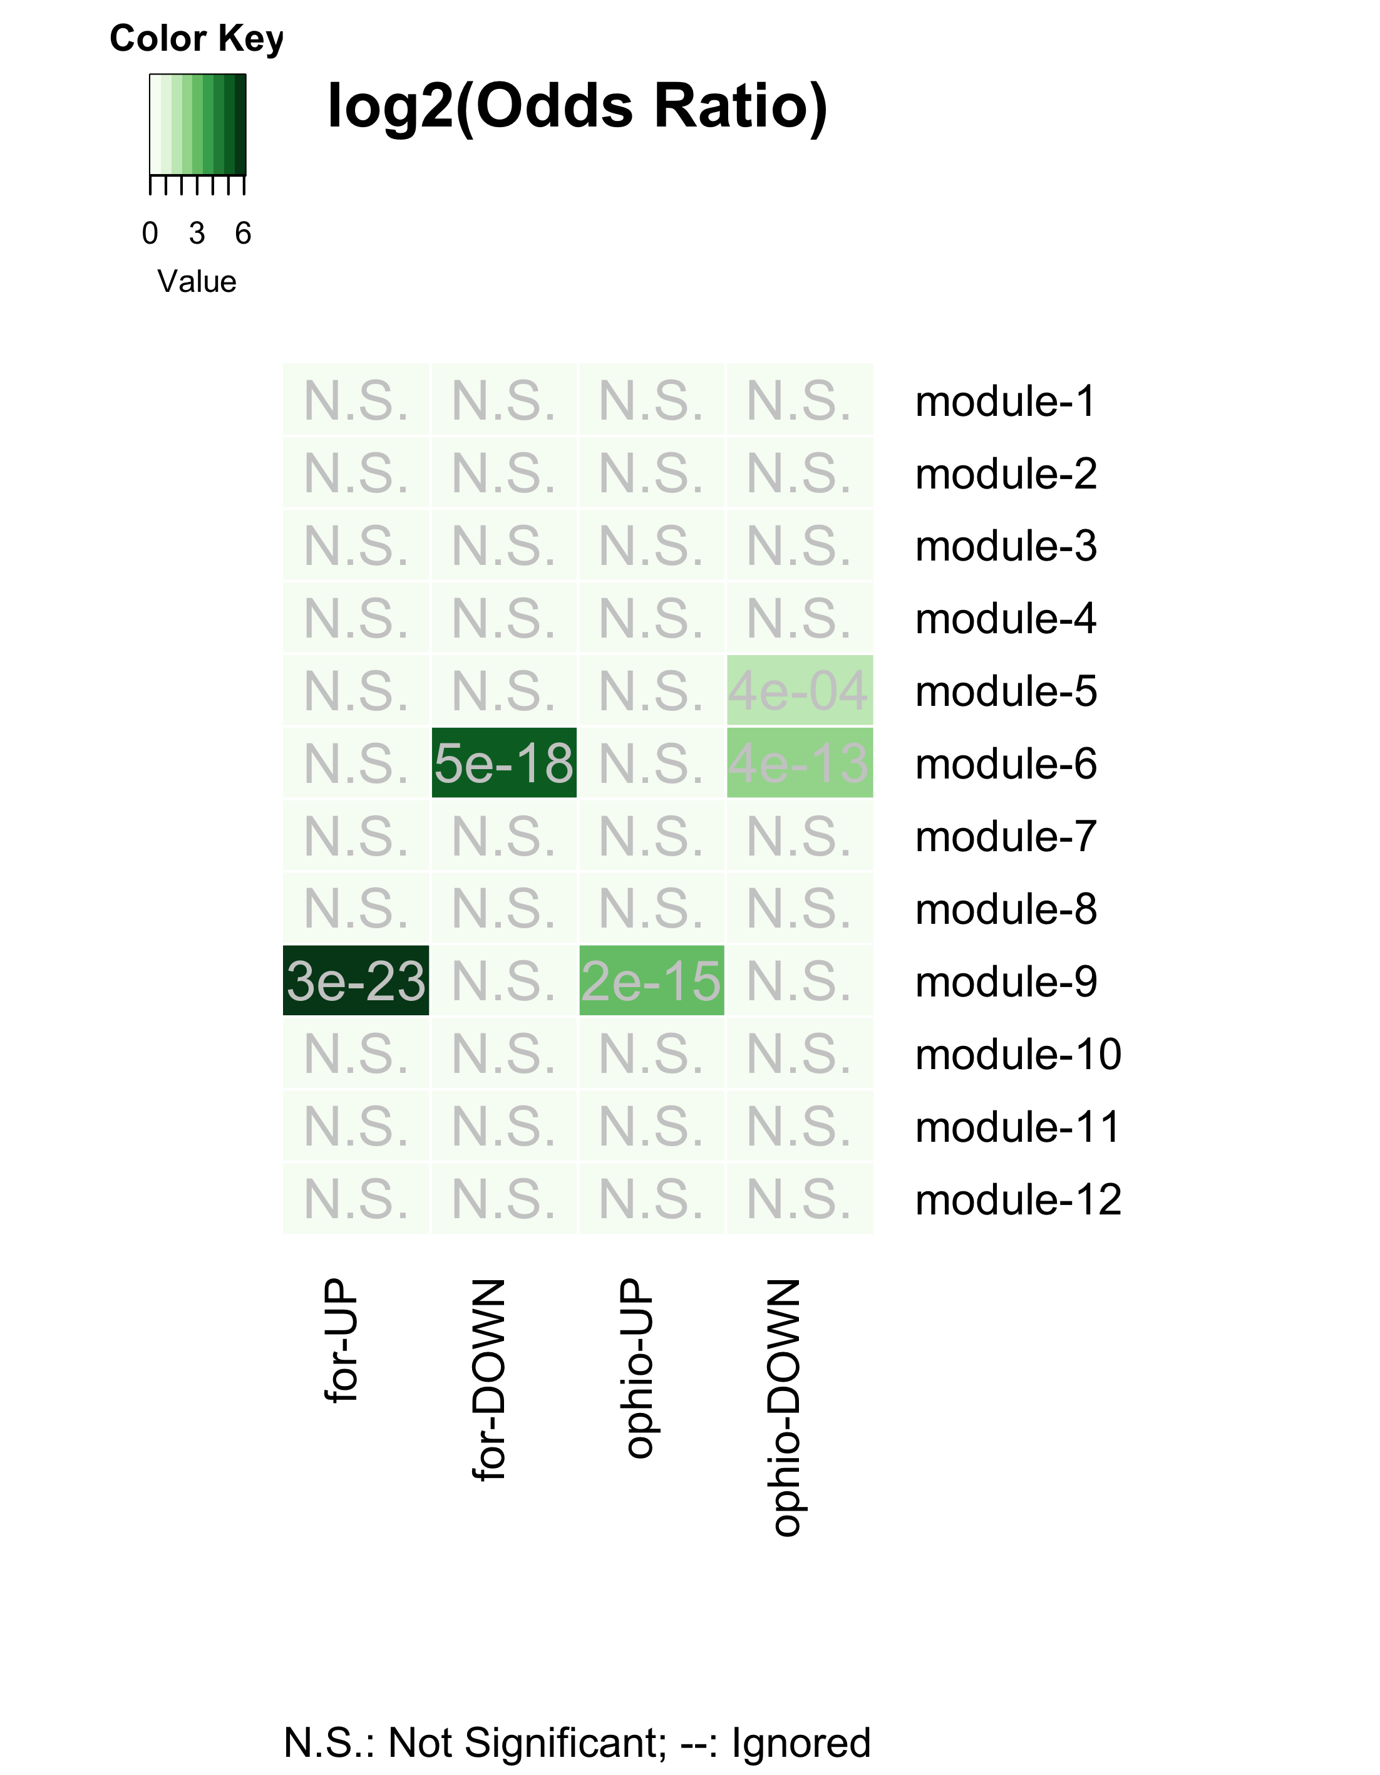

Gene-clusters underlying behavioral plasiticity and parasitic behavioral manipulation

Figure 12. Gene-clusters behavioral plasiticity and parasitic behavioral manipulation: The heatmap identifies the different gene modules that show an overrepresentation of the genes previously found to underlie behavioral plasticity (genes differentially expressed between foragers and nurses) and parasitic behavioral manipulation (genes differentially expressed in foragers during manipulated biting behavior).

The figure above shows that the gene-modules that putatively underlie behavioral plasticity (forager-nurse differentiation) and the ones that are affected during Ophiocordycpes-induced behavioral manipulation, are the same.

**In other words, to induce the characteristic manipulated biting behavior, the manipulating fungal parasite seems to be targeting the same genes and processes that otherwise allow ants to display behavioral plasticity (shown in the summary figure below).**

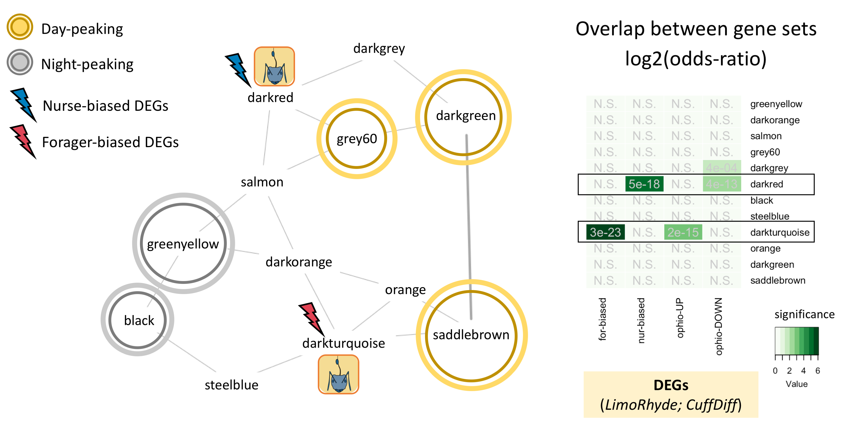

Annotated circadian GCN

## Step 4: Explore your clusters-of-interest

### 4.1 Cluster: module-9

#### 4.1.1 What are these overlapping genes?

* Let’s focus on the cluster module-9/module-9 that contains most Cflo genes that:
* are sig. higher expressed in foragers (v. nurses) and
* are sig. up-regulated in forager heads during behavioral manipulation (v. uninfected foragers)

# specify our cluster of interest (coi)  
coi.1 <- "module-9"  
# How many genes are there in the cluster?  
module_genes[[coi.1]] %>% length() # n = 209 genes

## [1] 209

# specify our genes of interest (goi)  
goi.1 <- ophio.up  
# how many genes are there in the gene-set?  
goi.1 %>% length() # n = 232 genes

## [1] 232

# Identify overlapping genes  
overlapping.genes.1 <- intersect(module_genes[[coi.1]], goi.1) # n = 32 genes  
# what are these genes?  
overlapping.genes.1.annot <-  
 db %>%   
 tbl(., "annot_fpkm") %>%   
 filter(gene_name %in% overlapping.genes.1) %>%   
 select(gene_name,   
 blast_annot=old_annotation,   
 GOs, pfams, signalP, TMHMM) %>%   
 collect() %>%   
 # add a column that indicates if the gene is rhythmic or not  
 ## in forager brains   
 mutate(rhy_foragers = ifelse(gene_name %in% for.rhy, "24h",  
 ifelse(gene_name %in% for.rhy.12, "12h",  
 ifelse(gene_name %in% for.rhy.8, "8h", "not_rhy")))) %>%   
 ## in nurse brains  
 mutate(rhy_nurses = ifelse(gene_name %in% nur.rhy, "24h",  
 ifelse(gene_name %in% nur.rhy.12, "12h",  
 ifelse(gene_name %in% nur.rhy.8, "8h", "not_rhy"))))  
  
# Visualize the results  
DT::datatable(overlapping.genes.1.annot, options = list(  
 pageLength = 5,  
 lengthMenu = c(5, 10, 15, 20)  
))

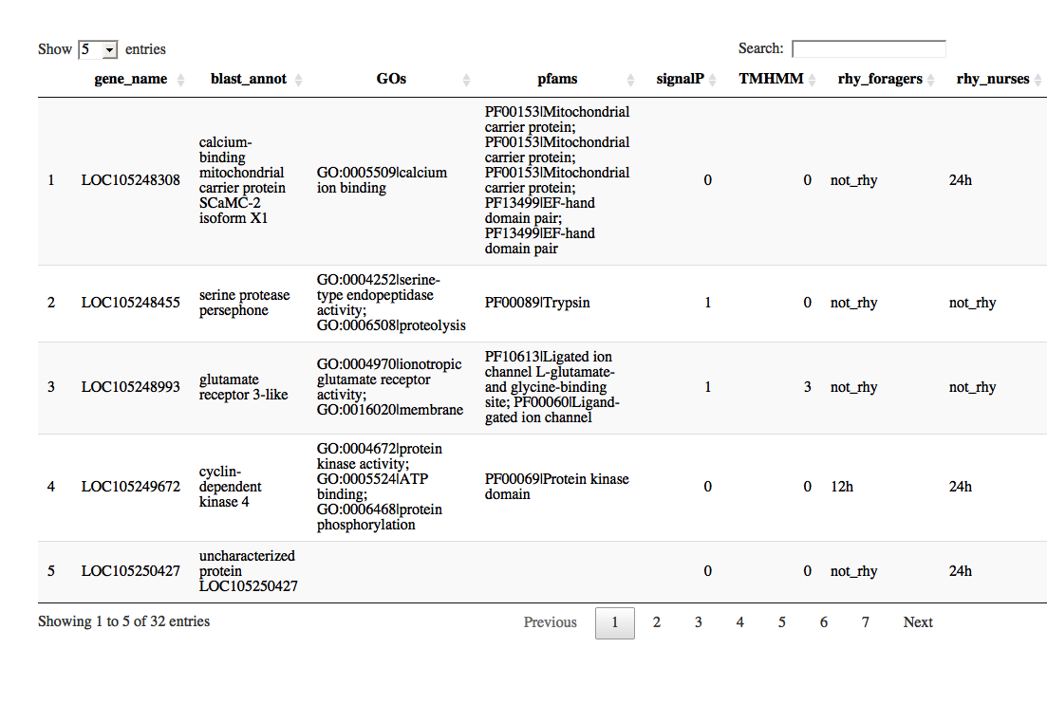

Which genes in module-9 show overlap with both genes of interests?

# define the second gene-set of interst  
goi.2 <- for.up  
# how many genes are up-regulated during manipulation?  
goi.2 %>% length() # n = 34 genes

## [1] 34

# Identify overlapping.genes  
overlapping.genes.2 <- intersect(overlapping.genes.1, goi.2) # n = 10 genes  
# what are these genes?  
overlapping.genes.2.annot <-   
 db %>%   
 tbl(., "annot_fpkm") %>%   
 filter(gene_name %in% overlapping.genes.2) %>%   
 select(gene_name,   
 blast_annot=old_annotation,   
 GOs, pfams, signalP, TMHMM) %>%   
 collect() %>%   
 # add a column that indicates if the gene is rhythmic or not  
 ## in forager brains   
 mutate(rhy_foragers = ifelse(gene_name %in% for.rhy, "24h",  
 ifelse(gene_name %in% for.rhy.12, "12h",  
 ifelse(gene_name %in% for.rhy.8, "8h", "not_rhy")))) %>%   
 ## in nurse brains  
 mutate(rhy_nurses = ifelse(gene_name %in% nur.rhy, "24h",  
 ifelse(gene_name %in% nur.rhy.12, "12h",  
 ifelse(gene_name %in% nur.rhy.8, "8h", "not_rhy"))))  
  
  
# Visualize the results  
DT::datatable(overlapping.genes.2.annot, options = list(  
 pageLength = 5,  
 lengthMenu = c(5, 10, 15, 20)  
))

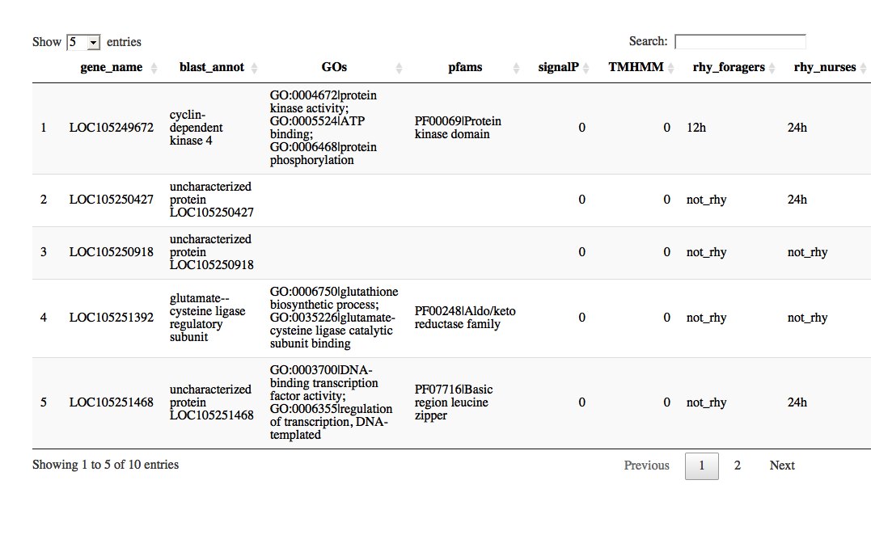

#### 4.1.2 What’s special about my cluster?

Now that we know that the module **module-9** contains most of our genes of interest, we can infer its function (enriched GOs and PFAMs) and also identify the genes that are important for the cluster to be functional (i.e., hub genes).

#### 4.1.3 Enriched GO terms

First up, let’s see which processes are overrepresented in the cluster.

# To run a functional enrichment analyis, we first need to define the set of background genes; for our purpose, we will use the 9139 genes that we used to build our circadian GCN  
bg.genes <- dat %>% pull(gene_name)  
  
# Run the enrichment function (note, GO HERE TO READ MORE ABOUT THIS FUNCTION)  
# png(paste0(path_to_repo, "/results/figures/module_9_enrichments.png"),   
# width = 16, height = 10, units = "cm", res = 400)  
go_enrichment(geneset = module_genes[[coi.1]],  
 function.dir = path_to_repo,  
 org = "cflo",   
 bg = bg.genes) %>% #view()  
   
 # visualize the results  
 go_enrichment_plot(function.dir = path_to_repo, clean = "no")

## [1] "Loading annotation file for Camponotus floridanus"  
## [1] "Done."  
## [1] "Number of genes in background geneset: 9139"  
## [1] "Number of genes in the test set: 209"  
## [1] "--------------------------------"  
## [1] "Number of GO terms in background geneset: 1968"  
## [1] "Number of GO terms (at least 5genes) in background geneset: 373"  
## [1] "Number of GO terms (at least 5genes) in test set: 13"  
## [1] "Testing for enrichment..."

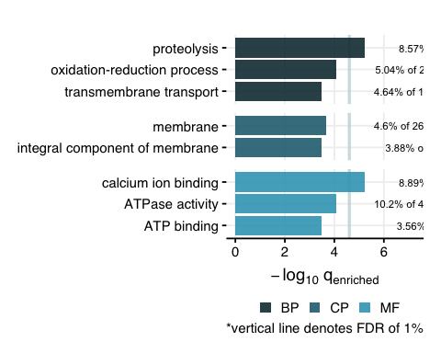

# trash <- dev.off()

#### 4.1.4 Daily rhythms?

Second, let’s plot the daily expression patterns of all genes in the cluster, for nurses and foragers.

# Obtain the stacked z-plots for nurses (blue) and foragers (red)  
zplots.module <-   
 module_genes[[coi.1]] %>%   
 stacked.zplot()  
  
# Plot them side by side  
zplots.module[[1]] / zplots.module[[2]]

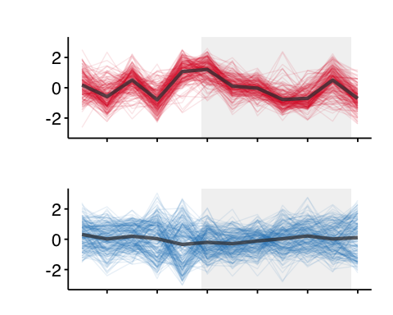

LEGEND: **RED** = Forager brains, **BLUE** = Nurse brains

#### 4.1.5 HUB genes?

Need to: - identify the hub genes in the module-9 cluster - other genes of interest based on their location in the network?

### 4.2 Cluster: module-6

#### 4.2.1 Overlapping genes

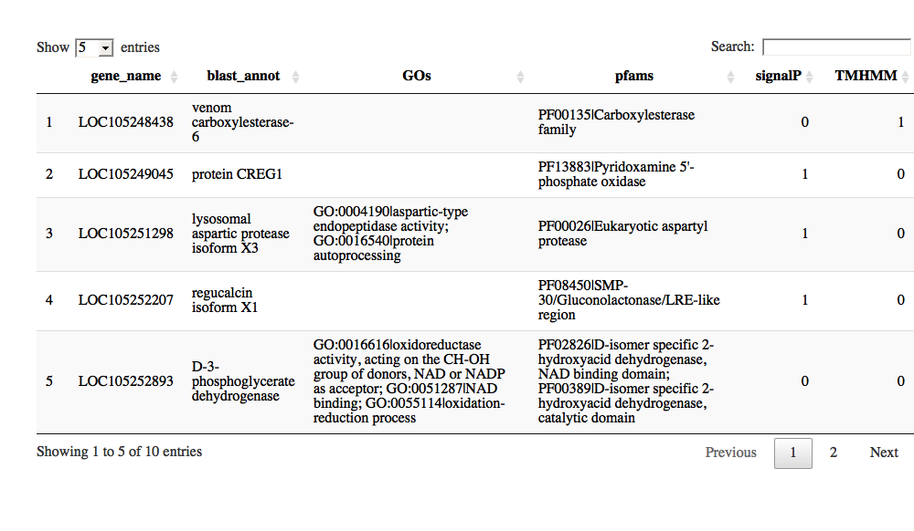

#### 4.2.2 Enriched GO terms

## [1] "Loading annotation file for Camponotus floridanus"  
## [1] "Done."  
## [1] "Number of genes in background geneset: 9139"  
## [1] "Number of genes in the test set: 179"  
## [1] "--------------------------------"  
## [1] "Number of GO terms in background geneset: 1968"  
## [1] "Number of GO terms (at least 5genes) in background geneset: 373"  
## [1] "Number of GO terms (at least 5genes) in test set: 16"  
## [1] "Testing for enrichment..."

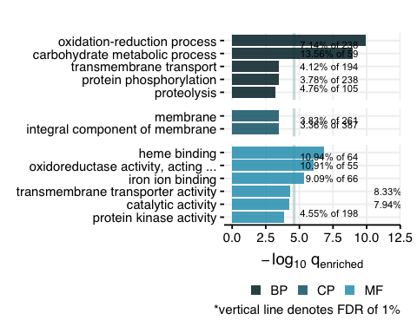

#### 4.2.3 Daily rhythms?

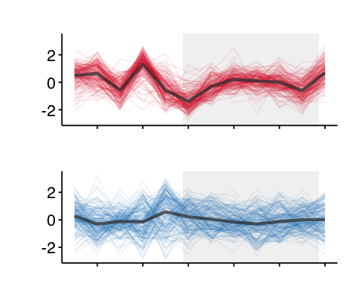

LEGEND: **RED** = Forager brains, **BLUE** = Nurse brains

#### 4.3.4 HUB genes?

coming soon…

### 4.3 Cluster: module-12

Connected to the forager-cluster (module-9)

#### 4.3.1 Explore cluster

## How many genes are there in the module-12 cluster?

## [1] 95

#### 4.3.2 Enriched GO terms

## [1] "Loading annotation file for Camponotus floridanus"  
## [1] "Done."  
## [1] "Number of genes in background geneset: 9139"  
## [1] "Number of genes in the test set: 95"  
## [1] "--------------------------------"  
## [1] "Number of GO terms in background geneset: 1968"  
## [1] "Number of GO terms (at least 5genes) in background geneset: 373"  
## [1] "Number of GO terms (at least 5genes) in test set: 5"  
## [1] "Testing for enrichment..."

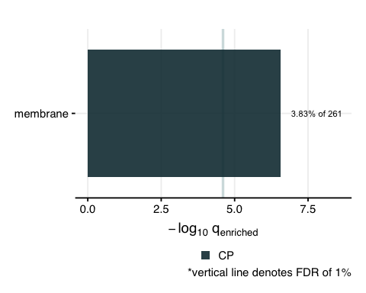

### 4.4 Cluster: module-4

Connected to the nurse-cluster (module-6)

#### 4.4.1 Explore cluster

## How many genes are there in the module-4 cluster?

## [1] 2269

#### 4.4.2 Enriched GO terms

## [1] "Loading annotation file for Camponotus floridanus"  
## [1] "Done."  
## [1] "Number of genes in background geneset: 9139"  
## [1] "Number of genes in the test set: 2269"  
## [1] "--------------------------------"  
## [1] "Number of GO terms in background geneset: 1968"  
## [1] "Number of GO terms (at least 5genes) in background geneset: 373"  
## [1] "Number of GO terms (at least 5genes) in test set: 92"  
## [1] "Testing for enrichment..."

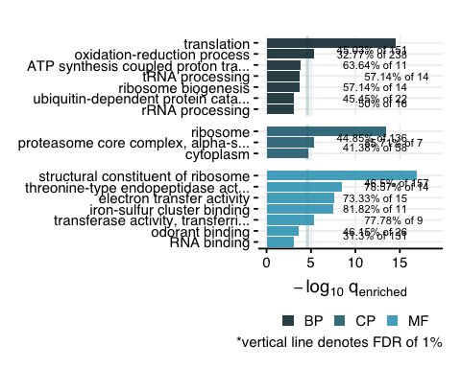

### 4.5 Cluster: module-11

Indirectly connected to forager- and nurse-cluster (and highly correlated to module-12)

#### 4.5.1 Explore cluster

## How many genes are there in the module-11 cluster?

## [1] 1533

#### 4.4.2 Enriched GO terms

## [1] "Loading annotation file for Camponotus floridanus"  
## [1] "Done."  
## [1] "Number of genes in background geneset: 9139"  
## [1] "Number of genes in the test set: 1533"  
## [1] "--------------------------------"  
## [1] "Number of GO terms in background geneset: 1968"  
## [1] "Number of GO terms (at least 5genes) in background geneset: 373"  
## [1] "Number of GO terms (at least 5genes) in test set: 72"  
## [1] "Testing for enrichment..."

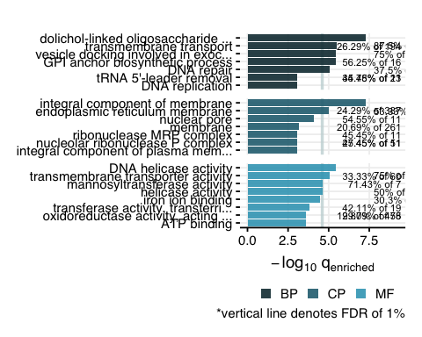

## Step 5: Random code chunks

# module-9 genes ----------------------------------------------------------  
  
db %>%   
 tbl(., "annot_fpkm") %>%   
 filter(gene_name %in% overlapping.genes.2) %>%   
 select(gene_name,   
 blast_annot=old_annotation,   
 GOs, pfams, signalP, TMHMM) %>%   
 collect() %>%   
   
 # add a column that indicates if the gene is rhythmic or not  
 ## in forager brains   
 mutate(rhy_foragers = ifelse(gene_name %in% for.rhy, "24h",  
 ifelse(gene_name %in% for.rhy.12, "12h",  
 ifelse(gene_name %in% for.rhy.8, "8h", "not_rhy")))) %>%   
 ## in nurse brains  
 mutate(rhy_nurses = ifelse(gene_name %in% nur.rhy, "24h",  
 ifelse(gene_name %in% nur.rhy.12, "12h",  
 ifelse(gene_name %in% nur.rhy.8, "8h", "not_rhy")))) %>%   
   
 # add a column to indicate if the gene is for-up/down and up/down-regulated at manipulation  
 mutate(identity = "upregulated in foragers; upregulated at manipulation") %>%   
   
   
   
 write.csv(., "./results/genes_of_interest/genes_for-up_manipulation-up_cluster9.csv", row.names = F)  
  
  
  
# module-6 genes ----------------------------------------------------------  
db %>%   
 tbl(., "annot_fpkm") %>%   
 filter(gene_name %in% overlapping.genes.4) %>%   
 select(gene_name,   
 blast_annot=old_annotation,   
 GOs, pfams, signalP, TMHMM) %>%   
 collect() %>%   
   
 # add a column that indicates if the gene is rhythmic or not  
 ## in forager brains   
 mutate(rhy_foragers = ifelse(gene_name %in% for.rhy, "24h",  
 ifelse(gene_name %in% for.rhy.12, "12h",  
 ifelse(gene_name %in% for.rhy.8, "8h", "not_rhy")))) %>%   
 ## in nurse brains  
 mutate(rhy_nurses = ifelse(gene_name %in% nur.rhy, "24h",  
 ifelse(gene_name %in% nur.rhy.12, "12h",  
 ifelse(gene_name %in% nur.rhy.8, "8h", "not_rhy")))) %>%   
   
 # add a column to indicate if the gene is for-up/down and up/down-regulated at manipulation  
 mutate(identity = "upregulated in nurses; downregulated at manipulation") %>%   
   
 write.csv(., "./results/genes_of_interest/genes_nur-up_manipulation-down_cluster6.csv", row.names = F)  
  
  
# Overlap between plasticity and manipulation genes ------------------------  
  
list.plasticity <- list(for.up, for.down)  
names(list.plasticity) <- c("for-UP", "for-DOWN")  
  
list.manipulation <- list(ophio.up, ophio.down)  
names(list.manipulation) <- c("ophio-UP", "ophio-DOWN")  
  
gom.plasticity_v_manipulation <- newGOM(list.plasticity, list.manipulation, genome.size = nGenes)  
png(paste0(path_to_repo, "/results/figures/gom_plasticity_v_manipulation.png"),   
 width = 12, height = 12, units = "cm", res = 400)  
drawHeatmap(gom.plasticity_v_manipulation,  
 adj.p=T,  
 cutoff=0.05,  
 what="odds.ratio",  
 # what="Jaccard",  
 log.scale = T,  
 note.col = "grey80")  
dev.off()  
  
  
# Odds ratio and fisher’s exact test --------------------------------------  
  
# for.rhy and module-7  
  
test.table <-   
 data.frame(  
 in.module = c(477, 187),  
 not.module = c(3092, 5383)  
 )  
rownames(test.table) <- c("in.for.rhy", "not.for.rhy")  
fisher.test(test.table)  
  
# for-up and module-9  
test.table <-   
 data.frame(  
 in.module = c(20,189),  
 not.module = c(14,8916)  
 )  
  
rownames(test.table) <- c("in.for.up", "not.for.up")  
  
fisher.test(test.table)  
  
# for-down and module-6  
test.table <-   
 data.frame(  
 in.module = c(18,161),  
 not.module = c(29,8931)  
 )  
  
rownames(test.table) <- c("in.for.down", "not.for.down")  
  
fisher.test(test.table)  
  
# ophio-up and module-9  
test.table <-   
 data.frame(  
 in.module = c(32,177),  
 not.module = c(177,8730)  
 )  
  
rownames(test.table) <- c("in.ophio.up", "not.ophio.up")  
  
fisher.test(test.table)  
  
# ophio-down and module-6  
test.table <-   
 data.frame(  
 in.module = c(42,137),  
 not.module = c(137,8428)  
 )  
  
rownames(test.table) <- c("in.ophio.down", "not.ophio.down")  
  
fisher.test(test.table)$p.value  
  
  
## are there any known clock genes and clock-controlled genes in module-4?  
  
rhy.genes.in.module4 <- intersect(for.rhy, module_genes[["module-4"]])  
  
db %>%   
 tbl(., "annot_fpkm") %>%  
   
 # filter the genes here  
 filter(gene_name %in% rhy.genes.in.module4) %>%  
   
 select(gene_name,   
 blast_annot=old_annotation,   
 GOs, pfams, signalP, TMHMM) %>%   
 collect() %>%   
   
 # add a column that indicates if the gene is rhythmic or not  
 ## in forager brains   
 mutate(rhy_foragers = ifelse(gene_name %in% for.rhy, "24h",  
 ifelse(gene_name %in% for.rhy.12, "12h",  
 ifelse(gene_name %in% for.rhy.8, "8h", "not_rhy")))) %>%   
 ## in nurse brains  
 mutate(rhy_nurses = ifelse(gene_name %in% nur.rhy, "24h",  
 ifelse(gene_name %in% nur.rhy.12, "12h",  
 ifelse(gene_name %in% nur.rhy.8, "8h", "not_rhy")))) %>%   
   
 # add a column to indicate if the gene is for-up/down and up/down-regulated at manipulation  
 mutate(identity = "24h-rhythmic in foragers; module-4 gene") %>%   
   
   
   
 write.csv(., "./results/genes_of_interest/rhythmic_genes_module4.csv", row.names = F)  
  
# png(paste0(path_to_repo, "/results/figures/module_4_enrichments.png"),  
# width = 16, height = 12, units = "cm", res = 400)  
# run enrichment for module-4  
module_genes[["module-4"]] %>%   
 # run enrichment  
 go_enrichment(.,  
 function.dir = path_to_repo,  
 org = "cflo",   
 bg = bg.genes) %>% view()  
 # visualize the results  
 go_enrichment_plot(function.dir = path_to_repo, clean = "no")  
# dev.off()  
  
  
## are there any known clock genes and clock-controlled genes in module-12?  
rhy.genes.in.module12 <- intersect(for.rhy, module_genes[["module-12"]])  
  
db %>%   
 tbl(., "annot_fpkm") %>%  
   
 # filter the genes here  
 filter(gene_name %in% rhy.genes.in.module12) %>%  
   
 select(gene_name,   
 blast_annot=old_annotation,   
 GOs, pfams, signalP, TMHMM) %>%   
 collect() %>%   
   
 # add a column that indicates if the gene is rhythmic or not  
 ## in forager brains   
 mutate(rhy_foragers = ifelse(gene_name %in% for.rhy, "24h",  
 ifelse(gene_name %in% for.rhy.12, "12h",  
 ifelse(gene_name %in% for.rhy.8, "8h", "not_rhy")))) %>%   
 ## in nurse brains  
 mutate(rhy_nurses = ifelse(gene_name %in% nur.rhy, "24h",  
 ifelse(gene_name %in% nur.rhy.12, "12h",  
 ifelse(gene_name %in% nur.rhy.8, "8h", "not_rhy")))) %>%   
   
 # add a column to indicate if the gene is for-up/down and up/down-regulated at manipulation  
 mutate(identity = "24h-rhythmic in foragers; module-12 gene") %>%   
   
   
   
 write.csv(., "./results/genes_of_interest/rhythmic_genes_module12.csv", row.names = F)  
  
# run enrichment for module-12  
# png(paste0(path_to_repo, "/results/figures/module_12_enrichments.png"),  
# width = 16, height = 12, units = "cm", res = 400)  
module_genes[["module-12"]] %>%   
 # run enrichment  
 go_enrichment(.,  
 function.dir = path_to_repo,  
 org = "cflo",   
 bg = bg.genes) %>%   
 # visualize the results  
 go_enrichment_plot(function.dir = path_to_repo, clean = "no")  
# dev.off()