**Performance Comparison between RL and SC for different service distribution:**

We change the service distribution, and compare the performance of SC and RL.

In the original code, total service time for a request= service time+ communication time. Service time is function of basic service time. Basic service time is already available, and generated from profiling information taken by actual simulation. Communication time is also generated using parameters available in the original code.

To change the service distribution, we take Exponential of Basic service time.

The requests are generated with inter-arrival rate uniformly distributed between (arrival rate-20, arrival rate+20).

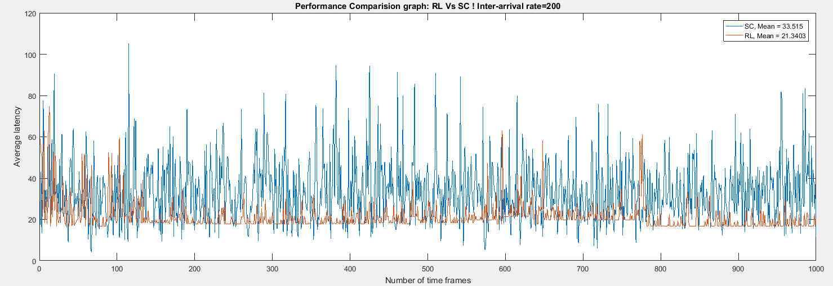Average Latency for RL=21.54

Average Latency for SC=33.515

Each time frame has 5 requests.

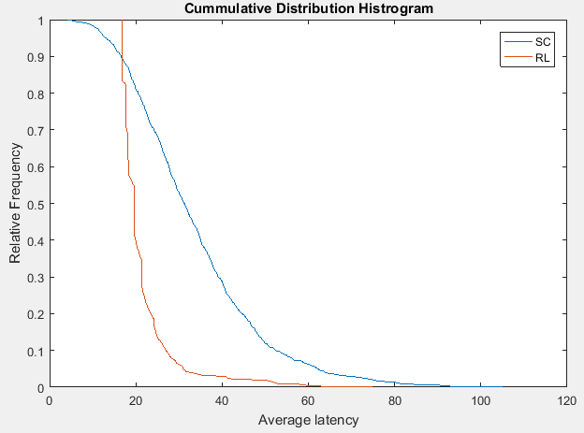

*************************************************************************************

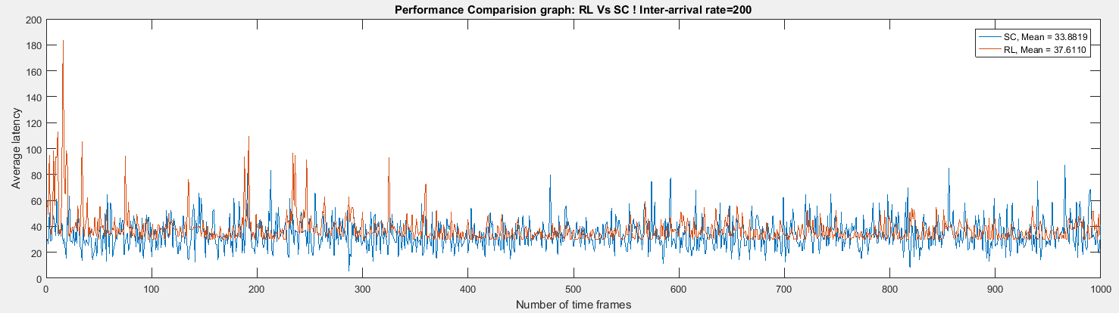For 10 requests in a time frame:

Average Latency for RL=37.61

Average Latency for SC=33.66

Each time frame has 10 requests.

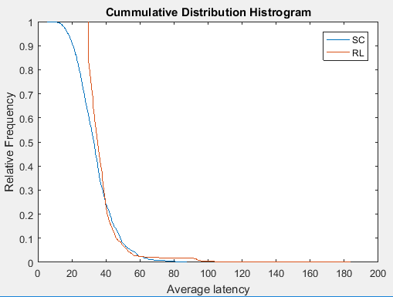

*************************************************************************************

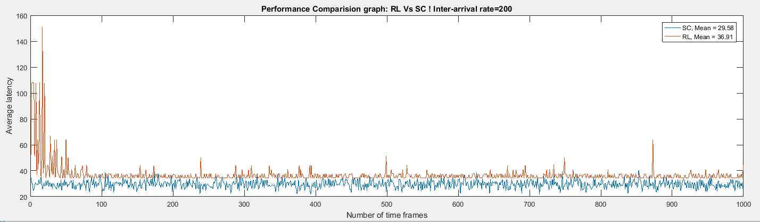Setting : 100 requests in a time frame

Average Latency for RL=44.54

Average Latency for SC=33.97

Each time frame has 100 requests.

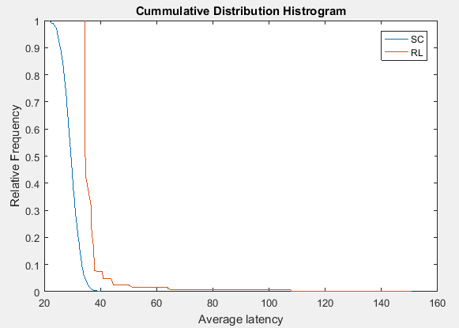

*************************************************************************************

For inter-arrival rate of 100,

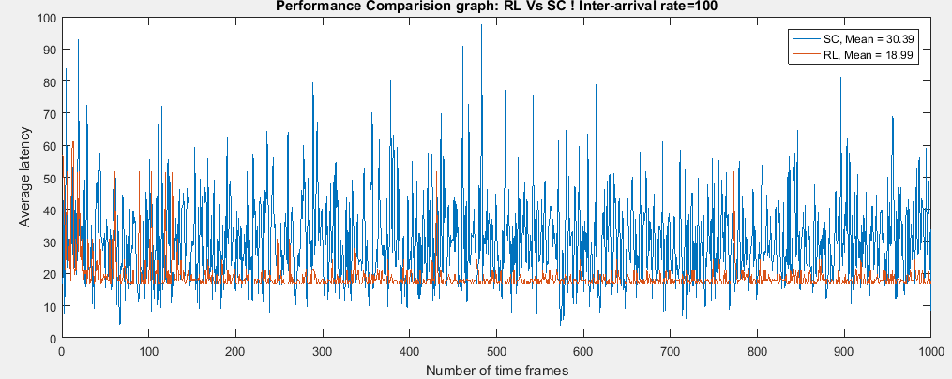Average Latency for RL=18.99

Average Latency for SC=30.29

Each time frame has 5 reqeusts. 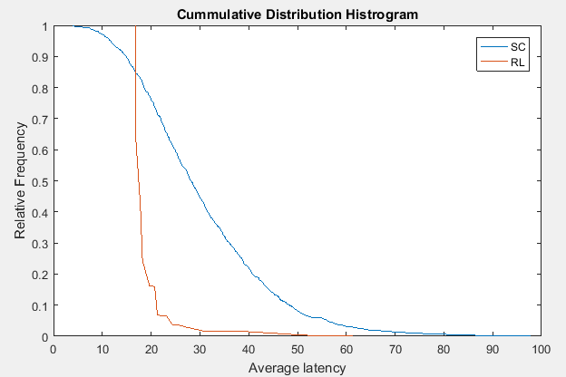

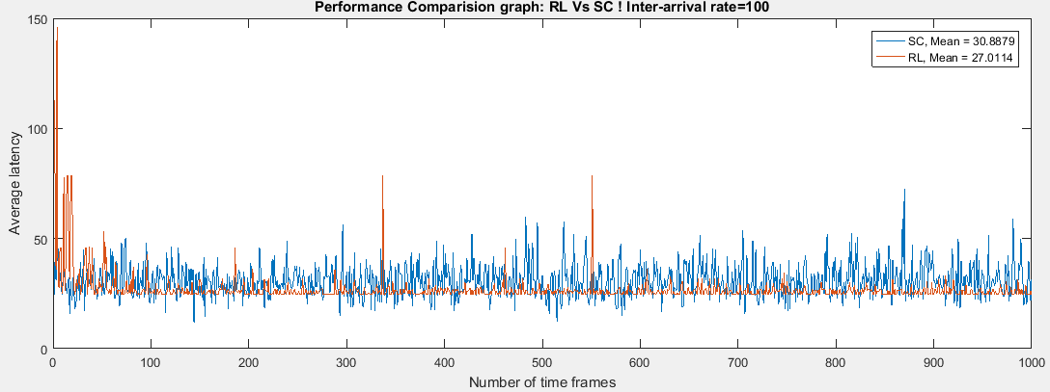

Average Latency for RL=27.0154

Average latency for SC=30.8879

Each Time frame has 20 requests.

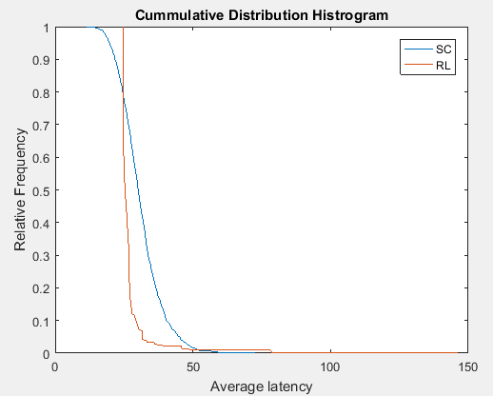

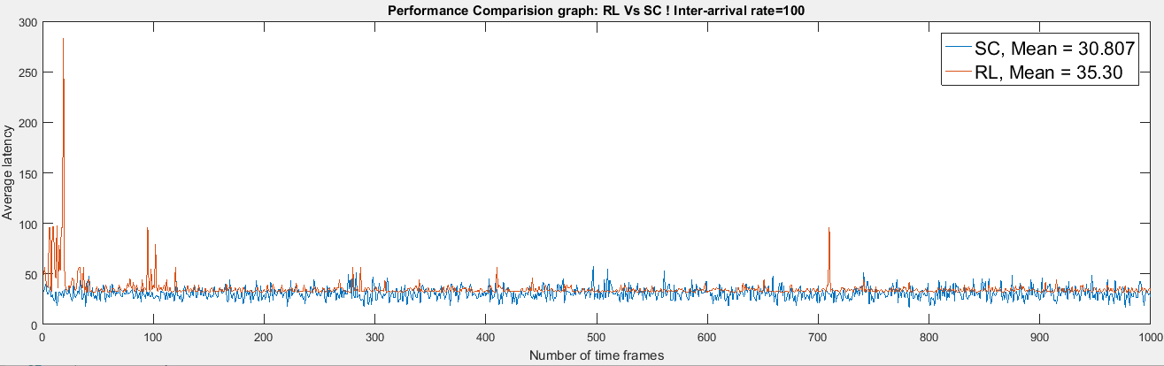Average Latency for RL=35.3

Average Latency for SC=30.807

Each Time frame has 35 request.

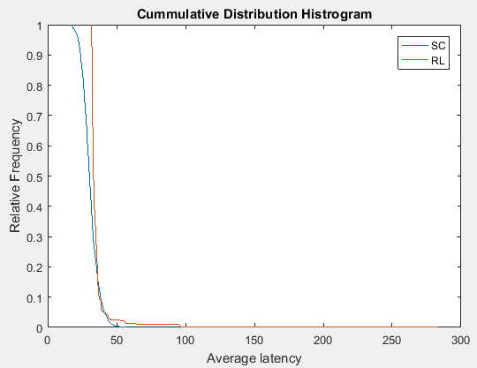

Inter-arrival rate=75

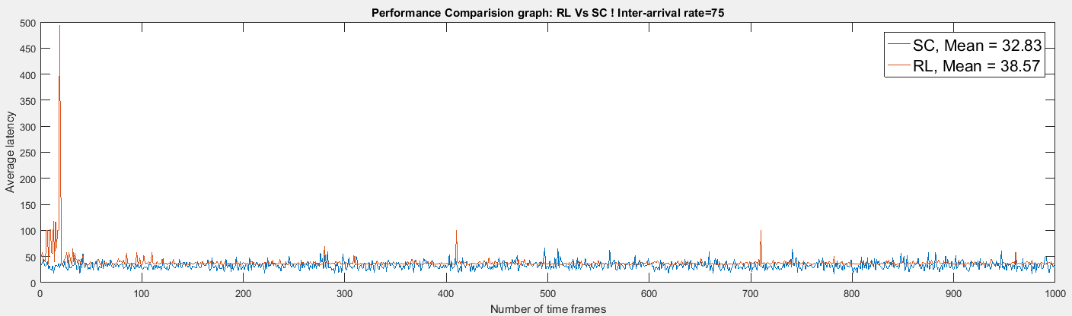

Average Latency for RL=38.57

Average Latency for SC=32.83

Number of requests in a time frame=35

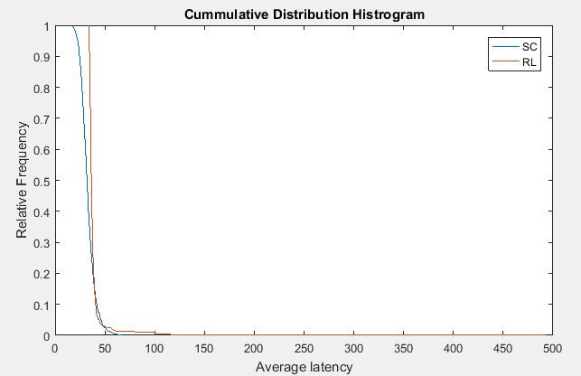

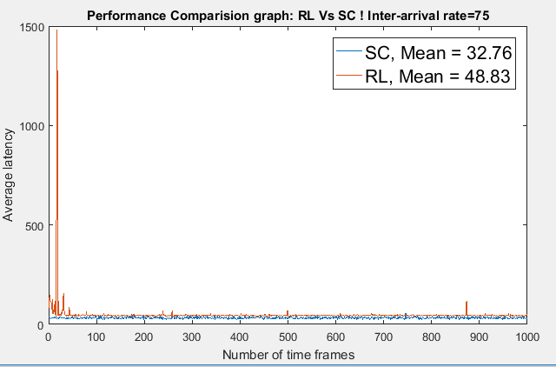

Average Latency for RL=48.83

Average Latency for SC=32.76

Number of requests in a time frame:100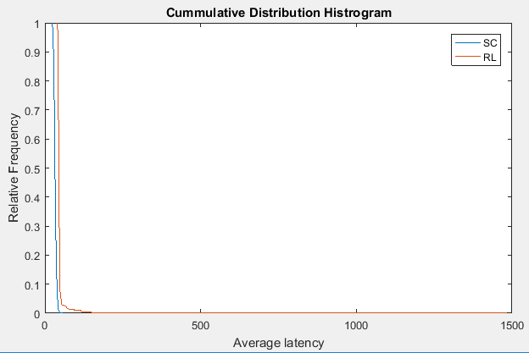

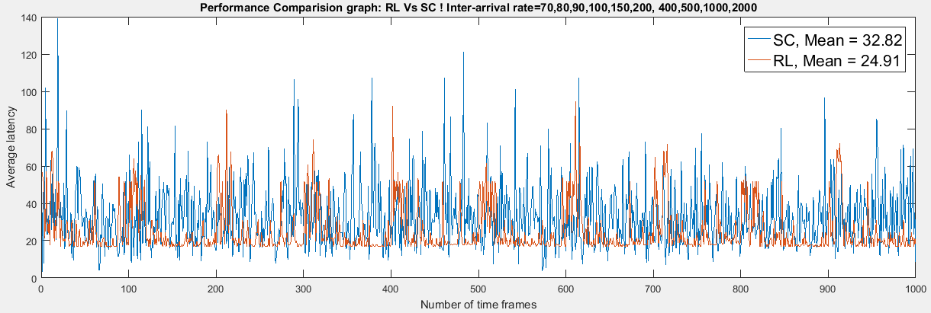

Average Latency for RL=24.91

Average Latency for SC=32.82

Number of requests in a time frame=5

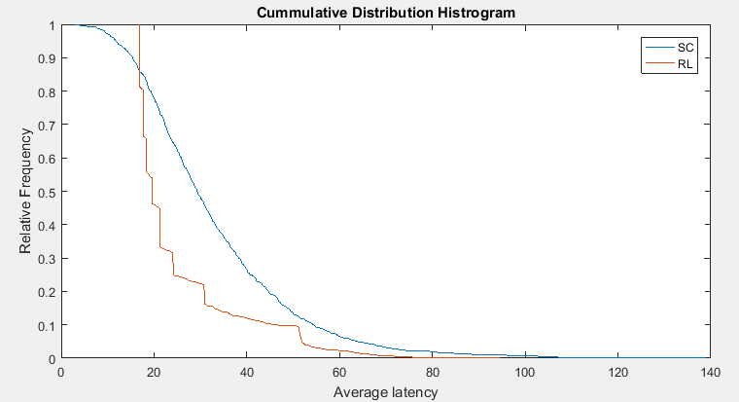

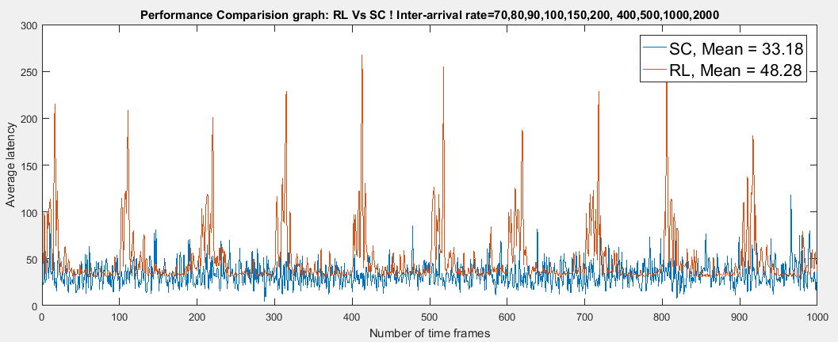

Average latency for RL=48.28

Average Latency for SC=33.18

Number of requests=10

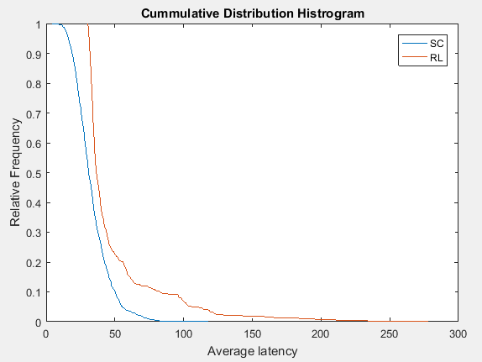

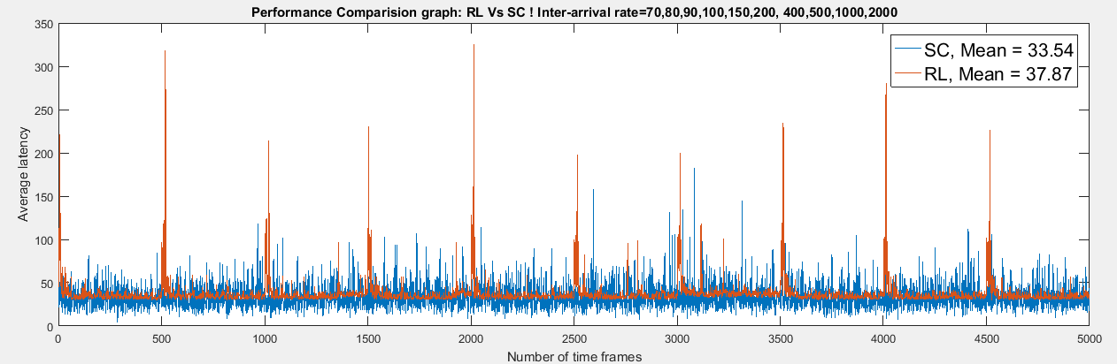

Average Latency for RL=37.87

Average Latency for SC=33.54

Number of requests in each time frame:10

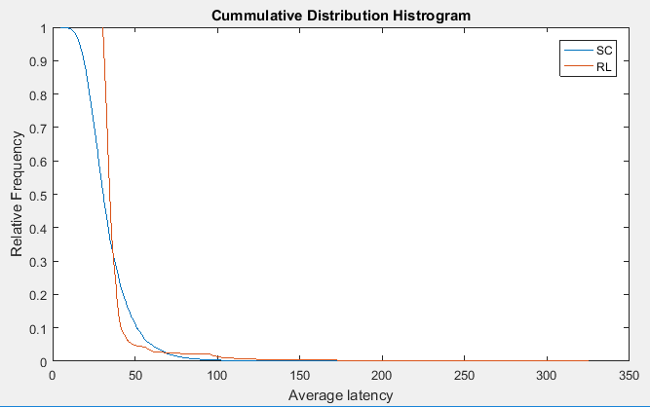

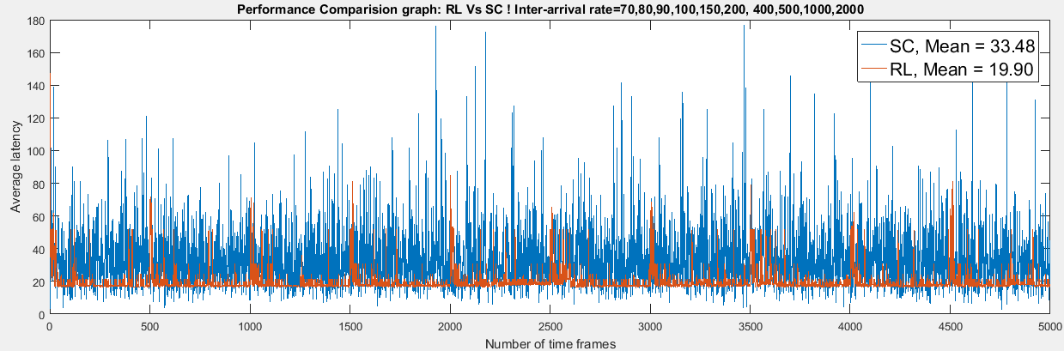

Average latency for RL=19.9

Average Latency for SC=33.48

Number of requests in a time frame: 5

