Inter-arrival rate=Uniform(g_arrivalmean-20, g_arrivalmean+20);

ServiceTime=Uniform(param-30, param+30)

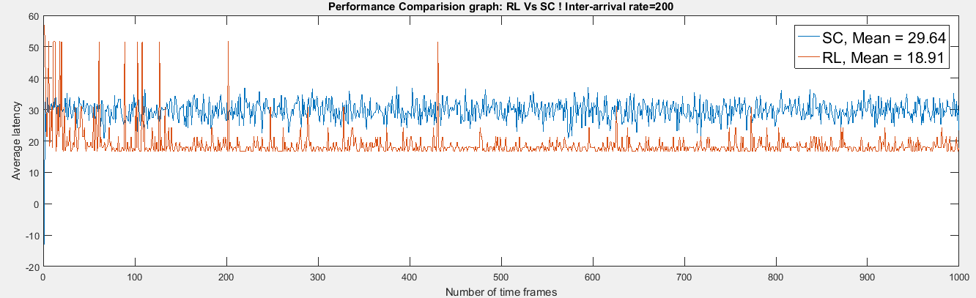

Average Latency for RL=18.91

Average Latency for SC=29.64

Number of requests in a time frame: 5

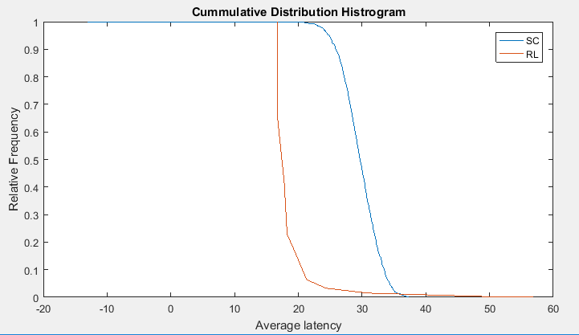

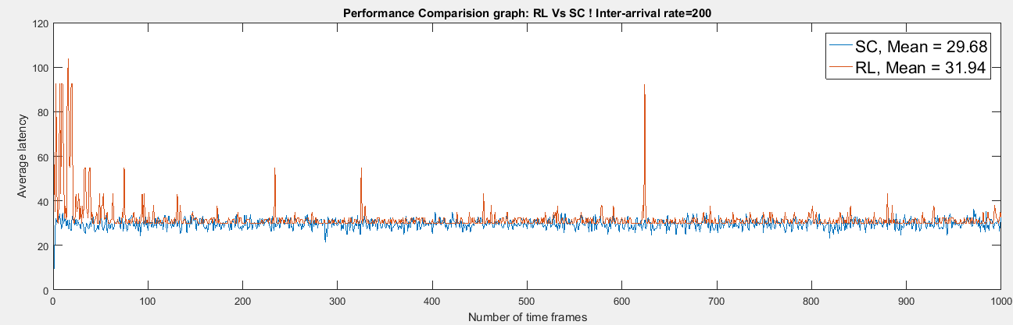

Average Latency for RL=31.94

Average Latency for SC=29.68

Number of requests in a time frame: 10

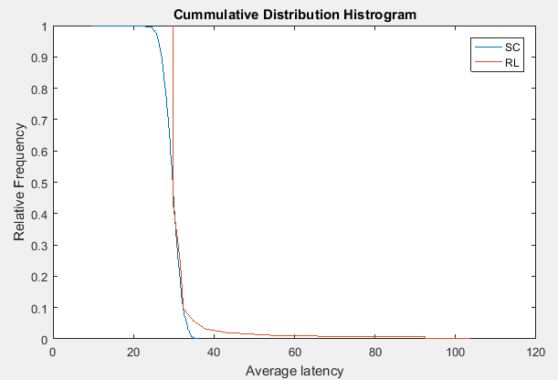

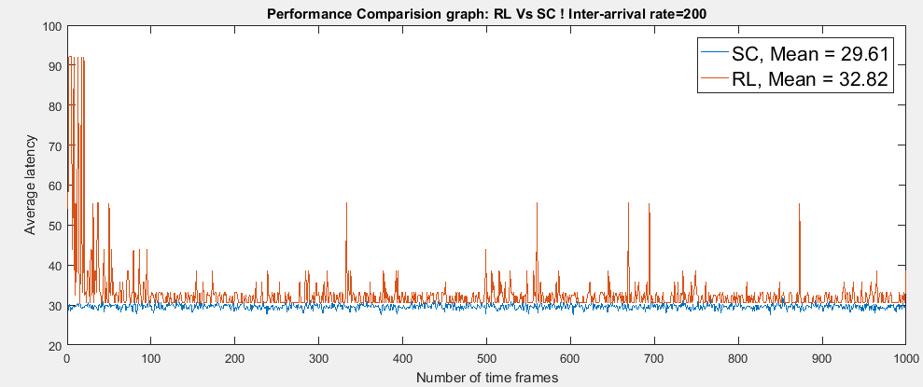

Average Latency for RL=36.91

Average Latency for SC=29.61

Number of requests in a timeframe= 100

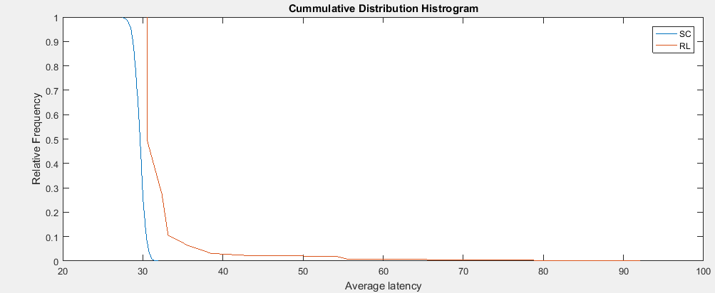

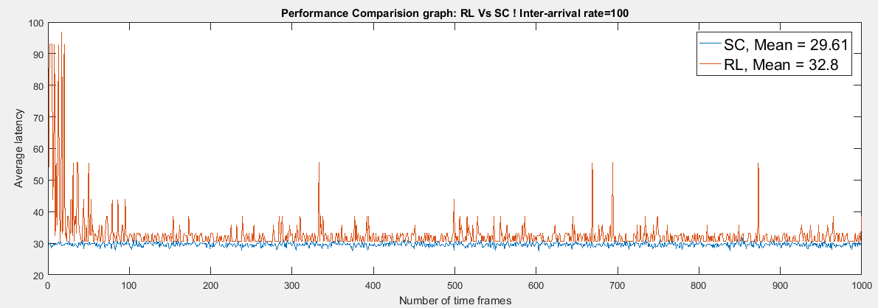

Average Latency for RL=39.54

Average Latency for SC=29.61

Number of requests in a time frame: 100

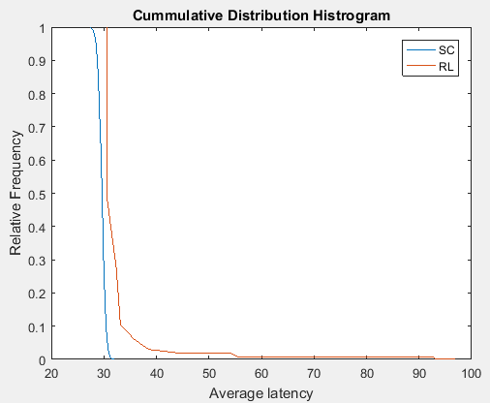

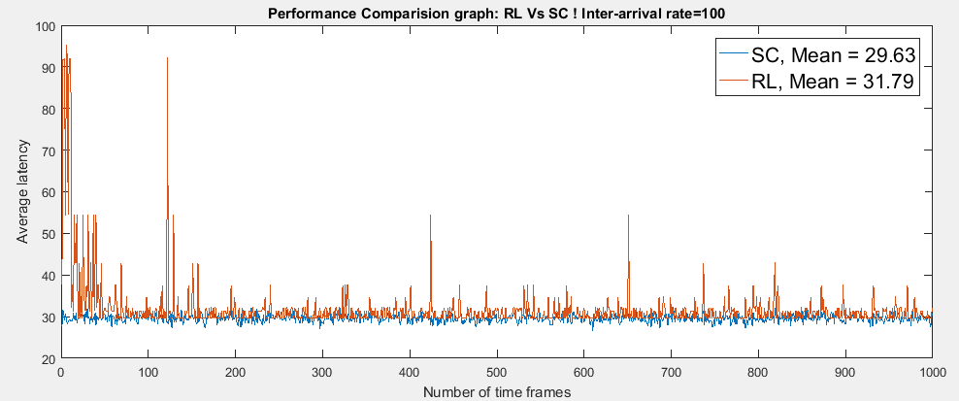

Average Latency for SC=29.63

Average Latency for RL=33.4

Total number of requests in a time frame=50

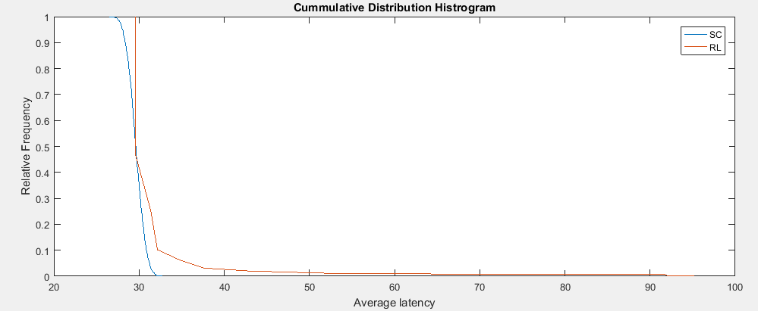

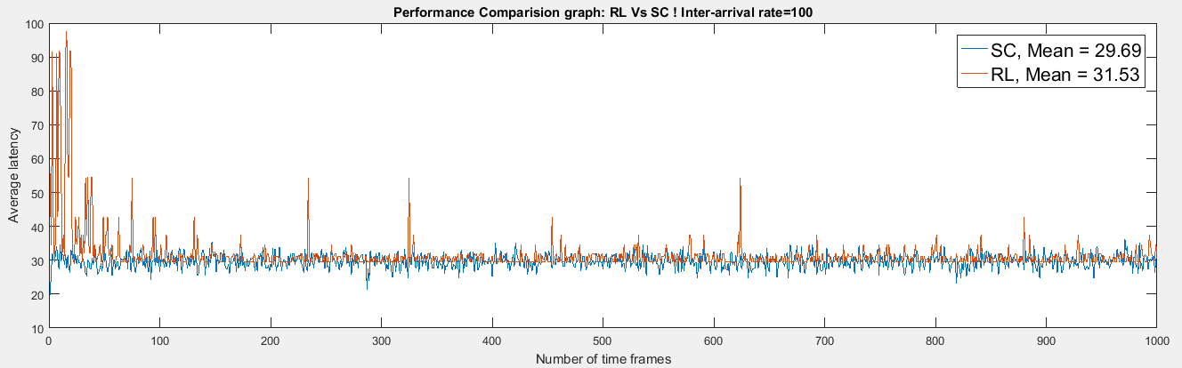

Average Latency for SC=29.69

Average Latency for RL=31.53

Number of request in a time frame=10

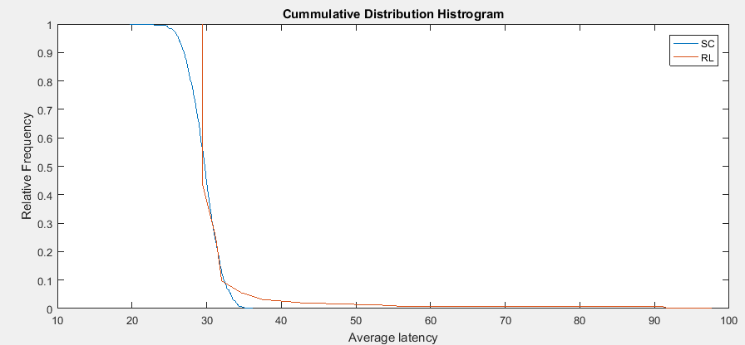

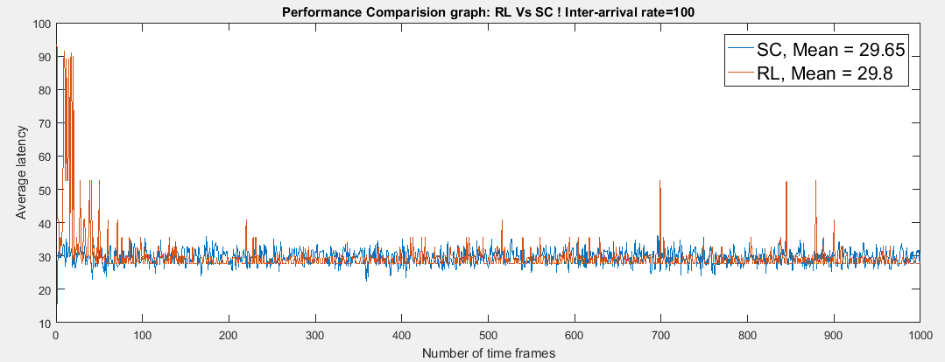

Average Latency for SC=29.66

Average Latency for RL=18.99

Number of request in a time frame=8

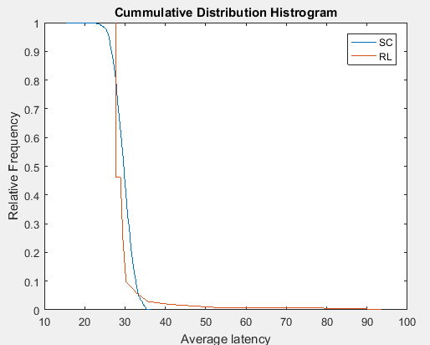

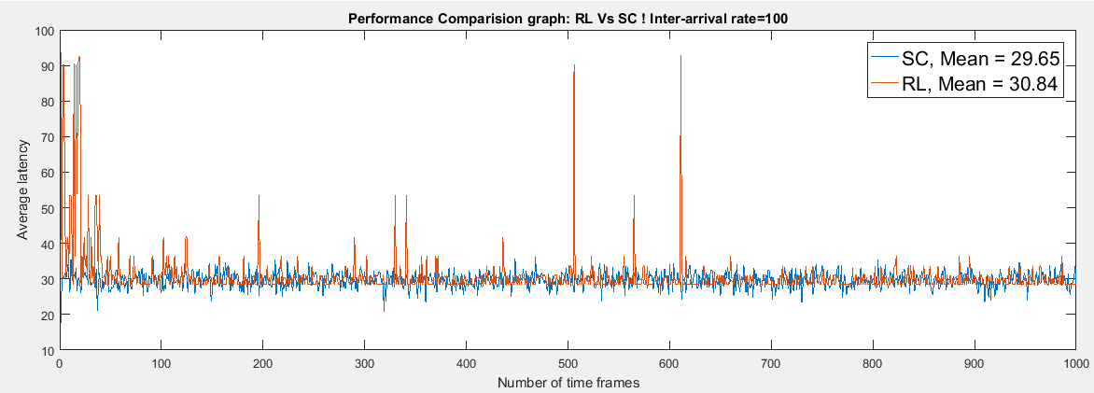

Average Latency for SC=29.66

Average Latency for RL=28.73

Number of request in a time frame=9

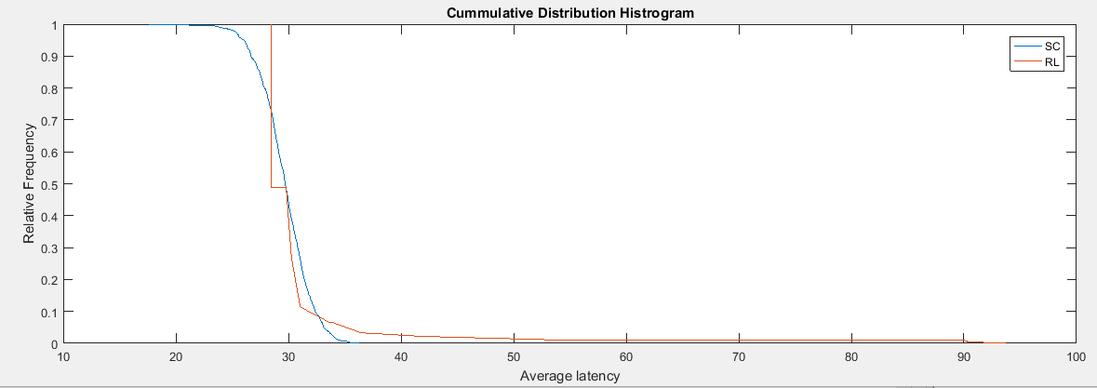

Inter-arrival rate: Exponential(g_arrivalmean)

Basic service time= Exponential(g_aMultifpleThreadInteferPara[g_servthreadNum - 1][0])

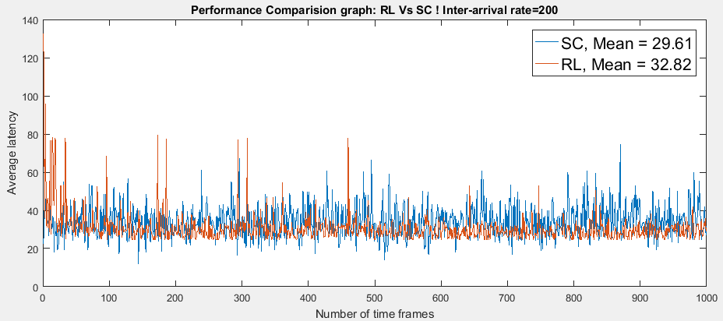

Average Latency for SC=29.66

Average Latency for RL=28.73

Number of request in a time frame=9

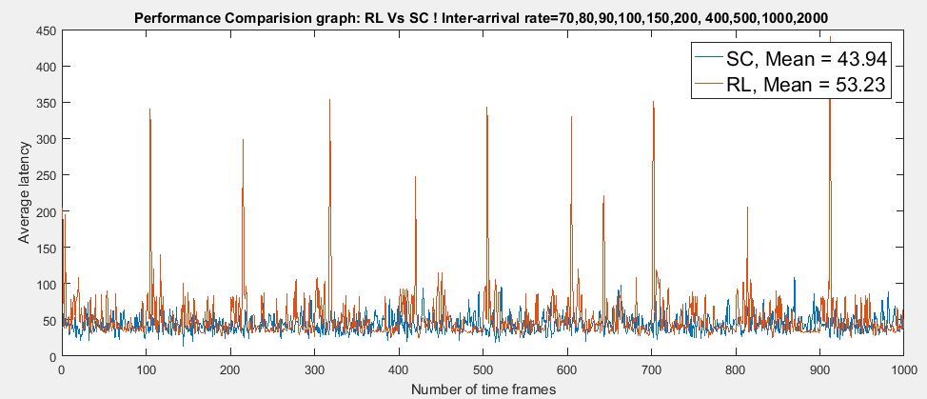

Average latency for RL=53.23

Average Latency for SC=43.94

Number of requests in a time frame=50

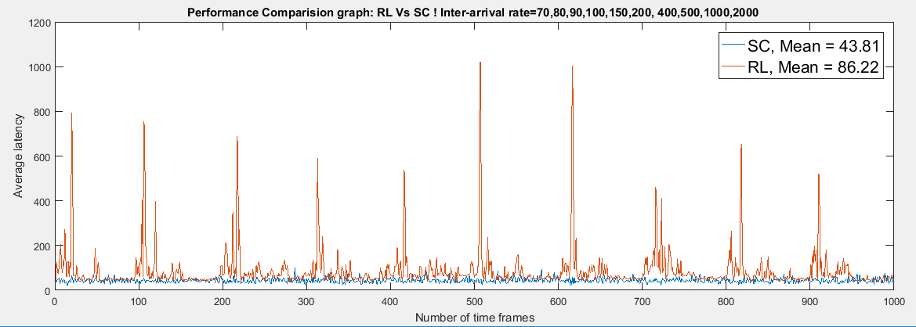

Average Latency for SC=43.81

Average Latency for RL=86.22

Number of request in a time frame=35

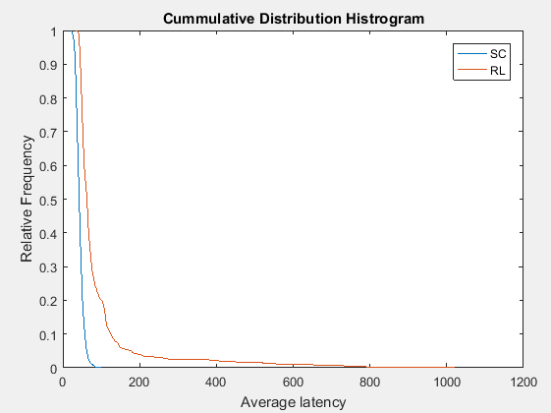

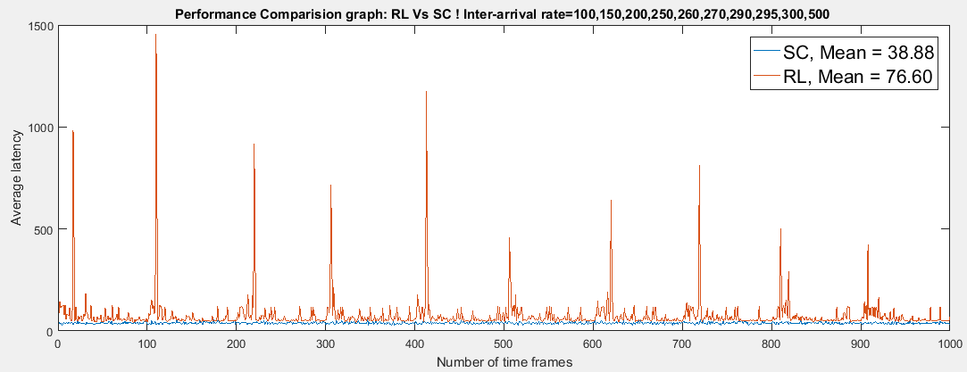

Average Latency for SC=38.88

Average Latency for RL=76.6

Number of requests in a time frame=100

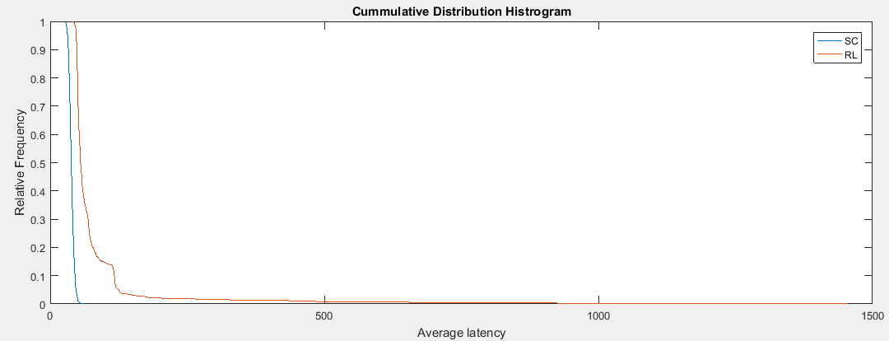

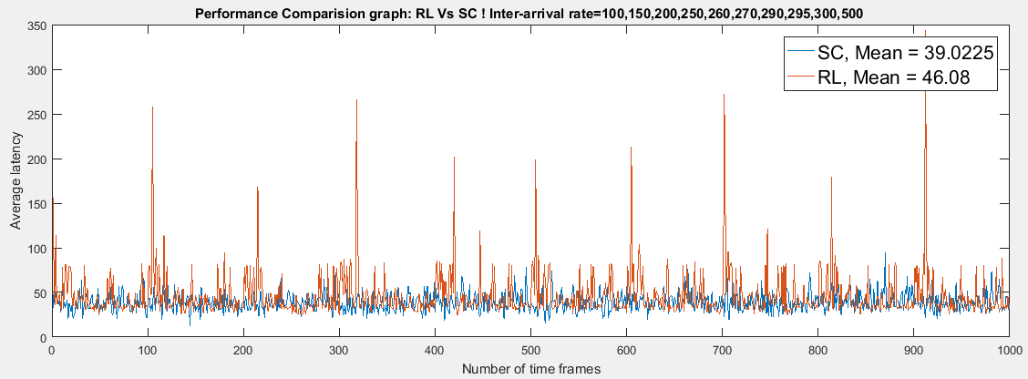

Average Latency for SC=39.0225

Average Latency for RL=46.08

Number of requests in a time frame=20

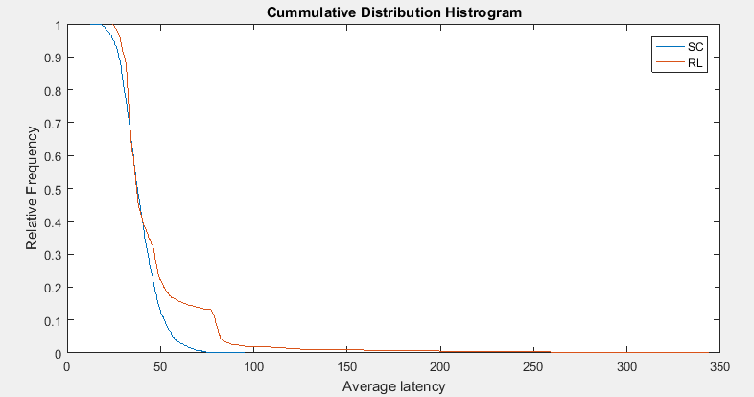

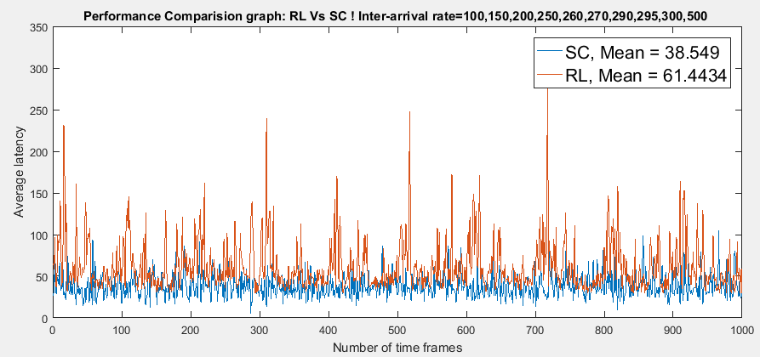

Average Latency for SC=38.549

Average Latency for RL=61.4434

Number of requests in a time frame=10

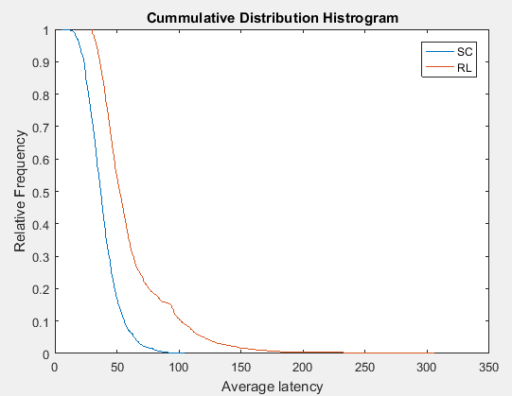

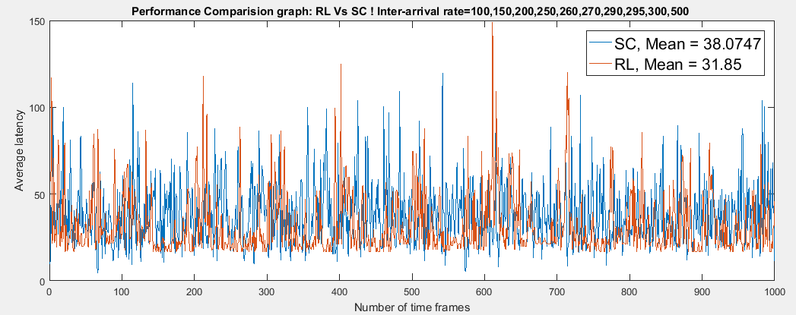

Average Latency for SC=38.0707

Average Latency for RL=31.85

Number of requests in a time frame=5

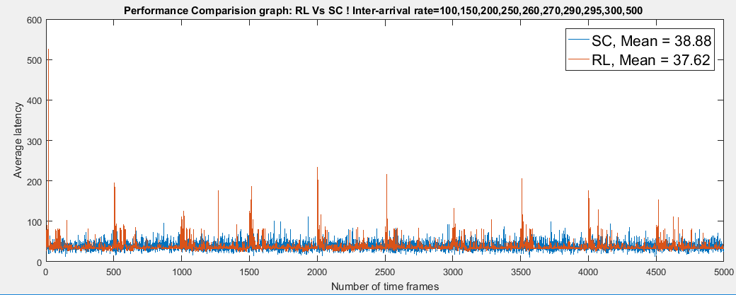

Average Latency for SC=38.0707

Average Latency for RL=31.85

Number of requests in a time frame=5

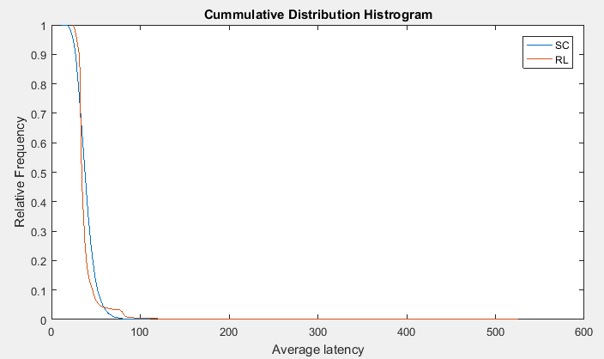

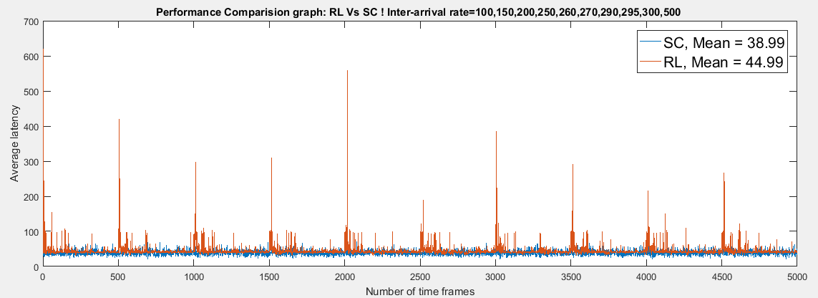

Average Latency for SC=38.0707

Average Latency for RL=31.85

Number of requests in a time frame=5

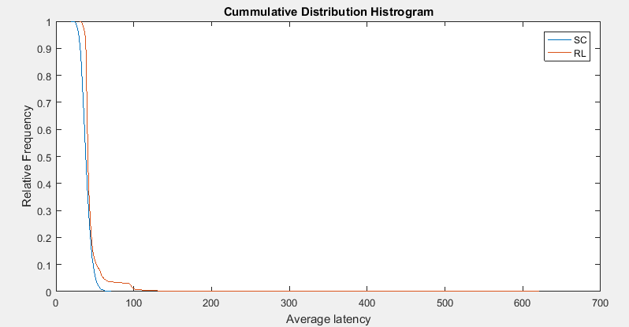

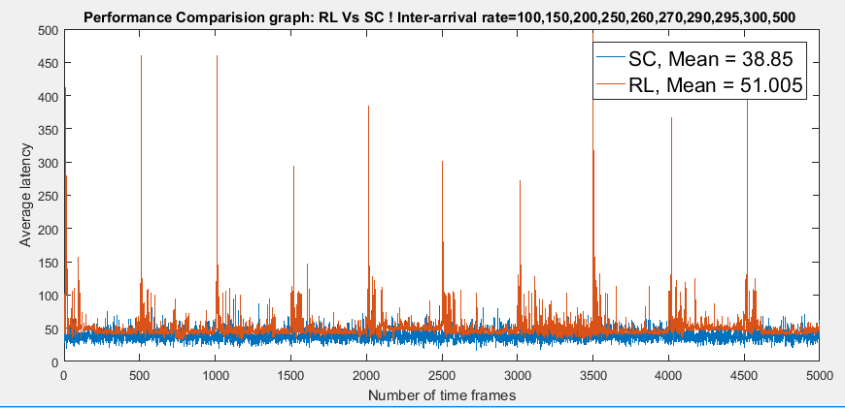

Average Latency for SC=38.85

Average Latency for RL=51.005

Number of requests in a time frame=30, repeated for 5000 times