**Table of Contents**

**Introduction**

* Welcome to RikiPDYea
* About RikiPDYea
* Getting Started

**Installation and Account Setup**

2.1 Navigating the Home Page

2.2 Creating and Editing Content

**Create New Page and Wiki Editor**

3.1 Editing, Moving, and Deleting Articles

3.2 Using the Search Function

**Performing a Search**

4.1 Executing Your Search

4.2 Navigating the Page Index and Tags

**Accessing and Understanding the Page Index**

5.1 Using Tags for Efficient Navigation

5.2 Managing Your Profile

**Accessing and Editing Your Profile**

6.1Managing Posts and Biography

6.2 Advanced Features

**AutoSave and Confirm Exit**

7.1 Language Translation Feature

7.2Uploading and Downloading Images

**How to Upload Images**

8.1Downloading Images from Pages

**Contact Details for Technical Support, Customer Service, and Feedback**

**Introduction**

Welcome to **RikiPDYea,** a new way to share and access knowledge. This guide is designed to help you maximize your experience with our website. Whether you're a curious learner, a researcher, or someone looking to explore diverse topics, **RikiPDYea** has you covered.

**About RikiPDYea**

**RikiPDYea** is a versatile app that grants access to a vast collection of articles spanning various subjects. Here, you can:

* Explore articles on a wide array of topics.
* **Contribute** to the knowledge base by creating articles.
* Stay updated with the latest information.

**Getting Started**

Whether you're a newcomer or an experienced user, this manual will guide you through the website's features. You'll learn how to navigate, search, read, and customize your experience. We've provided step-by-step instructions and useful tips to help you become a proficient user quickly.

**We Value Your Input**

At **RikiPDYea**, we're committed to improving our app to better serve you. If you have feedback, suggestions, or encounter issues, please reach out to our support team. Your input is crucial in making RikiPDYea even better.

Thank you for choosing RikiPDYea as your knowledge companion. Let's embark on a journey of discovery together!

**Getting Started**

Welcome to **RikiPDYea!** In this section, we'll walk you through the basics of using our app so you can start exploring the world of knowledge right away.

**1. Installation and Account Setup**

* **Installation**: You can access the app by cloning our Github repository and running the app. The app doesn’t have a URL yet.
* **Account Creation**: Upon opening the app, you will be greeted with a welcome screen. For unregistered users, locate and tap on the "Sign up here" button to initiate the registration process.

You will be prompted to enter basic information such as your

* + Username
  + Password
  + Confirm Password

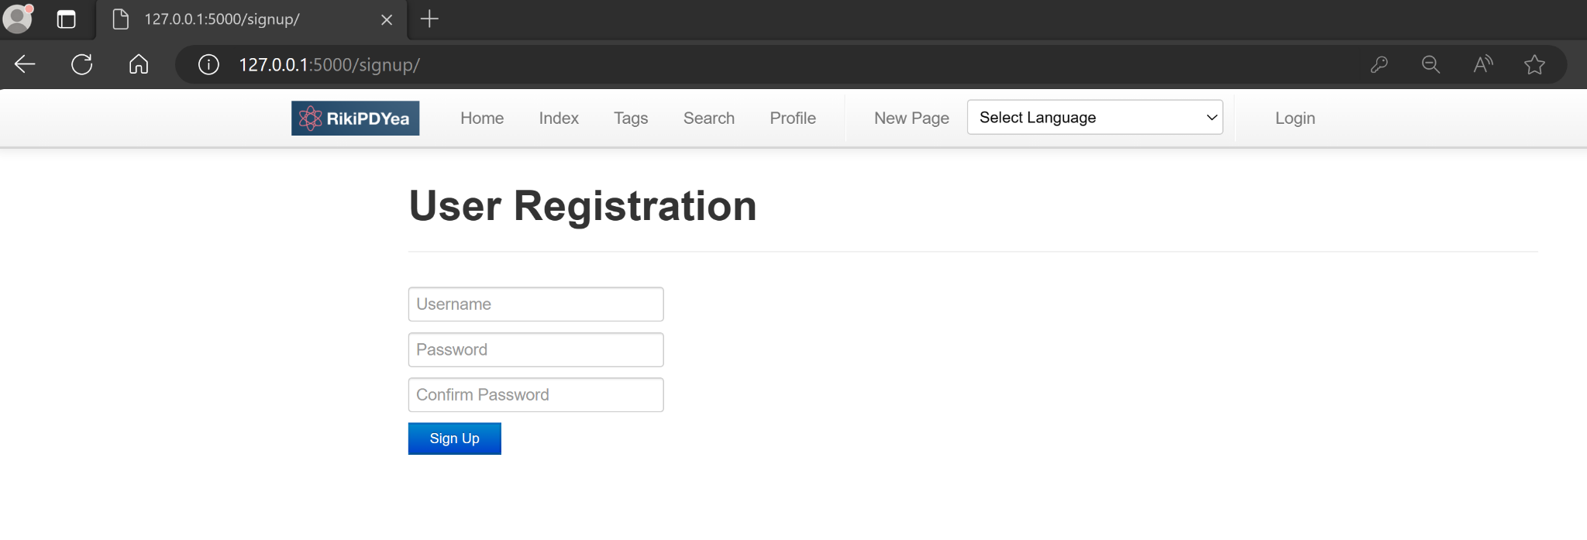

Once everything is in order, click on the "Sign Up" button to complete the registration

process. You will be redirected to Login Page. You can now login with your newly made credentials and enjoy the app

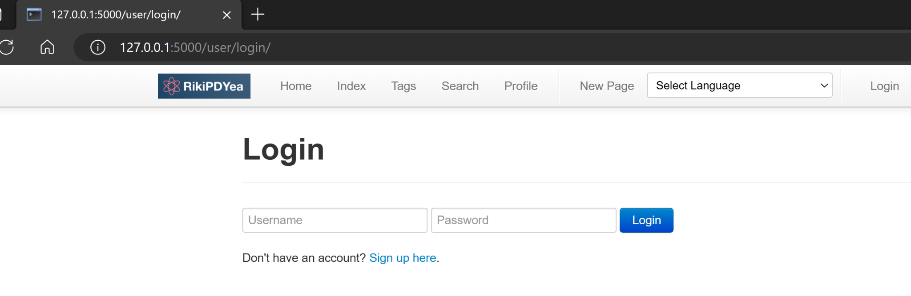

To ensure individual account and security, you cannot use an already existing username and your password and confirm password have to match for the Registration to be successful.

**2. Navigating the Home Page**

**2.1 Navigation Bar :**

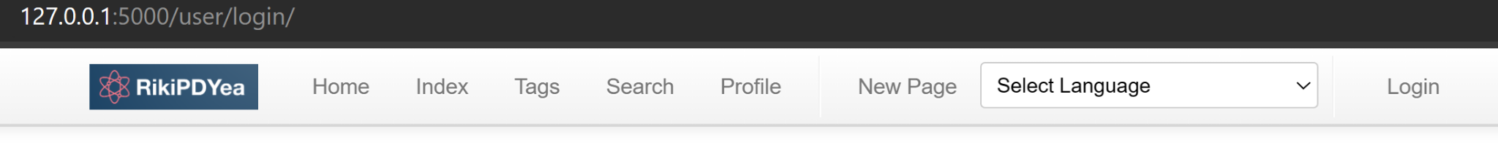

Our website is designed with ease of navigation in mind. The navigation bar, located at the top of each page, is your guide to finding content quickly and efficiently. Here’s how to use it:

* **Home**: Click on this tab to return to the homepage at any time, no matter where you are on the site. The homepage is explained in more details in section 2.2
* **Index**: This section acts as a comprehensive directory of all the content available on the site. The **Index** is explained in more details in section **6.1**
* **Tags**: Our content is tagged with keywords that describe its subject matter. By clicking on the 'Tags' tab, you can browse a list of all tags used across the site. Selecting a tag filters the content to show only those pages that include the chosen keyword. The **Tags** is explained in more details in section **6.2**
* **Search**: The search function is a powerful tool to quickly locate specific content. Click on the 'Search' tab to open a search bar where you can type keywords or phrases related to what you're looking for. **Search** is explained in more details in section **5.1**
* **Profile**: If you have an account with us, you can access your personal profile by clicking on the 'Profile' tab. Here, you can view and edit your account details, check your activity, and customize your user experience. The **Profile** is explained in more details in section **7**
* **New Page**: Use this tab to create new content on the site. **New Page** is explained in more details in section **3.1**

**2.2 Home Page**: When you open **[RikiPDYea],** you'll land on the home screen.

Depending on whether you're a new user or not, the appearance of the home screen will vary.

**For First-Time Users:**

When you use the app for the first time, you will be prompted to set up your homepage (see Figure 2.1). This will be the landing page every time you log in.

To create your homepage, click the "Create a homepage" button. You will be directed to the Editor page, where you can input a title, add markdown content, and include tags (separated by commas). For detailed instructions on how to create a page, please refer to Section 3.

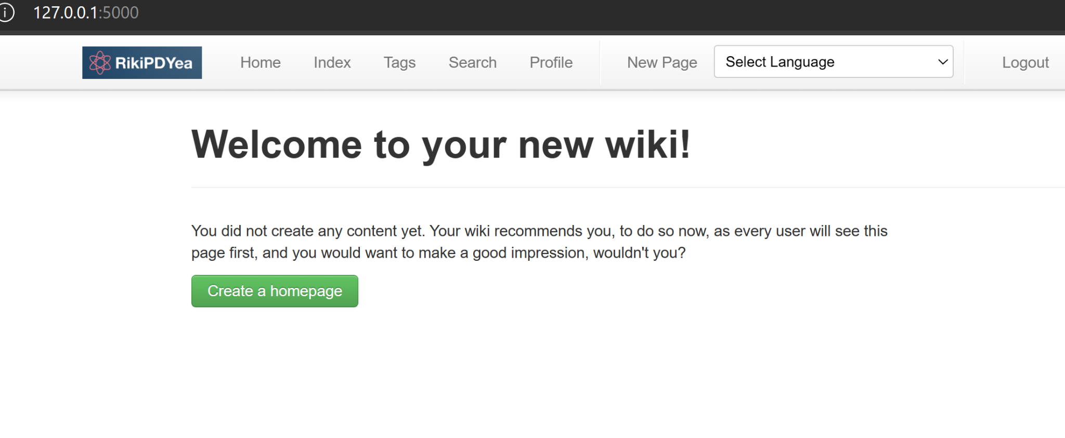

*Figure 2.1* **: Home screen view for first time user**

**For Users with an Existing Homepage:**

If you've already created a homepage, the home screen will simply display the articles you've authored (see Figure 2.2). Homepage displays article in same way as regular article, to read more about how article are displayed please refer to section 5  
 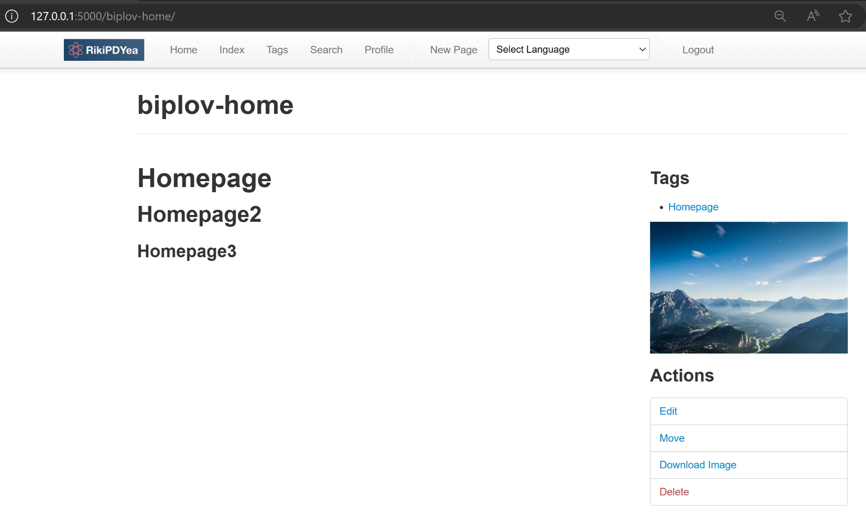

*Figure 2.2* **: Home screen view for other users**

**3. Create New Page and Wiki Editor->**

**3.1 Create Article :**

To begin crafting an article, select the “**New Page**” tab from the navigation bar. Upon doing so, you'll be prompted to specify a URL for the new page(see Figure 3.1), which effectively serves as the title of your article. Once you've entered the desired URL, press the "Create" button to proceed to the Wiki Editor Screen(see Figure 3.1).

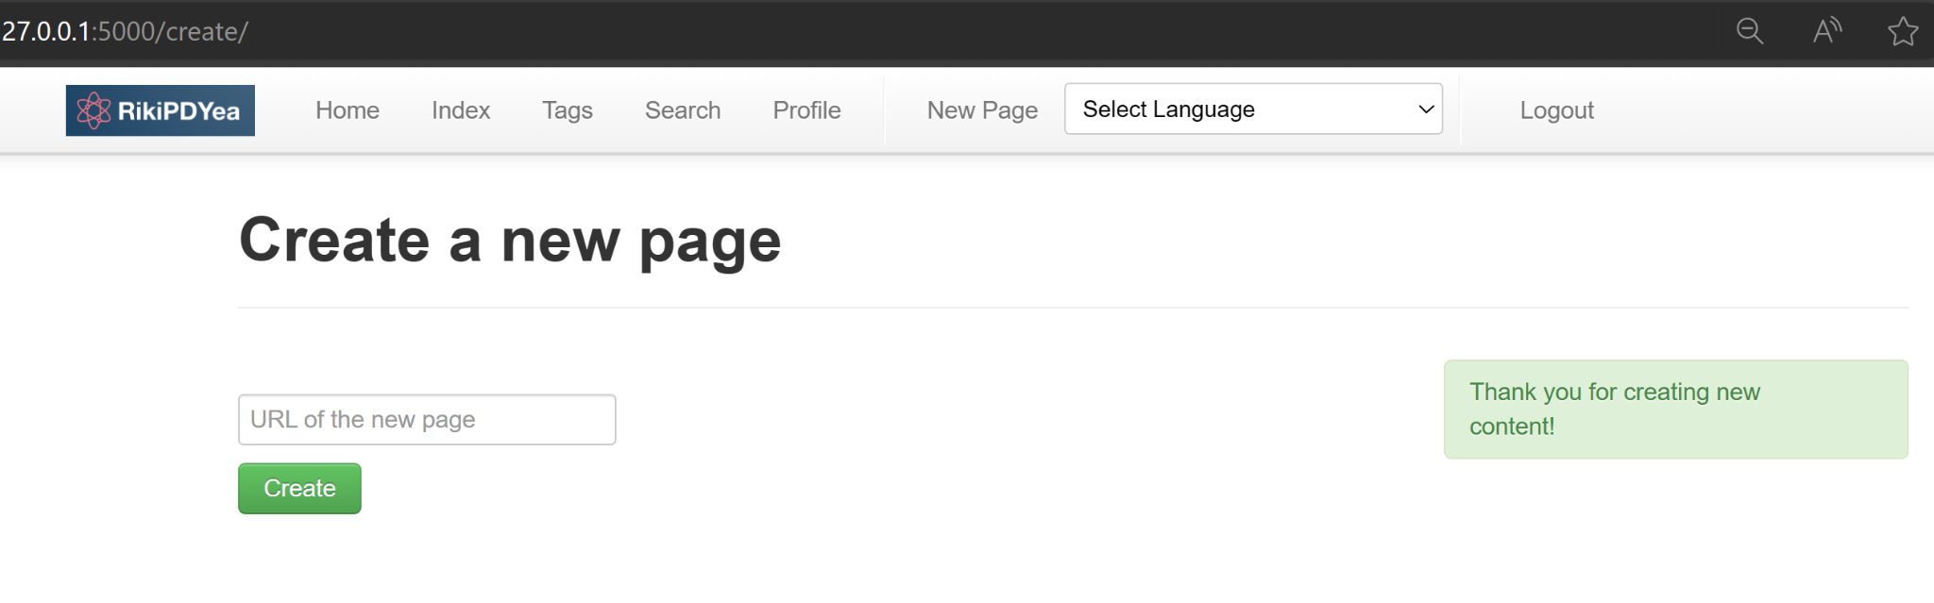

*Figure 3.1* **URL page used to enter URL**

**3.2 Wiki Editor:**

Please be aware that the Wiki Editor screen is utilized for both the creation of new pages and the editing of existing ones. Therefore, the process for creating or editing a page is identical.

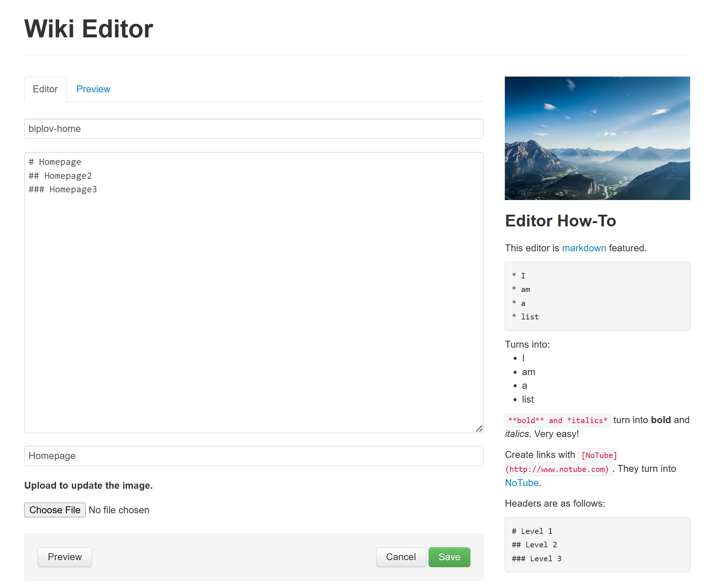

*Figure 3.2* ***Wiki Editor is used to edit pages***

The Wiki Editor is an intuitive tool that allows you to create and edit pages on our website with ease.

Using the Editor:

* **Title:** Start by entering the title of your new page in the 'Title' field at the top of the editor.
* **Markdown:** The editor uses Markdown, a lightweight markup language with plain-text formatting syntax that is converted into HTML. Below are some basics to get you started:
  + **Creating Lists:** Type an asterisk (*) followed by a space and your text to create a bulleted list.

For example:

* Item 1

* Item 2

* + **Bold and Italics:** For bold text, wrap your text in double asterisks **\*\*like this\*\***, and for italics, use a single asterisk **\*like this\***.
  + **Links:** To create a hyperlink, put the link text in brackets [like this], followed by the URL in parentheses ([http://www.example.com](http://www.example.com/)).
  + **Headers:** Organize your content with headers. Use one hash (#) for a top-level header, two hashes (##) for a second-level header, and three hashes (###) for a third-level header.
* **Previewing Your Work:** You can switch between the 'Editor' and 'Preview' tabs to see how your content will look once published.
* **Saving Your Work:**
  + Once you are satisfied with your content, click the 'Save' button to publish it.
  + If you wish to cancel your changes, click 'Cancel'.
* **Markdown Guide:** For a more comprehensive guide to Markdown syntax, refer to the 'Editor How-To' section on the right side of the page.

**4. Edit, Move, Delete Article ->**

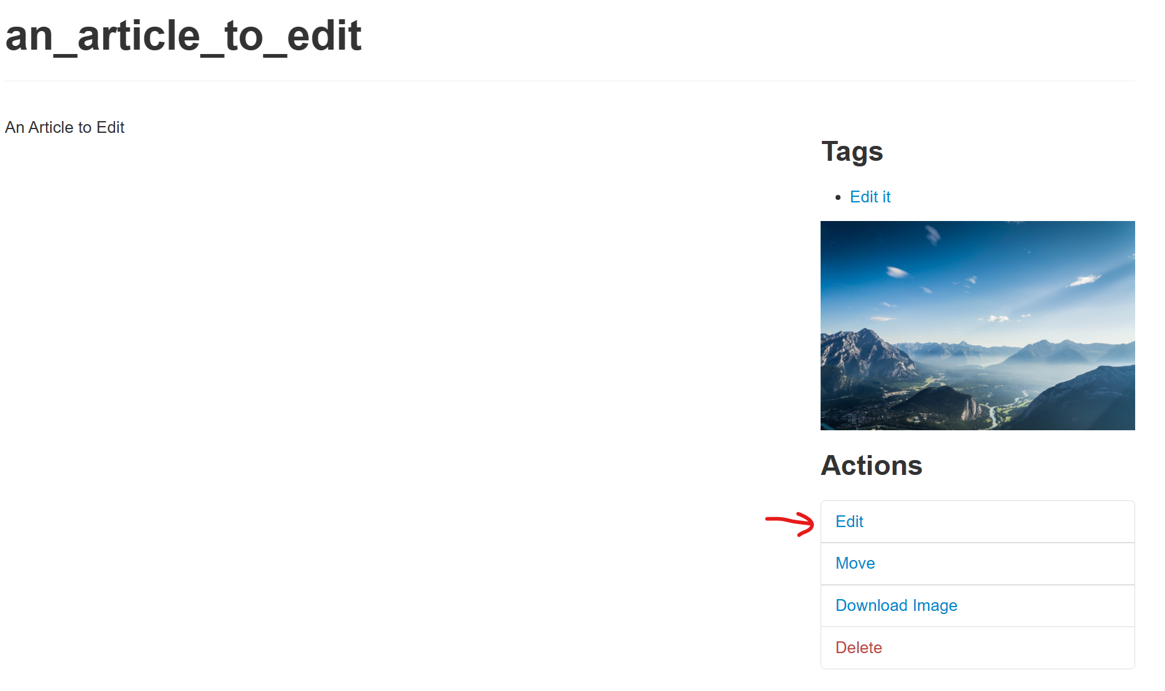

*Figure 4.1* **Article displayed with all the action possible listed on Right Side**

**4.1 Edit**

Editing an article allows you to update content, correct errors, or improve the formatting of your page. Follow this guide to navigate to and use the edit functionality:

**Selecting an article to Edit**

1. Identify the article you wish to edit. You must navigate to this article on the website to begin the editing process.

**Initiating the Edit**

1. Scroll to the 'Actions' section, which can be found beneath the content of the article.
2. Look for the 'edit' option. This may be represented by an icon or a button labeled 'edit' (see Figure 4.1).
3. Clicking on 'edit' will take you away from the current page and open the Wiki Editor interface.

**Using the Wiki Editor**

1. Once in the Wiki Editor, you can make the desired changes to your article. The editor may provide various tools for formatting text, inserting links, and adding media.
2. For comprehensive instructions on utilizing the full range of the Wiki Editor's capabilities, consult section 3.2 of the manual.

**Saving Changes**

1. After making the necessary modifications, review your changes to ensure accuracy and completeness.
2. Save your edits to update the article. There may be a 'Save' or 'Submit' button within the editor for this purpose.

**4.2 Move**

Moving an article to a new URL on our website is a straightforward process, but it's important to proceed with caution as the change is immediate and the old URL will no longer be valid. Here’s a step-by-step guide:

**Initiating the Move**

Click on the 'Move' action, found in actions menu associated with the article you wish to move(see Figure 4.2).

*Figure 4.2* **Move is located in the action tab on right**

**Entering the New URL**

1. After selecting 'Move', you will be directed to a new page where you are prompted to input the new URL. (see Figure 4.3).
2. Type the desired new URL in the designated field.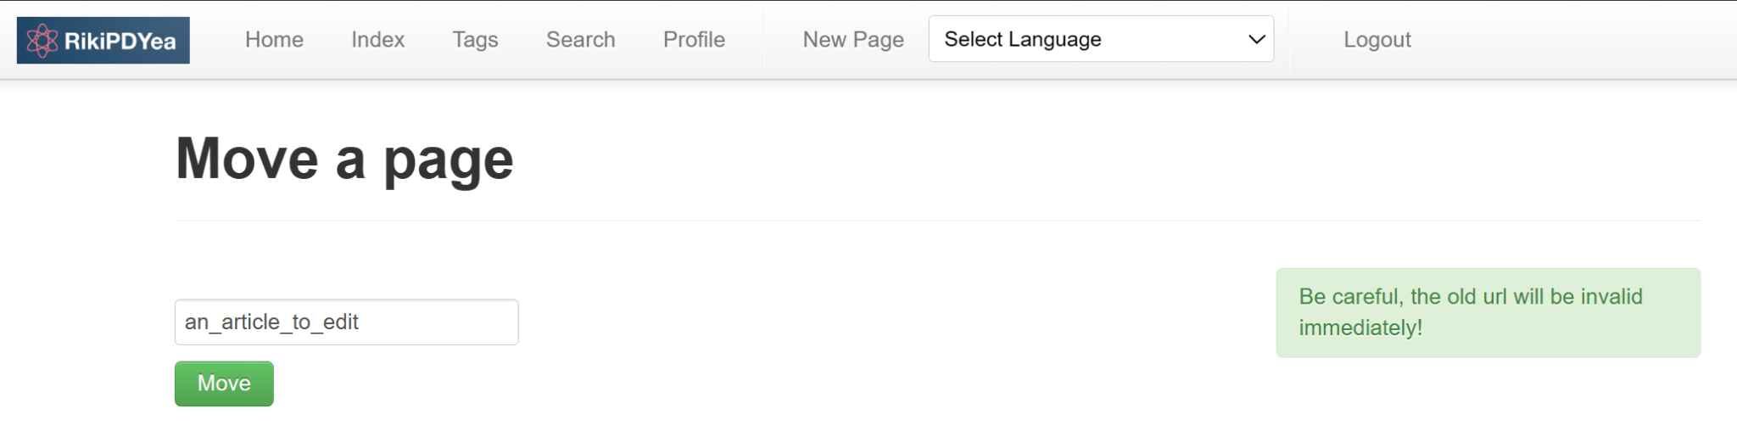

*Figure 4.3* **Enter New URL here**

**Confirming the Move**

1. Before proceeding, double-check the new URL for accuracy.
2. Click the 'Create' button to finalize the move(see Figure 4.3).

**Completing the Process**

* The article will now be accessible at the new URL. A confirmation message may appear to indicate a successful move.

**Important Warning**

* Be Careful: As soon as you hit 'Create', the article will be moved to the new URL, and the old URL will immediately become invalid. This means that any bookmarks or external links that point to the old URL will no longer work.

**4.3 Delete**

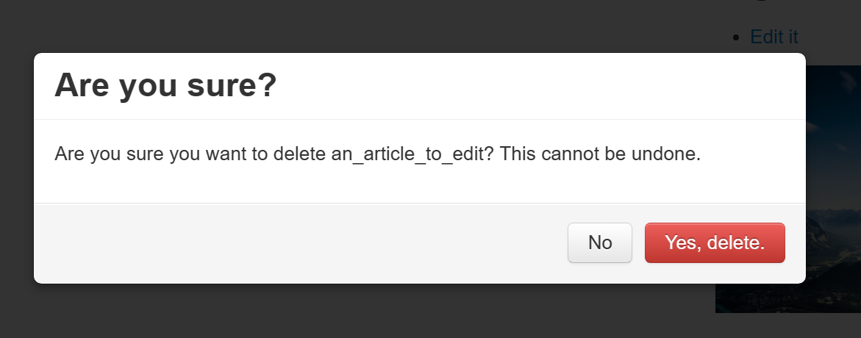

If you need to remove an article from our website, the process is designed to be simple yet secure to prevent accidental deletions. Below are the steps to delete an article:

**Starting the Deletion Process**

1. Navigate to the article you wish to delete.
2. Look for the 'Delete' option, which is located within the Actions tab on the right-hand side of the page.

**Confirming the Deletion**

1. After clicking 'Delete', a confirmation prompt will appear asking you to verify that you want to proceed with the deletion.
2. If you are certain you want to remove the article, click 'Yes, delete it'. If you have changed your mind or clicked 'Delete' by accident, select 'Cancel' to halt the process.

**Important Notes**

* **Be Cautious:** Confirm that you indeed intend to delete the article. Once an article is deleted, it may not be recoverable.
* **Check for Dependencies:** Ensure that deleting the article does not affect other pages or resources that might be linked to it.

**5.Search**

**5.1 Performing a Search**

Our search function is designed to help you find the information you need quickly and efficiently. Here’s how to use it:

Starting a Search

1. Navigate to the 'Search' tab located at the top of the page to access the search feature.
2. You will see a search box where you can type in your query(see figure 5.1).

**To utilize the search function:**

1. Users have the option to input a full or partial tag.
2. Users can input the title or keywords corresponds with the title
3. Users can input a keyword that corresponds with the content.

**Performing a Search**

* Enter your search terms in the text field. The search supports regular expressions (regex), allowing for advanced search patterns.
* If you want the search to be case-insensitive, meaning it does not differentiate between uppercase and lowercase letters, make sure the 'Ignore Case' box is checked.
* To narrow down your search to content created by a specific author, check the 'Search by Author's Name only' box. This will limit the results to pages where the author's name matches your query.

**5.2 Executing Your Search**

* Once you have entered your search criteria, click the green 'Search!' button to execute your search(see figure 5.1).
* The results will be displayed on a new page, where you can browse through the matches to find the content you're looking for.

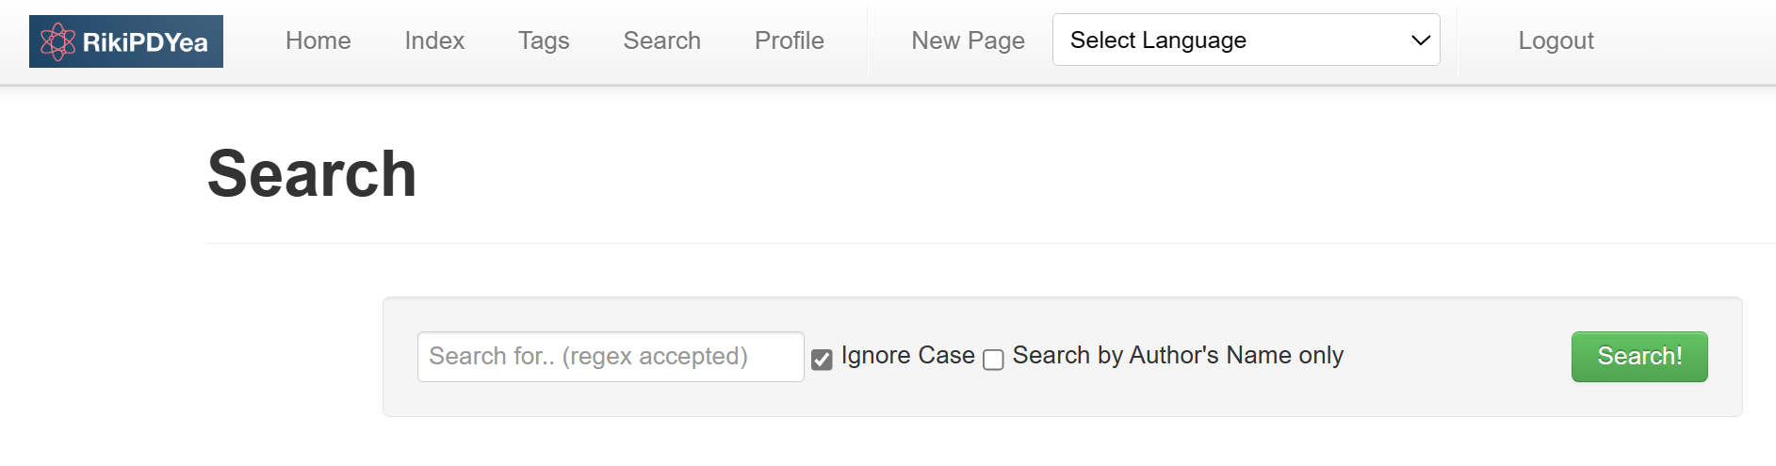

*Figure 5.1* **Search page with field to enter a query**

**6. Page Index and Tags ->**

**Navigating the Page Index and Using Tags**

Our website features an organized Page Index and a Tag system to help users efficiently navigate and find content. Here’s a concise guide on how to use these features:

**6.1 Page Index**

1. **Accessing the Index:** Click on the ‘Index’ tab in the navigation bar to view the Page Index.
2. **Understanding the Index:** The index displays a list of all pages with their titles and corresponding URLs (see figure 6.1).

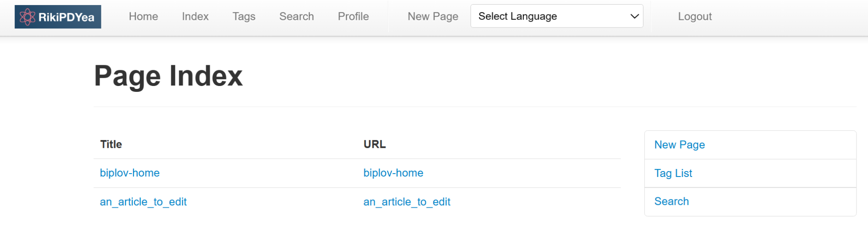

*Figure 6.1* **Index page displays title and URL**

**6.2 Tags**

1. **Accessing Tags:** From the Page Index, select 'Tag List' to view the Index by Tags.
2. **Navigating Tags:** The tag list shows all tags in alphabetical order along with the number of articles associated with each tag.
3. **Filtering by Tag:** Click on a tag to filter the index and display only the articles that are tagged with it (see Figure 6.2).

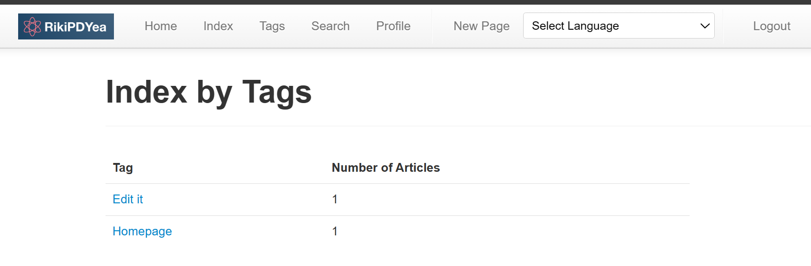

*Figure 6.2* **Tags page displays all tags along with the number of articles associated with each tag**

This system is designed to streamline your experience on our website, making it easier to manage and find content.

**7. Profile**

**Overview**: This manual provides instructions for managing the **Profile** content on the platform. The **Profile** page allows users to edit their biographical information and manage related posts.

Accessing Your **Profile**:

1. Navigate to the homepage of the "Riki" website.

2. Click on the "**Profile**" tab at the top of the page to access your personal profile.

3. The "Biography" section is displayed on the top. (See Figure 7.1)

4. Right under the "Biography" section, we have the “**Posts Created”** section to display all the posts. (See Figure 7.1)

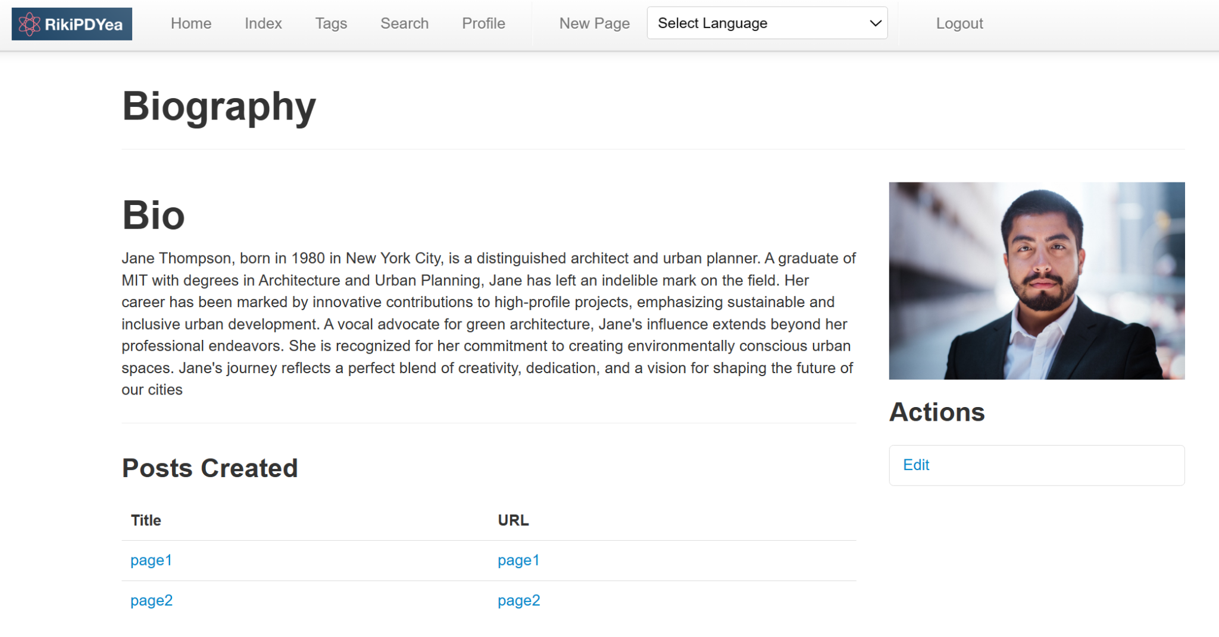

*Figure 7.1* **An overview of biography section**

**Biography Section**

**Editing Biography Information:**

1. On the biography page, locate the "Biography Actions" section on the right-hand side.

2. Click the "Edit Biography" button to make changes to your biography(See Figure 7.2).

3. An editable text field will appear containing your current biographical information.

4. Make the desired changes to your bio in the text field. You can add or remove information as necessary.

5. Once you have finished editing, save your changes by clicking the save button.

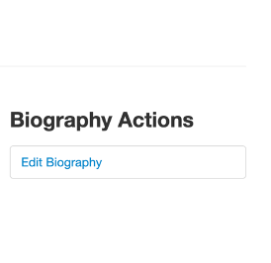

*Figure 7.2* **Edit Biography" button to make changes to your biography**

**Posts Created Section:**

1. Under the "Posts Created" section, you will see a list of your current posts with their titles and URLs(See Figure 7.3)

2. To access a post, click on the post you like.

*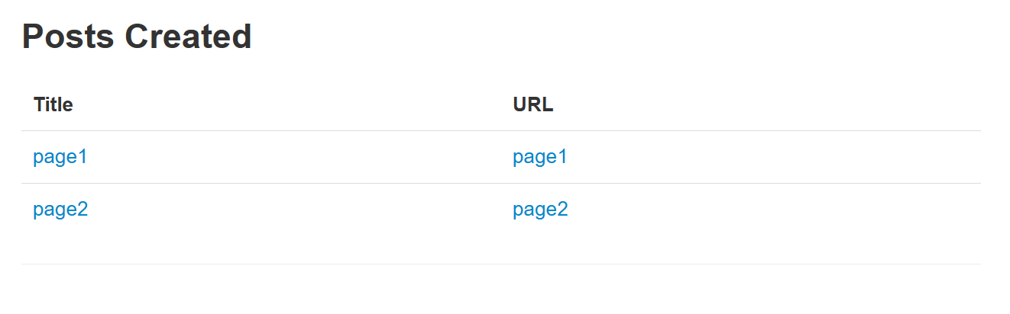Figure 7.3* **Posts Created section lists of your current posts with their titles and URLs.**

**8. AutoSave and confirm exit**

**Overview**: This manual provides instructions on how to use these features and how to benefit from them.

* When you are on the create page and you accidentally click on exit or navigate away from the current URL, you will be prompted to confirm whether you are sure about leaving the page. If you say yes, your data won’t be saved.

* When editing content, you don't have to click on the save button anymore. Your changes are saved automatically making it easier for you to work faster.

**9. Language Translation**

**Overview**: This manual provides instructions on how to use the language translation feature.

* In the navbar, you will see a dropdown with the prompt ‘Select language’. When you click it a list of languages will be shown and when you select a language, the entire page will change to the selected language. This way you can view everything in your own native language.

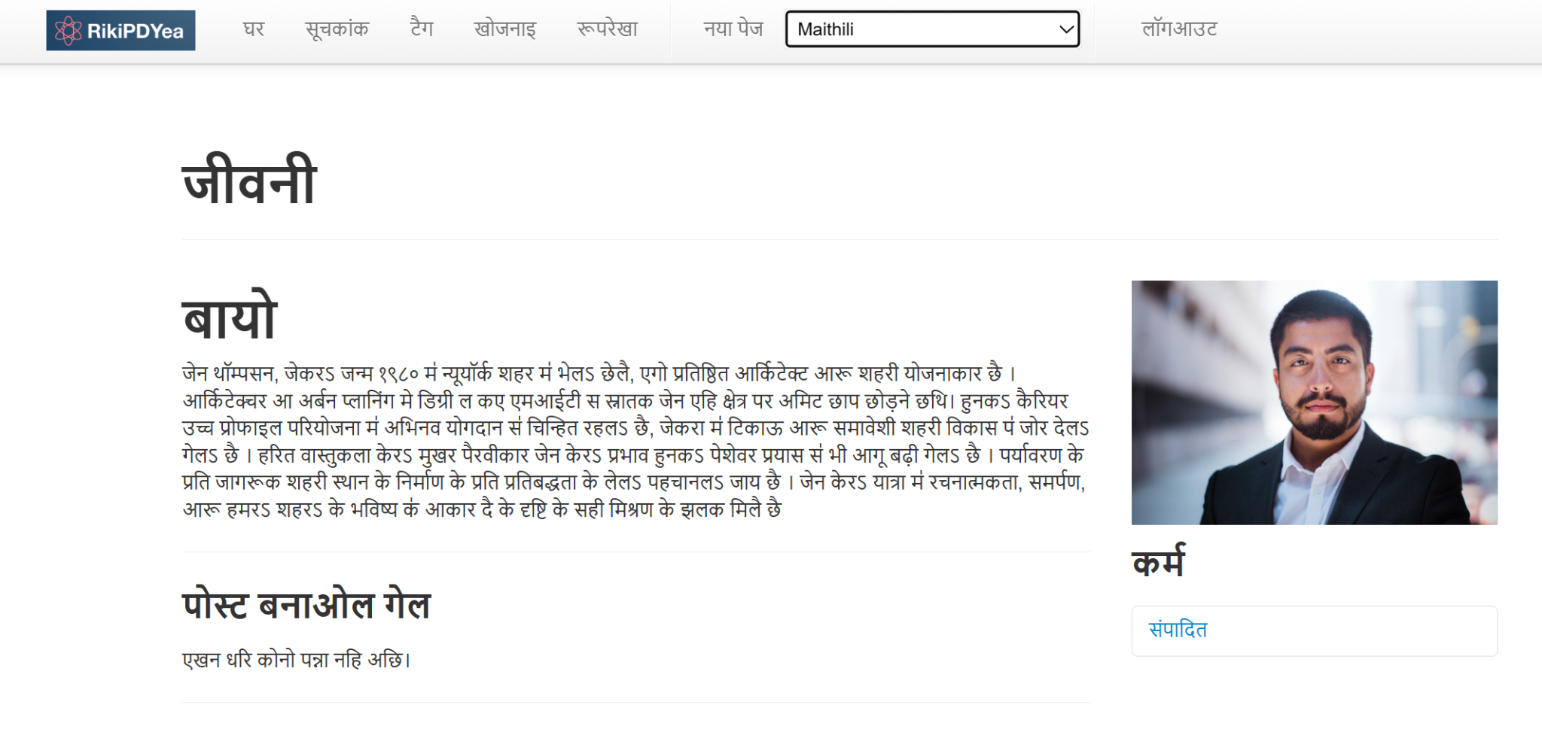

**10. Image Upload/Download**

**Overview**: This manual provides instructions on how to upload an image and download an image feature.

**Image Upload**

* When you are editing a page, there is a choose files option located at the bottom of the markdown editor. When you click on the choose file it opens up your local file explorer where you can choose an image to upload. The feature is validated so it only accepts files in the following formats .png, .jpg, .jpeg. When you hit save the page is saved with the uploaded image displaying in the right side.

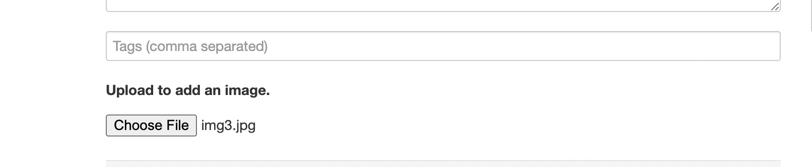

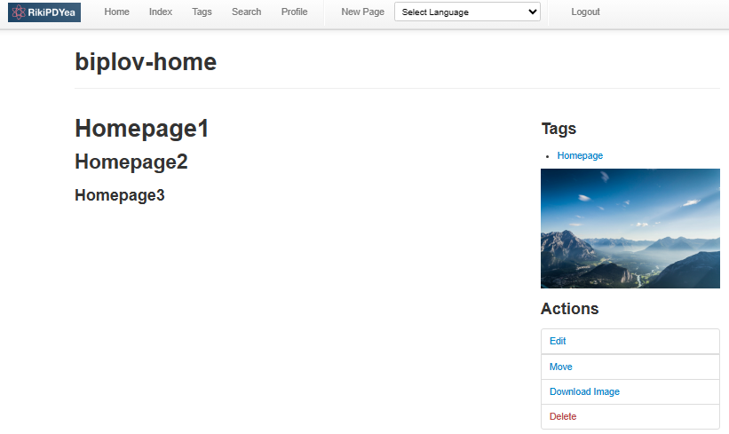

**Download Image**

* If a page has an uploaded image, you can click the Download Image button present on the Action Tab on the right hand side. When you click the download button, the image is downloaded to your local device.

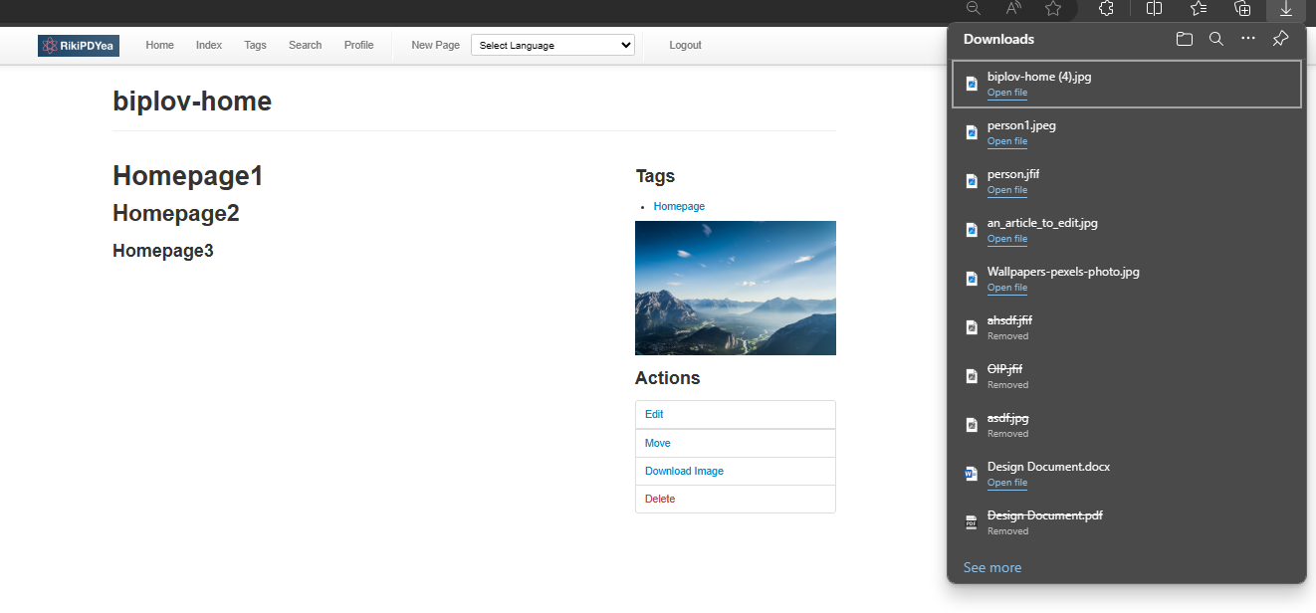

**More questions ?Technical Support:**

**For technical issues or troubleshooting, contact our support team.**

Email: [[RikiPDYea-support@email.com](mailto:RikiPDYea-support@email.com)]

Phone: [***-***-****]

**For general inquiries, feedback, or billing questions.**

Email: [[RikiPDYea-service@email.com](mailto:RikiPDYea-service@email.com)]

Phone: [***-***-****]

**Feedback and Suggestions:**

We welcome your input to improve our software.

Email: [RikiPDYea-feedback@email.com]