# Install R Base and R Studio on Desktop and install Swirl

1. Installed R base

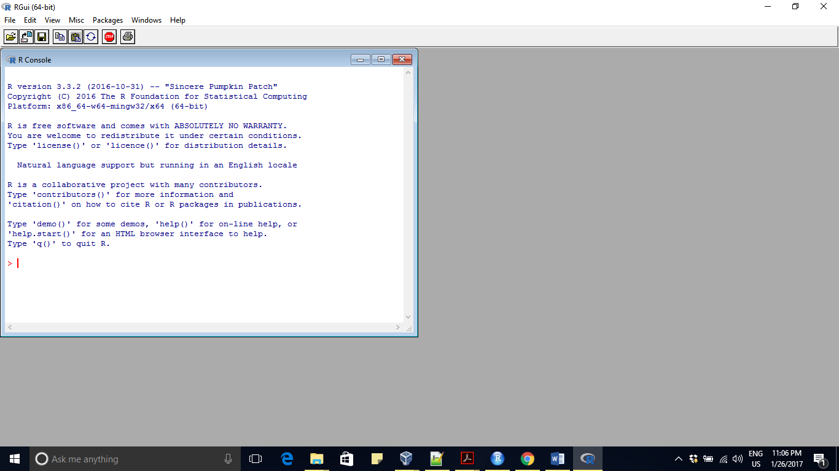

1. Installed R Studio

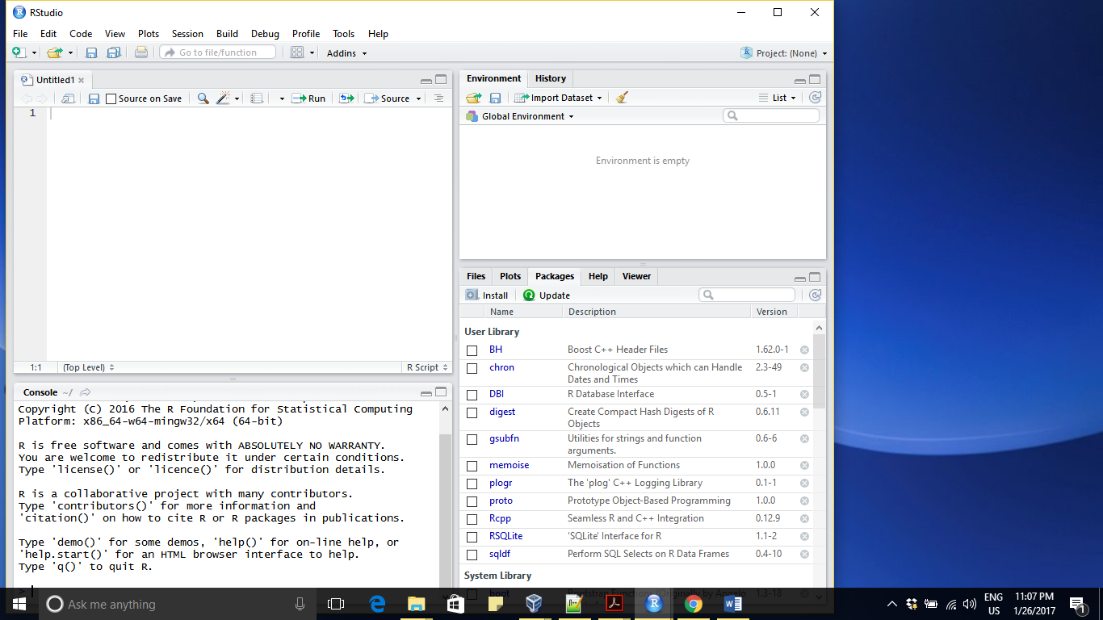

1. Installed swirl package

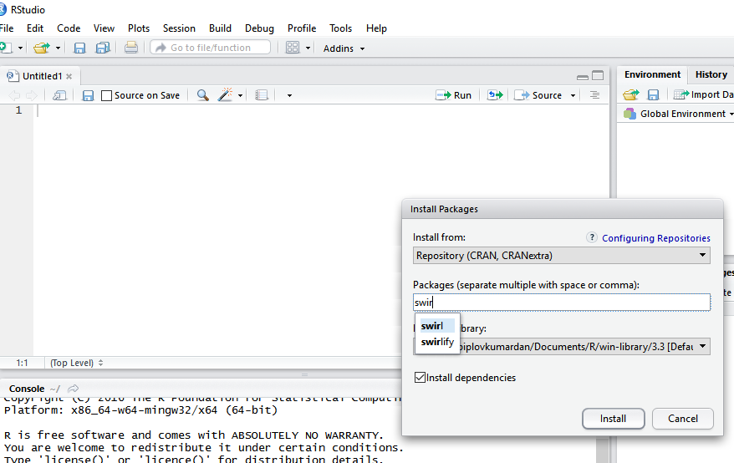

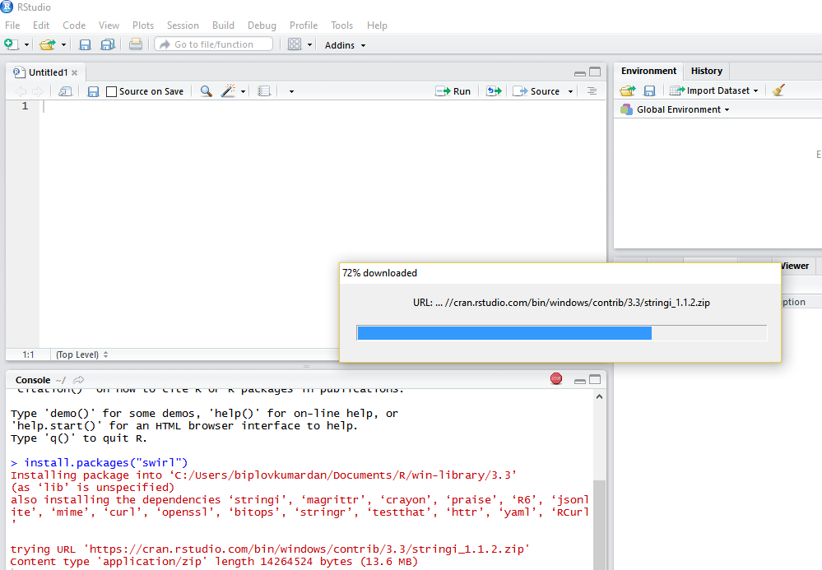

**Verifying swirl installation**

