**1. Exercise:** Explore the relationship between the following, where x contains numbers from 1 to 100:

**x and x^2**

**x and x^3**

**x + y = 101**

**xy = 500**

1. x and x^2

> x<-seq(1:100)

> y<-x^2

> plot(x,y)

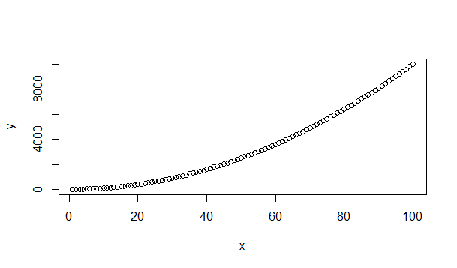

1. x and x^3

> x<-seq(1:100)

> y<-x^3

> plot(x,y)

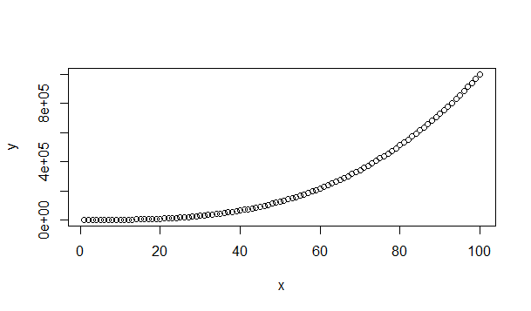

1. x + y = 101

> x<-seq(1:100)

> y<-101-x

> plot(x,y)

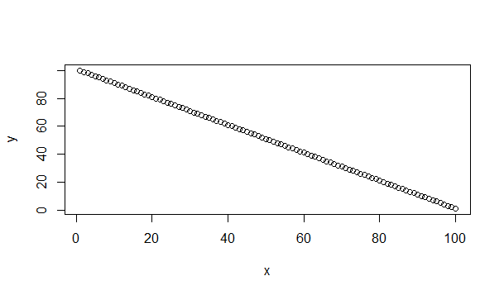

1. xy = 500

> x<-seq(1:100)

> y<-500/x

> plot(x,y)

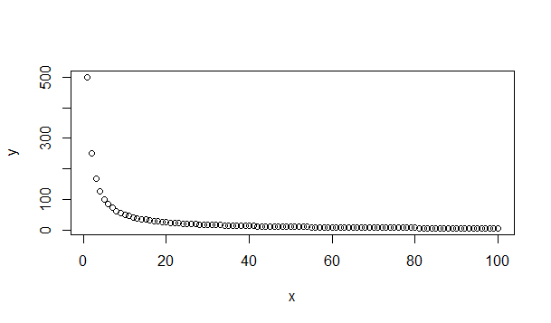

**2. First we'll produce a very simple graph using the values in the car vector:**

**# Define the cars vector with 5 values cars <- c(1, 3, 6, 4, 9)**

**# Graph the cars vector with all defaults plot(cars)**

> cars <- c(1, 3, 6, 4, 9)

> plot(cars)

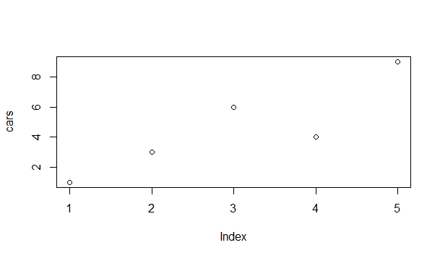

**Let's add a title, a line to connect the points, and some color:**

**# Define the cars vector with 5 values cars <- c(1, 3, 6, 4, 9)**

**# Graph cars using blue points overlayed by a line plot(cars, type="o", col="blue")**

> cars <- c(1, 3, 6, 4, 9)

> plot(cars, type="o", col="blue")

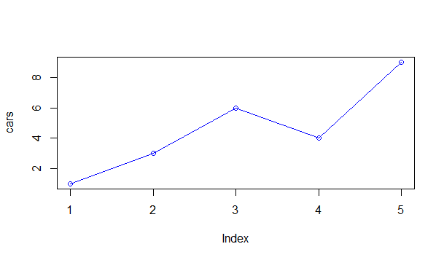

**# Create a title with a red, bold/italic font title(main="Autos", col.main="red", font.main=4)**

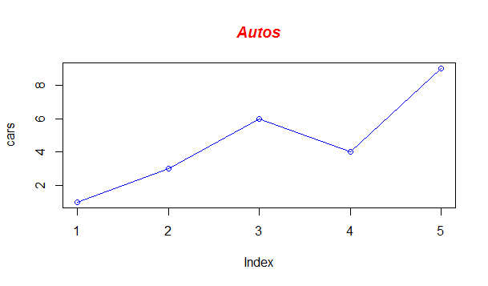

Now let's add a red line for trucks and specify the y-axis range directly so it will be large enough to fit the truck data:

• # Define 2 vectors cars <- c(1, 3, 6, 4, 9) **trucks <- c(2, 5, 4, 5, 12)**

• # Graph cars using a y axis that ranges from 0 to 12 plot(cars, type="o", col="blue", **ylim=c(0,12)**

• # Graph trucks with red dashed line and square points **lines(trucks, type="o", pch=22, lty=2, col="red")**

• # Create a title with a red, bold/italic font title(main="Autos", col.main="red", font.main=4)

> cars <- c(1, 3, 6, 4, 9)

> trucks <- c(2, 5, 4, 5, 12)

> plot(cars, type="o", col="blue", ylim=c(0,12) )

> lines(trucks, type="o", pch=22, lty=2, col="red")

> title(main="Autos", col.main="red", font.main=4)

