**1. Look at the data given below. Plot the data, find the outliers and find out µ, σ, σ2**

|  |
| --- |
| > comp<-c("Allied Signal","Bankers Trust", "General Mills", "ITT Industries", "J.P.Morgan & Co.", "Lehman Brothers", "Marriott", "MCI", "Merrill Lynch", "Microsoft", "Morgan Stanley", "Sun Microsystems", "Travelers", "US Airways", "Warner-Lambert")  > x<-c( 24.23, 25.53, 25.41, 24.14, 29.62, 28.25, 25.81, 24.39, 40.26, 32.95, 91.36, 25.99, 39.42, 26.71, 35.00)  >  > df<-data.frame(comp,x)  > df  comp x  1 Allied Signal 24.23  2 Bankers Trust 25.53  3 General Mills 25.41  4 ITT Industries 24.14  5 J.P.Morgan & Co. 29.62  6 Lehman Brothers 28.25  7 Marriott 25.81  8 MCI 24.39  9 Merrill Lynch 40.26  10 Microsoft 32.95  11 Morgan Stanley 91.36  12 Sun Microsystems 25.99  13 Travelers 39.42  14 US Airways 26.71  15 Warner-Lambert 35.00 |
| > plot(df$x, ylab ="%age", type="b") |

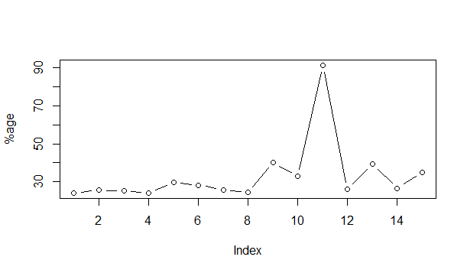

**find out µ, σ, σ2**

> meanX<-mean(df$x)

> meanX

[1] 33.27133

> stdevX<-sd(df$x)

> stdevX

[1] 16.9454

> varX<-var(df$x)

> varX

[1] 287.1466

**2)**



Answer the following three questions based on the box-plot above.

1. What is inter-quartile range of this dataset? (please approximate the numbers) In one line, explain what this value implies.

Inter-quartile range is 6 to 12.

It means that 50% of the X- values lie between Inter-quartile range.

1. What can we say about the skewness of this dataset?

It is Skewed right as most of the observations are concentrated on the low end of the scale.

1. If it was found that the data point with the value 25 is actually 2.5, how would the new box-plot be affected?

It will Skewed right more and 1st quartile become more with its left side move left to point 5.

**3)**

**Answer the following three questions based on the histogram above.**

1. **Where would the mode of this dataset lie?**

Mode is 5 and 7.

1. **Comment on the skewness of the dataset.**

It is skewed right. Most of the value is 4 to 12 in the range of (0, 25)

1. **Suppose that the above histogram and the box-plot in question 2 are plotted for the same dataset. Explain how these graphs complement each other in providing information about any dataset.**

Histogram will help us to identify the frequency of value occurred whereas box-plot will help as inter quartile and median value for this dataset. Combining both of this will help us to identifier outliers and get the exact distribution of data.

**4. AT&T was running commercials in 1990 aimed at luring back customers who had switched to one of the other long-distance phone service providers. One such commercial shows a businessman trying to reach Phoenix and mistakenly getting Fiji, where a half-naked native on a beach responds incomprehensibly in Polynesian. When asked about this advertisement, AT&T admitted that the portrayed incident did not actually take place but added that this was an enactment of something that “could happen.” Suppose that one in 200 long-distance telephone calls is misdirected. What is the probability that at least one in five attempted telephone calls reaches the wrong number? (Assume independence of attempts.)**

Probability of misdirected call = 1/200

> x<-1/200

Probability of well-directed call=199/200

> y<-199/200

Probability of at least one misdirected call out of 5: **0.004925499**

> z<-c(1:5)

> px<-x^z*y^(5-z)

> px

[1] 4.900748e-03 2.462687e-05 1.237531e-07 6.218750e-10 3.125000e-12

> sum(px)

[1] 0.004925499

**5) Returns on a certain business venture, to the nearest $1,000, are known to follow the following probability distribution**

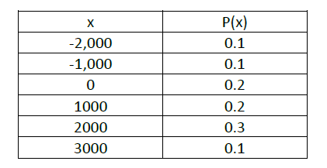

1. **What is the most likely monetary outcome of the business venture?**

**$3000 as its probability is heighest.**

1. **Is the venture likely to be successful? Explain**

It is 60% chance of getting positive return that means 60% chance of successful venture.

1. **What is the long-term average earning of business ventures of this kind? Explain**

It is around $500 avg earning

average earning = (-2000-1000+0+1000+2000+3000)/6=$500

1. **What is the good measure of the risk involved in a venture of this kind? Compute this measure**