**TASK 1: Solution**

Check if directory /user/acadgild exists or not

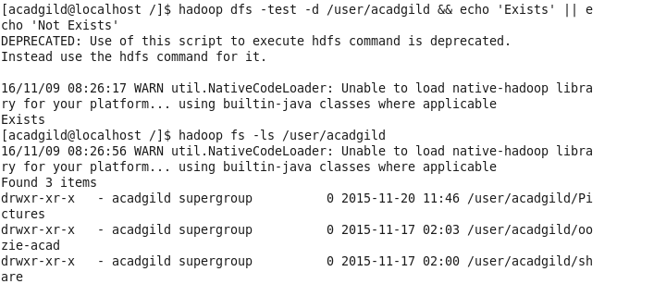

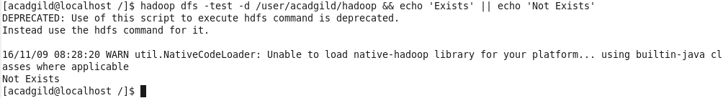

Create the Hadoop directory under /user/acadgild

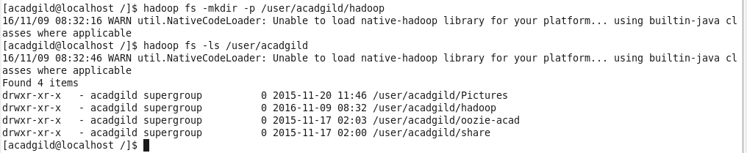

**TASK 2: Solution**

Create a file word-count.txt

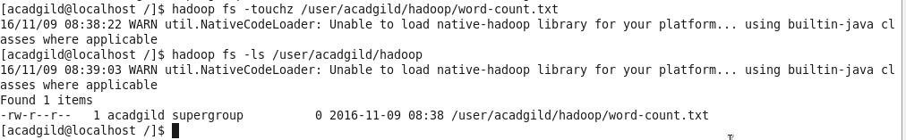

Append Text from CLI to file

