Task 1: Create a Sample data file in Local FS and move to Hadoop file system

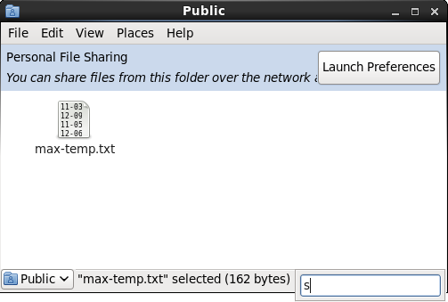

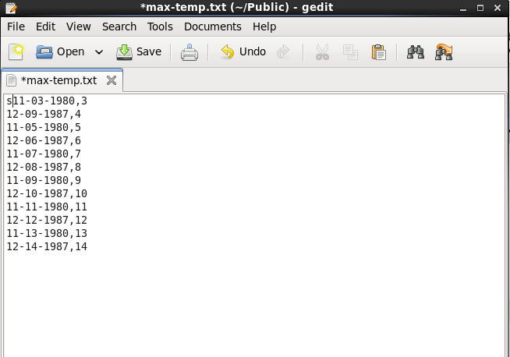

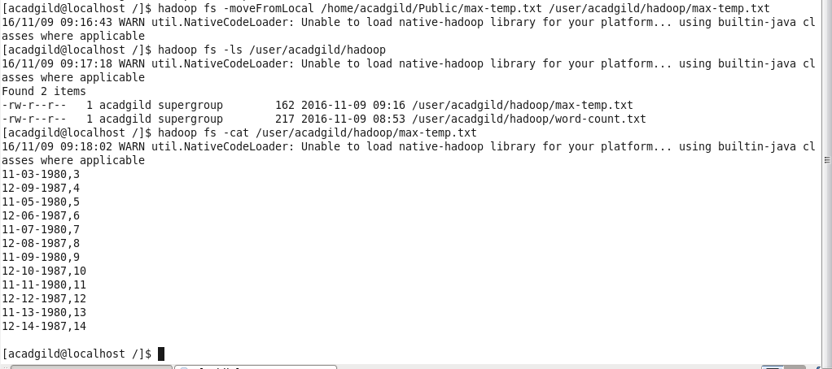

Task 2: Change the permission so that only Owner and Group member have Full Control

