# Session 7 ASSIGNMENT 2

## Initial data setup:

PIG -x local;

emp_det = LOAD '/home/acadgild/workspace/mywork/Session7/employee_details.txt' USING PigStorage(',') AS (id:int, name:chararray, salary:float, rating:int);

emp_expns = LOAD '/home/acadgild/workspace/mywork/Session7/employee_expenses.txt' USING PigStorage('\t') AS (id:int, expenses:float);

## Tasks:

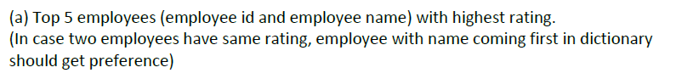

### Solution A:

emp_det_rating_name = ORDER emp_det BY rating ASC, name ASC;

top5_emp_det_rating_name = LIMIT emp_det_rating_name 5;

result = FOREACH top5_emp_det_rating_name GENERATE id, name;

DUMP result;

Output:

(106,Aamir)

(101,Amitabh)

(113,Jubeen)

(111,Tushar)

(112,Ajay)

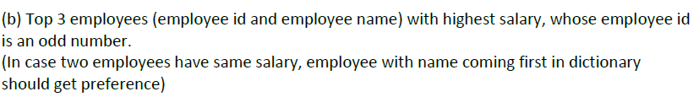

### Solution B:

x = FILTER emp_det BY id%2==1;

emp_salary_highest = ORDER x BY salary DESC;

Top3_emp_salary = LIMIT emp_salary_highest 3;

result = FOREACH Top3_emp_salary GENERATE id, name;

DUMP result;

Output:

(101,Amitabh)

(107,Salman)

(103,Akshay)

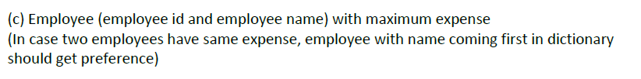

### Solution C:

emp_det_expns = JOIN emp_det BY id, emp_expns BY id;

emp_max_expns = ORDER emp_det_expns BY expenses DESC, name ASC;

result = FOREACH emp_max_expns GENERATE emp_det::id, name;

DUMP result;

(110,Priyanka)

(102,Shahrukh)

(104,Anubhav)

(101,Amitabh)

(114,Madhuri)

(101,Amitabh)

(105,Pawan)

(102,Shahrukh)



### Solution D:

emp_det_expns = JOIN emp_det BY id, emp_expns BY id;

result = FOREACH emp_det_expns GENERATE id, name;

DUMP result;

(110,Priyanka)

(102,Shahrukh)

(104,Anubhav)

(101,Amitabh)

(114,Madhuri)

(101,Amitabh)

(105,Pawan)

(102,Shahrukh)



### Solution E:

emp_left_outer = JOIN emp_det BY id LEFT OUTER, emp_expns BY id;

GH = FILTER emp_left_outer BY emp_expnx::id>0;

result = FOREACH GH GENERATE id, name;

resultDistinct = DISTINCT result;

DUMP resultDistinct;

(101,Amitabh)

(102,Shahrukh)

(104,Anubhav)

(105,Pawan)

(110,Priyanka)

(114,Madhuri)