Problem - 1: Perform a classification task with knn from scratch.
1. Load the Dataset:
• Read the dataset into a pandas DataFrame.
• Display the first few rows and perform exploratory data analysis (EDA) to
understand the dataset (e.g., check data types, missing values, summary
statistics).
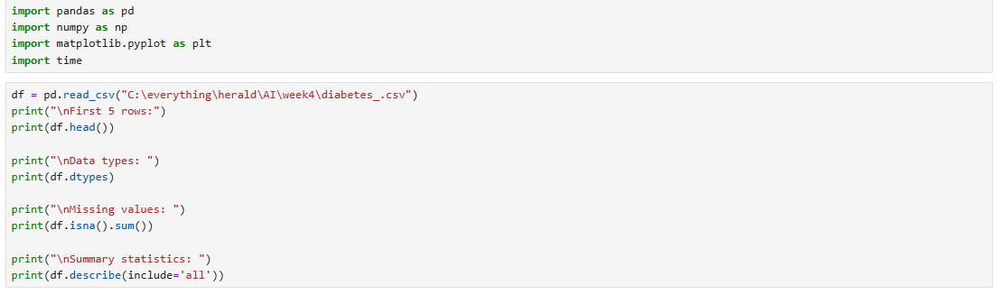
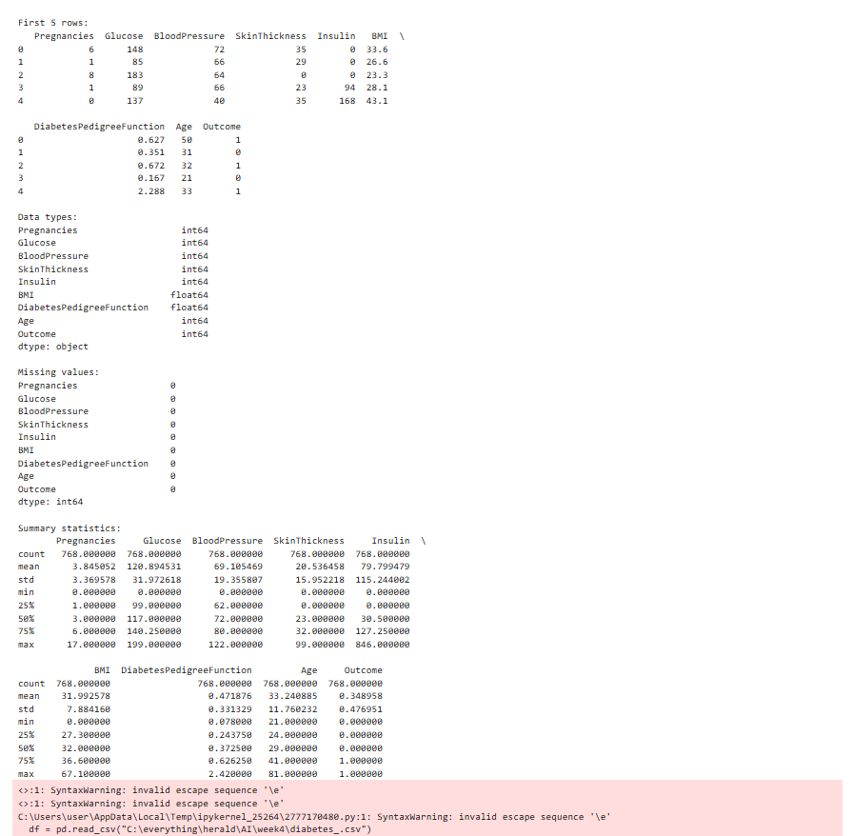

2. Handle Missing Data:
• Handle any missing values appropriately, either by dropping or imputing them based on the data.

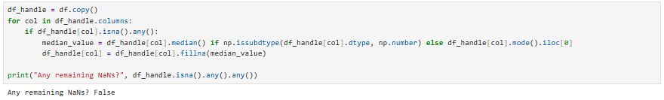

3. Feature Engineering:
• Separate the feature matrix (X) and target variable (y).
• Perform a train - test split from scratch using a 70% − 30% ratio.
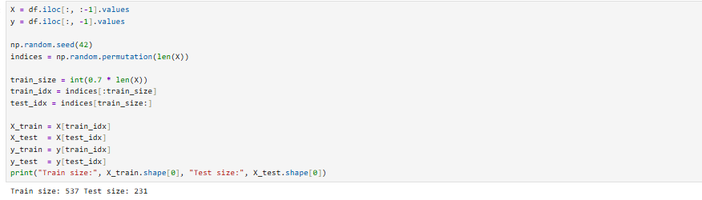

4. Implement KNN:
• Build the KNN algorithm from scratch (no libraries like sickit-learn for KNN).
• Compute distances using Euclidean distance.
• Write functions for:
– Predicting the class for a single query.
– Predicting classes for all test samples.
• Evaluate the performance using accuracy.
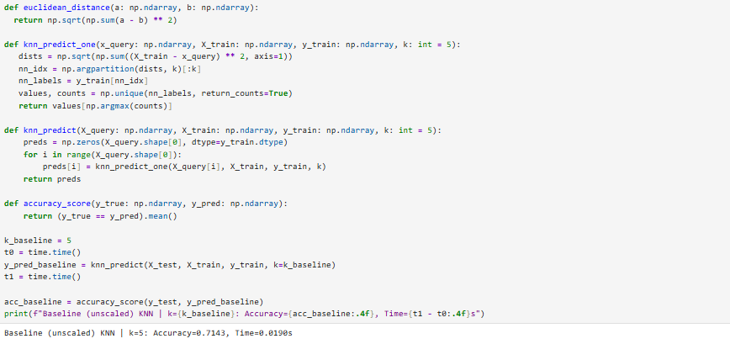

Problem - 2 - Experimentation:
1. Repeat the Classification Task:
• Scale the Feature matrix X.
• Use the scaled data for training and testing the kNN Classifier.
• Record the results.
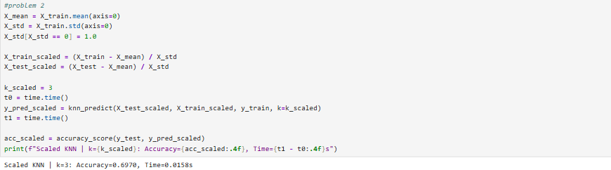
2. Comparative Analysis: Compare the Results -
• Compare the accuracy and performance of the kNN model on the original dataset from problem 1 versus the scaled dataset.
• Discuss:
– How scaling impacted the KNN performance.
– The reason for any observed changes in accuracy.
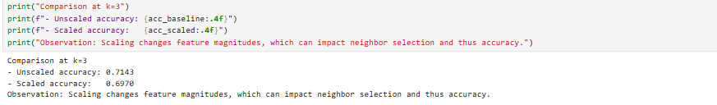

Problem - 3 - Experimentation with k:
1. Vary the number of neighbors - k:
• Run the KNN model on both the original and scaled datasets for a range of: k= 1, 2, 3, . . .15

• For each k, record:
– Accuracy.
– Time taken to make predictions.
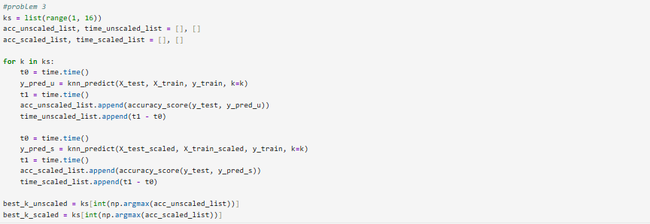

2. Visualize the Results:
• Plot the following graphs:
– k vs. Accuracy for original and scaled datasets.
– k vs. Time Taken for original and scaled datasets
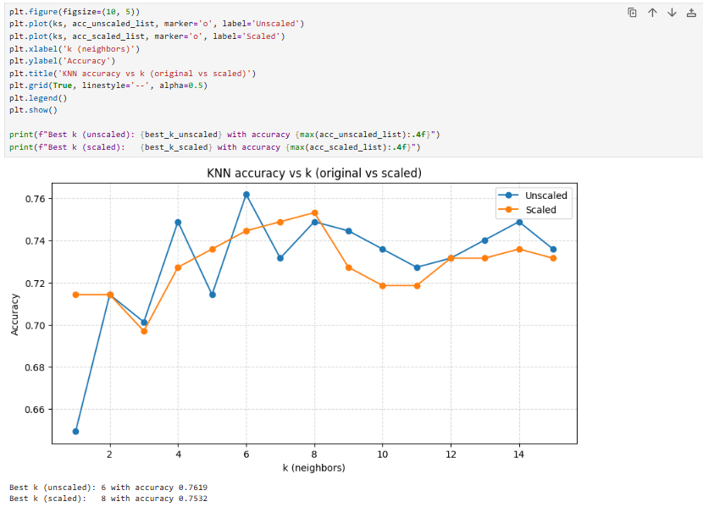

. 3. Analyze and Discuss:
• Discuss how the choice of k affects the accuracy and computational cost.
• Identify the optimal k based on your analysis.
