IE 301 · OPERATIONAL ANALYSIS OF MULTIMODAL INTERCHANGE HUBS
Kanjurmarg Station: Stochastic Simulation of Foot Overbridge Utilization Under Increased Passenger Demand
Technical report — five-gate model, Ghatkopar-referenced demand scenarios, utilization results and limitations
Department of Industrial Engineering and Operations Research, IIT Bombay
IE 301 project team · October 2026 · Version 3 (revised route splits)

FOB 2 baseline utilization  20.7%  → 31.9% with +100 pax/min | FOB 3 baseline utilization  9.3%  → 13.8% with +100 pax/min | Busiest simulated minute  45.1%  FOB 2, +100 pax/min (of reference capacity)
Utilization = one-minute FOB crossings ÷ reference capacity (W × 60 pax/m/min); mean of 30 stochastic replications. Gate route splits are modelling estimates (with random noise), the East-side split and the 500 pax/min Ghatkopar reference are assumptions, and the +50/+100 pax/min scenarios are input rates, not ridership forecasts. Simplified conceptual layout — not to scale.

Contents
1. Executive Summary
2. Problem Definition and Objectives
3. Scope and Simplified Station Layout
4. Observed Data and Input Parameters
5. Gate Route-Choice Assumptions
6. Ghatkopar-Referenced Demand Scenarios
7. Stochastic Arrival and Route-Choice Model
8. Capacity and Utilization Calculations
9. AnyLogic Implementation
10. Experimental Design
11. Simulation Results
12. Interpretation
13. Assumptions, Limitations, and Additional Data Required
14. Conclusion
15. Reproducibility Appendix

1. Executive Summary
A stochastic AnyLogic model estimates FOB 2 and FOB 3 utilization at Kanjurmarg for three scenarios: baseline, +50 and +100 pax/min of extra entering demand (10% and 20% of an assumed 500 pax/min Ghatkopar flow; 80% via Huma, 20% via Gandhi Nagar). Five gates, FOB 1 closed, Poisson arrivals, gate route splits with ±3 pp noise, 30 replications × 60 min.
Table 1. Mean one-minute utilization (% of reference capacity, ± 95% CI).
Scenario | FOB 2 | FOB 3
Baseline | 20.7 ± 0.5 | 9.3 ± 0.4
+50 pax/min | 26.3 ± 0.5 | 11.6 ± 0.4
+100 pax/min | 31.9 ± 0.6 | 13.8 ± 0.5

- FOB 2 is about twice as loaded as FOB 3 in every scenario. +100 pax/min adds about 11 points on FOB 2 and 4 on FOB 3.
- Busiest single minute in any run: 45.1% (FOB 2, +100 pax/min). Both bridges stay below reference capacity.
- Expected baseline flows from the assumed splits (68.9 and 32.6 pax/min) are close to the observed 70.0 and 33.3 pax/min. This is a consistency check, not validation.

2. Problem Definition and Objectives
Kanjurmarg is expected to become an interchange with Metro Lines 4 and 6. With FOB 1 closed, bridge movement relies on FOB 2 and FOB 3. Questions:
- How is gate demand split between direct PF1/PF1A, FOB 2, FOB 3 and the skywalk?
- What are baseline FOB 2 and FOB 3 utilizations?
- What changes with +50 and +100 pax/min?
- How variable are the results?
- How do estimated FOB flows compare with observed counts?
- Does extra demand change the FOB 2 / FOB 3 balance?
Scope note. +50 and +100 pax/min are scenario inputs, not ridership forecasts.

3. Scope and Simplified Station Layout
West side (north → south): Naval Colony gate, FOB 2, Huma gate, FOB 3, Gandhi Nagar gate. FOB 1 is closed. An east-side skywalk connects FOB 2 and FOB 3 (connector, not an FOB) with Northeast and Southeast exits.
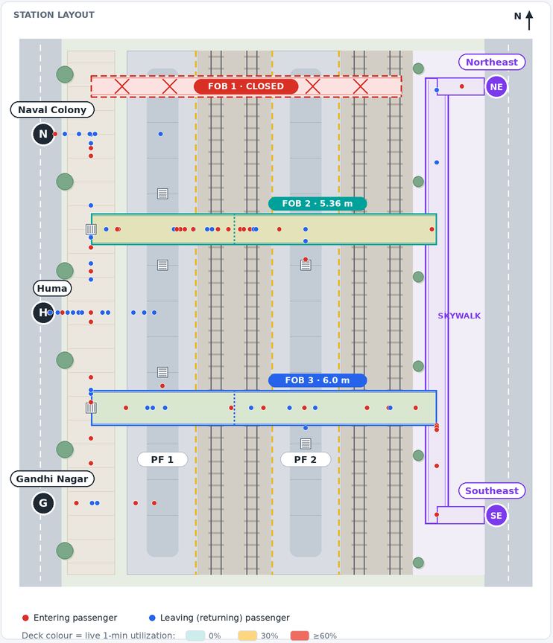
Figure 1. Simplified layout in the AnyLogic model (not to scale). Red = entering, blue = leaving.
Table 2. Model scope.
Included | Excluded
Five gates, entering and leaving streams + 2 extra-demand streams | Ticketing, buses, autos, metro operations
Routes: direct PF1/PF1A, FOB 2, FOB 3, skywalk → FOB 3 | Stair/escalator capacity, density, queuing
FOB 2 and FOB 3 one-minute utilization | Skywalk utilization (not an FOB)

4. Observed Data and Input Parameters
Table 3. Baseline gate demand (pax/min).
Gate | Entering | Leaving | Total | Status
Naval Colony | 10.00 | 42.00 | 52.00 | Observed
Huma | 27.20 | 50.00 | 77.20 | Observed
Gandhi Nagar | 33.33 | 6.66 | 39.99 | Observed
Northeast | 10.00 | 5.00 | 15.00 | Assumed: 50% of East-side count
Southeast | 10.00 | 5.00 | 15.00 | Assumed: 50% of East-side count
Total | 90.53 | 108.66 | 199.19
Source: IE 301 project report, Section 2.2.
Table 4. Observed FOB flows and widths (benchmark only).
Facility | Observed flow (pax/min) | Width (m) | Width status
FOB 1 | Closed | – | Not in use
FOB 2 | 70.0 | 5.36 | Recorded; to be verified
FOB 3 | 33.3 | 6.0 | Unverified
Source: project report Sections 2.3 and 4.6.

5. Gate Route-Choice Assumptions
Route splits are modelling assumptions, not measured choices. The same split applies to entering and leaving passengers at a gate.
Table 5. Route-choice probabilities by gate.
Gate | Direct PF1/PF1A | Via FOB 2 | Via FOB 3 | Skywalk → FOB 3
Naval Colony | 60% | 25% | 15% | 0%
Huma | 55% | 30% | 15% | 0%
Gandhi Nagar | 60% | 35% | 5% | 0%
Northeast | 0% | 95% | 0% | 5%
Southeast | 0% | 30% | 70% | 0%
Huma (additional demand) | 50% | 35% | 15% | 0%
Gandhi Nagar (additional demand) | 40% | 40% | 20% | 0%
Last two rows apply to the additional demand only. Skywalk users are counted on FOB 3.

5.1 Route-split noise
Each replication draws each gate's split from a Dirichlet distribution around these values (κ = 99, about ±3 pp for a 10–15% share). Zero shares stay zero.
(p_PF1, p_FOB2, p_FOB3, p_sky) ~ Dirichlet(κ · p̄), κ = 99 (5.1)

5.2 Expected flows vs observed counts
Table 6. Expected baseline flows (no randomness) vs observed.
Facility | Expected (pax/min) | Expected U | Observed (pax/min) | Observed U
FOB 2 | 68.9 | 21.4% | 70.0 | 21.8%
FOB 3 | 32.6 | 9.1% | 33.3 | 9.3%
FOB 2 = 13.0 + 23.2 + 14.0 + 14.25 + 4.5; FOB 3 = 7.8 + 11.6 + 2.0 + 10.5 + 0.75 (skywalk).
Not validation. The splits were chosen as estimates; their agreement with observed counts is a consistency check only.

6. Ghatkopar-Referenced Demand Scenarios
+50 pax/min = 500 × 0.10, +100 pax/min = 500 × 0.20 (6.1)
Table 7. Additional entering demand by gate (pax/min).
Scenario | Huma (80%) | Gandhi Nagar (20%) | Total
Baseline | 0 | 0 | 0
+50 pax/min | +40 | +10 | +50
+100 pax/min | +80 | +20 | +100
500 pax/min Ghatkopar flow is assumed. Baseline rates are unchanged.
Table 8. Expected routing of the additional demand (pax/min).
Route | +50 pax/min | +100 pax/min
Direct PF1/PF1A | +24 | +48
FOB 2 | +18 | +36
FOB 3 | +8 | +16
Huma extra × (50/35/15); Gandhi Nagar extra × (40/40/20).

7. Stochastic Arrival and Route-Choice Model
Table 9. Distributions.
Element | Distribution | Parameters
Arrivals (12 streams) | Poisson process | λ = gate rate; extra streams 0.8·Δ and 0.2·Δ
Inter-arrival time | Exponential | Mean 60/λ s
Gate split per replication | Dirichlet | κ = 99
Route per passenger | Categorical (inverse CDF) | That replication's split
Walking speed | Deterministic | 1.30 m/s

Δt = −ln(1 − U) · 60/λ, U ~ Uniform(0, 1) (7.1)
A crossing is counted once, in the minute the passenger reaches the deck mid-point. 95% CI over n = 30: x̄ ± 2.045 · s/√30. Seeds 1001–1030 are reused in every scenario (common random numbers). Empty start, no warm-up.

8. Capacity and Utilization Calculations
C = W × 60 pax/m/min, U = Q / C × 100% (8.1)
Table 10. Reference capacities.
Facility | W (m) | C (pax/min)
FOB 2 | 5.36 | 321.6
FOB 3 | 6.0 (unverified) | 360.0

Limit. U is a reference-capacity ratio, not a level-of-service or safety measure; stairs, counter-flow and platoons are not modelled.

9. AnyLogic Implementation
Table 11. Model structure (Kanjurmarg_FOB_Simulation.alp, AnyLogic 8.8).
Element | Role
Arrival(stream) | Poisson arrival, route choice, new passenger
Waypoint / Crossing | Move passengers; count FOB crossings per minute
minuteTick (60 s) | Utilization, gauges, deck colours, time plot
runBatch() | 30 replications × 3 scenarios; results to console and CSV
gateSplits, extraSplits, splitNoiseKappa | Editable route splits and noise

Screen: station layout (decks coloured by live utilization), FOB 2 and FOB 3 utilization gauges (now, mean, peak) and a utilization-over-time plot.
Verification. Model code compiles against AnyLogic API stand-ins; its headless run reproduced replication 1 exactly (4,157 FOB 2 and 2,058 FOB 3 crossings). Opening in AnyLogic itself is still to be confirmed.

10. Experimental Design
Table 12. Experiments.
Factor | Setting
Scenarios | Baseline, +50, +100 pax/min
Runs | 60 min × 30 replications per scenario, seeds 1001–1030
Route-split noise | On (κ = 99); a fixed-split set (κ = 0) is used only to size its effect

11. Simulation Results
Table 13. One-minute utilization (%), 30 replications.
Scenario | FOB | Mean ± 95% CI | P95 minute | Busiest minute
Baseline | FOB 2 | 20.7 ± 0.5 | 24.8 | 32.3
Baseline | FOB 3 | 9.3 ± 0.4 | 12.0 | 16.9
+50 pax/min | FOB 2 | 26.3 ± 0.5 | 31.1 | 37.6
+50 pax/min | FOB 3 | 11.6 ± 0.4 | 14.5 | 19.7
+100 pax/min | FOB 2 | 31.9 ± 0.6 | 37.2 | 45.1
+100 pax/min | FOB 3 | 13.8 ± 0.5 | 17.1 | 23.1
Source: data/scenario_summary.csv.
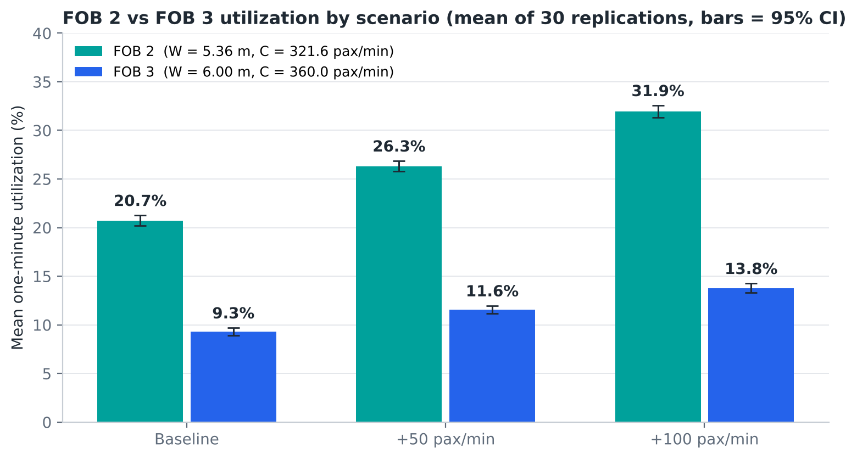
Figure 2. FOB 2 vs FOB 3 mean utilization by scenario.
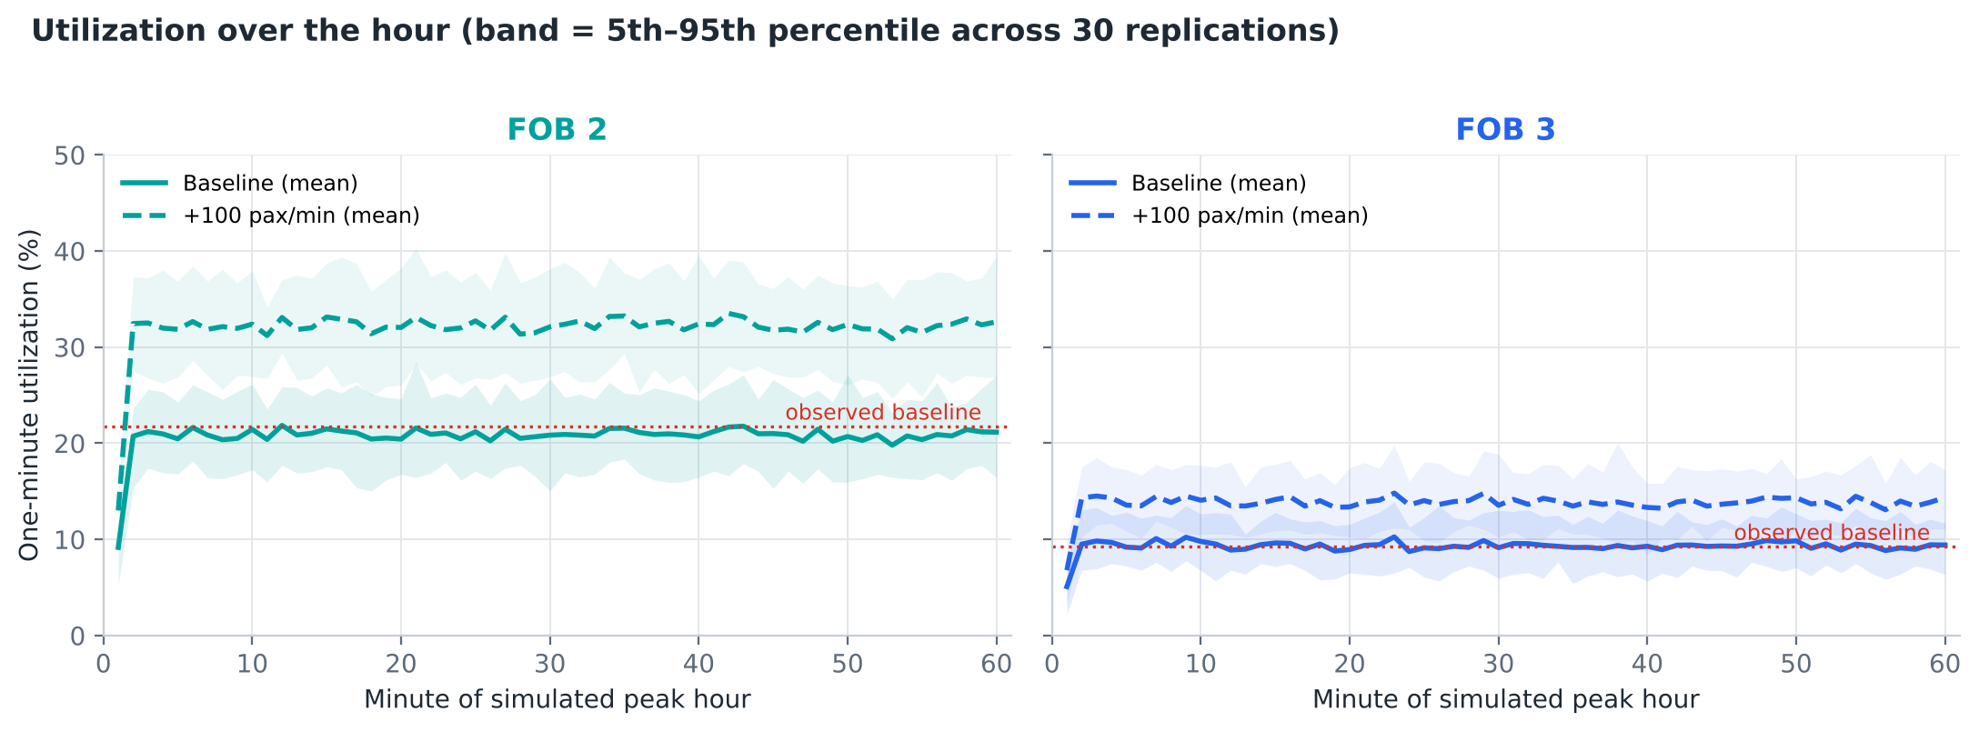
Figure 3. Utilization over the hour, baseline vs +100 pax/min (band = 5th–95th percentile).
About 94–96% of the replication-to-replication variance comes from route-split noise rather than random arrivals.

12. Interpretation
- Demand split: 49% direct PF1/PF1A, 35% FOB 2, 16% FOB 3, 0.4% skywalk.
- Baseline: FOB 2 20.7%, FOB 3 9.3%.
- Extra demand: +5.6 / +11.2 points on FOB 2 and +2.3 / +4.5 on FOB 3 for +50 / +100 pax/min.
- Variability: busiest minutes are about 30% (FOB 2) and 43% (FOB 3) above the hourly mean.
- Observed counts: simulated baseline (20.7%, 9.3%) is close to observed (21.8%, 9.3%) — a consistency check, not validation.
- Balance: FOB 2 carries 67% of FOB flow at baseline and 67% at +100 pax/min.
Implication. Deck width is not binding even at +100 pax/min; FOB 2 is the bridge to watch. Measured route-choice data would sharpen every result.

13. Assumptions, Limitations, and Additional Data Required
- East-side counts split 50/50 between Northeast and Southeast.
- Gate and additional-demand route splits are assumptions, not measurements.
- 500 pax/min Ghatkopar flow is assumed; +50/+100 are scenario inputs, not forecasts.
- FOB 3 width (6.0 m) is unverified; FOB 2 width (5.36 m) to be confirmed.
- Poisson arrivals ignore train-release platoons, so peak minutes are likely understated.
Table 14. Assumptions register.
ID | Assumption | Value | Evidence status
A1 | Five access gates | Naval Colony, Huma, Gandhi Nagar (west); Northeast, Southeast (east, skywalk exits) | Layout decision
A2 | East-side gate rates | NE and SE each 10.00 entering / 5.00 leaving pax/min | ASSUMPTION (50/50 split)
A3 | Baseline gate route-choice probabilities | NC 60/25/15/0, Huma 55/30/15/0, GN 60/35/5/0, NE 0/95/0/5, SE 0/30/70/0 (PF1/FOB2/FOB3/skywalk) | Modelling assumption, not measured
A3b | Route shares of the additional demand | Huma 50/35/15, Gandhi Nagar 40/40/20 (PF1/FOB2/FOB3) | Modelling assumption, not measured
A4 | Southeast split | 70% FOB 3, 30% FOB 2 | Explicit ASSUMPTION
A5 | Leaving passengers | Use the same route percentages as entering passengers at that gate | Assumption
A6 | Route-split noise | Dirichlet draw per gate per replication, concentration 99 (about +/-3 pp for a 10% share) | Modelling choice
A7 | Skywalk | Connector between FOB 2 and FOB 3 on the east side; 5% of Northeast users walk it to FOB 3 | Layout decision
A8 | FOB 1 | Closed; never offered as a route | Observed
A9 | Ghatkopar reference flow | 500 pax/min | ASSUMED, not independently verified
A10 | Additional demand | +50 and +100 pax/min entering only; 80% Huma, 20% Gandhi Nagar; own route shares (A3b) | Scenario input, not a forecast
A11 | Arrival process | Independent Poisson processes (exponential inter-arrival times) for 10 baseline + 2 additional streams | Simplification
A12 | Constant rates over 60 min | Peak-period observed rates | Simplification
A13 | FOB 2 width | 5.36 m | Recorded; clear width unverified
A14 | FOB 3 width | 6.0 m | UNVERIFIED assumption
A15 | Flow intensity I | 60 pax/m/min | Reference value
A16 | Walking speed / crossing point | 1.30 m/s; counted at FOB deck mid-point | Assumption
A17 | Initial state | Station starts empty, no warm-up | Assumption
A18 | Replications and seeds | 30 per scenario, seeds 1001-1030, common random numbers | Design choice
Full register: data/assumptions_register.csv.
Data needed: gate-to-route counts; separate Northeast/Southeast counts; synchronised gate and FOB counts; verified clear widths; one-minute profiles with train times; a verified Ghatkopar source.

14. Conclusion
Under the stated assumptions, FOB 2 runs at about 21% and FOB 3 at about 9% of reference capacity at baseline, rising to about 32% and 14% with +100 pax/min. FOB 2 remains the more loaded bridge. Measured route-choice data are the key next step.

15. Reproducibility Appendix

15.1 Deliverables
Table 15. Project files (folder kanjurmarg_fob_simulation/).
Path | Content
anylogic/Kanjurmarg_FOB_Simulation/Kanjurmarg_FOB_Simulation.alp | Native AnyLogic 8.8 project
engine/FobEngine.java | Stochastic core (embedded verbatim in the .alp)
engine/RunnerMain.java, scripts/run_engine.sh | Stand-alone batch runner
python/fob_twin.py | Independent Python re-implementation (cross-check)
python/analyze.py, python/make_charts.py | CSV export, verification checks, utilization charts
scripts/build_alp.py, check_alp_code.py, render_preview.py | Model generator, model-code check, screen preview
data/*.csv | observed_data, gate_route_splits, expected_route_allocation, scenario_summary, fob_time_series, replication_results, route_split_uncertainty, assumptions_register
charts/*.png | All figures in this report
README.md, VALIDATION.md | Instructions and verification record

15.2 Reproducing the results
scripts/run_engine.sh 30 60 1.30 1001 99 # replications, minutes, walk speed, base seed, noise kappa
python3 python/analyze.py # CSVs + verification checks
python3 python/make_charts.py # utilization figures
python3 scripts/build_alp.py && python3 scripts/check_alp_code.py

In AnyLogic: open the .alp from a folder AnyLogic can read (on macOS not Downloads, unless AnyLogic is allowed access), run the Simulation experiment, choose a scenario and press Run. 'Run replications' runs 30 seeds × 3 scenarios inside AnyLogic and reproduces data/scenario_summary.csv; output goes to anylogic_batch_results.csv in the model folder.

15.3 Verification summary
Table 16. Automated checks.
Check | Result
Route probabilities sum to 100% for every gate (defaults) | PASS — Naval Colony 100%; Huma 100%; Gandhi Nagar 100%; Northeast 100%; Southeast 100%
Additional-demand route shares sum to 100% | PASS — Huma 50/35/15, Gandhi Nagar 40/40/20
Route probabilities sum to 100% for every gate (noisy draws) | PASS — checked 90 replications x (5 gates + 2 additional-demand splits)
Impossible routes stay impossible under noise | PASS — routes with 0% default probability are never used
FOB 1 remains unavailable | PASS — FOB 1 crossings over 180 replications = 0
Skywalk is a connector, not an FOB | PASS — only Northeast passengers use the skywalk (8361 in total); they are counted on FOB 3 and there is no skywalk crossing count
Direct PF1 passengers never counted; each FOB passenger counted at most once | PASS — every replication: FOB 2 + FOB 3 crossings + passengers still approaching at t=60 = FOB-route passengers
East-side rates conserve the observed aggregate | PASS — Northeast + Southeast entering = 10 + 10 = 20; leaving = 5 + 5 = 10 pax/min
Baseline gate totals | PASS — entering 90.53, leaving 108.66, total 199.19 pax/min
Additional demand total and 80/20 split (+50 pax/min) | PASS — Huma +40, Gandhi Nagar +10, total +50 pax/min; Huma entering 67.20, Gandhi Nagar entering 43.33
Additional Huma arrivals are Poisson (+50 pax/min) | PASS — mean 2406.9 per hour vs expected 2400 (z = +0.77)
Additional Gandhi Nagar arrivals are Poisson (+50 pax/min) | PASS — mean 598.3 per hour vs expected 600 (z = -0.39)
Additional demand total and 80/20 split (+100 pax/min) | PASS — Huma +80, Gandhi Nagar +20, total +100 pax/min; Huma entering 107.20, Gandhi Nagar entering 53.33
Additional Huma arrivals are Poisson (+100 pax/min) | PASS — mean 4792.5 per hour vs expected 4800 (z = -0.60)
Additional Gandhi Nagar arrivals are Poisson (+100 pax/min) | PASS — mean 1193.4 per hour vs expected 1200 (z = -1.04)
Expected additional routing +50 | PASS — PF1 +24, FOB 2 +18, FOB 3 +8 pax/min (expected values, reported separately from simulation)
Expected additional routing +100 | PASS — PF1 +48, FOB 2 +36, FOB 3 +16 pax/min (expected values, reported separately from simulation)
Baseline streams unchanged by scenarios (no multipliers) | PASS — with the same seed, all 10 baseline gate-direction streams generate identical arrivals in every scenario
Poisson arrival counts for the 10 baseline streams | PASS — z-scores of hourly means vs lambda x 60: +0.2, +0.9, +0.9, +1.4, +0.5, -0.6, -1.3, -0.9, +0.8, -2.5
Per-passenger route choice follows each replication's split | PASS — pooled chi-square = 946.5 on 960 df, p = 0.616 (1,077,324 passengers)
Route-split noise has the intended size | PASS — SD of Naval Colony FOB 3 share (15%) across replications = 3.5 pp (theory 3.6 pp)
Different seeds generate different trajectories | PASS — 30 distinct arrival-count vectors from 30 seeds
Java engine reproduced by independent Python implementation | PASS — identical per-minute FOB 2 counts for sampled replications (full comparison of all 180 replications: 0 mismatches)
Capacity units | PASS — C2 = 5.36 m x 60 pax/m/min x 1 min = 321.6 pax; C3 = 6.0 x 60 x 1 = 360 pax
Simulated results recorded separately from expected values | PASS — baseline simulated minus expected flow: FOB 2 -2.25 pax/min, FOB 3 +0.81 pax/min
Java engine vs Python twin, all 180 replications | PASS — 0 mismatches in arrivals, route counts, noisy splits and per-minute crossings
Model code compile (scripts/check_alp_code.py) | PASS — all functions, events and 14 dynamic expressions compile against AnyLogic API stand-ins
Model event logic executed headless | PASS — identical to batch replication 1 (seed 1001); in-model replications reproduce scenario_summary.csv
Opened and run in AnyLogic 8.8 | NOT YET CONFIRMED — to be checked on the user's computer

15.4 Software
Java (OpenJDK 21), Python 3.13 with NumPy 2.5, pandas 3.0, SciPy 1.18 and Matplotlib 3.11. Target: AnyLogic 8.8 (Personal Learning Edition compatible; no paid libraries).

