NexusOS Enterprise HRMS
Unified SaaS Infrastructure & Core Protocol Manual

Technical Governance Framework
Version 2.5.0-PREMIUM
Internal Release: April 2026

Chapter 1: Initial Provisioning & Identity

Secure Authentication Gate
The NexusOS entry point facilitates multi-tenant orchestration, supporting both traditional corporate credentialing and unified Google OAuth integration for enterprise-grade accessibility.
Functional Note: New companies must initialize registration first. This can be executed manually or via Google Auth. If a matching organization domain is not detected, the system prompts for new company creation, designating the primary registrant as the 'Superadmin'.


Capture: Secure Authentication Gate Protocol Interface

Security Hardening Protocol
Upon initial entry via third-party providers, the system enforces a strict security hardening cycle to ensure credential redundancy and maximum data integrity.
Functional Note: If a backup password has not been established, the user is mandated to set one before proceeding to the core workspace.


Capture: Security Hardening Protocol Protocol Interface

Tenant Identification & Profiling
The foundational workspace identity is established here, capturing critical metadata including corporate addressing and geographic identifiers used in subsequent reporting cycles.
Functional Note: Post-password verification, new users are automatically routed to the Organization Provisioning layer for first-time setup.

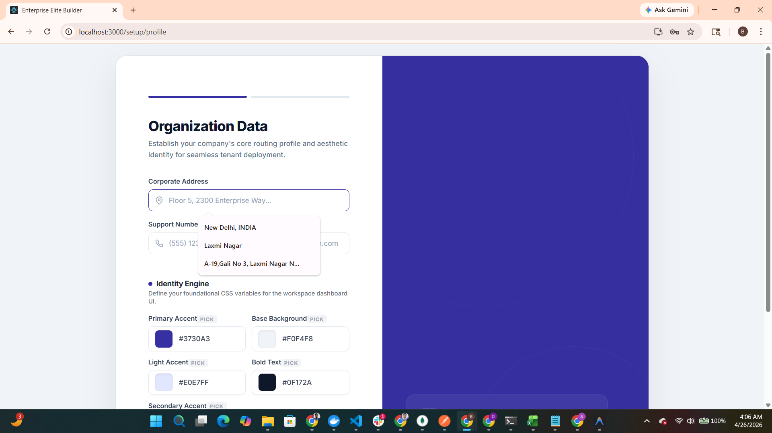
Capture: Tenant Identification & Profiling Protocol Interface

Dynamic Identity Engine
Administrators define the visual DNA of their workspace. The engine allows for granular control over CSS variables that define the brand presence throughout the application.
Functional Note: The selected theme profile dictates the global UI palette, ensuring that the entire interface reflects the company's established identity.

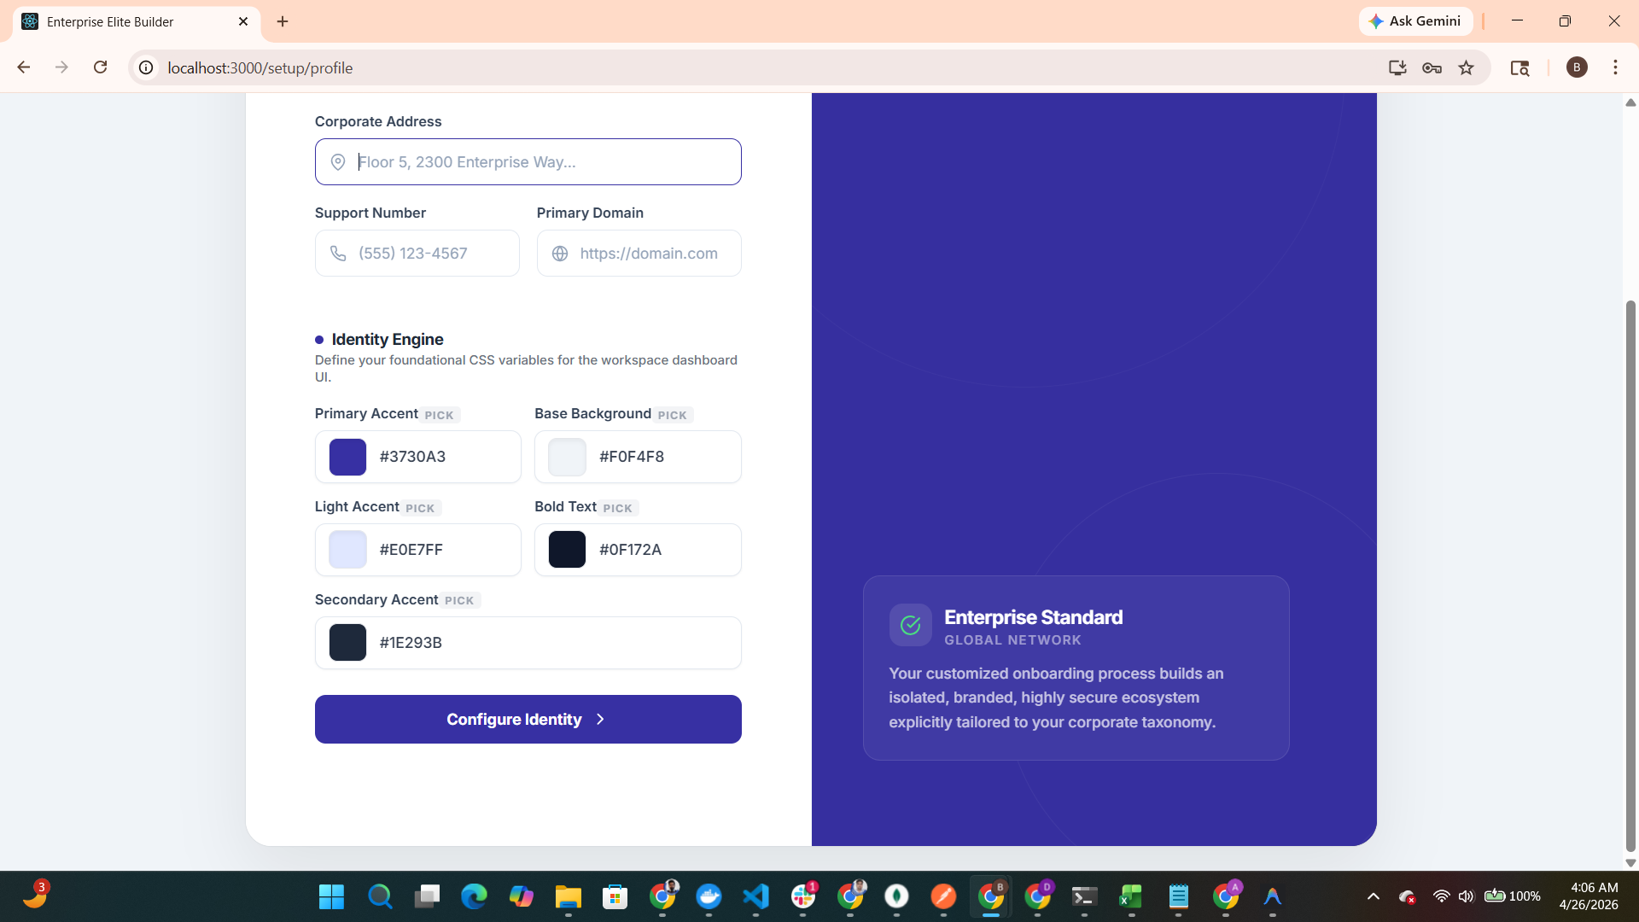
Capture: Dynamic Identity Engine Protocol Interface

Visual Asset Provisioning
The finalization of the tenant identity involves the injection of corporate visual assets, ensuring high-fidelity brand representation across all system outputs.
Functional Note: Corporate logos uploaded here are dynamically distributed across the administrative panel according to functional requirements.

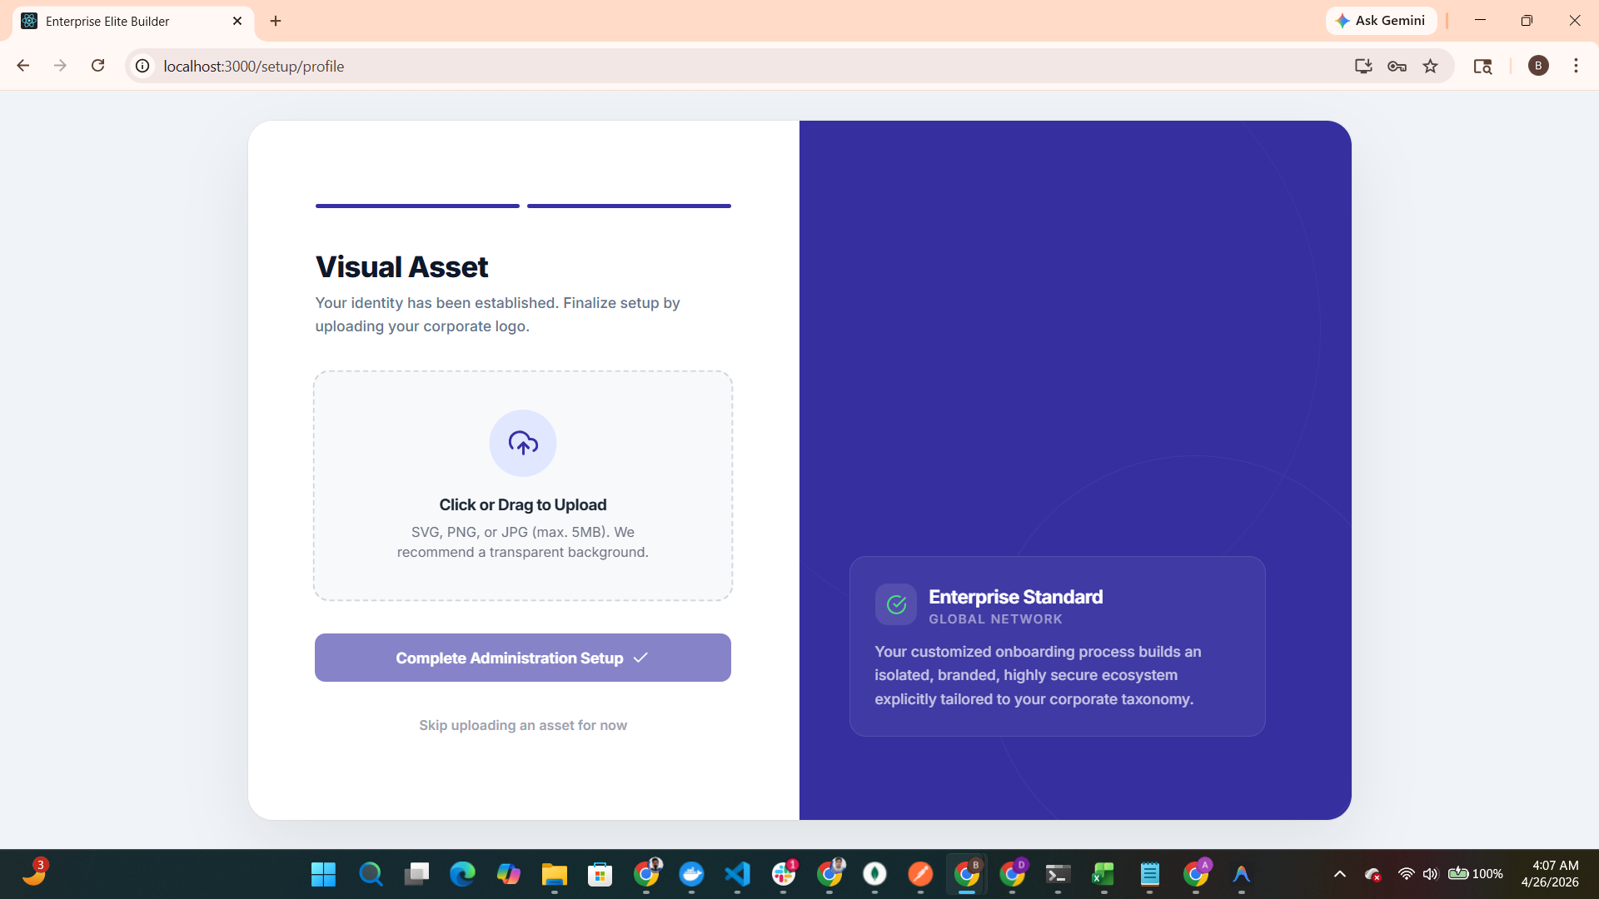
Capture: Visual Asset Provisioning Protocol Interface

Chapter 2: Communication Infrastructure

Infrastructure Readiness Audit
Once identity parameters are established, the system provides a comprehensive summary of the administration setup status, clearing the tenant for functional deployment.
Functional Note: Upon successful completion of the setup summary, the administrator is granted full access to the primary Command Dashboard.

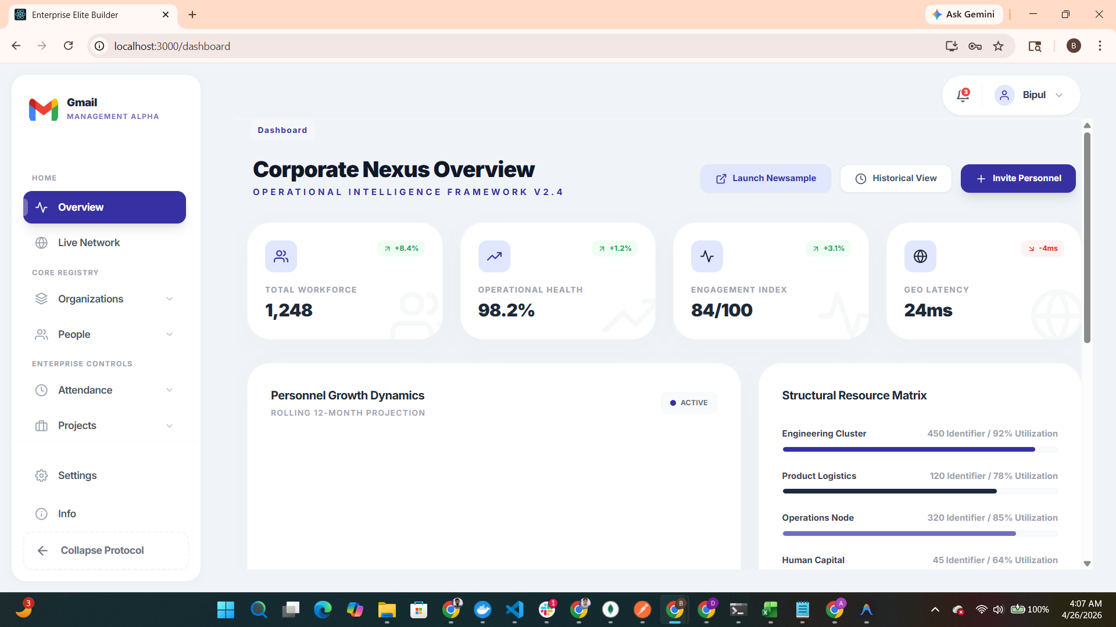
Capture: Infrastructure Readiness Audit Protocol Interface

SMTP Communication Protocol
A prerequisite for organizational scaling. Secure SMTP parameters must be verified to enable automated personnel invitations and system-wide notifications.
Functional Note: The 'Invite Personnel' action triggers a pre-flight check. If SMTP is not configured, the system enforces an immediate configuration intercept.

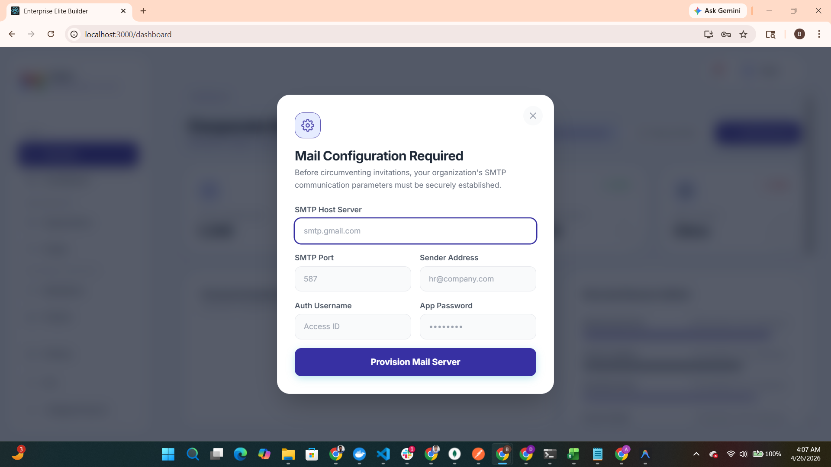
Capture: SMTP Communication Protocol Protocol Interface

Chapter 3: Strategic Command & Governance

Corporate Nexus Dashboard
The central Command Dashboard provides the Operational Intelligence Framework. It utilizes high-level data benchmarks to provide instant visibility into organizational health.
Functional Note: The entire dashboard interface dynamically adapts to the company's identity engine, maintaining brand consistency across all metrics.


Capture: Corporate Nexus Dashboard Protocol Interface

Personnel Invitation Lifecycle
This module manages the secure expansion of the organizational workforce, facilitating role assignment and departmental mapping in a unified workflow.
Functional Note: Successful SMTP provisioning enables the direct distribution of secure invitation tokens to prospective team members.


Capture: Personnel Invitation Lifecycle Protocol Interface

Secure Token Formulation
Generates unique, time-sensitive access strings that allow recipients to bypass manual registration and integrate directly with the corporate tenant.
Functional Note: The system delivers a dynamic email template, themed according to the company's identity engine, providing a premium onboarding experience.


Capture: Secure Token Formulation Protocol Interface

Chapter 4: Structural Hierarchy & Architecture

Personnel Matrix Flow (Live Network)
The Live Network module visualizes the organizational tree in real-time. This interactive graph allows for structural governance through direct node manipulation.
Functional Note: Admins and Superadmins can architect the hierarchy via the UI, connecting or detaching nodes as organizational needs evolve. Standard employees are restricted to 'View Only' mode.

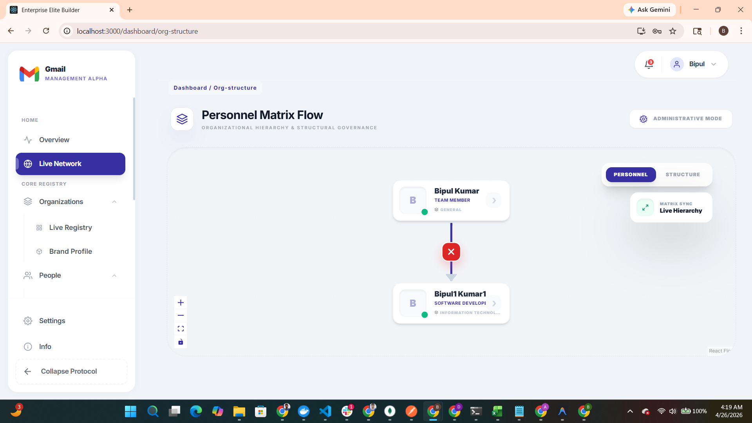
Capture: Personnel Matrix Flow (Live Network) Protocol Interface

Departmental Node Detail
Provides a deep-dive visualization of specific department-level clusters and their respective reporting structures.
Functional Note: This view offers a specialized network perspective tailored to individual departmental governance.

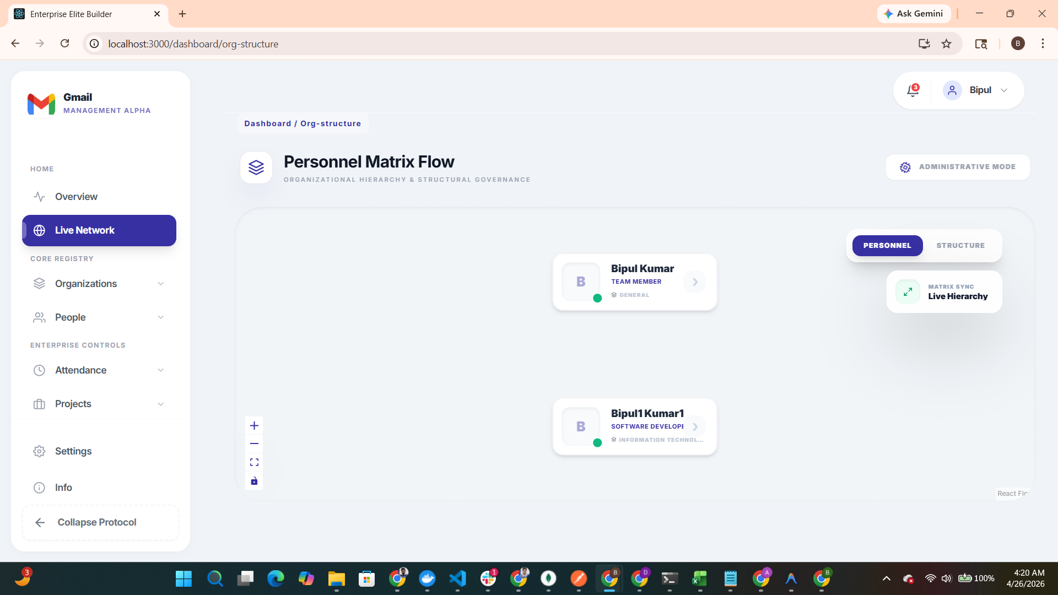
Capture: Departmental Node Detail Protocol Interface

Chapter 5: Operational Governance

Attendance Protocol Control
Enforces operational time-tracking through secure Punch In/Out protocols, providing an audit trail for workforce activity.
Functional Note: Administrators can utilize this module to manage department definitions, designations, and overarching operational clusters.

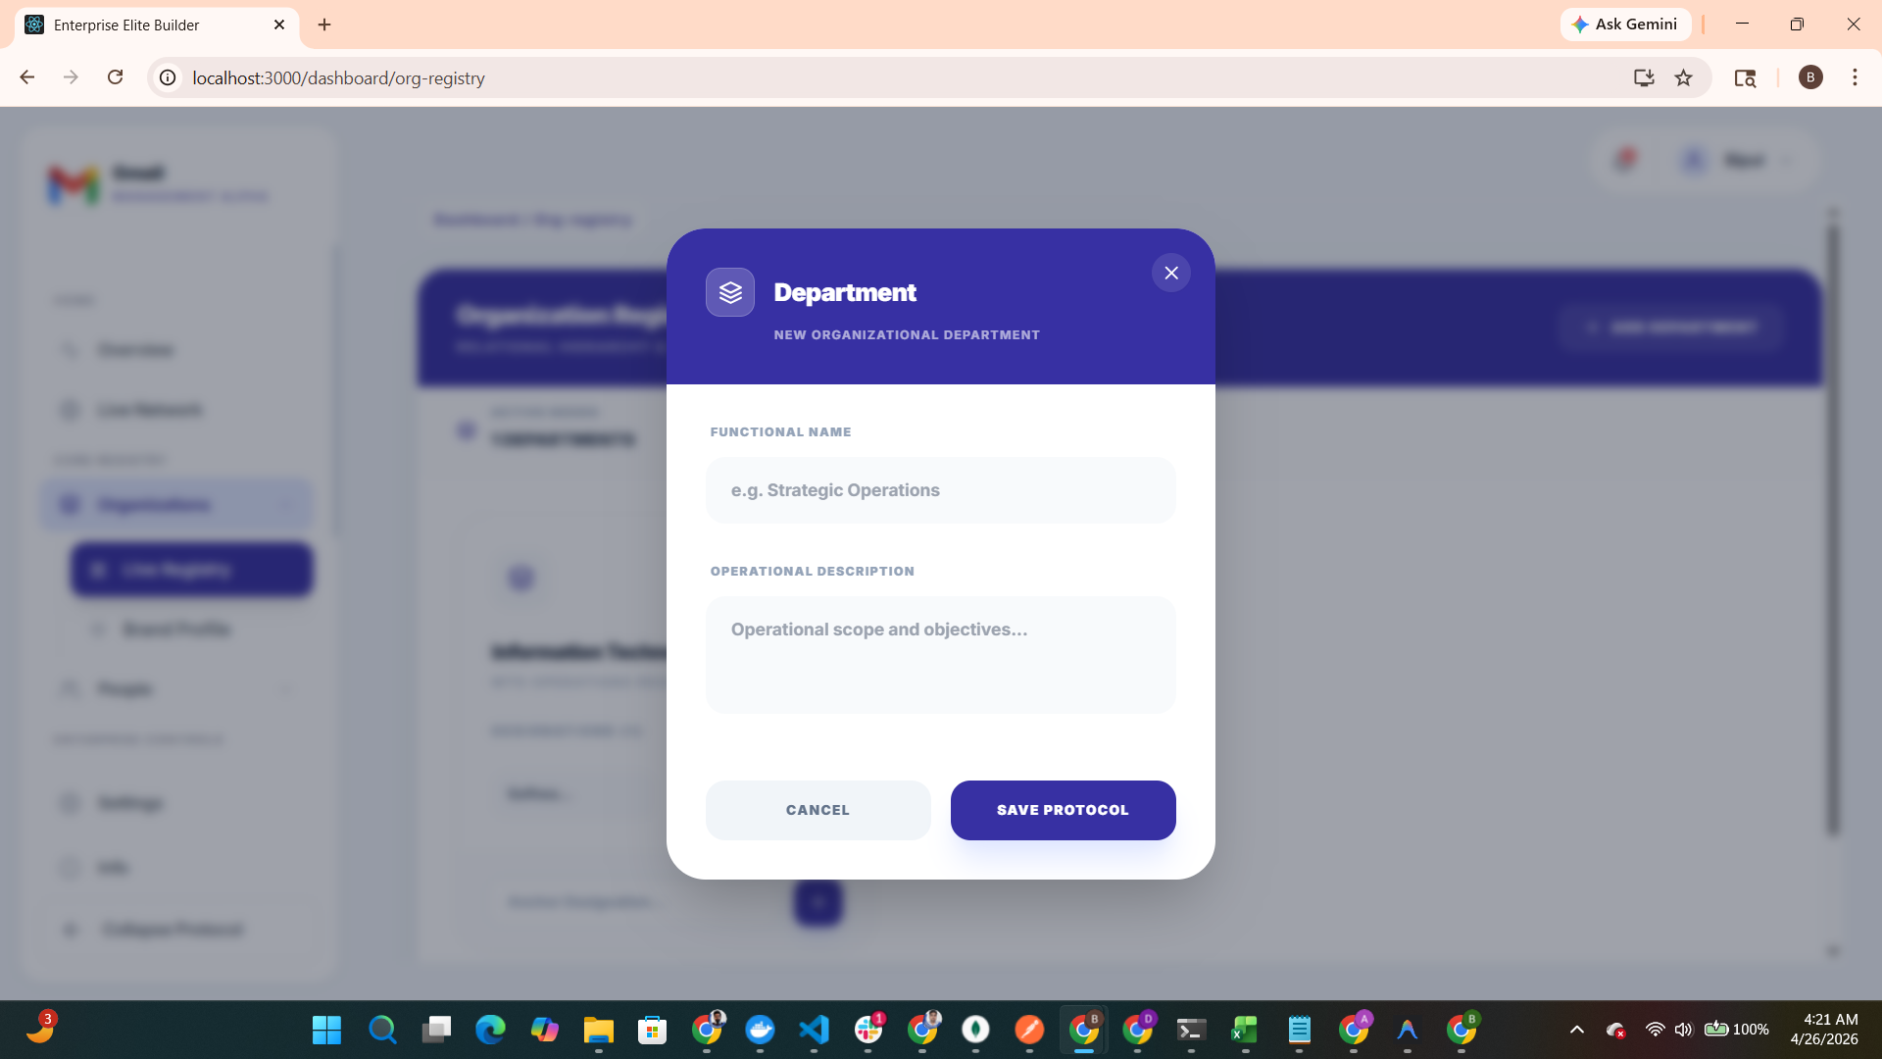
Capture: Attendance Protocol Control Protocol Interface

Timesheet Strategic Console
A comprehensive auditing tool for project-based effort tracking. It supports both manual entry and automated bulk uploads via Excel.
Functional Note: Users select assigned projects and submit effort logs for approval. The system supports Excel data payload imports with an integrated template download option for efficiency.

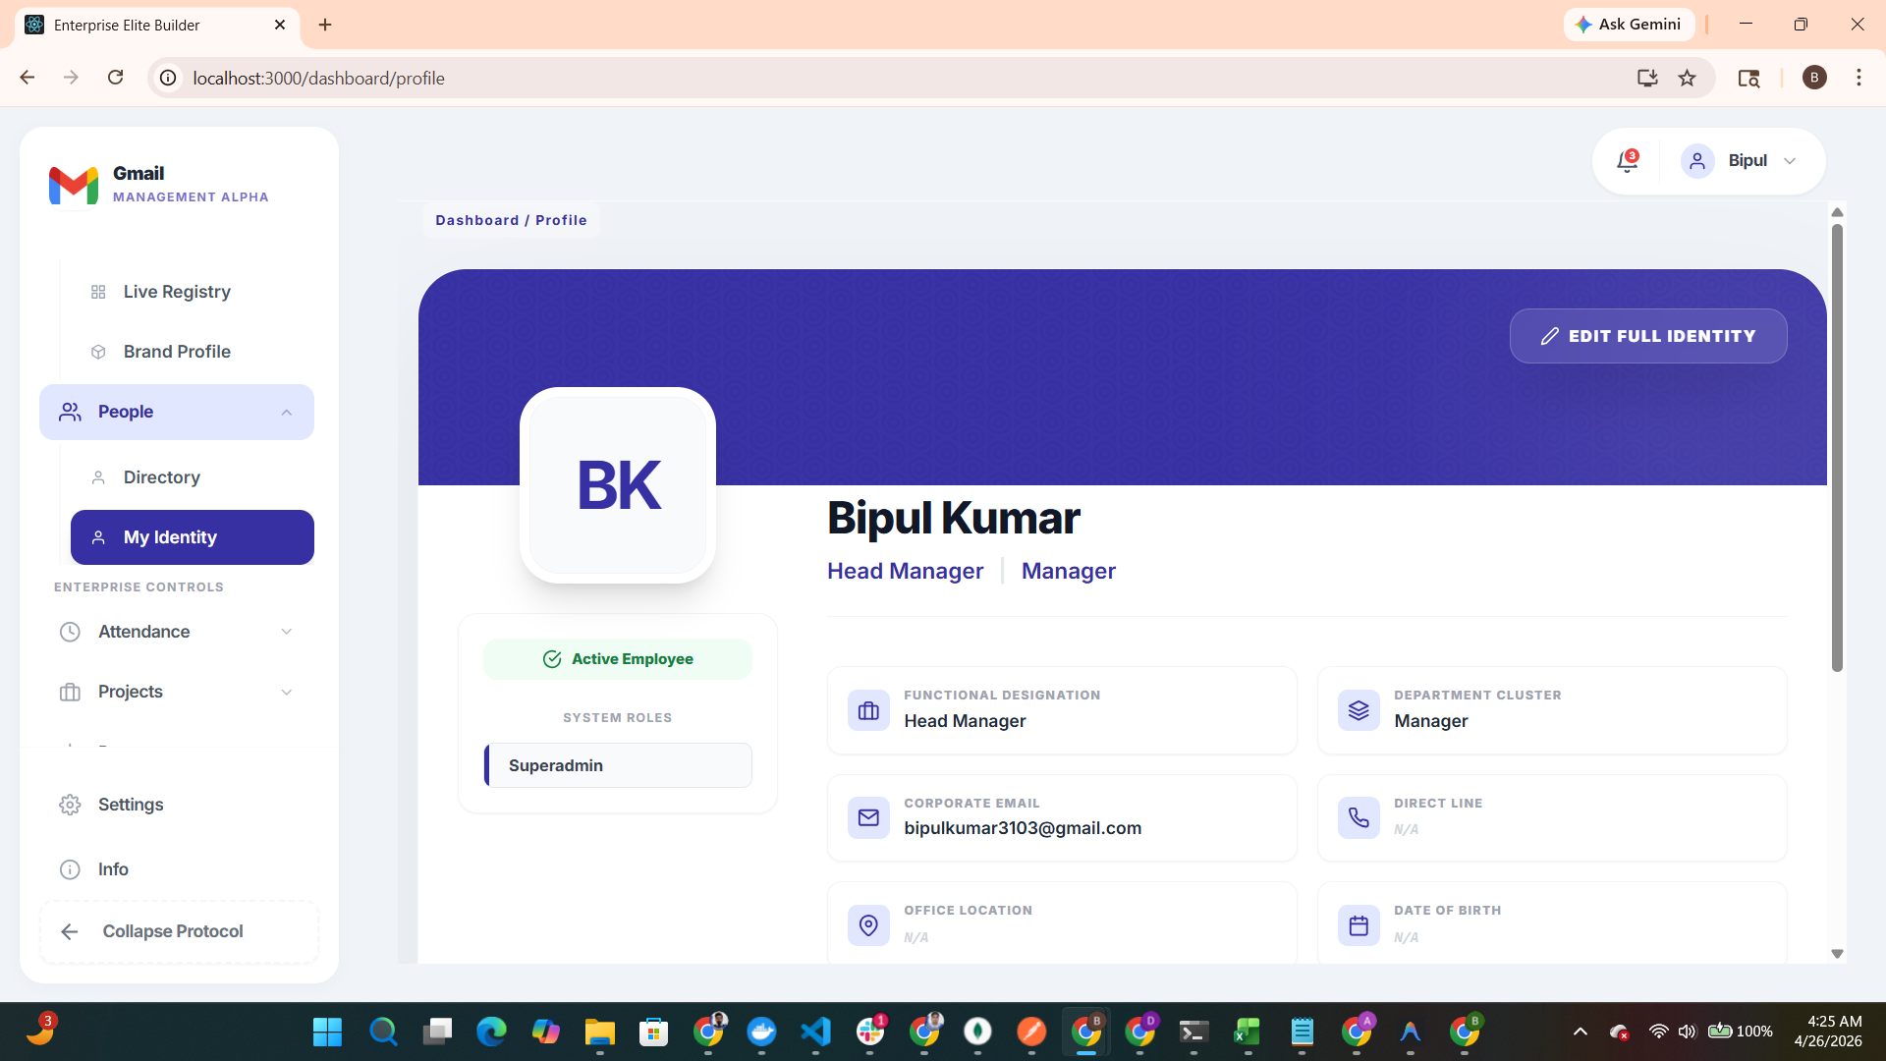
Capture: Timesheet Strategic Console Protocol Interface

Governance Queue: Approvals
The approval module allows reporting managers and HR personnel to audit, approve, or reject submitted timesheets based on project milestones.
Functional Note: Managers execute governance actions directly from their specialized profile consoles.

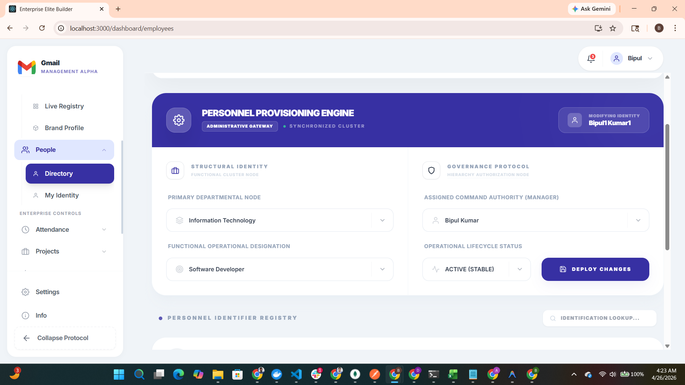
Capture: Governance Queue: Approvals Protocol Interface

Audit Visibility & Status
Provides employees with full transparency into the status of their submissions, including approval history and rejection justifications for re-submission.
Functional Note: This ensures a closed-loop governance cycle where reasons for rejection can be addressed and remediated for re-approval.

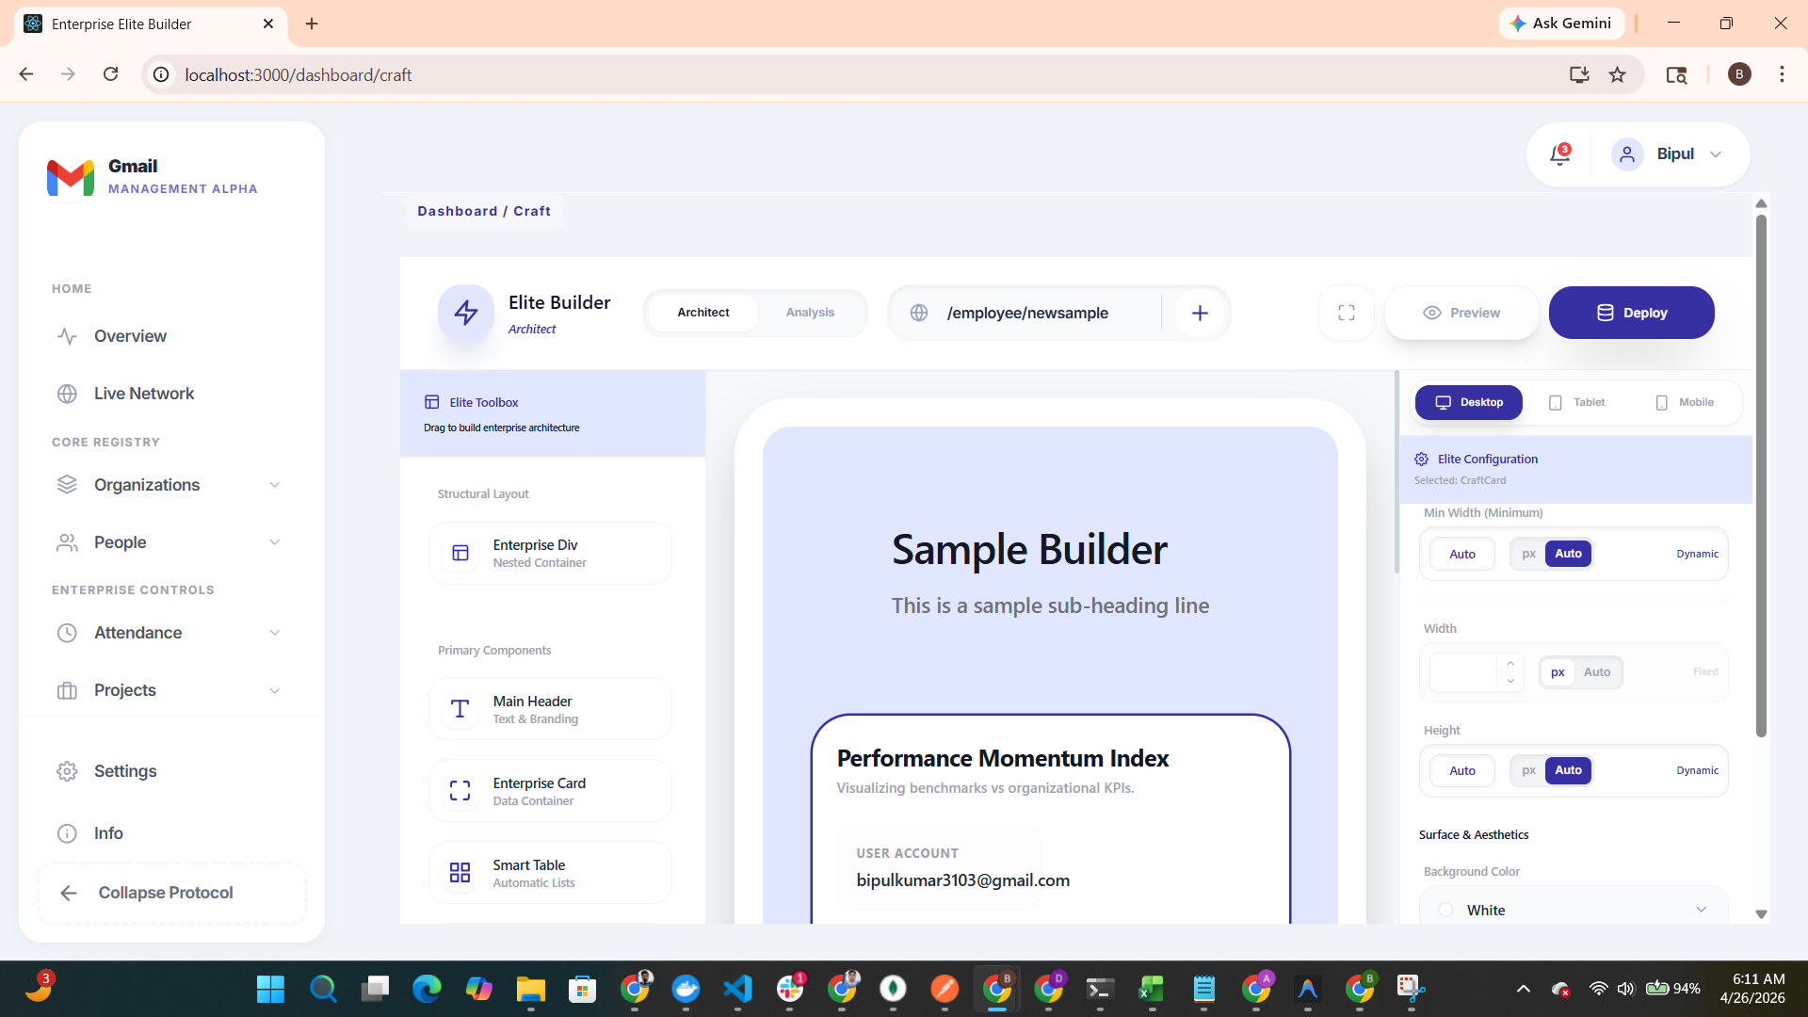
Capture: Audit Visibility & Status Protocol Interface

Chapter 6: Advanced Engineering (Elite Builder)

Elite Builder: Architect Mode
The proprietary 'Low-Code' engine for engineering dynamic UI components and complex data orchestration layers.
Functional Note: This builder allows administrators to architect custom employee pages (e.g., /employee/newsample) with native-level performance.

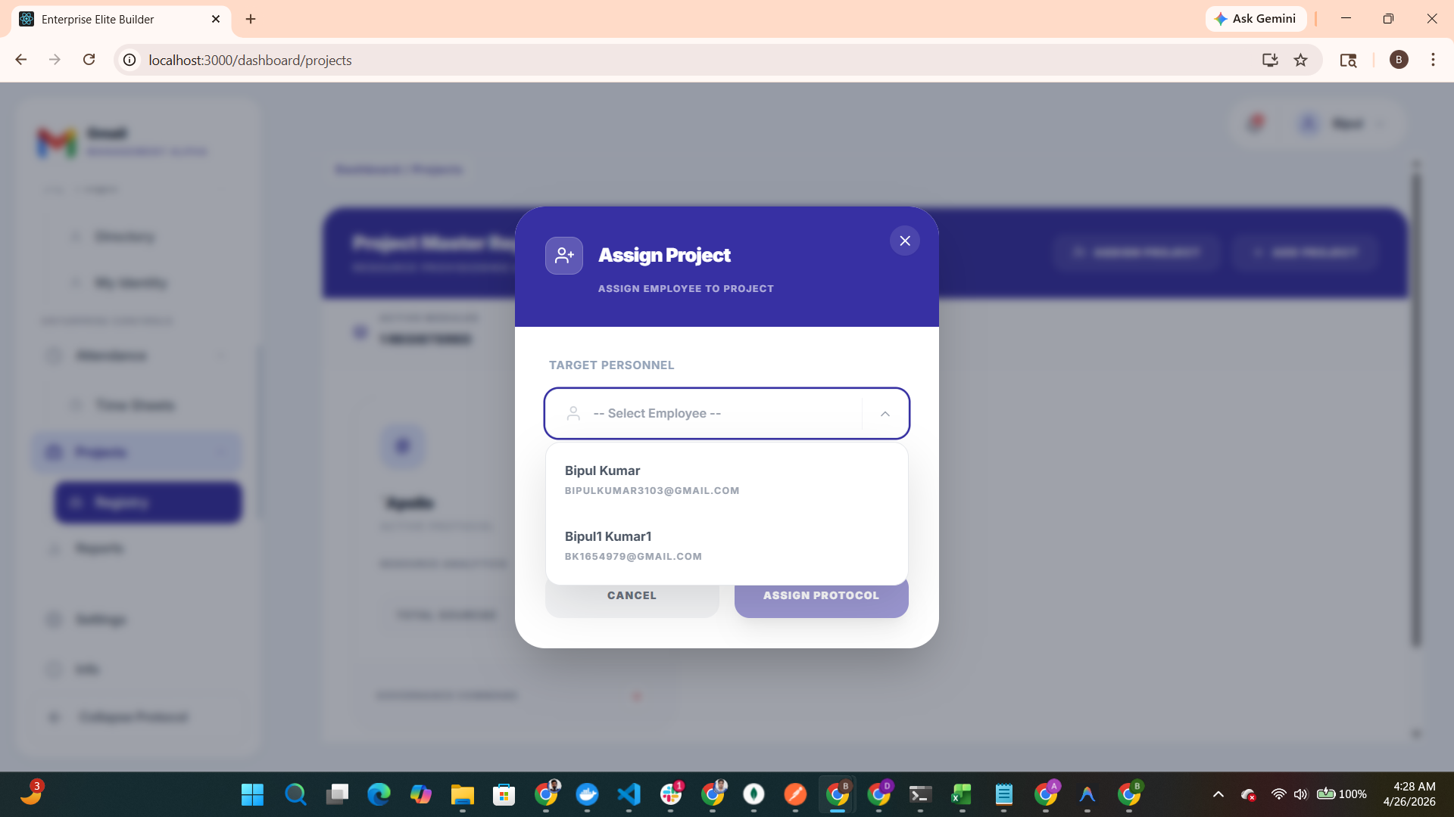
Capture: Elite Builder: Architect Mode Protocol Interface

UI Render Engine
The core of the SaaS platform. This engine translates architect-defined metadata into live, high-fidelity user interfaces.
Functional Note: Currently in the 'Elite Development' phase, this engine is being optimized to serve as the structural backbone of the entire application ecosystem.

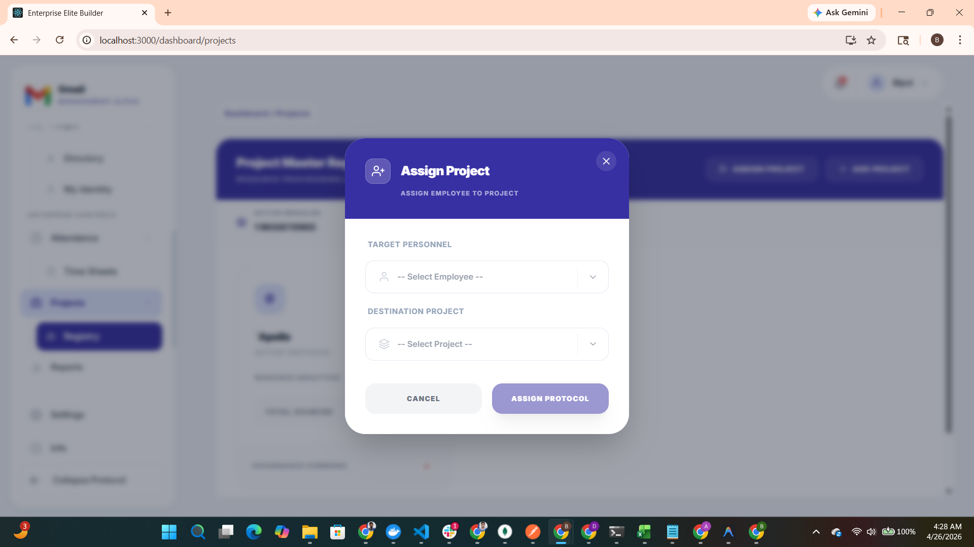
Capture: UI Render Engine Protocol Interface

Administrative Form Analysis
A real-time monitoring engine that analyzes data flow across the protocol layer, providing insights into form interaction and submission metrics.
Functional Note: Facilitates a deep-dive audit into how organizational data is captured and refined across different protocol levels.

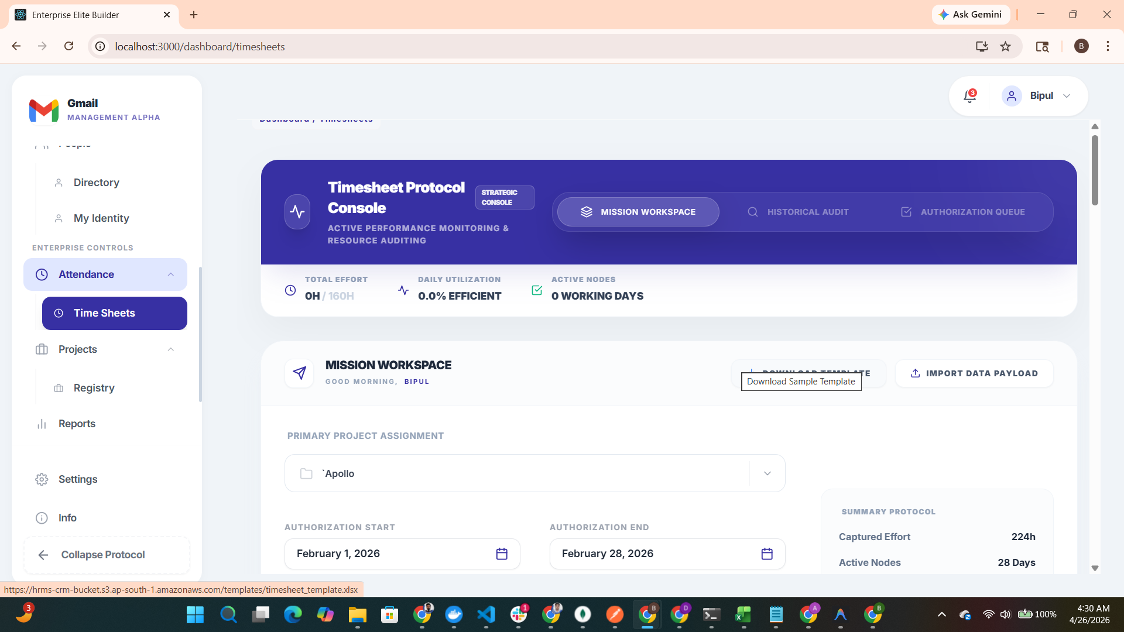
Capture: Administrative Form Analysis Protocol Interface

Chapter 7: Operational Status

Final System Health Summary
A concluding view of the fully provisioned enterprise workspace, showing an active, healthy, and audited ecosystem.
Functional Note: This view represents the current employee-level dashboard, showcasing the end-user experience post-provisioning.

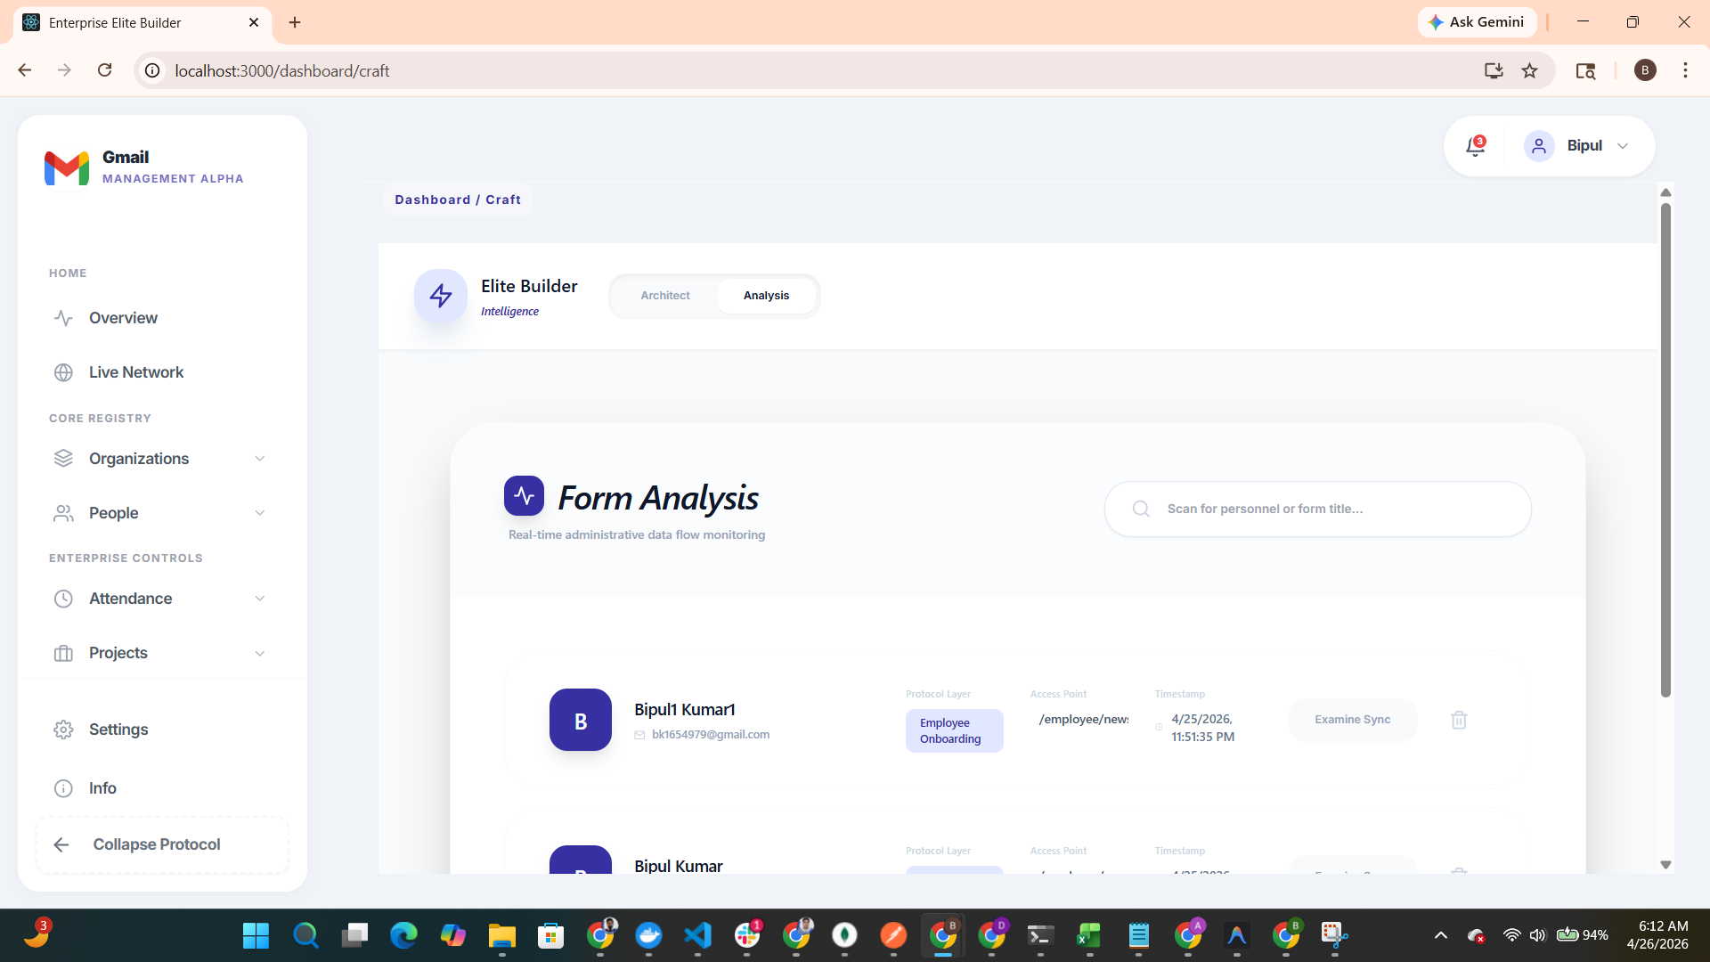
Capture: Final System Health Summary Protocol Interface

Chapter 8: Database Architecture

Technical Schema Overview
NexusOS is architected on a high-fidelity relational schema optimized for multi-tenant SaaS operations. The database ensures strict data isolation between tenants while facilitating complex cross-module governance. Key data clusters include the Identity Core, Organizational Matrix, and Operational Logic layers.

Core Entity Relationships
Data Cluster | Primary Entities | Operational Significance
Identity Core | Company, User, Role | Governs global authentication, multi-tenancy, and visual branding.
Org Matrix | Department, Designation | Defines the structural hierarchy and functional workforce clusters.
Operation Logic | Project, Timesheet, Punch | Tracks resource utilization and effort auditing across mission-critical goals.
Governance | ApprovalLog, Manager Link | Enforces the hierarchical approval cycle and operational transparency.
Elite Builder | UIMetadata, UIPage | Stores dynamic JSON configurations and manages low-code interface routing.

