**IBM- Naan Mudhalvan Data Analytics with Cognos**

**Phase 3**

**Development Part 1**

**Student Name :** Bipul Pandey

**Register Number :** 620821104020

**Branch :** B.E CSE

**Year :** 3rd Year

**Topic :** Data Analytics with Cognos

**Title :** Public Health Awareness

**College :** Gnanamani College of Technology

## Introduction

Public health awareness is a critical aspect of ensuring the well-being of communities and populations. It involves educating and informing the public about health-related issues, promoting healthy behaviors, preventing diseases, and improving overall quality of life. In this dialogue, we can explore various aspects of public health awareness and its significance.

**Objectives**

In this phase defines start to building the Project by loading and preprocessing the dataset and perform different analysis and visualization using IBM Cognos.

**Data source**

Dataset is collected from the kaggle.com named “Survey.csv”which has data about the Timestamp,Age,Gender,Country,State,Self_employed ect.

Dataset link: https://www.kaggle.com/datasets/osmi/mental-health-in-tech-survey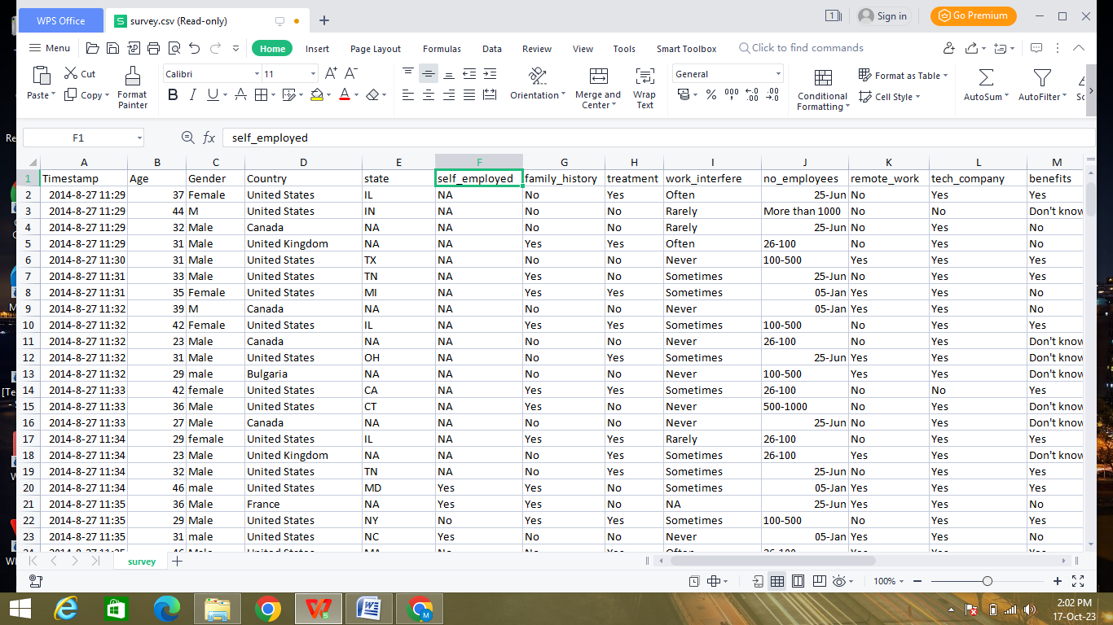

**Data Loading**

Steps Involved in data loading on IBM cognos.

1. Login to your IBM cognos
2. Click more menu from the left side
3. Select new tab

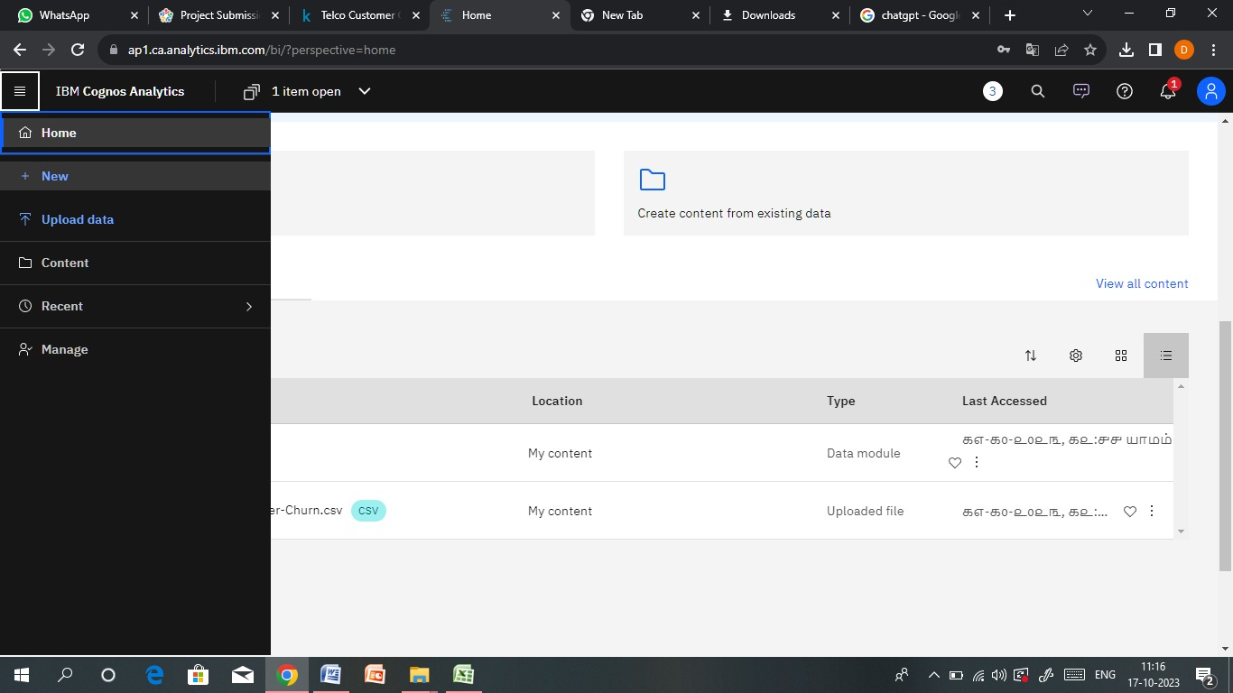

4. Click Data module tab

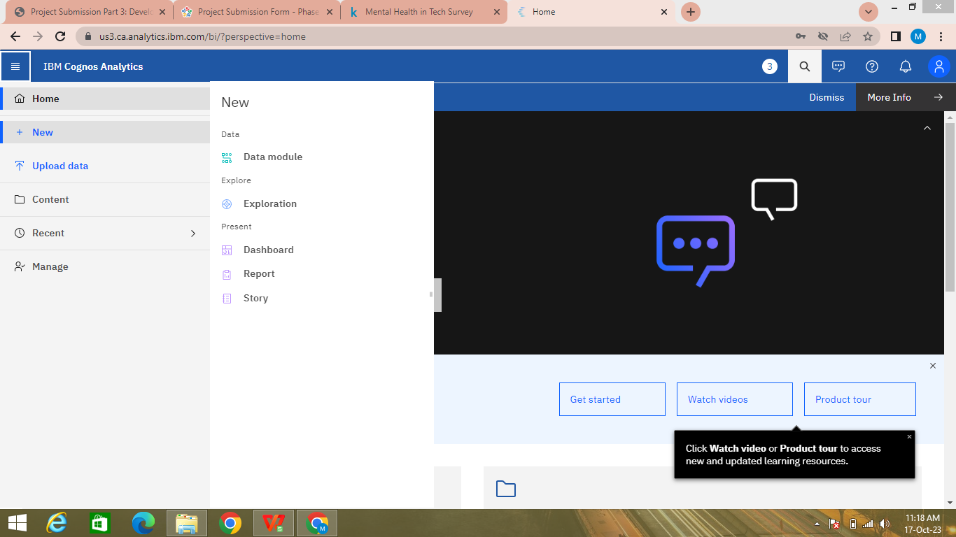

5.Upload the dataset for your project and select the Corresponding file

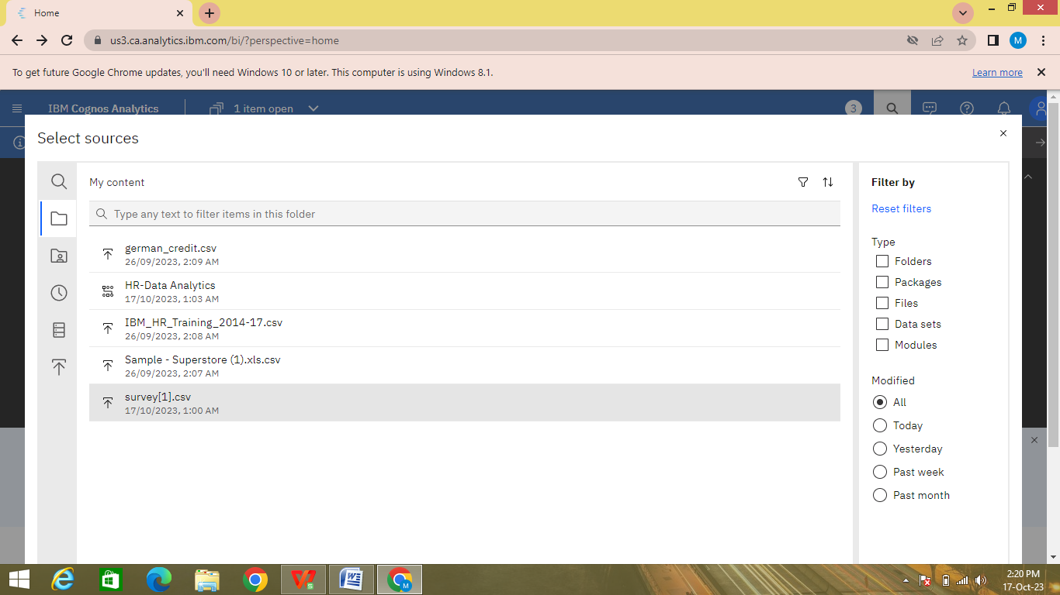

6. preview the data

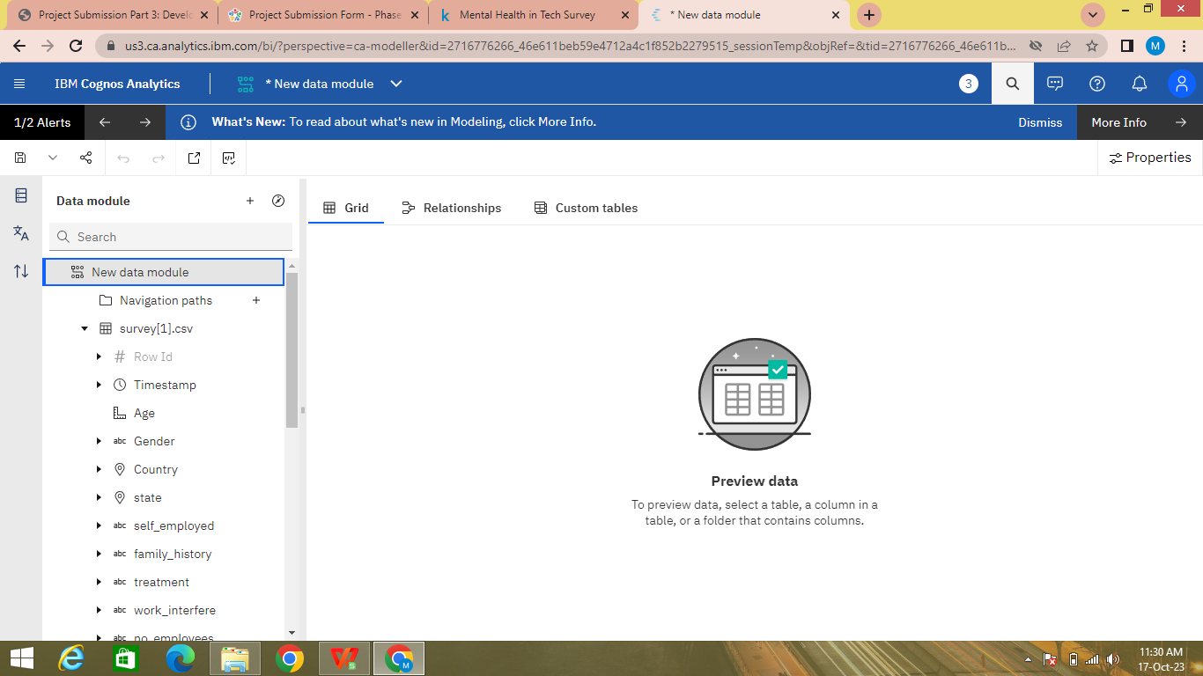

7.Explore the data

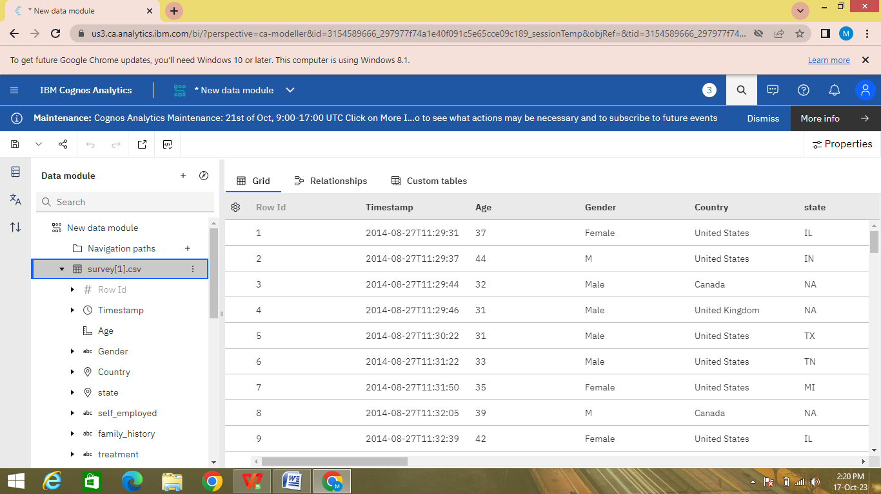

8. save the data module

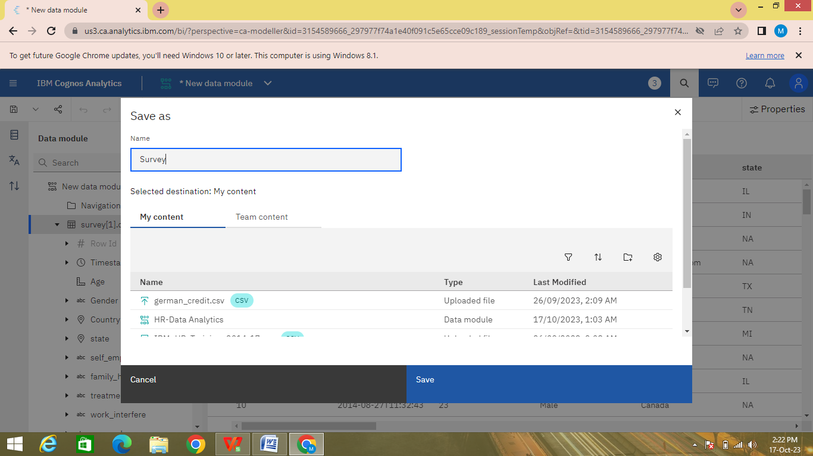

**Data Preprocessing and Cleaning**

In this phase the following steps will taken

* Handling missing data
* Data Transformation
* Data Type Conversion
* Removing Duplicates
* Dealing Outliers

Once you saved the data module. Click the corresponding dataset on IBM cognos and Preview the mosule

Right Click the row where you want to clean the data

It provides the UI to Clean the data and makes the task easy one, Now Updating and Replacing the Null values are simple

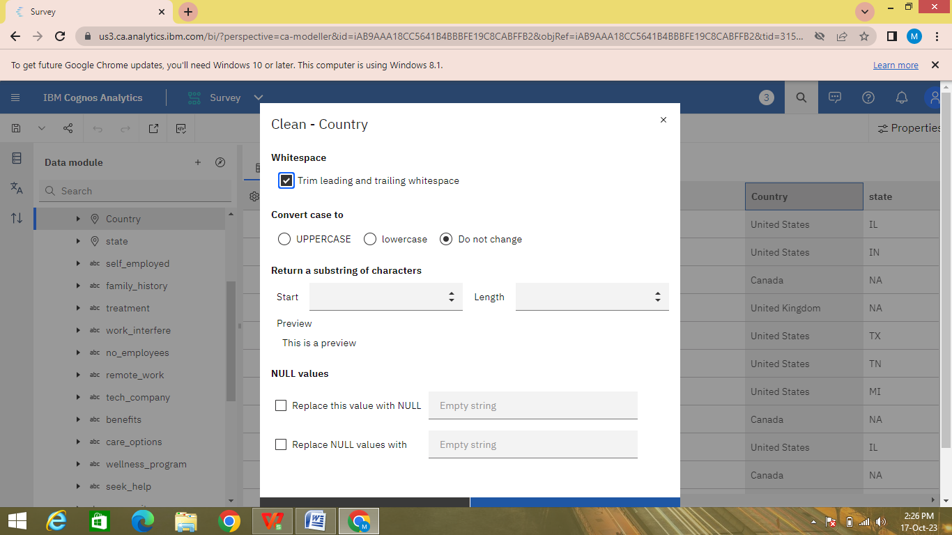

datamodule will be updated by doing the above process

after the completion ofprocess start creating the dashboard for Visualization

**Dashboard Creation**

Dashboard creation are helpful to visualizing the data

1. Goto Home menu
2. Select the new tab
3. Click dashboard

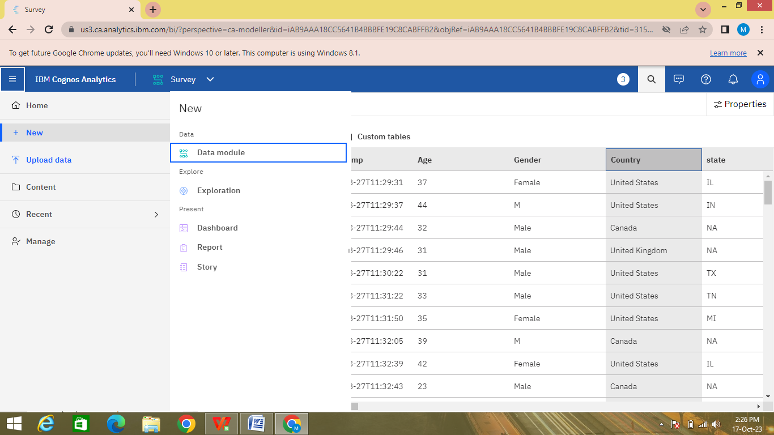

4. Choose the template for your project and click

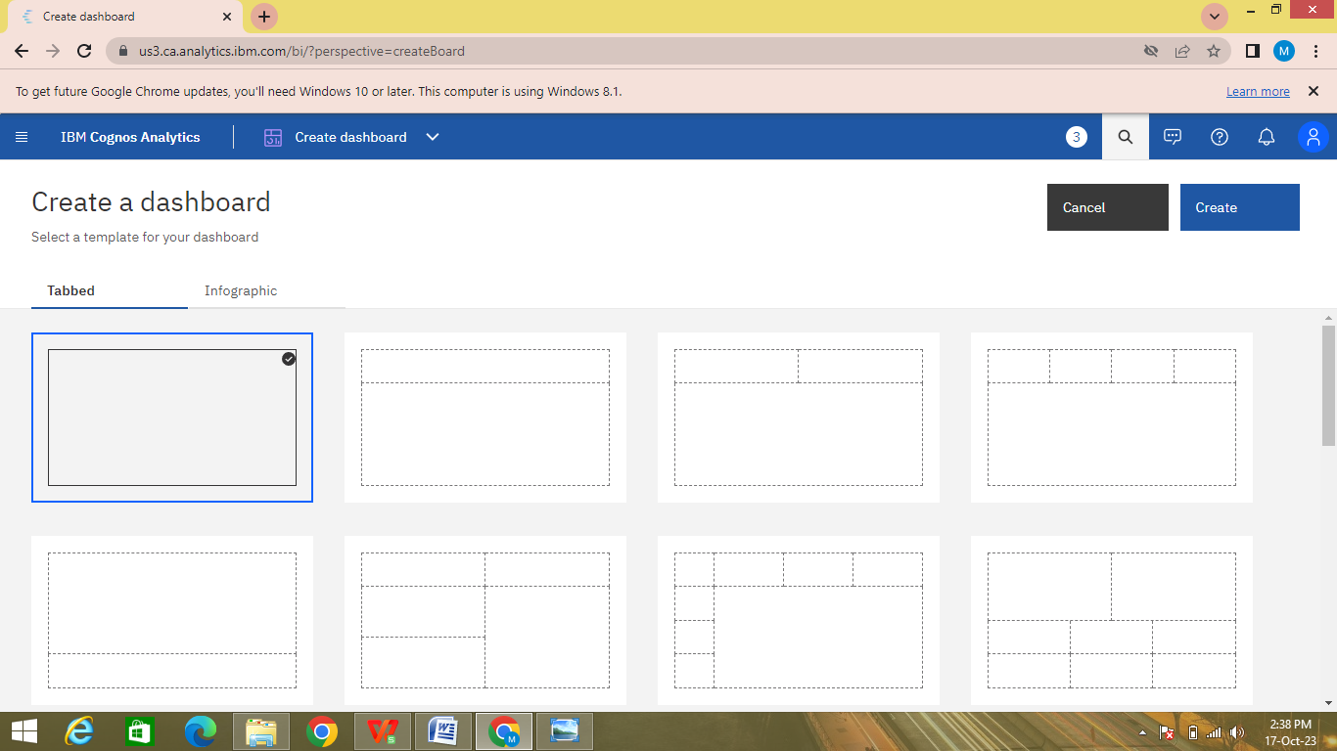

5.Now Dashboard is created

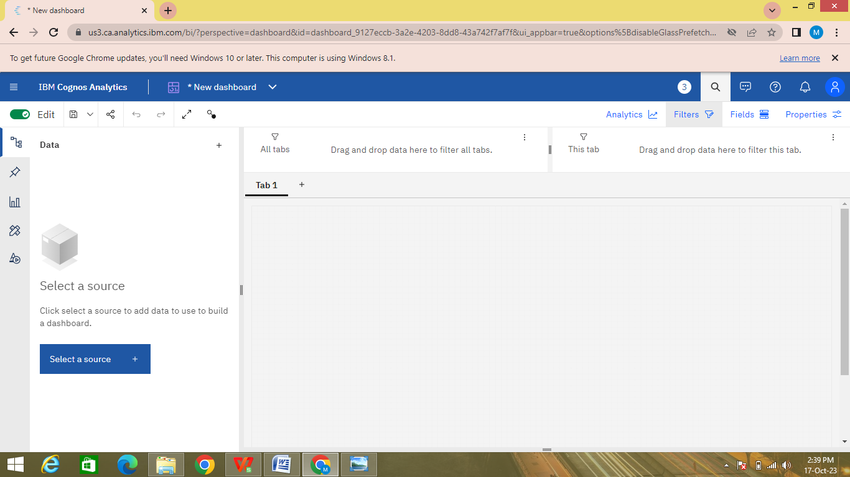

6. Select the data source

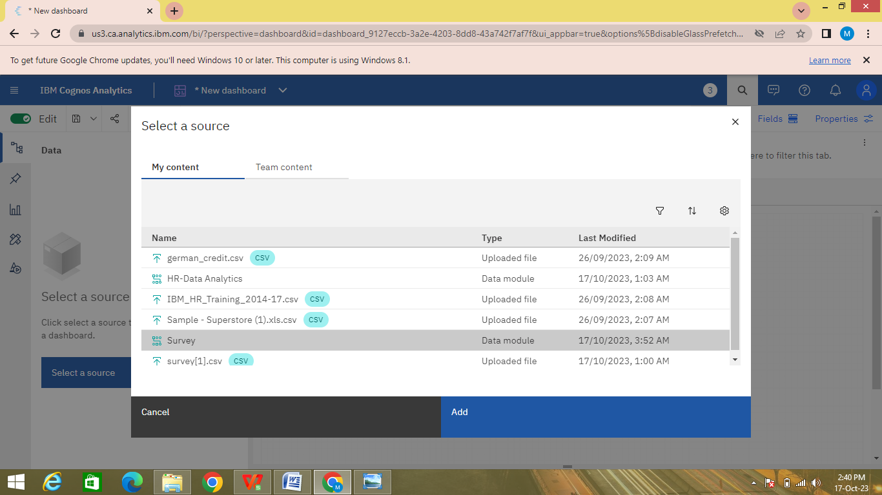

**Visualization**

After creating the dashboard, the next step is to visualize the data

In IBM Cognos

1. Goes to the Corresponding Dashboard

2. select the visualizations tab in the left side of title bar

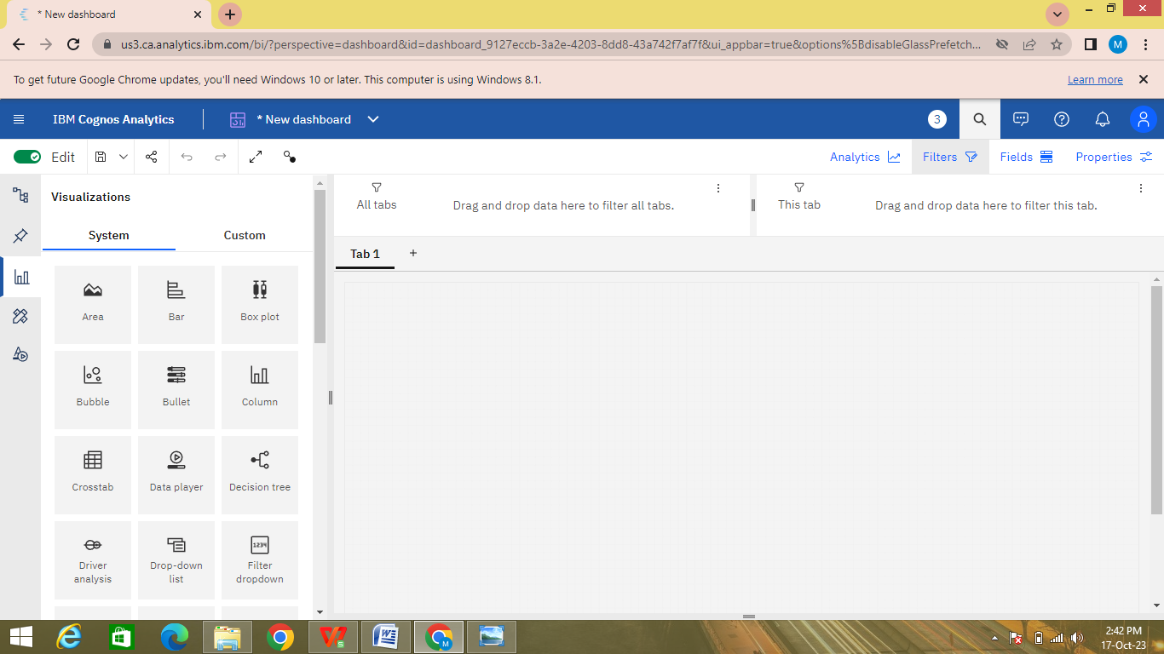

3.Choose the system as you want and put the data source for the required columns

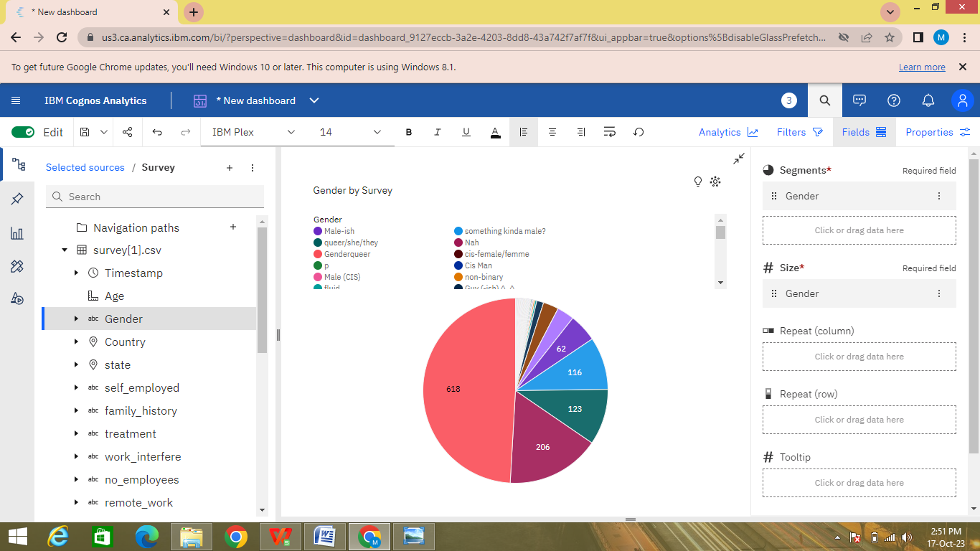

In the above screen shot displays the Pie chart in Gender by survey.

After performing these activities a comprehensive document will be created to demonstrate the ability to Communicate and share finding.

**Conclusion**

This technology project Involves loading and preprocessing a dataset, followed by various analysis and visualizations using IBM Cognos. Helpful to make an decisions to prevent disease,prolong life and promote health and efficiency of its people.