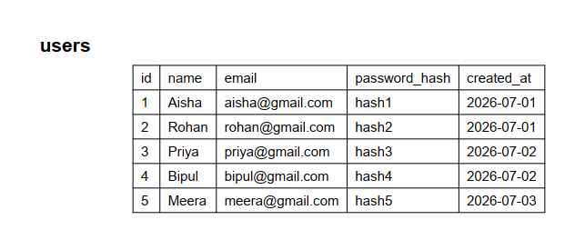
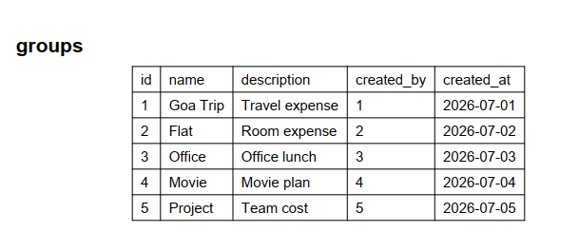
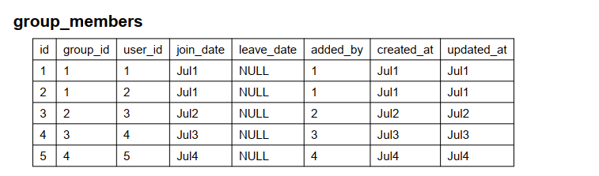

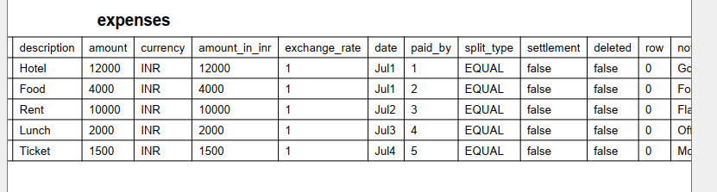

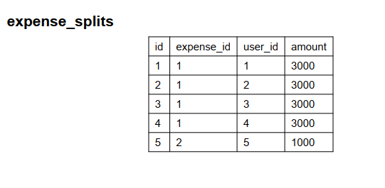

On frontend I convert the selected CSV file into FormData and send it using multipart/form-data. On backend multer middleware receives the file, temporarily stores it, then I read the CSV content and pass it to my CSV parser service for validation and anomaly detection."

