**Cloud Computing for Data Analysis**

**Exercise 10: Hierarchical Clustering**

Use the similarity matrix in following table to perform single and complete link hierarchical clustering. Show your results by drawing a dendrogram. The dendrogram should clearly show the order in which the points are merged.

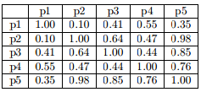

**Distance Matrix:**

|  |  |  |  |  |  |
| --- | --- | --- | --- | --- | --- |
|  | P1 | P2 | P3 | P4 | P5 |
| P1 | 0 |  |  |  |  |
| P2 | 0.90 | 0 |  |  |  |
| P3 | 0.59 | 0.36 | 0 |  |  |
| P4 | 0.45 | 0.53 | 0.56 | 0 |  |
| P5 | 0.65 | 0.02 | 0.15 | 0.24 | 0 |

**Single Link**

|  |  |  |  |  |  |
| --- | --- | --- | --- | --- | --- |
|  | P1 | P2 | P3 | P4 | P5 |
| P1 | 0 |  |  |  |  |
| P2 | 0.90 | 0 |  |  |  |
| P3 | 0.59 | 0.36 | 0 |  |  |
| P4 | 0.45 | 0.53 | 0.56 | 0 |  |
| P5 | 0.65 | 0.02 | 0.15 | 0.24 | 0 |

Updating the matrix after clustering P2 & P5:

|  |  |  |  |  |
| --- | --- | --- | --- | --- |
|  | P1 | P2, P5 | P3 | P4 |
| P1 | 0 |  |  |  |
| P2, P5 | 0.65 | 0 |  |  |
| P3 | 0.59 | 0.15 | 0 |  |
| P4 | 0.45 | 0.24 | 0.56 | 0 |

Updating the matrix after clustering (p2, p5) & p3:

|  |  |  |  |
| --- | --- | --- | --- |
|  | P1 | P2, P5, P3 | P4 |
| P1 | 0 |  |  |
| P2, P5, P3 | 0.59 | 0 |  |
| P4 | 0.45 | 0.24 | 0 |

Updating the matrix after clustering (p2, p5, p3) & p4:

|  |  |  |
| --- | --- | --- |
|  | P1 | P2, P5, P3 |
| P1 | 0 |  |
| P2, P5, P3, P4 | 0.45 | 0 |

**Dendrogram of Single Link**

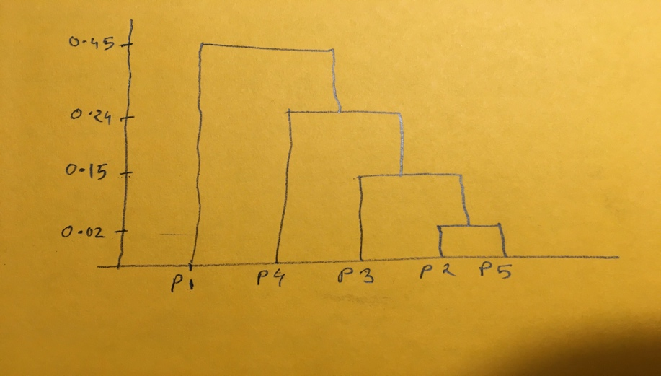

**Complete Link**

|  |  |  |  |  |  |
| --- | --- | --- | --- | --- | --- |
|  | P1 | P2 | P3 | P4 | P5 |
| P1 | 0 |  |  |  |  |
| P2 | 0.90 | 0 |  |  |  |
| P3 | 0.59 | 0.36 | 0 |  |  |
| P4 | 0.45 | 0.53 | 0.56 | 0 |  |
| P5 | 0.65 | 0.02 | 0.15 | 0.24 | 0 |

Updating the matrix after clustering P2 & P5:

|  |  |  |  |  |
| --- | --- | --- | --- | --- |
|  | P1 | P2, P5 | P3 | P4 |
| P1 | 0 |  |  |  |
| P2, P5 | 0.90 | 0 |  |  |
| P3 | 0.59 | 0.36 | 0 |  |
| P4 | 0.45 | 0.53 | 0.56 | 0 |

Updating the matrix after clustering (p2, p5) & p3:

|  |  |  |  |
| --- | --- | --- | --- |
|  | P1 | P2, P5, P3 | P4 |
| P1 | 0 |  |  |
| P2, P5, P3 | 0.90 | 0 |  |
| P4 | 0.45 | 0.56 | 0 |

Updating the matrix after clustering p1 & p4:

|  |  |  |
| --- | --- | --- |
|  | P1, P4 | P2, P5, P3 |
| P1, P4 | 0 |  |
| P2, P5, P3 | 0.90 | 0 |

**Dendrogram of Complete Link**

