A FEW SMALL CASE STUDIES IN HSCD
-------------------------------------
Q.1. Introduction to HSCD

Q.1 Design a circuit that does the matrix multiplication of Matrices A and B. Matrix A is 3 x 2 and Matrix B is 2 x 3.
- Write the different implementation options possible with the use of add & mul blocks ranging from complete software based to a complete hardware based solution. Illustrate the same using block diagrams.
- Analyze the said implementations with respect to the metrics of
  - Latency (performance) in terms of number of clock cycles.
  - Area of the device.
- Plot your implementation options onto a graph with latency along x-axis and area on y-axis.
Assume ::
- You have a multiplier and adder circuit that can be used.
- Each multiplication takes two cycles and 100 gates, and
- Each addition takes one cycle and 20 gates.

Answer to Q1.
There are multiple implementation options. One is a complete hardware solution where the whole multiplication happens as a separate piece of hardware in the SoC as an IP (which includes a cpu). The second is the complete software solution where there is no hardware but the whole matrix multiplication is done in software itself. The third approach is a mid approach where a portion of the matrix multiplication is done through software and another portion is done through a smaller dedicated hardware.

- Complete Software based solution.
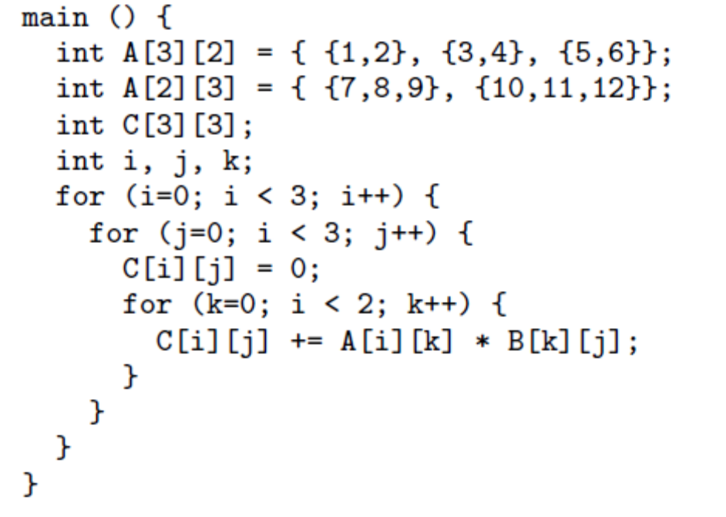
  - As we can see, there are 18 multipliers and 9 adders i.e., 2 multiplier and 1 adder per element of output.
  - Taking assumption from QZ-4 that for CortexM3, data path instructions take 1 clock cycle, load/store/branch takes 3 clock cycles, and multiplier takes 4 clock cycles.
  - We then have per element of output :-
    - 2 *(2 fetch, 1 multiply) + (1 add) + (1 store) = 2 ( 2 * 3 + 1 * 4) + (1 * 1) + (1 * 3) = 23 clocks.
  - So, for 9 elements of output it would be 23 * 9 = 207 clocks.
  - Since there are three counters which increment (the k counter ) * (the j counter) * (the i counter). Each counter would go through (reset, increment and compare * 2 times, terminal value) = 1 + (2 * 2) + 1 = 6 clocks. This * 3counters = 18 clocks.
  - Apart from these, the increment reset of the fetch counters would be (9 * 4) + 1 = 37clocks.
  - Also, the increment, reset of the store counter = 9 + 1 = 10clocks.
  - Total the following =207 + 18 + 37 + 10 = 272clocks.
  - This is the basic minimum, now there could be multiple based on software calls, push-pop on stack due to higher requirement of registers which is not a part of this computation.
Apart from the basic cpu subsystem itself (assume CortexM3), there is no additional hardware assumption.

- Complete Hardware based solution.
  - A complete hardware based solution would come about by the use of explicit 18 multipliers and 9 adders. The below diagram would depict the use of the explicit hardware solution as a “Peripheral Logic Block”.
  - The assumption here is that the inputs would be a part of the RAM logic (already in place) and the Peripheral Logic Block would be enabled by the Microprocessor (assume ARM CortexM3).
  - A DMA controller (another peripheral) would move data from the RAM to the “Matrix Multiplicaton Block” and after the output data is available (in 3 cycles = 2 multiplication + 1 addition) would move it back to the RAM in said locations.
  - This would not require intervention of the CPU except for initialization of the “Matrix Multiplication Block” and the “DMA block”.
  - The additional area (assume that the glue logic is negligible for this question), (9 * 2) multipliers * 100 gates + 9 adders * 20 gates = 1080gates.
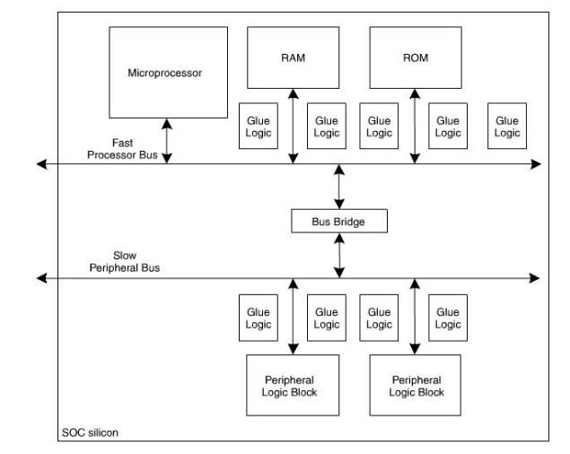
SoC diagram
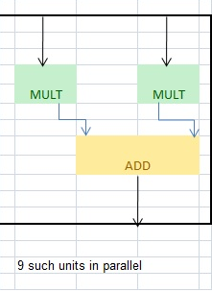
Indicative Block Diagram of the Peripheral Logic Block.

- A Hardware Software co-design based solution.
  - A typical hardware-software co-design based solution would be similar to the “SoC diagram above” in its block diagram. Only that the peripheral logic block would have lesser gates.
  - There can be many ways, but one typical way would be to have 3 units of the MUL+ADD in parallel to cater to one row of matrix output.
  - The total Area requirement would be (3 * 2) multipliers * 100 gates + 3 adder * 20 gates = 660gates.
  - This also has software overhead in the sense that beyond initialization, after every row computation is done, the software has to modify the dma pointers and initiate a new dma cycle with modified pointers for the next row.
  - The software overhead would be due to the following :-
    - Load pointer value into the dma engine.
    - Initiate a transfer from RAM to the Peripheral Block (to provide data to the datapath engine) and then from Peripheral Block back to the RAM.
    - Wait for DMA completion.
    - Do (i), (ii), (iii) 3 times = 9 clock cycle overhead.
    - Approximately the code would take 3 clocks (Load, initiate, wait) to complete, which is same as the clock cycles taken for the block to do the computation. This can be further optimized by doing pipelining of the hardware (not indicated here).
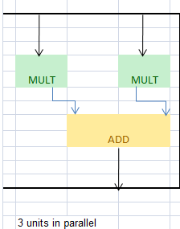
Indicative Block Diagram of the Peripheral Logic Block (mixed h/w – s/w based solution)

Design Parameter | Clock Cycles | Area
Complete Software based | 272 clocks | 0 additional area (for SoC)
Complete Hardware based | 0 cpu clocks used, 3 dedicated h/w clocks | 1080 gates
Mixed Hardware / Software approach | 9 cpu clocks used approx | 660 gates

Q.2. System Partitioning

Q.2-A What are the goals of partitioning. Describe the different stages and algorithm for Binary partitioning.

Answer to Q2A.

Taking from the class notes as thus.
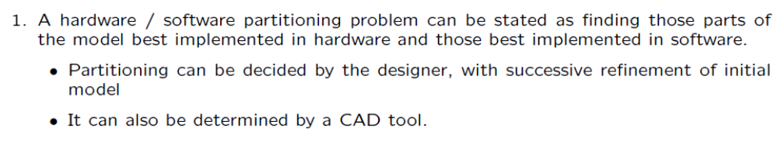
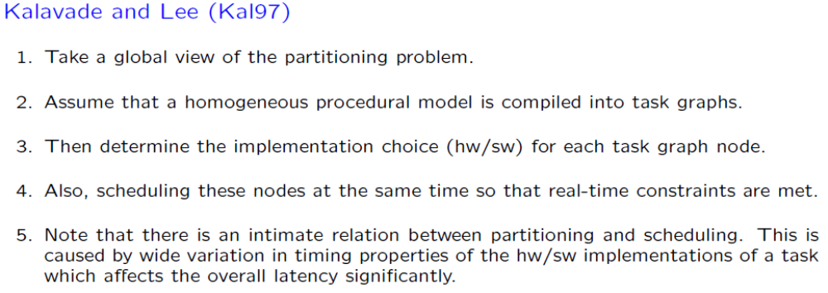

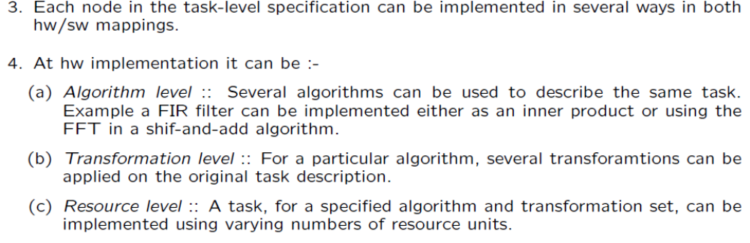
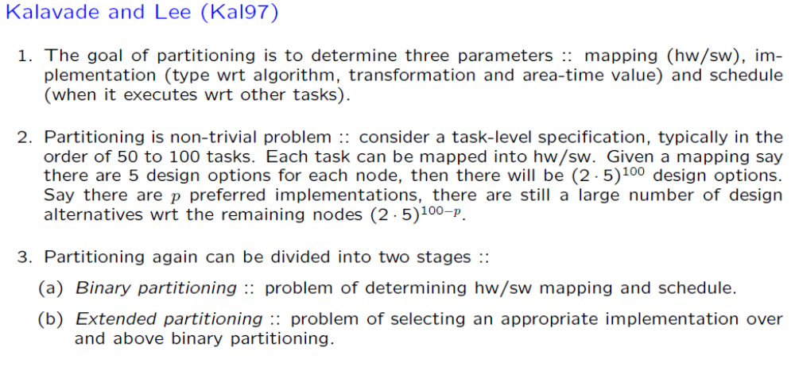

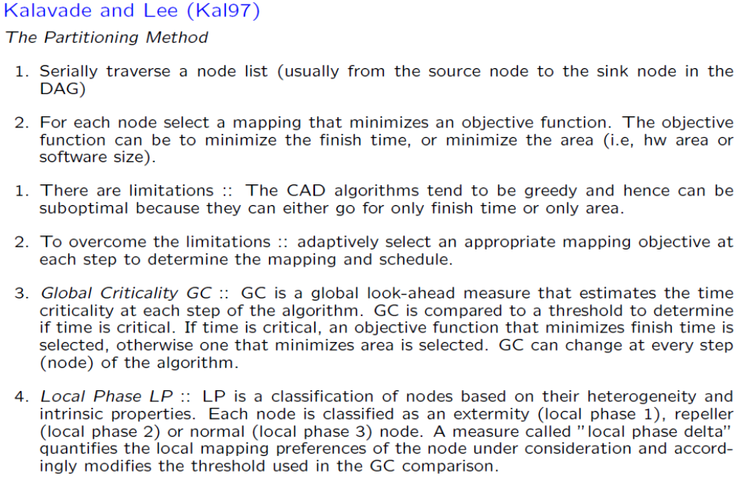

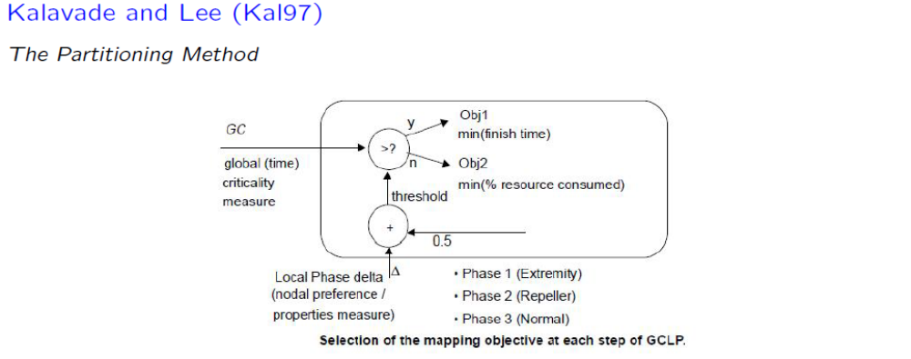
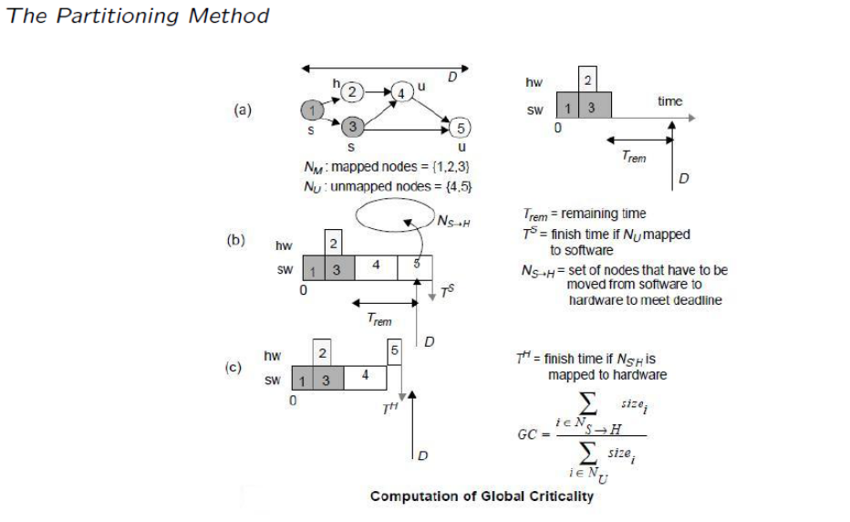

Q.2-B Consider the problem of image scaling (doubling) only in x-direction.
- Create a Directed Acyclic Graph (DAG) of the datapath.
- For each node in the data path, create one hardware implementation and one software implementation.
- Attempt to get to a feasible solution using the GCLP algorithm.

Assume:
  - Frame duration for input and output are same and consider only one hsync period as a frame.
  - Output doubling happens through duplication of the pixel input.
  - The processor used is a CortexM3 (so you can use instructions of the same for the application).
  - Mention any other assumptions you make (like clocking)

Answer to Q2B
The question to be noted is an oversimplified question of a broader image scaling problem. Here the problem indicates that there is scaling only in one direction – the x-direction. The frame duration of the input and output are same and hence there is a clear bias towards completion of the output frame in time. There can be image shifts due to the pipeline nature, but the input and output frame the duration is same.

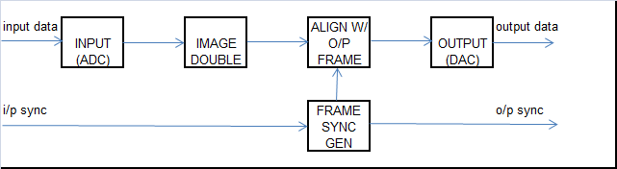
Typical image scaling data path

The input (adc), output(dac) cannot be done in software. These have to be hardware blocks. However, the “image double”, “align w/ output frame” and the “frame sync gen” can be done through software (or hw/sw). Let’s take the blocks to see the hw / sw implementation and which of it can be picked up. The overall SoC would be same as the SoC diagram drawn in Q1.

- Image Double :-
  - Hardware Implementation ::
    - The hardware implementation for this application can be a simple duplication of the path.
    - Other implementation types could be to add a FIFO to take in input and then the output would be through reading from the FIFO (after alignment with o/p frame) and sending the data to the DAC.
  - Software Implementation ::
    - The software implementation would be a method where the CPU reads data from the ADC and writes the data into a RAM frame. A frame would be sequential locations in RAM. We would have to assume a 24 or 32bit RAM to store image data such as RGB coming out of ADC.
Some basic assembly code would look like the following :-
WRITE_FRAME :
      - MOV R0, [R4] ; //move data from ADC output to R0
      - MOV [R5], R0 ; //write the R0 to RAM location.
      - INCR R5 ; //increment R5
At the minimum it takes 3 instructions (say 3 cycles), however in reality it would take more for we would need to synchronize with the ADC End Of Conversion, re-initialize the pointer in case the number of pixels in the frame is over.
The read case for output would be similar to the one above with different pointers i.e., [R4] = memory pointer, [R5] = output pointer.
    - Alternatively, one can use a dma controller to save cycles for the CPU, and while reading the data for output, move the same data twice to the output unit.
- Frame Sync Gen :-
  - Hardware Implementation :-
    - The frame sync gen typically will be a hardware only implementation. It would consist of a counter and a clock which would be twice the frequency of the input clock (or call it clock at which the input arrives).
    - The new frame sync would be generated based on the input frame and would synchronize (after delay cycles corresponding to the latency of the design) to produce the output frame.
- Align with output Frame :-
  - Alignment of the data with output frame would be as per the diagram below in the current design. This again is very hardware specific and would be done in h/w only.

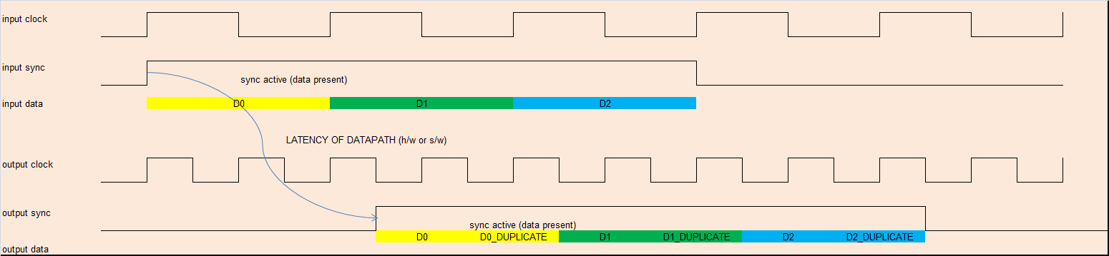

- Using the GCLP algorithm
  - As we see in the oversimplified example above, the only choice we need to make is for the “image doubling” where we have hardware and software choices.
  - Using the software approach, we would need at the minimum about 3 clocks latency. Depending on software overheads this could increase. However, with a hardware approach, the latency can be reduced to zero at the cost of say one register bus of 24bits width. With the oversimplified version of the GCLP, the choice would be in favor of hardware approach.
Q.3. Co-Simulation and Emulation

Q.3-A Compare an Emulator Vs FPGA.

Answer to Q3A

EMULATOR | FPGA
Emulators are typically 100x slower than FPGA | FPGA’s in recent times can go as fast as 200MHz +.
Emulator Cost is higher | FPGA’s have typically lower cost than an emulator
Emulator systems typically can be multi user. i.e., if a design takes 2 domains and the system has 4 domains, then there could be a user per domain | An FPGA system can be used by only one person, though there is re-configurability
Emulators require only synthesis cycle, there is no timing closure done (more closure to simulator) | FPGA’s require a separate cycle of timing closure (more closer to hardware)
Emulators can be used for architecture exploration, algorithmic verification, IP verification, Firmware verification, S/W validation | FPGA’s are used for real time algorithmic verification, IP verification, Firmware verification (acceleration), use case scenarios and field prototyping

Q.3-B For the image scaling design of Q.2-B, describe the typical methodology or co-simulation platform that would be applied for:-
- Architectural analysis.
- Design Verification.
- Field Prototyping.
Mention the reasons for choosing an emulation platform Vs FPGA based platform.

Answer to Q3B
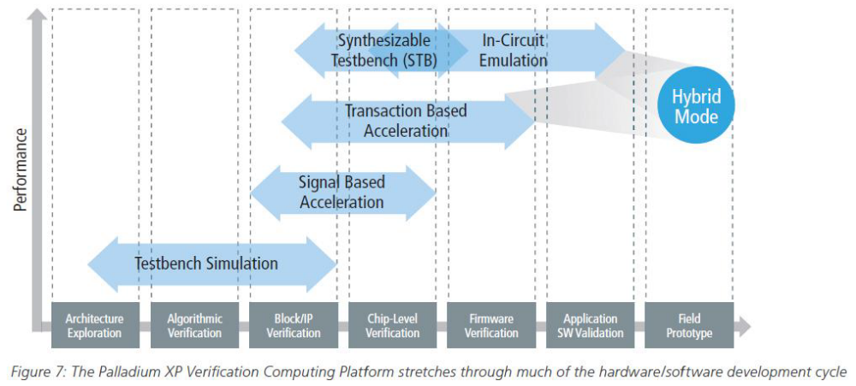
The above diagram explains the phases.
- Architectural analysis → system modeling followed by emulation for quick validation and freezing the said architecture for the specific application.
- Design Verification → RTL design verification through simulation. Emulation and FPGA can begin once the rtl is verified to a certain degree of correctness.
- Field Prototyping → For real time analysis and use case scenarios (like porting OS on the system) use FPGA’s. Emulation systems are too slow (100x slower typically) for this.

Q.3-C On Design Using FPGA
- What is a LUT. Using a 4-input LUT and a Flop, design a Configurable Logic Block (CLB). Call it EZ-CLB.
- Map a HEX to Seven Segment Display design onto a set of EZ-CLB’s. Assume valid interconnects.
- How many EZ-CLB’s are used?
- If each EZ-CLB takes 10ns delay from input to output, mention the max delay.

Answer to Q3C
An LUT is a Look Up Table, a kind of ROM Table, which has inputs as addresses, and output as the function which needs to be implemented.

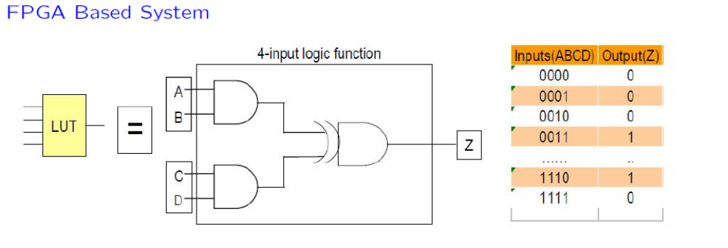
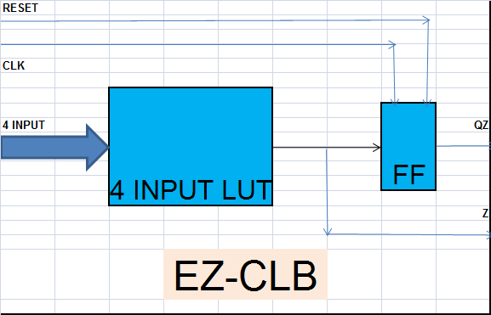
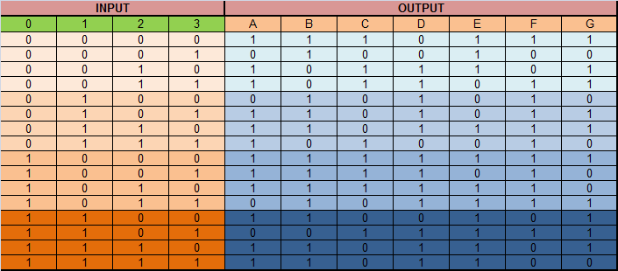

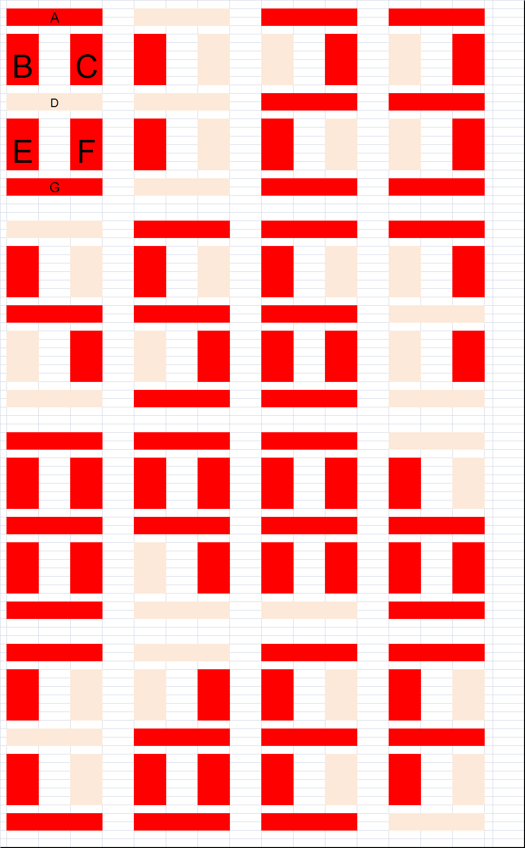
As can be seen from the table above, each of the display element (of the seven segment display) has a single row, which can be treated as a 4 input {I0, I1, I2, I3} to a single output say segment A, or segment B, or… segment G.
Thus there will be Seven EZ-CLB used (one per segment), and the total time taken from input to Seven Segment Display will be 10ns, since each EZ-CLB is in parallel. One can also use a flopped output of the CLB to ensure registered output.

Q.4. Compiler

Q.4-A Write a “C” program for HEX to Seven Segment Display.

Answer to Q4A
The input output table looks as follows. Assuming that the MSB of the 8bit output is always ‘0’.
The C program can be written such that there is an array of 16 data (OUT) and the index of the array is IN.

IN | OUT
0 | 77
1 | 24
2 | 5D
3 | 5B
4 | 2A
5 | 6B
6 | 6F
7 | 52
8 | 7F
9 | 7A
a | 7E
b | 2F
c | 65
d | 1F
e | 6D
f | 6C

main () {
int aray[15] = {0x77, 0x24, 0x5D, 0x5B, 0x2A, 0x6B, 0x6F, 0x52, 0x7F, 0x7A, 0x7E, 0x2F, 0x65, 0x1F, 0x6D, 0x6C};
int out;

while(1) {
out = aray[i]; // i is the input.
}

}

Q.4-B Assuming the simple instruction set below as an “Intermediate Representation (IR)”,
- Target the “C” program as in Q.4-A into the IR as a compiler would do. If your code would not exactly map into the said IR, then make assumptions and mention the same. Write it in the form of an assembly language program.
- If it were possible to add Application Specific Instructions, what would be your suggestions? Use your assembly code and profile the same.

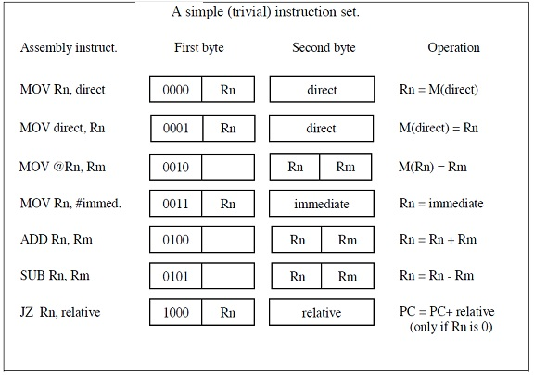

Answer to Q4B
main () {
int aray[15] = {0x77, 0x24, 0x5D, 0x5B, 0x2A, 0x6B, 0x6F, 0x52, 0x7F, 0x7A, 0x7E, 0x2F, 0x65, 0x1F, 0x6D, 0x6C};
int out;

while(1) {
out = aray[i]; // i is the input.
}

}
The aray array can be mapped as a data section called aray. The while loop can be broken as follows through the parsing process :-

.data ; //data section start pointer

aray = {0x77, 0x24, 0x5D, 0x5B, 0x2A, 0x6B, 0x6F, 0x52, 0x7F, 0x7A, 0x7E, 0x2F, 0x65, 0x1F, 0x6D, 0x6C};

.code
mov r4, #data_section_start_pointer;
mov r3, #pointer_to_seven_segment_display_output;
mov r2, #pointer_to_input_data;
mov r6, #0 ;
while_1_loop:
mov r1, [r2] ; // read the input data
add r1, r4 ; // input data + data_section_start_pointer = pointer to output.
mov r5, [r1]; //read the data from the data section
mov r3, [r5]; //output to the seven segment display
jz r6, while_1_loop ; //go back to while loop and begin

The way in which the C code is written, there are no new instructions required. The current Instruction Set is sufficient. However, if instead of using pointers, if explicit case statements are used, then there will be a need for having instructions such as JNZ (jump on not zero), CMP (compare) and an instruction for an unconditional branch. In this example, we assumed that we have about 8 general purpose registers and used up to 6 registers. If we had unconditional branch, we would not have needed the r6 register and hence saved on a register requirement. An unconditional branch, is believed to take lesser number of cycles than a conditional branch.

Q.4-C With the assembly program as in Q.4-B,
- How many clock cycles would it take to convert “HEX to Seven Segment” Display.
- If each clock cycle is 10ns. What would be the delay taken from hex input present to the seven segment display.
- Compare this with the max delay obtained (Q.3-C [4])

Assume:
- MOV takes 1 clock cycle,
- ADD/SUB takes 2 clock cycles and
- JZ takes 3 clock cycles.

Answer to Q4C

.code
mov r4, #data_section_start_pointer; (1 clock)
mov r3, #pointer_to_seven_segment_display_output; (1 clock)
mov r2, #pointer_to_input_data; (1 clock)
mov r6, #0 ; (1 clock)
while_1_loop:
//let r0 be the aray pointer to be used
mov r1, [r2] ; // read the input data (1 clock)
add r1, r4 ; // input data + data_section_start_pointer = pointer to output. (2 clock)
mov r5, [r1]; //read the data from the data section (1 clock)
mov r3, [r5]; //output to the seven segment display (1 clock)
jz r6, while_1_loop ; //go back to while loop and begin (3 clock)

It would take about 4 clocks to initialize and get into the while loop. Thereafter it would take 8 clock cycles per loop i.e., 8 * 10ns = 80ns. Compare this with 10ns using the EZ-CLB.

Q.5. Device Drivers

Q.5-A Explain in brief the Linux kernel view. Mention typical requirements of a Device Driver.

Answer to Q5A

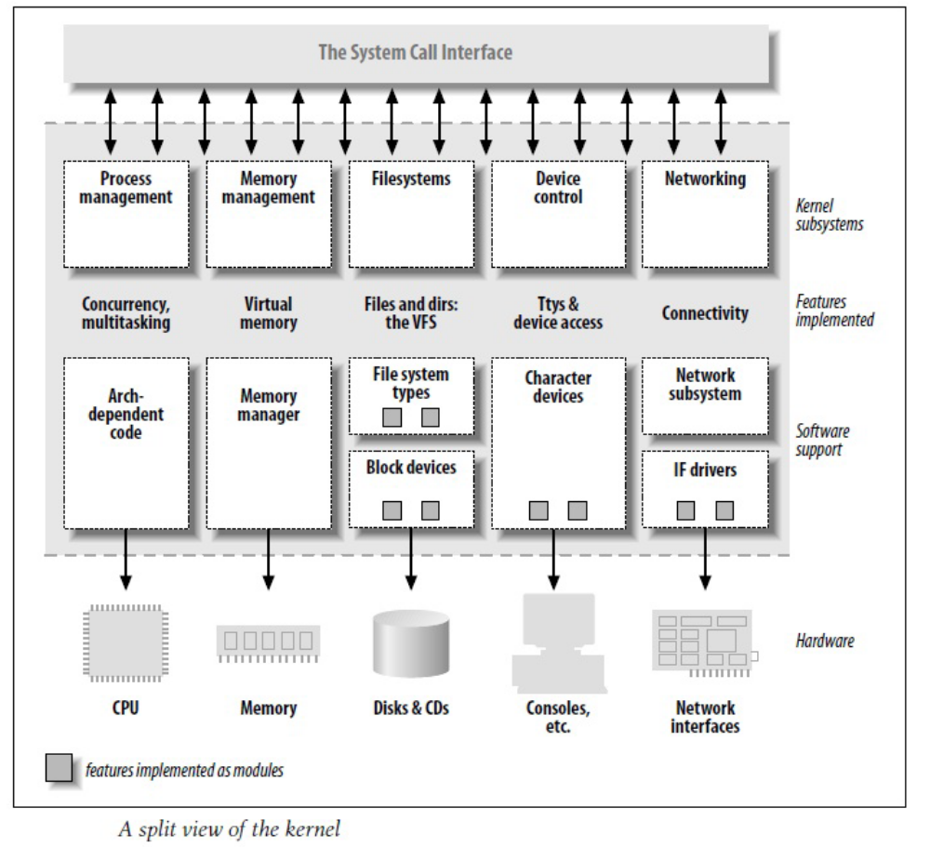

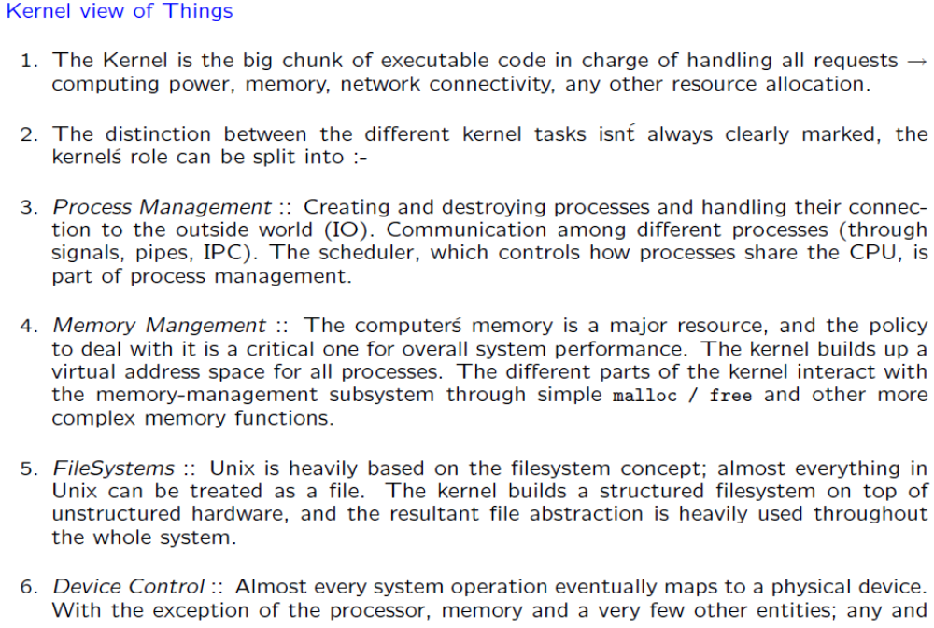
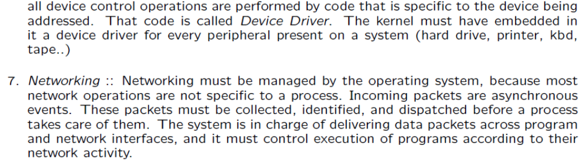
Requirements would include :-
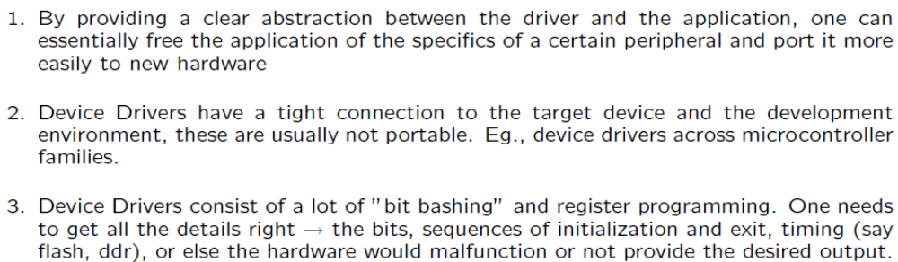

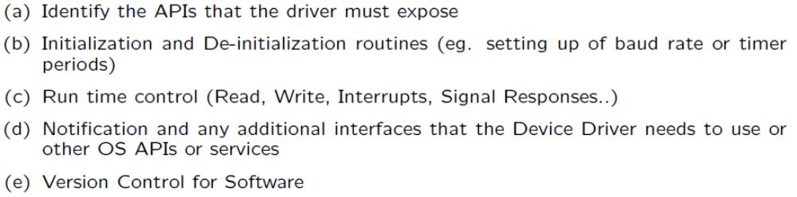
Q.5-B For a typical Serial IO type character devices (say UART), Mention the different device driver api routines which need to be provided as a library along with their functionality. Write pseudo code for each routine. Make appropriate assumptions about the UART IP.

Answer to Q5B

Think of the UART as a FILE IO type device. Hence the UART device driver would have a typical set of api’s which can be interchangeably used with file io.
The api’s would be :-
- Ioctl :: control the different registers of the uart module for various functions like initialization, read, write, error conditions etc.
- Read :: controls the read operation from the uart terminal, and takes in data either in different modes like single, burst and with various flavors like 8bit, 16bit, 32bit.
- Write :: similar to the read operation, but for write functions.
- Fopen :: opening a channel for the said uart if there are multiple uart modules in the device.
- Fclose :: closing an open channel for the said uart.

NOTE :: students are expected to write some sort of pseudo code for each of the api routines. Also, provide the data structures based on the assumptions of the UART IP.

Q.5-C On the actual device a gpio IP is present (no UART IP)
- What would be the pitfalls if the device driver written were a Monolithic library in the first place for UART.
- How would you modify the device drivers of Q.5-B to enable the same with GPIO functionality.
- What are the positive and negative effects of re-purposing gpio for uart.

Answer to Q5C

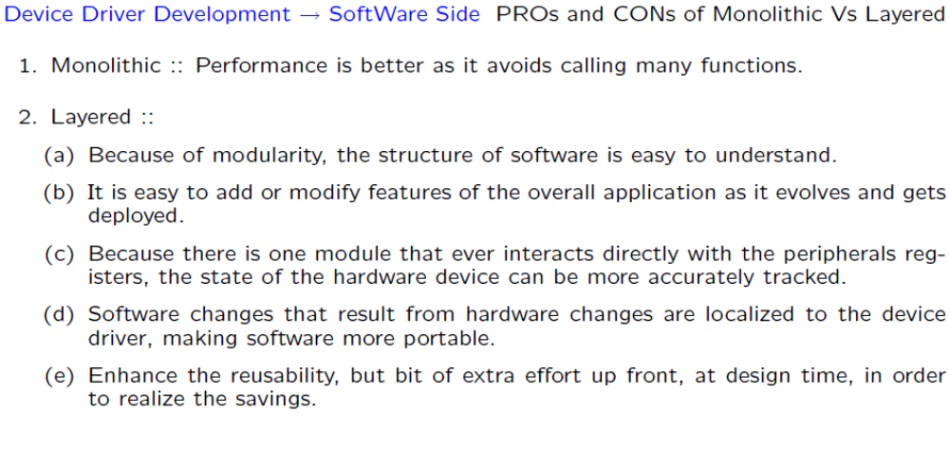
If the uart api’s were monolithic, then the drivers would almost need a re-writing since at many places inside the driver, the device specific programming (of registers or data structure) would be present and need to be reprogrammed.

However, if it were written in a structured layered manner, only the physical layer device driver needed changes, the rest of the logical layer device driver would remain the same and indeed be identical to the generic device driver library api’s.

The device driver modifications would be through gpio module being re-purposed as a uart module. The only way would be to do “bit bashing”, ie., create a uart protocol out of explicitly programming the gpio pins as input, output and sending, receiving data through bit by bit reading or writing.

The fallout would be that there will be a penalty on the speed (baud rate) at which the uart protocol would now operate. The advantage is that if the speed of the cpu is good enough or there is a system of asymmetric or symmetric multiprocessor SoC, the need of another IP is not required. The same gpio pins can be used as uart, spi, i2c and gpio itself removing the need of dedicated hardware for the said modules and replacing the same with a simple processor + gpio.

Q.Z. Section Z – Hardware Software Co-Design of a 1-D DCT function

Q.Z-1 Write the equation for 1-D DCT of length N. (For all questions below assume N = 8).

Q.Z-2 For the equation above write a “C” program for the same.

Q.Z-3 Convert the C program into assembly language using Mnemonics from the CortexM3 microcontroller. Mention the compiler techniques that were used for converting the C program into assembly language.

Q.Z-4 Profile the assembly language code. Make an invalid assumption (for sake of exam for the CortexM3) that data path instructions take 1 clock cycle, load/store/branch take 3 clock cycles, multiplier takes 4 clock cycles. What is the final latency between input and output? What is the memory requirement?

Q.Z-5 Break the assembly language code into multiple tasks. Create functions of those tasks. Create a Directed Acyclic Graph of the complete data path.

Q.Z-6 For each software function (task) create an equivalent hardware module. Write down the latency and area for the same. Mention the memory required for the tasks.

Q.Z-7 Attempt to get to a feasible solution using the GCLP algorithm. (Binary partitioning). Document the same in a tabular format.

Q.Z-8 Once you have the partitioning as above, draw the block diagram of Hardware.

Q.Z-9 Write the accompanying software tasks as device driver api’s for use at a top application layer. Do this by first documenting the driver function and what it is supposed to do followed by the C code (or pseudo code) of the driver function.

Q.Z-10 Mention the verification and validation that needs to be done with specific basic testcases. Also mention the platform that you will use for hardware & software co-verification of the design.

Assume the following :-
- You have a multiplier and adder circuit that can be used.
- Each multiplication takes two cycles and 100 gates, and
- Each addition takes one cycle and 20 gates.
- Tabular format for solution would be a list [TaskN, HW/SW, HW properties, SW properties].
- If any other assumptions are made, write them explicitly for more clarity.

Answer to Q-Z

The following question Z has been put as optional for the class. The solution is based on an Application Note on the FreeScale StarCore 8x8 DCT implementation.

Search for “freescale StarCore DCT” on www.google.co.in

http://www.google.co.in/url?sa=t&rct=j&q=freescale%20starcore%20dct&source=web&cd=1&ved=0CCsQFjAA&url=http%3A%2F%2Fcache.freescale.com%2Ffiles%2Fdsp%2Fdoc%2Fapp_note%2FAN2124.pdf&ei=epYuT_ruDsbirAe2gJXZDA&usg=AFQjCNHvGbx3vGpf5MvlIVXAbPF0spneLQ

