

STUDENT CASE STUDY EXECUTION REPORT

Department | FED
Subject | DSA-2
Academic Year | I-III Semester (2025-26)
Faculty Name | BALAIAH GUDIPUDI
Student Name | B. SATHISH KUMAR
Roll Number | 2520090008
Branch | CSIT
Course Outcome | COURSE OUTCOME - 2

Case Study Topic: Uber Bengaluru – Surge Multiplier Management using Segment Tree with Lazy Propagation

Work Done Summary

This case study analyzes how Uber manages surge multipliers across 16 geofenced demand zones in Bengaluru. Since surge values are frequently updated over contiguous ranges of zones and riders often request the maximum surge in a region, a Segment Tree with Lazy Propagation is used. This approach efficiently handles range updates and range maximum queries while minimizing computation time.

Implementation Details
- Implemented a Segment Tree to store surge multipliers for 16 demand zones.
- Used Lazy Propagation to efficiently perform range updates.
- Supported range addition operations on contiguous zones.
- Supported range maximum queries to find the highest surge multiplier.
- Stored pending updates in lazy nodes to avoid unnecessary recalculations.
- Reduced processing time for frequent updates and queries.
Output
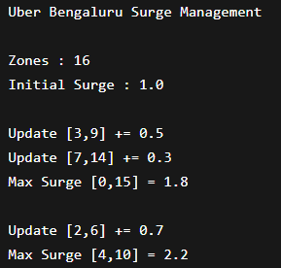

Result

Successfully performed range updates on multiple zones.

Retrieved maximum surge multipliers efficiently.

Reduced redundant updates using lazy propagation.

Supported real-time surge management across demand zones.

Demonstrated efficient handling of large-scale update and query operations.

Time Complexity
Operation | Segment Tree with Lazy Propagation
Build Tree | O(n)
Range Update | O(log n)
Range Maximum Query | O(log n)
Point Update | O(log n)

Conclusion
The Segment Tree with Lazy Propagation proved to be an efficient solution for managing surge multipliers across multiple demand zones. It supports fast range updates and maximum queries with O(log n) complexity, making it suitable for real-time ride-sharing applications where frequent updates and quick decision-making are required.
GitHub Link: https://github.com/biradharsathish2008/DSA_Case-studies--Codes.git

Student Signature | Faculty Signature

