

STUDENT CASE STUDY EXECUTION REPORT

Department | FED
Subject | DSA-2
Academic Year | I-III Semester (2025-26)
Faculty Name | BALAIAH GUDIPUDI
Student Name | B. SATHISH KUMAR
Roll Number | 2520090008
Branch | CSIT
Course Outcome | COURSE OUTCOME - 3

Case Study Topic: HDFC NetBanking — daily-spend prefix sums for monthly statements.

Work Done Summary

This case study analyzes how HDFC NetBanking manages daily customer spending records for monthly statements. Since transactions are updated frequently and customers often request total spending over a date range, a Binary Indexed Tree (BIT) is used. The BIT efficiently supports point updates and range-sum queries in O(log n) time while using minimal memory.

Implementation Details
- Implemented a Binary Indexed Tree (Fenwick Tree) to store daily spending amounts.
- Supported point updates whenever a new transaction occurs.
- Used prefix sums to calculate spending over a range of days.
- Processed range-sum queries using two prefix sum calculations.
- Achieved efficient O(log n) updates and queries.
- Required only O(n) memory for storage.
- Suitable for high-frequency banking transactions and statement generation..
Output
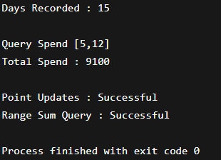

Result

Successfully maintained daily spending records.

Computed monthly spending ranges efficiently.

Supported frequent transaction updates in real time.

Reduced query processing time using prefix sums.

Demonstrated efficient handling of banking transaction data.

Time Complexity
Operation | Binary Indexed Tree
Build Tree | O(n log n)
Point Update | O(log n)
Prefix Sum Query | O(log n)
Range Sum Query | O(log n)

Conclusion

The Binary Indexed Tree proved to be an efficient solution for managing daily spending records in online banking systems. It supports fast point updates and range-sum queries with O(log n) complexity while using minimal memory. Therefore, it is well suited for generating monthly statements and processing high-frequency banking transactions.

GitHub Link: https://github.com/biradharsathish2008/DSA_Case-studies--Codes.git

Student Signature | Faculty Signature

