PATENT DOCUMENTATION
Smart Causal Impact Analyzer for Automated Data Source Comparison and Root Cause Detection

1. Title of the Invention
Smart Causal Impact Analyzer for Automated Data Source Comparison and Root Cause Detection

2. Problem Statement
In many data-driven environments, the same business metric may be generated from multiple data sources. Differences between these sources can arise because of missing records, duplicate records, different date ranges, inconsistent transaction attributes, or different calculation logic. Identifying such discrepancies manually is time-consuming and makes it difficult to determine the underlying cause and its financial impact.
The proposed system addresses this problem by providing an automated mechanism for comparing two transactional data sources, identifying discrepancies at the record and metric levels, and presenting potential root causes together with an estimated impact.

3. Abstract
The Smart Causal Impact Analyzer is a computer-implemented system designed to automatically compare transactional data obtained from two data sources and identify the potential causes of metric discrepancies. The system accepts structured data files containing transaction attributes such as Order ID, Date, Product, Quantity, Price, and Status. It performs data validation, record-level comparison, metric calculation, missing-record detection, duplicate detection, date-range verification, and order-level difference analysis. When a discrepancy is identified, the system evaluates relevant transaction attributes to determine a potential root cause, such as a quantity mismatch, price mismatch, missing record, or calculation difference. The system also estimates the financial impact associated with identified differences and presents the findings through an interactive user interface. The proposed approach reduces manual reconciliation effort and provides a structured, transparent, and actionable method for investigating inconsistencies between data sources.

4. Scope of the Invention
The invention is intended for automated reconciliation and discrepancy analysis of transactional datasets. The system can be applied where comparable records are maintained across multiple sources and where differences in calculated metrics need to be investigated. The present implementation focuses on order-level transactional data and sales-related metrics, while the underlying comparison approach can be adapted to other business metrics and structured datasets.

5. Objectives of the Invention
- To automate the comparison of two structured transactional data sources.
- To identify missing, duplicate, and inconsistent records.
- To detect differences in transaction attributes such as quantity and price.
- To identify potential root causes of metric discrepancies at the order level.
- To estimate and display the financial impact associated with detected differences.
- To provide an interactive and understandable interface for discrepancy investigation.
- To reduce the time and manual effort required for data reconciliation.

6. Existing Problem and Need for the Invention
Conventional reconciliation processes commonly depend on manual spreadsheet comparisons, basic aggregation checks, or separate validation scripts. Such approaches may indicate that two reported values are different without clearly showing which records caused the difference or why the difference occurred. A user may therefore need to inspect a large number of transactions manually before identifying the relevant discrepancy. The proposed system is designed to combine validation, comparison, root-cause analysis, and impact estimation within a single workflow.

7. Detailed Description of the Invention
The proposed invention provides an interactive, computer-implemented workflow for comparing two structured transactional data sources and investigating differences in a business metric. The present implementation uses CSV files as input and provides an interactive Streamlit-based user interface for uploading, processing, comparing, and reviewing the data.

7.1 Input Data Acquisition
The system provides two input interfaces identified as Source A and Source B. A user uploads one CSV file for each source. After both files are uploaded, the system reads the datasets and validates the presence of required transaction fields, including Order_ID, Date, Product, Quantity, Price, and Status.

7.2 Metric Calculation
The system calculates a Sales metric from the transaction attributes. For Source A, Sales is calculated from Quantity multiplied by Price. For Source B, the implementation supports a Discount field; when the field is present, Sales is calculated from Quantity multiplied by Price and reduced by Discount. The resulting values are aggregated to obtain the total Sales for each source.

7.3 Record-Level Comparison
The system compares the Order_ID values between the two sources to identify records that are present in one source but absent from the other. It also checks for duplicate Order_ID values within each source. These checks provide evidence for potential reconciliation issues before performing detailed order-level analysis.

7.4 Date Range and Calculation Logic Validation
The Date field is converted into a standard date representation and the minimum and maximum dates of each source are determined. The system reports whether the two sources cover the same date range. It also identifies whether Source B contains a Discount field and reports the corresponding difference in calculation logic.

7.5 Root Cause Detection
When a metric discrepancy exists, the system performs order-level difference analysis. Relevant transaction attributes are compared to determine a potential cause of the mismatch. The implemented analysis can identify conditions such as quantity mismatch, price mismatch, and missing records. The system presents the identified order, the differing attributes, and the associated impact to assist human review.

7.6 Impact Estimation
For detected order-level discrepancies, the system calculates an estimated impact based on the difference between the relevant transaction values. This impact provides a quantitative indication of the contribution of an individual discrepancy to the overall metric difference.

7.7 Interactive Output
The analysis results are presented through an interactive dashboard. The interface displays metric summaries for Source A and Source B, the overall difference, detected issues, missing orders, duplicate records, date-range results, formula checks, root-cause findings, and order-level difference analysis. A final recommendation indicates whether the values match, whether a single primary issue has been identified, or whether human review is required due to multiple possible causes.

7.8 Example of Detected Discrepancies
7.9 Prototype Demonstration Screenshots
The following screenshots document the implemented Streamlit prototype and provide visual evidence of the system workflow, discrepancy detection, root-cause identification, and impact estimation.
Figure 1: Streamlit User Interface for Source A and Source B Upload
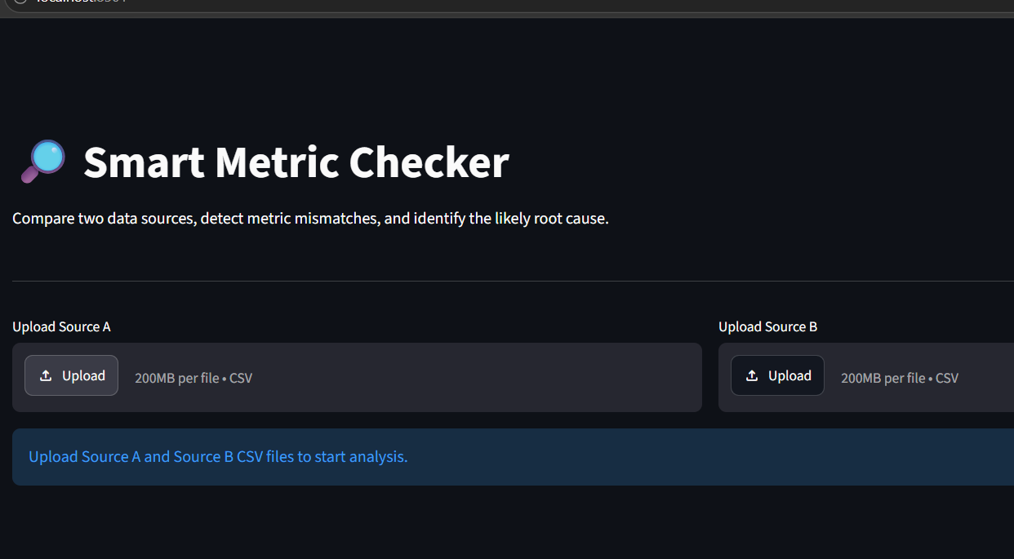

Figure 2: Missing Record Detection and Date Range Validation
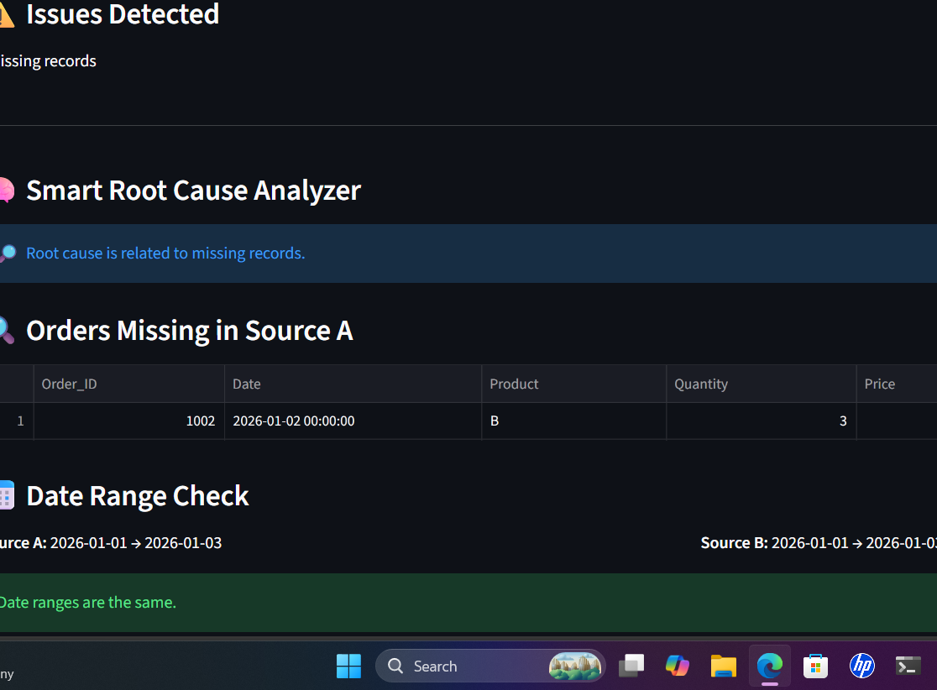

Figure 3: Quantity Mismatch, Root Cause Identification and Impact Analysis
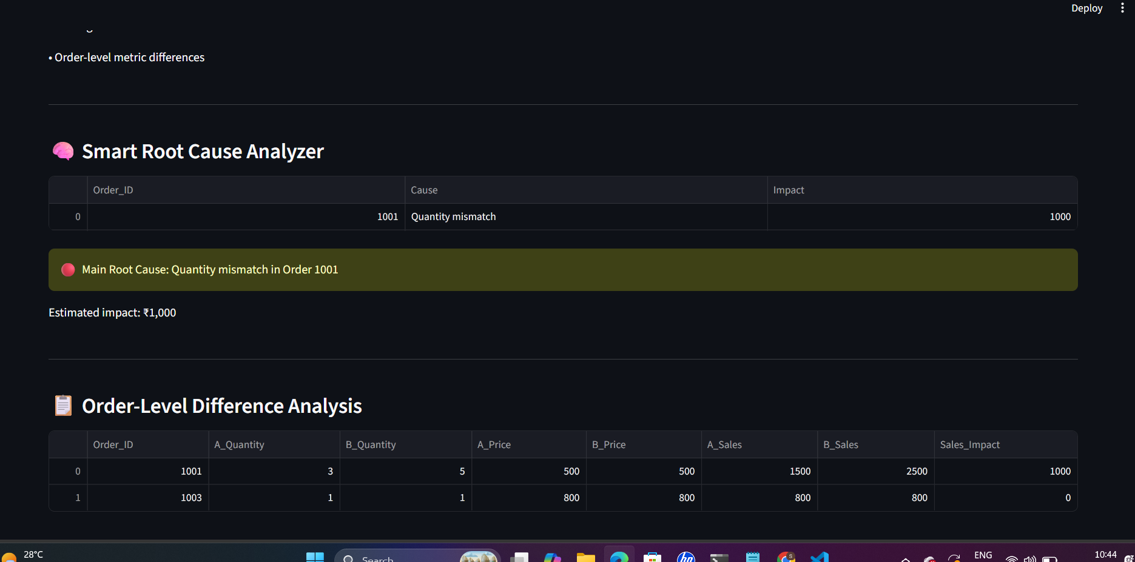

Figure 4: Price Mismatch and Estimated Financial Impact
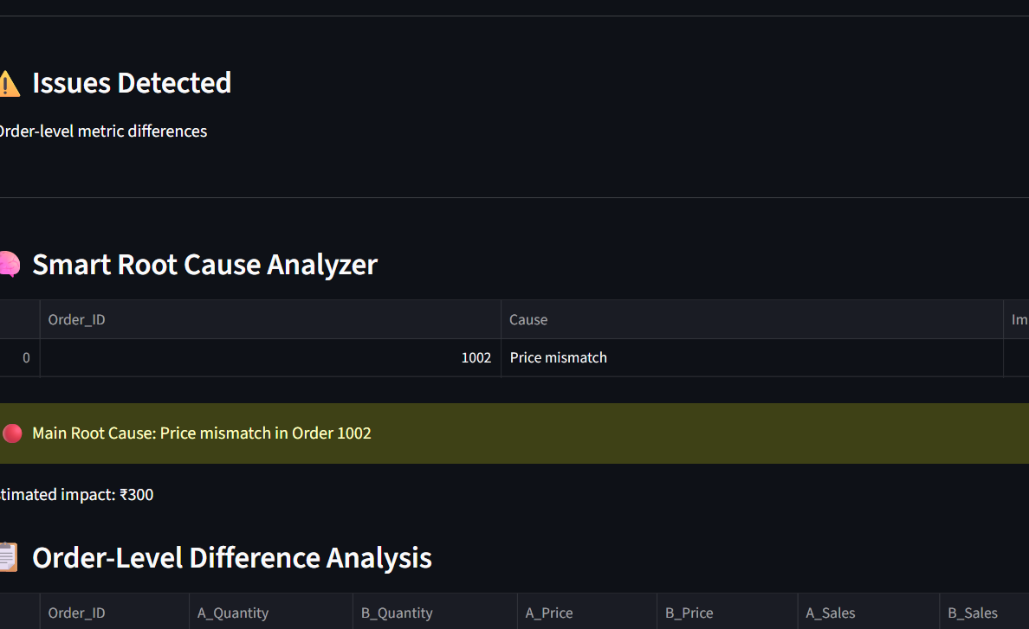

During testing of the implemented system, the dashboard identified a quantity mismatch for Order 1001 and a price mismatch for Order 1002. The system displayed these discrepancies in the Smart Root Cause Analyzer and Order-Level Difference Analysis sections, demonstrating the ability of the workflow to move from an overall metric difference to specific transaction-level evidence.

8. System Workflow
The operational workflow of the system can be represented as: Input Source A and Source B → Data Validation → Metric Calculation → Record Comparison → Duplicate and Date Checks → Order-Level Difference Analysis → Root Cause Identification → Impact Estimation → Interactive Report and Recommendation.

9. System Architecture
The system architecture consists of an input layer, a validation and processing layer, a comparison and analysis layer, a root-cause and impact analysis layer, and an output layer.
- Input Layer: Receives Source A and Source B transactional CSV files through the interactive interface.
- Validation Layer: Verifies required columns and prepares date and transaction fields for analysis.
- Processing Layer: Calculates the relevant Sales metric for each source and aggregates the metric values.
- Comparison Layer: Compares record identifiers, detects missing and duplicate records, and checks date ranges and calculation logic.
- Root-Cause Analysis Layer: Performs order-level comparison to identify potential causes such as quantity mismatch, price mismatch, or missing records.
- Impact Analysis Layer: Estimates the financial impact associated with detected order-level differences.
- Presentation Layer: Displays metric summaries, detected issues, root-cause findings, impact information, and recommendations through the Streamlit interface.

10. Key Technical Features
- Automated comparison of two structured transactional data sources.
- Required-column validation before analysis.
- Source-specific metric calculation and aggregation.
- Missing-record and duplicate-record detection.
- Date-range comparison between data sources.
- Detection of differences in calculation logic when applicable.
- Order-level comparison of transaction attributes.
- Potential root-cause identification for detected discrepancies.
- Estimated financial impact calculation for order-level differences.
- Interactive presentation of analysis results and recommendations.

11. Advantages of the Invention
- Reduces manual effort involved in reconciling transactional data.
- Provides evidence at the transaction level instead of reporting only an overall metric difference.
- Combines discrepancy detection, root-cause analysis, and impact estimation in a single workflow.
- Helps users prioritize discrepancies based on their identified impact.
- Provides a transparent and understandable analysis through an interactive interface.
- Supports human review when multiple potential causes are detected.

12. Draft Patent Claims
The following claims are a technical draft for documentation purposes and should be reviewed and refined by a qualified patent professional before filing.
Claim 1. A computer-implemented method for identifying causes of discrepancies between at least two structured data sources, comprising receiving a first transactional dataset and a second transactional dataset; validating required transaction attributes; calculating a corresponding metric for each dataset; comparing transaction identifiers and transaction attributes; identifying one or more discrepancies; and presenting an indication of a potential cause of the discrepancy.
Claim 2. The method of claim 1, wherein the discrepancies include one or more of missing records, duplicate records, differences in transaction quantity, differences in transaction price, differences in date ranges, and differences in calculation logic.
Claim 3. The method of claim 1, further comprising performing an order-level comparison to associate an identified metric discrepancy with one or more specific transaction records.
Claim 4. The method of claim 1, further comprising calculating an estimated financial impact associated with an identified transaction-level discrepancy.
Claim 5. The method of claim 1, further comprising generating an interactive report containing source-level metric values, detected issues, potential root causes, transaction-level differences, and a recommendation for further review.
Claim 6. A computer-implemented system comprising a data input component configured to receive multiple transactional datasets; a validation component; a metric calculation component; a comparison component; a root-cause analysis component; an impact analysis component; and an interactive presentation component configured to display identified discrepancies and associated analysis results.

13. Future Scope
The current implementation can be extended to support additional data formats and multiple data sources, configurable business metrics, additional discrepancy types, automated reconciliation rules, historical trend analysis, role-based access, database connectivity, and enhanced analytical models. Such extensions are considered potential future developments and are not represented as features of the present implementation unless specifically implemented.

14. Conclusion
The proposed Smart Causal Impact Analyzer provides an integrated workflow for comparing transactional data sources and investigating metric discrepancies. By combining data validation, metric comparison, record-level analysis, root-cause identification, and impact estimation within an interactive interface, the system provides structured evidence for understanding inconsistencies and supports efficient human decision-making.

15. Novelty and Inventive Features
15.1 Automated Multi-Source Comparison
The system automatically compares structured transactional data from two independent data sources and identifies inconsistencies without requiring manual record-by-record reconciliation.
15.2 Order-Level Root-Cause Identification
The system analyzes individual records to identify potential causes of discrepancies, including quantity mismatches, price mismatches, and missing records.
15.3 Integrated Impact Estimation
The system associates detected discrepancies with their estimated financial impact, allowing users to understand the business significance of each issue.
15.4 Combined Discrepancy-to-Impact Workflow
The proposed system integrates data comparison, discrepancy detection, root-cause identification, and impact estimation into a unified analytical workflow.
15.5 Actionable Analytical Output
The system converts raw differences between data sources into structured and actionable information that can assist users in investigating and prioritizing discrepancies.
Patentability Note
The above features describe the technical concept and intended inventive contribution of the prototype. Actual patentability depends on prior-art searching and formal evaluation of novelty, inventive step, and other applicable legal requirements.

16. Patentability Considerations
The present document describes the technical concept and implemented prototype of the Smart Causal Impact Analyzer. Patentability should be assessed through a formal prior-art search and professional review of novelty, inventive step, and other applicable legal requirements. The claims in this document are technical draft claims intended for further refinement before filing.

