**<https://www.tensorflow.org/>**

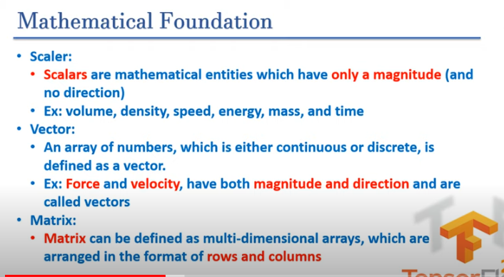

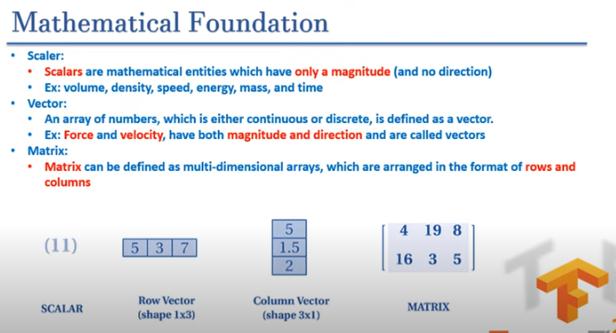

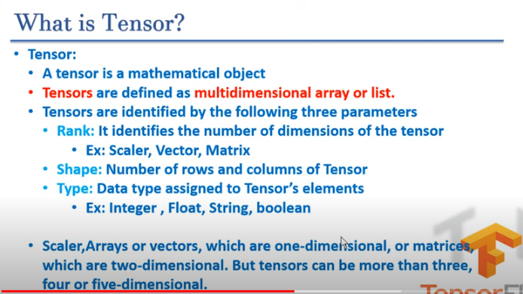

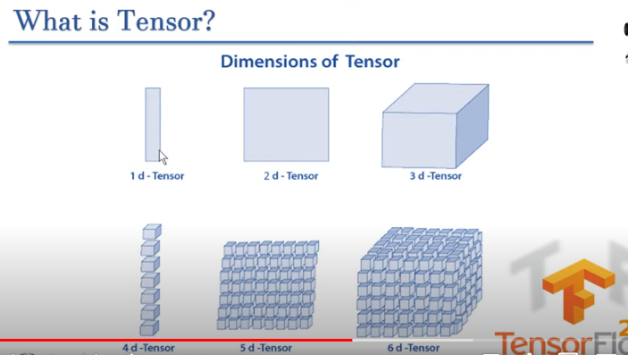

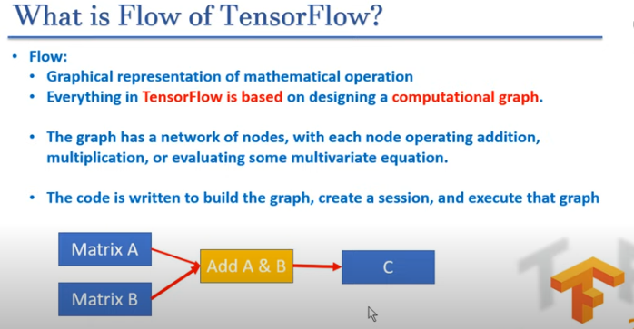

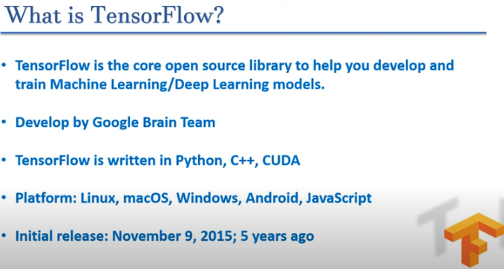

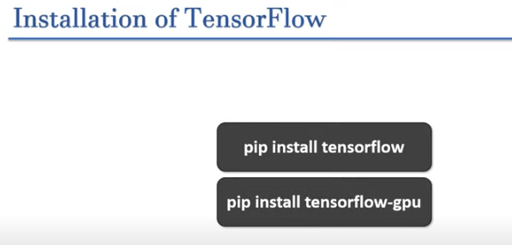

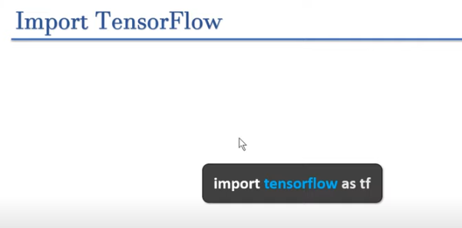

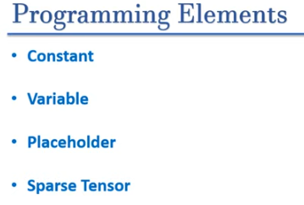

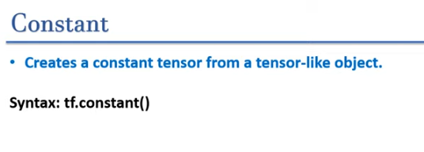

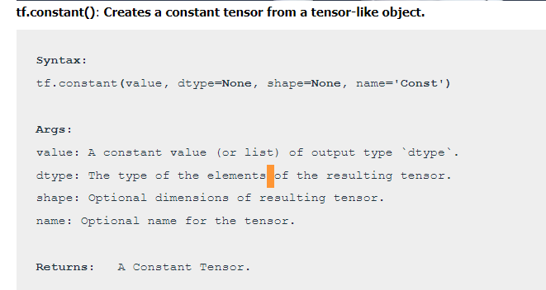

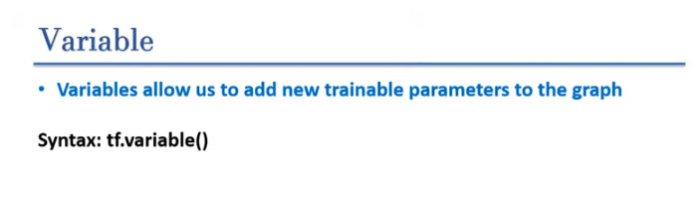

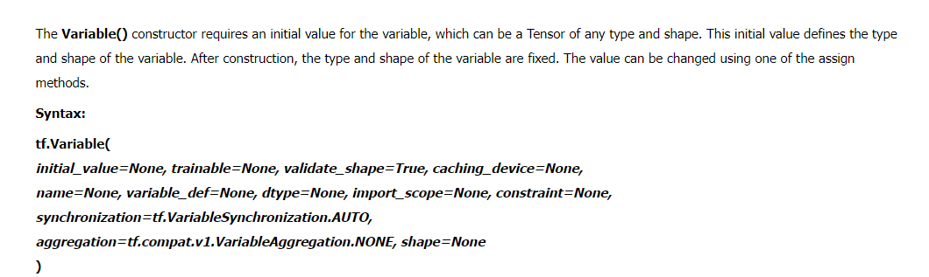

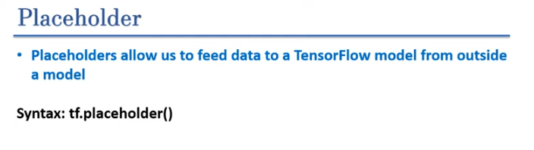

A **TensorFlow placeholder**is simply a variable that we will assign data to at a later date. It allows us to create our operations and build our computation graph, without needing the data.

***Syntax: tf.compat.v1.placeholder(dtype, shape=None, name=None)***

***Note:***

***TensorFlow placeholder is not available in TensorFlow 2.x.***

***In TensorFlow 1.x, tf.placeholder was used to create a tensor that is used for feeding input data into the computation graph. However, TensorFlow 2.x has deprecated the use of placeholders as it shifted to an eager execution mode by default, which means computations are executed immediately as they are called within Python. This approach eliminates the need for placeholders.***

***Alternatives to tf.placeholder in TensorFlow 2.x:***

* ***tf.Variable: Used for trainable variables.***
* ***tf.constant: Used for constants that do not change.***
* ***tf.Tensor: For directly creating tensor objects from data, since TensorFlow 2.x operates in eager execution mode.***

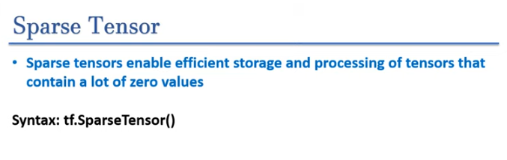

**What is Sparse Tensor?**

***Tensor that contain mostly zero values are called sparse tensor.***

When working with tensors that contain a lot of zero values, it is important to store them in a space- and time-efficient manner. Sparse tensors enable efficient storage and processing of tensors that contain a lot of zero values.  
Sparse tensors are used extensively in encoding schemes like TF-IDF as part of data pre-processing in NLP applications and for pre-processing images with a lot of dark pixels in computer vision applications.

Currently, sparse tensors in TensorFlow are encoded using the coordinate list (COO) format.

The COO encoding for sparse tensors is comprised of:

values: A 1D tensor with shape [N] containing all nonzero values.  
indices: A 2D tensor with shape [N, rank], containing the indices of the nonzero values.  
dense_shape: A 1D tensor with shape [rank], specifying the shape of the tensor.

**A nonzero value in the context of a tf.SparseTensor is a value that’s not explicitly encoded.**

**Syntax:** **tf.sparse.SparseTensor(*indices, values, dense_shape*)**