What is backend? The basics

Simply put, the backend, often referred to as the server-side, is the backbone of any web application. It is responsible for the server, application, and database that work together to make sure the frontend works as it should. The backend processes the business logic, database interactions, authentication, and much more.
Backend Development
Backend Development involves the logic, database, and other operations that are built behind the scenes to run the web servers efficiently. Backend Development refers to the server-side development of the web application. It is the part of the application where the server and database reside and the logics is build to perform operations. It includes the main features and functionalities of the application on the server. Programming languages for the backend are mainly Node. JS (for JavaScript), Django (for Python), Spring (Java), etc.

The backend is mainly responsible for:
- Database interactions: Handling the storage, retrieval, and management of data. This involves querying databases to fetch information or update records based on user interactions or system requirements.
- Server logic: Executing the server-side scripts and managing application workflows. It ensures that the right processes are executed at the right time, based on user actions or scheduled tasks.
- Application workflows: Ensuring the smooth operation of the application by managing the logic that underpins the frontend. This includes processing user requests, performing calculations, and returning the appropriate responses.
Key components of the backend
Each part serves a specific purpose in backend development , contributing to the overall functionality and performance of web applications. Here, we’ll break down the essential elements – servers, databases, and APIs – and see how they work together to power smooth interactions.
Servers
Servers are crucial in the backend architecture. They manage requests from the client side, process them, and return the appropriate response. This could involve querying a database, executing server-side scripts, or integrating with third-party services.
Servers act as the bridge between the user and the application's data, ensuring that requests are handled efficiently and securely.
Databases
Databases store, organize, and manage data that is used by the application. They ensure data is easily accessible and can be manipulated as needed. You might have heard of some of the more popular databases, such as:
- MySQL: A widely used relational database management system known for its reliability and performance.
- PostgreSQL: An advanced relational database with powerful features, like support for complex queries.
- MongoDB: A NoSQL document database known for its flexibility and rapid iteration possibilities.
- Redis: An in-memory data structure store, used as a database, cache, and message broker.
APIs
Application Programming Interfaces (APIs) are the bridges between the frontend and backend. They allow for seamless communication and data exchange, enabling the user experience to stay dynamic and interactive.
APIs define the methods and data formats that applications can use to communicate, enabling integration with other services and applications.
For example, when a customer adds a product to their cart on a website, the frontend sends this action to the backend through an API. The backend then updates the inventory and cart details, ensuring that the website displays the most current information. This interaction via API keeps the user experience smooth and the data accurate.
The importance of backend development
When it comes to building applications, the backend is where the real heavy lifting happens. Investing in a solid backend is essential for performance, security, and handling increased traffic.
Application functionality and performance
A solid backend ensures that the application performs efficiently, even under heavy user loads. Without a robust backend as a base, applications would struggle to handle complex operations and multiple user requests. To keep things running at peak performance, techniques like load balancing and caching are often used to manage traffic and optimize speed.
Data integrity and security
Security is a major concern in any app development project. The backend plays a key role in protecting sensitive data, ensuring users are authenticated, and defending against security threats. From encrypting data to designing secure APIs and running regular security audits, the backend is your first line of defense in maintaining data integrity and stopping unauthorized access.
Here is also where you ensure your application is compliant with all security and privacy regulations, such as PCI-DSS.
Scalability
As your app’s user base grows, so do the demands on the backend architecture. It must support scalability to handle increased traffic, data, and transactions without compromising performance.
This involves designing systems that can easily accommodate growth, such as using scalable databases, distributed servers, and cloud infrastructure.
Backend vs frontend development: What’s the difference?
Understanding the difference between backend and frontend development is crucial for knowing how each part contributes to the user experience.
Frontend development , on the other hand, is the client-side of things that deals with the visual and interactive aspects of an application. This means creating the user interface and ensuring a smooth user experience using technologies like HTML, CSS, and JavaScript. Frontend developers focus on making the application look good and function intuitively for users.
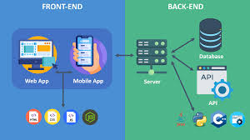

 | Frontend | Backend
Focus areas | UI & UX | Server, application, and database
Technologies | HTML, CSS, JavaScript, React, Vue.js | Python, Java, Ruby, Node.js, SQL databases
Responsibilities | Building the user interface, ensuring responsiveness, implementing visual designs | Server-side logic, database management, API integration
Data handling | Sends and receives data from the backend, displays data to users | Processes data, handles business logic, manages storage
User interaction | Direct; where the user has access and is able to interact with the elements | Indirect; processes requests from the frontend.
Frontend and backend development are both essential for a fully functional web application, working together to create a positive user experience.
Backend languages and technologies
Programming languages
Programming language | Why it’s used: | Great for:
Python | Simple and readable, ideal for both basic and complex apps | Fast prototyping, data-driven apps
Java | Scalable, reliable, great for enterprise-level apps | Banking, ecommerce platforms
Ruby | Clean syntax, fast development, easy to maintain | Fast-paced projects, startups
PHP | Versatile, established, widely used for web development | CMS, ecommerce platforms

What is CLI?
The term CLI is an abbreviation for Command Line Interface. The CLI lets users use commands/written commands that associate directly with the terminal or console window, which would allow them to interact directly with the OS.
The CLI is basically a medium or a platform, where a user writes a command to answer a visual prompt and then receives a response from the system/device. As a result, the ones who work on CLI for their systems must be aware of commands/train of commands to perform any task they want.
This medium is the most suitable for expensive and complicated computing.
What is GUI?
The term GUI is an abbreviation for Graphical User Interface. The GUI lets users use graphics for interacting with the OS. In a GUI, you get various menus for making things easy, such as buttons, windows, scrollbars, wizards, alternative icons, painting pictures, etc. It is very intuitive yet simple to use, even for a newbie. Also, remember that the information that a user wants to access via a GUI will be displayed in the form of images, plain texts, videos, gifs, videographs, etc.
Difference between CLI and GUI
Let us talk about the differences between CLI and GUI. To make this topic more understandable and clear, we are comparing both of the terms based on their individual characteristics in a table.
Parameters | CLI | GUI
Ease of Use | It is comparatively more difficult to understand and use. | It is comparatively easier to understand and use.
Memory Consumption | CLI consumes comparatively less memory. | The GUI consumes comparatively more memory.
Level of Precision | Higher precision of work can be obtained using CLI. | GUI offers a lower level of precision.
Speed | It works at a higher speed as compared to the GUI. | It works at a much slower speed as compared to the CLI.
Keyboard and Mouse | Its OS only requires a user’s keyboard. | Its OS requires both keyboard and mouse to work.
Modification of Appearance | We cannot change or modify the CLI operating system’s appearance. | We can change or modify the GUI operating system’s appearance.
Graphics | No graphs are included in CLI. | Graphics are always used in the GUI.
Menus | No menus are provided in CLI. | The GUI OS comes with menus.
Display of Information | The information that the user wants to view is displayed in files and plain text. | The information that the user wants to access is presented in various forms, like plain text, images, videos, gifs, videographs, etc.
Input of Information | The input is usually entered at the command prompt in CLI. | We can input the data anywhere on the computer screen in the case of GUI.
Pointing devices | Pointing devices are not used at all in CLI. | We use pointing devices in the GUI for choosing/selecting the items we want to.
Avoiding Errors | No typing errors or spelling mistakes can be avoided by CLI. | The typing errors or spelling mistakes cannot be avoided by the GUI.

What is Node.js?
Node.js is an open-source, cross-platform JavaScript runtime environment and library for running web applications outside the client's browser. Ryan Dahl developed it in 2009, and its latest iteration, version 15.14, was released in April 2021. Developers use Node.js to create server-side web applications, and it is perfect for data-intensive applications since it uses an asynchronous, event-driven model.

How Node.js Works
Node.js is a runtime environment that allows JavaScript to be executed on the server side. It is built on the V8 JavaScript engine from Chrome, which compiles JavaScript into efficient machine code. Node.js operates on a single-threaded event-driven architecture, utilizing an event loop to handle multiple concurrent operations without blocking.
When a client sends a request to a Node.js server, the request is added to an event queue. The event loop continuously checks this queue and processes each request. If a request involves an I/O operation, Node.js offloads it to the system kernel, which handles it asynchronously. Once the I/O operation is complete, the kernel notifies Node.js, executing the corresponding callback function.
This non-blocking I/O and event-driven model allows Node.js to handle many simultaneous connections efficiently, making it ideal for building scalable, high-performance network applications.

Why Do We Use NodeJs?
There are many reasons for which we prefer using NodeJs for the server side of our application, some of them are discussed in the following:
- NodeJs is built on Google Chrome’s V8 engine, and for this reason its execution time is very fast and it runs very quickly.
- There are more than 50,000 bundles available in the Node Package Manager and for that reason developers can import any of the packages any time according to their needed functionality for which a lot of time is saved.
- As NodeJs do not need to wait for an API to return data , so for building real time and data intensive web applications, it is very useful. It is totally asynchronous in nature that means it is totally non-blocking.
- The loading time for an audio or video is reduced by NodeJs because there is better synchronization of the code between the client and server for having the same code base.
- As NodeJs is open-source and it is nothing but a JavaScript framework , so for the developers who are already used to JavaScript, for them starting developing their projects with NodeJs is very easy.

Features of NodeJs:

  - Asynchronous in Nature and Event driven
The servers made with the NodeJs never waits for the from an API. Without waiting for the data from the API, it directly moves to the next API. So all the APIs of NodeJS are totally non-blocking in nature. In order to receive and track all the responses of the previous API requests, it follows an event driven mechanism. Hence we can say that all the NodeJs API are non-blocking in nature.
  - Single Threaded Architecture
With event looping, a single threaded architecture is followed by NodeJs and for this architecture makes NodeJs more scalable. In contrast to other servers, limited threads are created by them for processing the requests. Whereas for the event driven mechanism, the NodeJS servers reply in a non-blocking or an asynchronous manner and for this reason NodeJS becomes more scalable. If we compare NodeJs with other traditional servers like Apache HTTP servers, then we can say NodeJs handles a larger number of requests. A single threaded program is followed by NodeJS and this allows NodeJs to process a huge amount of requests.
  - Scalable
Nowadays, scalable software is demanded by most of the companies. One of the most pressing concerns in Software Development is addressed by NodeJs and that is scalability. Concurrent requests can be handled very efficiently using NodeJs. A cluster module is used by NodeJs for managing the load balancing for all the active CPU cores. The most appealing feature of NodeJs is that it can partition the applications horizontally and this partition procedure is mainly achieved by it due to the use of child processes. Using this feature, the distinct app versions are provided to the different target audiences and also for customization it allows them for catering to the client preferences.
  - Quick Execution Time for Code
V8 JavaScript runtime motor is used by NodeJs and this is also used by Google chrome. A wrapper is provided for the JavaScript by the hub and for that reason the runtime motor becomes faster and for this reason inside NodeJs, the preposition process of the requests also become faster.
  - Compatibility on the Cross Platforms
Different types of systems like Windows, UNIX, LINUX, MacOS and other mobile devices can use NodeJs. For generating a self-sufficient execution, it can be paired with any appropriate package.
  - Uses JavaScript
From an engineer's perspective, it is a very important aspect of NodeJs that this framework uses JavaScript Most of the developers are familiar with JavaScript, so for them it becomes very easier to grab NodeJs.

  - Fast Data Streaming
The processing time of the data that have been transmitted to different streams takes a long time. Whereas for processing the data, NodeJs takes a very short amount of time and it does it at a very fast rate. NodeJs saves a lot of time because the files are processed and uploaded simultaneously by NodeJs. So as a result, the overall speed of data and video streaming is improved by NodeJs.
  - No Buffering
The data is never buffered in NodeJs application.

Is Node.js a Programming Language?

Node.js is not a programming language; it is a runtime environment allowing you to execute JavaScript code on the server side, outside a web browser. Built on the V8 JavaScript engine from Chrome, Node.js compiles JavaScript into machine code for efficient execution. It extends JavaScript capabilities by providing additional features and libraries for server-side development, such as file system access, network communication, and asynchronous I/O operations.
While JavaScript is the programming language used with Node.js, the runtime environment provides the tools and frameworks to build scalable and high-performance server applications. Node.js’s non-blocking, event-driven architecture makes it ideal for real-time applications, web servers, APIs, and more. In summary, Node.js is a robust environment that leverages JavaScript to enable server-side programming, but it is not a programming language.

Node.js Architecture

Node.js operates on a single-thread, allowing it to handle thousands of simultaneous event loops. Here’s a diagram, provided by Sinform.com, that best illustrates Node.js architecture.
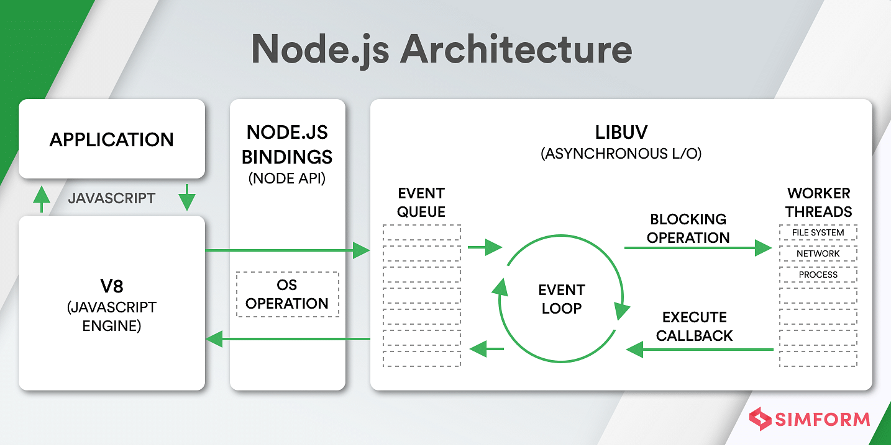

Parts of Node.js
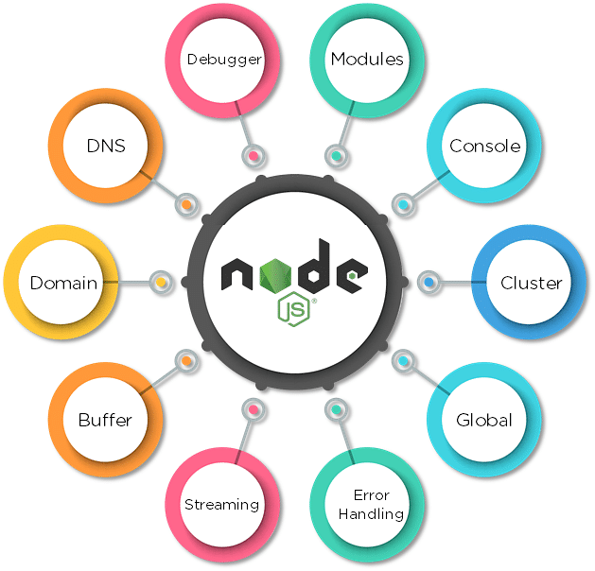
Fig: Parts of Node.js

Modules
Modules are like JavaScript libraries that can be used in a Node.js application to include a set of functions. In order to include a module in a Node.js application, use the require() function with the parenthesis containing the name of the module.
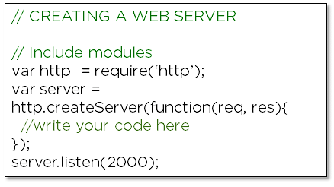
Fig: Include a module in Node.js
Node.js has many modules that provide the basic functionality needed for a web application. Some of them are mentioned in this table:
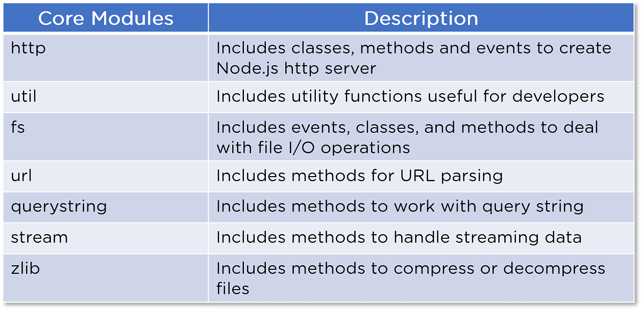
Fig: Node.js modules table
Console
The console is a module that provides a method for debugging that is similar to the basic JavaScript console provided by internet browsers. It prints messages to stdout and stderr.

Fig: Node.js console
Cluster
Node.js is built-on on the concept of single-threaded programming. Cluster is a module that allows multi-threading by creating child processes that share the same server port and run simultaneously.
A cluster can be added to an application in the following way:
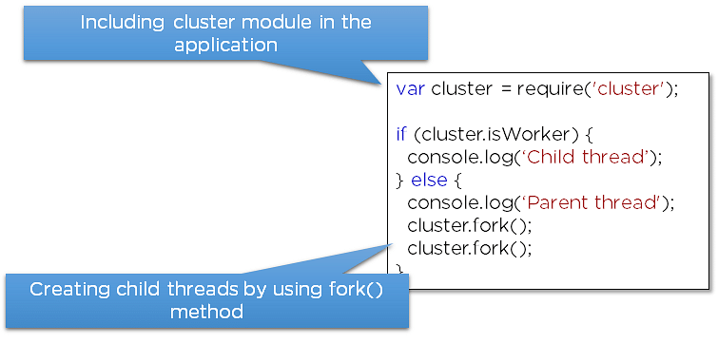
Fig: Add cluster in Node.js
Global
Global objects in Node.js are available in all modules. These objects are functions, modules, strings, etc. Some Node.js global objects are mentioned in the table below:
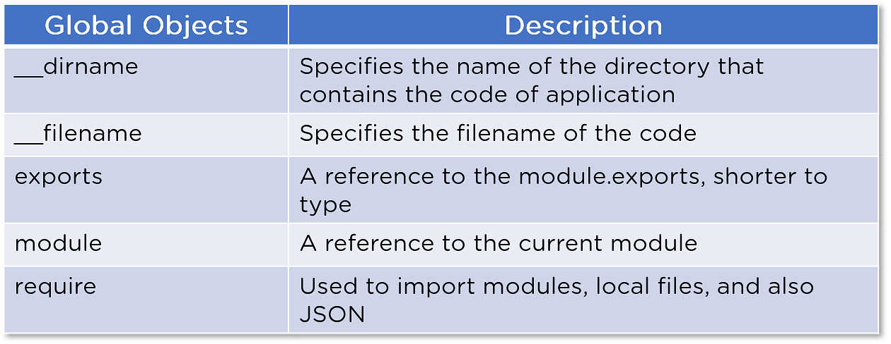
Fig: Global objects table

Error Handling
Node.js applications experience four types of errors.
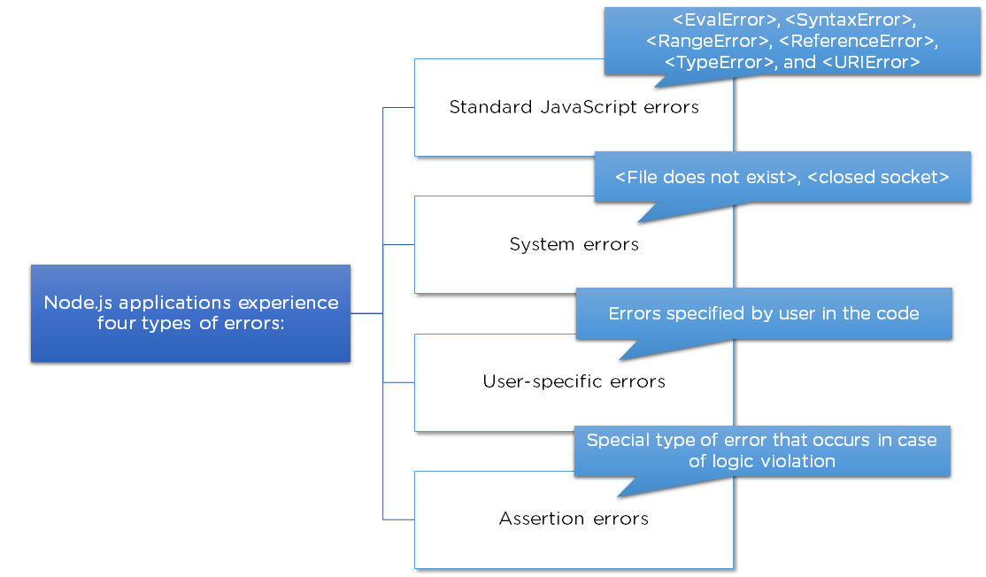
Fig: Node.js errors
Errors in Node.js are handled through exceptions. For example, let's handle the error that would occur when we divide a number by zero. This error would crash the Node.js application, so we should handle this error to continue with the normal execution of the application.
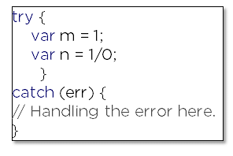
Fig: Node.js error handling

Streaming
Streams are the objects that let you read data or write data continuously. There are four types of streams:
- Readable: These are the types of streams from which data can be read
- Writable: These are the types of streams to which data can be written
- Duplex: These are both readable and writable streams
- Transform: Streams that can manipulate the data while it is being read or written

Buffer
Buffer is a module that allows the handling of streams that contain only binary data. An empty buffer of length ‘10’ can be created by this method:

Fig: Node.js buffer

Domain
The domain module intercepts errors that remain unhandled. Two methods are used for intercepting these errors:
- Internal Binding: Error emitter executes its code inside the run method
- External Binding: Error emitter is explicitly added to a domain via its add method

DNS
DNS module is used to connect to a DNS server and perform name resolution by using the following method:

Fig: DNS resolve
DNS module is also used for performing name resolution without a network communication by using the following method:

Fig: DNS lookup

Debugger
Node.js includes a debugging utility that can be accessed by a built-in debugging client. Node.js debugger is not feature-packed but supports the simple inspection of code. The debugger can be used in the terminal by using the 'inspect' keyword before the name of the JavaScript file. In order to inspect a file—myscript.js, for example—you can follow this method:

Fig: Node.js debugger

Node.js Express Framework
Express is a flexible Node.js web application framework that provides a wide set of features to develop both web and mobile applications. It's a layer built on the top of the Node.js that helps manage a server and routes.
Now look at some of the core features of the Express framework:
- Used for designing single-page, multi-page, and hybrid web applications
- Allows developers to set up middlewares for responding to HTTP Requests
- Defines a routing table that is used to perform different actions based on the HTTP method and URL
- Allows dynamic rendering of HTML Pages based on passing arguments to templates
Now look at an example of a simple "Hello World" program developed using the Express framework to gain a better understanding of this framework.
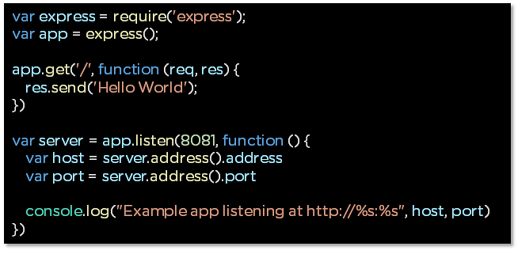
Fig: Node.js Express framework, "Hello World."
- var express: Importing Express framework into our Node.js application
- app.get(): Callback function with parameters ‘request’ and ‘response’
- The request object: It represents the HTTP request and has properties for the request query string, parameters, body, HTTP headers, etc.
- The response object: It represents the HTTP response that an Express app sends when it gets an HTTP request.
- The application will listen to the defined port, which in this case is "8081," and variables "host" and "port" will contain the address and the port, respectively.
- console.log: This is to show the address and port in the command prompt or terminal.

Applications of Node.js
Node.js is a versatile runtime environment widely used for building various applications due to its efficiency and scalability. Here are some typical applications of Node.js:
- Web Servers: Node.js is ideal for building fast and scalable web servers that handle numerous simultaneous connections with high throughput.
- Real-Time Applications: It excels in real-time applications like chat applications, online gaming, and live collaboration tools, where real-time data updates are crucial.
- APIs and Microservices: Node.js is commonly used to create RESTful APIs and microservices, facilitating communication between services in a distributed architecture.
- Single-Page Applications (SPAs): Node.js serves and handles the backend logic for single-page applications, enhancing user experience with smooth, dynamic content updates.
- Streaming Applications: Its asynchronous nature makes Node.js suitable for data streaming applications, such as video streaming services or real-time data processing.
- Command-Line Tools: Developers use Node.js to create command-line tools and scripts that automate various tasks, leveraging its rich ecosystem of packages.
- Internet of Things (IoT): Thanks to its event-driven architecture, Node.js is used in IoT applications to handle data from numerous devices in real time.

Who Uses NodeJs?
Well in 2025, there are 15+ popular companies who are using NodeJs .
Companies like NASA, Trello, Netflix, PayPal, LinkedIn, Walmart, Uber, Twitter, Yahoo, eBay, GoDaddy etc are using NodeJs.
Node.js Use Cases
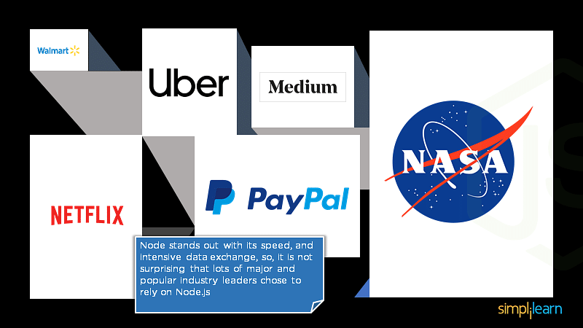
Fig: Node.js use cases

Netflix

Fig: Netflix
Netflix, the world's leading online entertainment network with more than 167 million users, is one of many top companies trusting Node.js for their servers. The reasons why the company chose to use Node.js include:
- Application scalability
- Data-intensive application

Walmart

Fig: Walmart
Walmart is the world's largest company by revenue, with US$ 559 billion in 2020, according to Forbes. Walmart chose Node.js because of the following attributes:
- Asynchronous I/O
- Efficient handling of concurrent requests

Uber
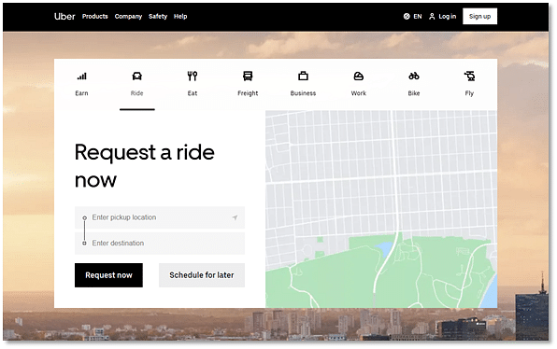
Fig: Uber
Uber is a U.S.-based, multinational ride-hailing company offering services that include peer-to-peer ridesharing, ride service hailing, and food delivery. The reasons why the company chose to use Node.js include:
- Asynchronous I/O
- Quick iterations
- Active open-source community

NASA

Fig: NASA
NASA, an independent agency of the United States Federal Government, is responsible for the civilian space program, as well as aerospace and aeronautics research. NASA chose to use Node.js for the following reasons:
- Reduced access times
- Ability to handle data-intensive tasks
- Capability to keep the server active 24/7

Paypal

Fig: Paypal
PayPal is a U.S.-based company operating a global online payment system that supports online money transfers, that is serving as an electronic alternative to traditional paper methods like checks and money orders. PayPal chose to use Node.js for the following reasons:
- Extremely fast build times
- Fewer lines of code
- Ability to handle large amounts of data

Medium

Fig: Medium
Medium is a popular online publishing platform developed by Evan Williams and launched in August 2012. The reasons why the company chose to use Node.js include the following:
- Data-driven applications
- Ability to run A/B tests
- Simple server maintenance

NPM: Node Package Manager
NPM is a popular Node.js package library and the jewel in the crown of the Node.js community. It has millions of downloadable libraries, organized according to specific requirements, and is the largest software registry in the world. NPM is free. These libraries are growing fast to this very day, and they strengthen the Node.js community.
When Can We Use NodeJS?
When very few CPU cycles are used by the server side code. When the non-blocking operations are done by us and that does not have heavy jobs or heavy algorithms that consume a lot of CPU cycles.
If we are already from JavaScript background and we are very comfortable in writing single threaded code just like client side JavaScript.
Now let us know when not to use NodeJs:
- NodeJS is a very CPU heavy application , when it comes to heavy computation, NodeJS is not the best option in hand. Other than NodeJs, there are plenty of better solutions available for CPU intensive applications.
Using a single CPU, an event based non blocking I/O model is leveraged by NodeJS and for that reason the incoming request will be actually blocked by all the intense CPU processing activity.
- When using NodeJs with basic crud or HTML application there is no need for high hopes . Though NodeJs will make it more scalable, there is no need for expecting a traffic flood only because the application is powered by NodeJs. So when the data is provided straightforwardly by, by the server and specially where there is no need to have a separate API, in this case there is no need for using NodeJs.
- For Relational database access type of projects, using NodeJs is not an efficient idea at all. In comparison with the other framework’s tool boxes, the relational database tools of NodeJs are not that robust, reliable and easy to work with.

Installation:
So for the installation of NodeJs, we need to follow a very straightforward process. This can be done by the installer package available at the official website of NodeJs.
- So for the first step, the installer from the official NodeJs website needs to be downloaded.
- Then the installer needs to be run.
- Then the simple installer steps need to be followed properly. The license agreement needs to be agreed and then click the next button.
- Then your system or machine needs a restart. That’s it, we are done with the NodeJs installation.
So far, we have got a good idea on NodeJs and when we have realized we should use it for our server side application.

Official Installation : https://nodejs.org/en/download

Official Documentation: https://nodejs.org/docs/latest/api/

NodeJS REPL (READ, EVAL, PRINT, LOOP)

NodeJS REPL (Read-Eval-Print Loop) is an interactive shell that allows you to execute JavaScript code line-by-line and see immediate results. This tool is extremely useful for quick testing, debugging, and learning, providing a sandbox where you can experiment with JavaScript code in a NodeJS environment.
What is REPL?
REPL is like a JavaScript playground in your terminal. If you type the code, REPL runs it, shows you the result, and then waits for your next command. It's a loop:
- READ: You type some JavaScript code into the terminal, and REPL reads what you typed.
- EVAL: REPL runs (evaluates) your code.
- PRINT: REPL shows you the result of your code.
- LOOP: REPL goes back to step 1, waiting for you to type more code. This loop continues until you quit REPL.

Best Practices for NodeJs REPL
- Use REPL for Quick Testing: Utilize the REPL to test small code snippets or experiment with new features without creating a separate file.
- Leverage Built-in Modules: Access and test NodeJS built-in modules directly in the REPL to understand their functionality and behavior.
- Save and Load Code with .save and .load: Continue your REPL sessions by saving code to a file and loading it back later for continued work or testing.
- Use for Prototyping and Debugging: Quickly test small code snippets or debug specific functionality by running them interactively in the REPL.

Why do we need Node.js & how is it different from JS in browser?
Node.js extends the capabilities of JavaScript beyond what is possible when running JavaScript solely in a browser environment. Here's what Node.js can do that normal JavaScript cannot, which makes it suitable for building backends.
Access to File System
- Node.js: Provides APIs to interact with the file system, allowing you to read, write, delete, and manipulate files and directories on the server.
- Normal JavaScript: In a browser, JavaScript is sandboxed for security reasons, meaning it cannot directly access the file system of the client device.
Networking Capabilities
- Node.js: Enables the creation of web servers, handles network requests, and supports low-level networking features like creating TCP/UDP servers, handling sockets, etc.
- Normal JavaScript: In the browser, JavaScript can make HTTP requests (via fetch or XMLHttpRequest), but it cannot create servers or handle low-level networking tasks.
Process Management
- Node.js: Can spawn child processes, manage multiple threads, and handle system-level tasks like interacting with operating system processes.
- Normal JavaScript: In the browser, JavaScript is limited to running in a single thread and cannot spawn processes or directly interact with the operating system.
Interacting with Operating System
- Node.js: Can interact with the operating system to perform tasks like reading environment variables, interacting with system processes, scheduling tasks, etc.
- Normal JavaScript: In the browser, JavaScript is sandboxed and cannot interact with the operating system directly, limiting its capabilities to browser-related tasks.

A brief history of Node.js

2009: Initial Release by Ryan Dahl
- Creator: Ryan Dahl introduced Node.js in 2009. He aimed to build a lightweight, efficient system for building web applications that could handle many connections simultaneously.
- Inspiration: Ryan Dahl was frustrated with the limitations of Apache HTTP Server, particularly the way it handled multiple connections by creating a separate thread for each request. He wanted a non-blocking, event-driven architecture.
- First Version: Node.js was initially released with support for Linux and MacOS, using Google's V8 JavaScript engine, which was chosen for its high performance.
2010-2011: Early Growth and Adoption
- npm Launch: In 2010, npm (Node Package Manager) was released, providing a way to share and manage libraries and dependencies in Node.js projects, significantly boosting its ecosystem.
- Windows Support: In 2011, Node.js added support for Windows, broadening its adoption across different operating systems
2012: Support of Joyent Company
- Joyent Sponsorship: Joyent, a cloud infrastructure company, became the corporate sponsor of Node.js, providing financial and organizational support, which accelerated its development.
2014-2015: Fork and Foundation
- io.js Fork: In 2014, due to disagreements over the pace and direction of Node.js development, a group of developers forked Node.js to create io.js. This fork was meant to offer faster development and better collaboration with the community.
- Node.js Foundation: In 2015, to resolve the fork and unify the community, the Node.js Foundation was created under the Linux Foundation. io.js and Node.js were merged back together, bringing in the best features from both projects.
2016-Present: Modern Node.js and LTS Releases
- Version 4.0 and LTS: The merger led to the release of Node.js version 4.0, marking the beginning of a more stable release cycle with Long-Term Support (LTS) versions, which ensured more predictable and stable updates.
- Rapid Growth: Node.js continued to evolve with the addition of features like async/await, HTTP/2 support, and improvements to performance and security. Its popularity grew, becoming one of the most widely used platforms for server-side JavaScript.
- Node.js 14 (LTS): In 2020, Node.js 14 was released, including features like optional chaining, nullish coalescing, and a new implementation of the Streams API.
Current State
- Ecosystem: Today, Node.js powers millions of websites and applications, with a vast ecosystem of libraries and tools. It is used by companies of all sizes and has become a key technology in modern web development.
- Community: Node.js remains open-source and community-driven, with an active community that continuously contributes to its growth and development.
Node.js has transformed the way JavaScript is used, making it a dominant force in backend development and enabling JavaScript developers to work on both client and server sides with a unified language.

Threads in Node.js
A thread in Node.js is a separate execution context in a single process. It is a lightweight, independent unit of processing that can run in parallel with other threads within the same process. It resides within process memory and it has an execution pointer. It has a stack of its own but a shared heap of the process.
Node.js uses two kinds of threads: a main thread handled by the event loop and several auxiliary threads in the worker pool. In the context of Node.js, auxiliary thread or thread is interchangeably used for worker threads.
In Node.js, the main thread is the initial execution thread that starts when Node.js starts. It is responsible for the execution of JavaScript code and handling incoming requests. A worker thread is a separate execution thread that runs alongside the main thread.

Is Node.js multithreaded or single–threaded?
Single-threaded means that a program has only one thread of execution, which allows it to perform only one task at a given time. Meanwhile, the term “multi-threaded” implies that a program has multiple threads of execution, which allows it to perform multiple tasks concurrently.
Each thread operates independently and task allocation is handled by the operating system. Both approaches have their challenges. In single-threaded processes, all tasks are executed in a sequence and a blocking operation will delay the execution of other tasks. Meanwhile, in multi-threaded processes, the pain point that arises is the synchronization and coordination between multiple threads.

