**Analysis of Gun & Gun-Related Crime**

Archit Dixit (CIN - 305879774)

Biran Li (CIN - 305174355 )

Chou I Cheong (CIN - 305176536 )

Department of Computer Information Systems

California State University, Los Angeles

**Abstract**

This project aims to examine the gun and gun related criminal and to predict the effectiveness of gun-control policy, while our data sources basically come from government and other related health and crime website during this past decade, such as state-level sales data from gun magazines, homicide data from FBI and county-level crime data and so on. According to this situation, our data size is approximately 150MB. For processing, we will use 'create table' Hive command to create the Hive table for our related data sets previously; second, we will load the CSV data file into Hive table; and finally, we will use Hive command to calculate and query the data we need. We hope to figure out that how the decline in gun ownership can explain approximately some percentage of the differential decline in gun homicides base on different state and the largest declines occurring in areas with the largest reductions in ownership of firearms associated with gun violence. Based on the above analysis and statistics from Hive, we can see if the gun control laws should be enacted .

**I. Introduction & Background**

In the United States, people have the legal rights to own a firearm. We can always see and hear the shocking news about gun related crime causes death that reported on the television and news. Firearm is much more dangerous than any other weapons and we understand that the U.S. Government is using as many resources as they can to protect every single person, but the gun related crime still happens again and again. In our research paper, we are trying to use apache hive in the HDInsight to filter and analysis the data of the gun and gun related crime in the United States, we believe our research will give people and government a better understanding of the current gun related crime rate and the factors that affect the gun related crime rate. Our purpose is to give government more ideas on how to decreasing the gun related crime based on our research and analysis.

**II.Section**

**US Gun Related Crime**

Figure. 1 and Figure. 2 showed U.S gun related crime in 2014 and 2015, using three colors to represent different level of occurrence of gun crime.

Obviously, the state of California, New York, Texas, Florida, Tennessee, North Carolina, Pennsylvania and Michigan have serious gun crime. As shown in Figure. 2, While the number of gun incident in New Mexico, Kansas and Missouri have a significant increase in 2015. Regarding to FBI report stated that firearms were used in 71.5 percent of the nation’s murder, 40.8 percent of robberies, and 24.2 percent of aggravated assaults in 2015[1][2]

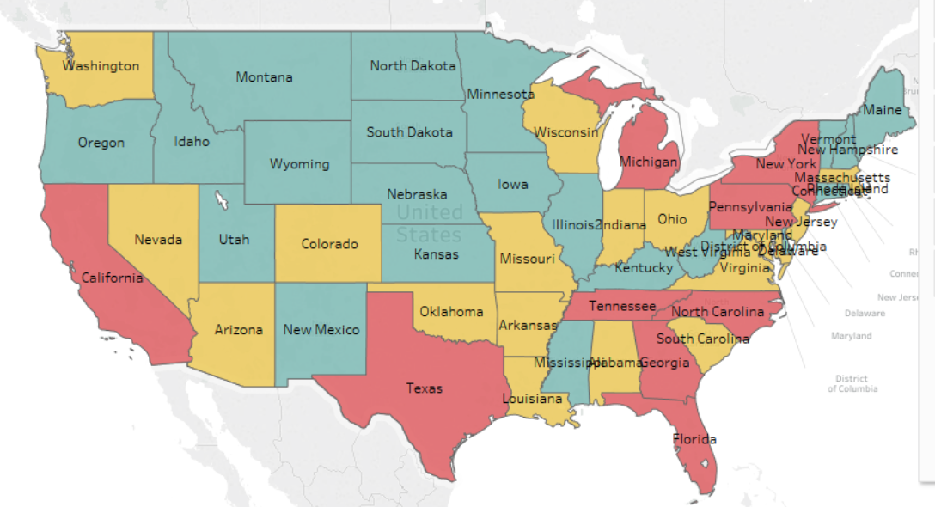

Figure. 1

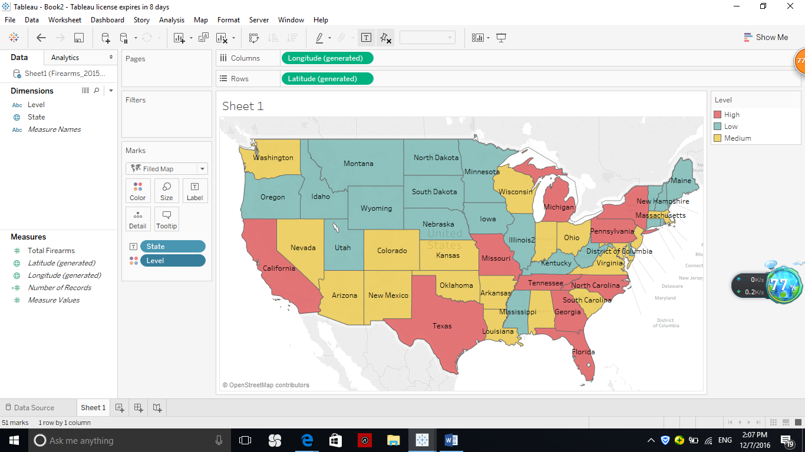 Figure. 2

**Gun Incident**

As shown on table 2, the total number of incident, deaths, injuries, mass shooting and accidental shooting have an increase for the third consecutive year. While the rate of using gun as defense purpose has decreased in 2015 and has increased in 2016. [3]

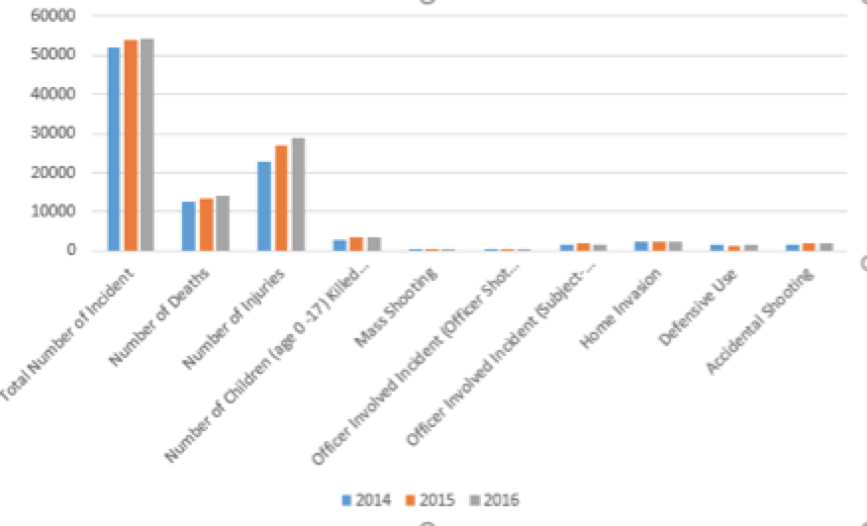

Table 2

**Background Check**

Background check can be the index to reflect the gun sales, because before people purchase a gun, they have to pass the background check in order to get a permission for gun purchasing. As shown in Figure 2, New Mexico, Kansas and Missouri have a significant increase in 2015, while we find that these three cities’ also have an increase in 2015( Table 1). So that we assume that there is a correlation relationship between the gun sales rate and the criminal rate in each state. Based on the finding, it showed that “More Gun, More Crime”. Regarding to FBI NICS report stated that the number of background check has about 6 percent increase than the previous year. [4] 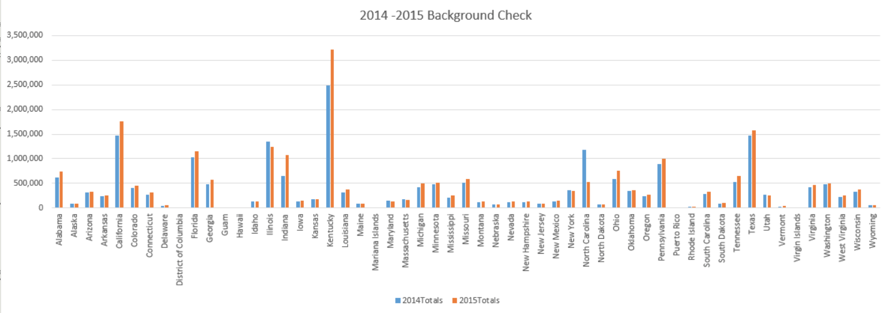

Table 1

**Gun Ownership**

American owns ridiculous numbers of guns. We put data in the Tableau in order to visualize the gun ownership rate in each state in the United States. From the Tableau map we can see that the deeper the color of the state, the higher the gun ownership. Obviously Idaho, Arkansas, West Virginia has deeper color, which has higher gun ownership rate than other states. We also use Tableau bar chart showed the gun ownership rate from the highest rate to the lowest rate. [5]

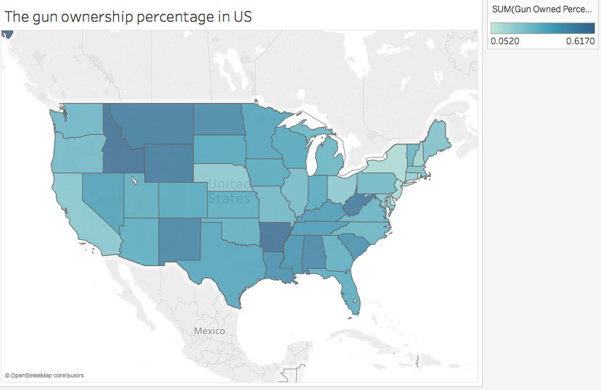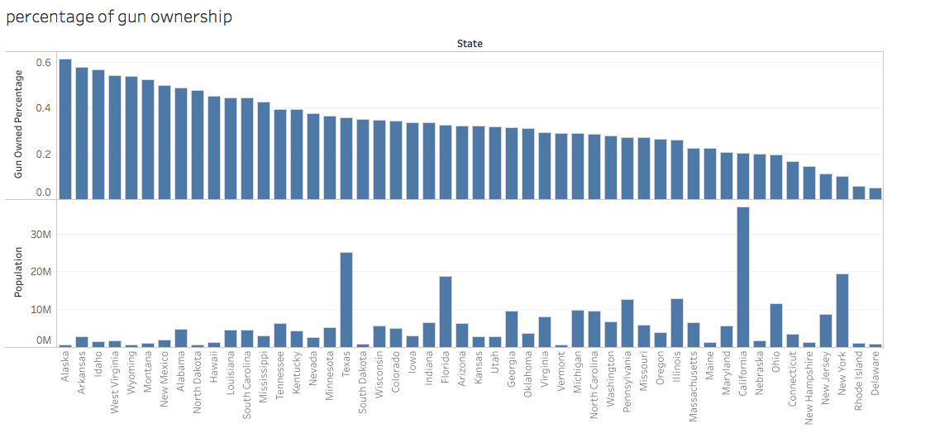

**Los Angeles gun related crime**

Since Los Angeles is one of the city with high crime rate, we examine Los Angeles crime data in greater Los Angeles Area in order to compare the gun related crime and other types of crime. The following two excel 3D map shows the gun related crime region in recent two years. The red dot presented the gun related crime and the green dot represent other types of crime. From the map we can obviously visualize that the downtown area of the Los Angeles higher rate of gun related crime than other areas.

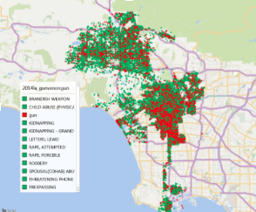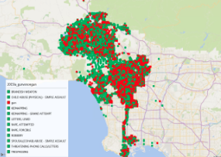

### Gun Related Crime In New York

### 

New York is one of the biggest state in the united states and also has a higher gun related crime rate and hence we chose to analyse New York's’ data and tried to link it with the income in different areas .

We can see from the map that Staten Island and Manhattan are areas with higher per capita income and reported less number of crimes associated with guns and on the other hand areas with lower per capita income reported higher number of crimes , with Bronx and Brooklyn leading with the maximum number of crimes followed by queens. Through this analysis , we can conclude that income can be used as a parameter to judge a person’s likelihood of performing any crime by using guns or any other lethal weapons .

**III. Conclusion**

1. The central LA has higher gun related crime rate than any other areas.
2. Gun related crimes comprised 28 % of the total number of crimes that took place in 2015 , which was 2% more than the previous year.
3. Areas with higher per capita income reported less gun related crimes in New York.
4. Bronx and Brooklyn reported the highest number of gun related crimes.

5. The state of Missouri , Kansas and New Mexico have had a increase in crimes

associated with the guns and the background checks had also increased in these areas . So we can conclude that there were more gun licenses issued during this tenure and the number of gun related crimes increased as well .

**IV. References**

[1]Crime in the U.S. 2014. “FBI.FBI, 2015. Web. 30 Nov .2016

[2]Crime in the U.S.2015. “FBI.FBI, 2016 Web. 30 Nov. 2016

[3]GunDeaths. “Gun Violence Archive” GUn Violence Archive N.p.n.d. Web. 30 Nov2016

[4]National Instant Criminal Background Check System(NICS)” FBI. FBI, 2016 WEB. 30 Nov 2016

[5] Business Insider/Andy Kiersz, data from Kalesan et. al., June 2015

[6]NYPD Complaint Data."NYC OpenData. 22 Nov. 2016