Bayesian Mixed-Media Model (MMM)
Pranav Birari

Q1. How do you model spend carry over?
Ans. To model spend carry over, I used the concept called Geometric Adstock. This basically means that the effect of a marketing spend in one week doesn't just happen instantly but lasts for several weeks, gradually fading away over time. The way it works in the model is by applying a decay rate parameter (alpha) which tells us how fast the impact decreases week by week
This method helps to capture realistic consumer behaviour where ads build brand awareness and influence over time, not just immediately. It’s also simple, uses just one main parameter per channel, and has proven effective in many marketing studies.

Q2. Explain your choice of prior inputs to the model?
Ans. The prior inputs used are listed below:
- intercept (Normal): Sets the starting point for sales if there was no marketing or seasonality. It sets the starting point for the model.
- likelihood (Normal with HalfNormal sigma): The model depends less on the priors and more on the observed data when the likelihood is given more importance. As a result, the model will be more dependent on data, enabling the observed results to have a greater impact on the parameter estimations.
- gamma_control (Normal): This prior helps the model account for background influences that aren't brought on by marketing, such as trend or seasonality.
- gamma_fourier (Laplace): This focuses on catching repeating patterns (like seasons or holidays). The Laplace shape means if there’s no strong pattern, the effect will just stay near zero.
- adstock_alpha (Beta): This indicates how quickly the effectiveness of a marketing channel declines each week. Each channel can have its own number for this, thus certain advertisements may stick with people longer than others.
- saturation_lam (Gamma): Sets how quickly marketing returns diminish for each channel as spend increases, so the model doesn’t overestimate the benefit of high spending.
- saturation_beta (HalfNormal): Measures the direct impact or effectiveness of marketing spend on a target variable.
- sigma (HalfNormal): Global noise term, making sure the model’s volatility matches the scale of sales data which is never negative.
- beta_channel (HalfNormal, scaled): Measures the impact of each marketing channel's spending on sales, and the use of a Half-Normal prior ensures this effect is non-negative and realistic. By scaling the effect by the spend amount, the results remain interpretable.
- trend_coef (Normal): Controls baseline growth or decline in sales over time.
- seasonality_coef (Normal): Handles repeating patterns in sales due to seasonal effects (holidays, weather, etc), set to learn from data.
Q3. How are your model results based on prior sampling vs. posterior sampling?
Ans.

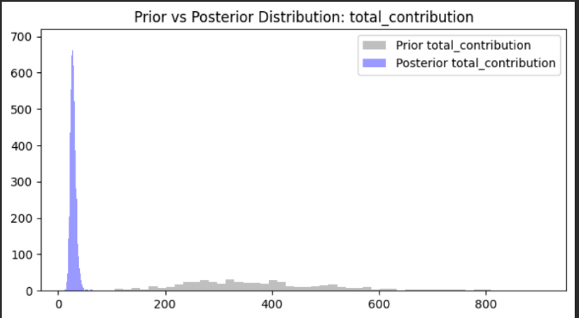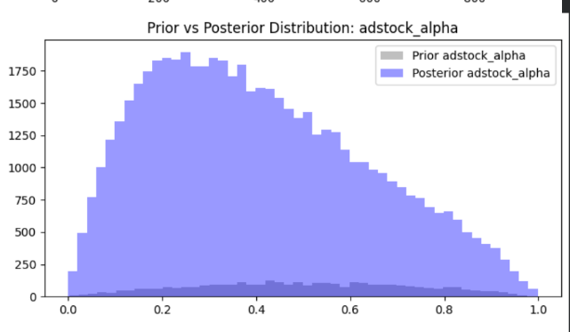
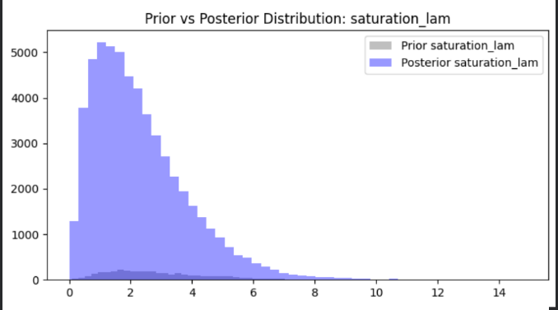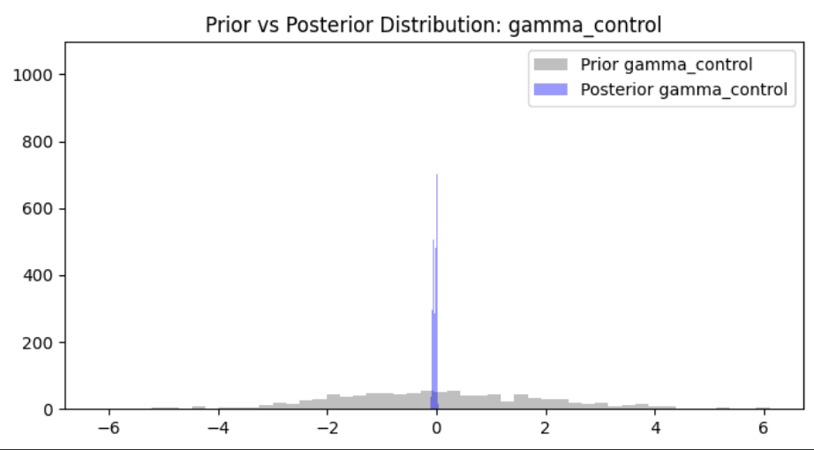

- The prior sampling distributions (shown as grey histograms) are generally more spread out and unconstrained. They represent a wide range of possible parameter values or predictions that the model considered plausible before looking at any data. For instance, the prior for total_contribution is much wider and flatter, showing the model was highly uncertain and made minimal assumptions about its likely value.
- The posterior sampling distributions (shown in purple) are much more concentrated and often shifted from the prior distributions. This indicates that after fitting the model to the observed data, the uncertainty in the parameters reduced significantly, and the model has learned specific, data-driven values for key parameters. For example, the posterior for gamma_control and saturation_lam is sharply peaked within a narrow range, meaning the model is now confident about their likely values.
Q4. How good is your model performing? How you do measure it?
Ans. The model captures overall revenue trends but does not fit all the low or high peaks in the dataset. This model is performing moderately but not optimal as seen by the RMSE score of 57214.95. Given the typical revenue range from 80,000 to 400,000, this reflects a moderate prediction error. RMSE quantifies the typical prediction error in original revenue, lower is better, with zero being perfect.
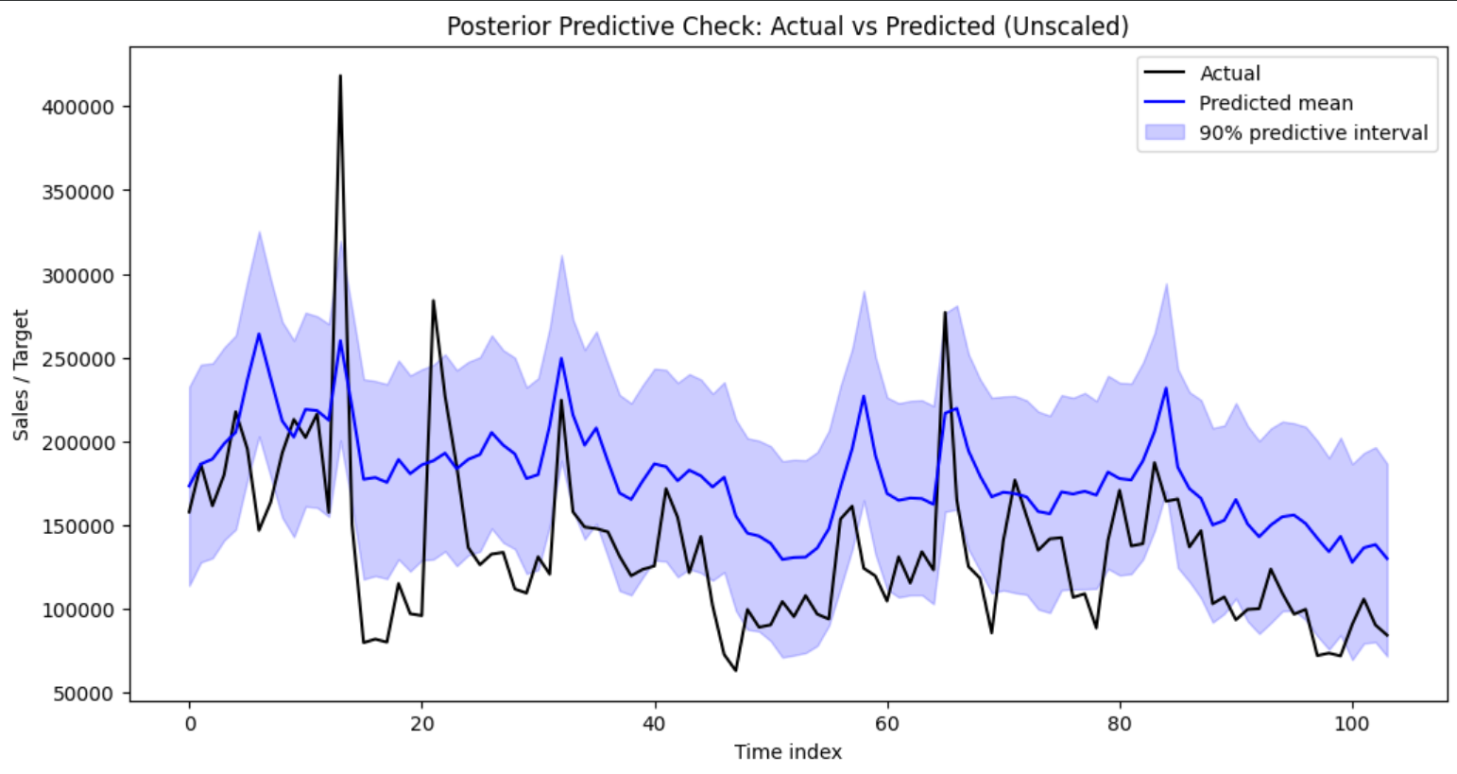

Q5. What are your main insights in terms of channel performance/ effects?
Ans. Main Insights on Channel Performance
- Top Performing Channel:
spend_channel_7 stands out as the channel with the highest total revenue contribution, at nearly 3.9 million units. This channel is the most impactful for driving sales and likely should be prioritized in future budget allocations.​
- Secondary Leaders:
spend_channel_3 (2.8 million) and spend_channel_4 (1.5 million) are also strong contributors to overall revenue, showing that investment in these channels is generating substantial results.​
- Moderate Performers:
spend_channel_2 and spend_channel_5 have mid-tier contributions, suggesting they are effective but not highest priority if budgets require focus.​
- Lowest Impact Channels:
spend_channel_1 and spend_channel_6 have the lowest total revenue contributions under 1 million each. These channels may warrant re-evaluation, as their impact on outcomes is relatively small given spend.
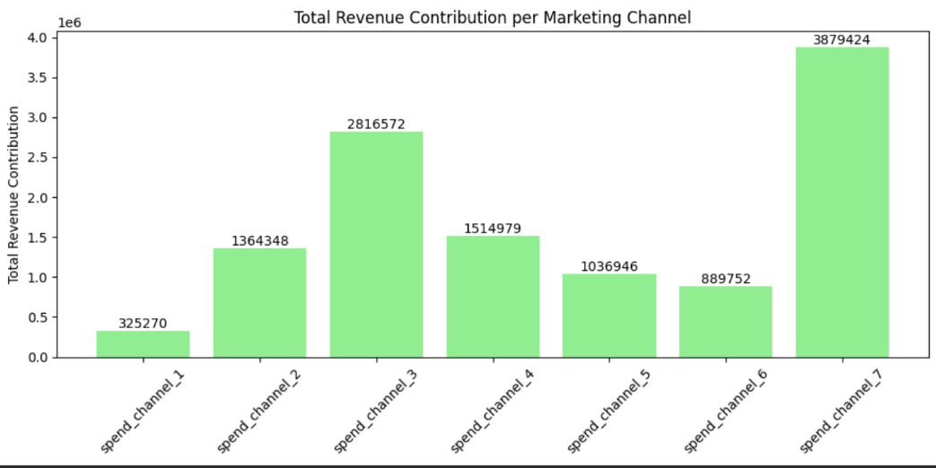
Q6. Can you derive ROI (return on investment) estimates per channel? What is the best channel in terms of ROI?
Ans. ROI is calculated as total revenue contribution divided by total spend for each channel. The plot shows the ROI for each channel as a bar, with the exact figure annotated.
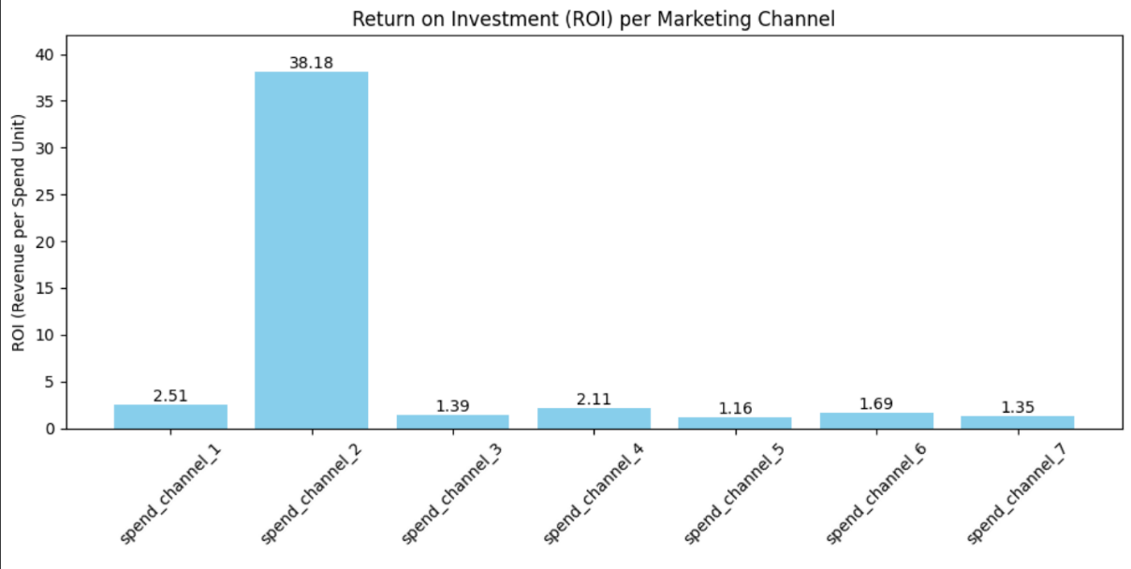

- Best channel in terms of ROI:
spend_channel_2 delivers the highest ROI at 38.18 for every unit spent, it generated over 38 units in revenue. This is a outperformance compared to other channels, making it the clear leader and the most cost-effective channel for future marketing investment.​
- Low to moderate ROI channels:
All other channels (1, 3, 4, 5, 6, 7) have ROI values ranging from 1.16 to 2.51. These are much lower and indicate less efficiency per spend unit despite some having high absolute revenue contributions.
Rather than simply investing in channels with the largest revenue, use these ROI results to ensure your marketing gives the highest return for spend, improving overall marketing efficiency and profitability.

