SERVER SIDE CREATION
DAL CREATION
- Logically organize your data…
  - Only include the tables that will be directly required by the Maintenance Screen, Utility Screen, Or Process, ect…
  - I will Use the User Maintenance UI as my step through…
    - We will always include the following tables…
      - Company table -- will parent 99% of all XERP tables allowing for multiple companies…
      - Temp –
        - Physical table in SQL that should never be populated with data…
        - The physical table is used logically in XERP as a generic schema defined object allowing for a strongly typed object to be used in a generic way…
        - Allowing us to transmit generic data through WCF Data Services as WCF Data Service requires Strongly Typed Objects.
        - It is used but not limited to by XERP to transmit the Schema definitions of each table included in the DAL to allow the client to be known as to how
        - to set the Max Field Length for each string field included in each of tables included in the Entity…
      - UDLists and UDListItems – These tables will allow you to publish customized lists to the module…
        - You may need an extra list for this or that…
        - This will allow you to capture user defined lists to one table throughout XERP…
        - Allowing you to share the lists among multiple modules in XERP…
        - Mostly used to populate Drop downs…
- Create a database Diagram in SQL Server
  - This will allow you a sand box to identify all the tables that you will include in the Entity within the DAL Project…
  - It has no bearing on the Module other than helping you to organize the table requirements…
  - Open up SQL Server…
    - Locate the XERP DataBase→DataBase Diagrams
    - Right click on the Data Diagrams and select New Database Diagram…
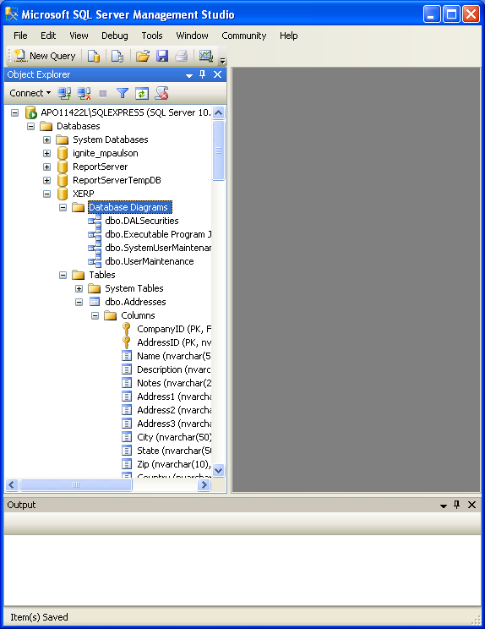
Diagram A-1 SQL Server DataBase Diagrams…
    - Below are the tables that I added to UserMaintenance DataBase Diagram…

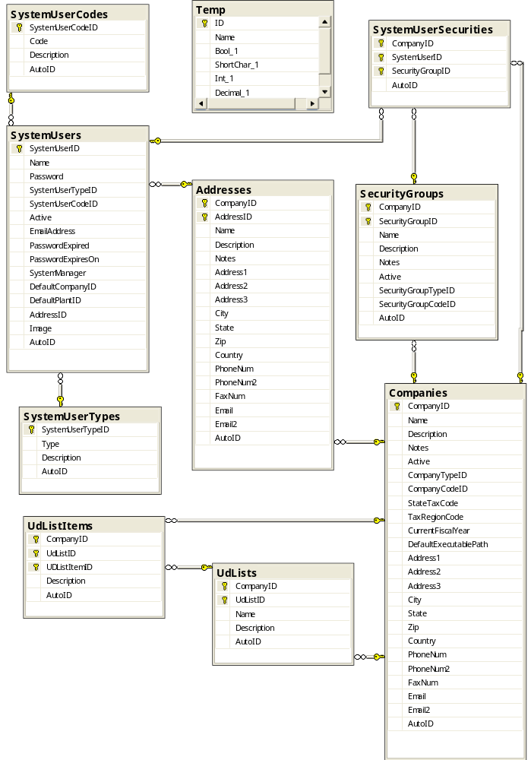
Diagram A-2 User Data Diagram…
  - The Data Diagram above will serve as my picture to use when I create the Entity in the XERP.Server.DAL.UserDAL project…
- Create the XERP.Server.DAL Project…(important to note throughout the creation process I will refer to Xxx in my instance I am creating the User module so my Xxx would be SystemUser…)
  - Open up the XERP.sln Solution…
  - Within the Solution Right Click on the Server/Server.DAL Solution Folder
    - Select Add→New Project
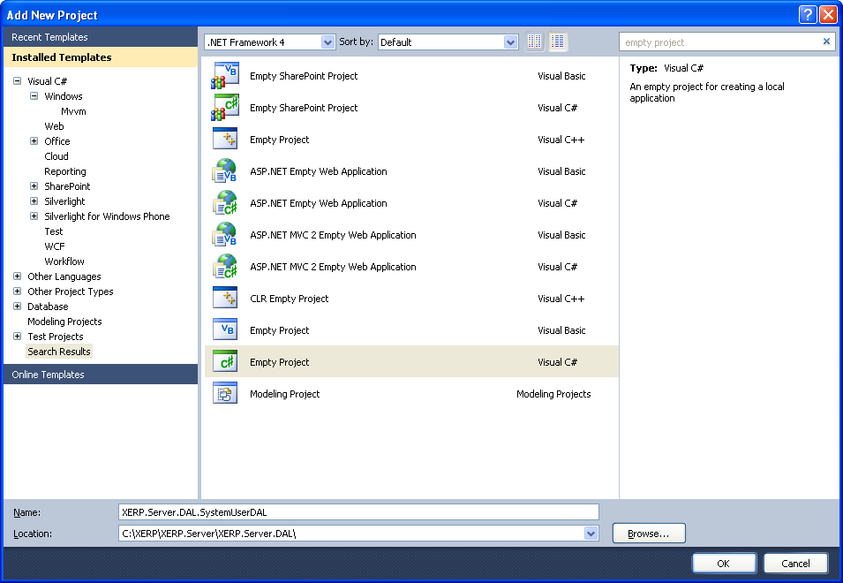
Diagram A-3 Visual Studio Empty Project Creation...
    - Select Empty Project
    - Name it XERP.Server.DAL.xxxDAL
    - Change the location to be …\XERP\XERP.Server\XERP.Server.DAL
    - Click OK…
  - Add required project reference/s
    - Within the newly created project right click on the Reference folder
      - Select Add Reference
      - From the Projects Tab select the XERP.Server.DAL
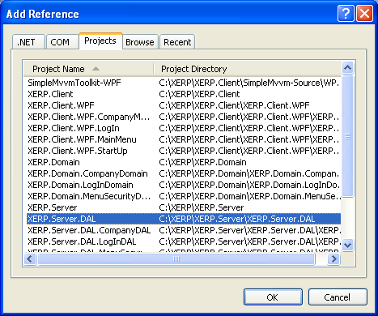
Diagram A-4
      - Click Ok the required project reference is now added…
      - The project reference added will be used later by the DALUtility.cs Class
      - To deliver the Base SQL Server Connection string…
  - Add the SharedAssemblyInfo.cs to the newly created project
    - Right click on the newly created project.
    - Select Add→Existing Item
    - Navigate to the …/XERP folder and then highlight the SharedAssemblyInfo.cs
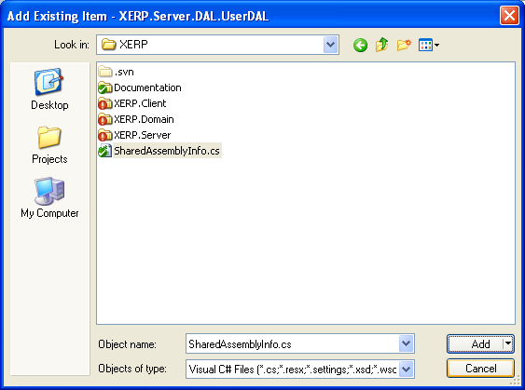
Diagram A-5 Add SharedAssemblyInfo.cs as a linked file
    - We need to add this as a shared file…
        - Click on the down arrow part of the Add button…
        - It will display a dropdown select Add As Link from the drop down…
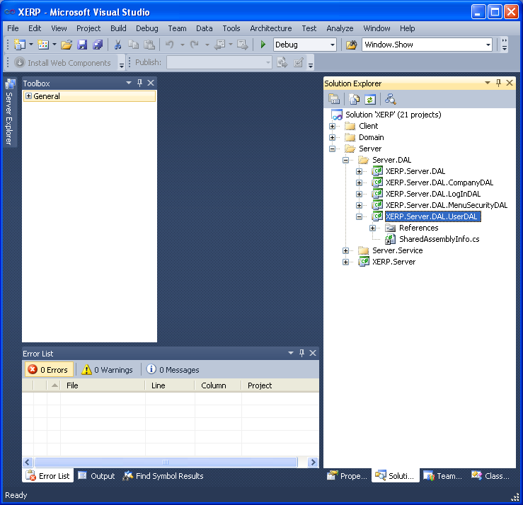
Diagram A-6 DAL Project with newly added SharedAssemblyInfo.cs as a linked file…
        - After you are done adding you will see it as above with the little arrow in the left corner of the SharedAssemblyInfo.cs
        - This is telling us it is linked file…
        - All XERP projects have this linked file to allow us to set assembly properties from a single location…
        - A very standard .net practice…
    - Check/Set Project Properties…
      - Right Click on the newly created DAL project and select Properties from the right clicked context menu…
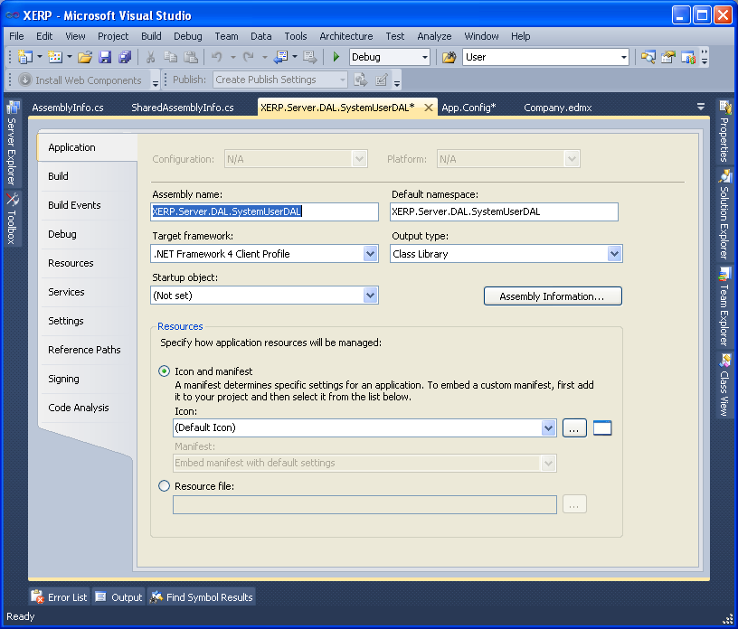
Diagram A-7 DAL Project Properties Set Up…
      - Change the Output Type dropdown to Class Library.
      - Double check the Assembly Name and the Default namespace and make sure they match the XERP DAL nomenclature…
        - XERP.Server.DAL.xxxDAL
      - Click the Assebly Information Button
        - Add the Title: make it the same as the Assembly Name and Default NameSpace…
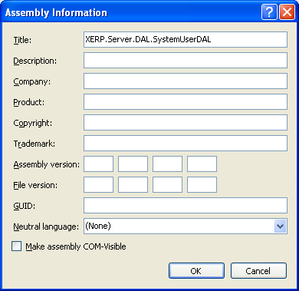
Diagram A-8 Assembly Information Dialogue…
      - The process above will generate an AsseblyInfo.cs file…
        - From within your solution explorer locate the newly created AssemblyInfo.cs file and open it up as below…
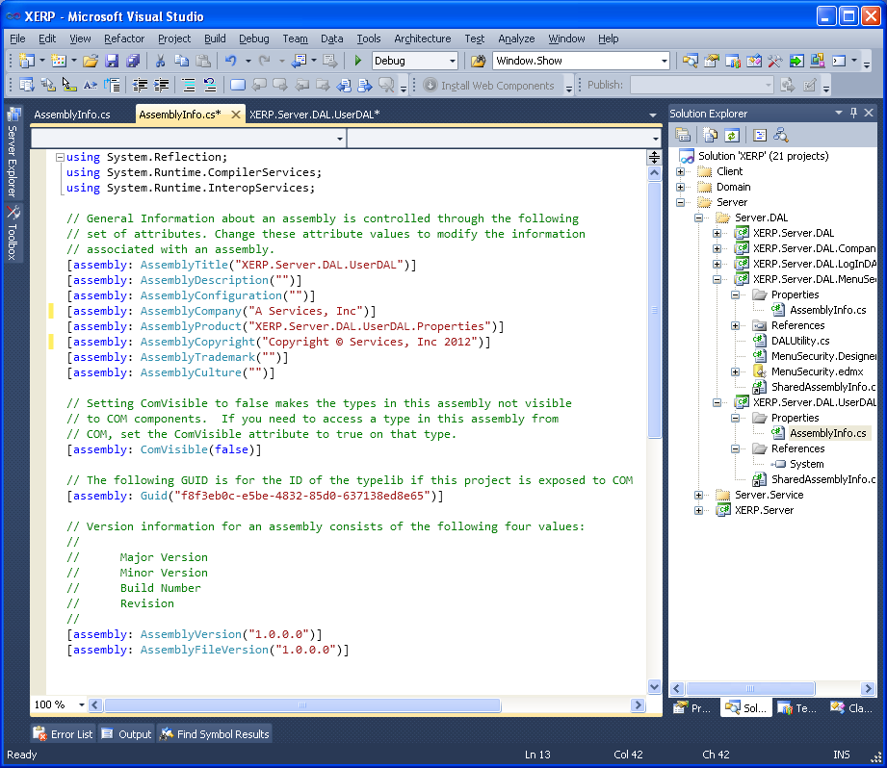
Diagram A-9 AssemblyInfo.cs before XERP required edits…
        - The SharedAssemblyInfo.cs we added earlier will trump and globalize some of the assembly properties…
        - So we will remove these properties from the AssemblyInfo.cs file; remove the following…
[assembly: AssemblyCompany("A Services, Inc")]
[assembly: AssemblyProduct("XERP.Server.DAL.XxxDAL.Properties")]
[assembly: AssemblyCopyright("Copyright © Services, Inc 2012")]

[assembly: AssemblyVersion("1.0.0.0")]
[assembly: AssemblyFileVersion("1.0.0.0")]

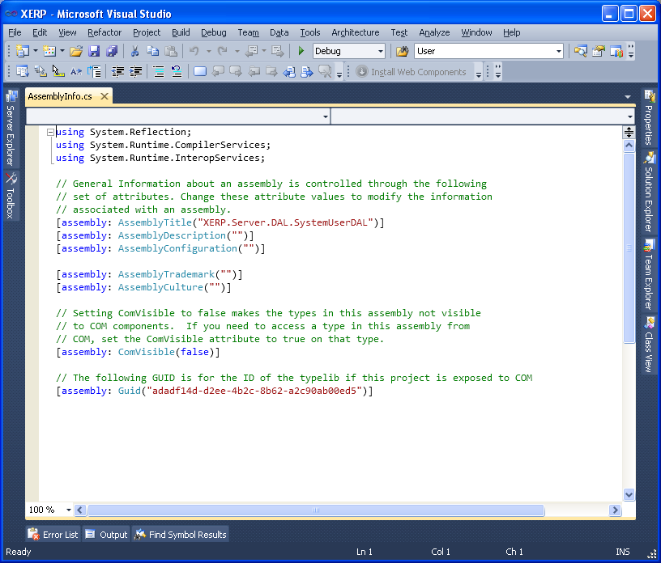
Diagram A-10 AssemblyInfo.cs after XERP required edits…
        - Ending up with the above…
          - Any commented lines done with // can be left or kept makes no difference as they are merely comments…
        - Look at the SharedAssemblyInfo.cs as you will then see that it is taking care of the assembly properties that we just removed…
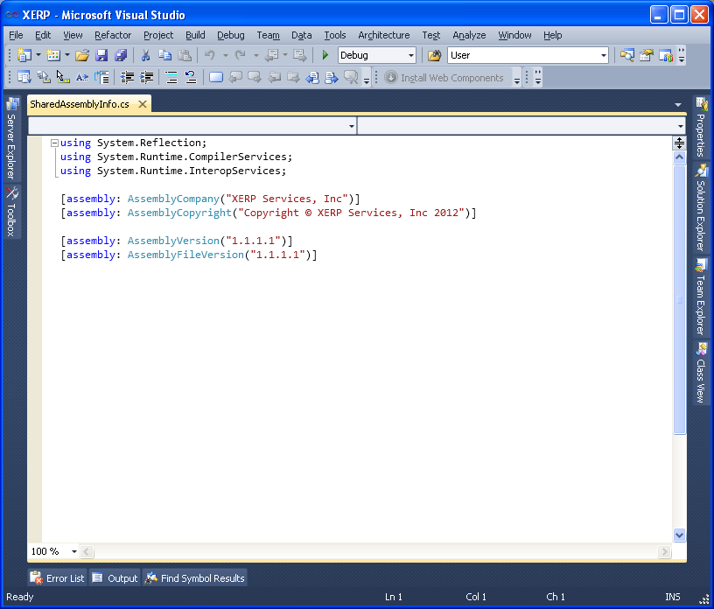
Diagram A-11 SharedAssemblyInfo.cs file...
  - Set Build Properties…
    - From the Properies Dialogue select the Build Tab
    - Select All Configurations from the Configuration: Dropdown…
    - In the Output Path: TextBox paste in the following…
      - ..\..\XERPServerBuild\bin\
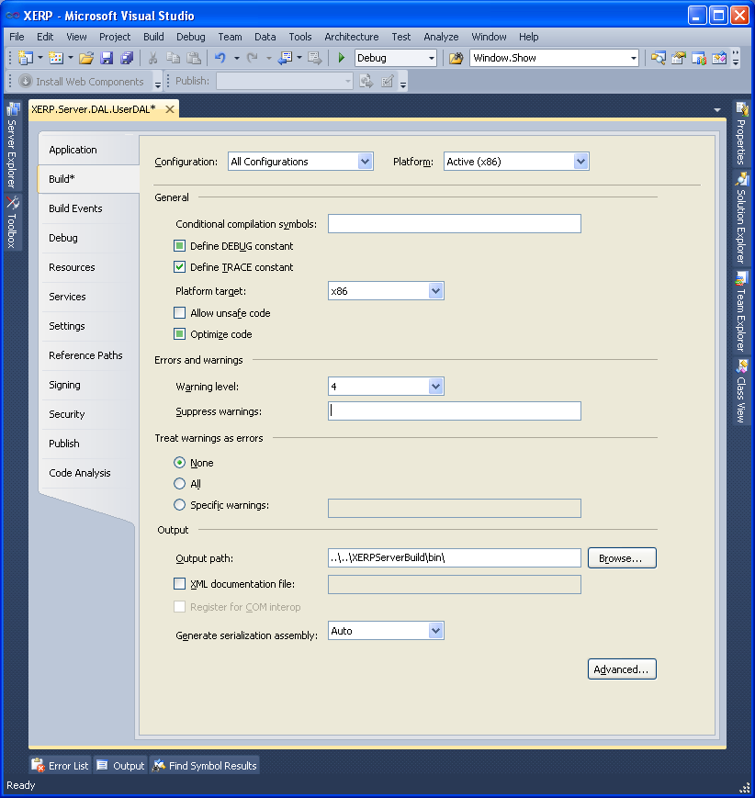
Diagram A-12 DAL Properties Build Tab Output Path setting…
    - Setting the Build Output Path will allow all of the separate projects to build their output to a centralized location that can easily be cumulated and x-copied to a target production server…
- Add an Entity to the newly created DAL project…
  - Using the data diagram (Diagram A-2) as your visual…
    - This will stipulate the tables we will add to our entity…
  - Right click on the newly created DAL project…
    - Add→New Item
    - Type Entity in the right corner to emulate a search
    - Select the ADO.NET Entity Data Model
    - Name it Xxx.edmx
    - I am creating the User DAL Project so I have named it SystemUser.edmx
    - Substitute the xxx for DAL Name you are creating the entity for…
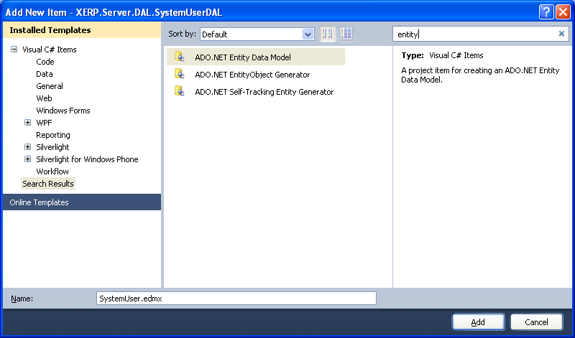
Diagram A-13 Add Entity Dialogue…
    - After selecting the ADO.Net Entity Data Model then click the Add button…

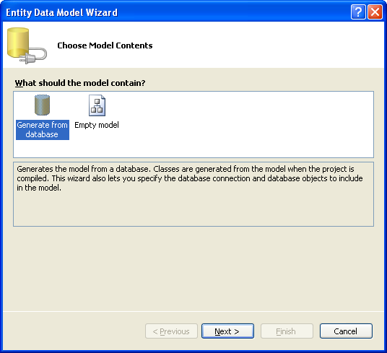
Diagram A-14 Entity Data Model Wizard Dialogue…
    - Select Generate from database and then click Next button…
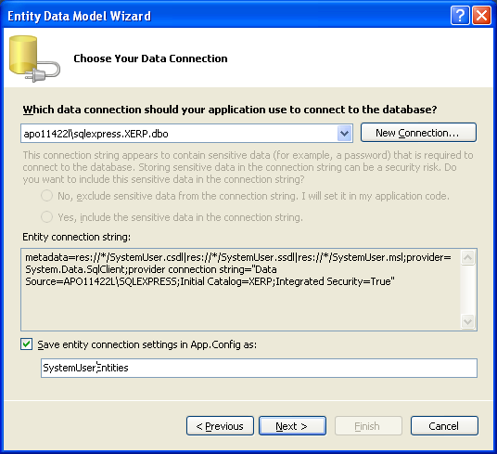
Diagram A-15 Entity Choose Your Data Connection Dialogue…
    - Make sure the Save entity connection settings in App.Config As: checkbox is checked…
    - Change it to be XxxEntities.
    - Click the Next button…
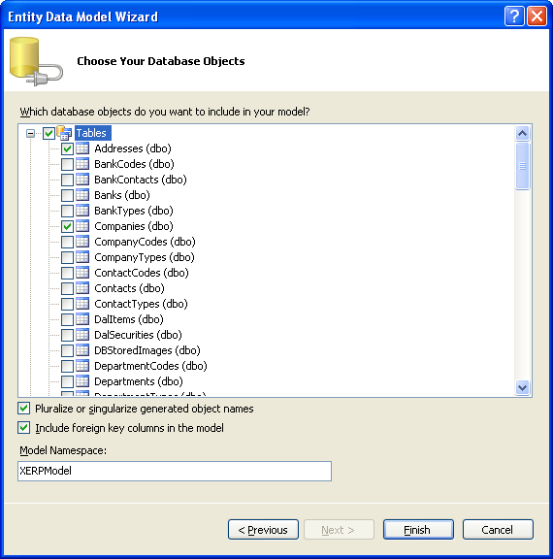
Diagram A-16 Entity Database Object selection Dialogue…
    - Expand the Tables node and select all the tables that you included in the database diagram you created from Diagram A-2.
    - After selecting the tables to be included then accept the checkbox defaults and Model Namespace: defaults and click the Finish Button…
      - We do not change the Defualt Namespace as it is overridden and defaulted to the one we set up earlier in the Project Properties section…
      - It will end up being XERP.Server.DAL.xxxDAL i.e. the same as the properties we set in the Project Properties section for default namespace…
      - Lastly we can delete the App.Config that got generated as we do not need it…
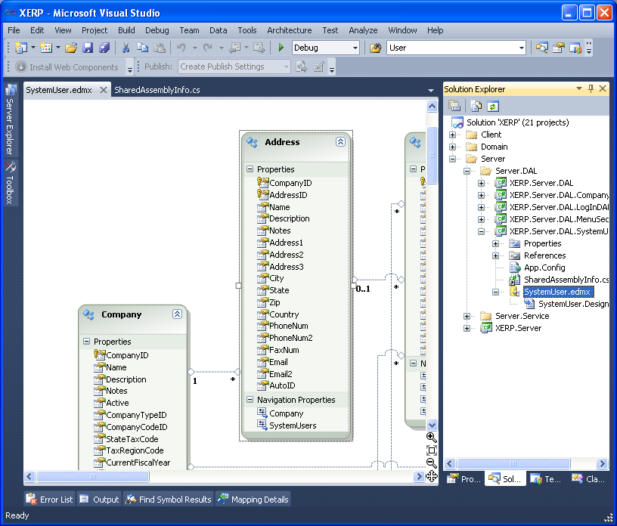
Diagram A-17 DALxxx.edmx entity Diagram…
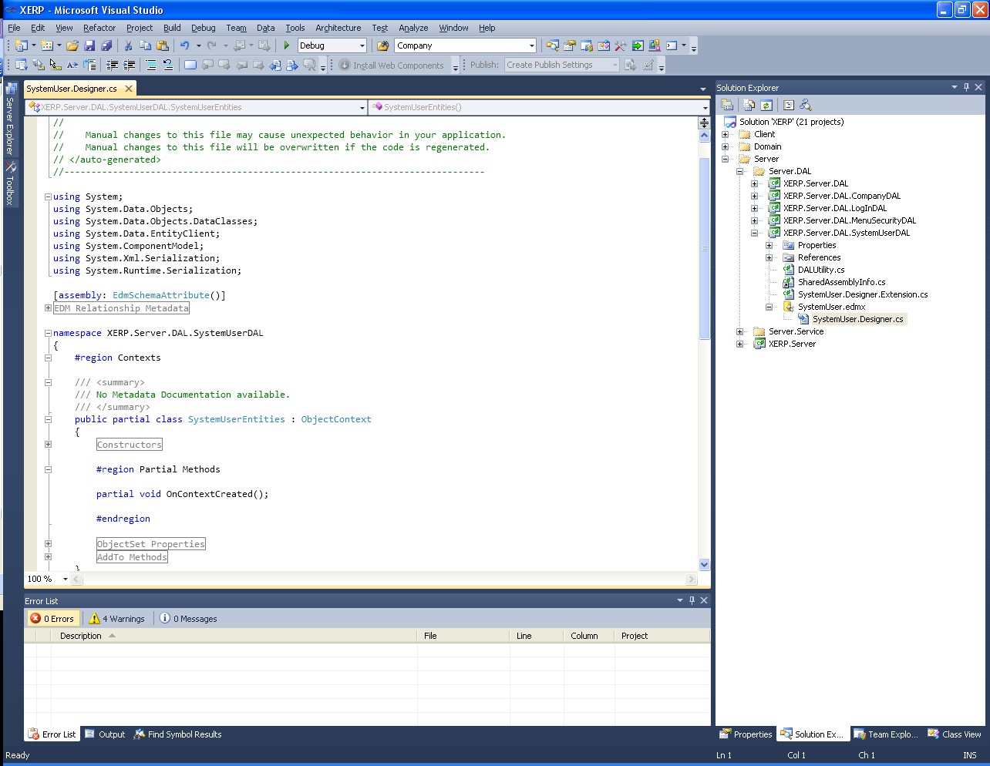
Diagram A-18 xxx.Designer.cs (Entities .edmx auto generated code behind)

  - Configure Entity Connection to XERP standards…
    - Entity default connections are not appropriate for XERP as it would produces 100’s of separate SQL config settings.
    - Causing a nightmare every time you wanted to switch db’s…
    - So we add a DAL Utility class to strip out the common SQL connection string and the more localized meta-string that entity requires for defining schema and what not…
    - Right Click on the newly created DAL project
      - Select Add→Class
        - Name it DALUtility.cs
      - Within the Namespace {} brackets paste in the following snippet…
      - Add the following namespace…
        - using System.Data.EntityClient;

//substitute Xxx for your Object name; The object name for this tutorial is SystemUser…
public class DALUtility
{
public const string _metadataString = @"res://*/Xxx.csdl|res://*/Xxx.ssdl|res://*/Xxx.msl";

private EntityConnectionStringBuilder _entityBuilder = new EntityConnectionStringBuilder();
public EntityConnectionStringBuilder EntityBuilder
{
get
{
XERP.Server.DAL.DALConfig dalConfig = new XERP.Server.DAL.DALConfig();
_entityBuilder.Provider = dalConfig.ProviderName;
_entityBuilder.ProviderConnectionString = dalConfig.BaseSQLConnectionString;
_entityBuilder.Metadata = _metadataString;
return _entityBuilder;
}
}

public string EntityConectionString
{
get { return EntityBuilder.ConnectionString; }
}

public DALUtility()
{

}
}

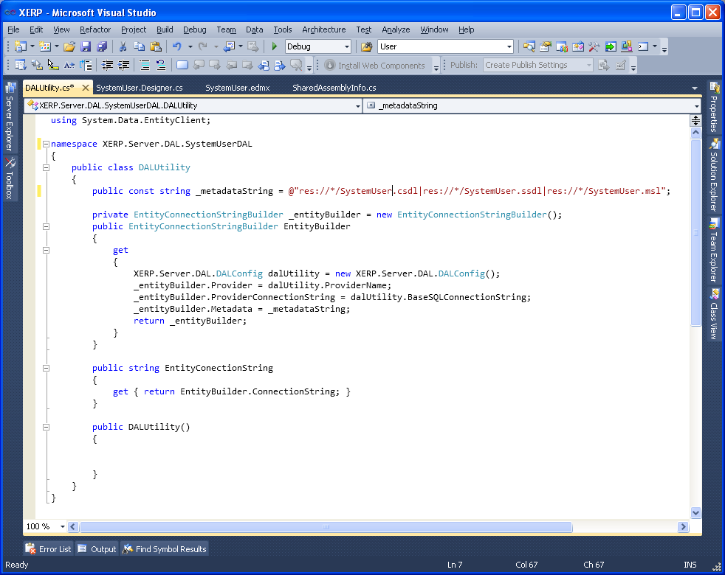
Diagram A-19 DAL Utility Class After Xxx Replacement…
    - When you paste it in if you did not add the using System.Data.EntityClient you will get some squiggly red lines
      - Hover over one of them; A menu will appear as in Diagram A-17
      - From the menu select using System.Data.Entity.Client
- Add Entity Extension Method Class…
  - In the case that the entity will be modified in the future we want to create a partial class of the entity that we can modify and persist…
  - Right click on the newly created DAL project
    - Add→Class
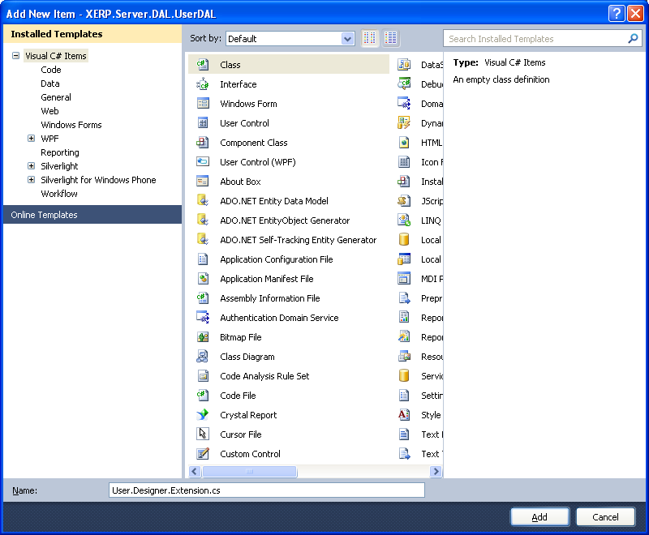
Diagram A-20 Add Entity Extension Class…
  - Name it Xxx.Designer.Extension.cs
  - Click the Add Button…
  - Paste in the code below …
  - Replace Xxx with your Project Name i.e mine is SystemUser
  - Include any additional tables where you will want to define schema in order to use the XERP MaxLength property…
  - As you can see if you browse the code below there is Module defined
    - For the Main Object SystemUser
    - The Type Object SystemUserType
    - And the Code Object SystemUserCode
    - So if there are any additional tables in the entity that will require client side Editing you will
    - Want to make sure to include them as well…
using System;
using System.Collections.Generic;
using System.Linq;
using XERP.Server.DAL.XxxDAL;
using System.Data.Metadata.Edm;
//namespace XERP.Server.DAL.XxxUserDAL
//{

//}

//we use the extension Method it allows to extend methods to existing entity objects...
//so that as long as use add the using ExtensionMethods you can utilize the methods below with a . reference...
//as if the the methods are part of the existing objects that they are referenced to by the this declaration
//in the parameter...
namespace ExtensionMethods
{
public static class MyExtensions
{
public static string GetPropertyValue(this Xxx myObj, string propertyName)
{
var propInfo = typeof(Xxx).GetProperty(propertyName);

if (propInfo != null)
{
return propInfo.GetValue(myObj, null).ToString();
}
else
{
return string.Empty;
}
}

public static List<Temp> GetMetaData(this Xxx entityObject)
{
XERP.Server.DAL.XxxDAL.DALUtility dalUtility = new DALUtility();
List<Temp> tempList = new List<Temp>();
int id = 0;
using (XxxEntities ctx = new XxxEntities(dalUtility.EntityConectionString))
{

var c = ctx.Companies.FirstOrDefault();
var queryResults = from meta in ctx.MetadataWorkspace.GetItems(DataSpace.CSpace)
.Where(m => m.BuiltInTypeKind == BuiltInTypeKind.EntityType)
from query in (meta as EntityType).Properties
.Where(p => p.DeclaringType.Name == entityObject.GetType().Name)
select query;

if (queryResults.Count() > 0)
{
foreach (var queryResult in queryResults.ToList())
{
Temp temp = new Temp();
temp.ID = id;
temp.Name = queryResult.Name.ToString();
temp.ShortChar_1 = queryResult.TypeUsage.EdmType.Name;
if(queryResult.TypeUsage.EdmType.Name == "String")
{
temp.Int_1 = Convert.ToInt32(queryResult.TypeUsage.Facets["MaxLength"].Value);
}
temp.Bool_1 = false; //we use this as a error trigger false = not an error...
tempList.Add(temp);
id++;
}
}
}
return tempList;
}

//All senior tables(Companies, Parts, Orders, ect...) tend to have a generic table called TableNameTypes
//i.e. XxxTypes PartTypes, OrderTypes...
//So this will constitute the meta data for that Type table...
//Xerp attempts to use generic naming where possible to allow for cloning...
public static List<Temp> GetMetaData(this XxxType entityObject)
{
XERP.Server.DAL.XxxDAL.DALUtility dalUtility = new DALUtility();
List<Temp> tempList = new List<Temp>();
int id = 0;
using (XxxEntities ctx = new XxxEntities(dalUtility.EntityConectionString))
{

var c = ctx.XxxTypes.FirstOrDefault();
var queryResults = from meta in ctx.MetadataWorkspace.GetItems(DataSpace.CSpace)
.Where(m => m.BuiltInTypeKind == BuiltInTypeKind.EntityType)
from query in (meta as EntityType).Properties
.Where(p => p.DeclaringType.Name == entityObject.GetType().Name)
select query;

if (queryResults.Count() > 0)
{
foreach (var queryResult in queryResults.ToList())
{
Temp temp = new Temp();
temp.ID = id;
temp.Name = queryResult.Name.ToString();
temp.ShortChar_1 = queryResult.TypeUsage.EdmType.Name;
if (queryResult.TypeUsage.EdmType.Name == "String")
{
temp.Int_1 = Convert.ToInt32(queryResult.TypeUsage.Facets["MaxLength"].Value);
}
temp.Bool_1 = false; //we use this as a error trigger false = not an error...
tempList.Add(temp);
id++;
}
}
}
return tempList;
}

//All senior tables(Companies, Parts, Orders, ect...) tend to have a generic table called TableNameCodes
//i.e. XxxCodes PartCodes, OrderCodes...
//So this will constitute the meta data for that Code table...
//Xerp attempts to use generic naming where possible to allow for cloning...
public static List<Temp> GetMetaData(this XxxCode entityObject)
{
XERP.Server.DAL.XxxDAL.DALUtility dalUtility = new DALUtility();
List<Temp> tempList = new List<Temp>();
int id = 0;
using (XxxEntities ctx = new XxxEntities(dalUtility.EntityConectionString))
{

var c = ctx.XxxCodes.FirstOrDefault();
var queryResults = from meta in ctx.MetadataWorkspace.GetItems(DataSpace.CSpace)
.Where(m => m.BuiltInTypeKind == BuiltInTypeKind.EntityType)
from query in (meta as EntityType).Properties
.Where(p => p.DeclaringType.Name == entityObject.GetType().Name)
select query;

if (queryResults.Count() > 0)
{
foreach (var queryResult in queryResults.ToList())
{
Temp temp = new Temp();
temp.ID = id;
temp.Name = queryResult.Name.ToString();
temp.ShortChar_1 = queryResult.TypeUsage.EdmType.Name;
if (queryResult.TypeUsage.EdmType.Name == "String")
{
temp.Int_1 = Convert.ToInt32(queryResult.TypeUsage.Facets["MaxLength"].Value);
}
temp.Bool_1 = false; //we use this as a error trigger false = not an error...
tempList.Add(temp);
id++;
}
}
}
return tempList;
}
}
}
Service Creation
- Add Service Project…
  - Right Click on the Server.Service Folder and Select Add→New Project
  - Select ASP.NET Empty Web Application…
  - Name it XERP.Server.Service.XxxService
  - Select the C:\XERP\XERP.Server\XERP.Server.Service\ Folder location…
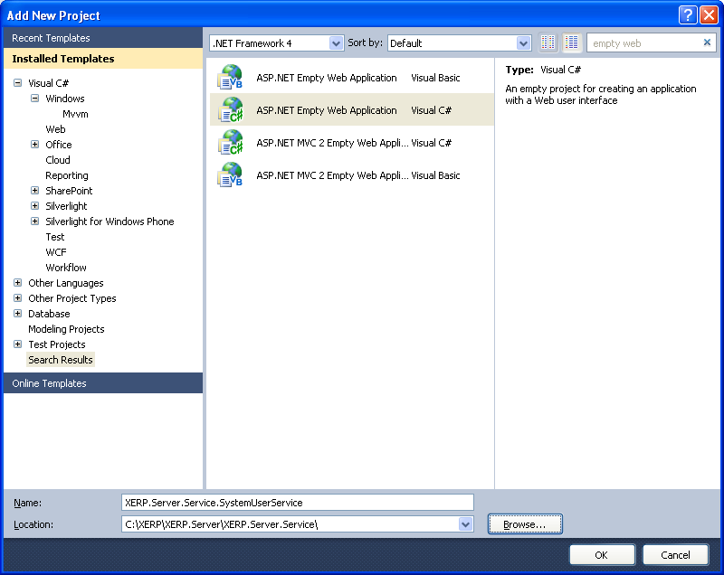
Diagram B-1 Create Service Project…
  - Add the shared AssemblyInfo.cs as a linked file…
    - refer to the directions and Diagram A-5 Add SharedAssemblyInfo.cs as a linked file
    - As all projects within XERP will required the SharedAssemblyInfo.cs file…
  - Set Service Project Properties…
    - Right Click on the newly created Service Project and select Properties…
    - Select the Application Tab…
      - Check the Assembly Name and Default Namespace
        - Make sure they are both XERP.Server.Service.XxxService
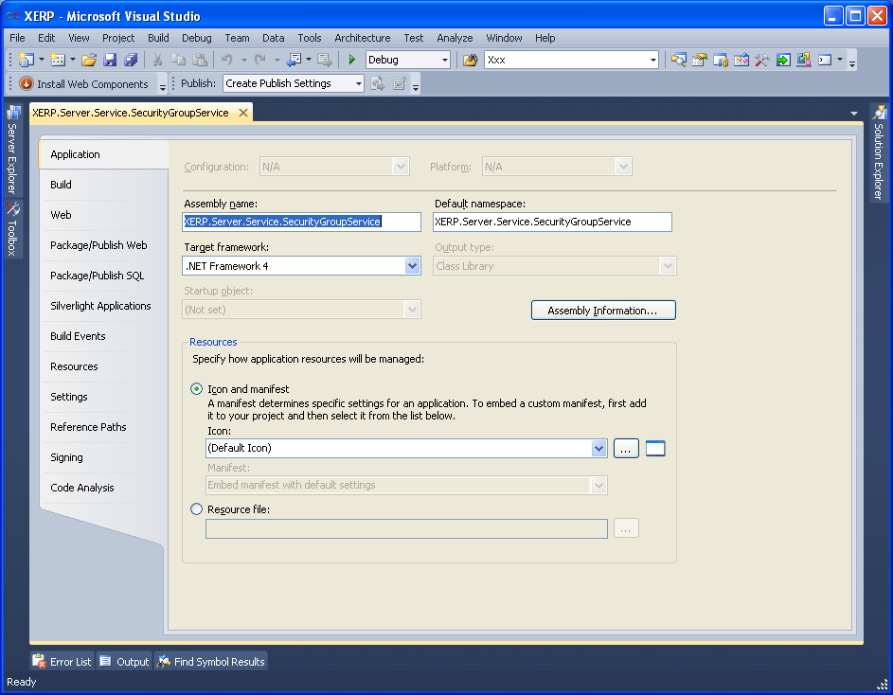
Diagram B-2 Service Application Properties
  - Click the Assembly Information Button…
    - Provide the Title and Description; same as the Assembly Name…
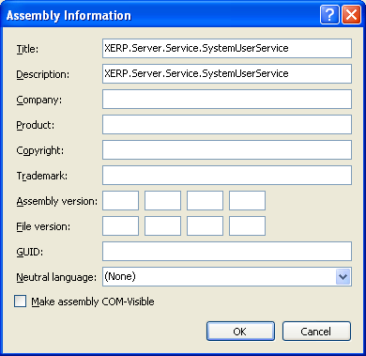
Diagram B-3
    - Delete the global Assembly properties as they will be provided by the Shared
      - Review steps near diagram A-9 and A-10 the same steps will apply for all XERP projects
    - Select the Build Tab…
      - Select the Debug from Configuration: dropdown…
        - Confirm the Output Path to be bin\
        - We do this to allow the service to be run in debug mode…
      - Change the Configuration: dropdown to Release…
        - Set the Output Path to be ..\..\XERPServerBuild\bin\
        - We do this to consolidate are build files to be in a shared release folder…
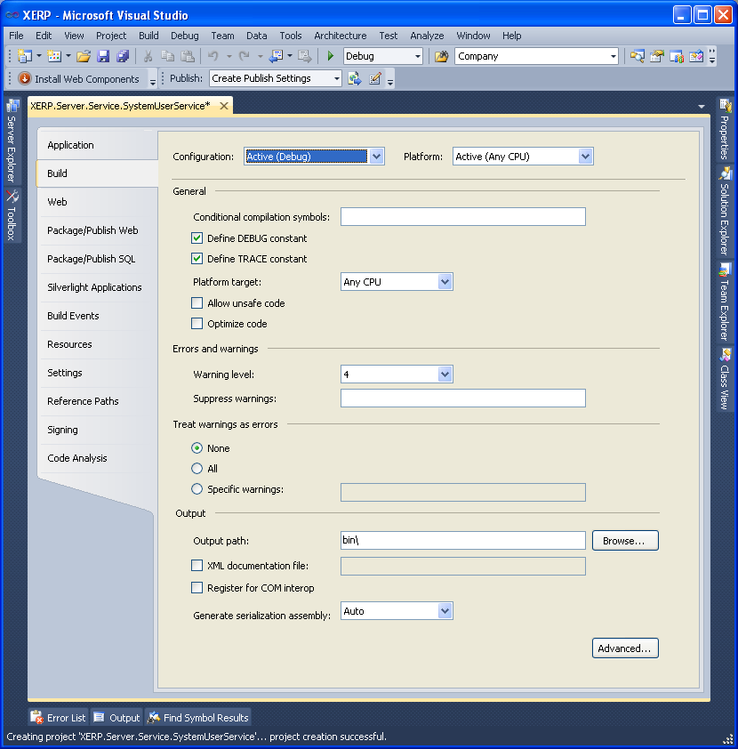
Diagram B-4 Service Project Debug Build Output Path…
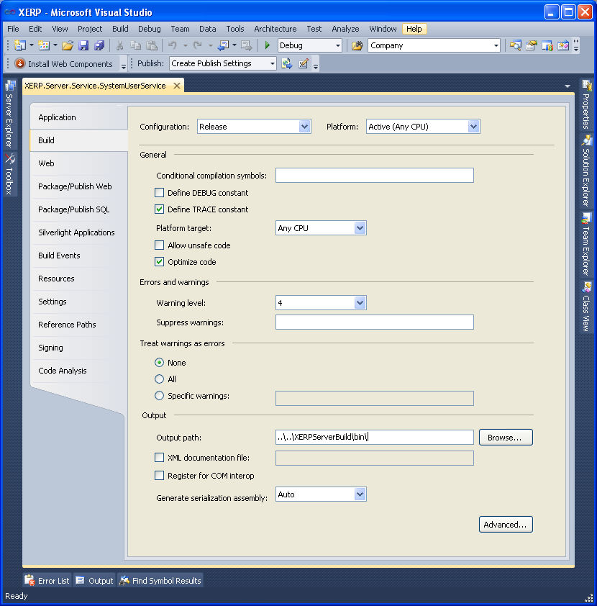
Diagram B-5 Service Project Release Build Output Path…
    - Select The Web Tab…
      - Select Specific Page from the Start Action and provide XxxDataService.svc in the adjacent textbox
        - We will create this later…
      - From the Servers Section select Specific Port and give it a unique port number…
        - Check all the current services in the solution and look for the next available port assignment…
        - My last port number used was 1203 so I will opt to use 1205 for no better reason then to
        - Start using port numbers that are divisible by 5…
        - So if the last port number was 1205 I would then to proceed to use 1210 and so on…
        - Remember this Port Number as we will utilize in the Domain Project…
        - Select the Specific port radio button and provide your unique port number and note it as we will use it later…
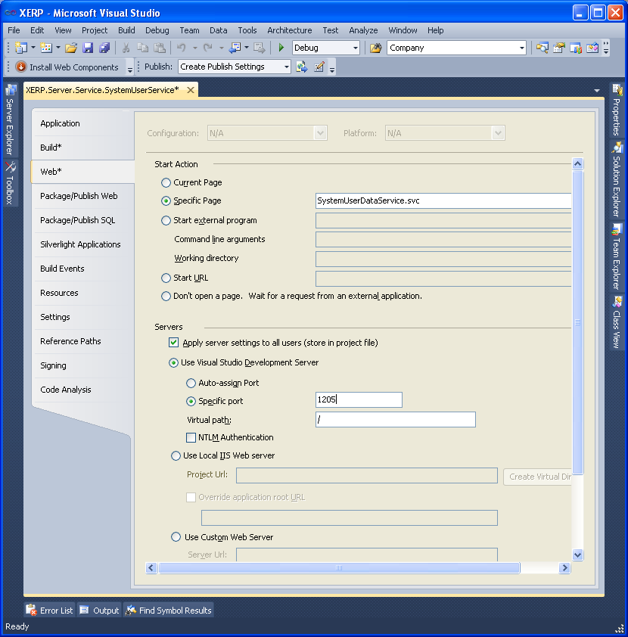
Diagram B-6
  - Add Required Project References
    - On the newly created service project right click on the References folder
      - From the Projects Tab
      - Select XERP.Server.DAL.XxxDAL
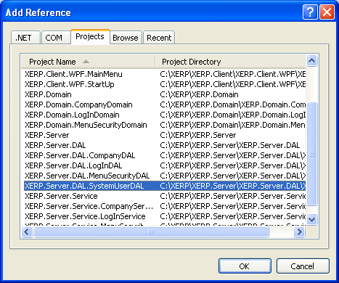
Diagram B-7 Add DAL Project Reference replace SystemUserDAL with XxxDAL…
  - Add WCF Data Service…
    - Right Click on the newly created Service
      - Select Add→New Item
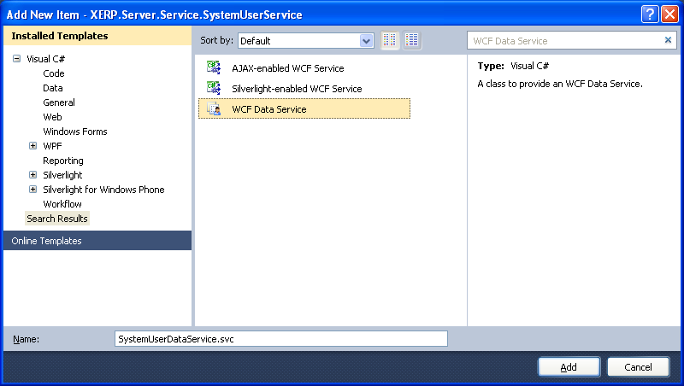
Diagram B-8 Adding WCF Data Service
      - Name it XxxDataService.svc
      - Open up the generated XxxDataService.svc.cs class…
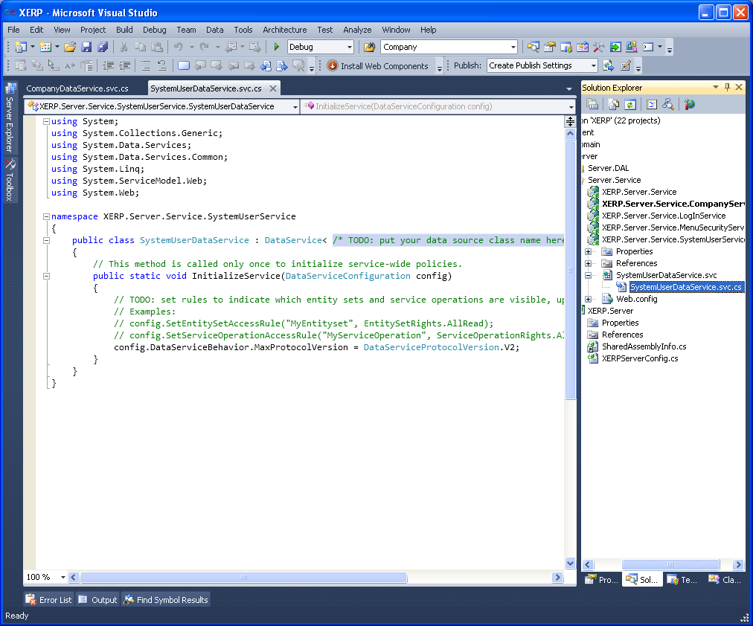
Diagram B-9 WCF Data Service generated class before providing the TODO:
      - Replace /* TODO: put your data source class name here */
      - With XxxEntities
      - Once added hover over the XxxEntities and select the blue line and add the necessary using statement…
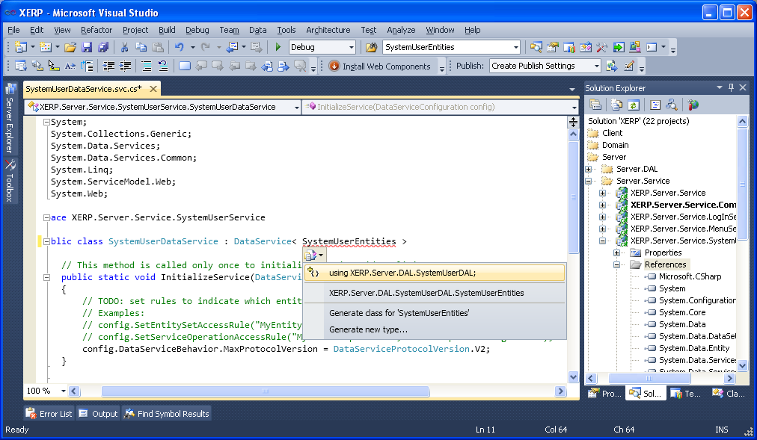
Diagram B-10 Add DAL Project Using Statement…
      - Here is the XxxDataService.cs class code in its entirety…
      - Massage the code base to fit your Xxx…
      - The easiest thing to do is paste in the using statements…
      - Then paste in the class from start { to end }
      - Then find and replace on the current document
      - Replace SystemUsers with Xxx/s or ies
        - If your plural is not just an addition of an s you will have to modify plurality accordingly…
        - If it is standard plurality as just adding an S then you can
          - Skip step 12
          - And just do step 13 as it will replace the singlularity and plurality
          - At the same replace of the singularity as it is just an additional s…
      - Replace SystemUser with Xxx
using System;
using System.Data.Services;
using System.Data.Services.Common;
using System.Linq;
using XERP.Server.DAL.SystemUserDAL;
using System.ServiceModel.Web;
using System.Collections.Generic;
using ExtensionMethods;

namespace XERP.Server.Service.SystemUserService
{
public class SystemUserDataService : DataService< SystemUserEntities >
{
// This method is called only once to initialize service-wide policies.
public static void InitializeService(DataServiceConfiguration config)
{
config.SetEntitySetAccessRule("*", EntitySetRights.All);
config.DataServiceBehavior.MaxProtocolVersion = DataServiceProtocolVersion.V2;
//I noticed when setting page size it would always limit my expand payload to 1
//I have elected to disable paging...
//config.SetEntitySetPageSize("*", 50);
config.SetServiceOperationAccessRule("*", ServiceOperationRights.All);
}
//The procedure below uses the Temp table as following...
//ID item count key id...
//Name MetaData FieldName
//Int_1 String Field Max Length
//Bool_1 Error Flag
[WebGet]
public IQueryable<Temp> GetMetaData(string tableName)
{
switch (tableName)
{
case "SystemUsers":
SystemUser SystemUser = new SystemUser();
return SystemUser.GetMetaData().AsQueryable();
case "SystemUserTypes":
SystemUserType SystemUserType = new SystemUserType();
return SystemUserType.GetMetaData().AsQueryable();
case "SystemUserCodes":
SystemUserCode SystemUserCode = new SystemUserCode();
return SystemUserCode.GetMetaData().AsQueryable();
default: //no table exists for the given tablename given...
List<Temp> tempList = new List<Temp>();
Temp temp = new Temp();
temp.ID = 0;
temp.Int_1 = 0;
temp.Bool_1 = true; //bool_1 will flag it as an error...
temp.Name = "Error";
temp.ShortChar_1 = "Table " + tableName + " Is Not A Valid Table Within The Given Entity Collection, Or Meta Data Was Not Defined For The Given Table Name";
tempList.Add(temp);
return tempList.AsQueryable();
}
}

[WebGet]
public IQueryable<SystemUser> RefreshSystemUser(string autoIDs)
{
var query = from val in autoIDs.Split(',')
select long.Parse(val);
XERP.Server.DAL.SystemUserDAL.DALUtility dalUtility = new DALUtility();
var context = new SystemUserEntities(dalUtility.EntityConectionString);

var queryResult = (from q in context.SystemUsers
where query.Contains(q.AutoID)
select q);

return queryResult;
}

[WebGet]
public IQueryable<SystemUserType> RefreshSystemUserType(string autoIDs)
{
var query = from val in autoIDs.Split(',')
select long.Parse(val);
XERP.Server.DAL.SystemUserDAL.DALUtility dalUtility = new DALUtility();
var context = new SystemUserEntities(dalUtility.EntityConectionString);

var queryResult = (from q in context.SystemUserTypes
where query.Contains(q.AutoID)
select q);

return queryResult;
}

[WebGet]
public IQueryable<SystemUserCode> RefreshSystemUserCode(string autoIDs)
{
var query = from val in autoIDs.Split(',')
select long.Parse(val);
XERP.Server.DAL.SystemUserDAL.DALUtility dalUtility = new DALUtility();
var context = new SystemUserEntities(dalUtility.EntityConectionString);

var queryResult = (from q in context.SystemUserCodes
where query.Contains(q.AutoID)
select q);

return queryResult;
}

protected override SystemUserEntities CreateDataSource()
{
try
{
XERP.Server.DAL.SystemUserDAL.DALUtility dalUtility = new DALUtility();
var context = new SystemUserEntities(dalUtility.EntityConectionString);

//test it...
//GetMetaData("SystemUsers");
//IQueryable<SystemUser> SystemUserQuery = (from c in context.SystemUsers
// select c);

//foreach (SystemUser cc in SystemUserQuery)
//{
// string s = cc.Name.ToString();
//}
//SystemUser SystemUser = new SystemUser();
//IQueryable<SystemUser> SystemUserQuery = Refresh("5,6");
return context;
}
catch (Exception ex)
{
throw (ex);
}
}
}
}
  - Add the following to the web configs <system.web> tag…
<httpRuntime requestPathInvalidCharacters="" requestValidationMode="2.0"/>
<pages validateRequest="false"/>
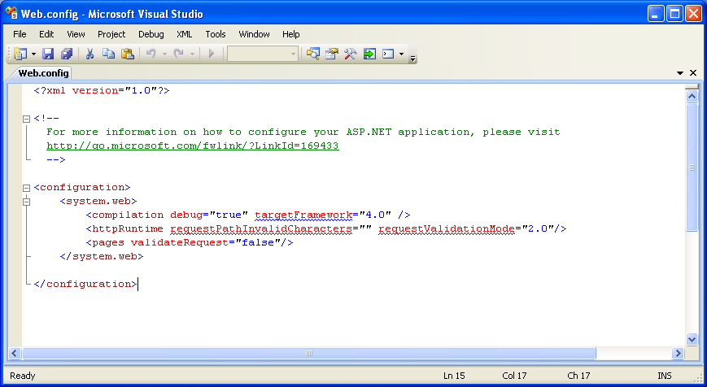
Diagram B-11
    - This will allow for strange characters such as <, > or * to be queried across the DataService…
    - Of course it does allot for injection attacks to your WCF data service…
    - If you plan on keeping it an intranet service this is completely acceptable…
    - If not you should not do this and just make sure you are not querying for special characters…
    - It is important to note all XERP Services once deployed will share a single Web Config
      - So good and bad…
      - You can set the web config per installed instance and it will adhere to all the Services Used in XERP…
      - It is recommended to allow special characters as the menu item module for one uses a * to
        - Represent all menu items…
        - So if it is not set in this manner the MenuSecurities service will error out…
  - Test the newly created data service…
    - Set the newly created service as the start up project…
    - Run the application from debug mode…
      - This will give your restful local query URL…
    - You now should have your restful service…
    - And can test it using restful queries…
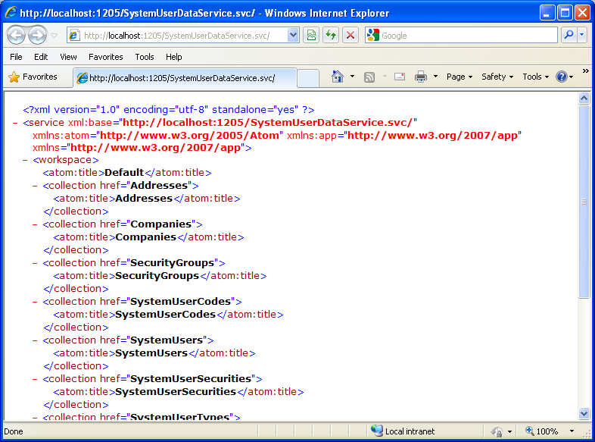
Diagram B-12 Testing your WCF Data Service…
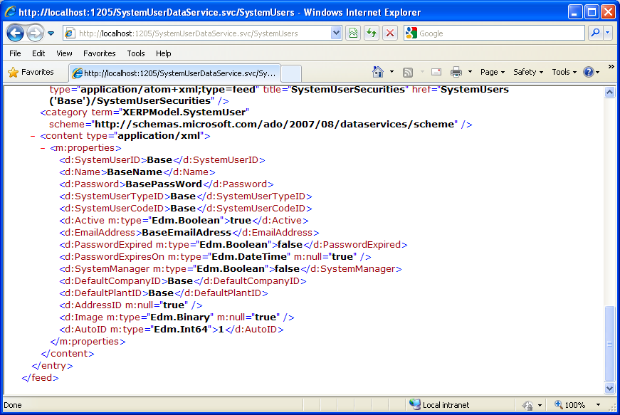
Diagram B-13 http://localhost:1205/SystemUserDataService.svc/SystemUsers Restful User Query Example…

CLIENT SIDE CREATION

Domain Creation – yes the domain is client side…
- Add Domain Project…
  - Right Click on the Domain Folder and Select Add→New Project
  - Select Empty Project…
  - Name it XERP.Domain.XxxDomain
  - Select the C:\XERP\XERP.Domain\ Folder location…
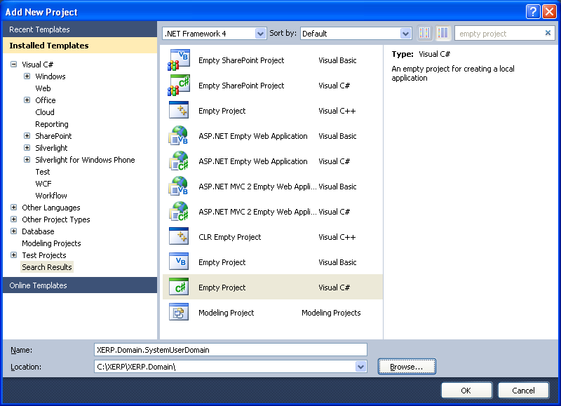
Diagram C-1 Create Domain Project…
  - Add the shared AssemblyInfo.cs as a linked file…
    - refer to the directions and Diagram A-5 Add SharedAssemblyInfo.cs as a linked file
    - As all projects within XERP will required the SharedAssemblyInfo.cs file…\
  - Set Domain Project Properties…
    - Right Click on the newly created Domain Project and select Properties…
    - Select the Application Tab…
      - Check the Assembly Name and Default Namespace
        - Make sure they are both XERP.Domain.XxxDomain
        - Change the Output type: to be Class Library
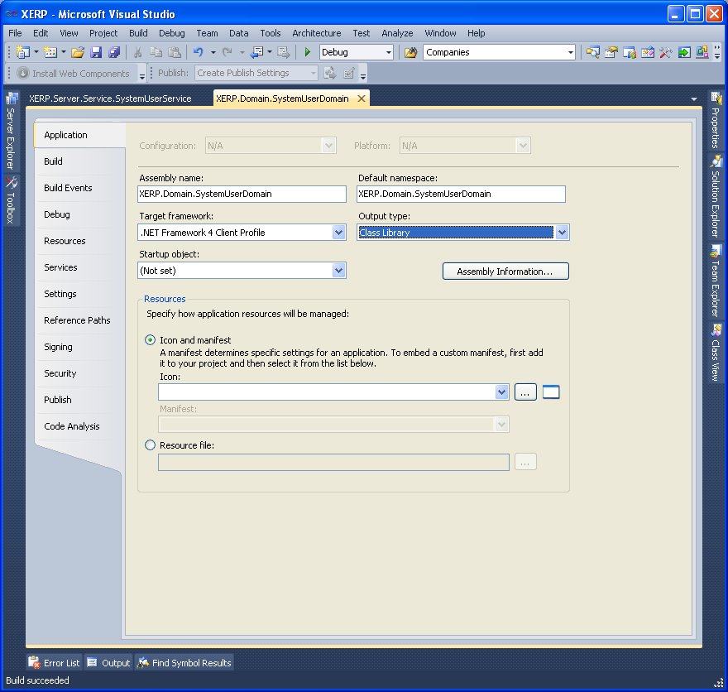
Diagram C-2 Domain Application Properties
  - Click the Assembly Information Button…
    - Provide the Title and Description; same as the Assembly Name…
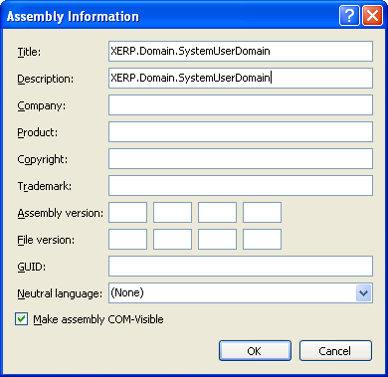
Diagram C-3
    - Delete the global Assembly properties as they will be provided by the Shared
      - Review steps near diagram A-8 and A-9 the same steps will apply for all XERP projects…
    - Select the Build Tab…
      - Select the All Configurations from the Configuration: dropdown…
      - Set the Output Path to be ..\XERPDomainBuild\bin\
      - We do this to consolidate are build files to a shared release file…
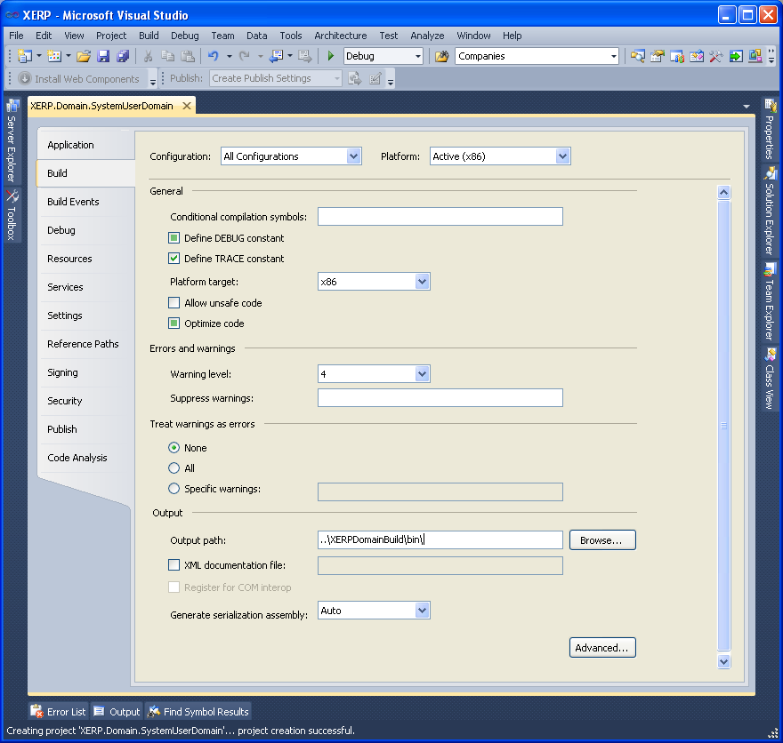
Diagram C-4 Domain Project Debug Build Output Path…
  - Add Required Project References
    - On the newly created domain project right click on the References folder
      - From the Projects Tab
      - Select XERP.Client
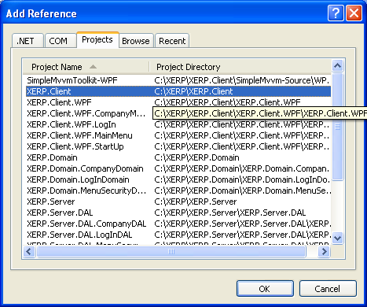
Diagram C-5 Add XERP.Client Project Reference…
- Add the domain logic…
  - There is a lot of code that is required to support the domain logic…
  - We can leverage the SecurityGroupDomain Logic…
  - Expand the XERP.Domain.SecurityGroup Domain project…
    - Copy the XERP.Domain.SecurityGroup Services folder and all its contents…
    - Paste the contents in to your newly created Domain Project…
  - We will change all .cs Files from SecurityGroup to Xxx…
Diagram C-7
  - We will do a mass find and replace for each of the SecurityGroup Domain objects we pasted in…
  - Do a mass replace as below for each of the service classes you pasted in…
  - We can select Entire Solution from the Look In: option…
  - Again we should take care of plural instances first…
    - securityGroups with xxxs/ies depending on your plurality…
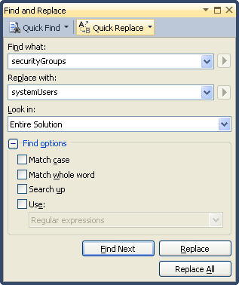
Diagram C-6
    - SecurityGroups with Xxxs/ies depending on your plurality…
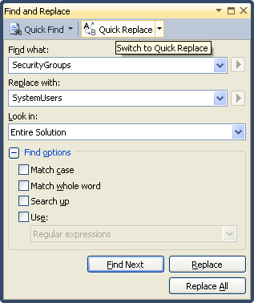
Diagram C-7

    - SecurityGroup with Xxx
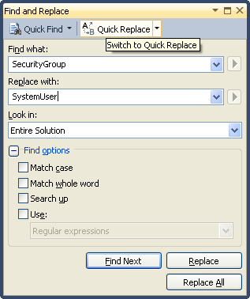
Diagram C-8
    - securityGroup with xxx
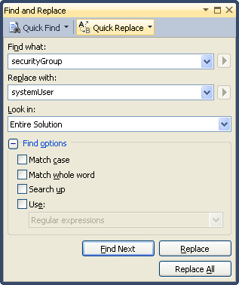
Diagram C-9
    - You can use Replace All
      - but it is important to note that their may be a xxx that is a field definition…
      - Or something to that effect that may not require to be modified…
      - When you are done with each class it will or should have no errors…
      - As well their may be instances in the class where only Xxx is found and replaced…
      - Take away here is that we need redefine the Object from Copied SecurityGroup to Xxx
        - Maintaining its camel case or plurality where and when required…
    - Before we do a build we will need to bring in the Service Reference…
      - The reason we do the service reference last is it has a bunch of
      - Client side references that we may whack in our mass replace of SecurityGroup…
      - So doing it after the mass replace is optimal….
      - And we can not build until we put it in as it is the link back to the entity model…
- Add the Service Reference…
  - Right click on the new Domain Project’s Reference Folder
    - Select Add Service Reference…
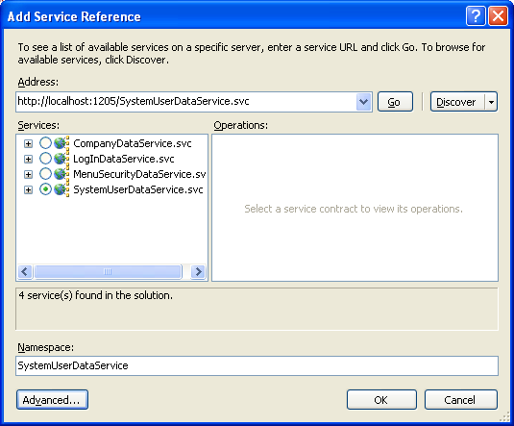
Diagram C-10
    - Click the discover button
      - It will display all the services available to the solution…
      - Select the XxxDataService.svc
        - This is the service we created in the Service Creations steps…
      - Change the namespace to XxxDataService
      - Click OK to generate the service reference…
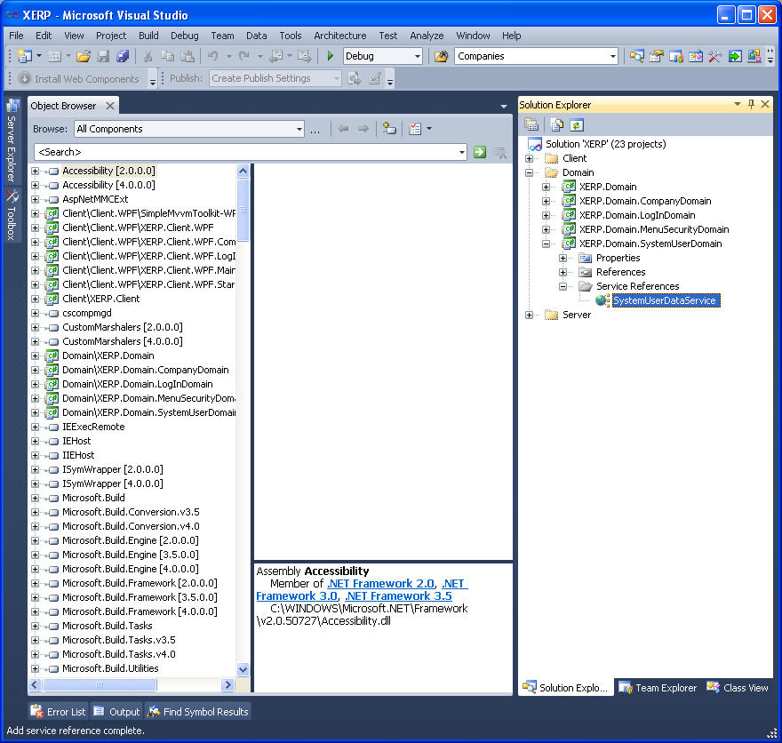
Diagram C-11
      - You will then see the XxxDataService in the Solution Explorer as above…
    - Deal with any left over errors…
    - Modify the jackknife search method if required…
      - Look for this method substituting Xxx with your object name… GetXxxs(Xxx xxxQueryObject)
      - The fields within the search object may match and may just be a matter of adding additional ones…
      - The method below is the jack knife search method…
        - It accepts the objects it is searching for and then has a case statement…
        - And string fields provided in the parameter object will not be null…
        - And then will append the query accordingly using a starts with clause for each field provided in the parameter object…
        - So with that said in order for it to function as expected you will have to add a case for each string in the object…
        - Or you can comment out any of the erroneous cases and move on…
        - Important to note this search jack knife method will only work as well as you code for each string field in the object…
        - So we will deal with any one off errors logically…
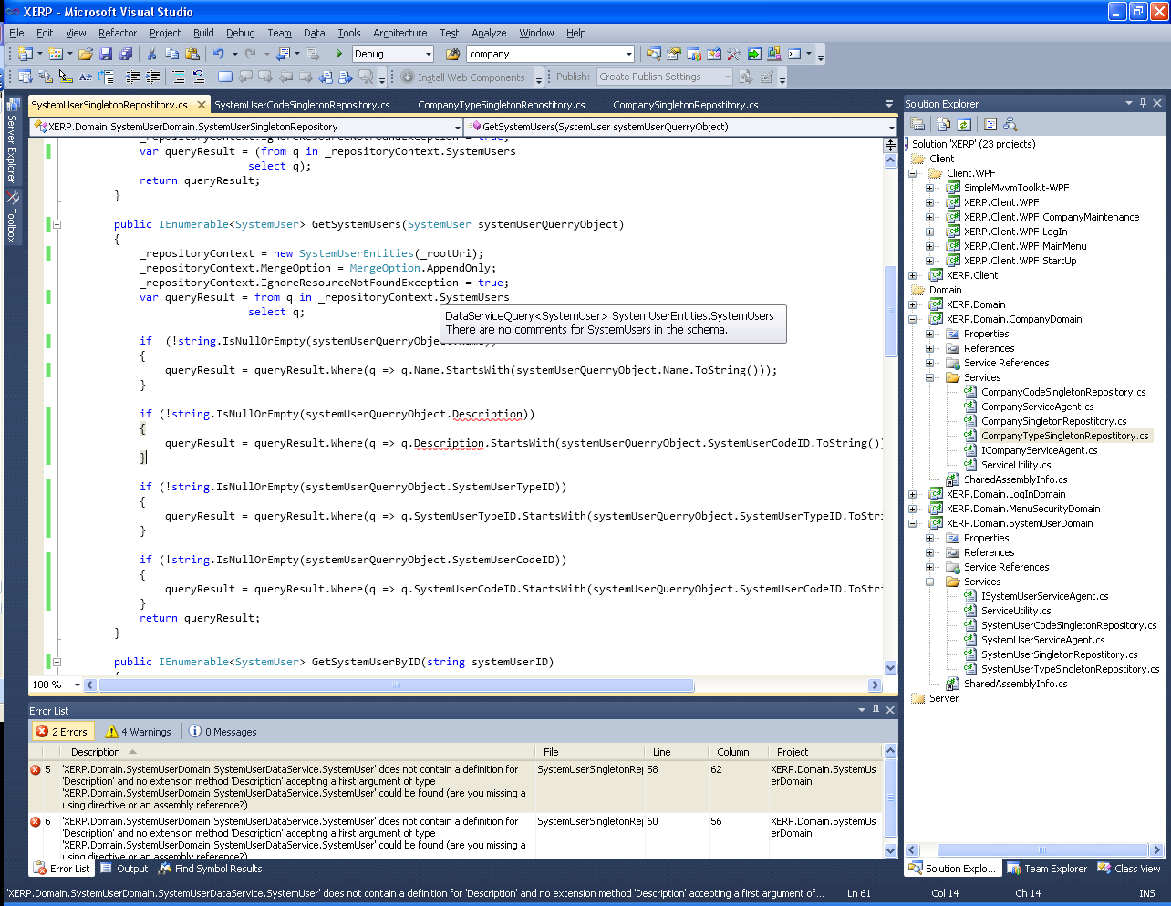
Diagram C-12

- Modify the ServiceUtility.cs
  - Open up the ServiceUtility.cs from the services folder…
  - Modify the Port Number to match what you set it to be in the WCD Data Service Project…
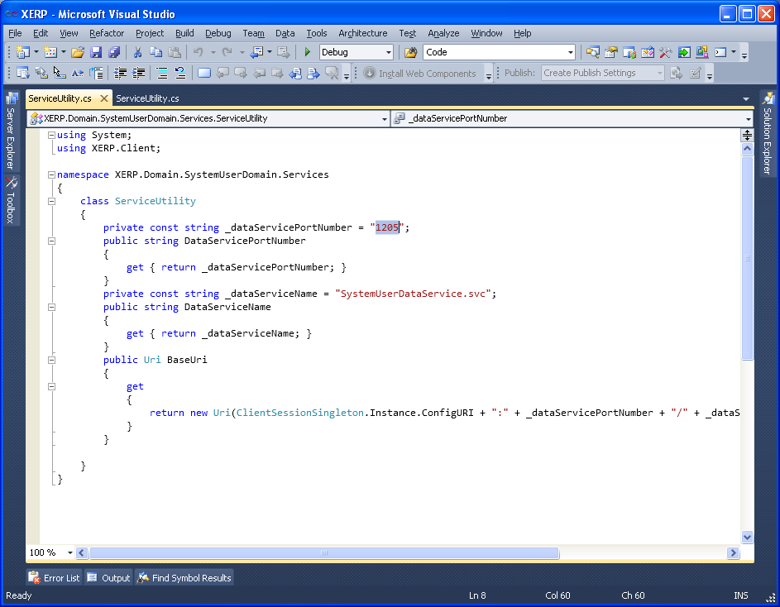
Diagram C-13 Modify Port In ServiceUtility.cs Class
CLIENT WPF CREATION
- Add Client WPF Project…
  - Right Click on the Client.WPF Folder and Select Add→New Project
  - Select WPF Application Project…
  - Name it XERP.Client.WPF.XxxMaintenance
  - Select C:\XERP\XERP.Client\XERP.Client.WPF\ Folder location…
  - Click OK to add the project to the solution…
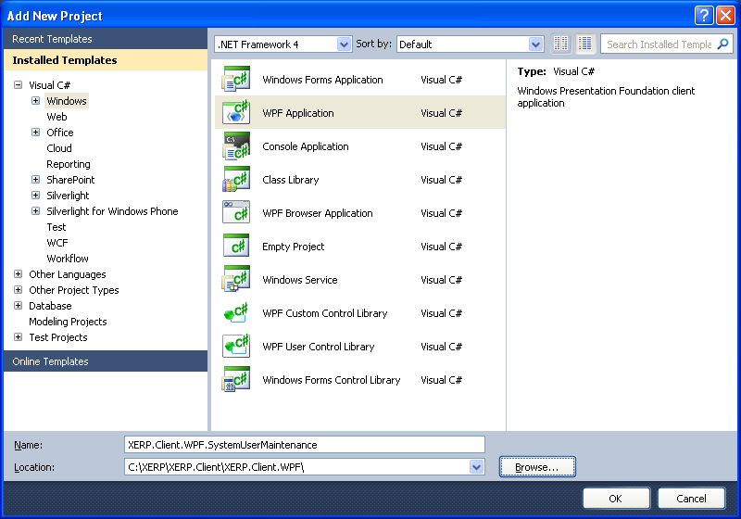
Diagram D-1 Create WPF Project…
  - Add the shared AssemblyInfo.cs as a linked file…
    - refer to the directions and Diagram A-5 Add SharedAssemblyInfo.cs as a linked file
    - As all projects within XERP will required the SharedAssemblyInfo.cs file…
  - Set WPF Project Properties…
    - Right Click on the newly created WPF Project and select Properties…
    - Select the Application Tab…
      - Check the Assembly Name and Default Namespace
        - Make sure they are both XERP.Client.WPF..xxxMaintenance
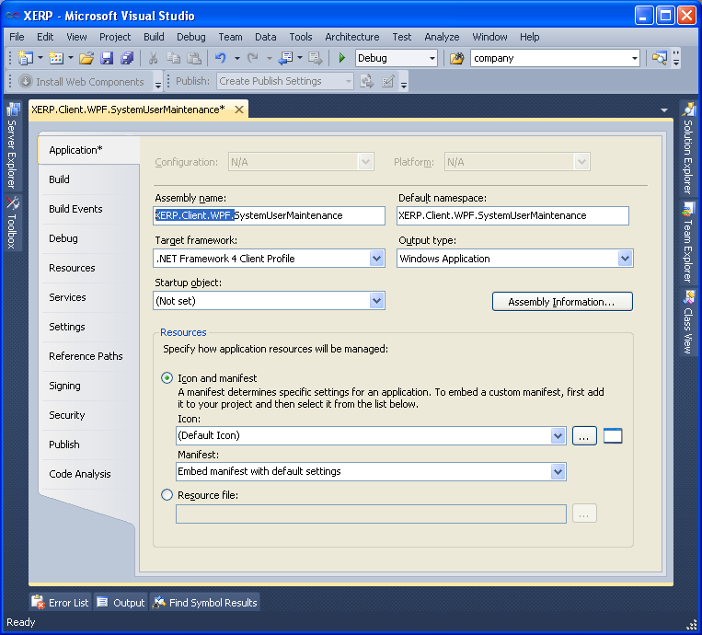
Diagram D-2 WPF Application Properties
  - Click the Assembly Information Button…
    - Provide the Title and Description; same as the Assembly Name…
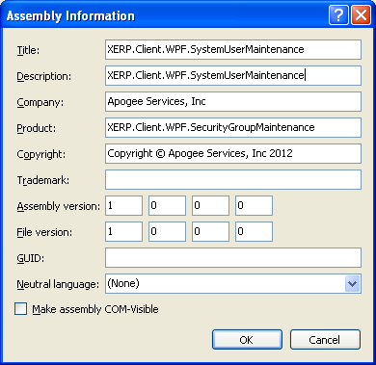
Diagram D-3
    - Review steps near diagram A-8 and A-9 to resolve global and project level assembly properties
      - the same steps will apply for all XERP projects…
    - Select the Build Tab…
      - Select All Configurations from the Configuration: dropdown…
      - Set the Output Path to be ..\..\XERPClientBuild\Bin\
      - We do this to consolidate are build files to a shared release folder…
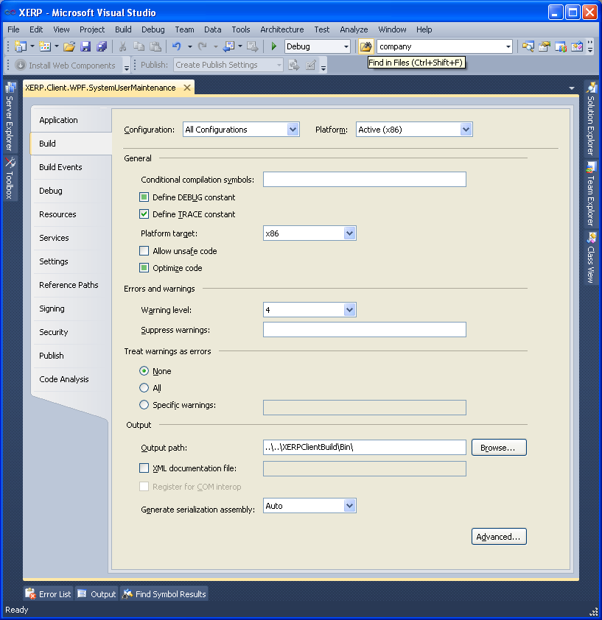
Diagram D-4 WPF Project Debug Build Output Path…
  - Add Required Project References
    - On the newly created domain project right click on the References folder
      - From the Projects Tab
      - Select
        - SimpleMvvmToolkit-WPF
        - XERP.Client
        - XERP.Client.WPF
        - XERP.Client.WPF.Login
        - XERP.Domain
        - XERP.Domain.XxxDomain
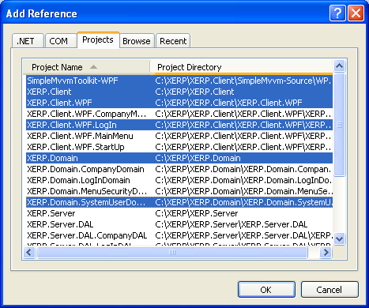
Diagram D-5 Add WPF Project Reference…
  - As well add the following .net References
    - Mircrosoft.Expression.Interactions
    - System.Windows.Interactivity
    - System.Data.Services.Client
- Copy in SecurityGroup WPF content…
  - There is a lot of POCO and XAML that creates and supports the maintenance screens…
  - Select the SecurityGroupMaintenance Project
  - Select then entire content from the Locators folder to the TypeSearchWindow.xaml…
  - Exclude the SharedAssemblyinfo.cs
  - And copy it to your clipboard…
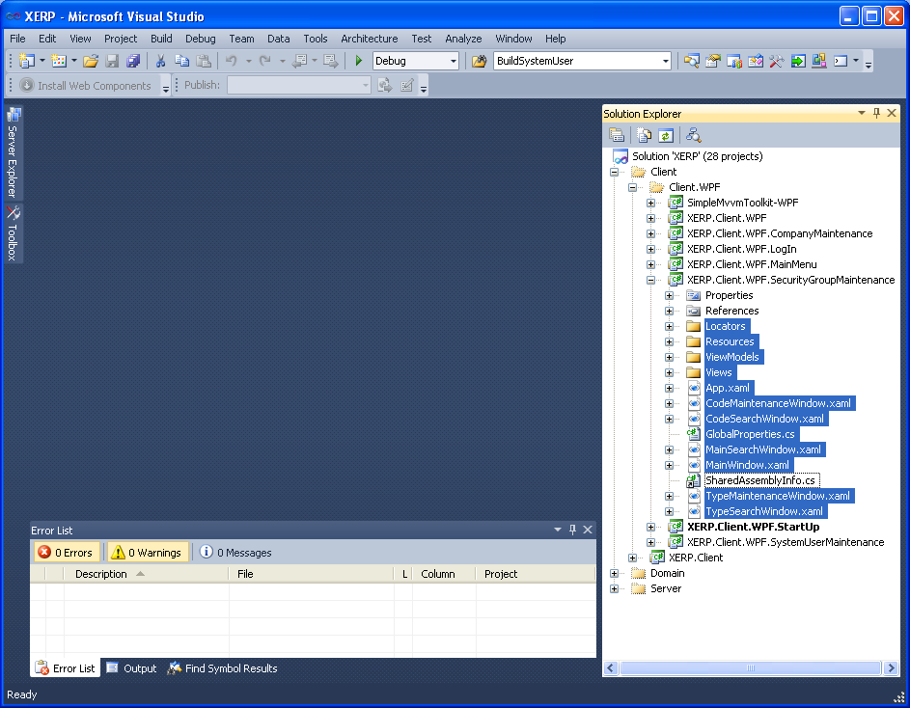
Diagram D-6 Copy WPF Content to your Clipboard
  - Paste the Clipboard contents in to your newly created WPF Project…
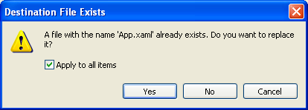
Diagram D-7 Click Yes Overwrite App.XAML…
  - When you get this message click Yes…
    - Do a project wide Replace make sure it is Case Sensative…
      - SecurityGroups to Xxxs/ies whatever the plurality requires…
      - securityGroups to xxxs/ies whatever the plurality requires…
      - SecurityGroup to Xxx
      - securitygroup to xxx
    - Build the project deal with any one off errors that may spring up…
    - Once the project Builds close it…
    - Open up the entire soltution again…
  - Add Search Tokens for your Main Maintenance UI, Its Code Maintenance UI and its Type Maintenance UI…
    - Open up the Utility.CS class from the XERP.Client Project…
    - Find the public enum MessageTokens
      - Add your tokens as required…
      - For System User we have
        - Main Maintenance Screen
        - Type Maintenance Screen
        - Code Maintenance Screen
      - Each of these screens allows for a search the search functionality opens up a Search screen
        - The tokens we add here allow for the unique token for each search to identify itself to the screen that invoked the search…
        - Allowing the search view to communicate its result back to the view that invoked the search…
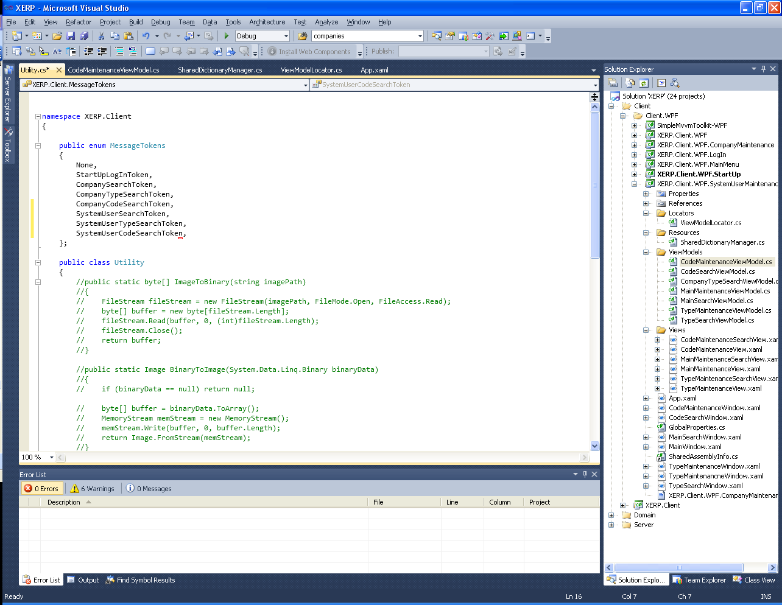
Diagram D-8 Add Search Tokens to Utility.cs Class
- Back door in the Menu Items that will allow the form/s to be opened from the main menu…
  - Create an ExecutableProgram record for each of the WPF Windows in your project…
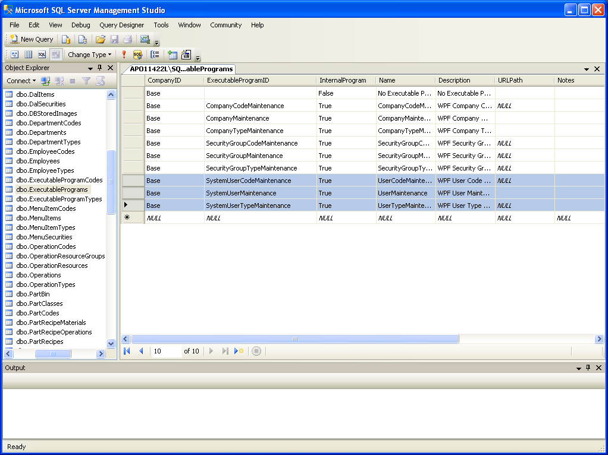
Diagram D-9 Add ExecutableProgram Records…
  - Create MenuItems for any parent folder where you want your Executable Programs to show up on…
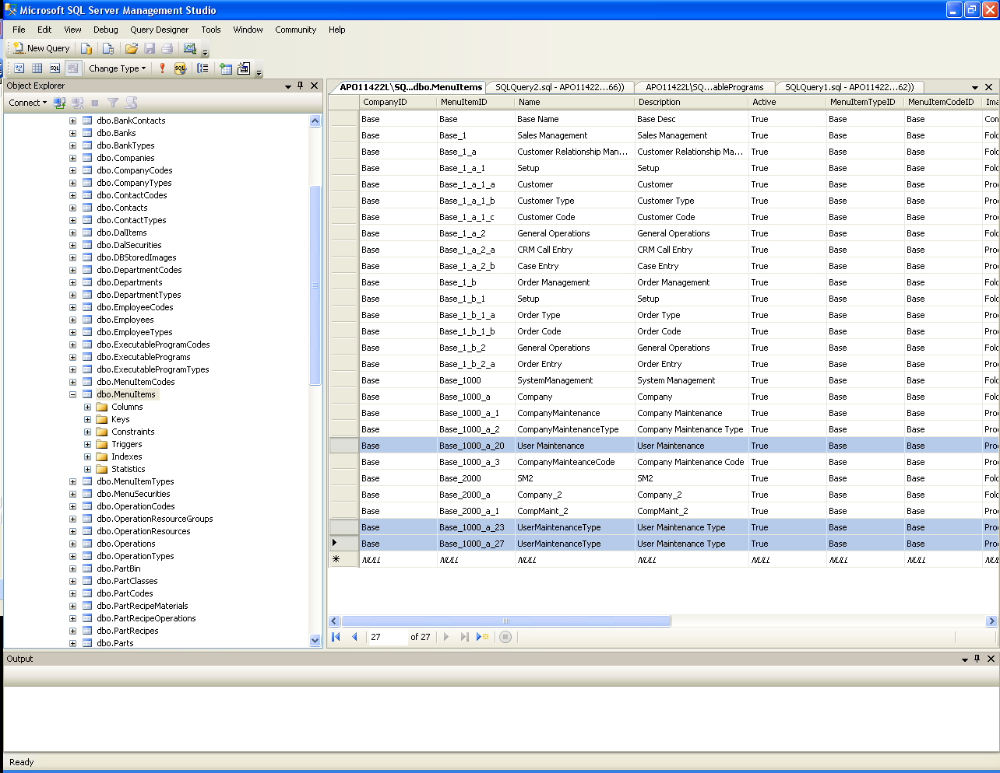
Diagram D-10 Add MenuItems where ever you want Executable Programs to be displayed on the menu…
- Add the Maintenacne Window/s to the WindowLocator Class
  - Open up the …WPF.MainMenu Project…
  - Add the XERP.Client.WPF.Xxx project reference to the WPF.MainMenu Project…
  - Open up the WindowLocator.cs class inside the Locators folder…
  - Add your ExecutableProgram Names to the _executableProgramEnum…
    - As you can see I add the SystemUserMaintenance Executable Programs…
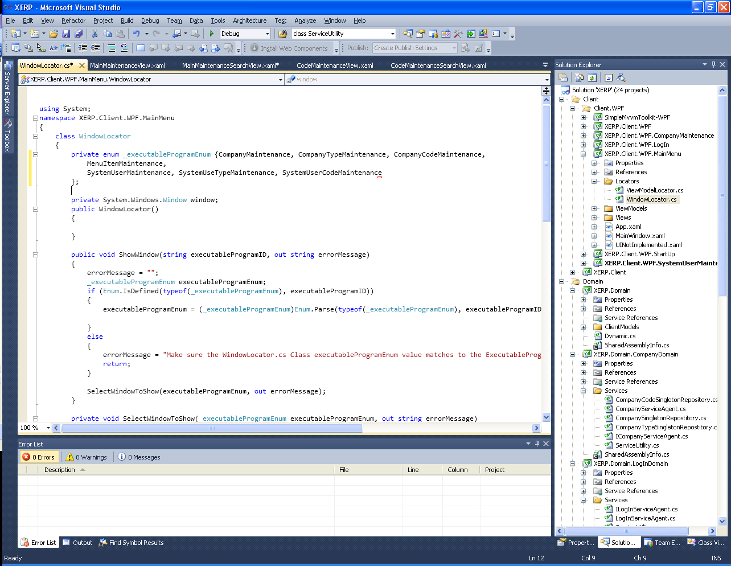
Diagram D-11 Add your ExecutablePrograms to the MainMenu WindowLocator.cs Class _executableProgram Enum enumerator…
  - Add a case for each of your Executable Programs…
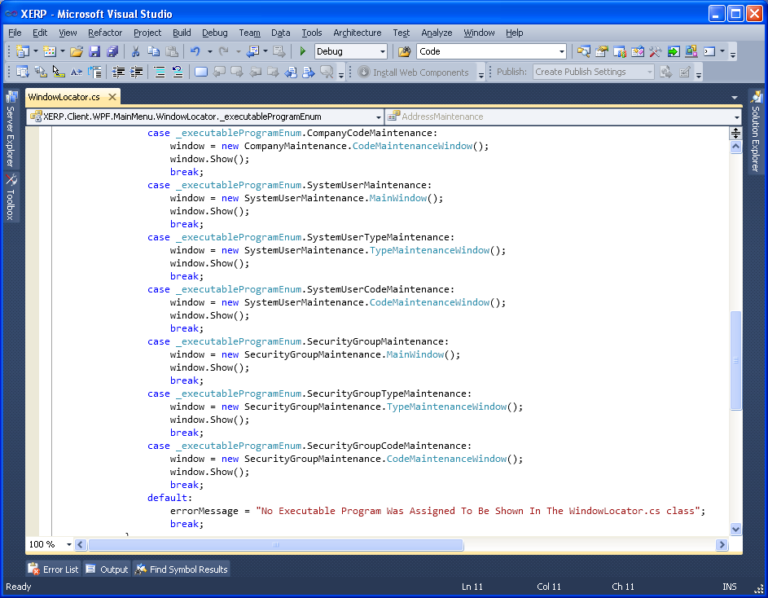
Diagram D-12 Add Case Statements for each of your Executable Programs…

