Assessing the Impact of Environmental and Anthropogenic Factors on Bird Diversity Using Integrated Satellite, Climate, and Air Pollution Data

Dilusha Chandrasiri¹, Maneesha Herath¹, Muditha Herath¹, Yasith Hewarathne¹, Gishan Bandara¹, Sandareka Wickramanayake², Nisansa de Silva², Madara Mendis², Nathali Athukorala²
University of Moratuwa, Department of Computer Science and Engineering; Moratuwa, Sri Lanka
dilushac.23@cse.mrt.ac.lk; maneeshah.23@cse.mrt.ac.lk; mudithah.23@cse.mrt.ac.lk; yasithh.23@cse.mrt.ac.lk; gishanb.23@cse.mrt.ac.lk; sandarekaw@cse.mrt.ac.lk; NisansaDdS@cse.mrt.ac.lk; madara.21@cse.mrt.ac.lk; nathalia@cse.mrt.ac.lk

Abstract - This study presents a comprehensive analysis of bird diversity across Sri Lanka by integrating spatial, temporal, and environmental data. Bird observation records were combined with environmental variables including weather conditions, air pollution, vegetation indices (NDVI), land cover, elevation, and artificial light at night (ALAN), and rigorously preprocessed to ensure data quality. Spatial analyses were conducted at multiple grid scales (2 km, 5 km, 10 km) to evaluate patterns in species richness while minimizing sampling bias through spatial thinning. Temporal trends were assessed using effort-corrected metrics including rarefied richness and occupancy rates to account for variations in observation effort over time. Environmental drivers of bird diversity were examined using multivariate statistical models, including Poisson GLMs and correlation analyses, to identify key associations between ecological factors and species richness. Additionally, community structure, dominance patterns, and beta diversity were analyzed to understand variations in species composition across regions and time. The study found that land-cover type is a stronger predictor of bird diversity than individual continuous variables such as NDVI or temperature alone. Urbanization, measured by ALAN, exhibits nuanced scale-dependent effects, supporting high abundances of a few generalist species while reducing overall richness. The findings provide actionable insights into the patterns and drivers of avian diversity in Sri Lanka, offering a scalable and reproducible framework for biodiversity research and conservation planning.
Keywords: bird diversity, species richness, Sri Lanka, spatial analysis, NDVI, air pollution, artificial light at night (ALAN), Poisson GLM

1. Introduction
This study examines patterns of bird species richness across Sri Lanka and how those patterns relate to environmental conditions measured from satellite and gridded data. The analysis links GBIF bird occurrence records to variables such as vegetation greenness, land-cover type, nighttime light, elevation, temperature, rainfall, and aerosol indicators, summarized at the scale of grid cells within Sri Lanka's subnational regions.
Birds are widely used as indicators of environmental change, and Sri Lanka combines strong ecological variation across a small area with ongoing habitat and land-use change [1]. National-scale information on where diversity is higher or lower, and how it aligns with habitat and climate-related measures, can inform conservation priorities and broader environmental monitoring when complete field inventories are not feasible. Citizen-science databases improve geographic coverage but must be analyzed in ways that separate ecological patterns from uneven sampling [9].
The practical challenge is that citizen-science records are not a random sample: they reflect where people go, how often they report, and spatial clustering. This project addresses that by cleaning and merging disparate data into one analysis- ready dataset, applying spatial thinning and grid-based summaries, and treating correlations and regression results as associative rather than causal. The work aims to produce transparent, comparable summaries of bird diversity and its environmental correlates for Sri Lanka while keeping the limitations of observational data explicit.
2. Literature Review
Understanding the drivers of bird diversity is critical for biodiversity conservation in the face of habitat loss, climate change, and increasing anthropogenic pressures. Traditional field-based monitoring methods are often limited by logistical constraints and insufficient spatial coverage, leading researchers to adopt remote sensing and multi-source data integration as scalable alternatives [7]. Remote sensing provides spatially continuous data on vegetation productivity, structural heterogeneity, and landscape configuration that are key determinants of biodiversity [1]. Vegetation indices such as NDVI have been widely used to represent habitat quality and primary productivity closely linked to bird species richness [4], while VIIRS-derived nighttime light data serve as reliable global indicators of human activity and infrastructure [11].

Anthropogenic pressures, particularly urbanization and agricultural intensification, are well-documented drivers of avian diversity loss [10]. Artificial light at night disrupts foraging, migration, and reproduction in many bird species [12], and urbanization broadly reduces species richness while promoting biotic homogenization [13]. The SatBird dataset links satellite imagery with citizen-science eBird records to enable scalable species encounter-rate modelling [5], and the EcoCast framework demonstrates how multi-modal inputs can forecast biodiversity patterns and climate risk [6]. NDVI shows stronger explanatory power when combined with land-cover classification rather than used as a standalone variable [4], and field and remote sensing integration enables perception of species heterogeneity across climate gradients [8]. Overall, the literature underscores the value of integrating satellite-derived indicators, climate variables, and anthropogenic data to capture the complex interacting drivers of bird diversity.
3. Methodology
3.1. Study Area and Data Sources
Sri Lanka was selected as the study area due to its exceptional ecological diversity concentrated within a small geographic extent, encompassing tropical lowland rainforests, montane cloud forests, dry-zone scrublands, and coastal wetlands [1]. Bird occurrence records were obtained from the Global Biodiversity Information Facility (GBIF) via the eBird citizen-science platform [9]. Environmental datasets include MODIS-derived NDVI and IGBP land-cover classification (17 classes); VIIRS nighttime light radiance as a proxy for urbanization [11]; MERRA-2 reanalysis variables for climate (temperature, rainfall, wind speed, humidity, shortwave radiation) and aerosol optical properties; and SRTM elevation data. All datasets were spatially aligned and merged into a unified analysis-ready database by joining environmental values to each occurrence record based on geographic coordinates.
3.2. Data Preprocessing and Bias Correction
Incomplete, duplicate, and unreliable records were removed before the analysis. Continuous variables were assessed for distributional skewness: NDVI (left-skewed) and ALAN (right-skewed) were normalized using a Yeo-Johnson power transformation, while bird abundance (individualCount) was log-transformed for bivariate analyses. Records where the cloud-free coverage band (cf_cvg) equaled zero were excluded to prevent the incorporation of interpolated or missing satellite data [3]. To mitigate spatial observer bias in citizen-science data, spatial thinning was applied by retaining at most one occurrence record per species per grid cell within each district, reducing pseudoreplication and ensuring richness summaries reflect genuine habitat-level occurrence.
3.3. Diversity Metrics and Spatial Aggregation
Bird diversity was quantified primarily using species richness, complemented by Shannon diversity, species occupancy (fraction of grid cells where a species was detected within a district), pairwise Jaccard dissimilarity for beta diversity, and Berger-Parker, Simpson, and Pielou evenness indices for community structure. The primary spatial analysis was conducted at a 5 km grid resolution, with 2 km and 10 km grids used for sensitivity testing. Rarefaction with 300 random subsamples per replicate was applied to standardize cross-district comparisons under unequal sampling effort.
3.4. Environmental and Anthropogenic Analysis
NDVI and rainfall were used to characterize vegetation phenology through dual-axis time-series analysis linking monthly NDVI to the monsoon calendar. NDVI distributions across the 17 IGBP land-cover classes were examined using violin plots. Because biological count data violate normality assumptions, a non-parametric Kruskal-Wallis H-test assessed the significance of land-cover class on avian distributions, followed by pairwise post-hoc comparisons. ALAN was used as a proxy for urbanization [11]; its associations with MERRA-2 aerosol variables were assessed via Pearson correlation, and its effect on habitat greenness via LOWESS regression against NDVI. A Spearman rank-order correlation matrix across all continuous environmental and biological variables was constructed to evaluate monotonic relationships and identify multicollinearity before modelling.
3.5. Statistical Modelling and Temporal Analysis
Pearson and Spearman correlations and ordinary least squares (OLS) regression served as initial exploratory analyses. Poisson generalized linear models (GLMs) with a log link and robust HC1 standard errors were used as the primary modelling framework for species richness as count data (n = 1,736 thinned grid cells). Predictors included NDVI, modal IGBP land-cover class, ALAN, elevation, mean temperature, rainfall, and total aerosol extinction. Temporal patterns were evaluated through monthly and annual richness indices and cross-correlation with rainfall. Effort-corrected temporal indices included rarefied annual richness, district-year richness per 100 sampled cells, and species occupancy on a stable grid panel. Species-specific abundance trends were estimated as log-linear slopes of annual abundance with Benjamini-Hochberg FDR correction.
4. Experiments and Results
The work proceeds along three complementary lines: (1) exploratory analyses at the level of individual records examining how temperature, vegetation, land cover, and air pollution co-vary with counts and diversity summaries; (2) spatially explicit analyses at the district scale using grid-based thinning, multivariate regression, and measures of compositional turnover; and (3) temporal analyses summarizing monthly and annual patterns in diversity and environment using effort-corrected indices.
4.1. Dataset Overview and Spatial Thinning
After cleaning and integration, the final dataset contained approximately 1.55 million records spanning 25 administrative districts and 429 bird species. Occurrence records were strongly clustered in western and southern coastal areas (55.988%), with the central (26.458%), northern (15.741%), and eastern (1.8%) regions markedly underrepresented, confirming the need for spatial thinning before richness comparisons. After thinning at 5 km resolution, island-wide species count remained stable at 429 across all grid resolutions tested (2 km, 5 km, 10 km), with a mean cell-level richness of 243.64 species per cell, indicating that district-level summaries are robust to the choice of thinning scale.
4.2. Effects of Habitat and Environmental Variables
Dual-axis time-series analysis confirmed that NDVI peaks lag behind monsoon rainfall onset, consistent with vegetation green-up following precipitation pulses.
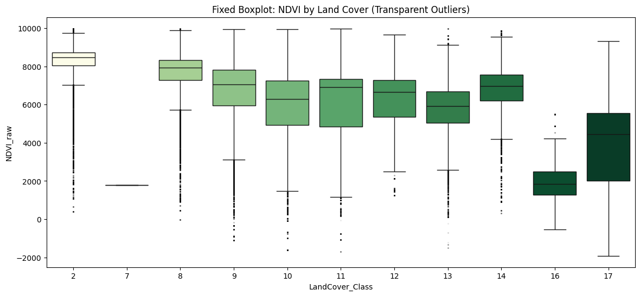
Fig. 1: Distribution of True NDVI partitioned by IGBP Land Cover classifications, highlighting the stability of evergreen habitats versus the volatility of croplands.

Violin plots of NDVI across the 17 IGBP classes revealed strong habitat partitioning: evergreen forests maintained high, stable NDVI while croplands showed pronounced seasonal variability. A Kruskal-Wallis test confirmed highly significant differences in avian distributions across land-cover categories (H > 1000, p < 0.001), with natural habitats, particularly evergreen forests and woody savannas, supporting substantially higher and more stable bird records than human-altered landscapes. Temperature also differed strongly among districts (Kruskal-Wallis, p ≈ 0). In contrast, the correlation between NDVI and raw observation counts was negligible (Pearson r = -0.022; Spearman rho = -0.094), and richness showed only weak positive associations with NDVI (rho = 0.033), despite statistically significant p-values driven by a large sample size. Land-cover class was a far stronger predictor: Kruskal-Wallis tests for richness (H = 295.0, p = 1.79×10⁻⁵⁷) and Shannon diversity (H = 333.3, p = 1.39×10⁻⁶⁵) confirmed that discrete habitat type dominates over continuous greenness measures.
4.3. Effects of Urbanization and Pollution
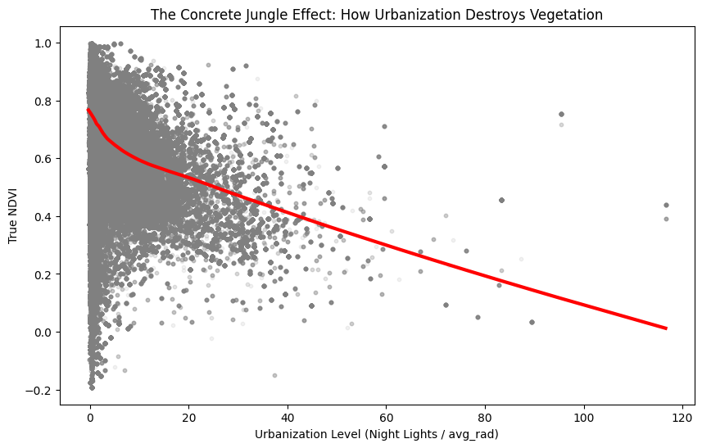
Pearson correlation revealed a strong positive association between nighttime radiance and MERRA-2 aerosol variables, reflecting the co-location of urbanization, traffic, and industrial pollution [13].
Fig. 2: LOWESS regression demonstrating the steep decline in vegetation density (NDVI) as Artificial Light At Night (ALAN) increases, indicating progressive urban habitat degradation.

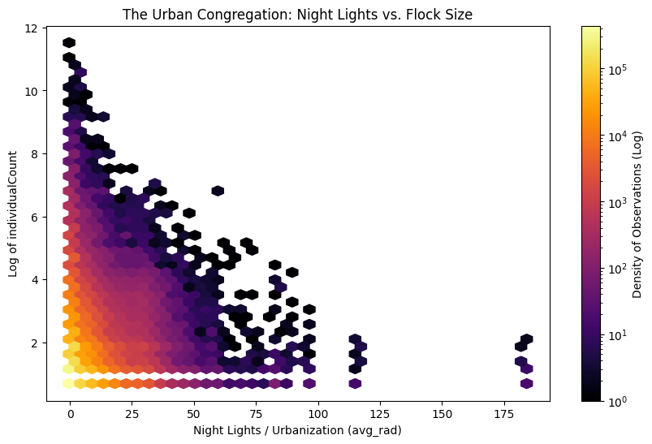
LOWESS regression confirmed a steep decline in NDVI with rising ALAN [12]. Across all records, correlations between bird counts and aerosol variables were negligible (|r| ≈ 0.01); however, species-level analysis revealed strong taxon-specific responses (e.g., Merops persicus |rho| ≈ 0.736 with several pollutant metrics), illustrating that pollution effects are heterogeneous rather than uniform [14].
Fig. 4: Hexbin density plot showing the urban congregation effect, where highly-lit areas support exceptionally large bird flocks while rural areas show moderate counts.

The hexbin density plot confirms a dual role for ALAN: highly lit areas support high abundances of a few synanthropic species while overall richness and evenness are reduced - consistent with biotic homogenization along urban gradients [15].
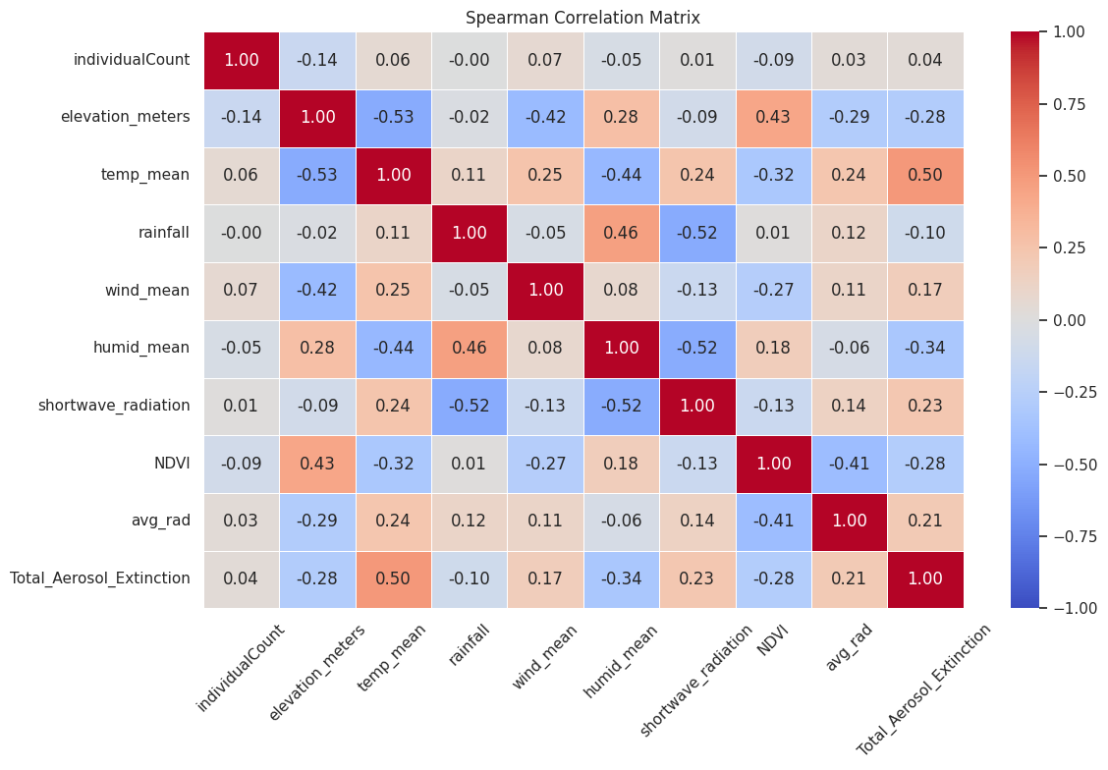
4.4. Multivariate Modelling of Species Richness
Fig. 3: Spearman rank correlation matrix of continuous environmental variables and biological metrics, revealing multicollinearity patterns among predictors.

The Spearman correlation matrix revealed complex multicollinearity: elevation correlated strongly and negatively with temperature (rho ≈ -0.85), and precipitation showed a positive association with NDVI. Bivariate correlations with raw bird abundance were statistically significant (p < 0.001) but ecologically negligible (rho < 0.2), reflecting the large-sample effect in crowd-sourced data. Among OLS models, the specification including NDVI and land-cover terms showed the strongest fit (Spearman r = 0.150, p = 7.28×10⁻¹⁰), outperforming climate-only (R² = 0.008) and aerosol-only (R² = 0.011) models. The Poisson GLM achieved a Cox-Snell pseudo R² ≈ 0.804 (training-sample fit). Key significant predictors were NDVI (negative, p ≈ 0.047), nighttime radiance (positive, p ≈ 0.002), mean temperature (negative, p ≈ 0.002), and several land-cover contrasts. Elevation, rainfall, and aerosol extinction were not significant. All results are associative, not causal.
4.5. Temporal and Regional Diversity Patterns
Monthly species richness and Shannon diversity showed strong seasonality, with higher richness in January–March and November–December and lower Shannon diversity during the late monsoon season. Cross-correlation analysis indicated richness aligns more clearly when rainfall leads by several months, consistent with a delayed ecological response through vegetation dynamics [4]. Effort-corrected rarefied
richness and district-year occupancy rates confirmed that temporal trends are not driven purely by sampling variation. Regional comparisons based on pairwise Jaccard dissimilarity revealed substantial compositional turnover across districts, indicating that bird communities differ meaningfully in structure across the island. Species-specific log-linear abundance trends with Benjamini-Hochberg FDR correction
confirmed that diversity changes are not uniform across taxa or regions [16].
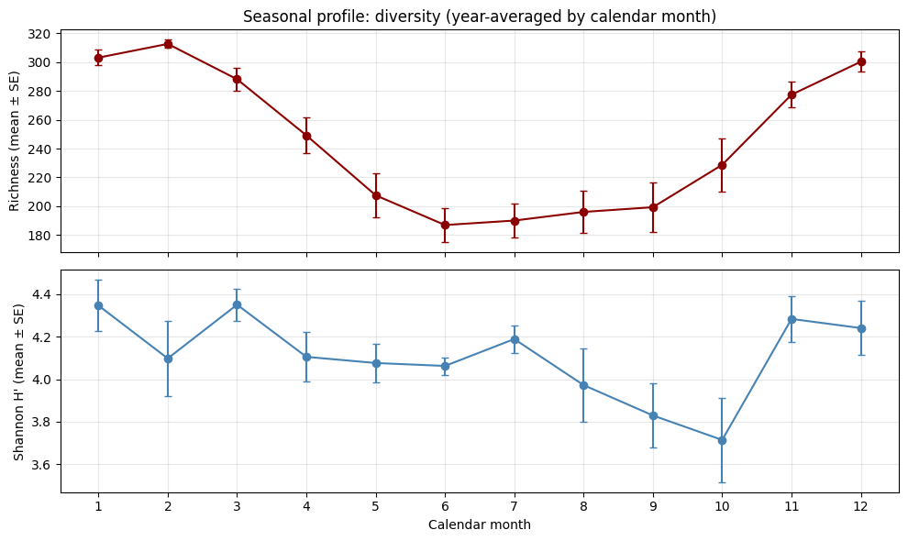
5. Discussion
A central finding of this study is the relatively weak association between individual continuous variables (NDVI, temperature, air pollution) and bird species richness in isolation. Despite statistically significant p-values attributable to the large sample size, effect sizes were ecologically small [1][2]. Categorical habitat structure - particularly IGBP land-cover class — emerged as a much stronger determinant, with natural ecosystems such as evergreen forests and woody savannas consistently supporting higher and more stable species richness than human-modified landscapes [8]. NDVI showed stronger explanatory power when combined with land- cover type, reinforcing that habitat quality is multidimensional and encompasses structure, composition, and disturbance regime, not productivity alone [4][10].

Anthropogenic influences exhibited nuanced scale-dependent effects. ALAN, used as a proxy for urban intensity, showed a dual role: weak positive associations with richness at fine scales likely reflect increased observer effort in accessible urban areas, while deeper analysis confirmed biotic homogenization – disproportionately high abundances of a few adaptable species alongside reduced overall richness and evenness [13][15]. Air pollution had minimal global effects but strong taxon- specific associations, suggesting that sensitivity depends on species traits such as ecological tolerance and feeding ecology [12][14].

Spatially, thinning and grid-based aggregation were essential for mitigating citizen-science sampling bias [9]. Richness summaries were stable across grid resolutions (2 km, 5 km, 10 km), strengthening confidence in observed spatial patterns. The Poisson GLM improved explanatory power over bivariate OLS approaches, and use of robust standard errors reflects careful treatment of count data. Nevertheless, the study remains observational and associative; detection probability is not explicitly modelled, limiting inferential strength regarding true species distributions.

For conservation, the dominant role of land cover suggests that protecting and restoring evergreen forest and woody savanna will yield the greatest benefits for avian diversity. Substantial beta diversity across districts indicates that strategies should be region-specific rather than island-wide uniform policies [16]. The integrated multi-source approach demonstrated here is scalable, reproducible, and adaptable to other taxa and geographies, supporting environmental monitoring under data-limited conditions.
6. Conclusion
This study presented an integrated, data-driven assessment of bird diversity across Sri Lanka by combining large-scale citizen-science occurrence records with satellite-derived environmental variables, climate data, air pollution indicators, and anthropogenic proxies. The findings demonstrate that bird diversity is governed by the interaction of multiple factors, with habitat structure (land-cover type) consistently showing stronger associations with species richness than individual continuous variables, while urbanization captured by ALAN promotes biotic homogenization by supporting a few generalist species at the expense of overall richness and evenness. Spatial thinning, grid-based aggregation, and effort-corrected temporal metrics proved essential for reliable biodiversity estimation from opportunistic data, and this reproducible framework offers a strong foundation for conservation prioritization, environmental monitoring, and future development of more predictive biodiversity models across tropical island systems.
7. Acknowledgements
The authors acknowledge the Global Biodiversity Information Facility (GBIF) for providing open-access bird occurrence data, and eBird for the citizen-science observation platform. Environmental data were sourced from MODIS, MERRA-2, VIIRS, and SRTM satellite and reanalysis products. The authors also thank the scientific community whose open-source tools and published methodologies informed the analytical framework of this study.

References

[1] M. L. Hunt, G. A. Blackburn, G. M. Siriwardena, and C. S. Rowland, "Using satellite data to assess spatial drivers of bird diversity," Remote Sens. Ecol. Conserv., vol. 9, no. 4, pp. 483-500, 2023. doi: 10.1002/rse2.322.
[2] I. Ribeiro, V. Proenca, P. Serra, J. Palma, C. Domingo-Marimon, X. Pons, and T. Domingos, "Remotely sensed indicators and open-access biodiversity data to assess bird diversity patterns in Mediterranean rural landscapes," Sci. Rep., vol. 9, art. 6826, 2019. doi: 10.1038/s41598-019-43330-3.
[3] C. D. Elvidge, M. Zhizhin, T. Ghosh, F.-C. Hsu, and J. Taneja, "Annual Time Series of Global VIIRS Nighttime Lights Derived from Monthly Averages: 2012 to 2019," Remote Sensing, vol. 13, no. 5, art. 922, 2021. doi: 10.3390/rs13050922.
[4] N. Pettorelli, J. O. Vik, A. Mysterud, J.-M. Gaillard, C. Tucker, and N. C. Stenseth, "Using the satellite-derived NDVI to assess ecological responses to environmental change," Trends Ecol. Evol., vol. 20, no. 9, pp. 503-510, 2005. doi: 10.1016/j.tree.2005.05.011.
[5] M. Teng, E. Elmustafa, B. Akera, Y. Bengio, H. Larochelle, H. Rolnick, and M. Brandt, "SatBird: Bird Species Distribution Modeling with Remote Sensing and Citizen Science Data," arXiv:2311.00936, 2023. [Online]. Available: https://arxiv.org/abs/2311.00936
[6] H. A. Akande and A. A. Gidado, "EcoCast: A Spatio-Temporal Model for Continual Biodiversity and Climate Risk Forecasting," arXiv:2512.02260, 2025. [Online]. Available: https://arxiv.org/abs/2512.02260
[7] H. Nagendra, "Using remote sensing to assess biodiversity," Int. J. Remote Sens., vol. 22, no. 12, pp. 2377-2400, 2001. doi: 10.1080/01431160116866.
[8] P. Sharma et al., "Integrating field- and remote sensing data to perceive species heterogeneity across a climate gradient," Sci. Rep., vol. 13, art. 22698, 2023. doi: 10.1038/s41598-023-50812-y.
[9] B. L. Sullivan et al., "The eBird enterprise: An integrated approach to development and application of citizen science," Biol. Conserv., vol. 169, pp. 31-40, 2014. doi: 10.1016/j.biocon.2013.11.003.
[10] P. F. Donald, R. E. Green, and M. F. Heath, "Agricultural intensification and the collapse of Europe's farmland bird populations," Proc. R. Soc. Lond. B, vol. 268, pp. 25-29, 2001. doi: 10.1098/rspb.2000.1325.
[11] C. D. Elvidge, K. Baugh, M. Zhizhin, F.-C. Hsu, and T. Ghosh, "VIIRS night-time lights," Int. J. Remote Sens., vol. 38, no. 21, pp. 5860-5879, 2017. doi: 10.1080/01431161.2017.1342050.
[12] K. J. Gaston, J. Bennie, T. W. Davies, and J. Hopkins, "The ecological impacts of nighttime light pollution: A mechanistic appraisal," Biol. Rev., vol. 88, no. 4, pp. 912-927, 2013. doi: 10.1111/brv.12036.
[13] M. L. McKinney, "Urbanization, Biodiversity, and Conservation," BioScience, vol. 52, no. 10, pp. 883-890, 2002. doi: 10.1641/0006-3568(2002)052[0883:UBAC]2.0.CO;2.
[14] B. J. McGill et al., "Species abundance distributions: moving beyond single prediction theories to integration within an ecological framework," Ecol. Lett., vol. 10, no. 10, pp. 995-1015, 2007. doi: 10.1111/j.1461-0248.2007.01094.x.
[15] R. B. Blair, "Land Use and Avian Species Diversity Along an Urban Gradient," Ecol. Appl., vol. 6, no. 2, pp. 506-519, 1996. doi: 10.2307/2269387.
[16] C. M. McCain, "Global analysis of bird elevation diversity," Global Ecol. Biogeogr., vol. 18, no. 3, pp. 346-360, 2009. doi: 10.1111/j.1466-8238.2008.00443.x.

