## Python install

<https://www.python.org/downloads/windows/>下载python-2.7.15.amd64.msi

安装python-2.7.15.amd64.msi时，选择add python.exe to Path

重启windows

Cmd下 python --version

http://www.jetbrains.com/pycharm/ 下载pycharm-professional-2018.2.5.exe

安装pycharm

## virtualenv

[root@localhost python]# python --version

Python 2.7.5

easy_install pip

pip list

pip install virtualenv

virtualenv –h

[root@localhost python]# virtualenv --version

15.1.0

mkdir -p /home/python/

cd /home/python/

virtualenv ENV

cd ENV/

source ./bin/activate

pip list

deactivate

cd /home/python/

virtualenv --no-site-packages ENV2

source ENV2/bin/activate

pip list

pip install jinja2

pip list

deactivate

ls ENV2/lib/python2.7/site-packages/

source ENV/bin/activate

pip list

deactivate

## scrapy

<http://scrapy-chs.readthedocs.io/zh_CN/1.0/intro/tutorial.html>

cd /home/python

source /home/python/ENV/bin/activate

(ENV) [root@localhost python]# pip install scrapy

scrapy startproject tutorial

cd tutorial/tutorial/spiders/

(ENV) [root@localhost spiders]# cat quotes_spider.py

import scrapy

class QuotesSpider(scrapy.Spider):

name = "quotes"

def start_requests(self):

urls = [

'http://quotes.toscrape.com/page/1/',

'http://quotes.toscrape.com/page/2/',

]

for url in urls:

yield scrapy.Request(url=url, callback=self.parse)

def parse(self, response):

page = response.url.split("/")[-2]

filename = 'quotes-%s.html' % page

with open(filename, 'wb') as f:

f.write(response.body)

self.log('Saved file %s' % filename)

(ENV) [root@localhost spiders]# scrapy crawl quotes

## Django – News

F:\python\web\Django

<http://study.163.com/course/courseLearn.htm?courseId=1004713025#/learn/video?lessonId=1049484933&courseId=1004713025>

### Setup

**Python on Windows 10**

1. Install python-2.7.14.amd64.msi

2 setup environment variable

系统变量Path里添加

C:\Python27\;C:\Python27\Scripts;

3.test python on commandline

Windows cmd

C:\Users\Shanping>python --version

Python 2.7.14

**Vitualenv**

easy_install pip

pip install virtualenv

C:\Users\Shanping>virtualenv --version

15.1.0

F:\python>cd f:\python\web\News

virtualenv ENV

f:\python\web\News>ENV\Scripts\activate

(ENV) f:\python\web\News>

Django

<https://www.djangoproject.com/download/1.8.19/tarball/>

(ENV) f:\python\web\News>cd Django-1.8.19

(ENV) f:\python\web\News\Django-1.8.19>python setup.py install

(ENV) f:\python\web\News\Django-1.8.19>python

Python 2.7.14 (v2.7.14:84471935ed, Sep 16 2017, 20:25:58) [MSC v.1500 64 bit (AMD64)] on win32

Type "help", "copyright", "credits" or "license" for more information.

>>> import django

>>> django.get_version()

'1.8.19'

**Pycharm**

pycharm-community-2017.2.3.exe

### run

F:\python>cd f:\python\web\News

f:\python\web\News>ENV\Scripts\activate

cd mynews

(ENV) f:\python\web\News\mynews>pip install pillow

(ENV) f:\python\web\News\mynews>pip install pillow

(ENV) f:\python\web\News\mynews>python manage.py runserver 0.0.0.0:8000

Performing system checks...

System check identified no issues (0 silenced).

July 15, 2018 - 14:44:47

Django version 1.8.19, using settings 'mynews.settings'

Starting development server at http://0.0.0.0:8000/

Quit the server with CTRL-BREAK.

<http://localhost:8000/>

--done

**Pycharm**

File -> Open -> “F:\python\web\News\mynews”

File -> setting : project mynews -> Project Interperer

* Add Local -> F:\python\web\News\ENV\Scripts\python.exe

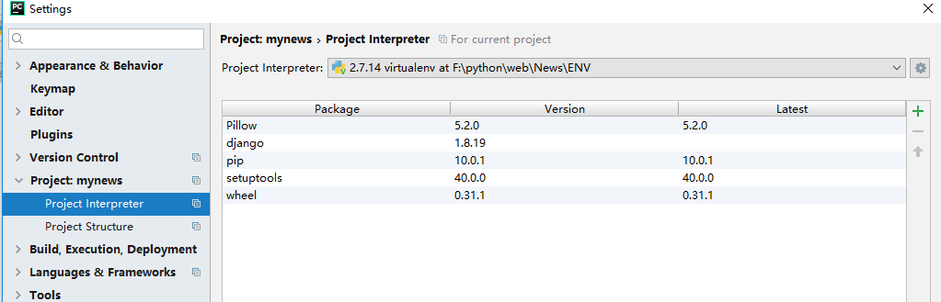

Open manage.py

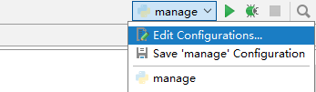

Set scrip parameters 对应的对话框中输入配置参数 **runserver 0.0.0.0:8000**

Run

Access <http://localhost:8000/>, not http://0.0.0.0:8000/

[15/Jul/2018 15:13:47] "GET /media/uploads/ho3.PNG HTTP/1.1" 200 8192

Traceback (most recent call last):

File "c:\python27\Lib\wsgiref\handlers.py", line 86, in run

self.finish_response()

File "c:\python27\Lib\wsgiref\handlers.py", line 128, in finish_response

self.write(data)

File "c:\python27\Lib\wsgiref\handlers.py", line 212, in write

self.send_headers()

File "c:\python27\Lib\wsgiref\handlers.py", line 270, in send_headers

self.send_preamble()

File "c:\python27\Lib\wsgiref\handlers.py", line 194, in send_preamble

'Date: %s\r\n' % format_date_time(time.time())

File "c:\python27\Lib\socket.py", line 328, in write

self.flush()

File "c:\python27\Lib\socket.py", line 307, in flush

self._sock.sendall(view[write_offset:write_offset+buffer_size])

error: [Errno 10053]

## excel

www.python-excel.org

https://xlsxwriter.readthedocs.io/

https://xlsxwriter.readthedocs.io/working_with_data_validation.html

https://openpyxl.readthedocs.io/en/stable/

## glob

[root@lab-centos home]# python

Python 2.7.5 (default, Aug 4 2017, 00:39:18)

[GCC 4.8.5 20150623 (Red Hat 4.8.5-16)] on linux2

Type "help", "copyright", "credits" or "license" for more information.

>>> import glob

>>> glob.glob('*.tar')

['linux-4.9.tar']

>>> glob.glob('*.sh')

['reboot_test2.sh', 'reboot_service.sh', 'reboot_with_command.sh']

>>> ret=glob.glob('*.sh')

>>> print ret

['reboot_test2.sh', 'reboot_service.sh', 'reboot_with_command.sh']

>>> print ret[0]

reboot_test2.sh

>>> exit()

os.remove(my_file)

os.removedirs(path)

[root@lab-centos home]# python

Python 2.7.5 (default, Aug 4 2017, 00:39:18)

[GCC 4.8.5 20150623 (Red Hat 4.8.5-16)] on linux2

Type "help", "copyright", "credits" or "license" for more information.

>>> import glob

>>> ret=glob.glob('*.b64*')

>>> print ret

['MS50eHQ=.b64', 'MS50eHQ=.b64.new']

>>> import os

>>> os.remove(ret[0])

>>> os.remove(ret[1])

>>> ret=glob.glob('*.b64*')

>>> print ret

[]

os.listdir('.')

os.rename('','')

[root@lab-centos rtest]# python

Python 2.7.5 (default, Aug 4 2017, 00:39:18)

[GCC 4.8.5 20150623 (Red Hat 4.8.5-16)] on linux2

Type "help", "copyright", "credits" or "license" for more information.

>>> import os

>>> import glob

>>> ret=glob.glob('*')

>>> print ret

['reboot_test39.sh', 'reboot_test.sh.bak', 'reboot_test.sh', '10.142.1.36_test.log', '10.142.1.36_dmesg.log']

>>> os.rename(ret[1], ret[1]+'remame')

>>> ret=glob.glob('*')

>>> print ret

['reboot_test39.sh', 'reboot_test.sh', '10.142.1.36_test.log', '10.142.1.36_dmesg.log', 'reboot_test.sh.bakremame']

>>>

>>> ret.sort()

>>> print ret

['10.142.1.36_dmesg.log', '10.142.1.36_test.log', 'reboot_test.sh', 'reboot_test.sh.bakremame', 'reboot_test39.sh']

>>>

>>> import glob

>>> ret=glob.glob('*.mp4')

>>> for f in ret:

... print f

...

>>> import os

>>> import glob

>>> ret=glob.glob('*')

>>> for f in ret:

... if f[-4:] !='.b64':

... print f

... os.remove(f)

...

>>> import os

>>> import glob

>>> ret=glob.glob('*.mp4')

>>> for f in ret:

... print f

... os.remove(f)