Microsoft Signal Integrity Laboratory

15101 NE 40th ST (Studio B)

Redmond, WA 98052

VNA TEST REPORT

|  |  |
| --- | --- |
| **Test Request Information** | |
| Test Request # | 12345 |
| MS Business Unit | SITestLab |
| MS Project Code Name | DemonstrationVNA |
| MS Build Phase | EV0.1 |
| Request Date | 1/1/2001 |
| Due Date | 7/3/2015 |
| **SI Engineers** | |
| SI Compliance Engineer | RTorCS |
| SI Lab Manager | JohnnyDeng(jodeng) |
| SI Test Engineer | JYorTB |



Table of Contents

1 Test Overview 3

2 Test Setup 3

2.1 PNA Test Setup 3

2.2 Hardware Apparatus 3

2.3 Software Apparatus 3

2.4 DUT Identification 3

2.5 Port Configuration & Probe Identification 3

3 Test Summary 3

# Test Overview

Hello. This section is being tested. Please do not write or spill water.

# Test Setup

## PNA Test Setup

|  |  |
| --- | --- |
| **Parameters** | **Values** |
| **Start Frequency** | 20.0MHz |
| **Stop Frequency** | 20.0GHz |
| **Frequency Step** | 10.0KHz |
| **IFBW** |  |
| **Avg. On/Off (# of Avg.)** |  |
| **Power level** |  |

## Hardware Apparatus

|  |  |  |  |
| --- | --- | --- | --- |
| **Equipment Description** | **Manufacturer/Model** | **SI #** | **Factory Cal Expired?** |
| **VNA/TDR** | KeySight PNA N5225A | SI-E005 | No |
| **Calibration Module** | KeySight ECAL N4693 | SI-E089 | No |
| **Cable 1** | Gore PhaseFlex - 3m | SI-110 | N/A |
| **Cable 2** | Gore PhaseFlex - 3m | SI-111 | N/A |
| **Cable 3** | Gore PhaseFlex - 3m | SI-112 | N/A |
| **Cable 4** | Gore PhaseFlex - 3m | SI-113 | N/A |

## Software Apparatus

|  |  |
| --- | --- |
| **Item Description** | **Version/Model #** |
| **PLTS Version** | 2015 |
| **Software PC/Desktop** | Intel NUC (PC Name: NUCi3) |
| **Operating System** | Windows 8 |

## DUT Identification

DUT IdentificationSI #DescriptionSI-1000-1HDMI cable 3-metersSI-1000-2DP CableSI-1000-3PCB prototypeSI-1000-4Test Coupon ASI-1000-5Test Coupon Z

|  |  |
| --- | --- |
| **SI #** | **Description** |
| **SI-1000-1** | HDMI cable 3-meters |
| **SI-1000-2** | DP Cable |
| **SI-1000-3** | PCB prototype |
| **SI-1000-4** | Test Coupon A |
| **SI-1000-5** | Test Coupon Z |

## Port Configuration & Probe Identification

|  |  |  |  |  |
| --- | --- | --- | --- | --- |
| **Configuration** | **VNA Port #** | **Virtual Diff Port #** | **Connected Net or Conductor** | **Probe Type (SN)** |
| **1** | 1 | 1 | Pos. conductor on unlabled DP or mDP connector | Test Fixture |
|  | 3 |  | Neg. conductor on unlabled DP or mDP connector | Test Fixture |
|  | 2 | 2 | Pos. conductor on labeled DP connector | Test Fixture |
|  | 4 |  | Neg. conductor on labeled DP connector | Test Fixture |
| **2** | 1 | 1 | DP_LANE0_P_C (on U201) | 250-GSSG (7234) |
|  | 3 |  | DP_LANE0_N_C (on U201) | 250-GSSG (7234) |
|  | 2 | 2 | DP_LANE0_P_C (on J23) | 250-GSSG (7283) |
|  | 4 |  | DP_LANE0_N_C (on J23) | 250-GSSG (7283) |

# Test Summary

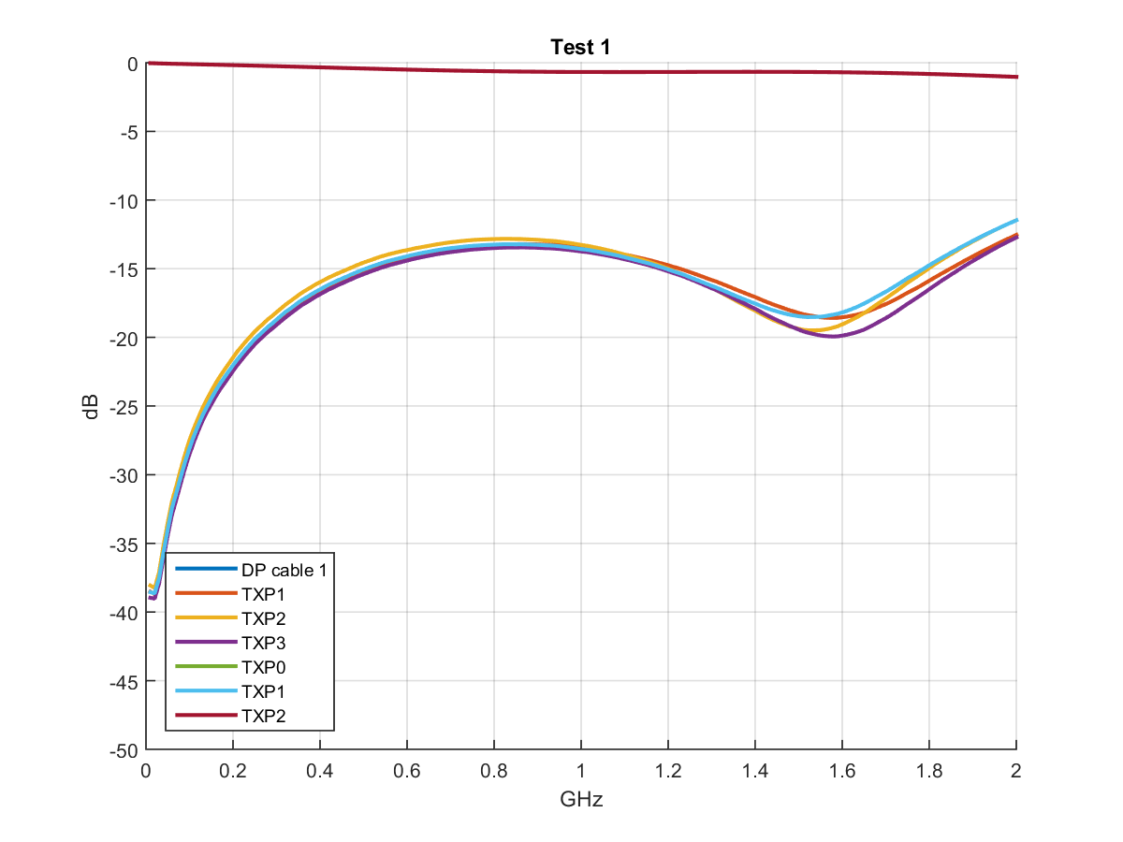

**Figure 1 Test 1**

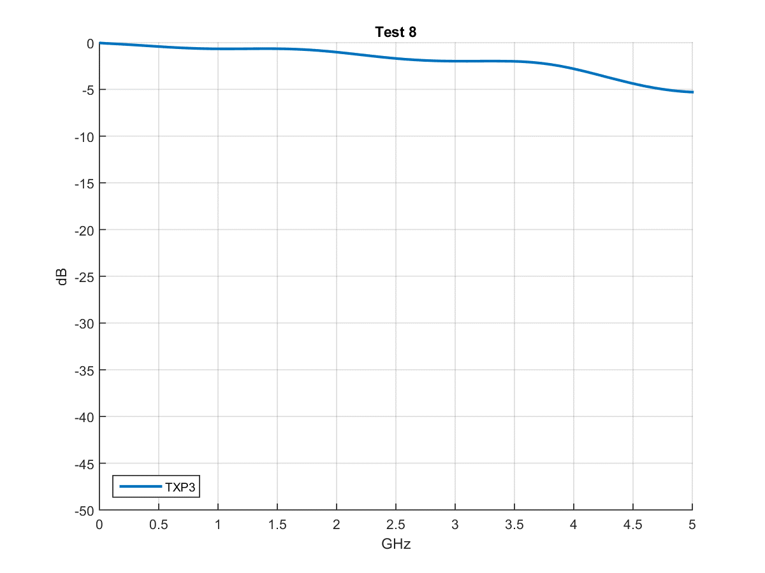

**Figure 2 Test 8**

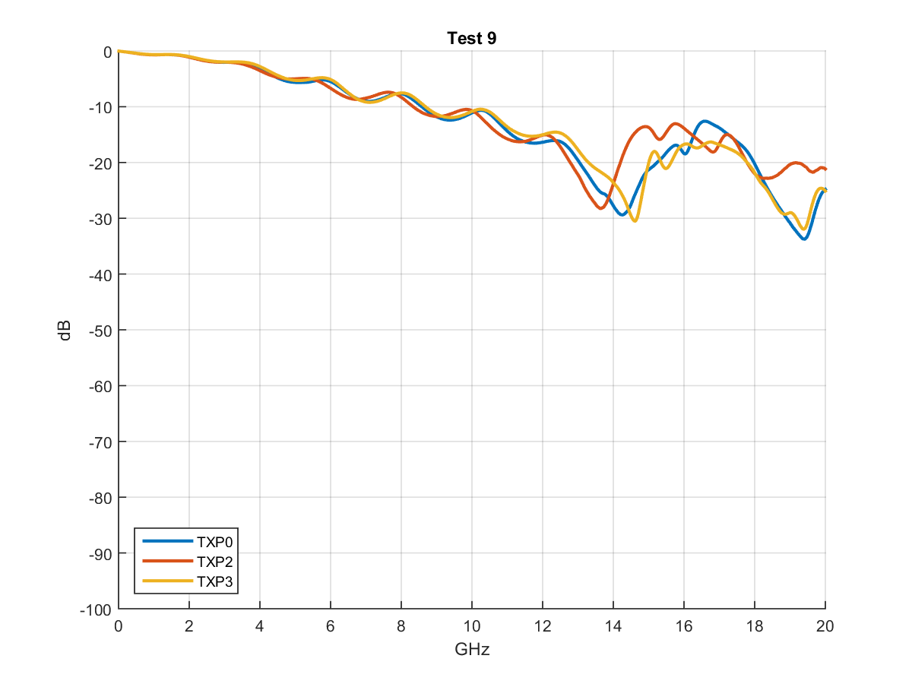

**Figure 3 Test 9**

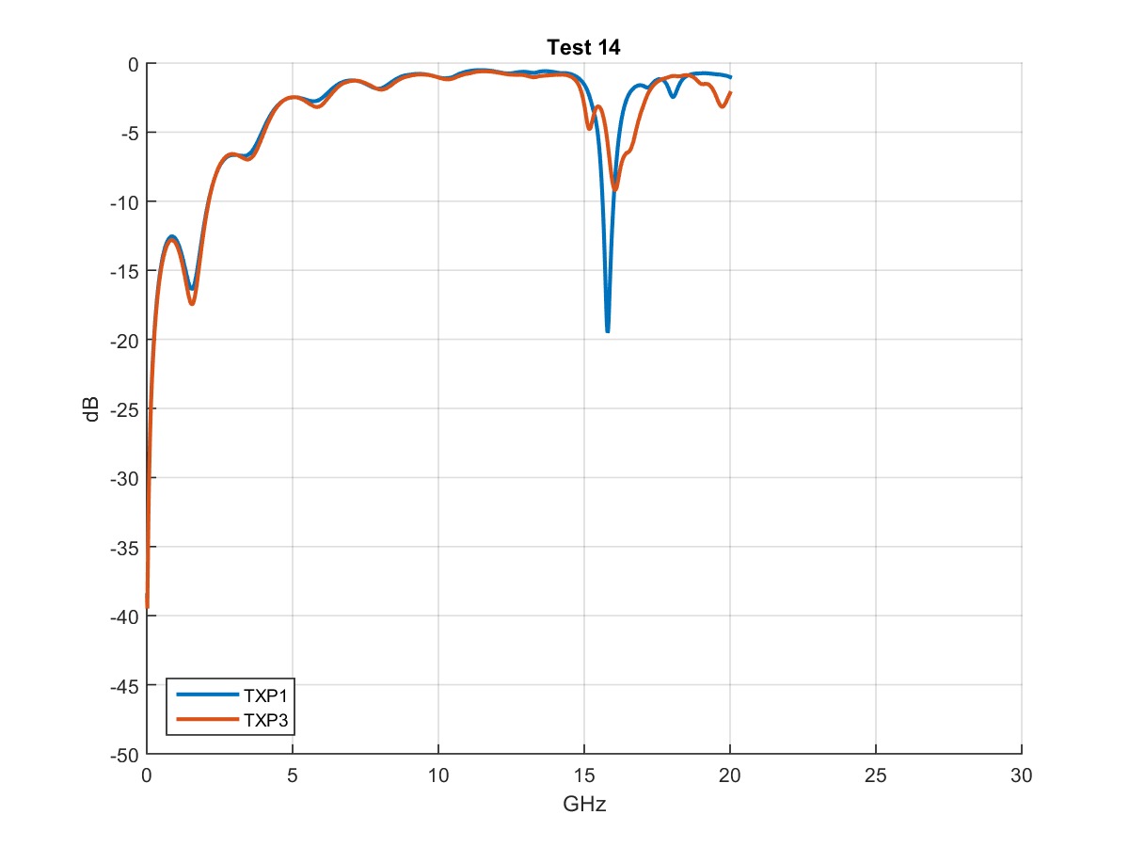

**Figure 4 Test 14**

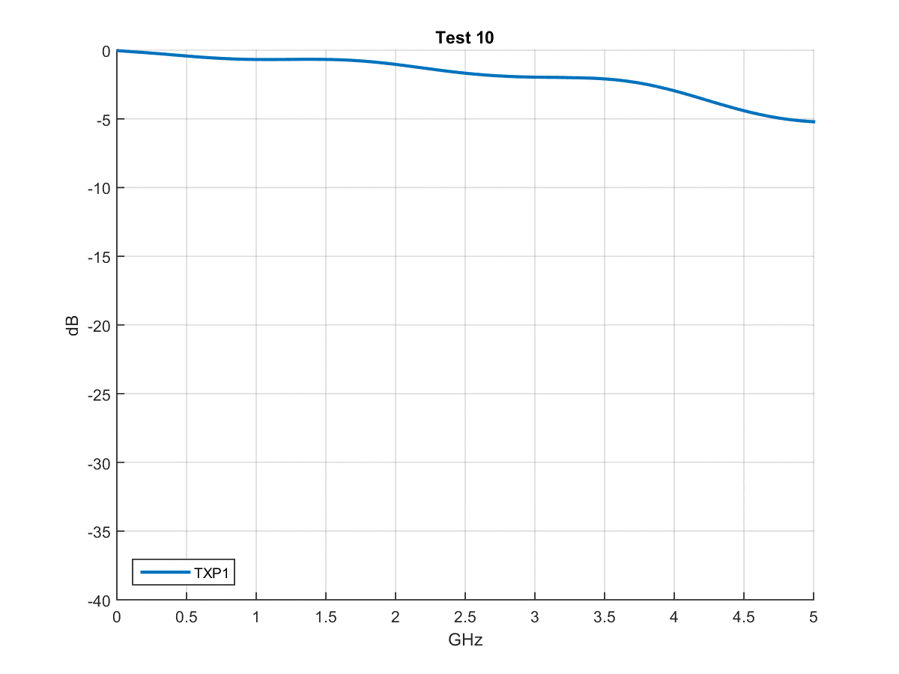

**Figure 5 Test 10**

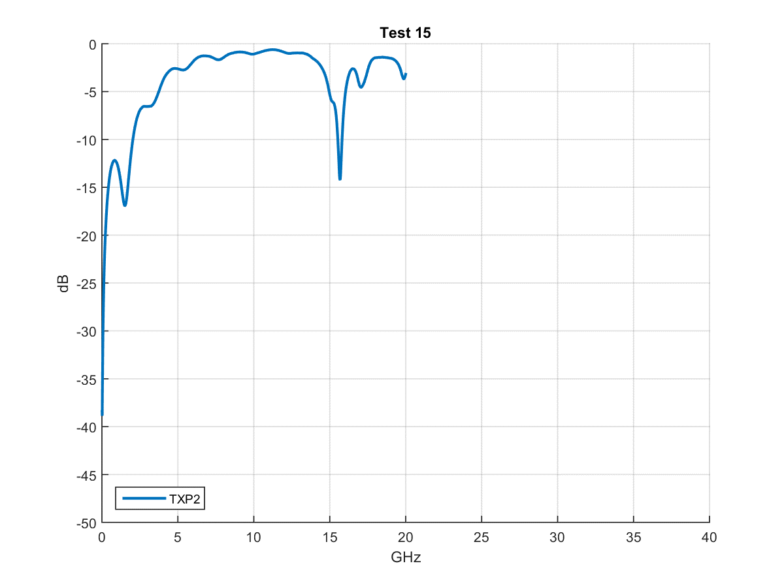

**Figure 6 Test 15**

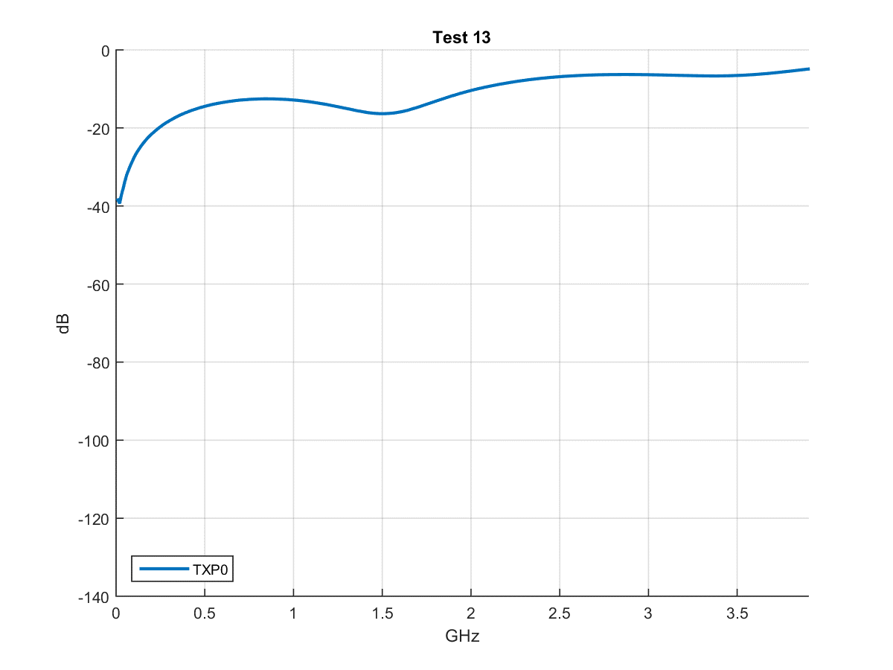

**Figure 7 Test 13**