The report of homework 7

B073040047 楊志璿

|  |  |  |  |  |  |
| --- | --- | --- | --- | --- | --- |
| scale/algorithm  (num/s) | Insertion  Sort | Merge  sort | Quick  sort | cstdlib  qsort | STL  sort |
| 100 | 3.5e-05 | 4.4e-05 | 1e-05 | 7e-06 | 9e-06 |
| 500 | 0.000726 | 5.9e-05 | 4.6e-05 | 3.5e-05 | 8.7e-05 |
| 1000 | 0.002904 | 0.000152 | 0.000106 | 5.9e-05 | 0.00015 |
| 5000 | 0.044353 | 0.000637 | 0.000613 | 0.000355 | 0.000566 |
| 10000 | 0.054195 | 0.001198 | 0.001322 | 0.000758 | 0.001214 |
| 50000 | 1.21397 | 0.006204 | 0.007496 | 0.004476 | 0.007065 |
| 100000 | 4.87161 | 0.013093 | 0.016177 | 0.009577 | 0.015017 |
| 500000 | 121.379 | 0.071538 | 0.093847 | 0.054098 | 0.089552 |
| 1000000 | 485.603 | 0.148523 | 0.195643 | 0.113956 | 0.182601 |
| 5000000 | 12140.075 | 0.82294 | 1.07888 | 0.638145 | 0.9906 |

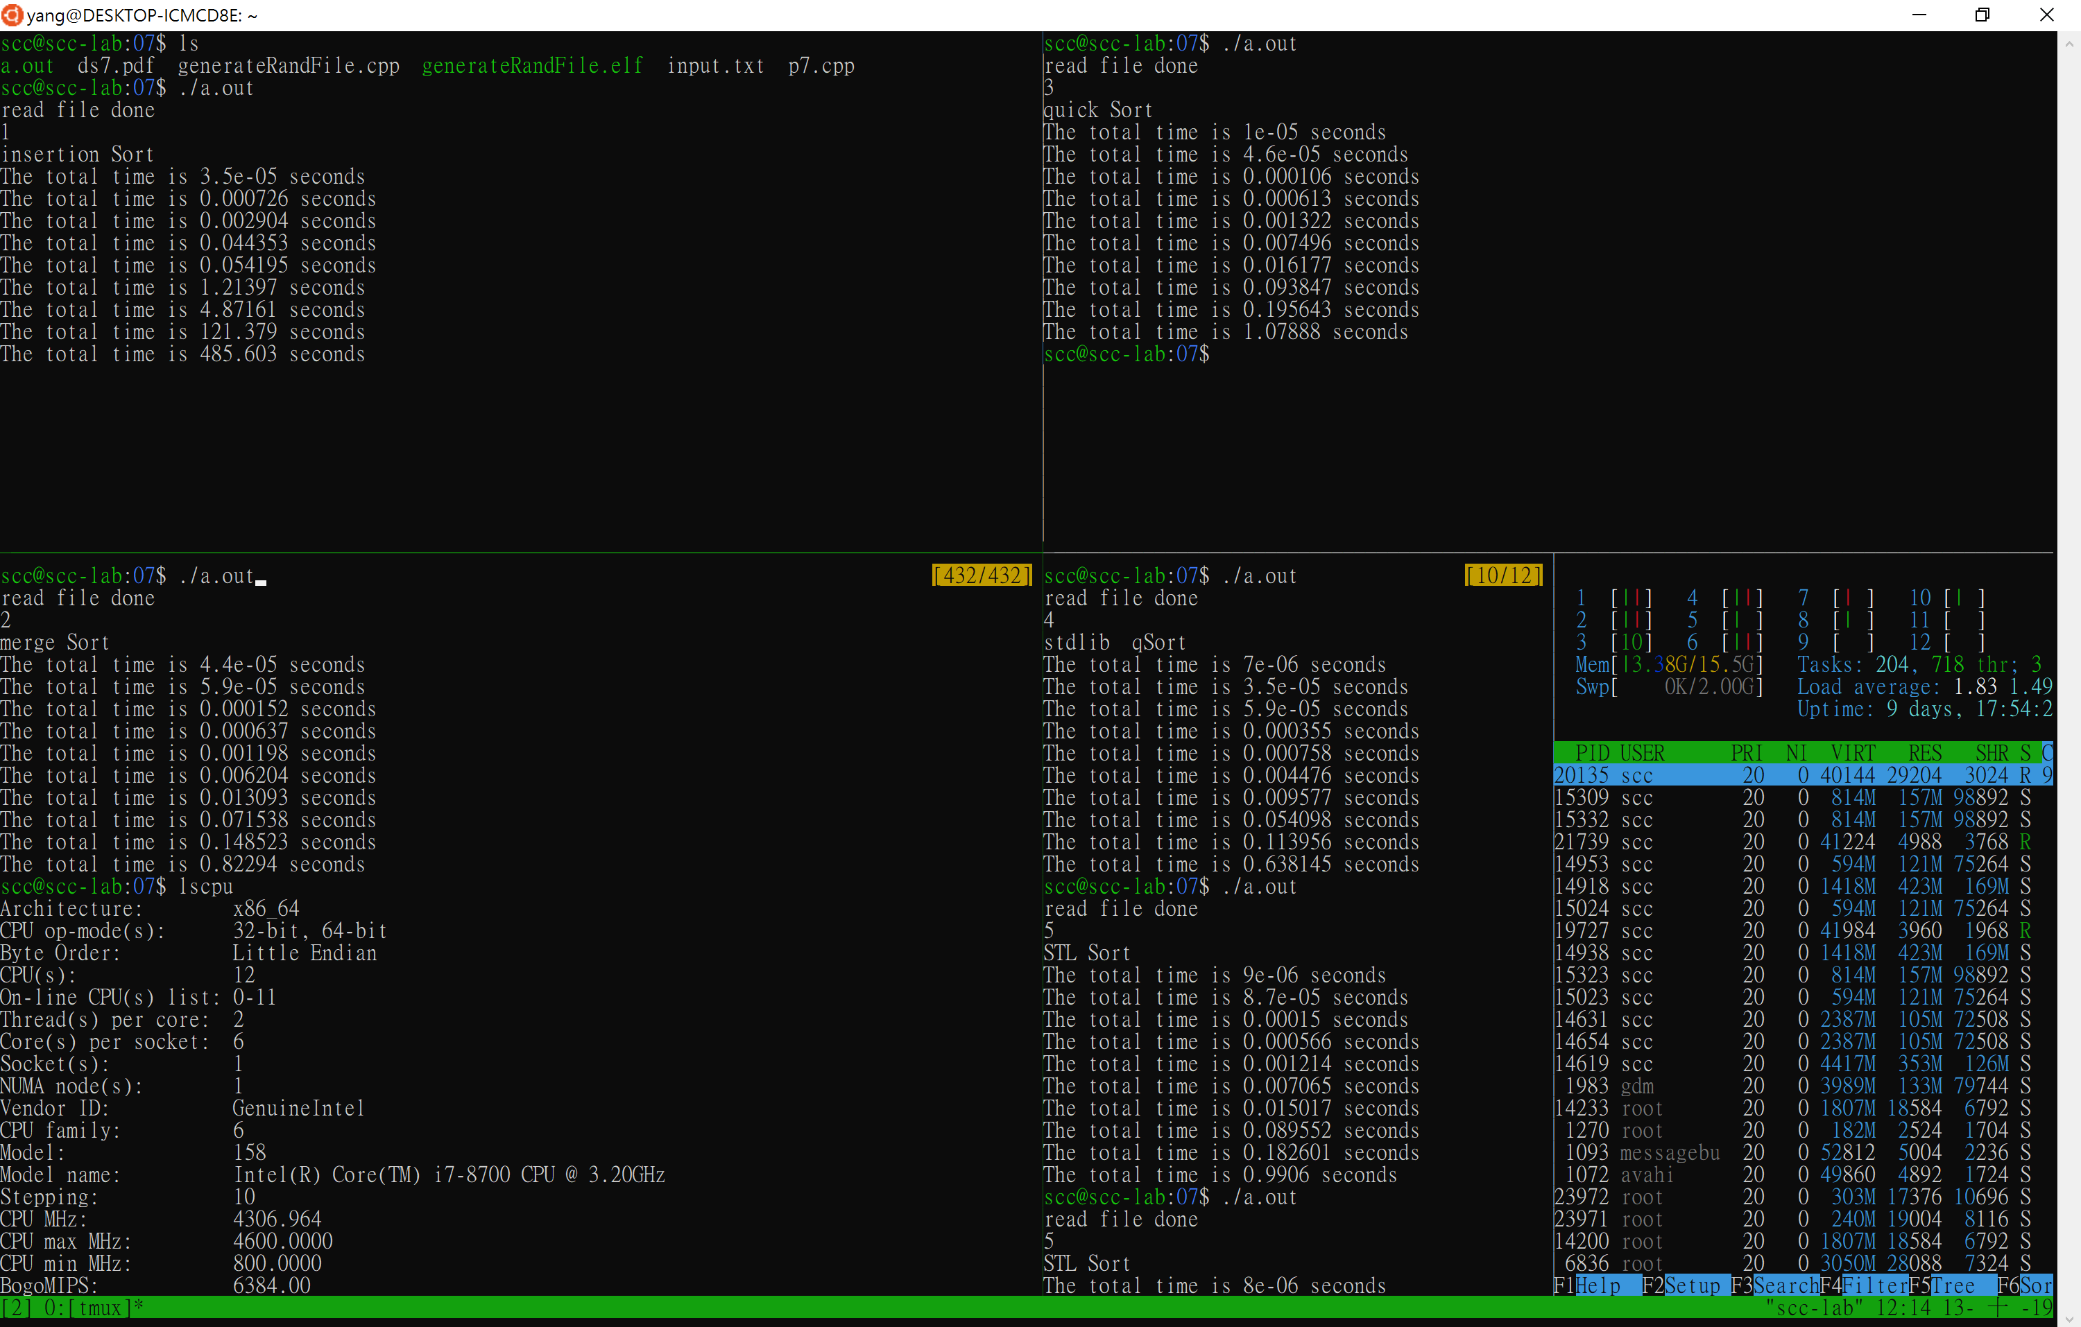

The last 2 results of insertion sore are time out! Which might coast 485 seconds and 3.37 hours.

I use yellow mark to repersent TLE(Time Limit Exceed).

Insertion sort :

Merge sort :

Quick sort :

cstdlib qsort :

STL sort :

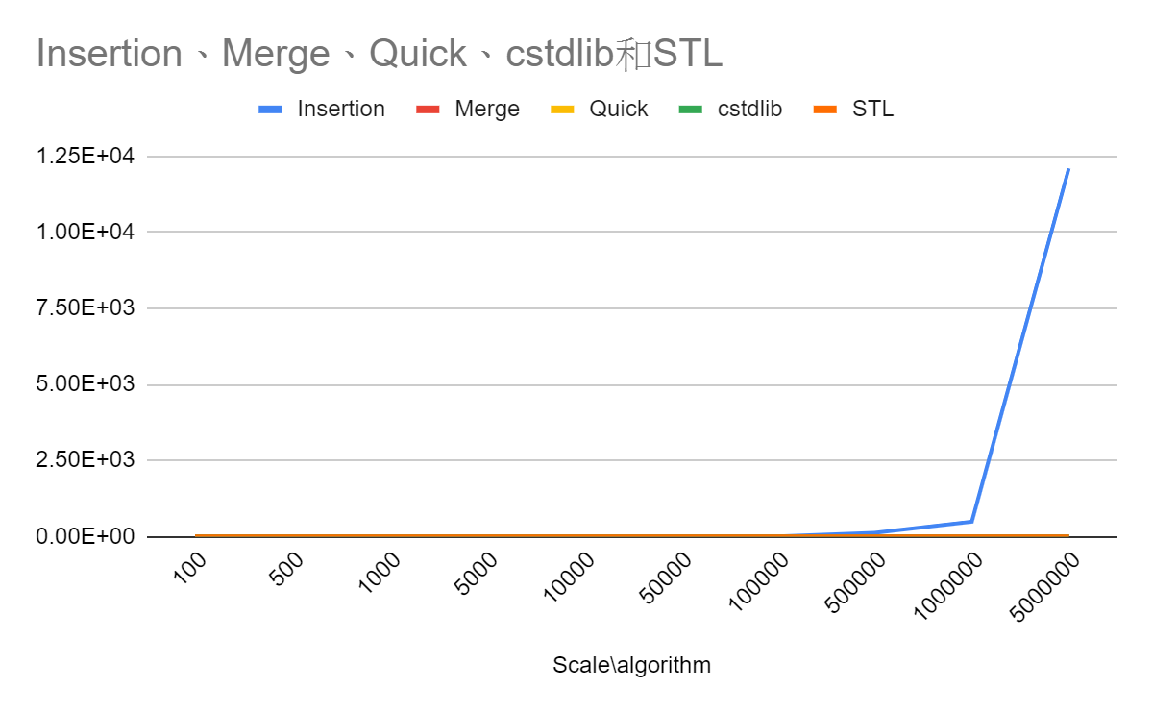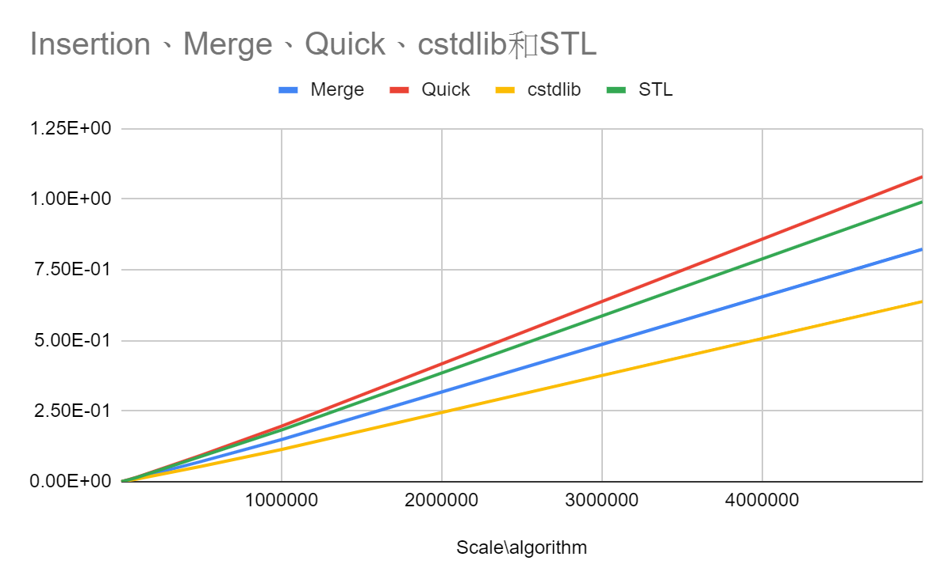

About

My CPU: i7-8700 3.2GHz

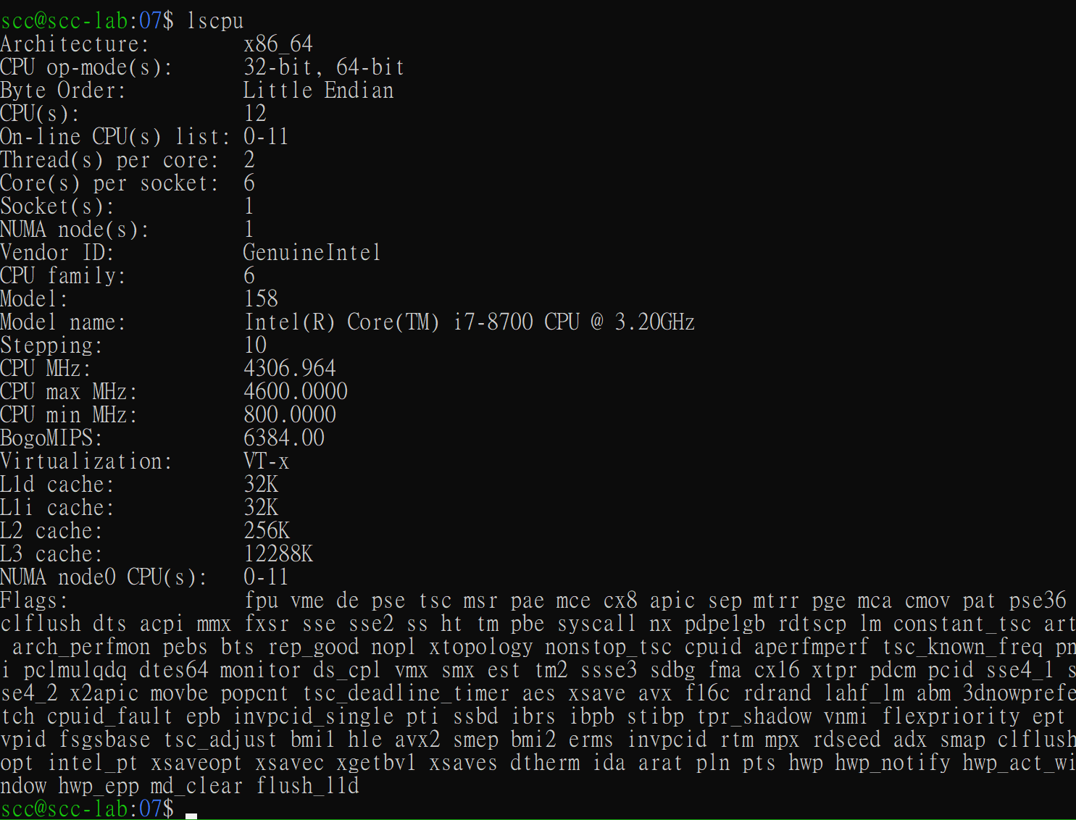

My RAM: (8G DDR4 2666)*2

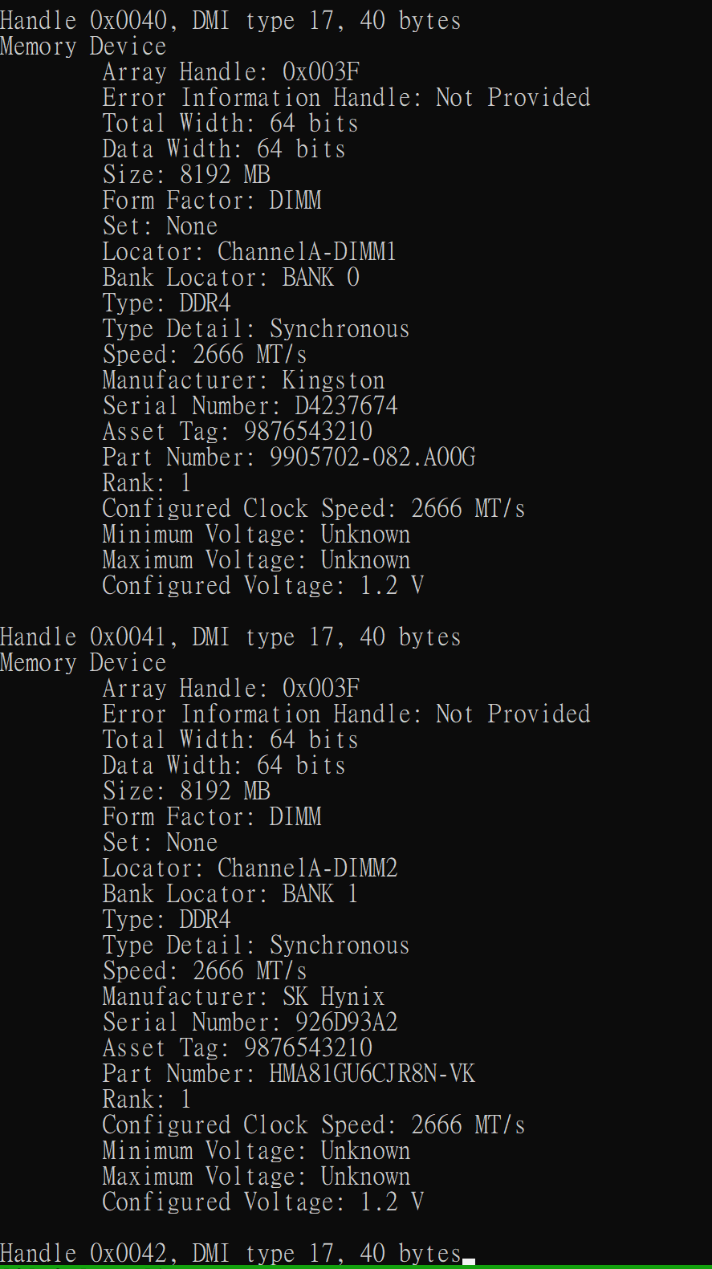

My OS: Ubuntu 18.04(Linux kernel: 4.15.0)



My compiler: GNU GCC 7.4.0

