

Installation Technical Manual
Project: Proethos
Version 0.14.34


DESCRIPTION
PROETHOS SETUP AND CONFIGURATION MANUAL
UPDATING |  | LANGUAGE | REVISION
jan./23/ 2015 |  | ENGLISH | 0.14.34
REVISION CONTROL
DATE | RESPONSIBLE | ACTION
05/nov./2014 | Rene Faustino Gabriel Junior | Document Creation
jan./19/2015 | BIREME/MTI/RST/acs | Document revision and translation

TABLE OF CONTENTS
System license 1
System introduction 1
Characteristics and main features 1
Architecture 1
Pre-requirements 2
Installing 3
System download 3
GIT client installation (versioning) 3
Zip file installation 3
Create a database in the MySQL server 4
Database connection activation 5
Manual creation of database access file 6
Initializing the system 6
Data configuration of the Committee 6
Software update 6

System license
ProEthos system is a partnership between Pan American Health Organization and the Pontifícia Universidade Católica do Paraná. All rights reserved to the Pan American Health Organization.

System introduction
ProEthos is a management system for the assessment of Ethics Research Committees, proposing a methodology for submission, assessment and management of the protocols submitted for consideration of the Ethics Committees.

Characteristics and main features
The source code is available for download from GitHub portal throught the address https://github.com/bireme/proethos. It has been implemented in ApacheTM and PHP4 or higher, having a layer for storage in MySQLTM database management.
The system has many features, being the most relevant:
- Submission of research protocols for ethics assessment;
- Document storage;
- Submission of amendments, adverse event reports and notifications after;
- Multi-language support, with existing Brazilian Portuguese, Spanish, English and French;
- Assessment by one or multiple rapporteurs;Access to protocols by all committee members;
- Interoperability of data with 20 fields from WHO's clinical trials (optional qualification);
- Communication with researchers by e-mail and communications' log.

Architecture
General requirements for installation
- A server with GNU/Linux preferred distro or hosting service of a Linux site with support to PHPTM and MySQLTM database.
- Minimun storage availability of 20 Gigabytes for file storage and system installation.
- FTP backup recommended or automatic backup in case of a dedicated server.
- Broadbend internet connection, specially for system managers.
- GIT client installed in case it is intended to install the system through the GitHub service.

Pre-requirements
Main services and authorizations required by the system:
- E-mail services enabled in the server, either by enabling to send messages by an authenticated e-mail.
- “Repository” directory enabled with read/write permissions for file transfer and storage.
- CURL enabled for access to system updates is recommended (optional)

Installing

System download
There are two possible ways to install the system:
- with versioning (git);
- without versioning (zipped).

GIT client installation (versioning)
This is the preferred mode for installing the system once it allows for simple and safe application updates, either in case of specific customizations, system general configuration etc.
To install the system by using the GIT client, type in the Linux command line - below the directory where the system is goint to be installed - the following command:
git clone git://github.com/bireme/proethos.git proethos

Zip file installation
In order to download the last version of ProEthos system, please access the link https://github.com/bireme/proethos and click the icon “Download ZIP” on the right side of the page.

Figure 1 - Download icon
After clicking, GitHub makes available the last version to be saved on your computer.
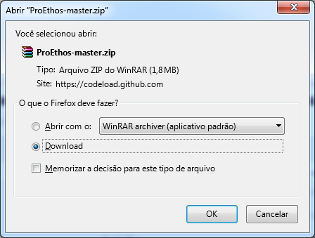
Figure 2 - Download of ProEthos in ZIP format
All the contents of the file must be unzipped - WinRar recommended - and then transferred to the web server that will host the system.
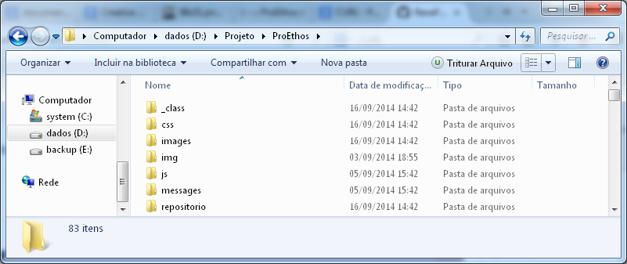
Figure 3 - File structure
It is recommended to send the files via FTP or install the system directly on Linux servers through GitHub client software.

Create a database in the MySQL server
Create a database in the MySQL server named proethos - or the most suitable name to the server being installed or to the institution's security criteria. The following data are required for the connection:
Requirement | Value (Example)
Server | Localhost
Database | Proethos
User | sa_proethos
Password | **********
DB Software | MySQL
This file is created just once. In case any system parameter is changed, the configuration file must be removed from the system by the technical administrator via FTP.
The configuration file is saved in the “_db” subdirectory, below system's root directory.

Database connection activation
The first access to the system requires the database connection file configurations. This operation occurs by accessing the system's installation page through the browser, e.g.: htttp://www.proethos.paho.org/ .
If the “_db/db_paho.php” is not found, the system redirects to the system configuration screen, as displayed in the Figure 4.
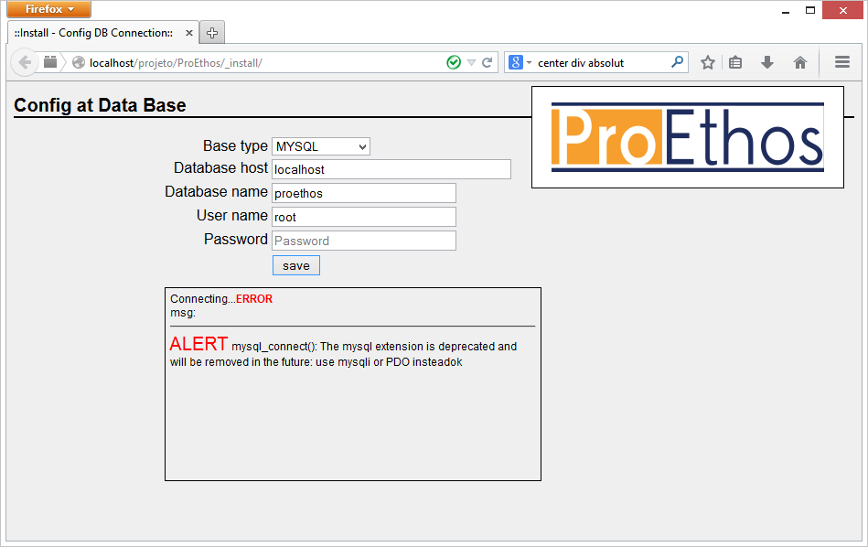
Figure 4 - DB file configuration screen
In this screen it is supposed to display the database type (Base Type), having the following options:
- MySQL parameter to connect to the MySQL database using the mysql_connect() method as it is default in most servers.
- MySQL(PDO) parameter to access the MySQL database using the PHP Data Objects (PDO) driver. This function is preferred when the server signals that mysql_connect() method is obsolete.
In the Database host field it is required to inform the IP or the servername where the database is located. Localhost can be used if both interface and database are in the same server.
All other fields refer to the connection with database, such as Database name, User name and Password. Whenever an error occurs, a text box displays the failure messages encountered. If all parameters are set correctly, the db_paho.php file is created and successful process message is displayed.

Manual creation of database access file
It is possible to create the“_db/db_paho.php” file manually, scecially when not giving write permissions to the Apache user below htdocs. Therefore, the file must be created below "_db" subdirectory and named to "db_paho.php" as described below and customized for each server.
db.php
<?php
/* Data Base - Config */

$base='mysql'; /* or mysqlPDO */
$base_host='localhost'; /* Host name */
$base_name='proethos'; /* Database name */
$base_user='root'; /* User name*/
$base_pass='password'; /* Password */

$ok = db_connect();
?>

Initializing the system
At the first attempt to log in the system it is set by default to the values below
User | Password
Admin | proethos

Data configuration of the Committee
Text being produced

Software update
If using the GIT client to install the system, it is possible to update it whenever the application repository is changed.
To process the update, just access the command line in the application directory (e.g.: proethos) and type in:
git pull
NOTE: If any part of the application code has been customized, GIT client generates a log of inconsistences before processing the update. In this case, check the GitHub documentation to redefine what files should be excluded from the update procedure.

