DEPARTMENT OF COMPUTER SCIENCE AND APPLICATIONS

COLLEGE OF ENGINEERING AND TECHNOLOGY

TECHNO CAMPUS , GHATIKIA , BHUBANESWAR , 751003



**CERTIFICATE**

This is to certify that the project entitled, “ Community Social Network ” is a bonafide work done and submitted by Mr. Krishna Das Mukharjee, bearing the Registration No.–1705106026 , Mr. Tapan Mahapatra , bearing the Registration No.–1705106028 and Mr. Birendra Kumar Behera, bearing the Registration No.- 1705106020 in partial fulfillment of the requirement for the award “ Master In Computer Applications ” Degree is an authentic record of the work done by them under my supervision and guidance .The matter embodied in the project has not been submitted to any Other University for the award of any Degree or Diploma to The best of my Knowledge .The work carried out by them during the project period is original and performance during the compilation of project was appreciable.

Mrs. Swarna Lata Pati Dr.Jibitesh Mishra

(Project Guide) (H.O.D Dept.Of.CSA) (External Examiner)

DEPARTMENT OF COMPUTER SCIENCE AND APPLICATIONS

COLLEGE OF ENGINEERING AND TECHNOLOGY

TECHNO CAMPUS , GHATIKIA , BHUBANESWAR , 751003



**DECLARATION**

 We , Hereby Declare that This written Submission Represents Our Ideas In Our Own words and where Others Ideas Or Words Have been Included . we Have Adequately Cited and Referenced The original source’s .We also Declare that we have Adhered to all principals of the academics honestly and integrity and Have not misrepresented or Fabricated any idea in my Submission .

We understand that any violation of the above will cause for disciplinary action by the institute and can also evoke penal action from the source’s which have thus not been properly cited or from whom proper has not been taken when needed.

Krishna Das Mukharjee (1705106026)

Tapan Kumar mahapatra (1705106028)

Birendra Kumar Behera (1705106020)

Date:

Place:

DEPARTMENT OF COMPUTER SCIENCE AND APPLICATIONS

COLLEGE OF ENGINEERING AND TECHNOLOGY

TECHNO CAMPUS , GHATIKIA , BHUBANESWAR , 751003



**ACKNOWLEDGEMENT**

**We take this opportunity to express my sincere thanks and deep gratitude to all those people who extended their wholehearted co-operation and helped us in completing this Project successfully.**

**We express our deep and sincere gratitude to Dr. Jibitesh Mishra ,(H.O.D Dept.Of.CSA) ,and Mrs. Swarna Lata Pati (Project Guide) who provided us an opportunity, inspiration and requisite facility by giving us a chance to show Our capabilities in this esteemed organization and also for making us feel comfortable in the strictly professional environment of the office premises.**

**we are highly obliged to Mrs. Swarna Lata Pati (Project Guide) for providing us continuous and invaluable guidance throughout the Project in spite of his busy schedule and patiently solving our rather amateurish queries. His kind and elderly advice always inspired us in putting our best effort to develop an efficient system.**

**Finally, we would like to thank all the members of the (Dept.Of.CSA) and for their help and valuable suggestions during the course of the project.**

Krishna Das Mukharjee (1705106026)

Tapan Kumar mahapatra (1705106028)

Birendra Kumar Behera (1705106020)

**Table of Contents**

1. Synopsis 5

2. Aspect of Users 8

3. Technology Used 10

4. Feasibility Study 12

5. Data Tables 13

6. Usecase Model 16

7. DFD diagram 18

8. Interfaces 19

9. Advantages 23

10. Conclusion 24

**COMMUNITY SOCIAL NETWORKING**

‘Community Social Network’ is a social website designed primarily to interact with each other in an intra-department environment in an education system. It provides an interface through which a number of users of a particular department can interact with each other after their sign up & login is approved by the admin. Once they successfully complete their sign up & log in after the admin’s approval, they can send their messages to all the users in the newsfeed section. These messages can include some useful links for study materials or some notification texts (notifications which will be useful for all the departments in an institutions) or some photos which will notify the users about some events, exam forms, etc. This website also has a section for messaging where each user can chat with others users of that department. It also has a notice board section, where the admin can post stuffs like holiday notice, exam notice, campus notice, etc. A question & answer section will help the users of a particular department to find the solutions of a problem in order to achieve a common goal of the institution. There is a profile section where each and every user can view his/her profile which contains his/her name, contact no., about himself/herself, department, mail id, etc. They can opt for the log out option once they have completed their activities in the website for their security. This ‘Community Social Network’ provides an online environment for its users to carry out different tasks of different departments in an institution which will help to achieve the goals of the institution. To make this website more efficient and more effective, there is also a feedback section where each user will have an option to provide better suggestions and in case of any query related to this website, the users will also have a Contact Us section through which they can directly contact with the admin.

1. **INTRODUCTION: -**

**1.1 OBJECTIVE:**

To design a website which aims to provide a social media like Interface for its users and helps for chatting and viewing recent news of a college and the events which are going to occur. This ‘Community Social Network’ Project aims to make the educational institution’s work flow more efficient and effective so that all the users can interact with each other in order to make the educational community more helpful for performing the organisation’s activities. It will help the students of a particular department to interact with the teachers of that department in order to solve their doubts through the message section. The students can also interact among themselves. It aims to make the interaction process more unique and more effective. This project also provides a notification section through which seminars and events can be organised.

It also aims to offer online instruction which can be delivered anytime and anywhere. It also helps to integrate flexibility of the educational schedules. It also creates a community that can work together towards a common goal of meeting the curricular goals. It also aims to provide a healthy and friendly environment to learn while not physically in the lecture hall. It aims to provide a chat interface to the users where they can be able to get one to one communication in message section as well as one to many communication in the question and answer section.

**1.2 SCOPE:**

Social Media is the most important medium today to reach out, connect and explore things. It will be growing more and more with increase in Data & Mobile penetration in India. More users from Tier 2 and Tier 3 cities are using Social Media .The exponential growth of use of social media can be used in various platforms like Education, Business etc.

This project (The community social network) provides closed interaction between the members of a community (in an educational institute).

This project emphasized on better interaction medium between student and teacher irrespective of their geographic location i.e. it removes the geographical barrier of a community. In future, this will become more effective for educational communities and hence the scope will be integrating more and more.

**1.3 FEATURES:**

* Easy to use.
* Makes communication easier.
* Always updated with news.
* Easier and faster way for Doubt Clearing.
* Make a healthy relationship between student and Teacher.
* Easy manageable
* Consistent
* View their own profile
* Messaging through one-to-one communication
* Communicating in one-to-many communication through notice board section

**1.4 OVERVIEW:**

This system contains following modules

* Register/signup
* Login
* Newsfeed
* Messages
* Notice Board
* Question & Answer section
* Profile
* User Request
* Feedback

**1.4.1 Register/Sign Up**

In this section a new user can register by providing the basic details such as Registration number, name, e-mail, branch, user type, contact number, password, confirm password, gender, date of birth, security question, etc.

**1.4.2 Login:**-

There is a quality login window because this is more secure than other login forms as in a normal login window there are multiple logins available so that more than one person can access services with their individual login (Which is Given at Registration Time ). So a student cannot access other students’ account or cannot login as Faculty or Admin. This makes it more secure.

**1.4.3 Newsfeed:-**

Here any member can post information which can be viewed by all the users.

**1.4.4 Messages:-**

In this section, a user can send private message to any users. For example a student/faculty/admin can send private message to any student/faculty/admin.

**1.4.5 Q-A section :**

Through this section, any member can ask a question, which is only visible to the members of his/her Department and the members of that particular department will have the option to answer that.

* + 1. **Notice Board:-**

In this section, only the admin has the access to post something which can be viewed by each and every user. The admin will also have an option to delete his/her previous posts.

**1.4.7 Profile:-**

Through this section a user (student/faculty) can edit their profile details, can read or delete the newsfeed and Question & Answers posted by him/her.

**1.4.8 Feedback:-**

This section allows all the users to give their feedback on the website which will be helpful for making it more efficient and effective.

**2. ASPECT OF USERS:**

**2.1 STUDENT ASPECT:**

* Registration.
* Logging into the system.
* Editing user information.
* Posting events in newsfeed.
* Messaging to other members.
* Asking questions to their department member.
* Answering different questions.
* Giving feedback for making the website more efficient.

**2.2 FACULTY ASPECT**

* Registration.
* Logging into the system.
* Editing own information.
* Posting events in newsfeed.
* Messaging to students and other faculty staffs.
* Asking question to their department’s students.
* Answering on different questions.

**2.3 ADMINISTRATOR ASPECT**

• Taking back up of the database.

• Editing/Deleting/Creating the database.

• Changing the password.

• Logging into the system.

• Accepting registrations of candidates.

1. **TECHNOLOGIES USED:**

**3.1 SOFTWARE REQUIRED :-**

**3.1.1 Front end as**:

1. HTML
2. CSS
3. JAVASCRIPT

**3.1.2 Back end as**:

1. PHP

**3.1.3 Server:**

1. Apache tomcat 6.0

**3.1.4 Database:**

1. MySql

**3.2 HARDWARE REQUIRED: -**

**3.2.1 Client side:**

***3.2.1.1*** ***Browser:***

Any browser

***3.2.1.2 Processor:***

Pentium 5.0 and above

***3.2.1.3 RAM:***

512 MB

**3.2.2 Server side:**

***3.2.2.1*** ***Processor:***

Pentium 5.0 and above

***3.2.2.2*** ***RAM:***

2GB

***3.2.2.*** ***Processor:***

16GB

**FEASIBILITY STUDY**

**4.1 ECONOMIC FEASIBILITY**

The most frequently used method for evaluating the effectiveness of a new system. More commonly known as cost/benefit analysis, the procedure is to determine the benefits and saving that are expected from a candidate system and compare them with costs. It benefits outweigh costs then the decision is made to design and implement the system. An entrepreneur must accurately weigh the cost versus benefits before taking an action.

* Cost-based study: It is important to identify cost and benefit factors, which can be categorised as follows:

1. Development costs

2. Operating costs.

This is an analysis of the costs to be incurred in the system and benefits derivable out of the system.

* Time-based Study: This is an analysis of the time required to achieve a return on investments.

**4.2 BEHAVIOURAL FEASIBILITY**

People are inherently resistant to change and computer has been known to facilitate changes. An estimate should be made of how strong the user is likely to move towards the development of computerized system. These are various levels of users in order to ensure proper authentication and authorization and security of sensitive data of the organization.

**Database Design**

**DATABASE:**

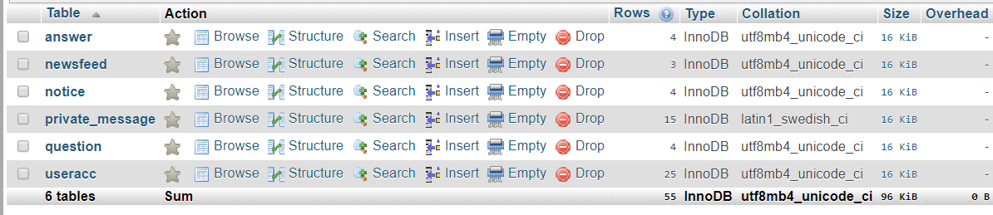

**User Table:**

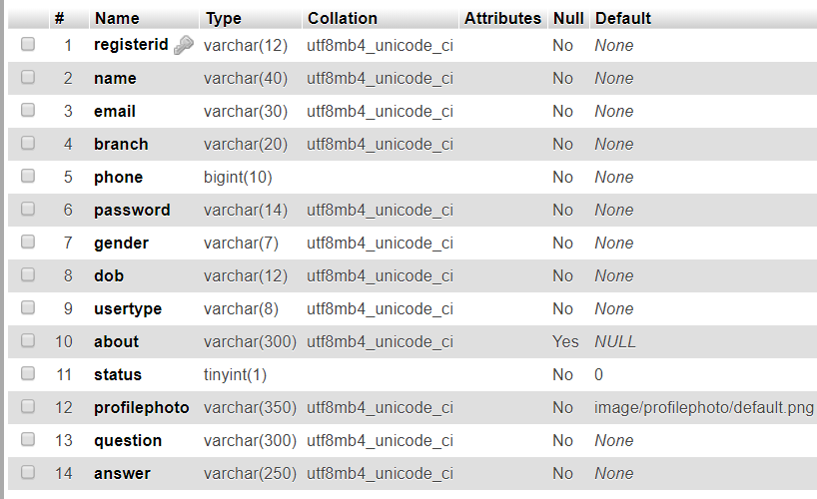

**Newsfeed:**

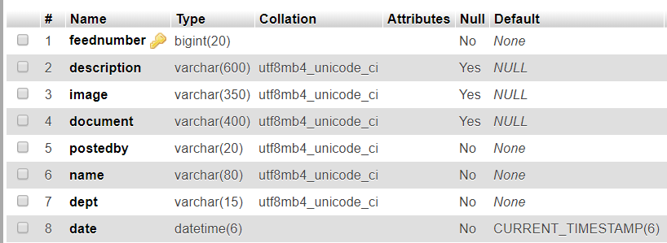

**Notice:**

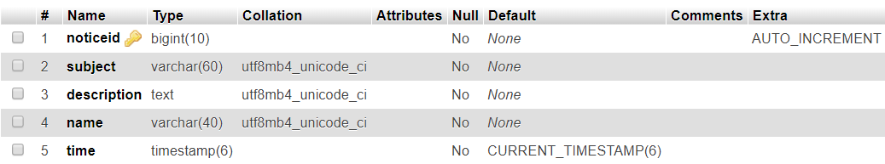

**Private_Message:**

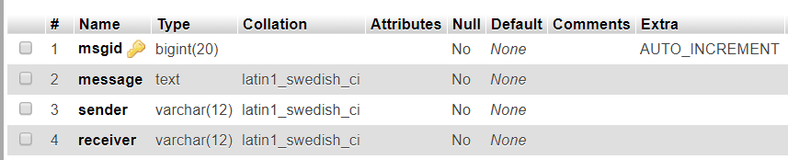

**Question:**

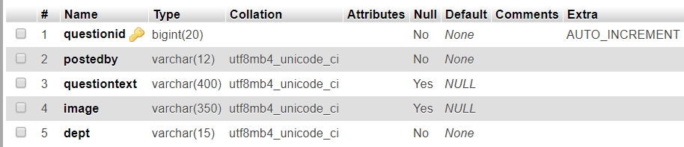

**Answer:**

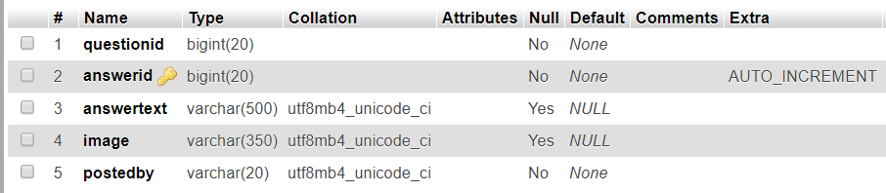

**Feedback Page :**

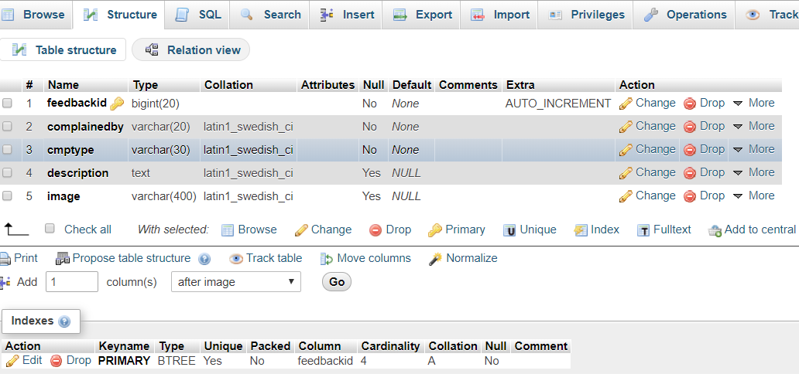**Implementation process**

* Students can register and login into the system once their registration is approved by the admin.
* Once the student logged in into the system, he/she can write and post an article on various topic of his/her choice.
* Also, he/she can chat with the other students.
* Students can also upload images with their post.
* All students can view News Feed posted by individual student.
* Admin can only post in notice board and anyone can view it.
* All the student registration will be approved/rejected by the admin.
* Admin Login has full authority on system, he/she can delete any member.

**Usecase Model**

Admin

**Student**

Faculty

**UseCase Specification**

**UseCase Name: Login**

**Actors : Admin ,Student ,Staff**

**Description :** A registered user can login to the system and once authenticated, can initiate subsequent actions.

**Flow of Events**

1. **Basic Flow**
2. The registered user chooses to Login.
3. The system prompts for username and password.
4. The registered user submits username and password.
5. The system verifies the username and password combination. It authorizes the registered user according to the role(s) to which the user has been assigned. Then it displays the main interface and awaits subsequent action from the user.
6. **Alternative Flows**
   1. **Invalid Username/Password:** The system displays the Authentication Failed message.

**Pre-conditions**

User must have registered.

**Post-conditions**

1. **Login Success:** The system displays the main interface from which additional actions can be initiated by the user.

**Login Failure:** If the Login fails as described in any of the alternative flows above, an appropriate message is displayed and the user is not considered authenticated.

|  |  |
| --- | --- |
| **Use Case** | Description |
| **Register** | A user must require a name, registration number/roll number and a password in order to register. |
| **Login** | The user must have login before starting any activity. |
| **Access account** | User get warning message after wrong password / Invalid account id. He/she is prompted to try again |
| **Logout** | Users safely logout after finishing their activity. |
| **Update profile** | User can update his profile i.e. can make modification as their wish. |
| **Request for update** | User makes request to admin for approving their updating profile(if user want to change its name and the of birth). |

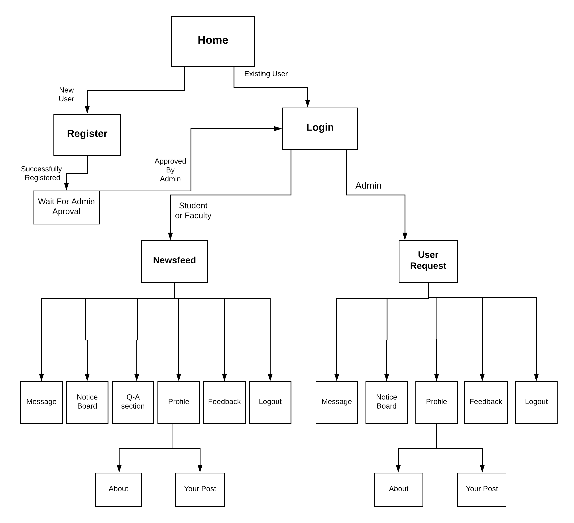**Overview of Project**

**DFD DIAGRAM**

View Home Page

Success

Login Successful or Unsuccessful

Provide User id and Password

Approve

by Admin

Registration success or Unsuccess

Invalid Entries

Provide Details

Enter Details

New

User

Data base

**Block Diagram**

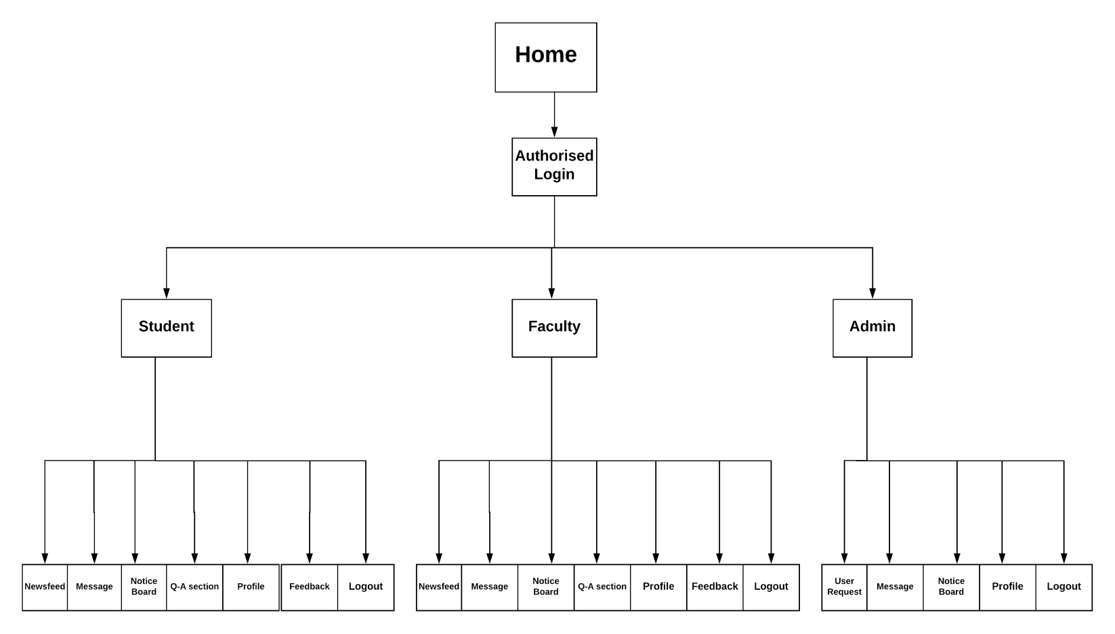

**INTERFACES :**

**Register/Sign Up:**

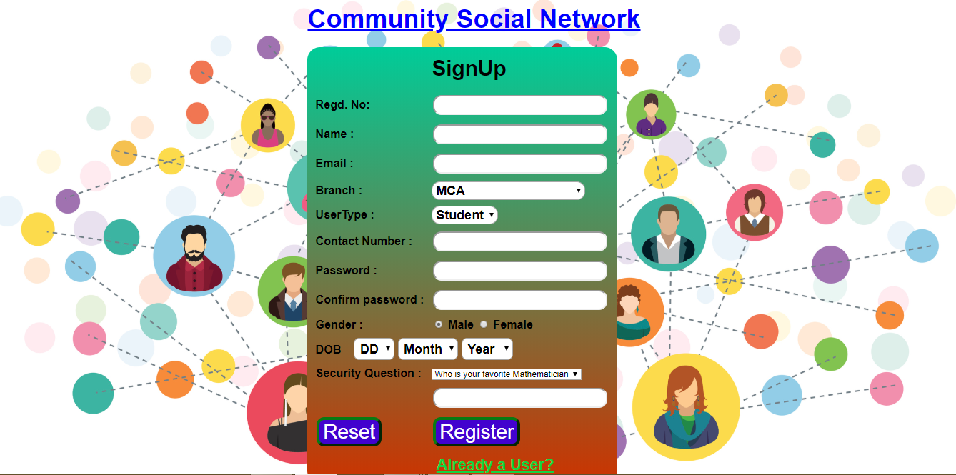

**Log In:**

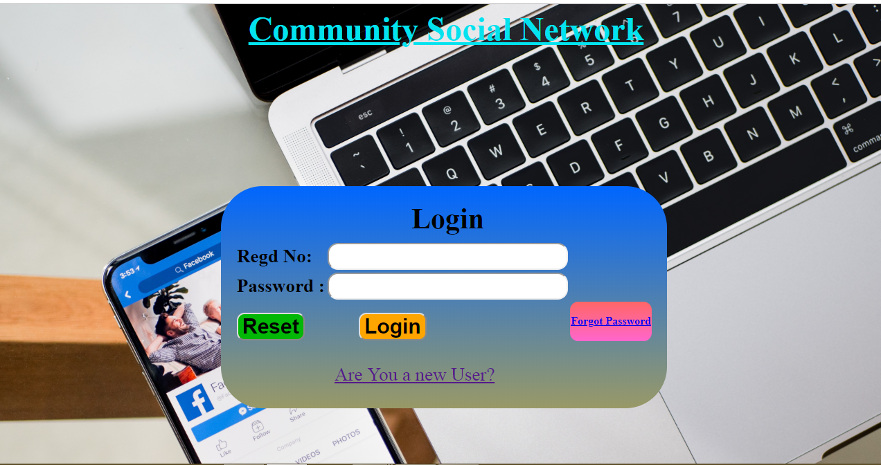

**Newsfeed:**

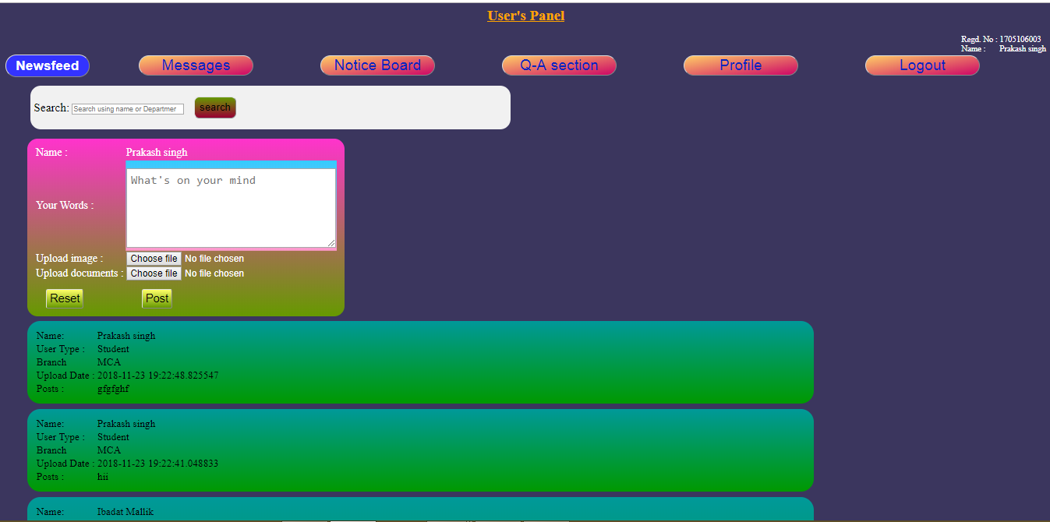

**Message**

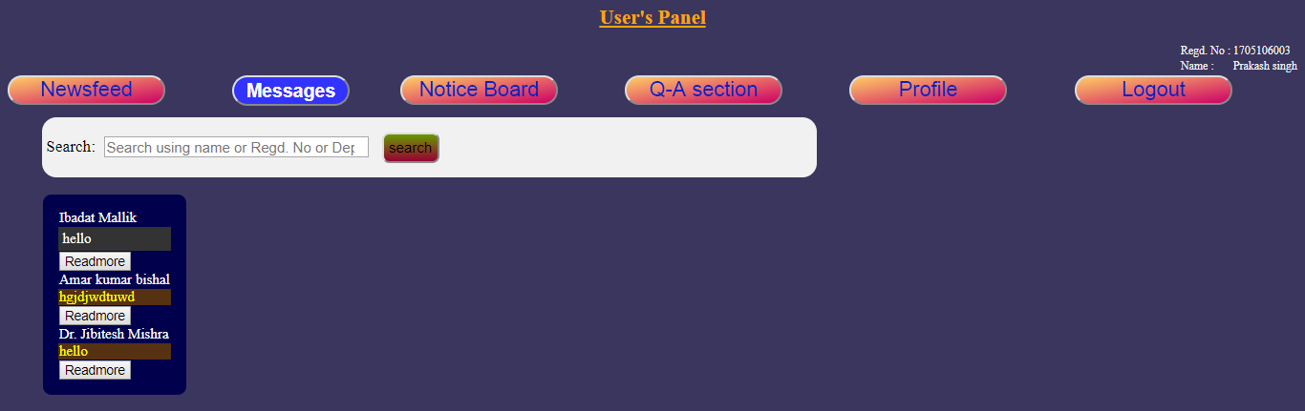

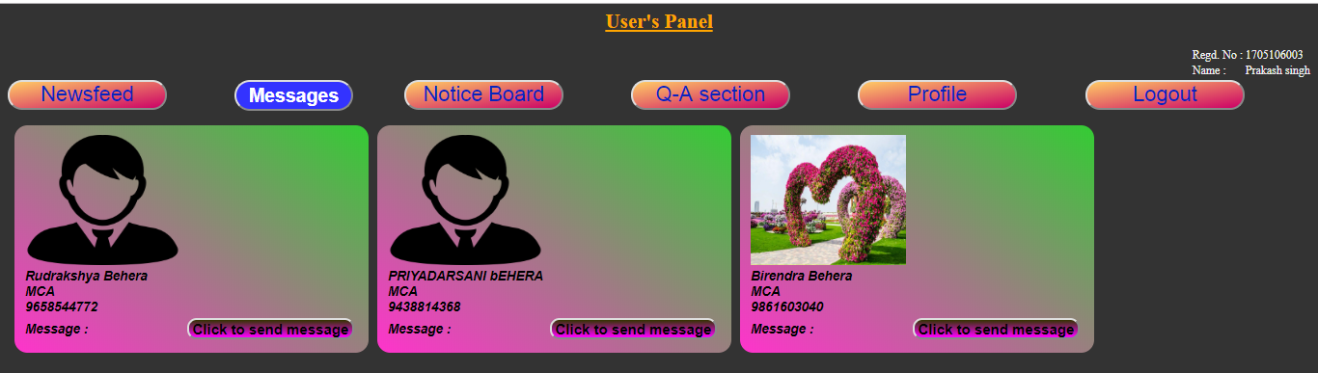

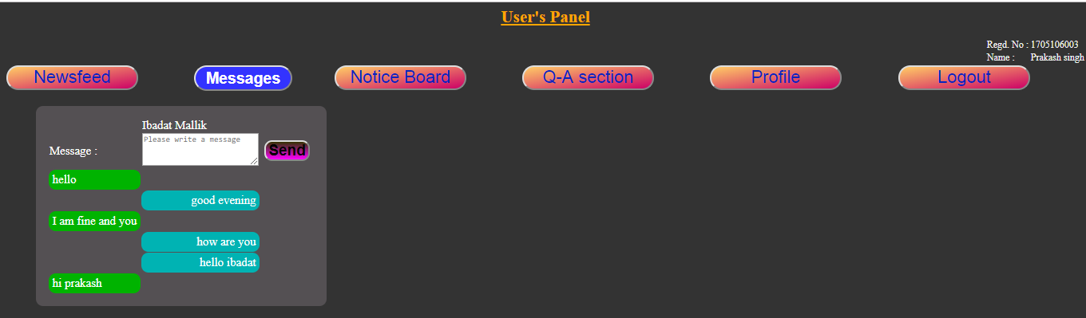

**Notice board:**

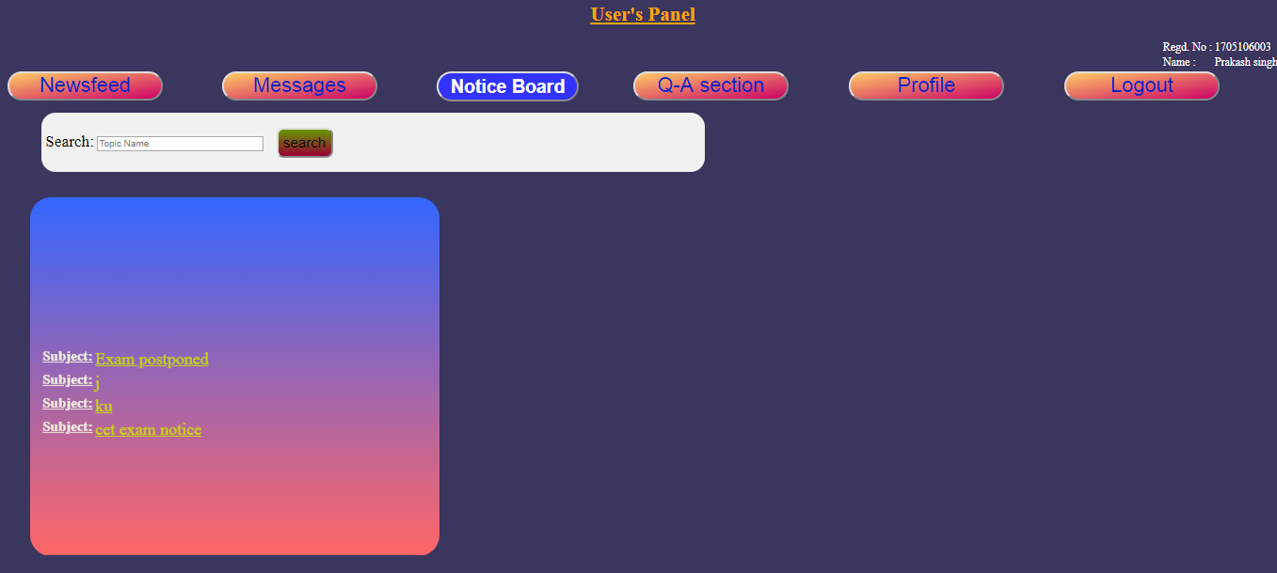

**Q&A Section:**

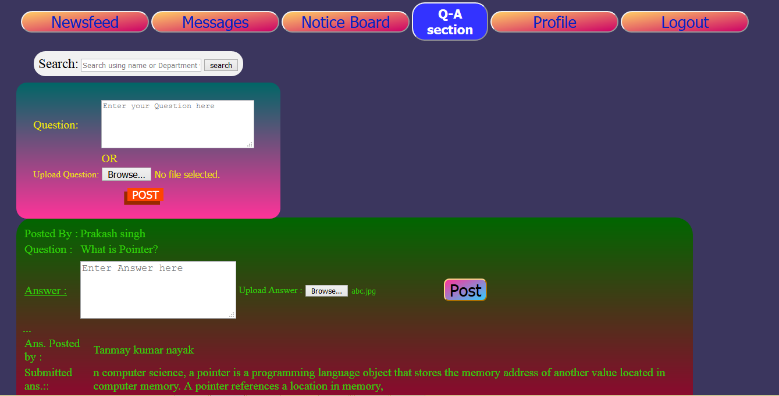

Profile

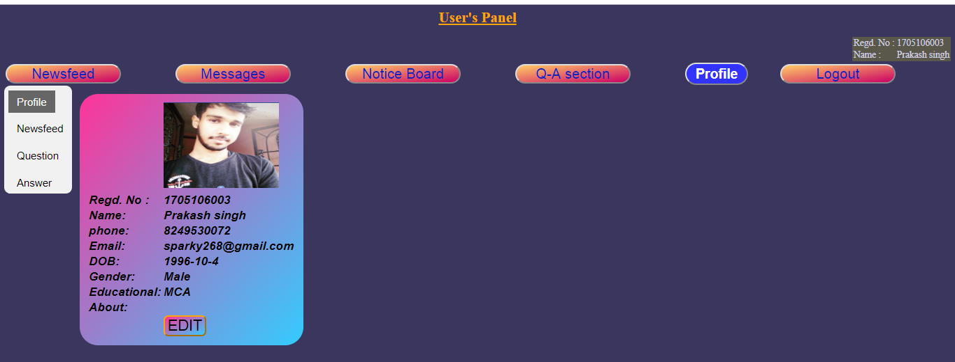

**Advantages**

1. ‘Community Social Network’ provides a social media like Interface for the students and faculties of different departments of an educational organisation which helps in chatting and viewing recent news of that organisation.
2. It helps in sending notifications to all the users which is very useful for organising special events for the college.
3. This ‘Community Social Network’ Project aims to make the educational institution’s work flow more efficient and effective so that all the users can interact with each other in order to make the educational community more helpful for performing the organisation’s activities.
4. Students will get an opportunity to be in a friendly environment with the teachers in order to solve their doubts through the message section.
5. This website can also be used for online education purpose as teachers can send useful contents in the question answer section and students will be able to read those.
6. The students can also interact among themselves which will help in making the interaction process more unique and more effective.
7. This project also provides a notification section through which seminars and events can be organised.
8. There will be no boundary of time factor i.e., users will be able to interact among themselves at any time they want.
9. It also helps to integrate flexibility of the educational schedules. It also creates a community that can work together towards a common goal of meeting the curricular goals.
10. It provides a healthy and friendly environment to learn through the question answer section where everyone of a particular department will get an opportunity to be a part and learn from it.
11. It provides a chat interface to the users where they can be able to get one to one communication in message section as well as one to many communication in the question and answer section.

**Conclusion**

The Community Social network is developed using PHP and SQL in backend, HTML,CSS,Java Script in front end.fully meets the objectives of the system for which it has been developed. The system has reached a steady state where all bugs have been eliminated. The system is operated at a high level of efficiency and all the teachers and user associated with the system understands its advantage. The system solves the problem. It was intended to solve as Requirement specification.