**DECLARATION**

We are here to declare that the project work entitled "***Student Result Management System"*** is an authentic record of our own work carried out as requirements of Minor project (III/I) for the award of degree in ***Diploma in Computer Engineering*** from **Basu Secondary school** (*Affiliated to CTEVT*), Kalighat, Byasi-2, Bhaktapur.

Submitted By:

*Archana Makaju* (074-01-CT)

Registration no.: DCOM-00002-017

*Nanu Maya Tamang* (074-27-CT)

Registration no.: DCOM-00018-017

*Kabita Buyo* (074-10-CT)

Registration no.: DCOM-00011-017

**Acknowledgement**

It gives us immerse pleasure to express our deepest sense of gratitude and sincere thanks to our highly respected and esteemed guide Er. **Ramesh Prajapati**, for his valuable guidance, encouragement and help for completing this work. His useful suggestions for this whole work and co-operative behavior are sincerely acknowledgement. We are also grateful to our teacher Er. **Ramesh Prajapati** for his constant support and guidance.

We would like to thanks **Diploma in Computer Engineering** for giving us this opportunity to carry out the project successfully. We would thank to our supervisor who guided and provide the technical and moral support throughout the project. Next, we would also to thank the entire faculty for their full co-operation.

At the end we would like to express our sincere thanks to all our friends and others who helped us directly or indirectly during this project.

**Project Association:**

Archana Makaju (074-01-CT)

Nanu Maya Tamang (074-27-CT)

Kabita Buyo (074-10-CT)

**Abstract**

This project deals with the analysis and design of student Transcript management system for providing the examination result to the student in simple way. The main objectives of the project is to provide the examination result to the student in simple way. This project is useful for students and institution for getting result in simple manner. By a result analyzer with subject status and marks in an application tool for displaying the result in secure way. The system was developed by vb.net and database and the system is intended for the student. The project Student Transcript management system is application developed to maintain the result of the students. It is a technological opportunity for the school, college, universities searching for a secure, simple and alternative solution to the conventional paper-based exam results evaluation, reporting and distribution. Technology in today’s world has reached to extent that it can be used to do various task in day to day life easily with less effort and time. Universities, colleges, schools today have loads of task to be completed in given timeline.

**TABLE OF CONTENTS:**

**TITLE PAGE NO.**

**Declaration 1**

**Acknowledgement 2**

**Abstract 3**

**Chapter 1. Project overview 5**

* 1. **Introduction 5**
     1. **Background 6**
     2. **Advantage of STMS 7**
     3. **Disadvantage of STMS 7**
  2. **Objectives 8**
  3. **Propose system 9**
  4. **Scope 10**
  5. **Project Features 10**

**Chapter 2. Literature Review 11**

**Chapter 3. Module Overview 12**

**3.1 Administrator module 12**

**3.2 Student module 12**

**3.3 Project module 13-14**

**Chapter 4. Design 15**

**4.1 Methodology 15**

**4.2 ER Diagram 15**

**Chapter 5. Result and analysis 16-20**

**Conclusion 21**

**Reference 21**

**Chapter 1: Project Overview**

**1.1 Introduction**

**Transcript Management project is a desktop application which is developed in VB platform**. The Student Transcript Management system is creating in such a way that serves an authority to the administrator in managing all the activities on a single platform. Transcript Management system is an application which refers to examination system. It maintain the information about student result and it makes and provide Transcript on easy way which is easy to manage and it becomes easy to handle for all students results. The main aim of this project is to store the result score of student on their results in the form of report cards. This system is mainly used for educational institutes like school and colleges to evaluates the performance of results for students and also generate performance reports like progress reports. Student Transcript Management System is a technological opportunity for the school, college, university and coaching center institutions searching for a secure, simple and alternative solution to the conventional paper-based exam results evaluation, reporting and distribution. We are able to see the individual student's transcript separately. The student transcript management system is extremely important to educational sectors such as:

* Effective use of time saving.
* Manage multiple subject department from a single computer.
* Communication between teachers, parents and students.
* Add and manage students and declare results.

**1.1.1 Background**

The present system uses traditional means of paper and excel sheets for managing the student academic records and results. Managing manually doesn't validates the exact information like students statistics and moreover it's difficult to maintain each record. The exam management cell become quite handy with the increasing number of students every year and limited resources Thus, there need a systematic software/program to maintain the information and the academic performances of all the students. The proposed system is one of the solution that can not only reduce human work but can become effective too. The system will maintain every necessary details about each student, compile result and allow the students to view the result. The development of transcript management system would help lecturers and students to easily manage and maintain the results. The Student Management System, being the dependency of Transcript Management System, would manage and update the students' information, get the statistics of students such as number of students passed or failed in certain years, details of students, etc. This will help the management to make the students results and provide the result in simple manner.

**1.1.2 Advantage of Student Transcript Management System**

**For Administration:**

* With student transcript management system, teachers, professors, and staff can create transcript system.
  + Exam Timetable Management.
  + Records marks and result on a single database.
  + Add & manage students and Declare Results.
  + Record and search details of every exam/test, student wise.
  + Calculate scores, percentages etc.

**For Student:**

* View transcript of yearly exam.
* Search exam marks with valid registration number, name and address.
* Request for re-evaluation.

**1.1.3 Disadvantage of Student Transcript Management System**

* The student transcript management system is prone to hacks.
* Administration cannot edit or modify scores after the deadline.
* Extensive modules and features make it difficult for a user to utilize the application.

**1.2 Objectives**

* To increase security and easily to store student's obtained marks in database.
* To manage the details of results, progress report, courses and quickly to searching.
* To provide Transcript within short time and easily to update, delete, add the student's information.

**1.3** **Propose system**

Student Transcript management System is a student driven system that is designed in order to keep record of student data by use of technology. Now-a-day Transcript management system is done manually taking lots of effort and time then too desired accuracy is not achieved. Also update of data is very difficult as all data needs to revision again. In addition more paperwork and documentation is required.

This project system that will manage:

* Information about students, subjects offered in various classes.
* Marks obtained by student in all classes.

Student transcript management system is simple web based application designed using vb.net. In this system database is designed using SQL server. Logical coding is done using vb.net which contains main logic of overall system functionality. The system is covered under all validation checks for authentication. These student data is been analyzed based on various aspects like marks, percentage, rank. System will be designed in such a way that it can be later updated to accept different format. In the proposed system, there are various controls to provide user friendliness. Details can be records and information can be stored. It provides high level of security, and there is no risk of data mismanagement. The overall transcript management system is easier, flexible and requires less time.

**1.4 Scope**

* The application will manage the information about various students enrolled in this course in one years.
* The mark obtained by the various students in various subject.
* It will greatly simplify and speed up the result preparation and management process.
* It is one of the application to improve the information during examination of any particular student.

**1.5 Project Features**

Two main features of this project are: entering marks in transcript and provide result. Both these functions are done automatically by this software application. Some other features of the project are add, update, delete and exit from the application. The transcript entry form includes “student details” and “obtained mark” by the student. Students’ name, registration number, address, date of birth, school name are to be provided in student details. All these information are saved in the system.

**Chapter 2: Literature Review**

The Student transcript management system is the software that enables user to easily store and search record from database such as name, address, school name, date of birth, student's marks etc. There are record-centric databases (tbl_Students and user_info) that provide a fully integrated approach to store record from user and communicated with the software. The main advantage of this software is that Records marks and result on a single database, Add & manage students and Declare Results, Record and search details of every exam/test, student wise and Calculate scores, percentages etc. The main disadvantage of this software is that the student transcript management system is prone to hacks, Administration cannot edit or modify scores after the deadline.

According to Royce, the manual methods being employed suffer a number of setbacks; they make the process to be time consuming and prone to error. They lead to examination results being published late, sometimes with wrong grades being entered and students percentage being wrongly computed. The solution of this problem is to find a method of processing examination transcripts that would be sufficiently accurate and reasonably timely. The development of database concept is the answer to these problems, where the amount of redundant data is reduced.

According to Inventional Standard Organization (ISO) in (1985), define result management system as the act an outcome of examination to have a meaningful grade point at the end. Consequently, result management served as a method of generating collecting, gathering a student mark and average grade point of yearly examination.

**Chapter 3: Module Overview**

There are two users or modules in student Transcript management system. They are briefly described below:

**3.1 Administrator Module**:

They can log in to their system with their unique id (username and password). Administrators can view and update various things such as personal details of students, Transcript of students, schedules, etc. The admin is responsible for add the subject marks and they make any kind of modifications like storing, updating, deleting.

* 1. **Student Module**:

Student must be an authenticated user of the college to access this application. As in the administrator module, students have their unique registration number and date of birth to log into the system. The students can view the yearly marks, individual subject marks and their personal details and their results. Students will able only to view his/her data.so access level restrictions has also been implementation on the project.

**3.3 Project Module:**

**User and Student Login Form:**

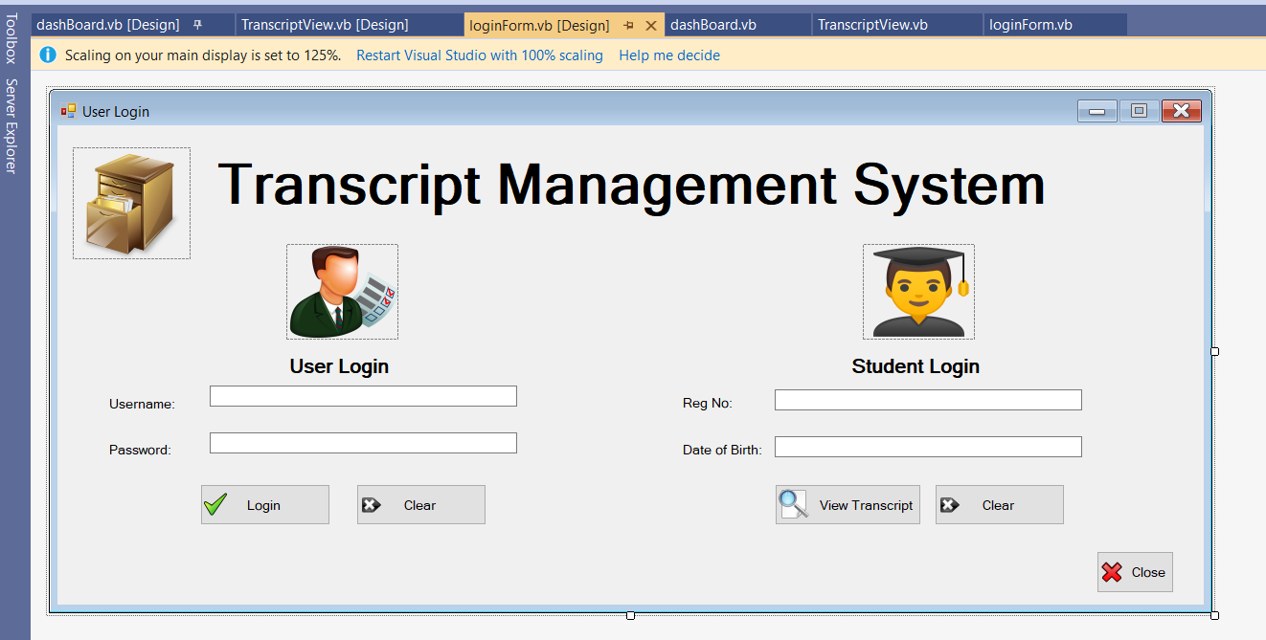**Dashboard view:**

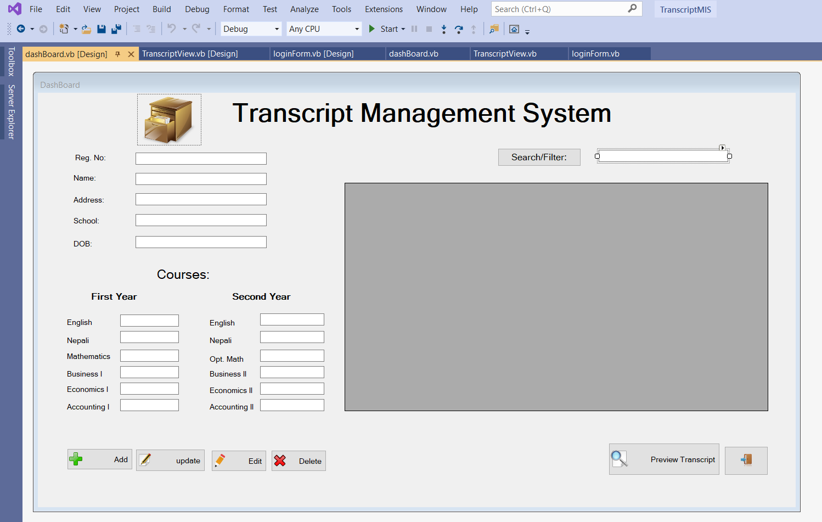

**Transcript view:**

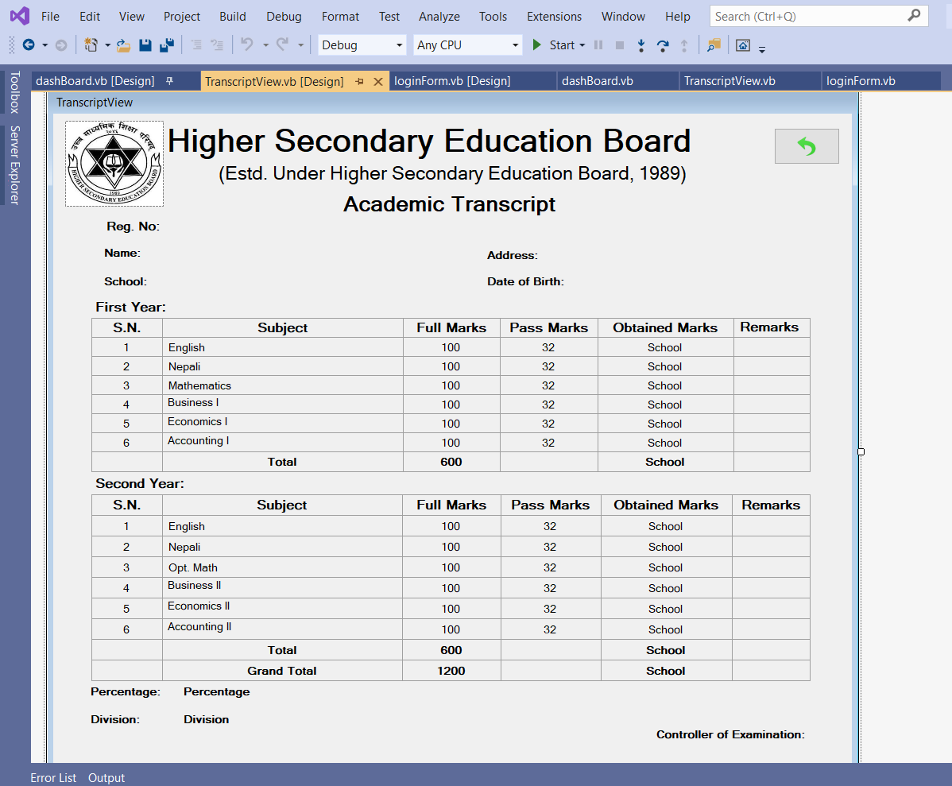

**Chapter 4: Design**

**4.1 Methodology**

* In this project, we have applied the concept of vb.net and database for the better development and preparation of the project.
* We have followed some concept from the project that have already been developed by others that are related to this project.

Along with these, we have also used some of our course books for the reference of the project

**4.2 ER Diagram of Student Transcript Management SystemChapter 5: Result and Analysis**

User

Students

Subject

manages

studies

manages

**Output of Student Transcript Management System:**

**User Login Form:**

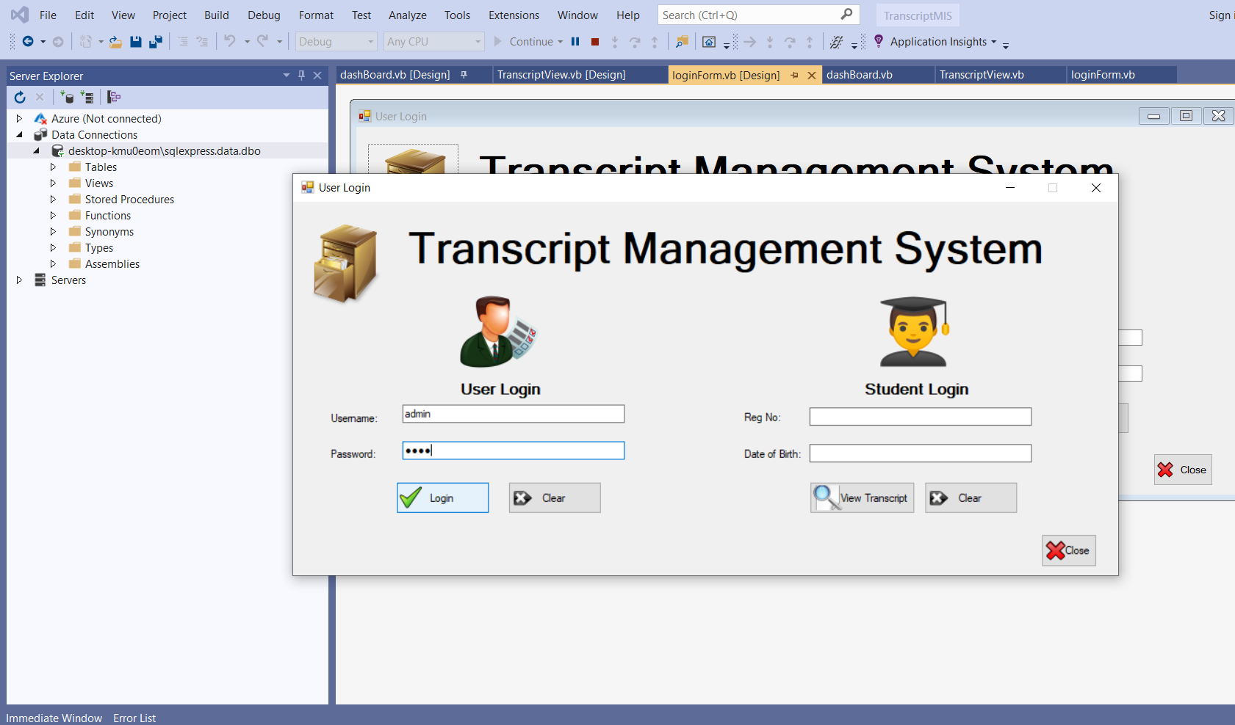

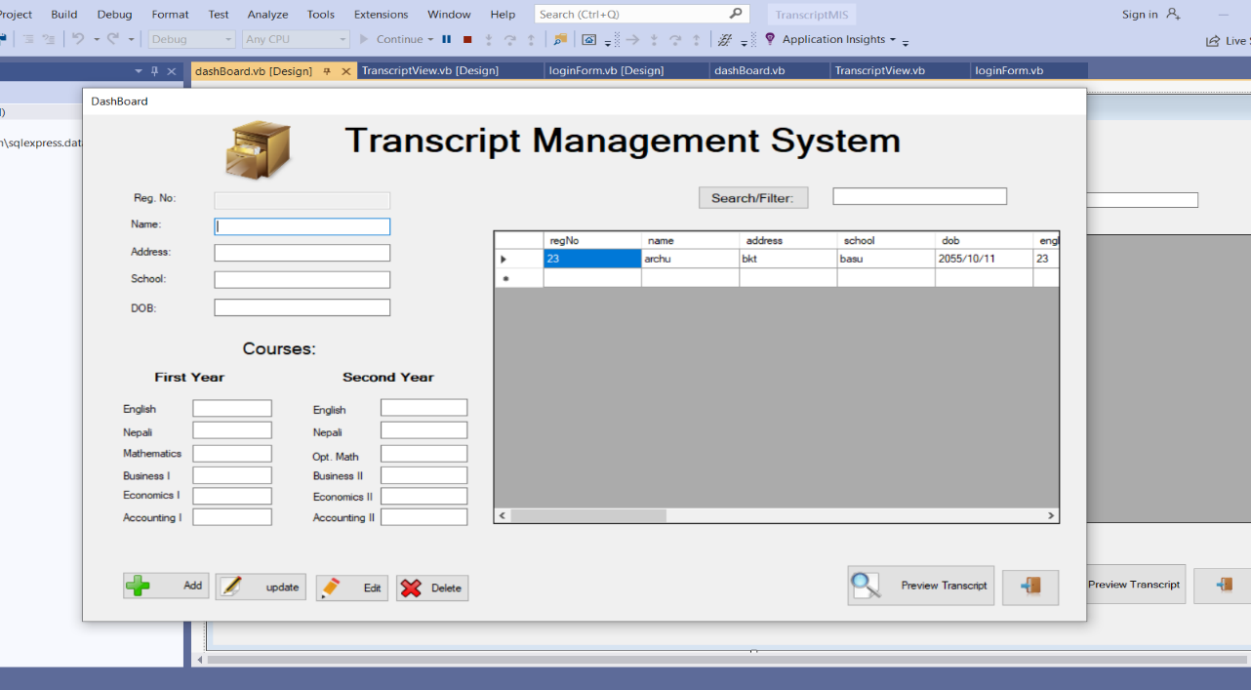

**To Add record:**

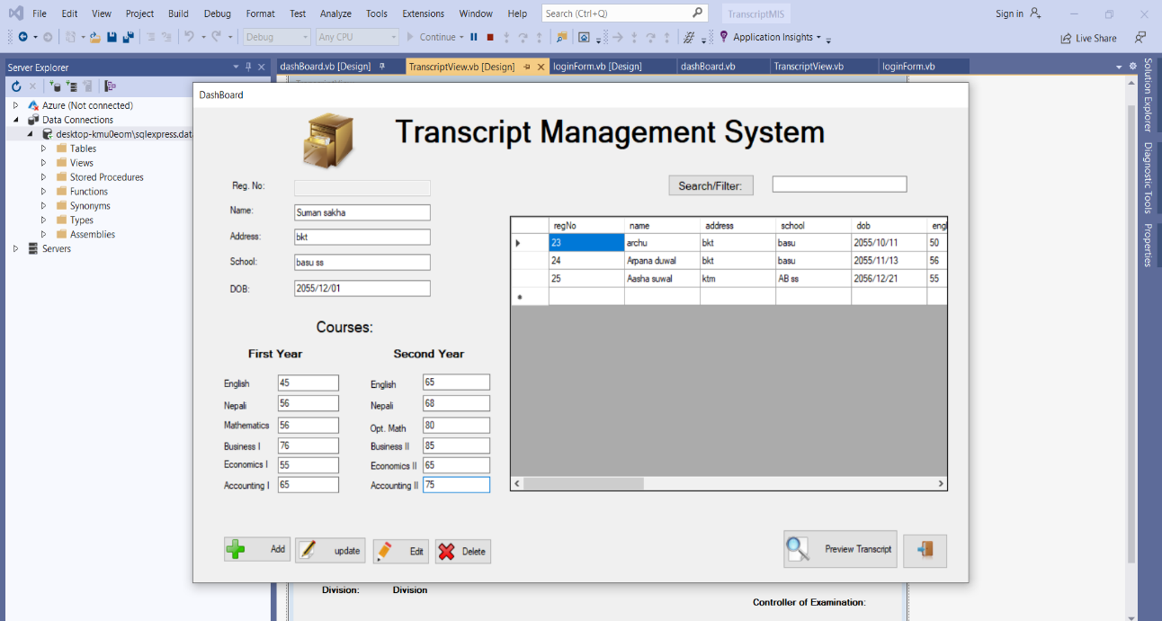

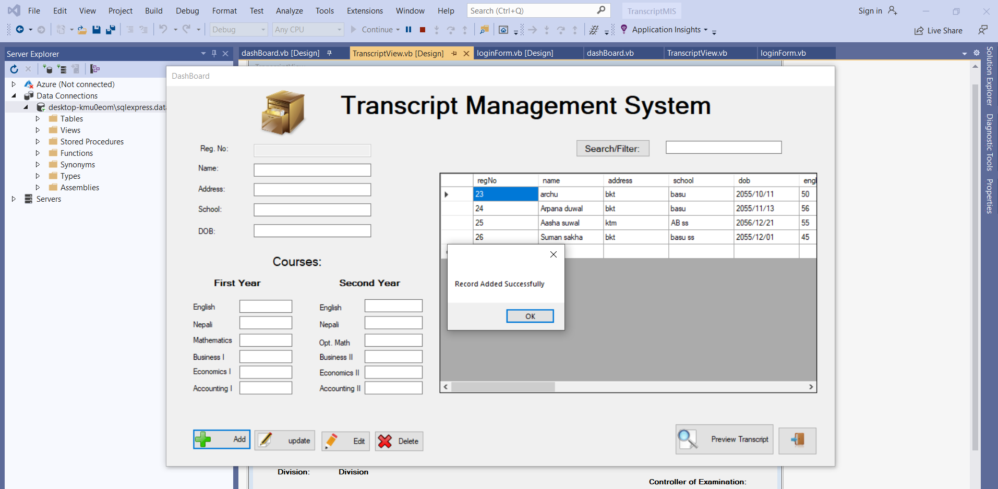

**To Update Record:**

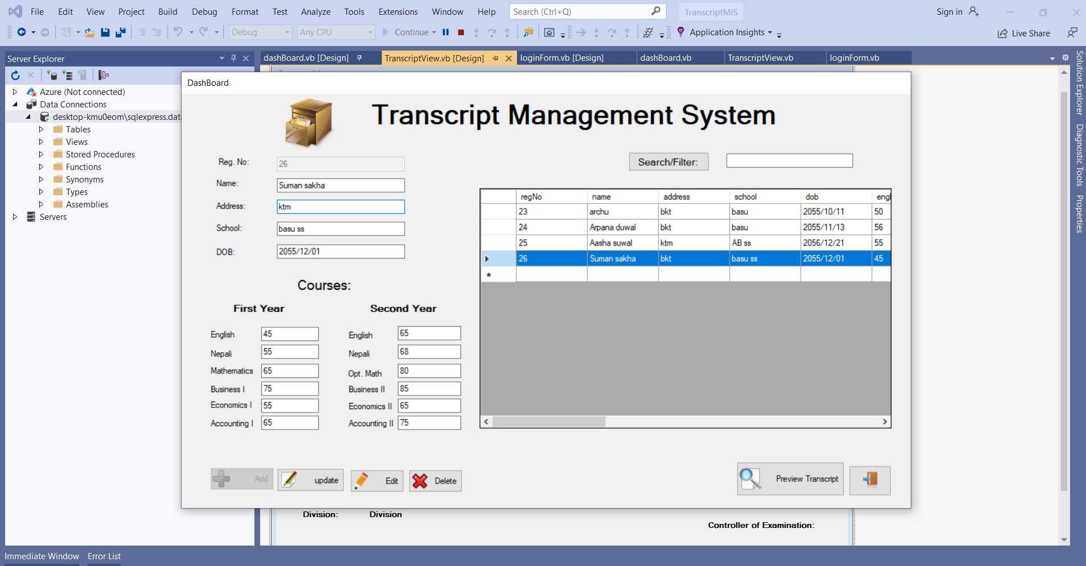

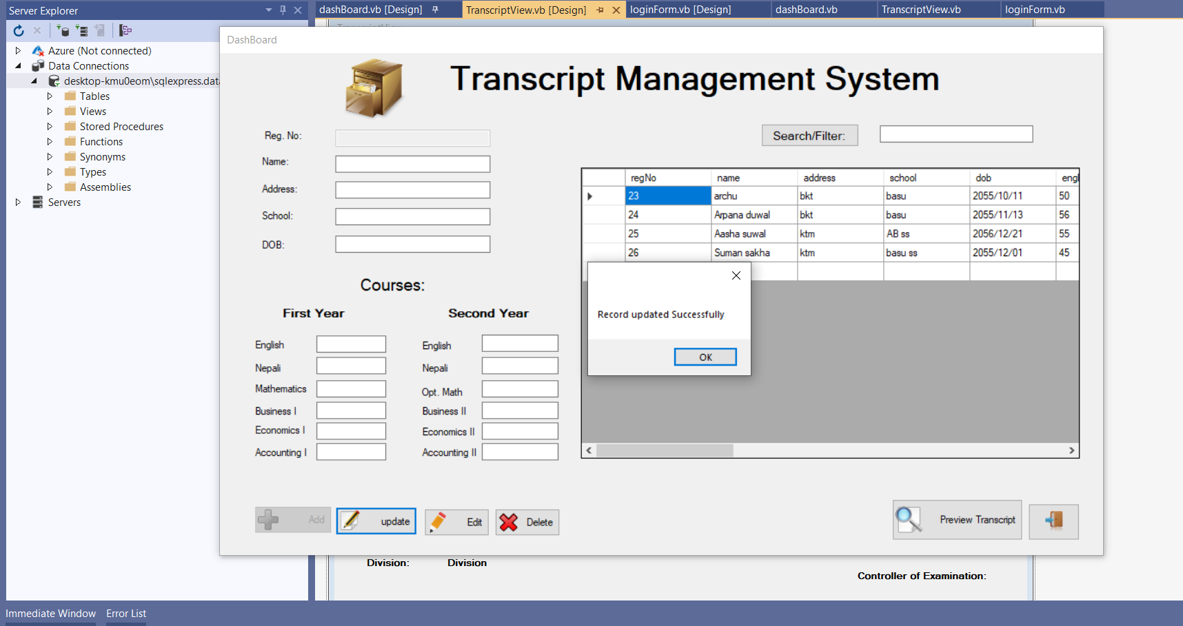

**Delete Record:**

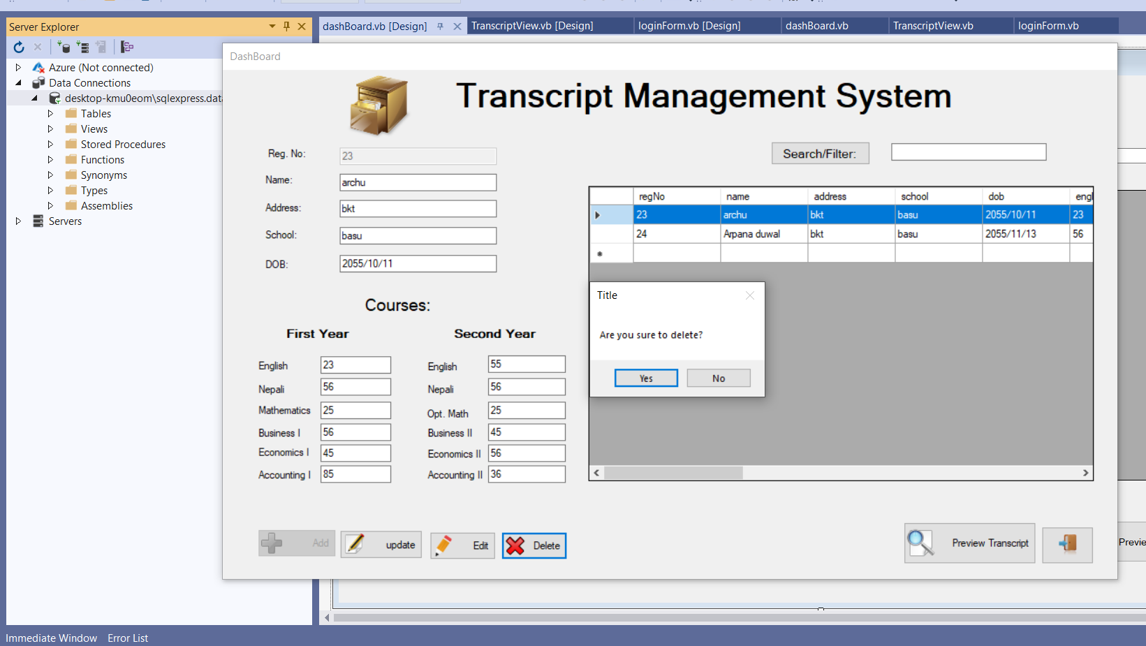

**Search data:**

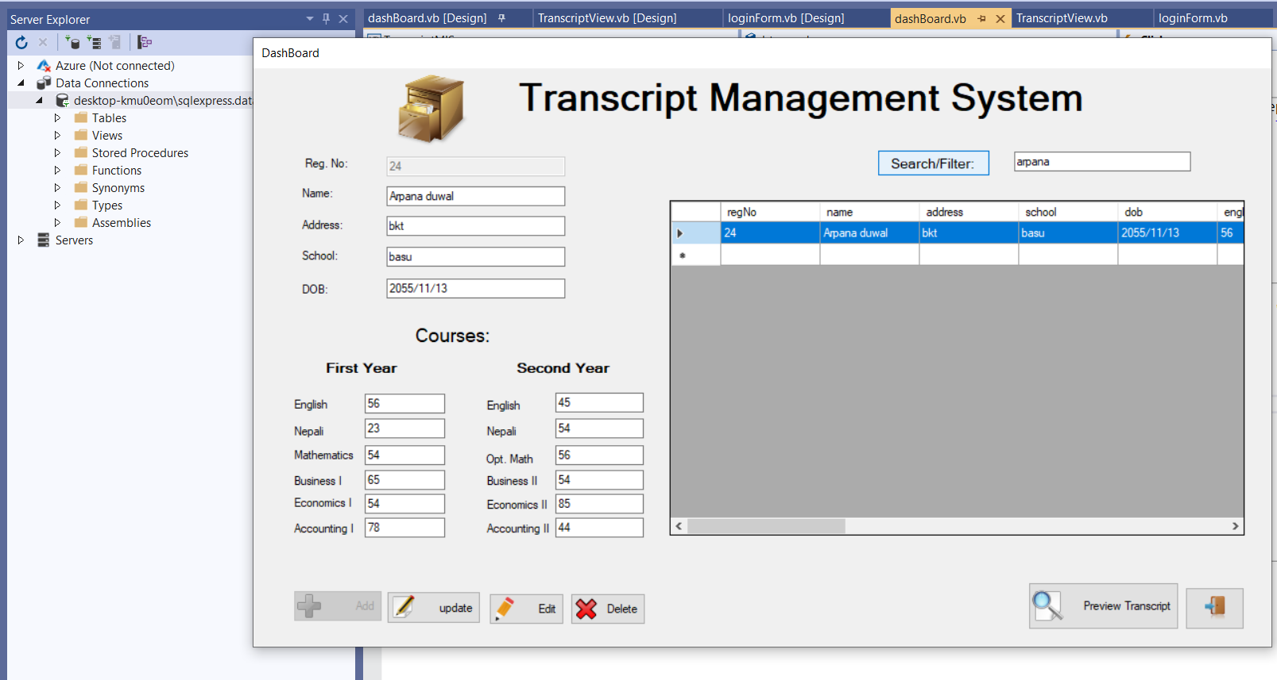

**Students Transcript view:**

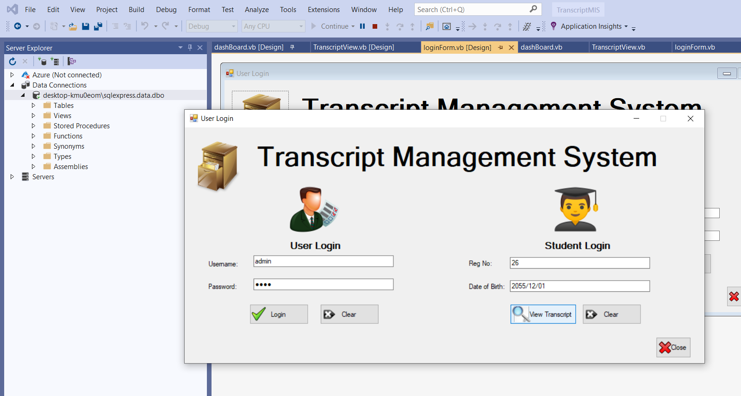

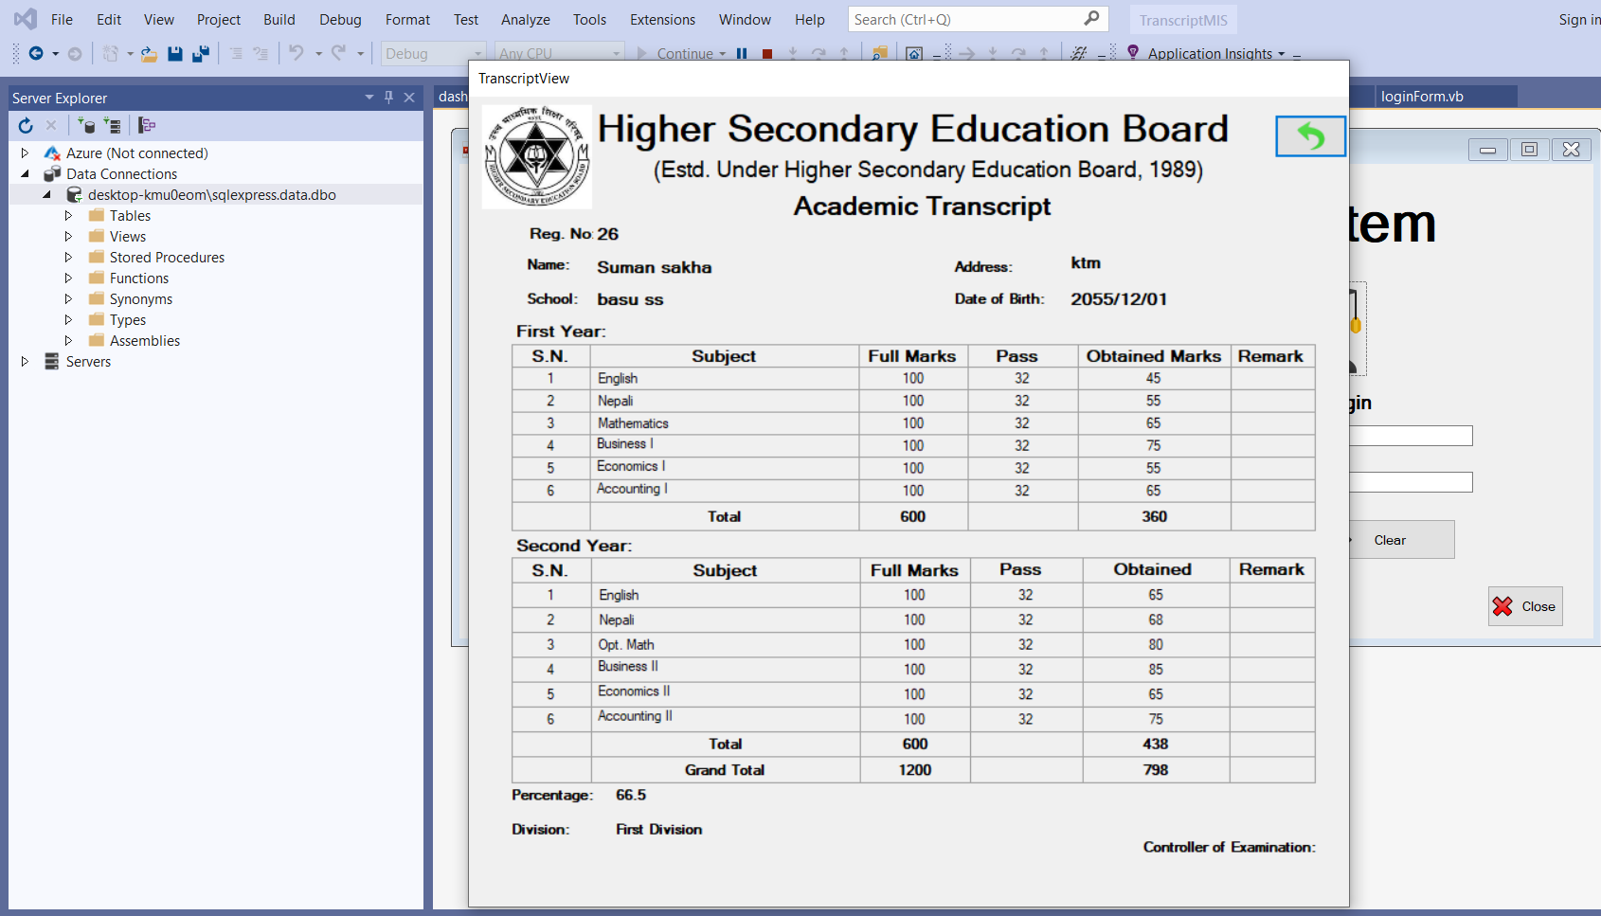

**Conclusion**

In Conclusion, Teacher can manage student's information during examination so that, it reduce the unnecessary paper work in maintaining student's information. We are very hopefully because our system will be very secure and it provide the examination transcript to the students in a simple way. Thus, it also user friendly with easy to access. The present system uses traditional means of paper and excel sheets for managing the student academic records and results. This will help the management to make the students transcript and provide the transcript in simple manner.

**Reference**

1. Rogers muwanika, http://www.slideshare.net,(muni university) , published on Oct 5, 2017, Scribd will begin operating the slideshare business on December 1,2020 (6.17 PM, 22/1/2020)
2. http://[www.technofist.com/,](http://www.technofist.com/,) student transcript management, BANGALORE 4.13 PM ,22/1/2020)
3. <https://www.academia.edu/36234156/Student_Result_Management_System,2020> (6.20PM,22/1/2020)
4. [https://phdessay.com/student-result-management-system/ (3.07](https://phdessay.com/student-result-management-system/%20(3.07) PM, 09/11/2020)
5. Ashwin Mehta1, Jugal Patel2, Aditya Mewada3, 3 Student,Dept. of Computer Engineering , K.J.Somaiya College of Engineering and Information Technology, Mumbai, Maharashtra , India © 2018, IRJET