
RAT (Radar Tools)
Tutorial “Polarimetric Classification” V1.0

1. Import SAR data
- Import some polarimetric SAR data. You have two possibilities
  - In case you already have a file in RAT format File->Open RAT file
  - In case you have to import a sensor specific format File->Open external-> *
Depending on the sensor, the function will ask whether you want to read a single data set or polarimetric data in vector or matrix format. Select “multiple”, resp. vector or matrix data. Single channel data cannot be classified with RAT (yet).
- RAT needs a while to read the data and to calculate the preview. You should see something like this:
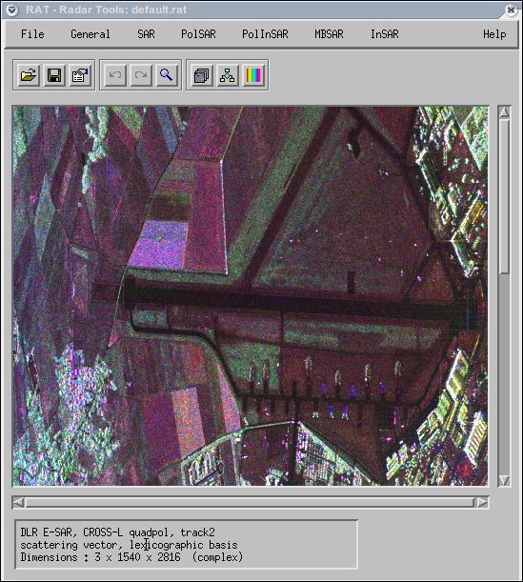
In the so-called info-box at the bottom of the RAT window you get some information about the currently loaded data. In the above example you have loaded 3 complex channels with 1540x2816 pixel.
- If necessary, crop your region of interest General->Cut out region
With the mouse, drag a box to select an area. A window with precise coordinates appear, which can be changed if necessary. If you've change a value, press <enter> to update the white box on the screen.
- Don't forget to save your data into a *.rat file File->Save RAT file
RAT always saves two files: the *.rat, containing the data, and a *.rit, containing the processing history and the last colour palette. RAT can open *.rat files without having the corresponding *.rit file.
Note: Import from POLSARPRO internal polarimetric format (scattering vector and covariance/coherency matrix) is supported. Import from ENVI might work if you're lucky (not well tested, we don't own ENVI). Reading generic binary might work if you're lucky (not well tested).
Note: ASAR-APP mode delivers 2 polarimetric channels of amplitude-only data. RAT supports these data only as single-channel SAR data. Polarimetric analyses are not supported.

2. Watching the data
- By default, RAT displays a RGB composite of the three first channels. To watch individual channels, press the icon in the icon bar under the pull-down menus to open the channel selection dialogue. Here you can switch between single channel display and RGB display. With the button “reset to defaults”, you can always restore the original settings.
- If you want to magnify a region of interest, press the icon to activate the zoom function. With the mouse, drag a box to select the area to magnify. A window with a zoomed ROI will appear. The zoom function zooms into the full-resolution image, not into the preview.
3. Covariance matrix generation
In the following it is assumed that you imported a 3-element scattering vector. If you already have a covariance matrix, please proceed with “speckle filtering”.
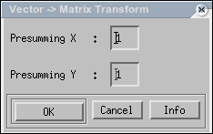
- Complex scattering vectors cannot be speckle-filtered. Therefore, the image has to be transferred to covariance matrix representation PolSAR->Transform->Vector2Matrix
At this point it makes sense to correct for different pixel spacing in range an azimuth. Select appropriate factors to shrink the image differently both directions and to get approximately quadratic pixels. If your image is very large, some presumming is good to reduce speckle and computation times.
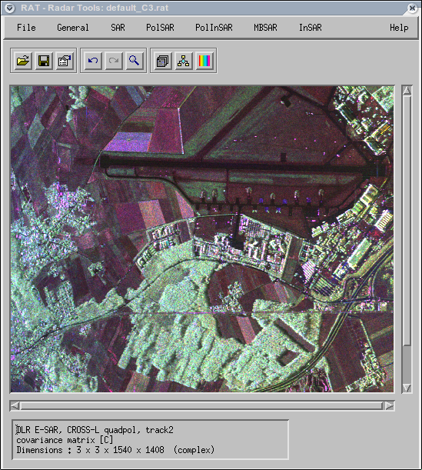
- RAT needs a while to read the data and to calculate the preview. You should see something like this:
In the info-box, the updated image parameters appear: Now you have 9 channels (3x3 matrix) of complex data of the size 1540x1408. The azimuth size got smaller, because in this example a 1x2 presumming was performed.
- Again, don't forget to save the covariance data into a *.rat file File->Save RAT file

4. Speckle filtering & presumming
After formation of the covariance matrices it is necessary to do some speckle filtering. This is mandatory because otherwise your covariance matrices will be singular and classification approaches won't work.
- Perform speckle filtering. You have two possibilities:
  - Pre-summing of the data General->Presumming
This averages adjacent pixels and reduces the image size accordingly. Fast, precise, but causes a loss of resolution. Especially helpful in combination with other filters.
  - Use a “real” speckle filter PolSAR->Speckle filter-> *
You can choose between several filtering strategies. Boxcar is the fastest filter, which simply performs local averaging. Lee is an adaptive speckle filter which filters according to the local statistics, while refined Lee combines this with directional windows. The IDAN filter works similarly, but using a region growing window and is rather slow. Simulated annealing is extremely slow. Recommendation: Refined Lee or IDAN.
- Filter size: Sufficient speckle filtering is required to obtain good results. Recommendation: Choose a filtering window, which contains at least about 50 samples, i.e. a 7x7 window
- Number of looks: The number of looks have to be set in some of the filters. This value corresponds to the amount of presumming you performed, i.e. a 2x4 presumming is equivalent to 8 looks. If you don't know what to put here, or if you want to check your data, use PolSAR->Inspect-># of looks
This function performs a course estimation, which sometimes can be a bit underestimated.
- Hint: It can be helpful to perform some presumming prior to speckle filtering. Similarly, some presumming after speckle filtering to reduce the image size might help in getting better classification results.
- Some tries with different settings might be helpful. Use the zoom function to check image quality
- In out example, first a 2x2 presumming was applied, followed by IDAN filtering with the settings 100/25 neighbourhood size and 8.0 number of looks (1x2 presumming in the covariance calculation, multiplied with 2x2 presumming). As result, one obtains:
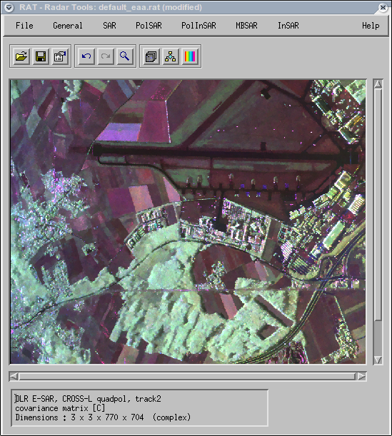
- Again, don't forget to save the filtered covariance data into a *.rat file File->Save RAT file

5. Classification
RAT offers several sophisticated unsupervised clustering techniques. The description of the algorithms goes beyond the scope of this tutorial. If you're interested in more details, please click on the button “Info” in each of the routines to get some literature reference. In the following, three different algorithms are described.

- Entropy/Alpha or Entropy/Alpha/Anisotropy segmentation
This functions perform a simple segmentation of the Entropy/Alpha feature space into 8 classes., or segmentation of the Entropy/Alpha/Anisotropy feature space into 16 classes.
  - Load your filtered covariance matrix File->Open RAT file
  - Calculate the Entropy/Alpha parameters PolSAR->Parameters->Entropy / Alpha / ...
RAT will perform some necessary transformations.
  - Perform the classification PolSAR->Classification->Ha segmentation
or PolSAR->Classification->HaA segmentation
Below are two examples: Ha-segmentation (left) resp.HaA segmentation (right) .
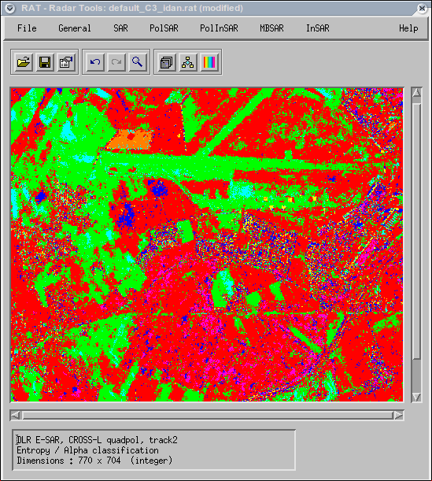
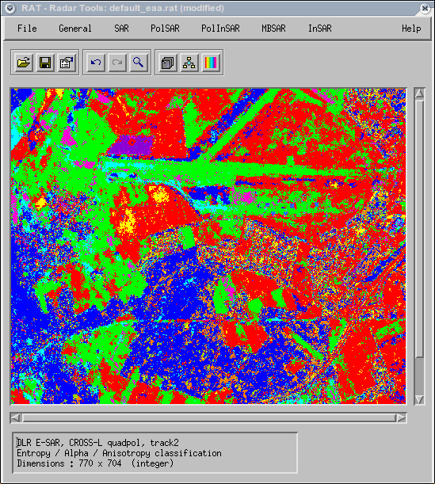

  - Save the classification result into a *.rat file File->Save RAT file
  - If you have saved your Entropy/Alpha parameters, you can also start from there instead of recalculating it.

- K-means Wishart clustering
K-means clustering is a technique to iteratively determine optimal classes and to assign each pixel to one of these classes. It requires an initialisation in form of another classification. If this is not available, a random initialisation can be performed
  - Load your filtered covariance matrix File->Open RAT file
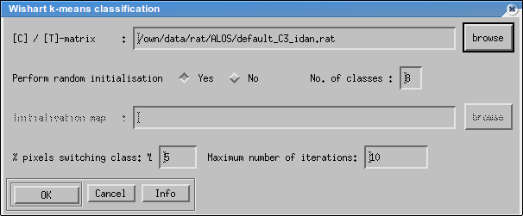
  - Start the classification routine PolSAR->Classification->K-mean Wishart gen.
In the top row, the file with the covariance matrix can be selected. In the second row, you can choose between random initialisation and initialisation with another classification. In case of random initialisation you have to set the desired number of classes. In case of an initialisation map, both files have to have the same size; the number of classes is automatically determined . In the bottom line, the termination criterion is specified: You can set a the percentage of pixels changing class at which the iteration is stopped, and a maximum number of allowed iterations. Press <OK> to start the clustering.
Below are two examples, obtained with random initialisation and 8 (left) resp.16classes (right) .
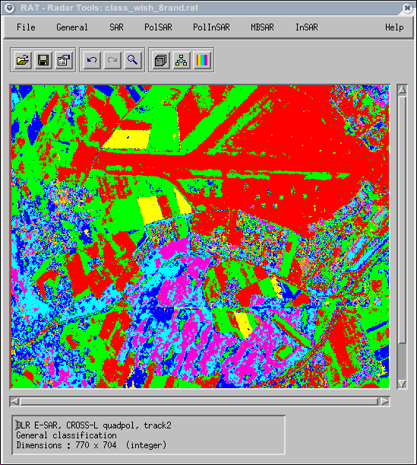
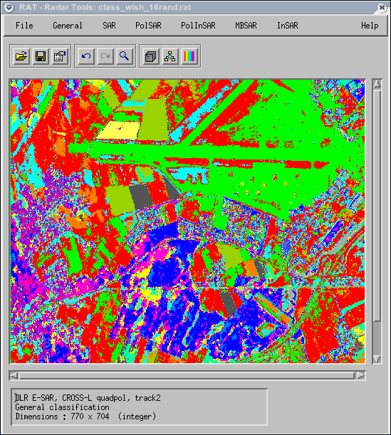
Note: Using this classifier, the final number of classes can be smaller than the chosen one. This is because empty classes are removed from the process.

- K-means Wishart Entropy/Alpha/Anisotropy clustering
This algorithm is almost identical to normal k-means clustering. However, this routine uses a special strategy to initialise the clustering using an entropy/alpha segmentation and the anisotropy. The clustering into 16 classes is performed in two independent rounds. This classifier has a good reputation and often gives superior results compared to normal Wishart clustering.
  - Load your filtered covariance matrix File->Open RAT file
  - Start the classification routine PolSAR->Classification->K-mean Wishart HaA
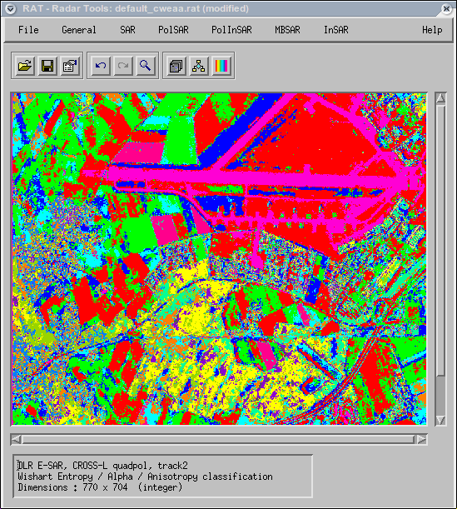
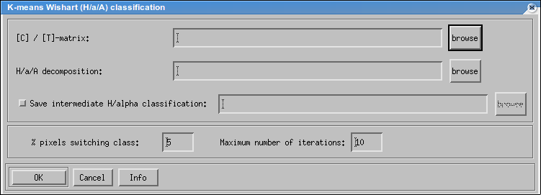
In the top row, the file with the covariance matrix can be selected. In the second row, the file with the corresponding Entropy/Alpha/Anisotropy parameters has to be selected.Both files have to have the same size. In the third line, is desired, a file for saving the intermediate classification result can be specified. In the bottom line, the termination criterion is specified: You can set a the percentage of pixels changing class at which the iteration is stopped, and a maximum number of allowed iterations. Press <OK> to start.
the clustering.
Below an example of a possible result.
Note: Using this classifier, the final number of classes can be smaller than the chosen one. This is because empty classes have to be removed from the process.

- Expectation maximisation with probabilistic label relaxation (EMPLR)
Expectation maximisation is another technique to iteratively determine optimal classes and closely related to fuzzy decision rules. Here, each pixel is assigned to all classes, only for the final result the most probable class is selected. This classifier requires an initialisation in form of another classification. If this is not available, a random initialisation can be performed.
Additionally, this module has the capability of performing internal probabilistic label relaxation. This techniques uses spatial context to derive more homogeneous classification results. EMPLR is very powerful and well suited for data with a low number of looks / strong speckle.
  - Load your filtered covariance matrix File->Open RAT file
  - Start the classification routine PolSAR->Classification->EM-PLR
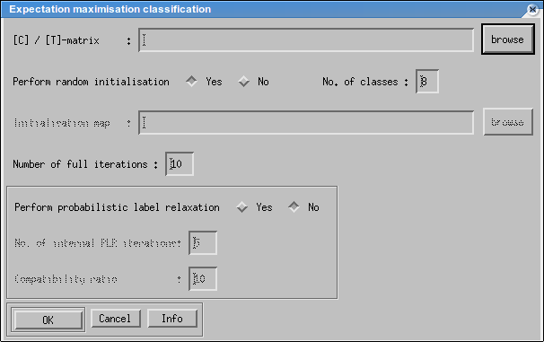
In the top row, the file with the covariance matrix can be selected. In the second row, you can choose between random initialisation and initialisation with another classification. In case of random initialisation you have to set the desired number of classes. In case of an initialisation map, both files have to have the same size; the number of classes is automatically determined. In the bottom line, as termination criterion only a fixed number of iterations can be set. If you want to use probabilistic label relaxation, set the switch to “yes”. The higher you set the both parameters below, the smoother the resulting classification result will get. Press <OK> to start the clustering.
Below are two examples, obtained with random initialisation and 8 (left) resp.16classes (right) and PLR.
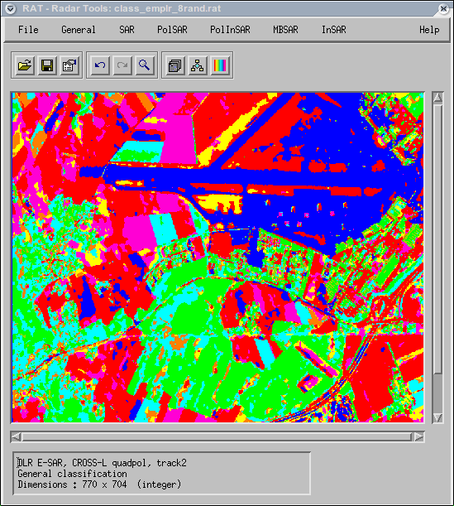
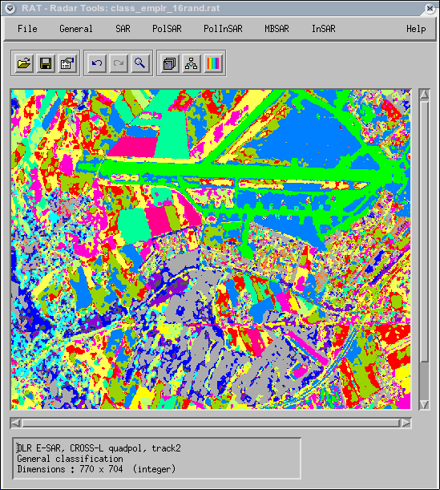
Note: Using this classifier, the final number of classes is always the same as the chosen one. However, since at the end the most likely class is selected for each pixel, some classes might not be present in the derived classification map.
6. Post-classification
- Median filter PolSAR->Post classification->Median filter
Use this filter to remove noise pixels from the classification result and to homogenize the classification result. Every small feature in the map will be eliminated, but edges will be preserved.
- Resort clusters PolSAR->Post classification->Resort clusters
This function changes class numbering in a way that the more pixels a class has, the smaller the class index gets, i.e. the largest class gets index zero, etc. The main effect is that the colouring sometimes gets better, as the most important classes get the most distinct colours when using the default colour palette.

Known issues at time of writing
- Polarimetric mode with 4 channels is not well tested. Use it on your own risk and report errors
General Notes
- Author: Andreas Reigber
- This tutorial refers to RAT V0.18. In other versions the procedure might be different.
- If you encounter any errors or crashes, please report them in the RAT forum.

